Atikha Chapter 4 Screen Hierarchy and Project Testing

Screen Hierarchy
The following figures present the System Administrator and Management and Board screens of the Atikha Financial Management System. The sidebar connects the financial overview, accounting workspaces, books of accounts, communications and role-specific pages. Each figure explains the purpose of the displayed screen and the controls available in the captured state. The Administrator screens are followed by the Management and Board screens.
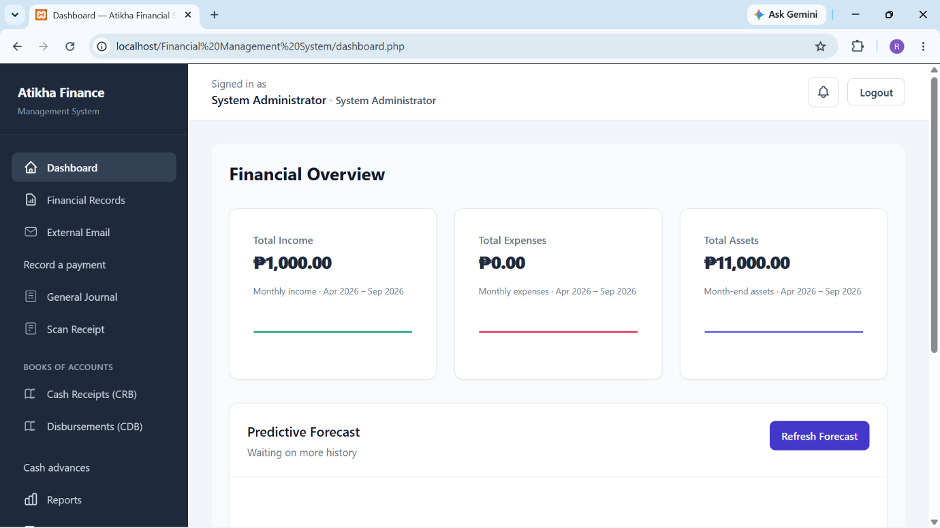
Figure [SH01]. Dashboard Page (System Administrator)
Figure [SH01] shows the Dashboard page, which presents the financial overview of the Atikha Financial Management System. It displays summary cards for total income, total expenses and total assets, together with charts for the indicated reporting periods. The sidebar provides access to financial records, transaction entry, books of accounts, communications and administrative tools. The predictive forecast area indicates its current availability; in the illustrated state, it is waiting for additional history.
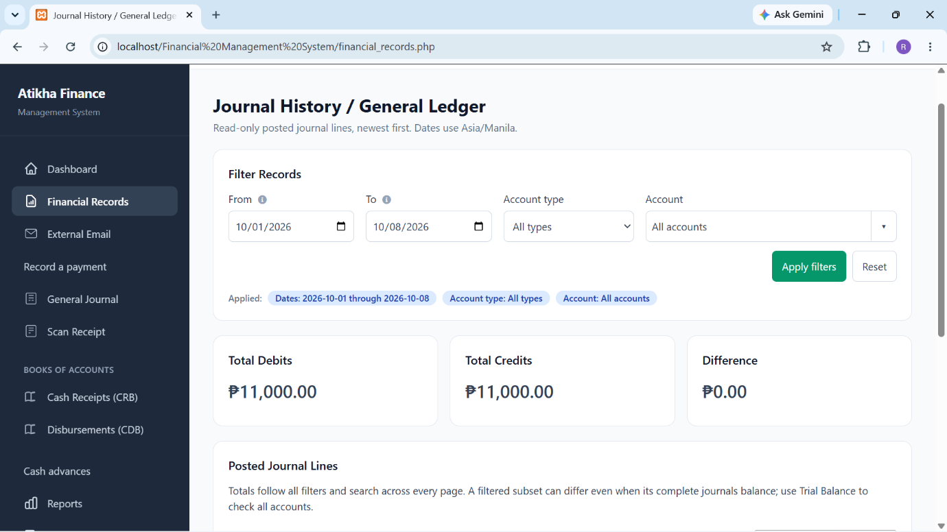
Figure [SH02]. Financial Records Page (System Administrator)
Figure [SH02] shows the Financial Records page, which displays the Journal History / General Ledger as read-only posted journal lines. The administrator can narrow the records by date range, account type and account, then apply or reset the filters. The page also presents total debits, total credits and their difference for the selected records. These totals help users inspect the displayed activity. An account-filtered subset may differ even when its complete journals balance; the Trial Balance provides the separate all-account balance check.
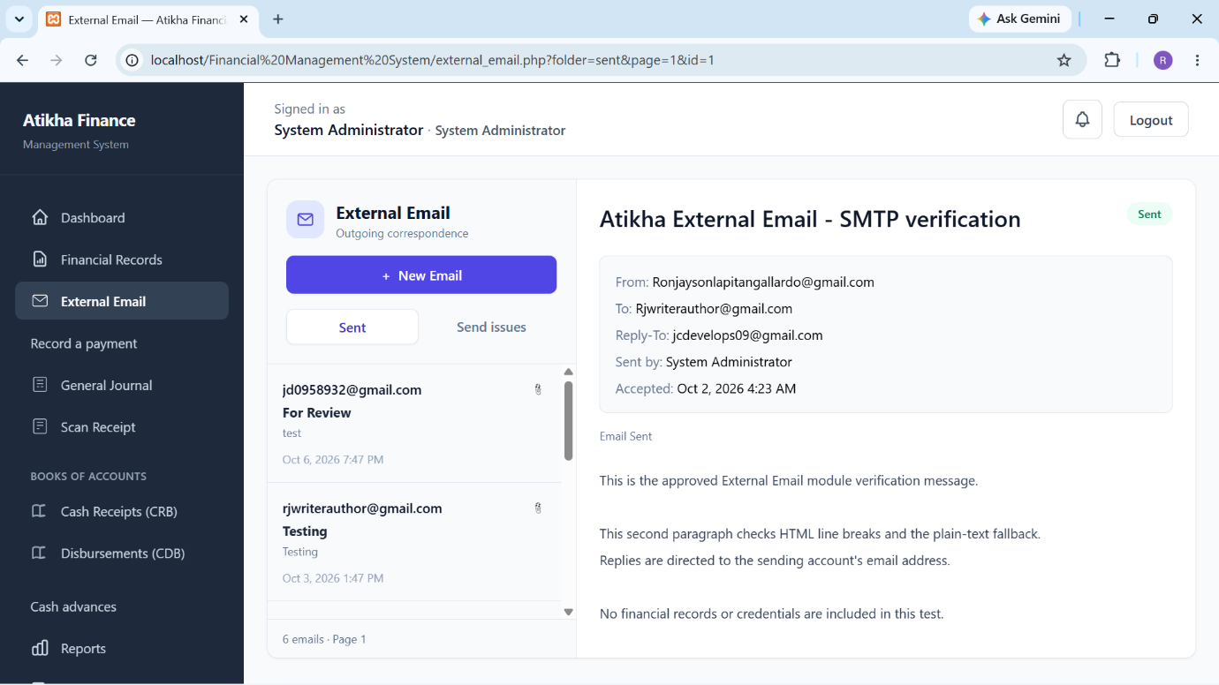
Figure [SH03]. External Email Page (System Administrator)
Figure [SH03] shows the External Email page, which organizes outgoing correspondence into Sent and Send Issues views. The administrator can select a message from the list to inspect its subject, sender, recipient, reply address, sending account, recorded acceptance time and message body. The New Email button provides access to message composition. The illustrated message is marked Sent. This status records the sending outcome shown by the application and does not independently confirm that the recipient opened or read the email.
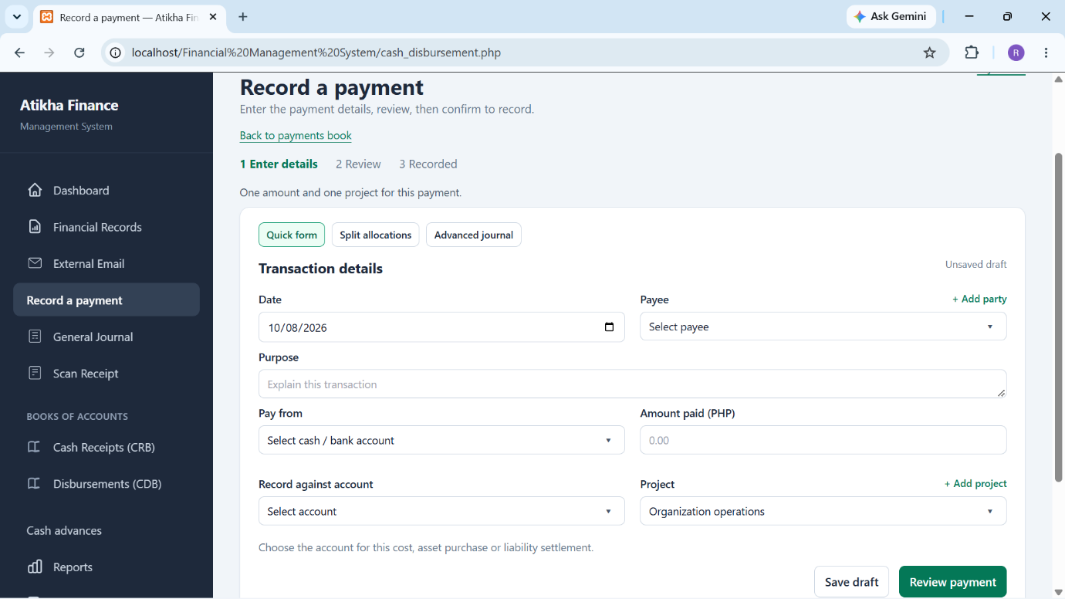
Figure [SH04]. Record a Payment Page (System Administrator)
Figure [SH04] shows the Record a Payment page, which guides the administrator through Enter details, Review and Recorded states. The Quick form presents the date, payee, purpose, paying cash or bank account, payment amount, counterpart account and project. Split allocations and Advanced journal controls retain access to more complex entries. Save draft preserves unfinished work, while Review payment prepares the entry for checking. Review does not itself record the payment or constitute Management approval; financial recording requires a separate final confirmation after successful validation.
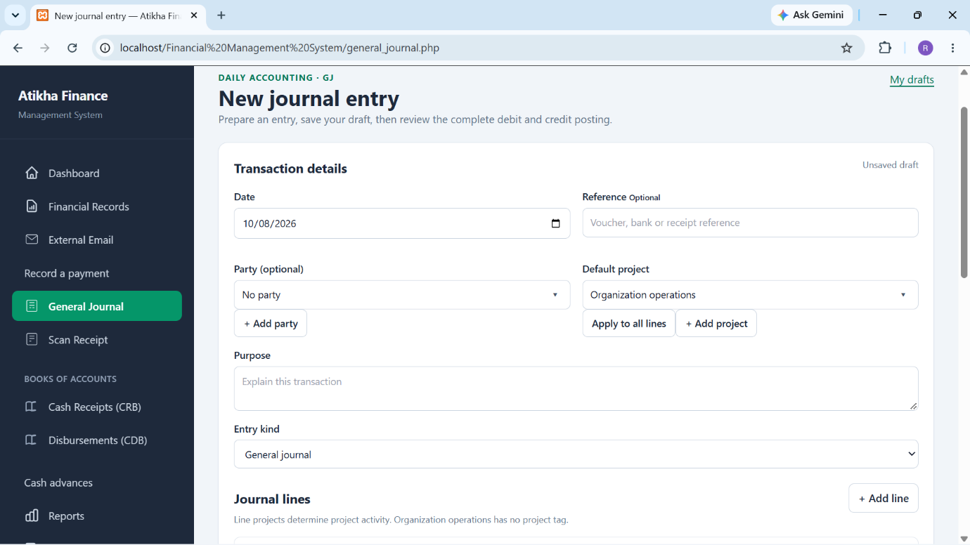
Figure [SH05]. General Journal Page (System Administrator)
Figure [SH05] shows the General Journal page, which provides a detailed workspace for preparing debit and credit entries. The administrator enters the transaction date and purpose, with an optional reference and party, and selects the entry kind. A default project can be applied to the journal lines, while individual line projects identify the corresponding project activity. Additional lines can be added as needed. The entry is saved as a draft and reviewed before posting, and the server requires a valid balanced journal. This page retains the detailed journal presentation shown in the screenshot.
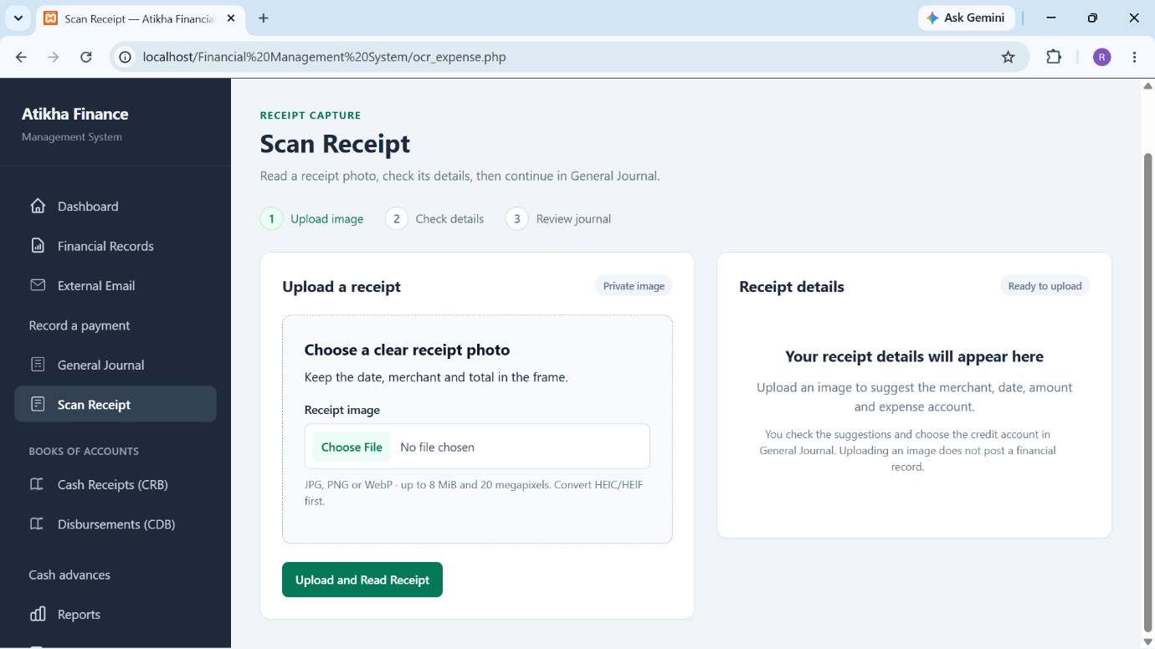
Figure [SH06]. Scan Receipt Page (System Administrator)
Figure [SH06] shows the Scan Receipt page, which provides the sequence Upload image, Check details and Review journal. The administrator selects a receipt image for reading and then checks the suggested merchant, date, amount and expense account. The illustrated screen is the initial upload state, so it does not display an extraction result. Accepted suggestions can be carried into General Journal, where the credit account and complete entry are checked. Uploading or reading an image does not automatically post a financial record.
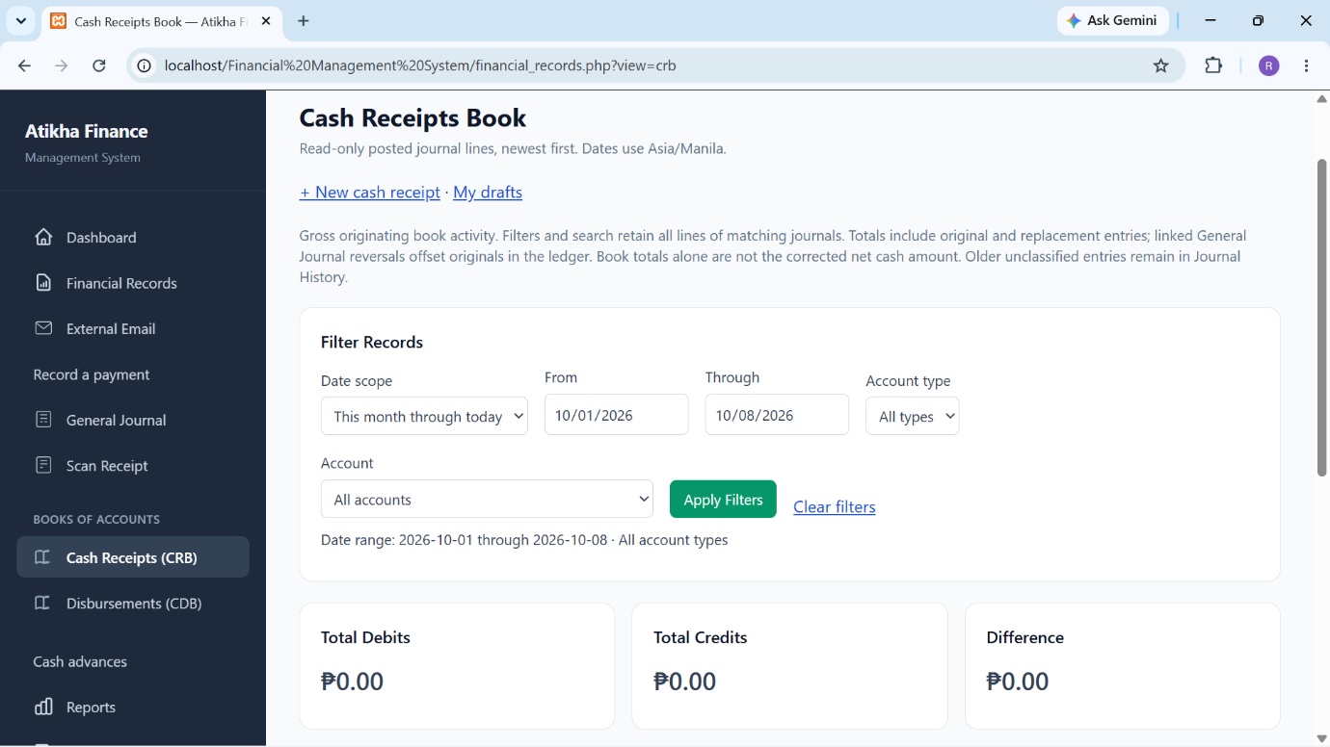
Figure [SH07]. Cash Receipts Book Page (System Administrator)
Figure [SH07] shows the Cash Receipts Book page, which presents posted entries originating from the cash-receipt workflow. Date scope, date range, account type and account filters support inspection of the book, while New cash receipt and My drafts links connect to entry preparation. Debit and credit totals summarize the selected originating activity. The book retains all lines of matching journals. Original and replacement entries contribute to gross book activity; linked General Journal reversals offset originals in the ledger, so the book total alone is not the corrected net cash amount.
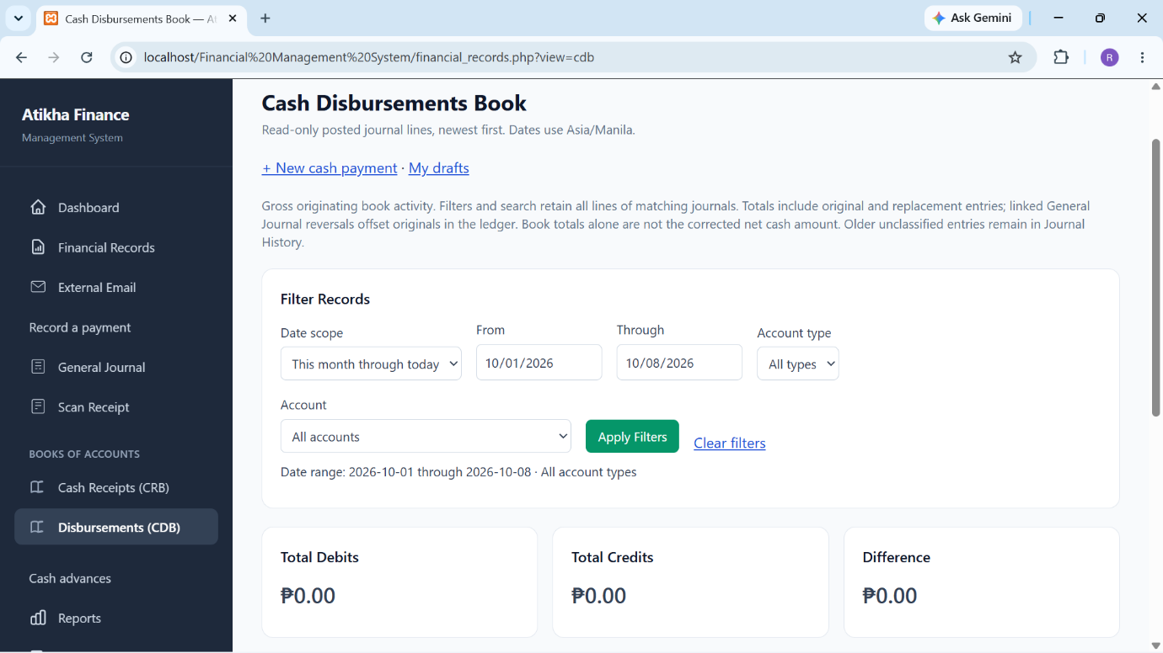
Figure [SH08]. Cash Disbursements Book Page (System Administrator)
Figure [SH08] shows the Cash Disbursements Book page, which presents posted entries originating from the cash-payment workflow. The administrator can filter the displayed activity and use the New cash payment or My drafts links to prepare or resume an entry. Summary cards show total debits, total credits and their difference. As with the Cash Receipts Book, the displayed totals represent gross originating book activity. Linked reversal and replacement records preserve the correction history rather than removing the original payment from the book.
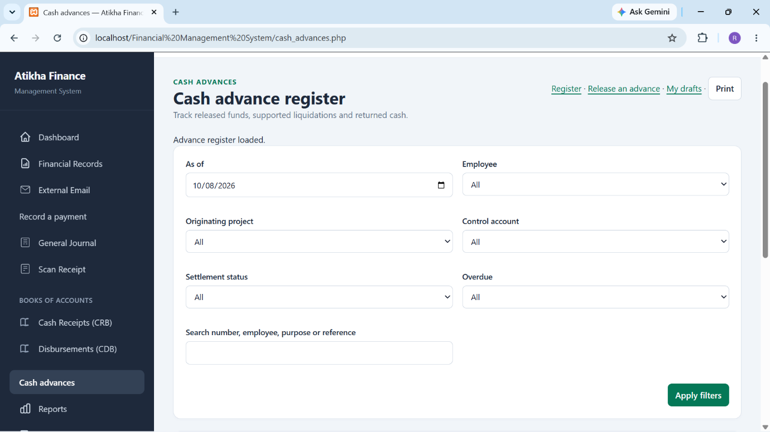
Figure [SH09]. Cash Advance Register Page (System Administrator)
Figure [SH09] shows the Cash Advance Register page, which supports monitoring of released funds, supported liquidations and returned cash. The administrator can filter by as-of date, employee, originating project, control account, settlement status and overdue condition, or search by advance number, employee, purpose or reference. Links provide access to releasing an advance, private drafts and printing. These filters help identify advances that require follow-up. An advance release is tracked as an asset until the applicable settlement entries reduce the outstanding amount.
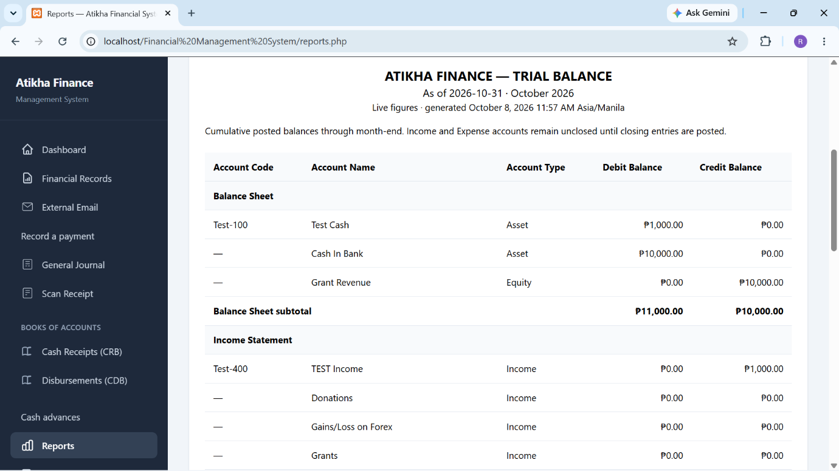
Figure [SH10]. Reports Page (System Administrator)
Figure [SH10] shows the Reports page, which displays the Trial Balance for the selected reporting period. The illustrated report identifies its as-of date, generation time, account codes, account names, account types, debit balances and credit balances. Accounts are grouped into balance-sheet and income-statement categories for presentation. The report uses cumulative posted balances through the specified month-end. Income and expense accounts remain unclosed until closing entries are posted.
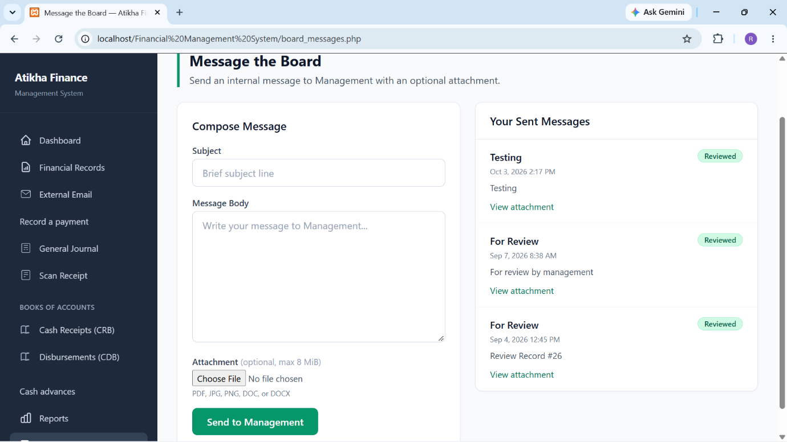
Figure [SH11]. Message the Board Page (System Administrator)
Figure [SH11] shows the Message the Board page, which allows the administrator to compose an internal message to Management using a subject, message body and optional attachment. The adjacent sent-message list displays previously submitted correspondence, recorded dates, review status and attachment links. The Send to Management button submits the message through the internal communication workflow. A Reviewed status refers to the handling of that message; it should not be interpreted as approval of a journal entry or financial transaction.
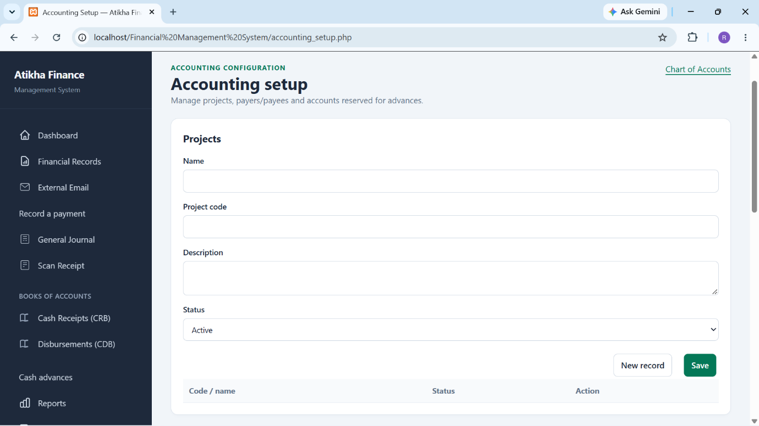
Figure [SH12]. Accounting Setup Page (System Administrator)
Figure [SH12] shows the Accounting Setup page, which provides maintenance controls for projects, payers and payees, and accounts reserved for advance workflows. The illustrated Projects section contains name, project code, description and status fields, together with New record and Save controls. A list below the form provides access to existing project records. The Chart of Accounts link opens account maintenance separately. These reference records support transaction preparation; they do not themselves post a financial entry.
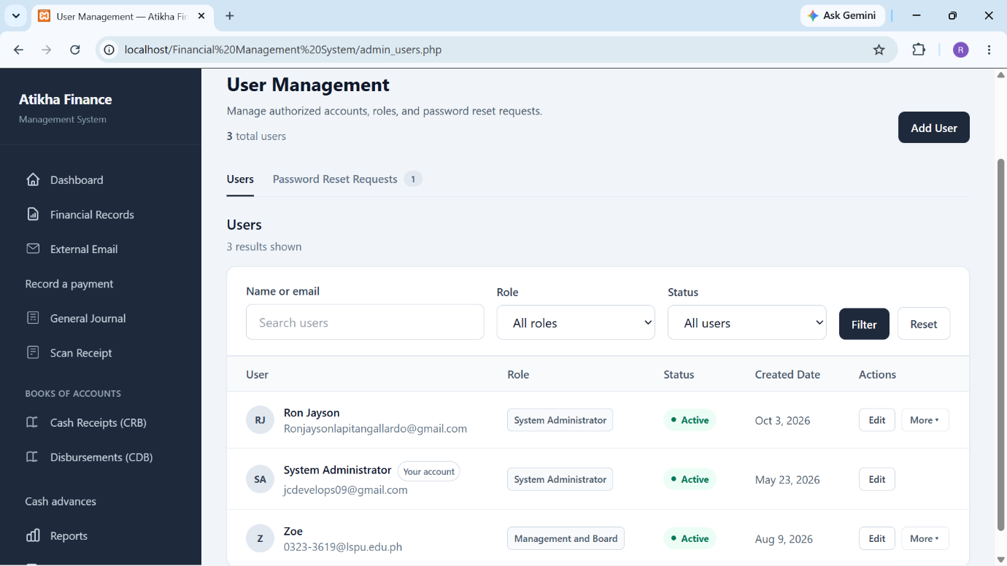
Figure [SH13]. User Management Page (System Administrator)
Figure [SH13] shows the User Management page, which allows the administrator to manage authorized application accounts and password-reset requests. Users can be located by name or email and filtered by role or status. The list displays each account’s role, active status and creation date, with controls for adding or editing users and other permitted account actions. The illustrated role labels distinguish System Administrator from Management and Board. These are application roles, and access to restricted functions remains subject to authorization.
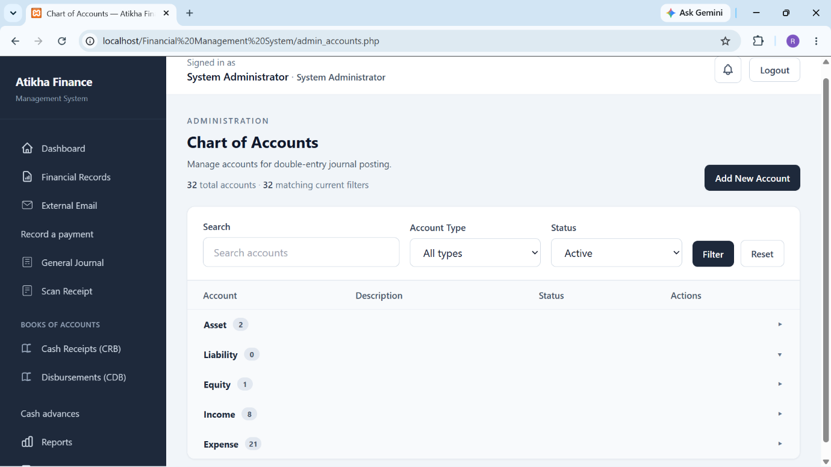
Figure [SH14]. Chart of Accounts Page (System Administrator)
Figure [SH14] shows the Chart of Accounts page, which organizes the accounts used for double-entry journal posting. The administrator can search accounts and filter them by account type or status. The list groups accounts into Asset, Liability, Equity, Income and Expense categories, and the Add New Account control opens account creation. Account definitions guide the classification of journal lines, while the account groups help the administrator locate the relevant records.
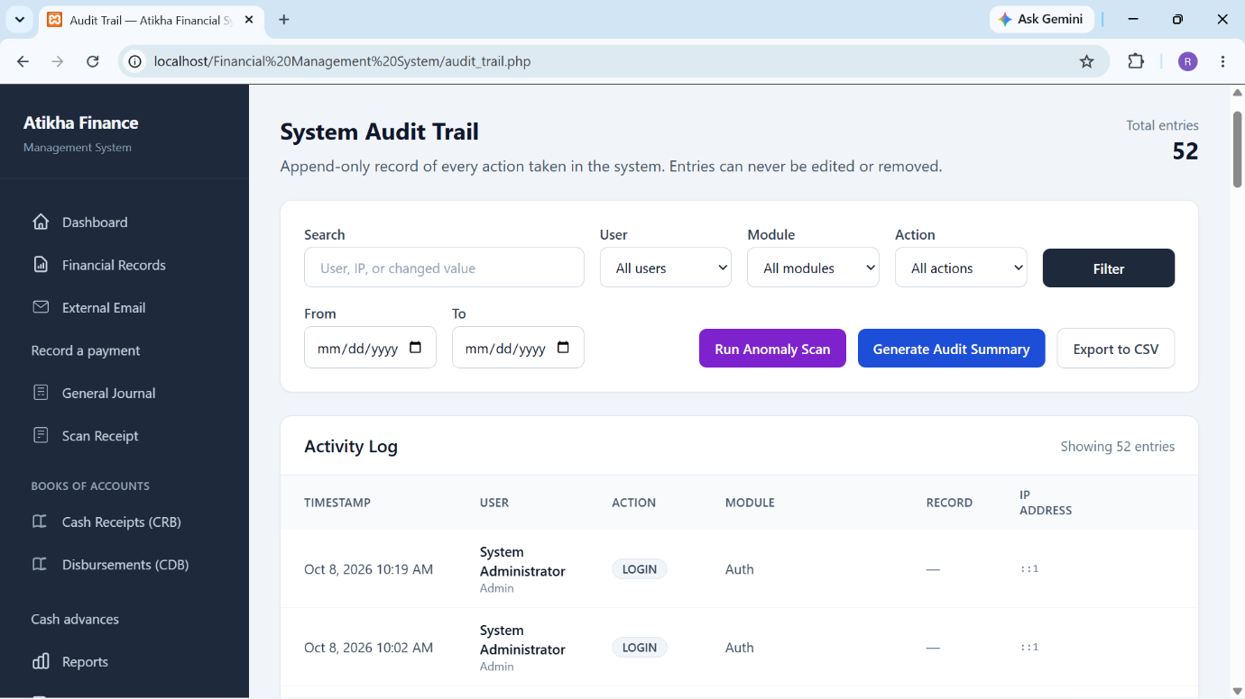
Figure [SH15]. System Audit Trail Page (System Administrator)
Figure [SH15] shows the System Audit Trail page, which displays recorded system activities with their timestamps, users, actions, modules and available record references. Search, user, module, action and date filters help the administrator locate relevant log entries. The page also provides controls for anomaly scanning, audit-summary generation and CSV export. The illustrated activity list includes login events. This screen supports inspection of the recorded history and identification of activities requiring further review.

Management and Board Screens
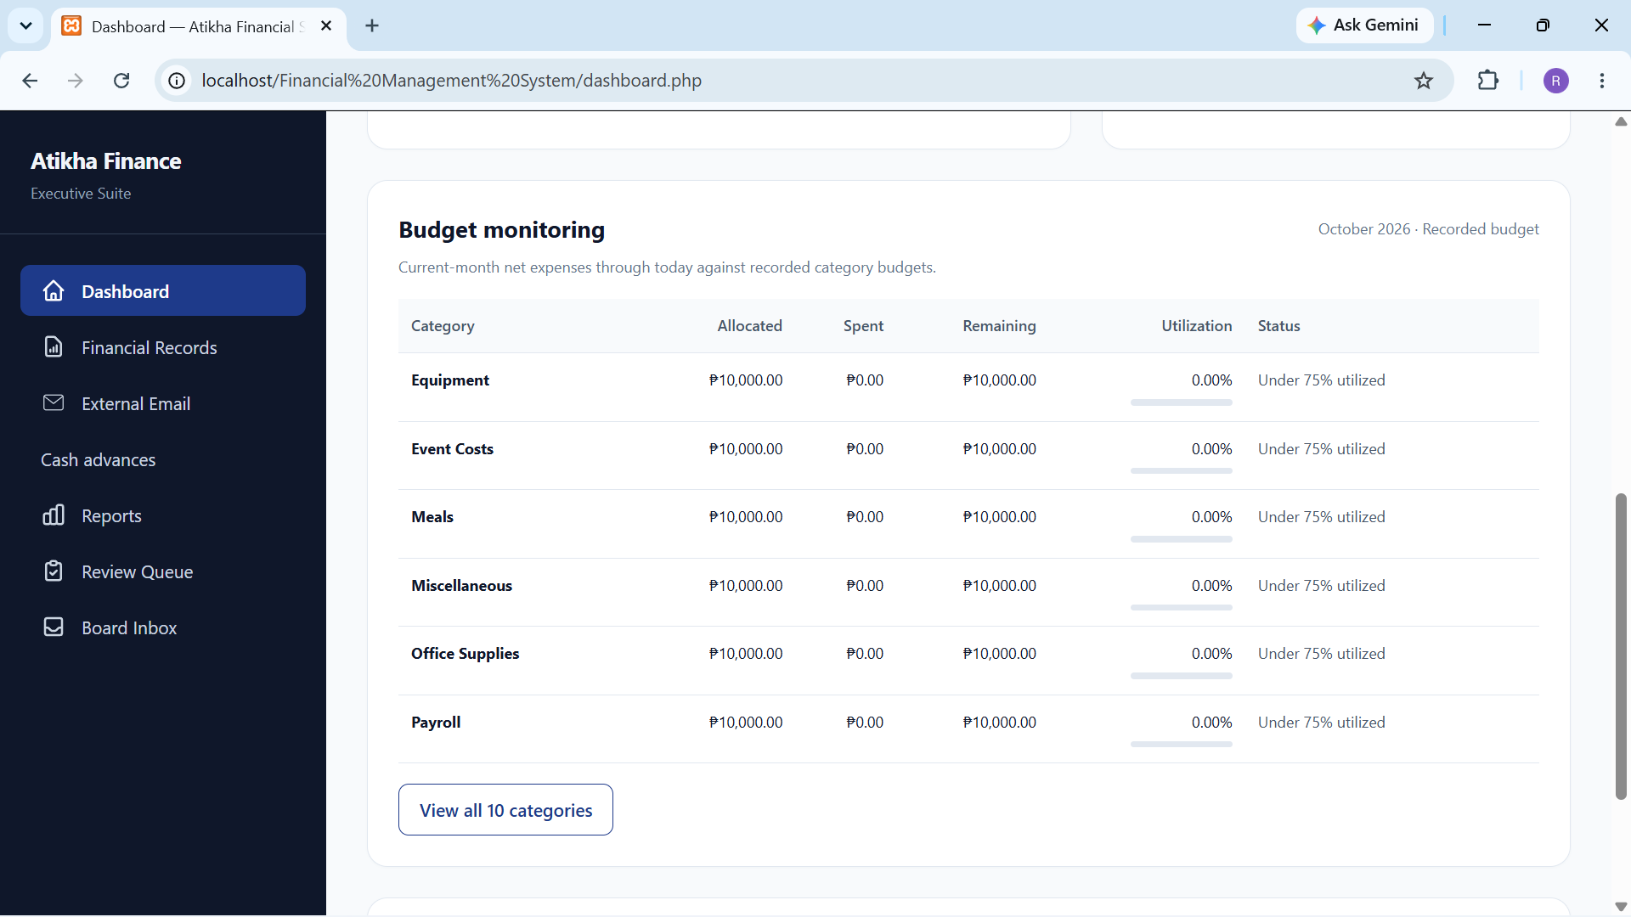
Figure [SH16]. Dashboard Page (Management and Board)
Figure [SH16] shows the Dashboard page for Management and Board, with the Budget monitoring section visible. The table presents the recorded category budgets for the indicated month, together with allocated amounts, spending, remaining balances, utilization percentages and status labels. The View all 10 categories control provides access to the remaining categories. This view supports comparison of current-month net expenses through the displayed date against recorded budgets and helps identify categories requiring attention. The screenshot illustrates the budget-monitoring display; it does not by itself establish that the displayed allocations are approved client budgets or that the complete budgeting module has been accepted.
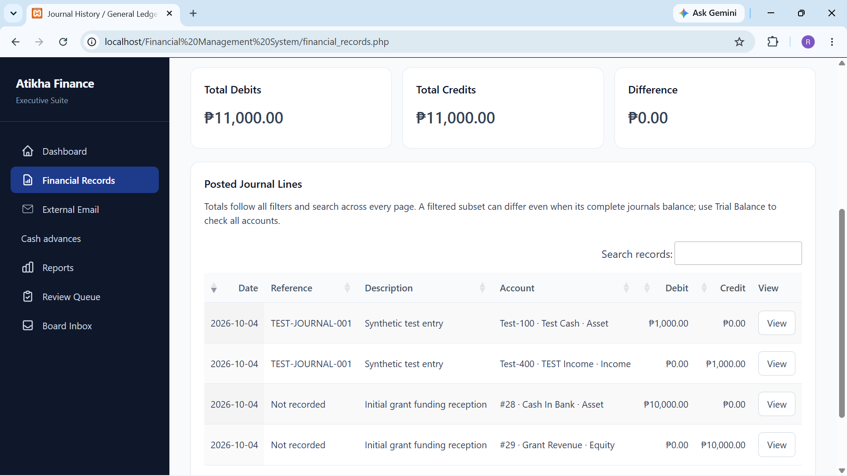
Figure [SH17]. Financial Records Page (Management and Board)
Figure [SH17] shows the Financial Records page for Management and Board, which presents posted journal lines for financial inspection. Summary cards display total debits, total credits and their difference for the selected records. The table identifies each line through its date, reference, description, account, debit and credit amounts, while the search field helps locate matching records. The View control opens the corresponding recorded transaction for further inspection. The displayed totals are equal in the captured state. A filtered subset may differ even when complete journals balance, so the Trial Balance remains the separate all-account balance check. This screen supports reading recorded activity rather than directly editing posted journal lines.
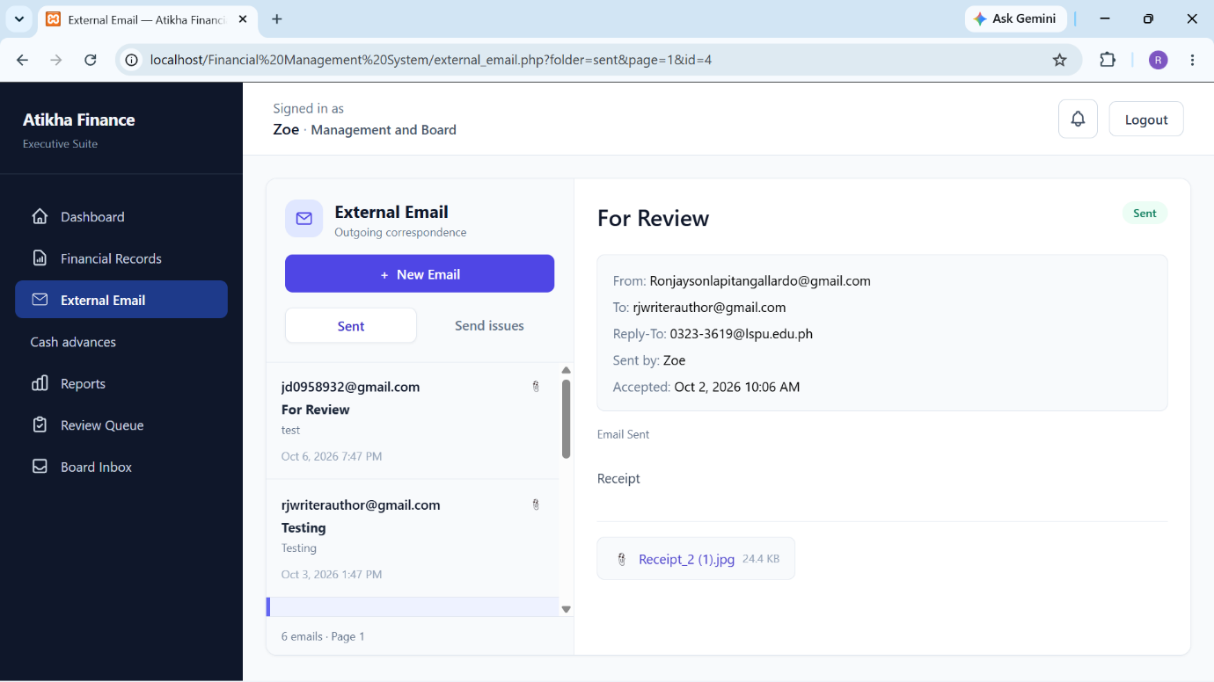
Figure [SH18]. External Email Page (Management and Board)
Figure [SH18] shows the External Email page for Management and Board, which organizes outgoing correspondence into Sent and Send Issues views. The user can select a message from the list to inspect its subject, sender, recipient, reply address, sending account, recorded acceptance time, message body and available attachment link. The New Email control provides access to message composition. In the illustrated state, the selected message is marked Sent and contains an attachment. The displayed status records the sending outcome reported by the application; it does not independently confirm that the recipient opened the message or read the attachment.
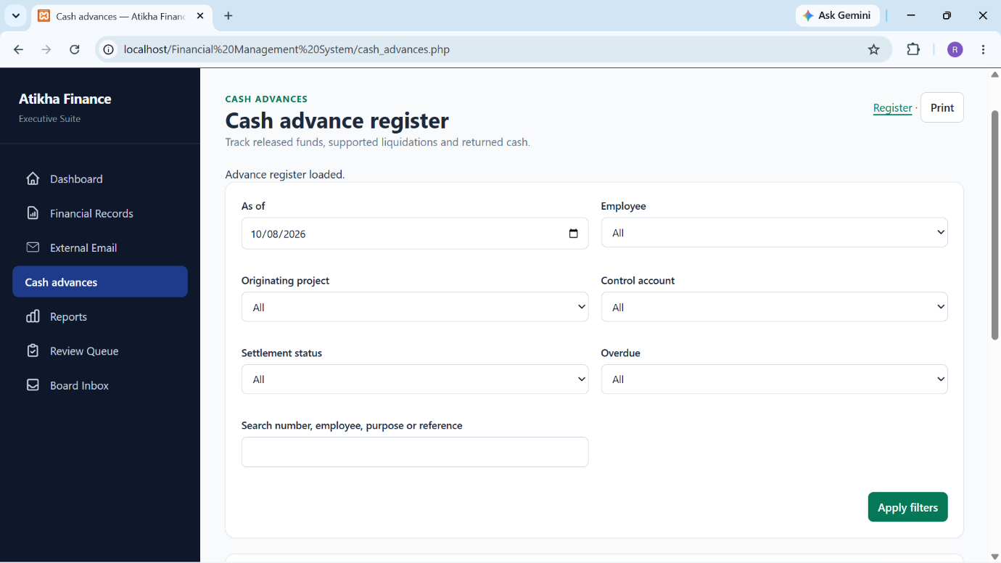
Figure [SH19]. Cash Advance Register Page (Management and Board)
Figure [SH19] shows the Cash Advance Register page for Management and Board, which supports inspection of released funds, supported liquidations and returned cash. The user can filter by as-of date, employee, originating project, control account, settlement status and overdue condition, or search by advance number, employee, purpose or reference. The Apply filters control updates the selected register view, while Print provides a printed representation of the permitted information. The captured interface provides register inspection without the Administrator release and draft controls. An advance release represents an accountable asset until the applicable settlement entries reduce its outstanding amount; this figure shows the filtering interface rather than a completed advance settlement.
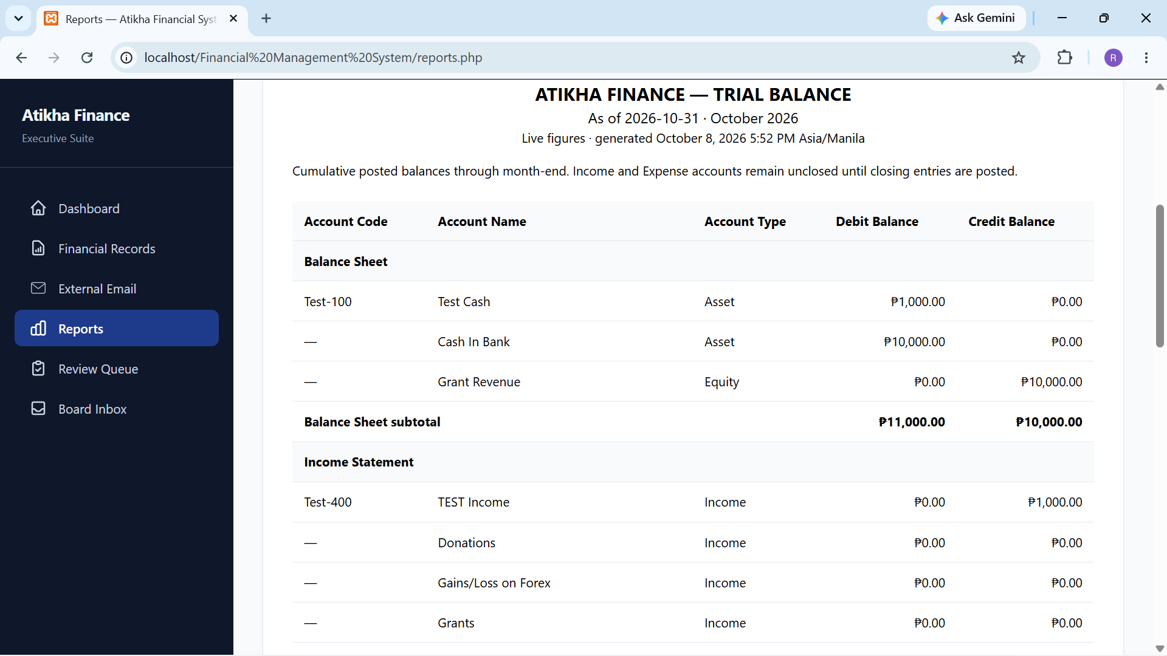
Figure [SH20]. Reports Page (Management and Board)
Figure [SH20] shows the Reports page for Management and Board, displaying the Trial Balance for the selected reporting period. The report identifies its as-of date, generation time, account codes, account names, account types, debit balances and credit balances. Accounts are grouped into balance-sheet and income-statement categories for presentation. The figures represent cumulative posted balances through the specified month-end, and the notice explains that income and expense accounts remain unclosed until closing entries are posted. This view supports financial inspection of the recorded account balances. The screenshot illustrates the available Trial Balance and does not establish completion of every planned financial report.
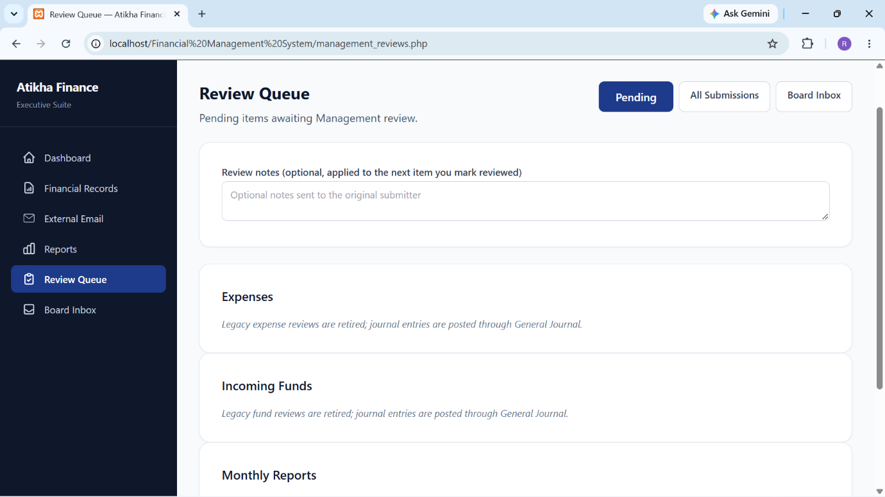
Figure [SH21]. Review Queue Page (Management and Board)
Figure [SH21] shows the Review Queue page for Management and Board, with navigation for Pending items, All Submissions and the Board Inbox. An optional Review notes field allows comments to be associated with the next item marked reviewed and communicated to its original submitter. In the captured state, the Expenses and Incoming Funds sections explicitly state that their legacy review workflows are retired and that journal entries are posted through General Journal. The Monthly Reports section begins below these notices. The queue therefore should not be described as an approval step required to post current journal entries. This figure illustrates the review interface and retirement notices rather than a completed review action.
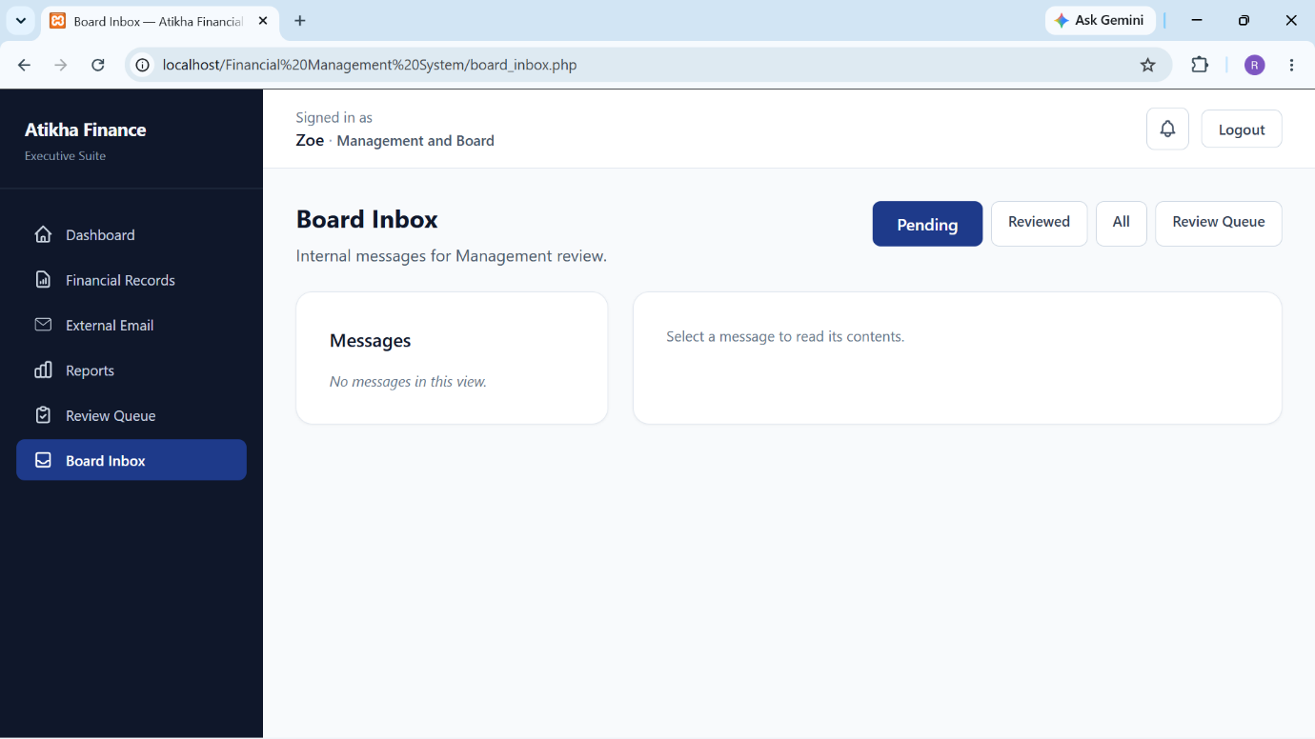
Figure [SH22]. Board Inbox Page (Management and Board)
Figure [SH22] shows the Board Inbox page for Management and Board, which provides access to internal messages submitted for Management review. The Pending, Reviewed and All controls select the message view, while Review Queue connects to the separate review page. The left panel lists messages in the selected view, and the right panel displays the contents of a selected message. In the illustrated Pending view, the page reports that no messages are available and prompts the user to select a message. This empty state applies only to the selected view and does not establish that the other views contain no messages. Reviewing internal correspondence remains distinct from approval or posting of a financial journal entry.

Project Testing and Evaluation Results

Project Testing
Testing of the Atikha Financial Management System compared observed behavior with the requirements for transaction preparation, balanced journal recording, evidence handling, access control and correction history. Developer verification used guarded disposable databases, synthetic records and identified source versions so that testing did not require fictitious postings in the working database. The results below distinguish executed scoped checks from final-system cases that still require testing. Screenshot availability establishes the displayed screen state, but does not by itself establish that every control or workflow passed.

Functionality Testing
The functionality matrix records the expected outcome, purpose, action and available result for each workflow. A passed result applies only to the cited cases, source version and environment. Partial coverage means that some relevant behavior was checked but the complete matrix row is not accepted. Pending and not-yet-tested cases are excluded from passed totals. Administrator preparation and recording are separated from Management’s permitted inspection and privacy checks.
The October 7 integrated Stage 3 delivery recorded 694 complete-schema backend assertions, 19 migration or partial-schema assertions, 370 mixed browser/HTTP assertions and 10 additional presentation assertions [E2]. These categories total 1,093 assertions, rather than 1,093 independent user tasks. The October 8 payment revision recorded 121 browser/HTTP assertions, 16 exact-reader assertions, 42 presentation-adapter assertions and 68 affected Stage 1 browser/HTTP assertions [E1]. These runs cover different dated source captures and overlap with earlier coverage; their counts are not added together as one final acceptance total.
Table [T01]. Functionality Testing in the Administrator Workflows
Test sequence or control | Expected result | Function | Action | Actual result and evidence | Status
F01 Save draft and resume | Preserve the acknowledged entry and its owner’s access. | Retain unfinished work. | Enter details; save; reopen. | Saved versions and owner restrictions matched the expected results in isolated cases [E1, E2]. | Passed in cited scope
F02 Review invalid payment | Identify invalid fields and retain unrelated unresolved errors. | Validate input before recording. | Submit invalid details; correct individual fields. | Inline errors, summary links and error persistence passed the revised payment checks [E1]. | Passed in cited scope
F03 Review payment | Show paying account and actual allocation accounts, amounts and projects without posting. | Check the complete proposed transaction. | Review a valid quick, split or complex payment. | The visible summary matched the authoritative response, including split projects and withholding [E1]. | Passed in cited scope
F04 Confirm and record payment | Create one balanced journal after deliberate confirmation. | Record the reviewed payment. | Confirm the reviewed synthetic entry. | Recording, journal identity and read-only posted controls passed the isolated payment cases [E1]. | Passed in cited scope
F05 Recover uncertain recording | Recover the original result without another journal. | Prevent duplicate payment recording. | Interrupt the response; retry the same request. | The original request identity survived reauthentication and no duplicate journal was created [E1]. | Passed in cited scope
F06 View exact transaction | Display complete lines, totals and linked correction information without writes. | Inspect a specific posted journal. | Open the exact journal link. | Reader and HTTP cases passed complete-line, authorization, correction-link and no-write checks [E1]. | Passed in cited scope
F07 Receipt, General Journal and transfer | Preserve balanced entries and durable original-request recovery. | Record other ordinary entries. | Use isolated posting and retry cases. | Core workflow checks and original-request replay after correction passed [E2]. Their U2 redesign remains pending. | Passed in dated scope
F08 Book and history filters | Return the correct matching lines and totals without losing required journal context. | Locate posted activity. | Apply filters; search; change pages. | Full-entry CRB/CDB behavior, history behavior and saved-date boundaries passed scoped checks [E1, E2]. | Passed in cited scope
F09 Advance release | Create an advance asset linked to its release journal. | Track released accountable funds. | Save; review; confirm an isolated release. | Release identity, control-account protection and register behavior passed Stage 2 cases [E2]. | Passed in dated scope
F10 Liquidation and return | Apply supported settlements and context-bound return confirmation; reject invalid excess. | Reduce the advance correctly. | Review and record supported liquidation and confirmed return. | Support, settlement, proof-binding, retry and reconciliation cases passed [E2]. | Passed in dated scope
F11 Journal correction | Post a linked reversal and any selected replacement while preserving the original. | Correct recorded activity through audit-preserving entries. | Review; confirm; inspect the chain; retry. | Ordinary and advance correction, dependency-blocker and recovery cases passed [E2]. | Passed in dated scope
F12 Scan Receipt controlled workflow | Require user review and preserve evidence/privacy before posting. | Assist receipt entry. | Use synthetic upload, provider response and failure cases. | Controlled provider-response and failure/manual-handoff cases passed. Live extraction accuracy was not established [E2]. | Passed in controlled scope
F13 Trial Balance calculations | Derive balances from the known posted journal fixture. | Check account balances. | Run calculation and snapshot checks. | Ledger, Trial Balance and frozen-snapshot checks passed the isolated accounting profile [E2]. This is not the future report-bundle acceptance. | Passed in dated scope
F14 External Email controls | Compose correspondence and report sending outcomes correctly. | Send authorized external messages. | Create and send a controlled message; inspect issues. | The supplied figure shows a recorded Sent message. A final-build control-by-control result has not been supplied for this matrix. | Pending final matrix
F15 Message the Board controls | Submit messages and expose attachments only to permitted users. | Support internal correspondence. | Compose; send; open; inspect review status. | The supplied figure shows sent messages and statuses. A final-build end-to-end result has not been supplied for this matrix. | Pending final matrix
F16 Setup and account maintenance | Maintain permitted reference records while protecting historical and control-account meaning. | Manage projects, parties and accounts. | Add; edit; filter; test invalid or restricted changes. | Inline masters and control protections have scoped coverage [E1, E2]. Complete maintenance-page acceptance remains unrecorded here. | Partial coverage
F17 User management | Apply permitted account changes and enforce authorization. | Manage access and reset requests. | Add or edit a test user; inspect restrictions. | The user list is visible in the supplied screenshot. No final-build account-management result has been supplied for this matrix. | Pending final matrix
F18 Audit and forecast controls | Display logged activity and explain unavailable or failed analysis. | Inspect logs and available analytical output. | Filter/export logs; exercise controlled analysis cases. | The screenshots show logs and a forecast waiting for more history. They do not establish a final export, anomaly-accuracy or forecast-accuracy result. | Pending final matrix
Table [T02]. Functionality Testing in the Management Workflows
Test sequence or control | Expected result | Function | Action | Actual result and evidence | Status
M01 Exact journal access | Permit appropriate posted-journal reading; restrict unauthorized entry actions. | Provide read-only financial inspection. | Open valid, invalid and restricted routes as Management. | Exact-reader and HTTP authorization cases passed [E1]. | Passed in cited scope
M02 Evidence privacy | Withhold private receipt images and details, including when UI flags are disabled. | Protect confidential supporting evidence. | Request journal/evidence views and protected downloads. | Reader and browser/HTTP redaction and attachment restrictions passed scoped cases [E1, E2]. | Passed in cited scope
M03 Advance inspection | Show permitted advance totals and confirmation summaries without private proof details. | Monitor accountable funds. | Inspect register, timeline and corrected advance cases. | Register, correction and Management restriction cases passed in the dated Stage 2/3 suites [E2]. | Passed in dated scope
M04 Review Queue and Board Inbox | Present authorized review items and messages and preserve the distinction between message and financial review. | Support Management review and communication. | Open items; review; inspect permitted attachments. | These Management screens were not among the supplied captures. A final-build workflow result has not been supplied for this matrix. | Pending final matrix
Tables [T01] and [T02] show that the cited financial-workflow and privacy cases met their expected outcomes in the isolated environments. They also identify incomplete final-build coverage for supporting screens and Management review/communication. Receipt extraction used a controlled provider response for the cited cases, so live OCR accuracy is a separate question. The recorded checks do not establish that Atikha staff can complete the workflows independently, that all remaining modules are finished, or that performance is acceptable under working conditions.
An additional usability baseline identified an advance-comparison delay. With 29 synthetic advances, median HTTP response times were 5.706 seconds for Administrator and 11.637 seconds for Management; with 100 advances, they were 6.146 and 12.227 seconds respectively [E4]. The measurements used an isolated PHP development server. They warrant a separate diagnostic task and do not establish normal XAMPP performance or an acceptable working response time.

Browser Compatibility Testing
Browser compatibility testing assesses the selected workflows in different browsers while controlling the application build, data, computer, operating system and viewport within each comparison group. Windows Chrome, Edge and Firefox form one group. Mac Chrome and Safari form a separate group, consistent with the Chapter III plan. The current results contain scoped Edge execution and supplied Chrome appearance evidence. The researcher has reported no additional browser tests; Firefox and the Mac group remain untested.
Table [T03]. Browser Compatibility Testing
Browser and environment | Expected result | Actual result | Status or result | Recommended
Google Chrome on Windows | Required pages, inputs, workflow states and authorized results match the controlled reference. | The 15 supplied screenshots show Administrator pages rendered in Chrome. Browser version and controlled interaction results were not supplied. | Appearance observed; functional comparison pending | Final recommendation pending
Microsoft Edge on Windows | The same specified cases complete with correct values, state and permissions. | Edge 154.0.4258.62 passed 121 revised U2-A and 68 affected Stage 1 browser/HTTP assertions in isolated copies [E1]. Other Stage 2/3 results are dated [E2]. | Passed scoped checks; complete matrix pending | Candidate for desktop use; final recommendation pending
Mozilla Firefox on Windows | Controls, dates, selectors, uploads, downloads and reports remain usable in the same Windows comparison setup. | No executed Firefox comparison result was supplied. | Not yet tested | Pending
Google Chrome on macOS | Establish a Mac reference using the same available cases and data as Safari. | No executed Mac Chrome result was supplied. | Not yet tested | Pending
Safari on macOS | Complete the required cases against the Mac Chrome reference, including native inputs and downloads. | No executed branded Safari result was supplied. | Not yet tested | Pending
Table [T03] separates a successful scoped check from completion of the cross-browser matrix. The supplied Chrome screenshots show the listed Administrator screens, but do not document keyboard behavior, upload/download handling, uncertain-posting recovery or every browser control. The Edge runs provide stronger interaction evidence for their specified cases, without proving parity across every browser or module. Browser versions, OS versions, test date, application source identity and case results must be recorded for the remaining comparisons before final browser recommendations are made.

Device Compatibility Testing
Device compatibility testing assesses the complete device and platform configuration, including display size, input method, orientation and access to required controls. It is reported separately from browser compatibility testing. Existing layout checks used browser viewports of 1366 × 768 and 1920 × 1080 CSS pixels. These are viewport configurations and must not be relabelled as tests on two independently identified physical devices.
Table [T04]. Scoped Browser Viewport Verification
Viewport | Test configuration | Actual result | Status
1366 × 768 CSS pixels | Browser viewport on the existing Windows test host; not a separate physical laptop. | The revised simple-payment confirmation was accessible within the viewport. Complex entries and long labels could require vertical scrolling [E1]. | Scoped payment layout checks passed
1920 × 1080 CSS pixels | Browser viewport on the existing Windows test host; not a separate physical desktop. | Revised Enter, validation, Review, Recorded, recovery and exact-record captures were inspected. The supplied Chrome images separately show the 15 current screens [E1, E3]. | Scoped layout evidence; no device-wide pass
Table [T05]. Device and Platform Compatibility Testing
Device or platform | Configuration to record | Expected result | Actual result | Status or result
Windows laptop | Record model, Windows/browser versions, actual viewport, display scale and zoom; use the selected reference browser. | Required controls remain reachable and values survive input, scrolling and task navigation. | 1366 × 768 viewport evidence exists, but a separately identified physical-laptop result was not supplied. | Physical-device test pending
Windows desktop | Record model, Windows/browser versions, viewport, display scale and input method. | Required pages remain readable and sampled workflows complete with correct data. | 1920 × 1080 viewport and Chrome screenshot evidence exists. It does not identify or independently test a separate desktop device. | Physical-device test pending
Mac computer | Record model and macOS version; use Chrome as the platform reference. | Applicable desktop workflows, file selection and downloads remain usable. | No physical Mac result was supplied. | Not yet tested
Linux computer | Record device and distribution/version; use the stated Chrome reference. | Applicable desktop workflows preserve data and permissions and present readable output. | No Linux device/environment result was supplied. | Not yet tested
Android phone | Record model, Android/Chrome versions, CSS viewport, orientation and touch/keyboard behavior. | Assess whether selected viewing and receipt-selection tasks are usable; document inaccessible controls or overflow. | No real Android result was supplied. Phone coverage remains exploratory. | Not yet tested
iPhone | Record model, iOS/Safari versions, CSS viewport, orientation and touch/keyboard behavior. | Assess selected viewing and image-selection tasks without assuming desktop-equivalent workflow support. | No real iPhone result was supplied. Phone coverage remains exploratory. | Not yet tested
Table [T04] records the available viewport evidence, while Table [T05] retains the physical-device and platform cases from the Chapter III plan. No additional physical-device results were supplied. Phone assessment remains exploratory; the current shared layout uses a 1,024-pixel minimum width, so complete phone usability must not be assumed [E5]. A physical-device pass requires observed completion of the selected tasks on the recorded hardware and software configuration. Device model, OS/browser versions, actual CSS viewport, display scale, zoom, input method and test date should accompany each result. Until those checks are executed, compatibility recommendations remain provisional.

