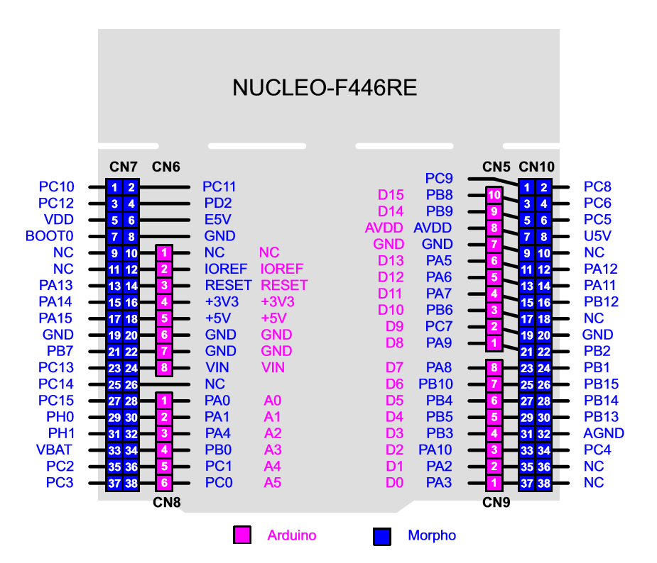

**Motors**

TIM3

M0-CH4: C9

M1-CH2: B5

M2-CH1: B4

M3-CH3: C8

**GPS**

USART1

rx: A10

tx: A9

**Modem**

USART3

rx: C11

tx: C10

**SBUS**

UART4

rx: A1

**Gyro, Accel, Baro**

I2C_2

scl: B10

sda: B3

**Mag**

I2C_1

scl: B8

sda: B9

**SPORT**

GPIO

Allow TX: A8

UART5

tx: C12

rx: D2