DESIGN DOCUMENT

General Workflow:

User(browser)------->request------->load balancer/Ngnix server----->VOD front end microservice---->Load balancer/Nginx server------>backend server service

Requirement FR001 -FR004

Workflow:

1. User should opening a webpage(www.tritrontech.com/vod/register)

a) user will enter the url and click enter

b) A GET request is raised against the URL above where the URL is looked up in DNS server for ip-address and the appropriate page(HTML) is returned.

Note: In internet world the communication happens via HTTP protocol. HTTP protocol stands for Hyper text transfer protocol. HTTP protocol supports various methods for data transfers.

1. GET Method---Retrieve information

2. POST Method--POST information for first time

3. PUT Method--Update information which is already POSTED

4. PATCH Method-- Update a part of information that is already POSTED

5. DELETE Method--DELETE any resource/data

2. Webpage should open asking for username and password

3. Also, webpage should display an option for signup

4. Also, webpage should display an option for reset password

5. User should click on signup for registering himself.

6. User should be prompted with a form that include 1. Username 2. Password 3. contact number 4. Email 5. Organization name 6. Location(optional) 7. Company logo(optional)

7. Also, the page should have submitted button to submit the request.

8. The data submitted should be persisted to database

9. return response to the user

Ngnix server

1. Will look at the path and will decide which service to be invoked.

Frontend

A single microservice that will handle all the requests

1. home page to be implemented (static icons, animations, a frame that has options for entering username, password, hyperlink for signup and forgot password. button for login)

2. upon clicking signup hyperlink open a registration form with text boxes for 1 through 6 in requirement 6 and a system dialog box for 7 in requirement 6. There should be a button for submit and cancel

Backend

Login service----Microservice

will have paths for 1. Registration 2. login

url: www.tritrontech.com/vod/register

1. POST--- POST handler

Lets first implement complete backend and then implement the frontend

Flow chart and sequence diagram

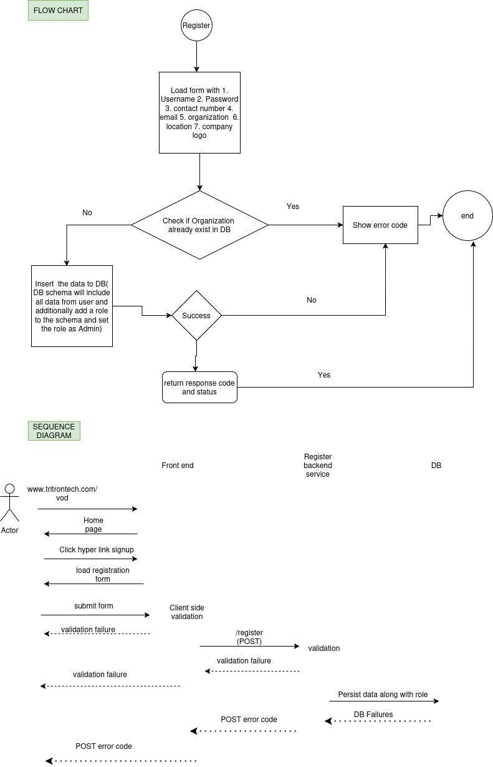

**FLOW CHART**



