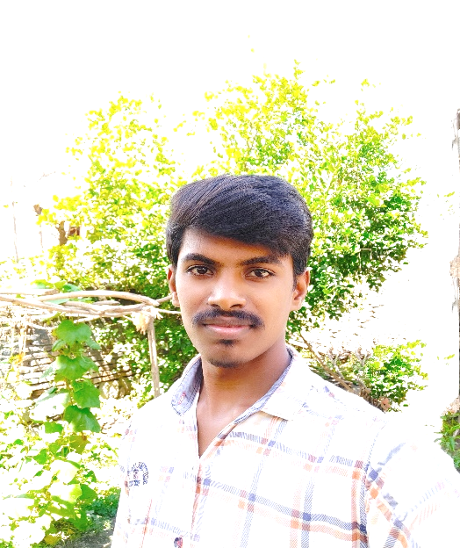
SUDARSAN REDDY ERUVURI

CONTACT

- Phone

+91 9666441711

- Email sudarsanreddyeruvuri@gmail.com

- Address

1-142, Main Road, Bodduvaripalem,
Santhanuthalapadu, Prakasham (523225)

CO-CURRICULAR ACTIVITIES

- Participated in Workshop on IOT Projects

- Participated in Micro Projects Boot camp

EXTRA CURRICULAR ACTIVITIES
- Achieved First Prize in District Level Cricket competition

LANGUAGES

- English
- Hindi
- Telugu

CAREER OBJECTIVE

To seek a job in accompany which provides ample opportunities to exhibit the skills. To pursue a challenging career for utilizing my skills towards the growth of the organization.

EDUCATION

B.TECH (Electronics & Communication) | 2019 - 2023
INSTITUTION: Universal College of Engineering & Technology
UNIVERSITY: JNTU Kakinada
PERCENTAGE (%): 67%
INTERMEDIATE (10+2) | 2017 - 2019
INSTITUTION: Sri Chaitanya JR College
BOARD: Board of Intermediate AP (MPC)
PERCENTAGE (%): 91.3%
SSC (10th) | 2016 - 2017
INSTITUTION: Sri Santhinikethan High School

BOARD: Board of Secondary Education AP
PERCENTAGE (%): 85%

PROGRAMMING LANGUAGES

- Python Basics
C
- Devops
- SQL

PERSONAL STRENGTHS

- Self-motivated and Hardworking.
- Leadership Skills
- Time Management
- Flexible & Adaptable
HOBBIES
Playing Cricket
- Reading Books
- Listening Music

ACADEMIC PROJECT

1.Smart Dustbin Using Arduino (Mini Project): The main objective of the project is to design a smart dustbin which will help in keeping our environment clean and also eco friendly. We are inspired by the Swachh Bharat Mission. Nowadays technologies are getting smarter day-by-day so, as to clean the environment we are designing a smart dustbin by using Arduino

2.CBIR : In this work, a new retrieval system for digital images has been presented which is based on speech to text conversion and customized bag-of-features workflow. Growing number of customers with huge digital images on their computers, retrieving images has become a vital problem in the management of virtual photographs.

DECLARATION

I hereby declare that the details furnished above are true to the best of my knowledge and belief.

