### **The Benefits of a Balanced Diet**

A balanced diet is essential for maintaining good health and well-being. It provides the body with the right proportions of nutrients it needs to function properly — including carbohydrates, proteins, fats, vitamins, and minerals. Eating a variety of foods in the correct ratios not only helps in preventing diseases but also boosts energy levels, improves mood, and supports a healthy immune system.

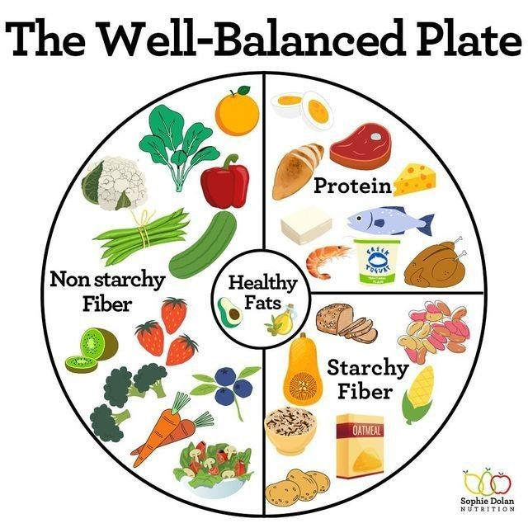

Many people today tend to follow unhealthy eating habits due to busy schedules, convenience foods, or lack of awareness. This can lead to nutritional deficiencies, obesity, fatigue, and even chronic diseases such as diabetes or heart conditions. By understanding and incorporating a balanced diet into daily life, individuals can improve both their short-term vitality and long-term health.

Below is a table showing the **major food groups**, some **examples**, and their **key benefits**:

|  |  |  |  |  |  |
| --- | --- | --- | --- | --- | --- |
| **Food Group** | **Examples** | **Key Benefits** |  |  |  |
| Carbohydrates | Rice, bread, pasta, oats | Provide energy, fuel brain and muscle activity |  |  |  |
| Proteins | Meat, eggs, beans, tofu | Build and repair tissues, support immune function |  |  |  |
| Healthy Fats | Olive oil, nuts, avocado | Aid in brain health, hormone production, vitamin absorption |  |  |  |
| Vitamins & Minerals | Fruits, vegetables, dairy | Regulate body functions, strengthen bones, fight disease |  |  |  |
| Water | Drinking water, fruits, soups | Maintains hydration, supports digestion and circulation |  |  |  |

A well-balanced plate should ideally consist of **half vegetables and fruits**, **a quarter protein**, and **a quarter whole grains**, with a small portion of healthy fat. Regular hydration is also crucial; drinking enough water aids in digestion, nutrient transport, and body temperature regulation.

In addition to physical health, eating a balanced diet can significantly influence mental well-being. For example, omega-3 fatty acids (found in fish and flaxseeds) are known to support brain function and reduce symptoms of depression. Leafy greens and berries are rich in antioxidants that help protect the brain from aging and stress.

Children, in particular, benefit greatly from a nutritious diet as it supports proper growth and cognitive development. For adults, it can help maintain a healthy weight, reduce the risk of chronic diseases, and enhance productivity. Seniors benefit from strong bones, better memory, and increased resistance to illness.

It’s important to note that balance doesn’t mean strict limitation or avoiding all indulgences. Occasional treats can be part of a healthy lifestyle as long as they are consumed in moderation. The key is consistency and variety — ensuring you’re not relying too heavily on one food group or skipping important nutrients altogether.

In conclusion, adopting a balanced diet is one of the most effective and sustainable ways to support a healthy body and mind. Combined with regular physical activity, adequate sleep, and stress management, proper nutrition forms the foundation for a longer, happier life.