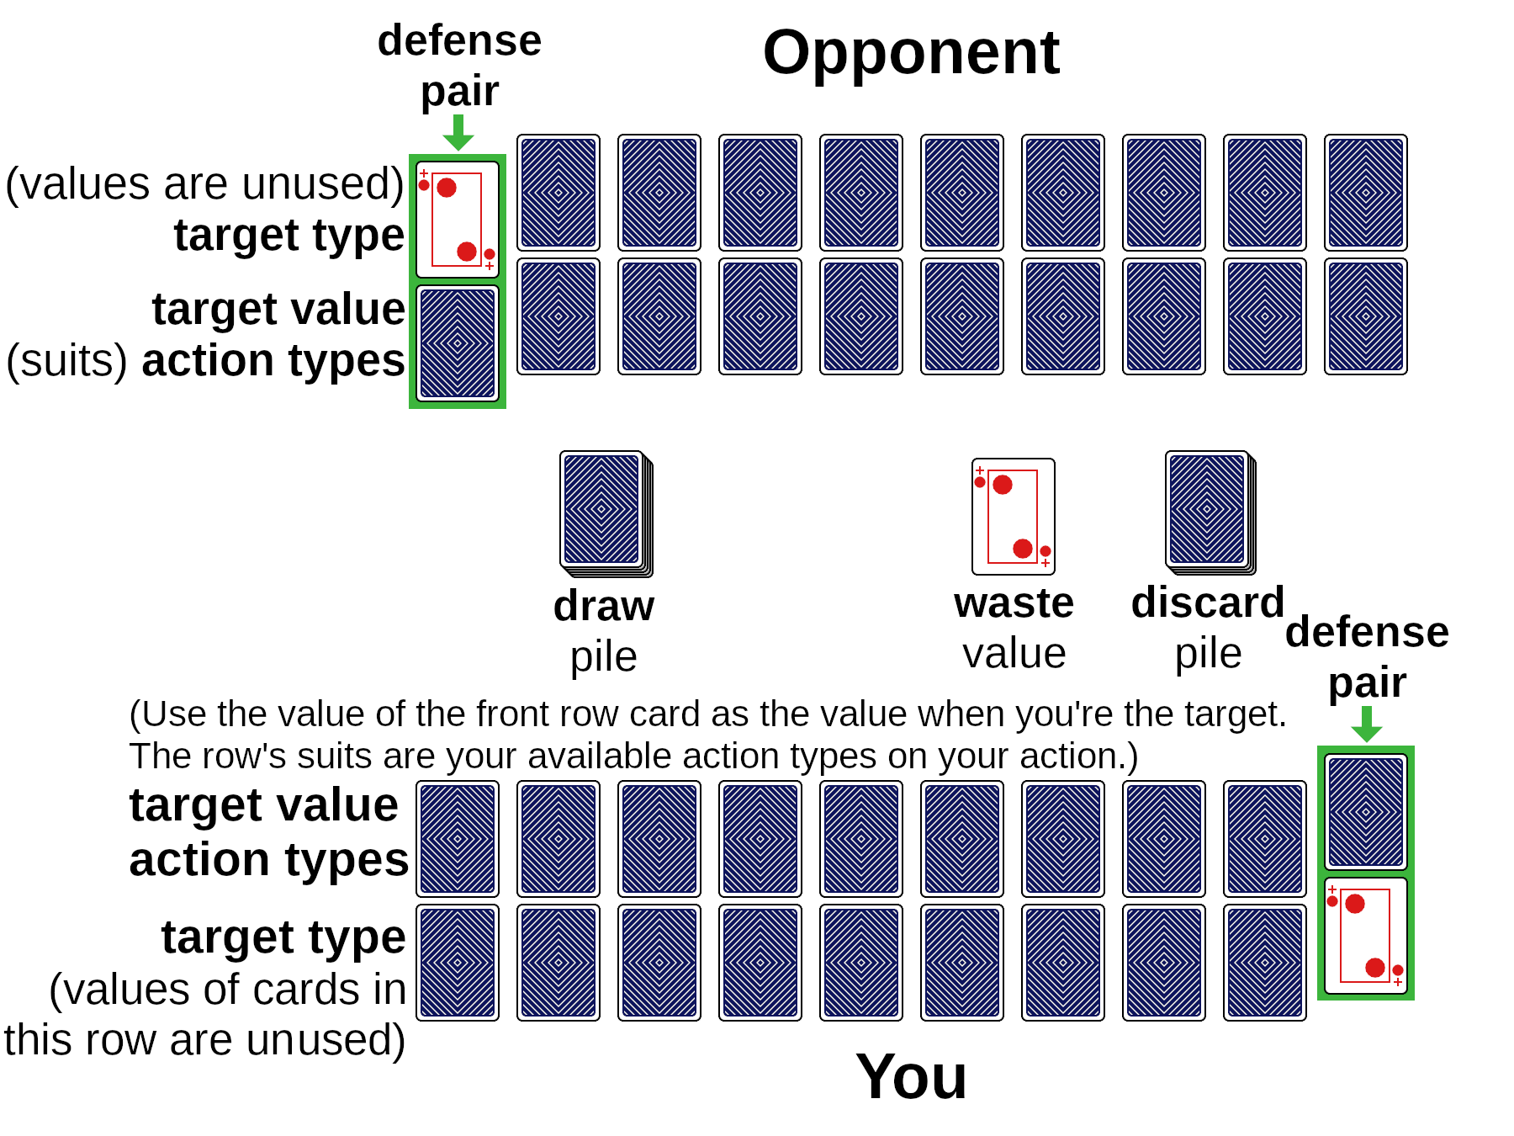 | 16 Combos | Rules version: Poikilos 2022-02-14
16 Combos is an *ultra-advanced* (lol) card game such as for people who find regular card games repetitive. I invented this game while watching other people play various games that use playing cards. The games were uninspiring, so the game is mostly inspired by role-playing games :). 16 Combos (16combos.com) by Poikilos (the author of The Path of Resistance [zahyest.com]) is also a multi-player turn-based battle system using playing cards! You don't need a computer: 16 Combos has multiple dimensions of gameplay while requiring only playing cards and counters (such as coins, chips, bingo counters, or something on which to write numbers).

What makes the game interesting is that it isn’t just a game of “this number vs that number” like most card games. The meanings of the suits are: ♥ vitality ♦ wealth ♣ strength ♠ finesse and these are called the four types. There can be 16 different actions depending on the combination of the target type (that your opponent has) and the action type you choose (See “Combo Table”). Each rule has a name (underlined where defined) for easy reference.
Requirements
- (2) decks of cards, one deck having backs being clearly different from the other deck. Each deck having jokers is recommended but not required.
- Counters: You can use any type of numbered devices or countable devices for counters which will show the value of a value card that has changed. Examples: You can use small pieces of paper (and pencil so you can erase and change the number on it, otherwise many numbered pieces), a large dry-erase board under the cards, a third deck of cards so you can swap the card for one with a new value, coins, chips, or bingo counters to determine the value of any value card that has changed in value. See the “Reusing Value Cards” Optional Rule.

Dealing Steps
Number of Cards: The example surface below uses two characters (such as two players with one character each; there could be either more players or each player could have more than one character). You can choose to start with fewer or more columns but at least 10 is recommended to try a variety of combos (See the “One of Each Type” Optional Rule).
- Decide Optional Rules: Players must have know what optional rules are in effect before preparing pairs.
- Target Type Order: Type cards are dealt from left to right.
- Preparing Pairs: The rest of the cards dealt to the player are placed by the player. For example, if the player places a 5 in front of any heart card the player has 5 vitality when that pair is targeted (The “Drop Lowest Dealt” Optional Rule affects this step).
- Show Defense Pair Type: The defense pair (rightmost) always has the type card face up unless a rule or combo says otherwise.

Combo Table
The chart is supposed to mimic real life: For example, if you use your vitality against someone’s wealth, you dig through the trash and try to overcome the opponent’s wealth that way (See “Scavenge” on the chart). Below are underlined steps for a turn.
Target Character: Announce the target character when your turn starts (If you yourself have more than one character [only if you have more than two rows of cards], first announce what character is doing the action). Defense Pair: The defense pair of the target character is the target*. Choose an Action Type: Choose an available action type (one of the four types, limited by the Available Actions rule) and announce which, such as “I use vitality”. Reaction: The target player can make changes to their defense now even if the action is a surprise action There is only one reaction per turn. Draw a Value: Draw a card from the draw pile then use the “Check” rule to determine the outcome: “defeated”, “damaged” or “critical failure”. The target type card determines the action. The action occurs successfully only if the target pair is defeated. For example, if you choose vitality as your action type, use the first column, and if the target pair’s type card is wealth then your action is Scavenge. If the outcome is damage, the action doesn’t occur*, but the target’s value card is reduced in value. On a critical failure, your character becomes the target and the target pair is your defense pair*.
Action Type:  Target Type | ♥ vitality | ♦ wealth | ♣ strength | ♠ finesse
♥ vit | Poison: Any remaining attack value that didn’t go toward reducing the target to zero does damage to the next pair to their left (to right if none there). | Hire Assassin: Get another turn and choose any pair to target (announce an action type and draw a new value card). ***** | Throw: You get to switch any two defense pairs of the target and if one pair becomes the defense pair, the type card becomes face up. | Insight: The target character turns one card you choose face up. *****
♦ wth | Scavenge: Draw two value cards on your next attack and either add them together or choose to take the waste value and then discard the two drawn (the second drawn becomes the new waste card). **** The target pair isn’t affected. | Bribe: The target character decides whether to accept your value card as a wild card but still loses the target pair. **** | Steal: You get the defense pair & add it to the right of your defense pair as your new defense pair or use its type and value as your next action. ***** | Snipe: Change the damaged or defeated target to any of the opponent’s pairs but only affect that pair (& ignore the type). *****
♣ str | Defend: Place the drawn card on top of any card in your value row to increase the pair’s value. *** The target pair is not discarded. | Hire Guard: Replace any of your target type cards with either card you are using (If you use the drawn card, discard the replaced card, otherwise swap the replaced card and used card). | Grapple: You get an extra turn & use an action on the target character’s next pair (next to their defense pair) but their current target pair returns to play at the start of their next turn. Unless there is a critical failure, the target pair both become face up. ** | Stealth: Switch any pair in your defense with another pair but keep both new defense cards face down. *****
♠ fin | Adrenaline: Place the value card from the drawn pair on top of your defense pair’s target value card to increase its value.***, ***** | Consultation: Draw a second card as a type, face up. Place the drawn pair above your defense pair. The next time you are targeted, you can choose to have the action affect your consultation pair instead of defense pair, but discard the other pair). | Shove: The target character must use their defense pair and value as their action type and value on their next turn (ignores “Available Actions” rule & doesn’t draw a value card). | Dodge: Switch any pair in your defense with another pair (The new type card becomes face up & each card in the old pair remains up only if it was).
* Override: Unless a combo affects that. ** Second Turn: You can’t use a two-turn action if you get a second action (if the defense changes due to another rule or combo, you have to change the type or lose the second turn if you have no attack type that doesn’t have a two-turn action) *** Use Maximum Value rule **** Ignore Maximum Value rule **** Use Wild Card rule
***** Surprise: Regardless of other rules or combos, the target can’t make changes to their target pair in any way after the action value is revealed (but they can do so before).
You can freely print and distribute the rules including the combo table as many times as you want according to the license (This game is copyright 2022 Jake “Poikilos” Gustafson and can be used and distributed freely under the terms of the MIT License).
Rules for Playing
1. Character Order: Before playing, each character gets one order card from the top of the draw pile (one for each character if the player has more than one [two rows is one character]) and keeps it face up for the entire match. In each round, characters take turns in order from highest to lowest order card. Alternatively, use “Round-robin Order” from the Optional Rules. When your character’s turn occurs your character is called the active character and you are the active player.
2. Available Actions: The active (including countering) character can pass instead of taking an action * (unless shoved etc.). Your available action types are any where you have two of the type in your value (front) row, or one there if it matches the type of the value card (usually drawn).
3. Determine Type and Value: Each attack or defense has a pair, one card being used as the type and one card being used as the value (Keep track of the value another way if using the “Reusing Value Cards” optional rule).
a. Attack Value: In the case of an attack, the value is determined by drawing a new card after choosing an attack type unless another rule sets the value.
4. Check: Whenever the defense card’s type and value must be known, that is called a check. The target doesn’t have to reveal the number if there is a ref or proof—the target can just say, the attack “destroyed,” “damaged,” or “critically failed.”
- Proving the Outcome: If one of the target pair’s cards is face down, the active player can either take the target’s word for what the type and value card are, ask “show me” (but the player can show only the type [suit] or value if only one or the other is required), or someone can be a ref and view the card or view a record of the card that the ref recorded or ensured that someone else including the attacker recorded correctly.
- Outcomes of a Check: The difference is determined as follows: action value card’s value minus target value card’s current value. The difference ranges from 12 to -12 (Joker [14] minus 2; or if no Jokers then 11 which is Ace minus 2 to -11). There are 3 outcomes of a check:
  - Defeated: 6 to 12: The action defeats the target pair (it is discarded, and the value replaces the waste value). If you lose a check, discard the pair (See also: “Discard Pile”). *
  - Damaged: 1 to 5: The action doesn’t occur* but damages the defense value card.
  - Missed: -5 to 0: The action does nothing and doesn’t successfully occur.
  - Critical Failure: -12 to -6: The action is a critical failure.
    - Counter: In the case of a critical failure, the target can choose to perform a counter action using the defense pair’s type and value (See also: “Recovery” in Optional Rules).
  - Discard Attack Value Card: In any of the four outcomes, you discard the attack value card*.
5. Maximum Value: A target pair’s value card’s value can never be more than 14, but if it is 14 or more it behaves as a Joker.
6. Face Cards: Face cards can be used to change the type if drawn as an attack value card, optionally, as shown below. The type in parenthesis below is non-optional if the face card is used as a target pair’s type card. Whether used as action or target, and whether used as type or value, the player can optionally swap the position of the type and value cards (If attacking, swap with either type card if you have two of the type in your value [front] row) after the action value is known to the person with the face card.
- Jack: 11 (strength)
- King/Queen: 12 (wealth)
- Ace: 13 (finesse)
- Joker: 14 (The target using it decides finesse or health each time the pair is targeted, but after action type and value is revealed unless the action is a surprise action. The active character decides the type on announcing their action type.)
7. Discard Pile and Waste: Discarded cards other than the most recently discarded point card(s) goes into the discard pile face down. The last value card(s) discarded is left face up beside the discard pile. It is called the waste. The waste goes into the pile face down like the others the next time a card(s) is discarded.

Optional Rules
A. Recovery: On a critical failure, the target can take the attacker’s value card and can add it to any defense value (see the Maximum Defense rule).
B. Reusing Value Cards: You can replace a value card with some kind of counter as soon as it is drawn (and you can discard it at that time but discard it before the drawn card) if you have some other way of determining its face (such as drawing on a dry erase board under the counter(s)). You can hide the face in accordance with other rules.
C. Drop Lowest Dealt: You can give each player one extra value card and they must discard one card after arranging them.
D. Round-robin Order: Have the player with the highest card go first at the beginning of the game, and choose an order such as clockwise or counter-clockwise to make determining turns easier.
E. One of Each Type: You get four pairs, one of each type. No cards are face up except that one*. The number gets added to the value of the value card unless using the “Multiple Values Dealt” Optional Rule. Choose defense pair at end of your every turn.
F. Multiple Values Dealt: Use the “Drop Lowest Dealt” dealing but stack instead of discarding values (“Maximum Value” applies).
* Unless another rule or a combo says otherwise

