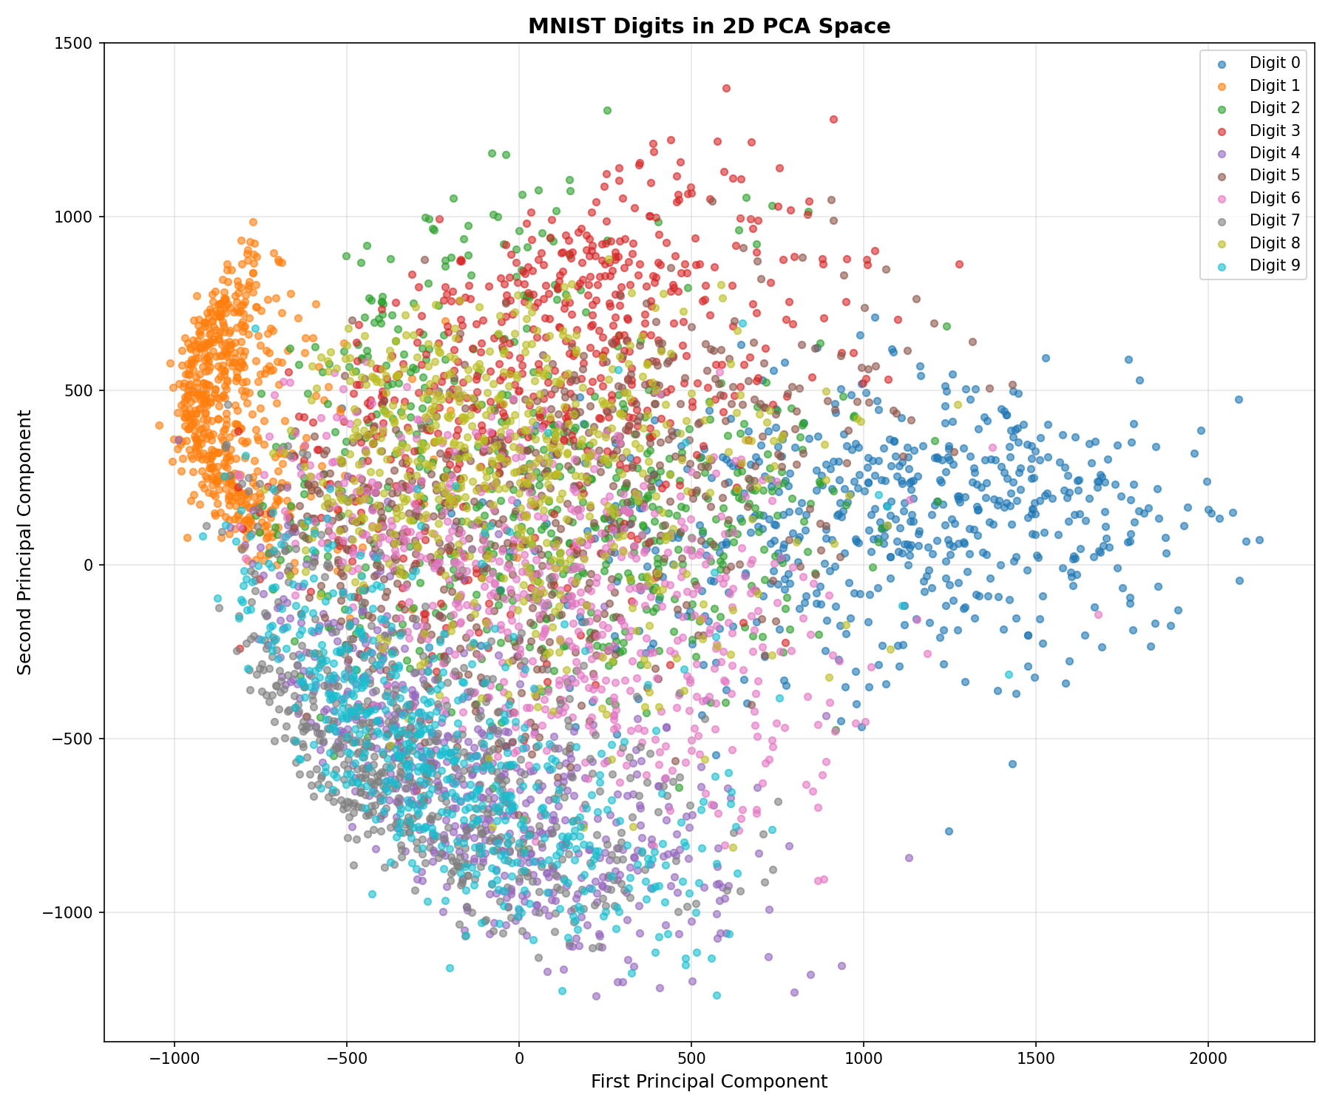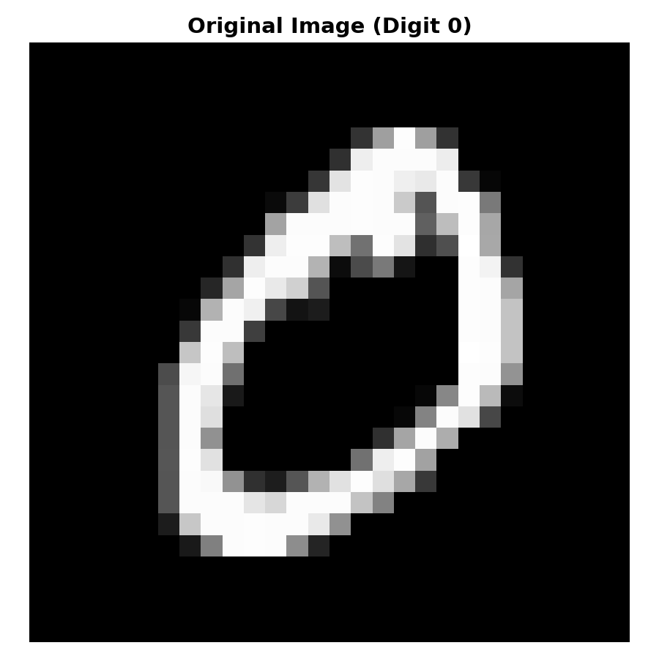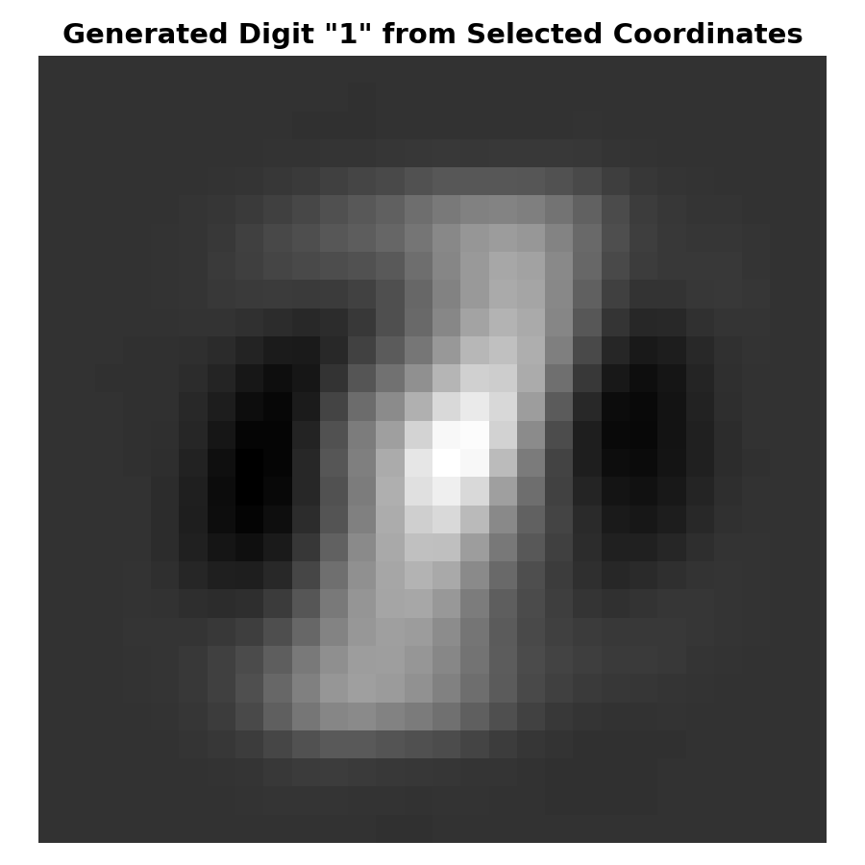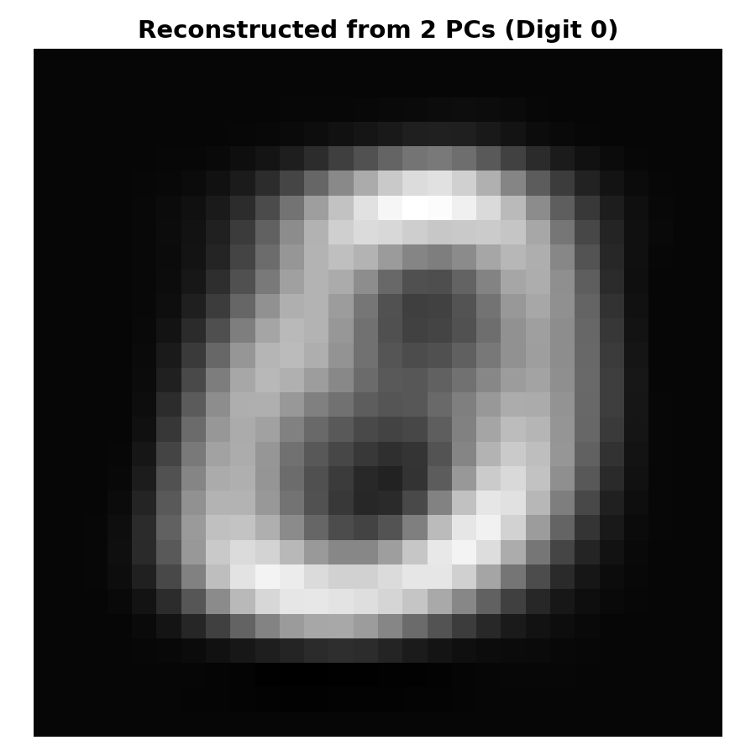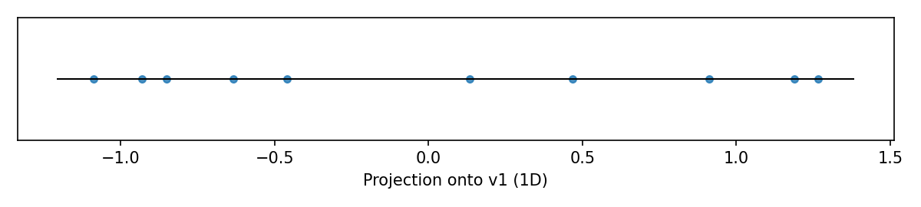
The code matches the assignment’s mathematical workflows and required outputs. In Part 1 the data are centered, a 2×2 covariance is computed, and np.linalg.eigh is used with eigenvalues reordered descending; the leading eigenvector aligns with sklearn’s PCA components up to sign, and the eigenvalues equal sklearn’s explained_variance. The printed eigenvalue ratios equal explained_variance_ratio, and the manual 1D projection Xc @ v1 matches x_pca[:,0] up to sign, confirming the derivation. The saved projection_1D.png shows the expected ordering/spread along the dominant variance direction, consistent with the original diagonal trend.
In Part 2 PCA(n_components=2) on the 6000×784 MNIST matrix produces a 6000×2 embedding that clusters by digit in MNIST_PCA_2D.png. Reconstruction uses inverse_transform, yielding MNIST_reconstructed_2PC.png that is a blurred but faithful low-rank approximation of MNIST_original.png, and selecting coordinates in PCA space generates MNIST_reconstructed_1_from_coord.png as expected. In Part 3 NMF (nndsvda init, non-negative X) returns W,H; rows of W are normalized to sum to 1, then averaged by clade. The TSV is alphabetically sorted by clade, ancestry columns are ordered by prevalence across clades, values are rounded to two decimals, and the file is saved as dogs_ancestry_summary.tsv. Shapes, filenames, and prints match the specification, indicating correctness.

