**Instructions for Uploading BackgroundJobServer**

**June 14, 2017**

1. Build Traffk.BackgroundJobServer in Visual Studio under the “Release” configuration (could do Debug)
   1. If you want to publish under a different configuration, use the name of your desired configuration in all subsequent steps
2. Open up a command prompt and navigate to the Traffk.BackgroundJobServer
   1. For example: cd Source\Repos\HealthInformationPortal\src\Traffk.BackgroundJobServer
3. Run the command: dotnet publish -c Release
4. A publish folder will be created within the bin\Release folder
   1. In this example, the newly created folder is located in “C:\Users\Darren\Source\Repos\HealthInformationPortal\src\Traffk.BackgroundJobServer\bin\Release\netcoreapp1.1\publish”
5. In the publish folder, add a file titled “run.cmd”
6. In the run.cmd file, add the following instruction: dotnet Traffk.BackgroundJobServer.dll
7. Zip up the publish folder
8. Sign in to the Azure Portal
9. Navigate to the traffkbackgroundserver resource
10. In the middle blade, click on “WebJobs”

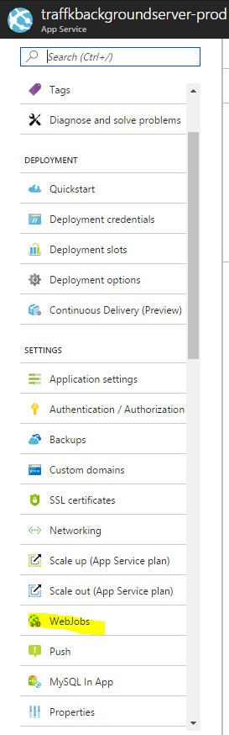

1. Click “Add”

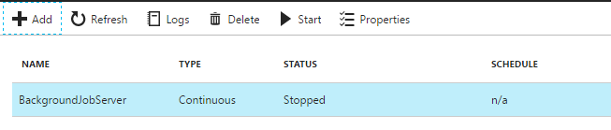

1. Configure the options, and upload the “publish” zip file you created

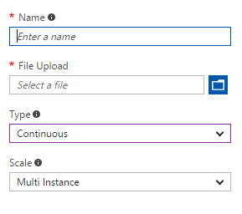

Sources:

<https://blogs.msdn.microsoft.com/benjaminperkins/2017/03/07/how-to-deploy-a-net-core-console-application-to-azure-webjob/>

<https://stackoverflow.com/questions/43268344/azure-webjob-in-net-core>

<https://stackoverflow.com/questions/42857997/publish-simple-asp-net-core-app-net-framework-with-webjob/42914048#42914048>