成都大学

计算机学院
实验报告书

课程名称 Python程序设计
专 业 软件工程
年级班级 2020级 2 班
学 号 202010414227
姓 名 郑才华
指导教师 叶安胜
2022 至 2023 学年 第 2 学期
计算机学院实验室制

实验日期 | 评阅日期 | 评阅人 | 实验成绩
2023-3-20

实验项目名称 | 学生成绩管理系统
实验目的 | 综合集成下述相关编程技术，完成一个微型综合应用，主要掌握如下技术。  （1）面向对象程序设计。类的定义、数据成员和方法成员，构造函数和析构函数等。能够根据主要业务需求，设计合理的类，包括合理的数据成员以及完成相关业务的方法等。  （2）综合应用python数据库编程。利用pymysql包，完成对数据表的增删改查等数据操作。  （3）GUI编程。利用主流GUI开发工具tkinter，开发具有友好交互的桌面程序。掌握GUI编程模型以及常用的组件设计，包括属性、方法和事件的使用方法以及如何跟具体业务应用绑定，包含但不限于多窗口切换、菜单、事件等技术的应用。  （4）综合应用Python的其他相关编程技术。
实验仪器 | PC电脑、pycharm，MySQL
实验过程(可另附页)
1、实验环境说明
Windows10 操作系统，pycharm编译器

采用团队的方式，组长为：郑才华，组员为李奇莲，周波。

2、实验过程：
编写页面，添加逻辑，增加数据库
3、实验结果及分析：
说明实验结果，并分析试验是否成功，体现什么原理等

现在先演示一下实验结果：
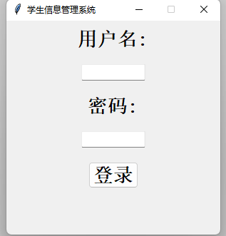
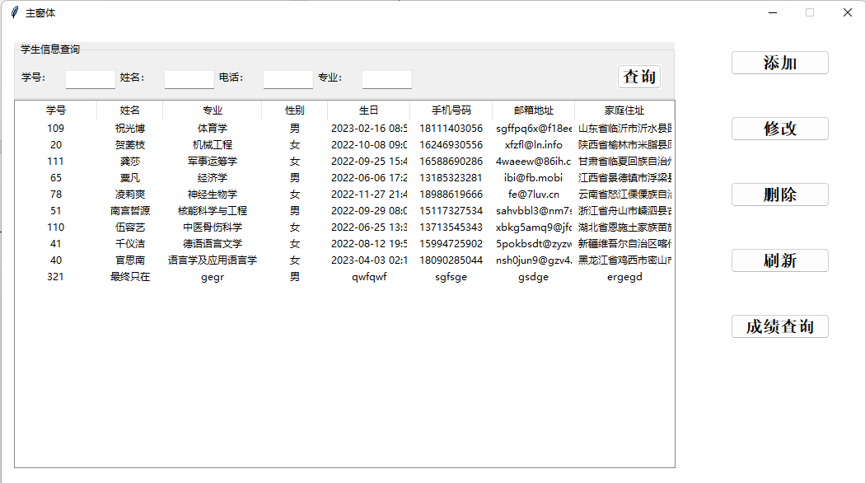
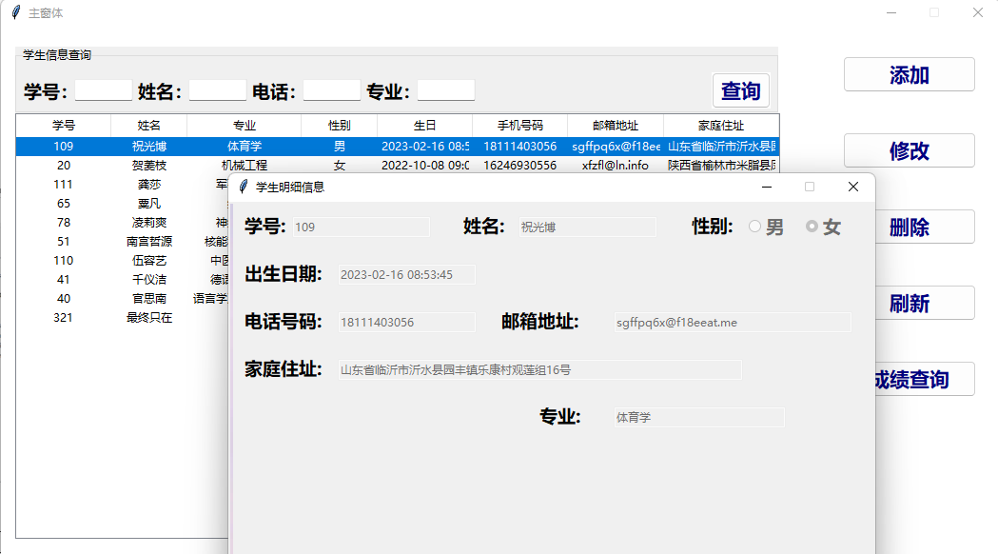
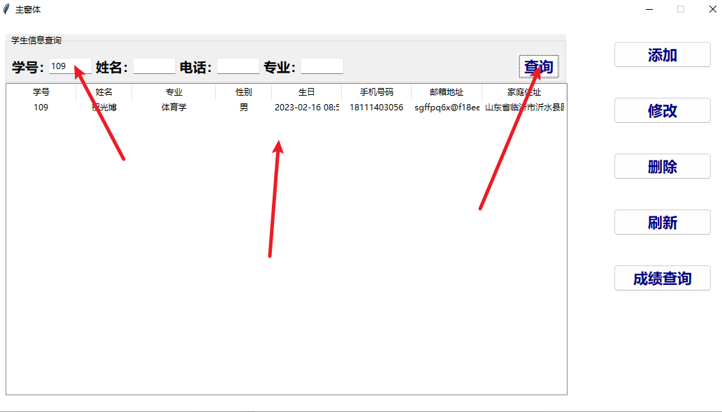
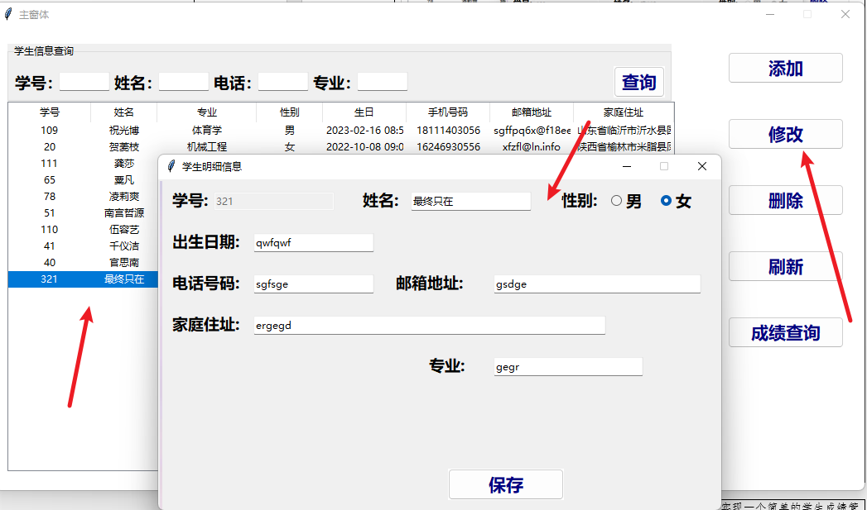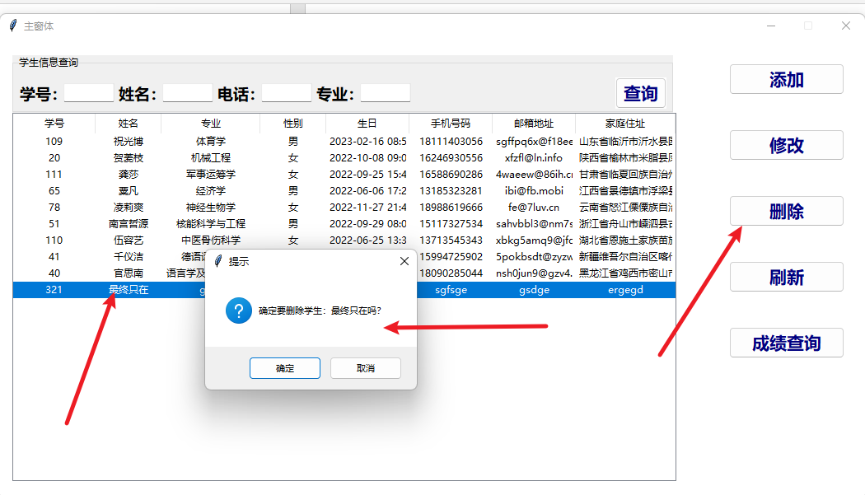
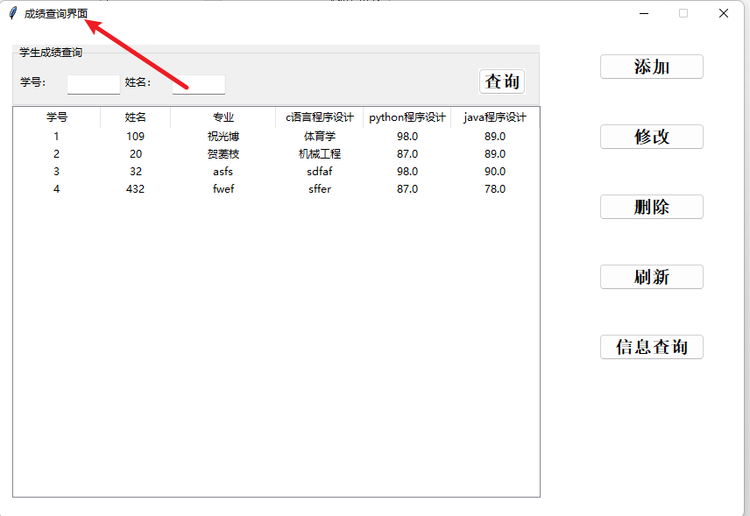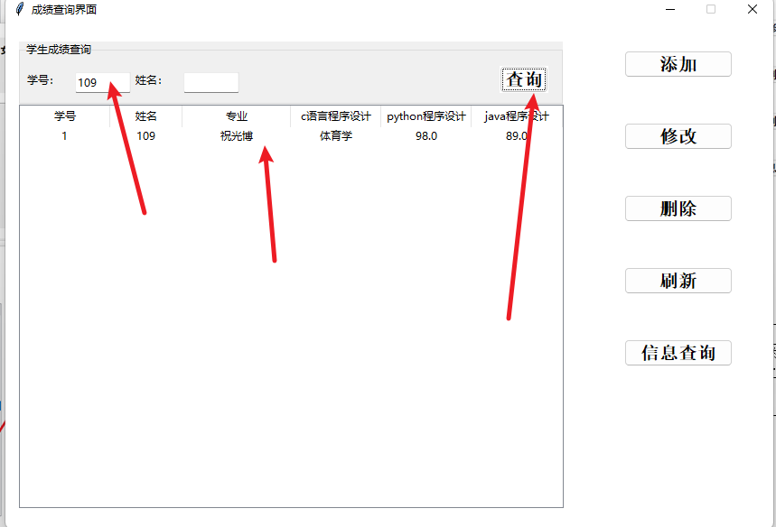
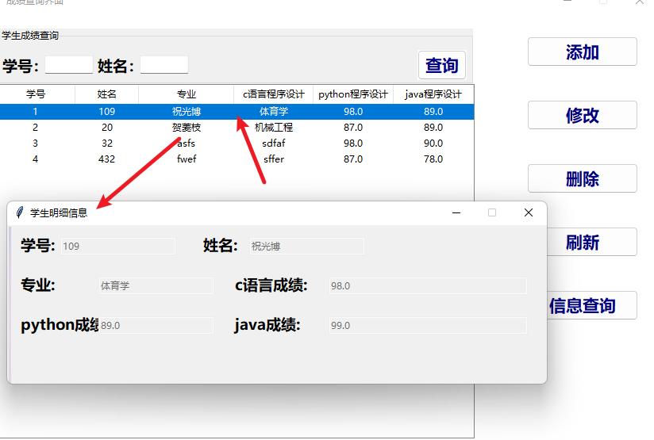
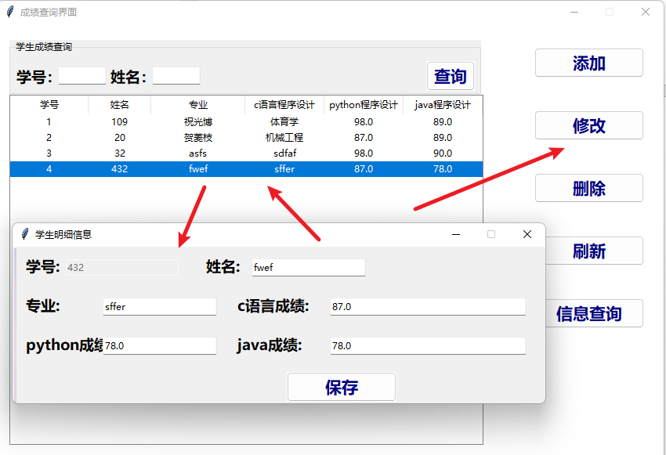

然后就是实验代码：
- from tkinter import *
- from tkinter.ttk import *
- from tkinter import messagebox
- import datetime

- import mainGUI
- import pymysql
- import os

- class LoginWindow(Tk):
- """创建登录窗体的GUI界面以及登录的方法"""

- # 构造函数，在对象被创建后就自动运行
- def __init__(self):
- super().__init__() # 先执行tk这个类的初始化
- self.title("学生信息管理系统")
- self.geometry("300x300")
- self.resizable(0, 0) # 窗体大小不允许变，两个参数分别代表x轴和y轴

- # 这三个参数都是为了传入下一个界面
- self.user = ""
- self.pwd = ""
- self.state = 1

- # 加载窗体
- self.setup_UI()
- self.user_list = [] # 存储用户信息

- def setup_UI(self):
- # ttk中控件使用style对象设定
- self.Style01 = Style()
- self.Style01.configure("user.TLabel", font=("华文黑体", 20, "bold"), foreground="black")
- self.Style01.configure("TEntry", font=("华文黑体", 20, "bold"))
- self.Style01.configure("TButton", font=("华文黑体", 20, "bold"), foreground="black", bg='red')
- self.Label_user = Label(self, text="用户名:", style="user.TLabel")
- self.Label_user.pack(padx=10, pady=10)
- self.Entry_user = Entry(self, width=12)
- self.Entry_user.pack(padx=10, pady=10)
- # 创建一个Label标签 + Entry --- 密码
- self.Label_password = Label(self, text="密码:", style="user.TLabel")
- self.Label_password.pack(padx=10, pady=10)
- self.Entry_password = Entry(self, width=12, show="*")
- self.Entry_password.pack(padx=10, pady=10)
- # 创建一个按钮 --- 登录
- self.Button_login = Button(self, text="登录", width=4, command=lambda: self.login())
- self.Button_login.pack(padx=20, pady=10)

- def load_main(self):
- # 关闭当前窗体
- #
- self.destroy()
- # 加载新窗体
- if __name__ == '__main__':
- main_Window = mainGUI.MainWindow(self.user, self.get_now_time(), self.pwd, self.state)
- main_Window.mainloop()

- def login(self):
- # 获取用户的用户名和密码
- user = self.Entry_user.get()
- password = self.Entry_password.get()
- db = pymysql.connect(
- host="localhost",
- user="root",
- password="248613",
- database="python_test"
- )
- cursor = db.cursor()
- sql = "select * from user where user_name=%s"
- cursor.execute(sql, user)
- # 将得到的管理员数据存放在列表中
- self.user_list = cursor.fetchall()
- print(self.user_list)
- cursor.close()
- db.close()
- if len(self.user_list) != 0:
- if 0 == self.user_list[0][2]:
- messagebox.showinfo("系统消息", "账号已禁用，请联系管理员")
- else:
- if password != str(self.user_list[0][1].strip().lower()):
- messagebox.showinfo("系统消息", "输入密码错误")
- else:
- messagebox.showinfo("系统消息", "登录成功！")
- self.user = self.user_list[0][0]
- self.pwd = self.user_list[0][1]
- self.state = self.user_list[0][2]
- self.load_main()
- else:
- messagebox.showinfo("系统消息", '输入用户名不存在')

- def get_now_time(self):
- today = datetime.datetime.today()
- return ("%04d-%02d-%02d %02d:%02d:%02d" % (
- today.year, today.month, today.day, today.hour, today.minute, today.second))

- if __name__ == '__main__':
- this_login = LoginWindow()
- print(this_login.get_now_time())
- this_login.mainloop()

- from tkinter import *
- from tkinter.ttk import *
- from tkinter import messagebox

- import ScoresGUI
- import detailGUI
- import login_page
- import pymysql
- import os
- import sys

- class MainWindow(Tk):

- def __init__(self, login_user, login_time, psw, state):
- super().__init__()
- self.title("主窗体")
- self.geometry("1050x560+100+20")
- self.resizable(0, 0)
- self["bg"] = "white"
- # 从登录界面传过来的管理员登录名和登录时间
- self.current_user = login_user
- self.current_time = login_time
- self.current_psw = psw
- self.current_state = state
- # 加载页面UI
- self.setup_UI()

- # 读取学生信息
- self.all_student_list = [] # 使用一个list来存放读取的学生信息
- self.load_file_student_info()

- # 在treeview中加载学生信息
- self.load_treeview(self.all_student_list)

- # 定义一个存储查询结果的列表
- self.query_result_list = []

- self.current_student_list = []

- def setup_UI(self):
- # 设定Style
- self.Style01 = Style()
- self.Style01.configure("left.TPanedwindow", background="white")
- self.Style01.configure("right.TPanedwindow", background="white")
- self.Style01.configure("TButton", width=10, font=("华文黑体", 15, "bold"), background="white")

- # 右边：按钮区域，创建一个容器
- self.Pane_left = PanedWindow(width=200, height=541, style="left.TPanedwindow")
- self.Pane_left.place(x=845, y=10)
- self.Pane_right = PanedWindow(width=830, height=540, style="right.TPanedwindow")
- self.Pane_right.place(x=5, y=10)

- # 添加右边按钮
- # self.Button_image = PhotoImage(file="."+os.sep+"images"+os.sep+"tianjia.png")
- self.Button_add = Button(self.Pane_left, text="添加", style="TButton", command=lambda: self.add_studnet())
- self.Button_add.place(x=40, y=20)
- self.Button_update = Button(self.Pane_left, text="修改", style="TButton", command=lambda: self.update_student())
- self.Button_update.place(x=40, y=100)
- self.Button_delete = Button(self.Pane_left, text="删除", style="TButton", command=lambda: self.delete_student())
- self.Button_delete.place(x=40, y=180)
- self.Button_showall = Button(self.Pane_left, text="刷新", style="TButton",
- command=lambda: self.load_all_student())
- self.Button_showall.place(x=40, y=260)

- self.Button_showall = Button(self.Pane_left, text="成绩查询", style="TButton",
- command=lambda: self.load_Scores())
- self.Button_showall.place(x=40, y=340)

- # 左边：查询，TreeView
- # self.Pane_right = PanedWindow(width=725,height=540,style="right.TPanedwindow")
- # self.Pane_right.place(x=170,y=94)
- # LabelFrame
- self.LabelFrame_query = LabelFrame(self.Pane_right, text="学生信息查询", width=802, height=70)
- self.LabelFrame_query.place(x=10, y=10)

- # 添加控件
- # 学号
- self.Label_sno = Label(self.LabelFrame_query, text="学号：", style=None)
- self.Label_sno.place(x=5, y=13)
- self.Entry_sno = Entry(self.LabelFrame_query, width=8, style=None)
- self.Entry_sno.place(x=60, y=15)

- # 姓名
- self.Label_name = Label(self.LabelFrame_query, text="姓名：", style=None)
- self.Label_name.place(x=125, y=13)
- self.Entry_name = Entry(self.LabelFrame_query, width=8, style=None)
- self.Entry_name.place(x=180, y=15)

- # 电话
- self.Label_mobile = Label(self.LabelFrame_query, text="电话：")
- self.Label_mobile.place(x=245, y=13)
- self.Entry_mobile = Entry(self.LabelFrame_query, width=8)
- self.Entry_mobile.place(x=300, y=15)

- # 学院
- self.Label_academy = Label(self.LabelFrame_query, text="专业：")
- self.Label_academy.place(x=365, y=13)
- self.Entry_academy = Entry(self.LabelFrame_query, width=8)
- self.Entry_academy.place(x=420, y=15)

- # 查询按钮
- self.Button_query = Button(self.LabelFrame_query, text="查询", width=4, command=lambda: self.get_query_result())
- self.Button_query.place(x=730, y=8)

- # 添加TreeView控件
- self.Tree = Treeview(self.Pane_right,
- columns=("sno", "names", "academy", "gender", "birthday", "mobile", "email", "address"),
- show="headings", height=21)

- # 设置每一个列的宽度和对齐方式
- self.Tree.column("sno", width=100, anchor="center")
- self.Tree.column("names", width=80, anchor="center")
- self.Tree.column("academy", width=120, anchor="center")
- self.Tree.column("gender", width=80, anchor="center")
- self.Tree.column("birthday", width=100, anchor="center")
- self.Tree.column("mobile", width=100, anchor="center")
- self.Tree.column("email", width=100, anchor="center")
- self.Tree.column("address", width=120, anchor="center")

- # 设置每个列的标题
- self.Tree.heading("sno", text="学号")
- self.Tree.heading("names", text="姓名")
- self.Tree.heading("academy", text="专业")
- self.Tree.heading("gender", text="性别")
- self.Tree.heading("birthday", text="生日")
- self.Tree.heading("mobile", text="手机号码")
- self.Tree.heading("email", text="邮箱地址")
- self.Tree.heading("address", text="家庭住址")

- self.Tree.place(x=10, y=80)
- # 为tree绑定双击事件，双击后显示点击学生的详细信息
- self.Tree.bind("<Double-1>", self.view_student)

- # 读取文件/数据库中学生的信息
- def load_file_student_info(self):
- # 使用数据库读取信息
- config = {
- "host": "localhost",
- "user": "root",
- "password": "248613",
- "database": "python_test"
- }
- db = pymysql.connect(**config)
- cursor = db.cursor()
- sql = "select * from student"
- cursor.execute(sql)
- self.all_student_list = list(cursor.fetchall())
- print("使用函数查找的所有学生：", len(self.all_student_list))
- print(self.all_student_list)
- cursor.close()
- db.close()

- # 将学生数据加载出来
- def load_treeview(self, current_list: list):
- # 判断是否有数据：
- if len(current_list) == 0:
- messagebox.showinfo("系统消息", "没有数据加载")
- else:
- for index in range(len(current_list)):
- self.Tree.insert("", index, values=(current_list[index][1], current_list[index][2],
- current_list[index][3], current_list[index][4],
- current_list[index][5], current_list[index][6],
- current_list[index][7], current_list[index][8]))

- # 查询
- def get_query_result(self):
- # 准备查询条件：获取学号
- query_condition = [self.Entry_sno.get(),
- self.Entry_name.get(),
- self.Entry_academy.get(),
- self.Entry_mobile.get()
- ]
- if len(query_condition[0]) == 0 and len(query_condition[1]) == 0 and len(query_condition[2]) == 0 and len(
- query_condition[3]) == 0:
- messagebox.showinfo("系统消息", "请输入要查找的内容！")
- else:
- for item in self.all_student_list:
- if query_condition[0] in str(item[1]) \
- and query_condition[1] in item[2] \
- and query_condition[2] in item[3] \
- and query_condition[3] in item[6]:
- self.query_result_list.append(item)
- # 这个操作要把所有子节点都删掉，后面会将查询到的节点添加上
- for i in self.Tree.get_children():
- self.Tree.delete(i)
- # print(self.query_result_list)
- # 将查询结果保存进excel
- from openpyxl import Workbook
- workbook = Workbook()
- # 默认sheet
- sheet = workbook.active
- sheet.title = "学生信息"
- columns = (
- "student_id", "name", "gender", "birthday", "ident", "mobile", "email", "address"
- )
- sheet.append(columns)
- for data in self.query_result_list:
- sheet.append(data)
- workbook.save('student.xlsx')
- # 将查询到的结果集渲染到页面上
- self.load_treeview(self.query_result_list)
- # 将结果集清空
- self.query_result_list.clear()

- def load_all_student(self):
- for i in self.Tree.get_children():
- self.Tree.delete(i)
- # 点击显示全部按钮后输入框清空
- self.Entry_sno.delete(0, "end")
- self.Entry_name.delete(0, "end")
- self.Entry_academy.delete(0, "end")
- self.Entry_mobile.delete(0, "end")
- # 查找所有学生信息
- self.load_file_student_info()

- from openpyxl import Workbook
- workbook = Workbook()
- # 默认sheet
- sheet = workbook.active
- sheet.title = "学生信息"
- columns = (
- "student_id", "name", "gender", "birthday", "ident", "mobile", "email", "address")
- sheet.append(columns)
- for data in self.all_student_list:
- sheet.append(data)
- workbook.save('student.xlsx')

- # 加载所有的学生信息到TreeView中
- self.load_treeview(self.all_student_list)

- def load_detail_window(self, flag):
- detail_window = detailGUI.DetailWindow(flag, self.current_student_list)
- # 等待detail_window被destroy，然后继续执行以下代码
- self.wait_window(detail_window)
- # tree中刷新信息
- self.load_all_student()

- def add_studnet(self):
- flag = 2
- self.current_student_list = []
- self.load_detail_window(flag)

- def update_student(self):
- flag = 3
- try:
- item = self.Tree.selection()[0]
- print(item)
- Temp_student_list = self.Tree.item(item, "values")
- print(Temp_student_list)
- # 遍历获得完整学生明细信息
- for item in self.all_student_list:
- if int(item[1]) == int(Temp_student_list[0]):
- self.current_student_list.append(item)
- print("ceshi", self.current_student_list)
- self.load_detail_window(flag)
- except:
- messagebox.showinfo("系统消息", "请选择要修改的学生")

- def view_student(self, event):
- flag = 1
- # 获取Tree表格双击某一行的数据，selection()如果没有指定参数，则表明以列表形式返回所有的item
- # 获取双击某一行的项目标识符
- item = self.Tree.selection()[0]
- print("item: " + item)
- # 这个Tree表格中的数据，只是显示了部分数据，为了显示明细窗体，我们需要加载文件中的读取出来的完整信息
- Temp_student_list = self.Tree.item(item, "values") # 通过item方法，获取改列的所有元素，以元组的形式返回
- print(Temp_student_list)
- print("查看详情的所有学生", self.all_student_list)
- # 遍历获得完整学生明细信息
- for item in self.all_student_list:
- if int(item[1]) == int(Temp_student_list[0]):
- self.current_student_list.append(item)
- # print(self.current_student_list)
- # print(self.current_student_list)
- self.load_detail_window(flag)

- def delete_student(self):
- try:
- item = self.Tree.selection()[0]
- Temp_student_list = self.Tree.item(item, "values")
- print("选择是：", Temp_student_list)
- config = {
- "host": "localhost",
- "user": "root",
- "password": "248613",
- "database": "python_test"
- }
- db = pymysql.connect(**config)
- cursor = db.cursor()
- sql = "delete from student where sno=%s"
- cursor.execute(sql, Temp_student_list[0])
- num = messagebox.askokcancel("提示", "确定要删除学生：%s吗？" % Temp_student_list[1])
- if num:
- db.commit()
- messagebox.showinfo("系统消息", "学生%s已被删除！" % Temp_student_list[1])
- else:
- messagebox.showinfo("系统消息", "您取消了删除学生%s" % Temp_student_list[1])
- cursor.close()
- db.close()
- self.load_all_student()
- except:
- messagebox.showinfo("系统消息", "请选择要删除的学生")

- def load_Scores(self):
- self.destroy()
- main_Window = ScoresGUI.MainWindow(self.current_user, self.current_time, self.current_psw, self.current_state)
- main_Window.mainloop()

- # 学生窗体GUI基本布局

- from tkinter import *
- from tkinter import messagebox
- from tkinter.ttk import *
- import pymysql
- import os

- class DetailWindow(Toplevel):
- def __init__(self, flag, current_student):
- super().__init__()
- self.title("学生明细信息")
- self.geometry("680x400+200+20")
- self.resizable(0, 0) # 不能改变窗体大小
- self.flag = flag # 接收从主窗口传过来的flag来控制自己窗口的控件状态
- self.current_student_list = current_student # 接收从主窗口床过来的学生信息
- self.temp_list = []
- # 加载控件
- self.setup_UI()

- # 加载学生详细信息
- def load_student_detail(self):
- if len(self.current_student_list) == 0 and self.flag == 1:
- messagebox.showinfo("系统消息","没有任何数据需要展示!")
- else:
- self.var_sno.set(self.current_student_list[0][1]) # 学号
- self.var_name.set(self.current_student_list[0][2]) # 姓名
- if "男" in self.current_student_list[0][2]: # 性别
- self.var_gender.set(1)
- else:
- self.var_gender.set(0)
- self.var_age.set(self.current_student_list[0][5]) # 出生日期
- self.var_mobile.set(self.current_student_list[0][6]) # 电话
- self.var_email.set(self.current_student_list[0][7]) # 邮箱
- self.var_home.set(self.current_student_list[0][8]) # 地址
- self.var_academy.set(self.current_student_list[0][3]) # 专业

- def setup_UI(self):
- # detail_UI(self)
- # 设置style
- self.Style02 = Style()
- self.Style02.configure("TPanedwindow")
- self.Style02.configure("title.TLabel", font=("微软雅黑", 10, "bold"))
- self.Style02.configure("TLabel", font=("微软雅黑", 14, "bold"))
- self.Style02.configure("TButton", font=("微软雅黑", 16, "bold"), foreground="navy", width=10)
- self.Style02.configure("TEntry", font=("微软雅黑", 16, "bold"), width=10)
- self.Style02.configure("large.TEntry", font=("微软雅黑", 16, "bold"), width=30)
- self.Style02.configure("TRadiobutton", font=("微软雅黑", 14, "bold"))
- #
- # 加载上面的banner
- self.Login_image = PhotoImage(file="." + os.sep + "images" + os.sep + "shouye.png")
- self.Lable_image = Label(self, image=self.Login_image)
- self.Lable_image.pack()

- # 添加一个title
- self.var_title = StringVar()
- self.Label_title = Label(self, text="==明细窗体==", style="title.TLabel")
- self.Label_title.place(x=500, y=40)

- # 加载一个pane
- self.Pane_detail = PanedWindow(self, width=690, height=450, style="TPanedwindow")
- self.Pane_detail.place(x=5, y=0)

- # 添加属性
- # 第一排:学号
- self.Label_sno = Label(self.Pane_detail, text="学号:")
- self.Label_sno.place(x=10, y=10)
- self.var_sno = StringVar()
- self.Entry_sno = Entry(self.Pane_detail, textvariable=self.var_sno, style="TEntry")
- self.Entry_sno.place(x=62, y=15)
- # 姓名
- self.Label_name = Label(self.Pane_detail, text="姓名:", style="TLabel")
- self.Label_name.place(x=240, y=10)
- self.var_name = StringVar()
- self.Entry_name = Entry(self.Pane_detail, textvariable=self.var_name, style="TEntry")
- self.Entry_name.place(x=300, y=15)
- # 性别
- self.Label_gender = Label(self.Pane_detail, text="性别:").place(x=480, y=10)
- self.var_gender = IntVar()
- self.Radio_man = Radiobutton(self.Pane_detail, text="男", variable=self.var_gender, value=1,
- style="TRadiobutton")
- self.Radio_man.place(x=540, y=10)
- self.Radio_woman = Radiobutton(self.Pane_detail, text="女", variable=self.var_gender, value=0,
- style="TRadiobutton")
- self.Radio_woman.place(x=600, y=10)
- # 第二排:出生日期
- self.Label_age = Label(self.Pane_detail, text="出生日期:", style="TLabel")
- self.Label_age.place(x=10, y=60)
- self.var_age = StringVar()
- self.Entry_age = Entry(self.Pane_detail, textvariable=self.var_age, style="TEntry")
- self.Entry_age.place(x=110, y=65)
- # 第三排:手机号码
- self.Label_mobile = Label(self.Pane_detail, text="电话号码:", style="TLabel")
- self.Label_mobile.place(x=10, y=110)
- self.var_mobile = StringVar()
- self.Entry_mobile = Entry(self.Pane_detail, textvariable=self.var_mobile, style="TEntry")
- self.Entry_mobile.place(x=110, y=115)
- # 邮箱地址
- self.Label_email = Label(self.Pane_detail, text="邮箱地址:", style="TLabel")
- self.Label_email.place(x=280, y=110)
- self.var_email = StringVar()
- self.Entry_email = Entry(self.Pane_detail, textvariable=self.var_email, width=35)
- self.Entry_email.place(x=400, y=115)

- # 第四排:家庭住址
- self.Label_home = Label(self.Pane_detail, text="家庭住址:", style="TLabel")
- self.Label_home.place(x=10, y=160)
- self.var_home = StringVar()
- self.Entry_home = Entry(self.Pane_detail, textvariable=self.var_home, width=60)
- self.Entry_home.place(x=110, y=165)
- # 专业
- self.Label_academy = Label(self.Pane_detail, text="专业:", style="TLabel")
- self.Label_academy.place(x=320, y=210)
- self.var_academy = StringVar()
- self.Entry_academy = Entry(self.Pane_detail, textvariable=self.var_academy, width=25)
- self.Entry_academy.place(x=400, y=215)

- # 放置两个按钮
- self.Button_save = Button(self, text="保存", style="TButton", command=lambda: self.commit())
- self.Button_save.place(x=350, y=350)

- # 初始化界面数据及控件状态
- self.load_student_detail()
- self.load_windows_flag()

- #
- def load_windows_flag(self):
- if self.flag == 1:
- self.Button_save.place_forget()
- self.Entry_sno["state"] = DISABLED
- self.Entry_name["state"] = DISABLED
- self.Radio_man["state"] = DISABLED
- self.Radio_woman["state"] = DISABLED
- self.Entry_age["state"] = DISABLED
- self.Entry_mobile["state"] = DISABLED
- self.Entry_email["state"] = DISABLED
- self.Entry_home["state"] = DISABLED
- self.Entry_academy["state"] = DISABLED
- elif self.flag == 2:
- self.Label_title.configure(text="==新建学生明细==")
- elif self.flag == 3:
- self.Label_title.configure(text="==修改学生明细==")
- self.Entry_sno["state"] = DISABLED

- def commit(self):
- if self.flag == 1:
- pass
- else:
- # 添加学生信息
- if self.flag == 2:
- break_flag = 1
- try:
- while break_flag:
- self.get_input()
- if len(self.Entry_sno.get()) == 0 or len(self.Entry_name.get()) == 0 \
- or len(self.Entry_mobile.get()) == 0 or len(self.Entry_academy.get()) == 0 :
- messagebox.showinfo("系统消息", "学号、姓名、电话号码、专业都不能为空！")
- else:
- self.get_input()
- sql = "insert into student(sno, name, academy, gender, birthday, mobile, email, address) values (%s,%s,%s,%s,%s,%s,%s,%s)"
- self.connect_database(sql, (self.temp_list[0],
- self.temp_list[1],
- self.temp_list[7],
- self.temp_list[2],
- self.temp_list[3],
- self.temp_list[4],
- self.temp_list[5],
- self.temp_list[6]))
- messagebox.showinfo("系统消息", "学生信息添加成功")
- break_flag = messagebox.askyesno("提示", "继续添加学生？")
- if break_flag:
- self.Entry_sno.delete(0, "end")
- self.Entry_name.delete(0, "end")
- # self.var_gender.delete(0,"end")
- self.Entry_age.delete(0, "end")
- self.Entry_mobile.delete(0, "end")
- self.Entry_email.delete(0, "end")
- self.Entry_home.delete(0, "end")
- self.Entry_academy.delete(0, "end")
- # 保存后销毁此窗口
- self.destroy()
- except pymysql.err.OperationalError as e:
- messagebox.showerror("错误", e)
- except pymysql.err.DataError as e:
- messagebox.showerror("错误", e)

- # 修改学生信息
- elif self.flag == 3:
- self.get_input()
- print(self.temp_list)
- if len(self.Entry_sno.get()) == 0 or len(self.Entry_name.get()) == 0 \
- or len(self.Entry_mobile.get()) == 0 \
- or len(self.Entry_academy.get()) == 0:
- messagebox.showinfo("系统消息",
- "学号、姓名、电话号码、专业都不能为空！")
- else:
- self.get_input()
- sql = "update student set " \
- "name=%s,gender=%s,birthday=%s,mobile=%s,email=%s,address=%s,academy=%s " \
- "where sno=%s"
- self.connect_database(sql, (self.temp_list[1],
- self.temp_list[2],
- self.temp_list[3],
- self.temp_list[4],
- self.temp_list[5],
- self.temp_list[6],
- self.temp_list[7],
- self.temp_list[0]))
- messagebox.showinfo("系统消息", "学生信息修改成功！")
- # 保存后销毁此窗口
- self.destroy()

- def connect_database(self, sql, *value):
- config = {
- "host": "localhost",
- "user": "root",
- "password": "248613",
- "database": "python_test"
- }
- db = pymysql.connect(**config)
- cursor = db.cursor()
- cursor.execute(sql, *value)

- db.commit()
- # self.find_all=cursor.fetchall()
- cursor.close()
- db.close()

- def get_input(self):
- # 获取输入框信息保存到list中
- self.temp_list = []

- self.temp_list.append(int(self.Entry_sno.get()))
- self.temp_list.append(self.Entry_name.get().strip())
- if self.var_gender.get() == 1:
- self.temp_list.append("男")
- else:
- self.temp_list.append("女")
- self.temp_list.append(self.Entry_age.get().strip())
- self.temp_list.append(self.Entry_mobile.get().strip())
- self.temp_list.append(self.Entry_email.get().strip())
- self.temp_list.append(self.Entry_home.get().strip())
- self.temp_list.append(self.Entry_academy.get().strip())
- print("测试", self.temp_list)

这里我只放学生管理这三个模块的代码，因为后面的成绩管理和这里基本一致。

实验小结 | 本实验考察python的图形库tkinter，实现一个简单的学生成绩管理系统，最难的还是布局，需要花费大量时间去写。…
教师评阅意见及建议

实验一：
文件操作
实验目的：
1、掌握python基本文件操作编程。
2、熟练python文件操作的应用。

实验二：
数据库操作
实验目的：
- 熟悉python操作数据库的方法。
- 熟悉python中使用sql查询和处理数据库的数据。

实验三：
网络编程
实验目的：
1. 理解网络程序的编程方法；
2. 理解客户服务器通信的原理，能够使用TCP套接字传输消息。

实验四：
多线程TCP服务
实验目的：
1. 理解python多线程编程的方法；
2. 掌握python TCP服务器多线程模型及编程方法。

实验五：
图形用户界面项目设计设计
实验目的：
1. 理解python图形界面程序设计；
2. 熟悉客户端程序用户界面设计。

