Guidelines for the prediction of species interactions through binary classification
Species interactions, forming ecological networks, are a backbone for key ecological and evolutionary processes; yet enumerating all of the interactions between species is a daunting task, as it scales with , i.e. the squared species richness (Martinez, 1992). Recent contributions to the field of ecological network prediction (Becker et al., 2022; Pichler et al., 2020; Strydom et al., 2021) highlight that although interactions can be predicted by adding ecologically relevant information (in the form of, e.g. traits), we do not have robust guidelines as to how the predictive ability of models recommending species interactions should be evaluated, nor about how these models should be trained. Here, by relying on simple derivations and a series of simulations, we formulate a number of such guidelines, specifically for the case of binary classifiers derived from thresholded values. Specifically, we conduct an investigation of the models in terms of their skill (ability to make the right prediction), bias (trends towards systematically over-predicting one class), class imbalance (the relative number of cases representing interactions), and show how these effects interact. We conclude on the fact that models with the best interaction-scale predictive score do not necessarily result in the most accurate representation of the true network.
The prediction of ecological interactions shares conceptual and methodological issues with two fields in biology: species distribution modelling (SDMs), and genomics. SDMs suffers from issues affecting interactions prediction, namely low prevalence (due to sparsity of observations/interactions) and data aggregation (due to bias in sampling some locations/species). An important challenge lies in the fact that the best measure to quantify the performance of a model is not necessarilly a point of consensus (these methods, their interpretation, and the way they are measured, are covered in depth in the next section). In previous work, Allouche et al. (2006) suggested that Cohen’s agreement score ( thereafter) was a better test of model performance than the True Skill Statistic (TSS; which we refer to as Youden’s informedness thereafter); these conclusions were later criticized by Somodi et al. (2017), who emphasized that informedness is affected both by prevalence and bias. Although this work offers recommendations about the comparison of models, it doesn’t establishes baselines or good practices for training on imbalanced ecological data, or ways to remedy the imbalance. Steen et al. (2021) show that, when applying spatial thinning (artificially re-balancing observation data in space to avoid artifacts due to auto-correlation), the best approach to train ML-based SDMs varies according to the balancing of the dataset, and the evaluation measures used; there is no single “recipe” that is guaranteed to give the best model. By contrast to networks, SDMs have the advantage of being able to both thin datasets to remove some of the sampling bias (e.g. Inman et al., 2021), but also to create pseudo-absences to inflate the number of supposed negatives in the dataset (e.g. Iturbide et al., 2015). These powerful ways to remove data bias often have no analogue in networks, removing one potential tool from our methodological toolkit, and making the task of network prediction through classification potentially more demanding, and more prone to underlying data biases.
An immense body of research on machine learning application to life sciences is focused on genomics (which has very specific challenges, see a recent discussion by Whalen et al., 2021); this sub-field has generated recommendations that do not necessarily match the current best-practices for SDMs, and therefore hint at the importance of domain-specific guidelines. Chicco & Jurman (2020) suggest using Matthews correlation coefficient (MCC) over , as a protection against over-inflation of predicted results; Delgado & Tibau (2019) advocate against the use of Cohen’s , again in favor of MCC, as the relative nature of means that a worse classifier can be picked over a better one; similarly, Boughorbel et al. (2017) recommend MCC over other measures of performance for imbalanced data, as it has more desirable statistical properties. More recently, Chicco et al. (2021) temper the apparent supremacy of the MCC, by suggesting it should be replaced by Youden’s informedness (also known as , bookmaker’s accuracy, and the True-Skill Statistic) when the imbalance in the dataset may not be representative of the actual imbalance. In a way, the measures themselves need not be a strong focus for network prediction, as they are routinely used in other field; the discipline-specific question we seek to address is: ‘which metric should be employed when predicting networks, and how to optimize it?’.
Species interaction networks are often under-sampled (Jordano, 2016a, 2016b), and this under-sampling is structured taxonomically (Beauchesne et al., 2016), structurally (de Aguiar et al., 2019) and spatially (Poisot, Bergeron, et al., 2021; Wood et al., 2015). As a consequence, networks suffer from data deficiencies both within and between datasets. This implies that the comparison of classifiers across space, when undersampling varies locally (see e.g. McLeod et al., 2021) is non-trivial. Furthermore, the baseline value of classifiers performance measures under various conditions of skill, bias, and prevalence, has to be identified to allow researchers to evaluate whether their interaction prediction model is indeed learning. Taken together, these considerations highlight three specific issues for ecological networks. First, what values of performance measures are indicative of a classifier with no skill? This is particularly important as it can evaluate whether low prevalence can lull us into a false sense of predictive accuracy. Second, independently of the question of model evaluation, is low prevalence an issue for training or testing, and can we remedy it? Finally, because the low amount of data on interaction makes a lot of imbalance correction methods (see e.g. Branco et al., 2015) hard to apply, which measures of model performance can be optimized by sacrificing least amount of positive interaction data?
A preliminary question is to examin the baseline performance of these measures, i.e. the values they would take on hypothetical networks based on a classifier that has no-skill. It may sound counter-intuitive to care so deeply about how good a classifier with no-skill is, as by definition, is has no skill. The necessity of this exercise has its roots in the paradox of accuracy: when the desired class (“two species interact”) is rare, a model that gets less ecologically performant by only predicting the opposite class (“these two species do not interact”) sees its accuracy increase; because most of the guesses have “these two species do not interact” as a correct answer, a model that never predicts interactions would be right an overwhelming majority of the time; it would also be utterly useless. Herein lies the core challenge of predicting species interactions: the extreme imbalance between classes makes the training of predictive models difficult, and their validation even more so as we do not reliably know which negatives are true. The connectance (the proportion of realized interactions, usually the number of interactions divided by the number of species pairs) of empirical networks is usually well under 20%, with larger networks having a lower connectance (MacDonald et al., 2020), and therefore being increasingly difficult to predict.

A primer on binary classifier evaluation
Binary classifiers, which it to say, machine learning algorithms whose answer is a binary value, are usually assessed by measuring properties of their confusion matrix, i.e. the contingency table reporting true/false positive/negative hits. A confusion matrix is laid out as

In this matrix, tp is the number of times the model predicts an interaction that exists in the network (true positive), fp is the number of times the model predicts an interaction that does not exist in the network (false positive), fn is the number of times the model fails to predict an interaction that actually exists in the network (false negatives), and tn is the number of times the model correctly predicts that an interaction does not exist (true negatives). From these values, we can derive a number of measures of model performance (see Strydom et al., 2021 for a review of their interpretation in the context of networks). At a coarse scale, a classifier is accurate when the trace of the matrix divided by the sum of the matrix is close to 1, with other measures informing us on how the predictions fail.
A lot of binary classifiers are built by using a regressor (whose task is to guess the value of the interaction, and can therefore return a value considered to be a pseudo-probability); in this case, the optimal value below which predictions are assumed to be negative (i.e. the interaction does not exist) can be determined by picking a threshold maximizing some value on the ROC or the PR curve. The area under these curves (ROC-AUC and PR-AUC henceforth) give ideas on the overall goodness of the classifier, and the ideal threshold is the point on these curves that minimizes the tradeoff represented in these curves. Saito & Rehmsmeier (2015) established that the ROC-AUC is biased towards over-estimating performance for imbalanced data; on the contrary, the PR-AUC is able to identify classifiers that are less able to detect positive interactions correctly, with the additional advantage of having a baseline value equal to prevalence. Therefore, it is important to assess whether these two measures return different results when applied to ecological network prediction. The ROC curve is defined by the false positive rate on the axis, and the true positive rate on the axis, and the PR curve is defined by the true positive rate on the axis, and the positive predictive value on the axis.
There is an immense diversity of measures to evaluate the performance of classification tasks (Ferri et al., 2009). Here we will focus on five of them with high relevance for imbalanced learning (He & Ma, 2013). The choice of metrics with relevance to class-imbalanced problems is fundamental, because as Japkowicz (2013) unambiguously concluded, “relatively robust procedures used for unskewed data can break down miserably when the data is skewed”. Following Japkowicz (2013), we focus on two ranking metrics (the areas under the Receiver Operating Characteristic and Precision Recall curves), and three threshold metrics (, informedness, and MCC; we will briefly discuss but show early on that it has undesirable properties).
The measure (Landis & Koch, 1977) establishes the extent to which two observers (the network and the prediction) agree, and is measured as

Informedness (Youden, 1950) (also known as bookmaker informedness or the True Skill Statistic) is , where and . Informedness can be used to find the optimal cutpoint in thresholding analyses (Schisterman et al., 2005); indeed, the maximal informedness corresponds to the point on the ROC curve that is closest to the perfect classifier point. The formula for informedness is

The MCC is defined as

Finally, is the harmonic mean of precision (the chance that interaction was correctly detected as such) and sensitivity (the ability to correctly classify interactions), and is defined as

One noteworthy fact is that and MCC have ties to the PR curve (being close to the expected PR-AUC), and that informedness has ties to the ROC curve (whereby the threshold maximizing informedness is also the point of maximal inflection on the ROC curve). One important difference between ROC and PR is that the later does not prominently account for the size of the true negative compartments: in short, it is more sensitive to the correct positive predictions. In a context of strong imbalance, PR-AUC is therefore a more stringent test of model performance.

Baseline values for the threshold metrics
In this section, we will assume a network with connectance equal to a scalar , i.e. having interactions (where is the species richness), and non-interactions. Therefore, the vector describing the true state of the network (assumed to be an unweighted, directed network) is a column vector (we can safely drop the terms, as we will work on the confusion matrix, which ends up expressing relative values). We will apply skill and bias to this matrix, and measure how a selection of performance metrics respond to changes in these values, in order to assess their suitability for model evaluation.

Confusion matrix with skill and bias
In order to write the values of the confusion matrix for a hypothetical classifier, we need to define two characteristics: its skill, and its bias. Skill, here, refers to the propensity of the classifier to get the correct answer (i.e. to assign interactions where they are, and to not assign them where they are not). A no-skill classifier guesses at random, i.e. it will guess interactions with a probability . The predictions of a no-skill classifier can be expressed as a row vector . The confusion matrix for a no-skill classifier is given by the element-wise (Hadamard, outer) product of these vectors , i.e.

In order to regulate the skill of this classifier, we can define a skill matrix with diagonal elements equal to , and off-diagonal elements equal to , which allows to regulate how many predictions are wrong, under the assumption that the bias is the same (i.e. the classifier is as likely to make a false positive or a false negative). The skill-adjusted confusion matrix is , i.e.

When , (the classifier is always wrong), when , the classifier is no-skill and guesses at random, and when , the classifier is perfect.
The second element we can adjust in this hypothetical classifier is its bias, specifically its tendency to over-predict interactions. Like above, we can do so by defining a bias matrix , where interactions are over-predicted with probability , and express the final classifier confusion matrix as , i.e.

The final expression for the confusion matrix in which we can regulate the skill and the bias is

In all further simulations, the confusion matrix is transformed so that it sums to unity, i.e. the entries are the proportions of guesses.

What are the baseline values of performance measures?
In this section, we will change the values of , , and , and report how the main measures discussed in the introduction (MCC, , , and informedness) respond. Before we do so, it is important to explain why we will not focus on accuracy too much. Accuracy is the number of correct predictions () divided by the sum of the confusion matrix. For a no-skill, no-bias classifier, accuracy is equal to ; for , this is , and for , this is equal to . In other words, the values of accuracy are high enough to be uninformative (for small, ). More concerning is the fact that introducing bias changes the response of accuracy in unexpected ways. Assuming a no-skill classifier, the numerator of accuracy becomes , which increases when is low, which specifically means that at equal skill, a classifier that under-predicts interactions will have higher accuracy than an un-biased classifier (because the value of accuracy is dominated by the size of tn, which will increase). These issues are absent from balanced accuracy, but should nevertheless lead us to not report accuracy as the primary measure of network prediction success; moving forward, we will focus on other measures.
In order to examine how MCC, , , and informedness change w.r.t. the imbalance, skill, and bias, we performed a grid exploration of the values of and linearly from to ; means that is essentially 0, and means it is essentially 1 – this choice was motivated by the fact that most responses are non-linear with regards to bias and skill. The values or were taken linearly in , which is within the range of connectance for species interaction networks. Note that at this point, there is no network model to speak of; the confusion matrix we discuss can be obtained for any classification task. Based on the previous discussion, the desirable properties for a measure of classifier success should be: an increase with classifier skill, especially at low bias; a hump-shaped response to bias, especially at high skill, and ideally centered around ; an increase with prevalence up until equiprevalence is reached.
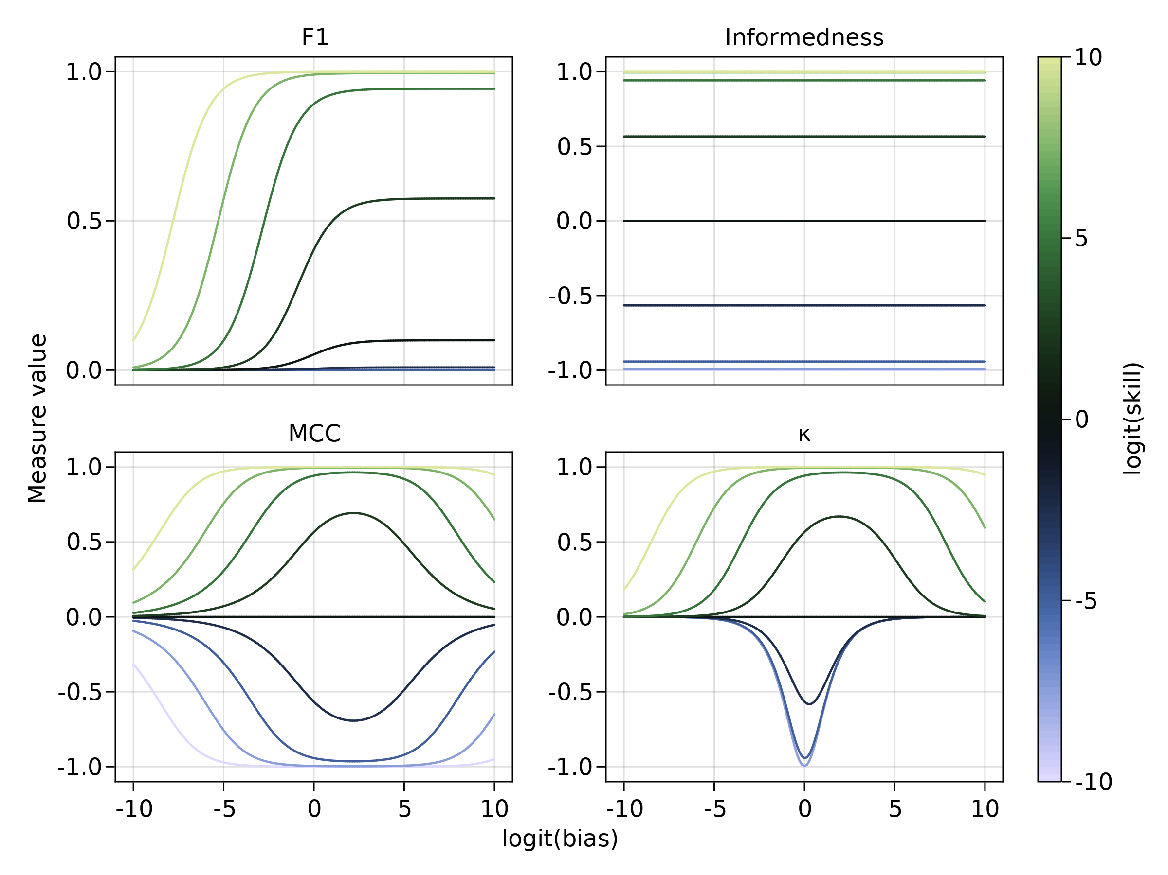
Figure 1: Consequences of changing the classifier skills () and bias () for a connectance , on , informedness, MCC, and . Accuracy increases with skill, but also increases when the bias tends towards estimating fewer interactions (this follows from the derivations in the text, not shown in the figure). Interestingly, responds as expected to skill (being negative whenever ), and peaks for values of ; nevertheless, the value of bias for which is maximized in not , but instead increases with classifier skill. In other words, at equal skill, maximizing would lead to select a more biased classifier.
In fig. 1, we show that none of the four measures satisfy all the considerations at once: increases with skill, and increases monotonously with bias; this is because does not account for true negatives, and the increase in positive detection masks the over-prediction of interactions. Informedness varies with skill, reaching 0 for a no-skill classifier, but is entirely unsensitive to bias. Both MCC and have the same behavior, whereby they increase with skill. peaks at increasing values of bias for increasing skill, i.e. is likely to lead to the selection of a classifier that over-predicts interactions. By contract, MCC peaks at the same value, regardless of skill, but this value is not : unless at very high classifier skill, MCC risks leading to a model that over-predicts interactions. In fig. 2, we show that all measures except give a value of 0 for a no-skill classifier, and are forced towars their correct maximal value when skill changes (i.e. a more connected networks will have higher values for a skilled classifierd, and lower values for a classifier making mostly mistakes).
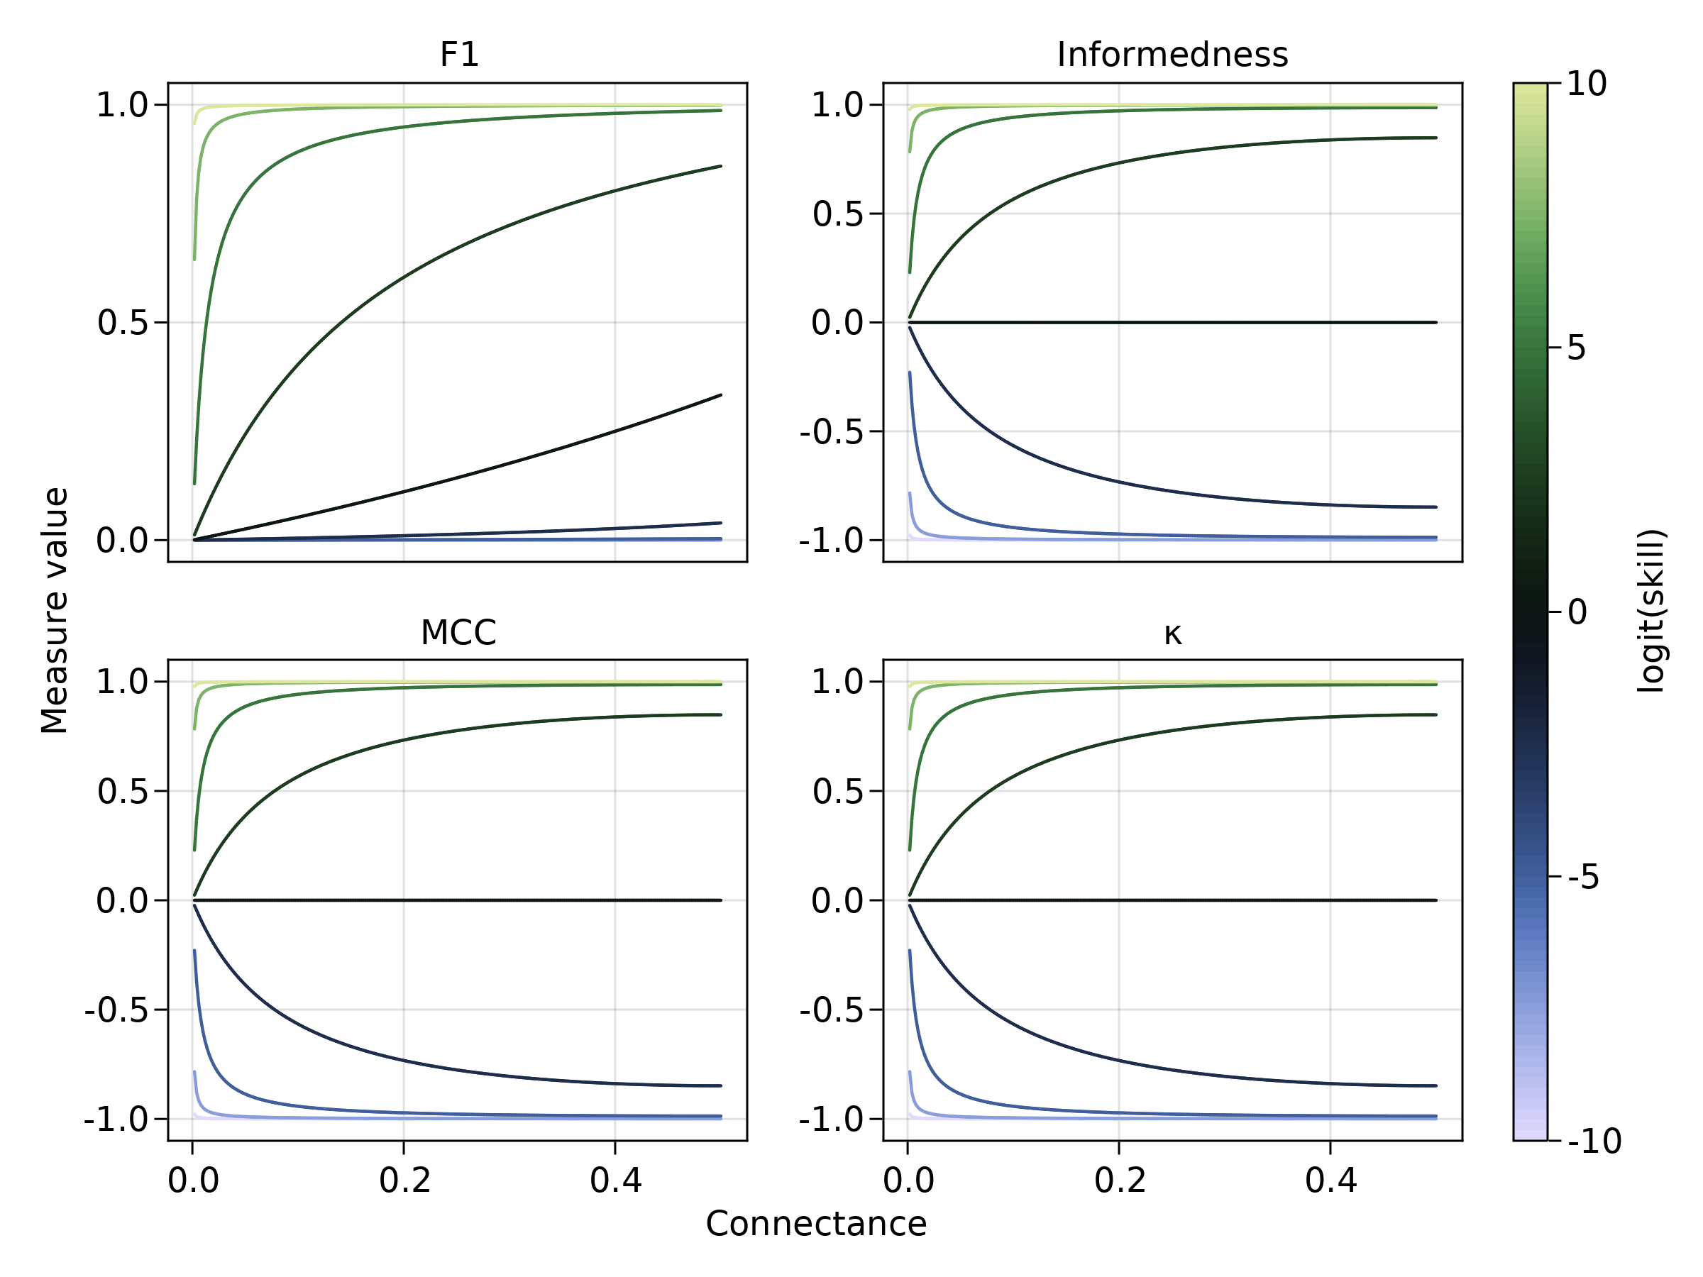
Figure 2: As in fig. 1, consequences of changing connectance for different levels of classifier skill, assuming no classifier bias. Informedness, , and MCC do increase with connectance, but only when the classifier is not no-skill; by way of contrast, a more connected network will give a higher value even with a no-skill classifier.
These two analyses point to the following recommendations: MCC is indeed more appropriate than , as although sensitive to bias, it is sensitive in a consistent way. Informedness is appropriate at discriminating between different skills, but confounded by bias. As both of these measures bring valuable information on the model behavior, we will retain them for future analyses. is increasing with bias, and should not be prioritized to evalue the performance of the model. The discussion of sensitivity to bias should come with a domain-specific caveat: although it is likely that interactions documented in ecological networks are correct, a lot of non-interactions are simply unobserved; as predictive models are used for data-inflation (i.e. the prediction of new interactions), it is not necessarily a bad thing in practice to select models that predict more interactions than the original dataset, because the original dataset misses some interactions. Furthermore, the weight of positive interactions could be adjusted if some information about the extent of undersampling exists (e.g. Branco et al., 2015). In a recent large-scale imputation of interactions in the mammal-virus networks, Poisot, Ouellet, et al. (2021) for example estimated that 93% of interactions are yet to be documented.

Numerical experiments on training strategy
In the following section, we will generate random bipartite networks, and train four binary classifiers (as well as an ensemble model using the sum of ranged outputs from the component models) on 50% of the interaction data. In practice, testing usually uses 70% of the total data; for ecological networks, where interactions are sparse and the number of species is low, this may not be the best solution, as the testing set becomes constrained not by the proportion of interactions, but by their number. Preliminary experiments using different splits revealed no qualitative change in the results. Networks are generated by picking a random infectiousness trait for 100 species (from a beta distribution distribution), and a resistance trait for 100 species (from distribution). There is an interaction between and when , where is a constant regulating the connectance of the network (visual exploration of the parameters show that there is an almost 1:1 relationship between and connectance), and varies uniformly in . This model gives fully interval networks that are close analogues to the bacteria–phage model of Weitz et al. (2005), with both a modular structure and a non-uniform degree distribution. This dataset is easy for almost any algorithm to learn: when trained with features to predict the interactions between and , all four models presented below were able to reach almost perfect predictions all the time (data not presented here) – this is in part because the rule (there is maximum value of the distance between traits for which there is an interaction) is fixed for all interactions, and any method able to learn non-linear relationships should infer it without issues. In order to make the problem more difficult to solve, we use as a feature vector (i.e. the traits on which the models are trained), and therefore the models will have to uncover that the rule for interaction is . The models therefore all have the following form, where is an interaction from species to species :

The training sample is composed of a random pick of up to 50% of the possible entries in the network, i.e. . Out of these interactions, we pick a proportion (the training set balance) to be positive, so that the training set has interactions, and non-interactions. We vary uniformly in . This allows to evaluate how the measures of binary classification performance respond to artificially rebalanced dataset for a given network connectance. The rest of the dataset is used as a testing set, on which all further measures are calculated. Note that although the training set is balanced arbitrarily, the testing set is assembled so that it has the exact connectance of the entire network; this ensures that the model is evaluated under the class imbalance where the predictions will be made, which represents a more meaningful evaluation. Furthermore, to avoid artifacts due to different sizes of the training and testing set within a single network, the number of entries in both sets are equal. Note also that although the simulated networks are bipartite, the algorithms have no “knowledge” of the network structure, and simply look at pairs of species; therefore, the approach outlined here would also work for unipartite networks.
The dataset used for numerical experiments is composed of a grid of 35 values of connectance (from 0.011 to 0.5) and 35 values of (from 0.02 to 0.98); for each pair of values, 500 networks are generated and predicted. For each network, we train four machines: a trait-based k-NN (e.g. Desjardins-Proulx et al., 2017), a regression tree, a regression random forest, and a boosted regression tree; the later three methods are turned into classifiers using thresholding, which oftentimes provides better results than classification when faced with class imbalance (Hong et al., 2016). Following results from Pichler et al. (2020), linear models have not been considered (in any way, the relationship in the simulated networks is non-linear). The point of these numerical experiments is not to recommend the best model (this is likely problem-specific), but to highlight a series of recommendations that would work for supervised learning tasks. All models were taken from the MLJ.jl package (Blaom et al., 2020; Blaom & Vollmer, 2020) in Julia 1.7 (Bezanson et al., 2017). All machines use the default parameterization; this is an obvious deviation from best practices, as the hyperparameters of any machine require training before its application on a real dataset. As we use 612500 such datasets, this would require over 2 millions unique instances of tweaking the hyperparameters, which is prohibitive from a computing time point of view. An important thing to keep in mind is that the problem we simulate has been designed to be simple to solve: we expect all machines with sensible default parameters to fare well — the results presented in the later sections show that this assumption is warranted, and we further checked that the models do not overfit by ensuring that there is never more than 5% of difference between the accuracy on the training and testing sets. All machines return a quantitative prediction, usually (but not necessarily) in , which is proportional (but not necessarily linearly) to the probability of an interaction between and . The ROC-AUC and PR-AUC (and therefore the thresholds) can be measured by integrating over the domain of the values return by each machine, but in order to make the average-based ensemble model more meaningful, all predictions are expressed in .
In order to pick the best confusion matrix for a given trained machine, we performed a thresholding approach using 500 steps on predictions from the testing set, and picking the threshold that maximized Youden’s informedness. During the thresholding step, we measured the area under the receiver operating characteristic (ROC-AUC) and precision-recall (PR-AUC) curves, as measures of overall performance over the range of returned values. We report the ROC-AUC and PR-AUC, as well as a suite of other measures as introduced in the next section, for the best threshold. The ensemble model was generated by summing the predictions of all component models on the testing set (ranged in ), then put through the same thresholding process. The complete code to run the simulations is available at 10.17605/OSF.IO/JKEWD.
After the simulations were completed, we removed all runs (i.e. triples of model, , and ) for which at least one of the following conditions was met: the accuracy was 0, the true positive or true negative rates were 0, the connectance was larger than 0.25. This removes both the obviously failed model runs, and the networks that are more densely connected compared to the connectance of empirical food webs (and are therefore less difficult to predict, being less imbalanced; preliminary analyses of data with a connectance larger than 0.3 revealed that all machines reached consistently high performance).

Effect of training set balance on performance
In fig. 3, we present the response of two thresholding measures (PR-AUC and ROC-AUC) and two ranking measures (Informedness and MCC) to a grid of 35 values of training set balance, and 35 values of connectance, for the four component models as well as the ensemble. ROC-AUC is always high, and does not vary with training set balance. On the other hand, PR-AUC shows very strong responses, increasing with training set balance. It is notable here that two classifiers that seemed to be performing well (Decision Tree and Random Forest) based on their MCC are not able to reach a high PR-AUC even at higher connectances. All models reached a higher performance on more connected networks, and using more balanced training sets. In all cases, informedness was extremely high, which is an expected consequence of the fact that this is the value we optimized to determine the cutoff. MCC increased with training set balance, although this increase became less steep with increasing connectance. Three of the models (kNN, decision tree, and random forest) only increased their PR-AUC sharply when the training set was heavily imbalanced towards more interactions. Interestingly, the ensemble almost always outclassed its component models. For larger connectances (less difficult networks to predict, as they are more balanced), MCC and informedness stared decreasing when the training set bias got too close to one, suggesting that a training set balance of 0.5 may often be appropriate if these measures are the one to optimize.
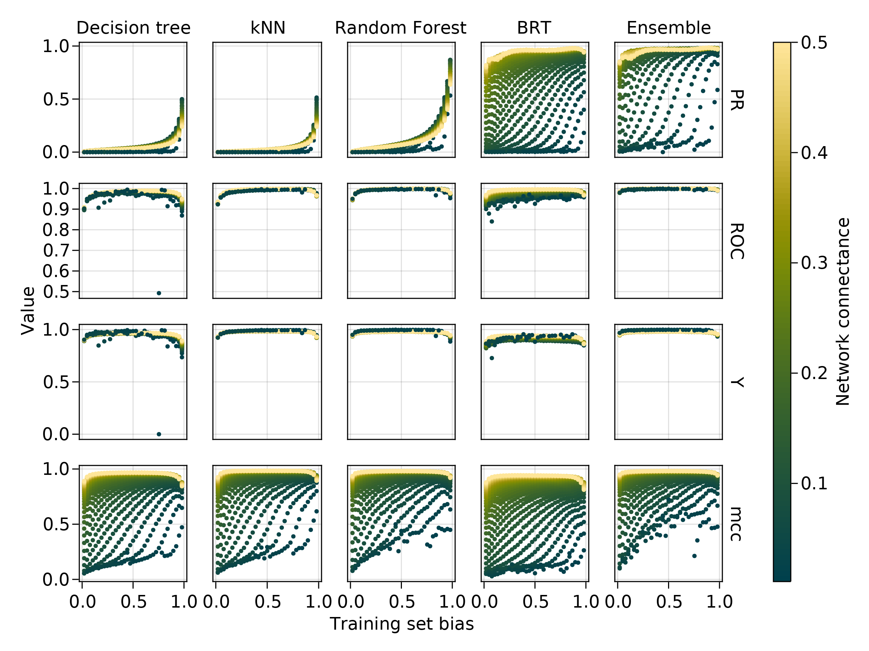
Figure 3: Response of MCC, Informedness, ROC-AUC, and PR-AUC to changes in the training set balance (on the axis) for a series of increasing connectances (color). All of these values approach 1 for a good model, but should be lower when the prediction is more difficult. Informedness is consistently high, and by contrast, MCC increases with additional training set balance. Across all models, training on a more connected network is easier. ROC-AUC is consistently high, and therefore not properly able to separate good from poor classifiers. On the other hand, PR-AUC responds to changes in the training set.
Based on the results presented in fig. 3, it seems that informedness and ROC-AUC are not necessarily able to discriminate between good and bad classifiers (although this result may be an artifact for informedness, as it has been optimized when thresholding). On the other hand, MCC and PR-AUC show a strong response to training set balance, and may therefore be more useful at model comparison.

Required amount of positives to get the best performance
The previous results revealed that the measure of classification performance responds both to the bias in the training set and to the connectance of the network; from a practical point of view, assembling a training set requires one to withhold positive information, which in ecological networks are very scarce (and typically more valuable than negatives, on which there is a doubt). For this reason, across all values of connectance, we measured the training set balance that maximized a series of performance measures. When this value is high, the training set needs to skew more positive in order to get a performant model; when this value is about 0.5, the training set needs to be artificially balanced to optimize the model performance. These results are presented in fig. 4.
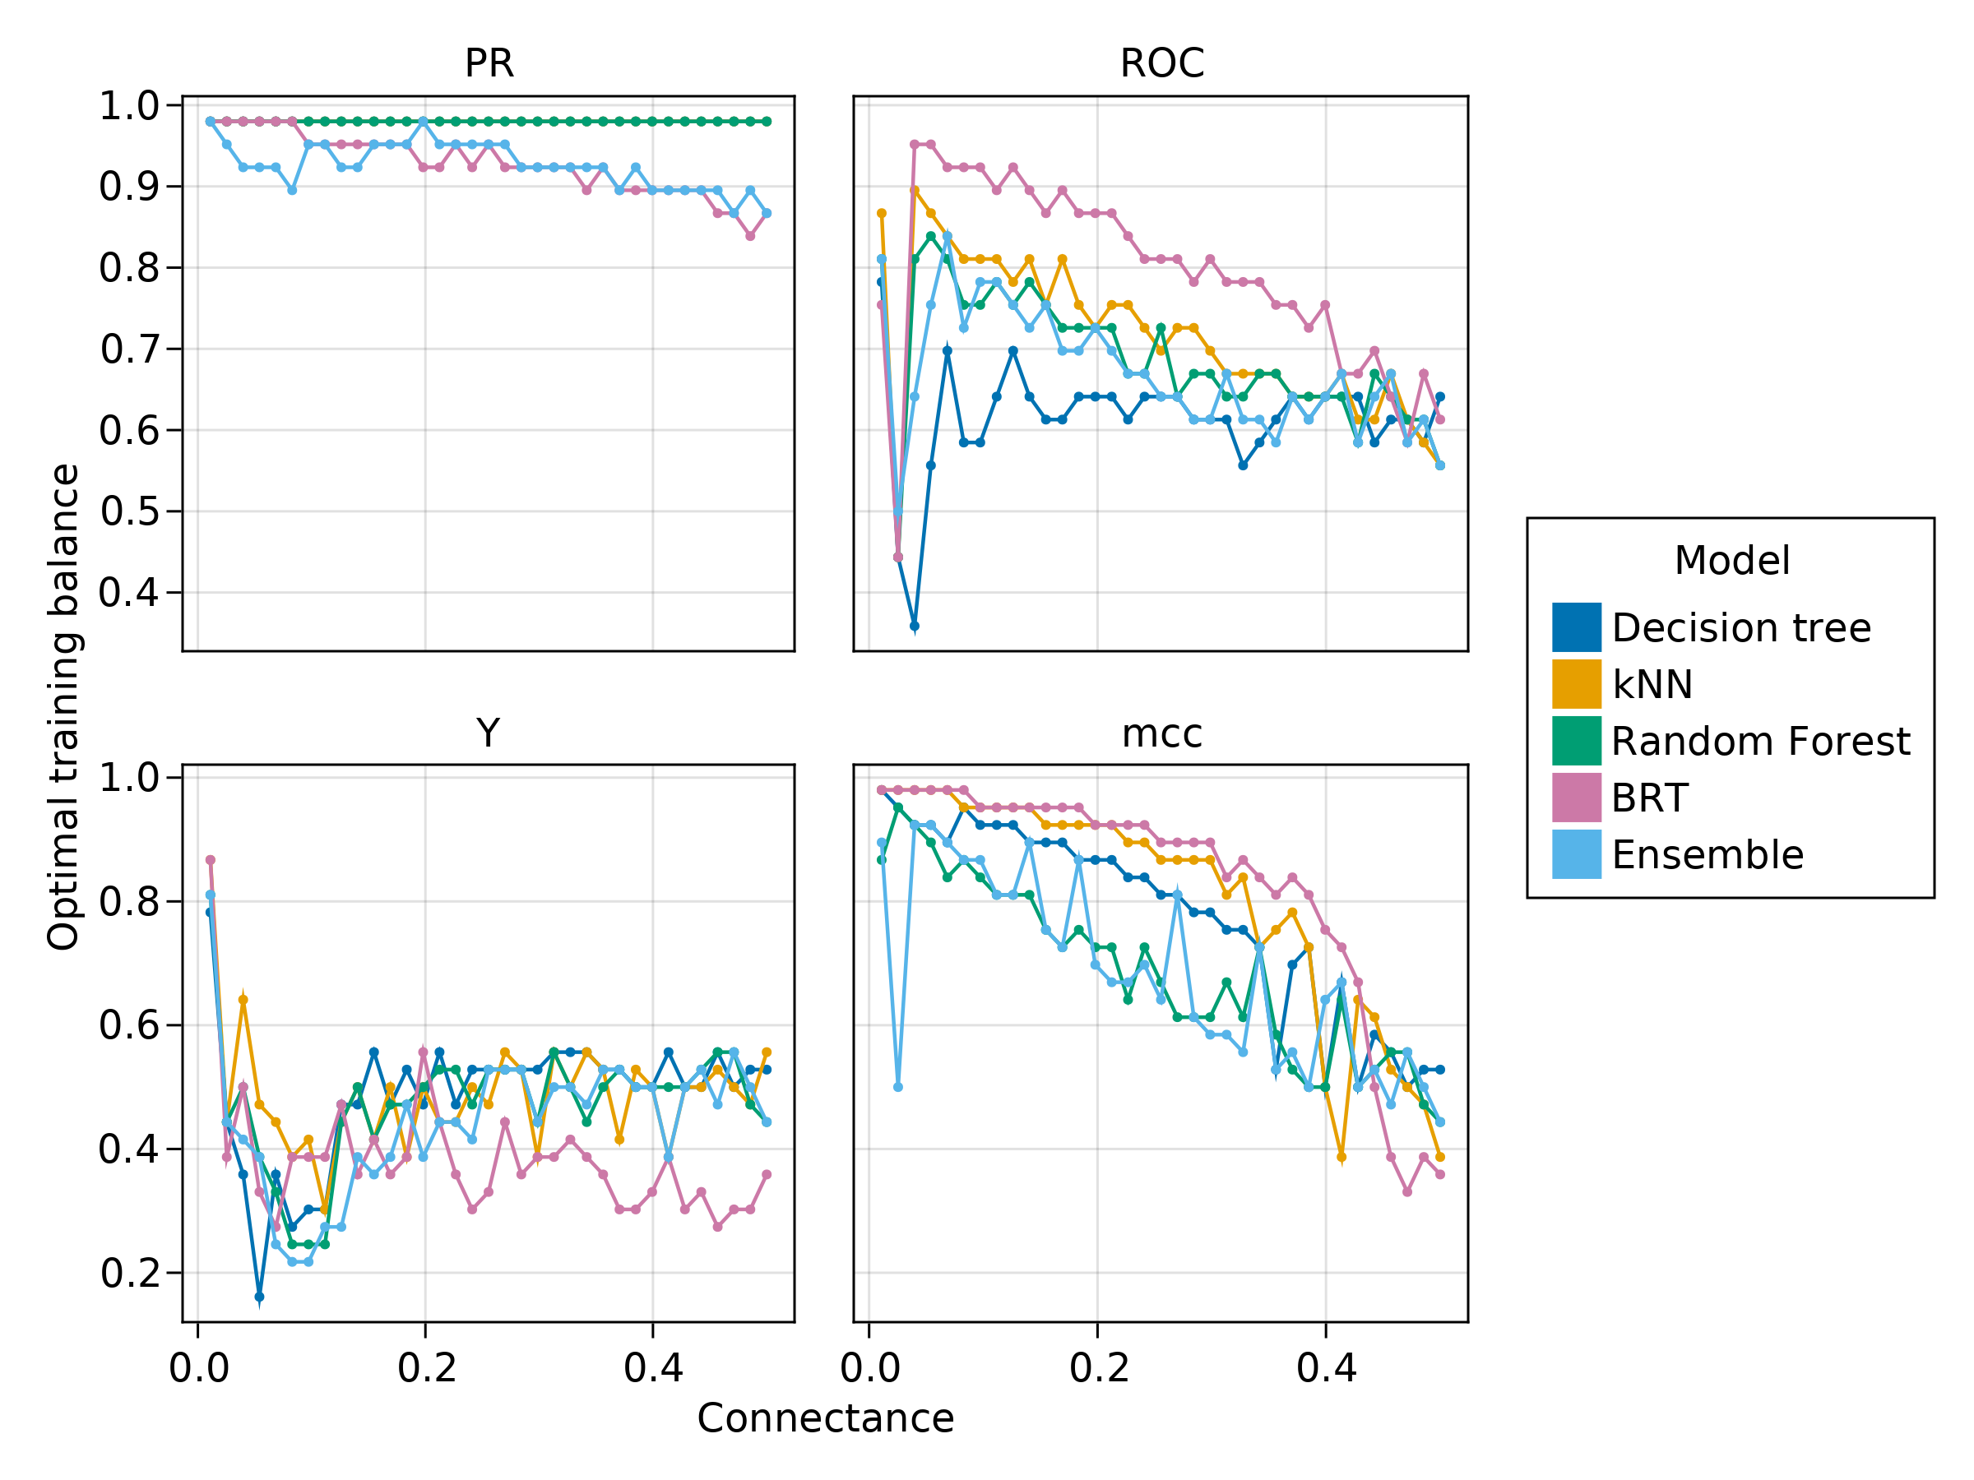
Figure 4: Value of the optimal training set balance for the different models and measures evaluated here, over a range of connectances. Informedness was reliably maximized for balanced training sets, and kept this behavior across models. For other measures, larger connectances in the true network allowed lower biases in the training set. In a large number of cases, “over-correcting” by having training sets with more than half instances representing interactions would maximize the values of the model performance measures.
The more “optimistic” measures (ROC-AUC and informedness) required a biasing of the dataset from about 0.4 to 0.75 to be maximized, with the amount of bias required decreasing only slightly with the connectance of the original network. MCC and PR-AUC required values of training set balance from 0.75 to almost 1 to be optimized, which is in line with the results of the previous section, i.e. they are more stringent tests of model performance. These results suggest that learning from a dataset with very low connectance can be a different task than for more connected networks: it becomes increasingly important to capture the mechanisms that make an interaction exist, and therefore having a slightly more biased training dataset might be beneficial. As connectance increases, the need for biased training sets is less prominent, as learning the rules for which interactions do not exist starts gaining importance.
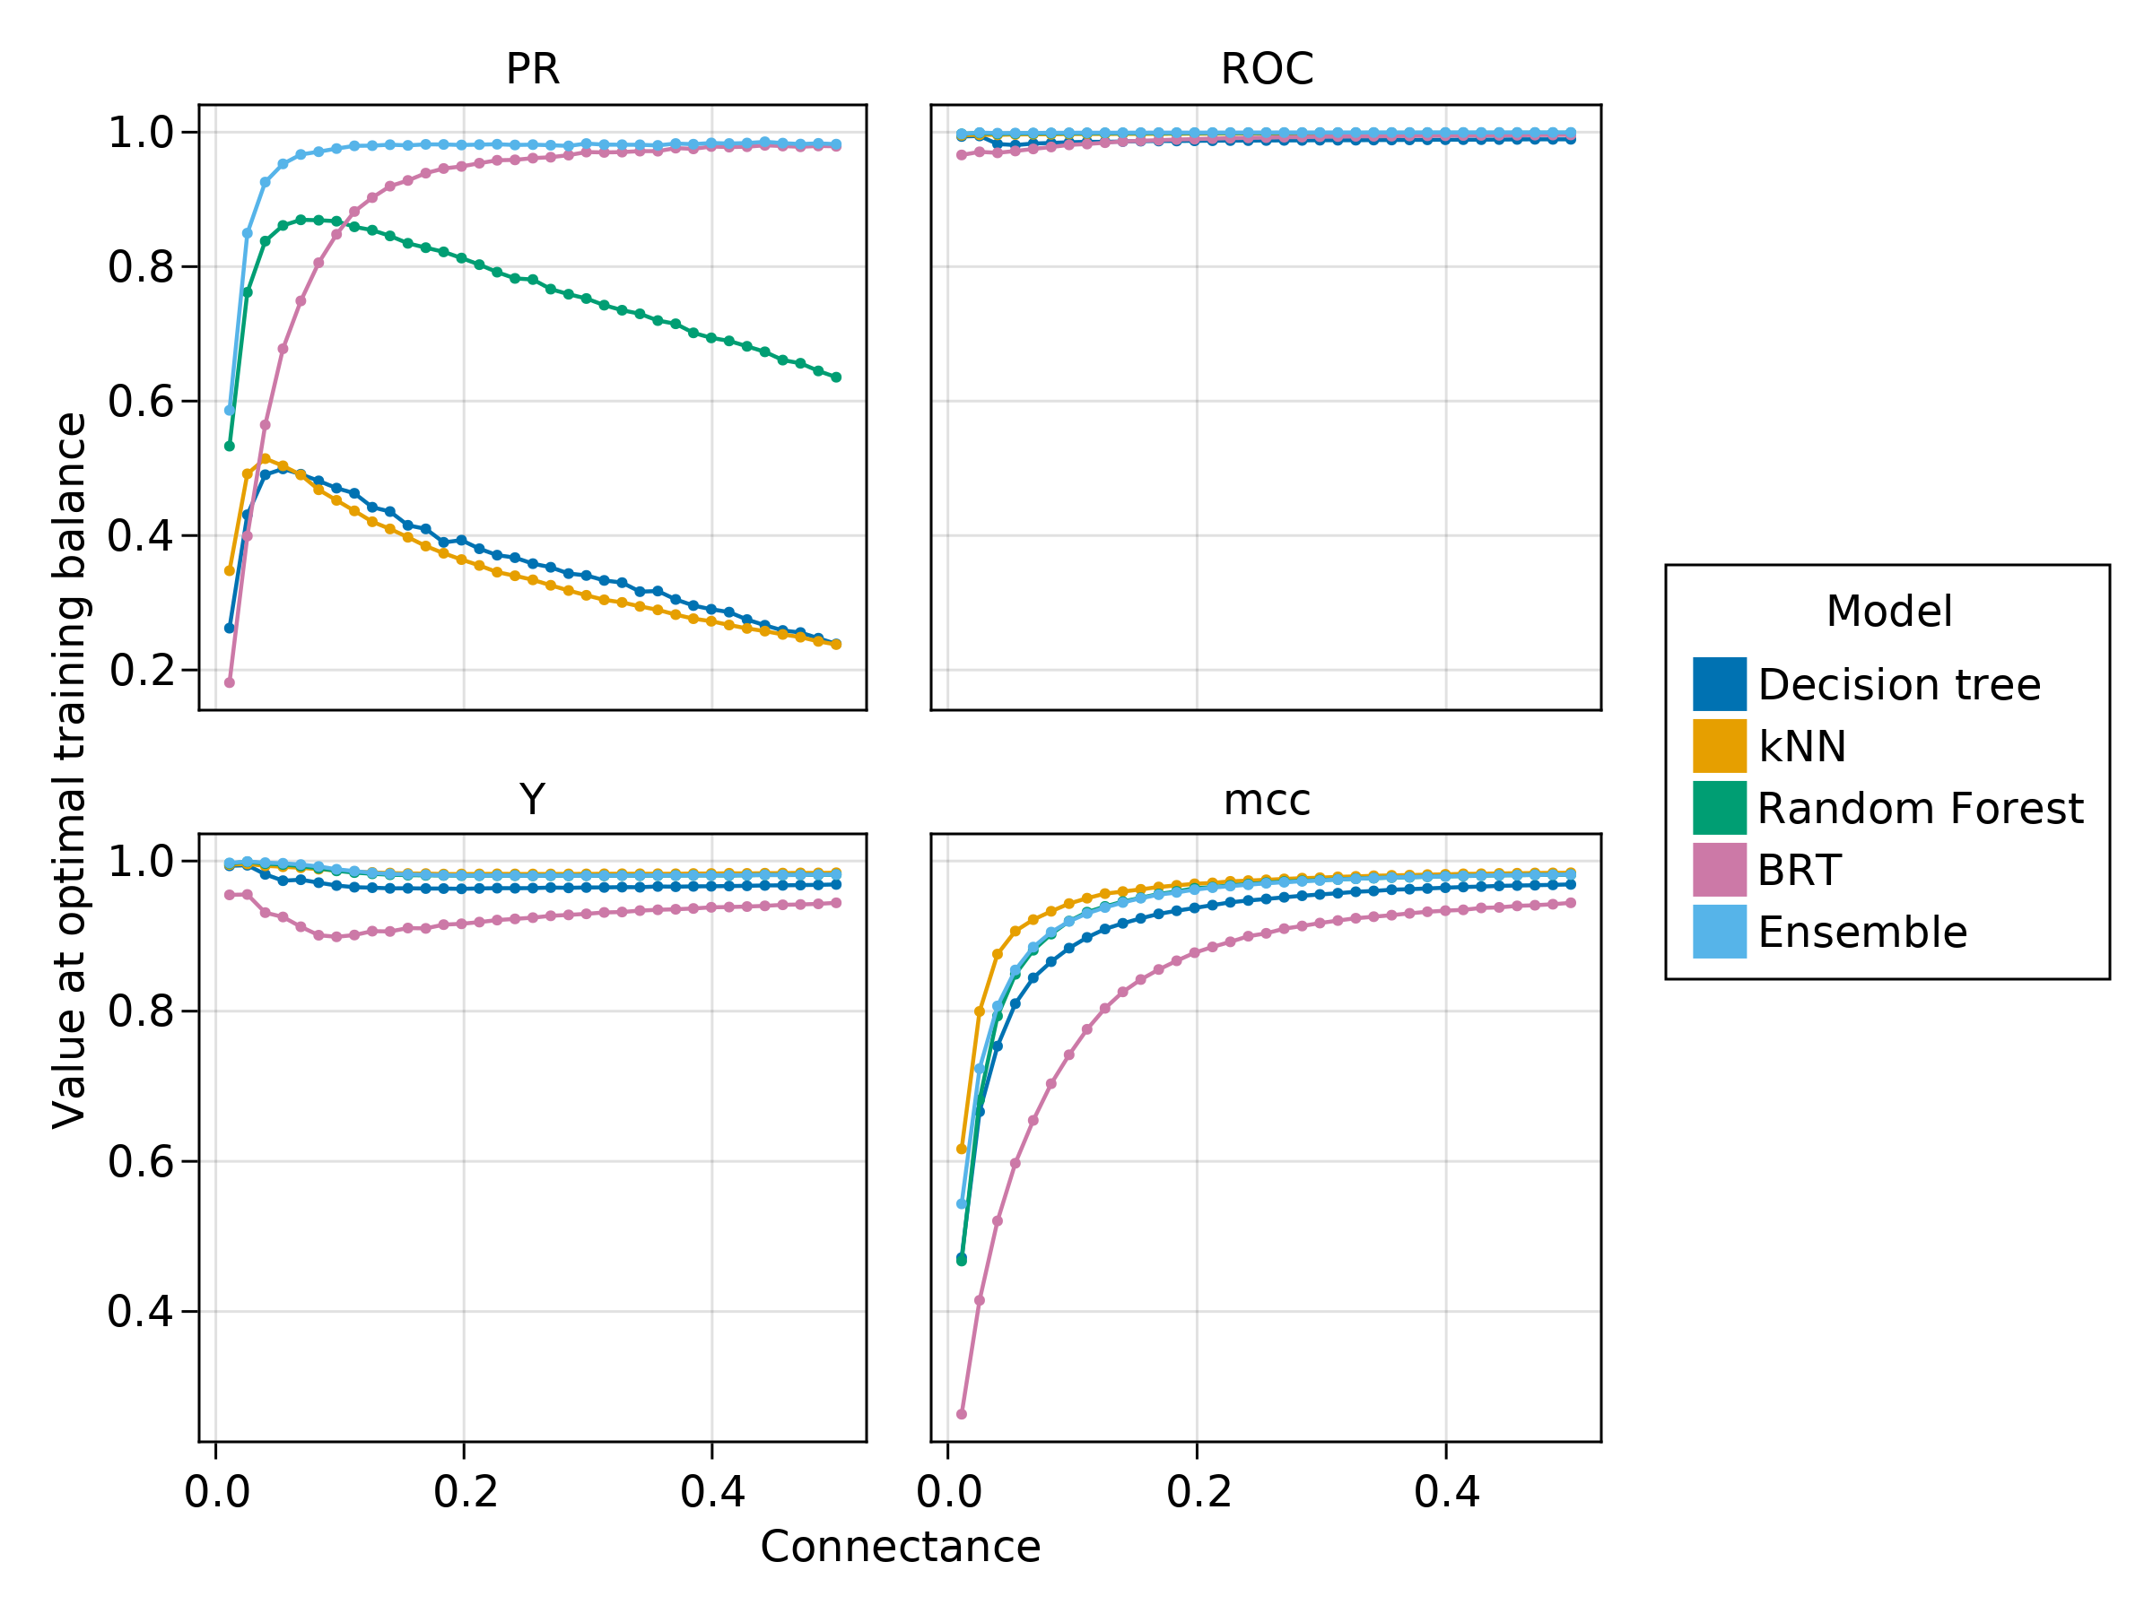
Figure 5: When trained on their optimally biased training set, most models were able to maximize their performance; this is not true when measuring PR-AUC for decision tree, k-NN, and to a lower extent RF. The ensemble had a consistently high performance despite incorporating low-performing models.
When trained at their optimal training set balance, connectance still had a significant impact on the performance of some machines (fig. 5). Notably, Decision Tree, and k-NN, as well as Random forest to a lower extent, had low values of PR-AUC. In all cases, the Boosted Regression Tree was reaching very good predictions (especially for connectances larger than 0.1), and the ensemble was almost always scoring perfectly. This suggests that all the models are biased in different ways, and that the averaging in the ensemble is able to correct these biases. We do not expect this last result to have any generality, and provide a discussion of a recent example in which the ensemble was performing worse than its components models.

Do better classification accuracy result in more realistic networks?
In this last section, we generate a network using the same model as before, with species, a connectance of (), and a training set balance of , as fig. 4 suggests this is the optimal training set balance for this range of connectance. The prediction made on the complete dataset is presented in fig. 6.
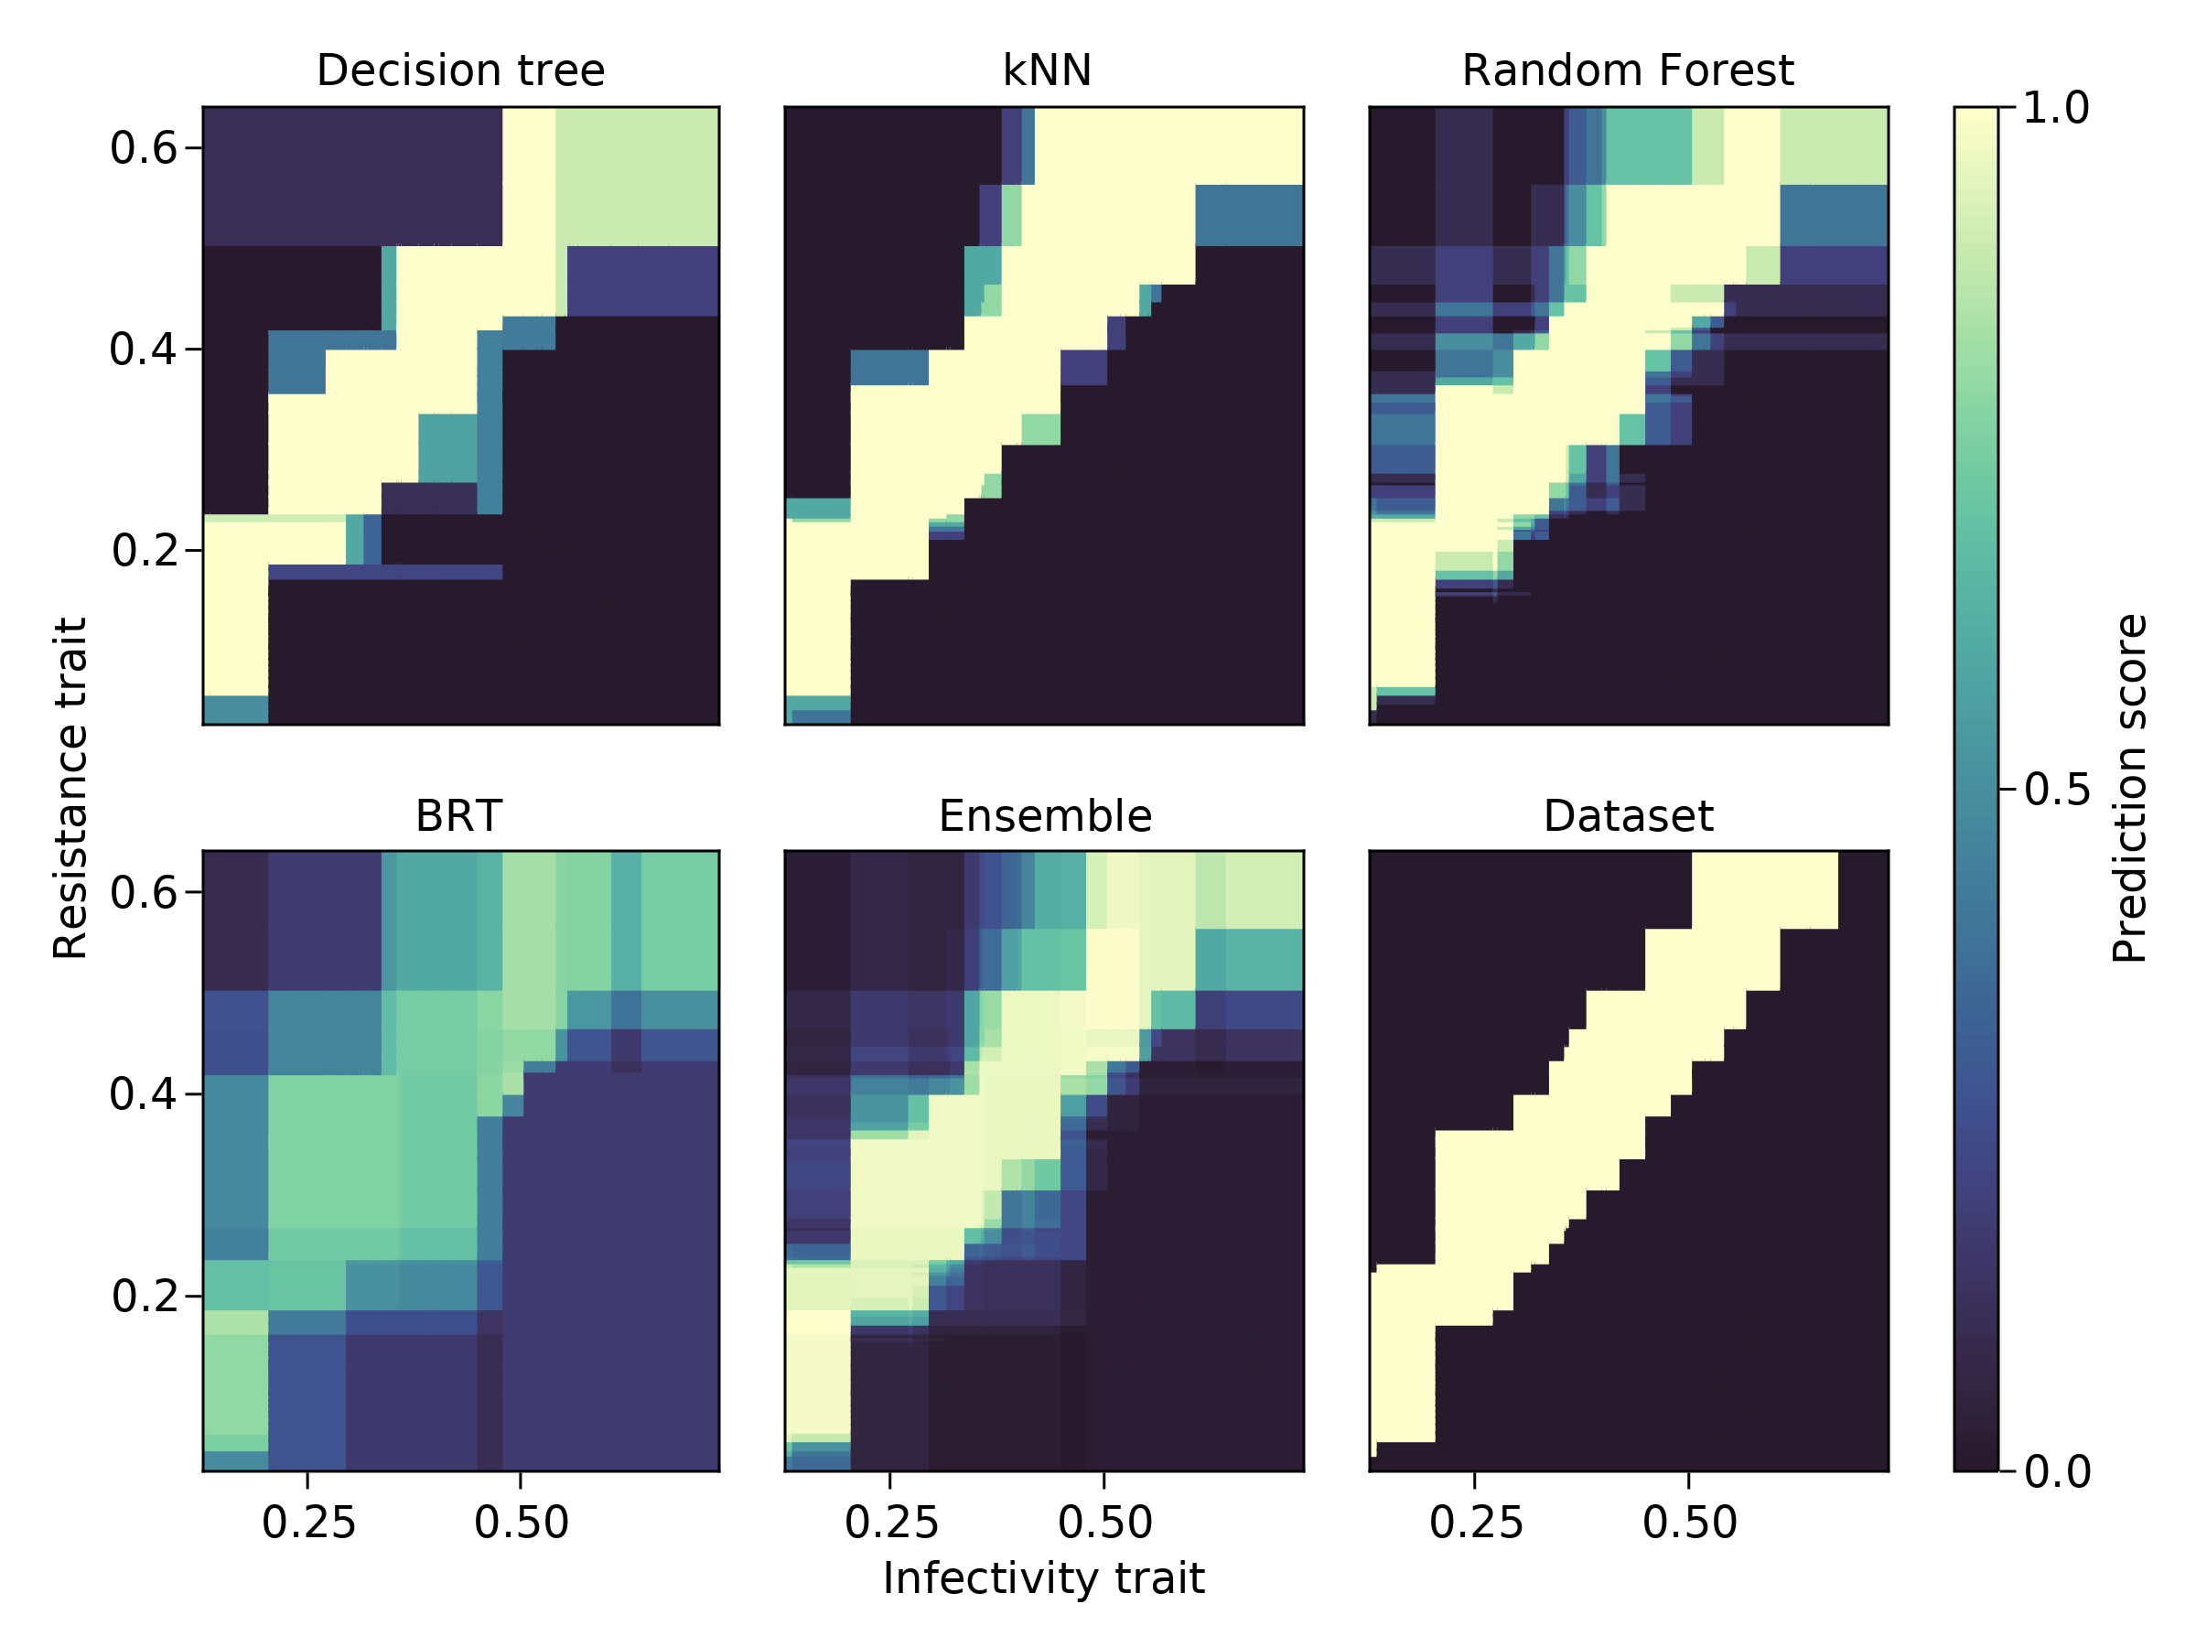
Figure 6: Visualisation of the raw (un-thresholded) models predictions for one instance of a network prediction problem (shown in the “Dataset” panel). Increasing the value of the parameter would make the diagonal structure “broader”, leading to more interactions. A visual inspection of the results is important, as it highlights how some models can “miss” parts of the network; by combining them in an ensemble, these gaps compensate one another, and lead (in this case) to a better prediction.
The trained models were then thresholded (again by optimising informedness), and their predictions transformed back into networks for analysis; specifically, we measured the connectance, nestedness [; Bastolla et al. (2009)], modularity [; Barber (2007)], asymmetry [; Delmas et al. (2018)], and Jaccard network dissimilarity (Canard et al., 2014). This process was repeated 250 times, and the results are presented in tbl. 1. The k-NN model is an interesting instance here: it produces the network that looks the most like the original dataset, despite having the lowest PR-AUC, suggesting it hits high recall at the cost of low precision. The ensemble was able to reach a very high PR-AUC (and a very high ROC-AUC), which translated into more accurate reconstructions of the structure of the network (with the exception of modulairty, which is underestimated by ). This result bears elaborating. Measures of model performance capture how much of the interactions and non-interactions are correctly identified. As long as these predictions are not perfect, some interactions will be predicted at the “wrong” position in the network; these measures cannot describe the structural effect of these mistakes. On the other hand, measures of network structure can have the same value with interactions that fall at drastically different positions; this is in part because a lot of these measures covary with connectance, and in part because as long as these values are not 0 or their respective maximum, there is a large number of network configurations that can have the same value. That ROC-AUC is consistently larger than PR-AUC may be a case of this measure masking models that are not, individually, strong predictors (Jeni et al., 2013). In this specif example, the combination of individually “adequate” models resulted in an extremely strong ensemble, suggesting that the correct prediction of interactions (as measured by MCC, Inf., ROC-AUC, and PR-AUC) and network properties is indeed a feasible task under appropriately hyper-parameterized models.
Table 1: Values of four performance metrics, and five network structure metrics, for 500 independent predictions similar to the ones presented in fig. 6. The values in bold indicate the best value for each column (including ties). Because the values have been rounded, values of 1.0 for the ROC-AUC column indicate an average .
Model | MCC | Inf. | ROC-AUC | PR-AUC | Conn. |  |  |  | Jaccard
Decision tree | 0.59 | 0.94 | 0.97 | 0.04 | 0.17 | 0.64 | 0.37 | 0.42 | 0.1
BRT | 0.46 | 0.91 | 0.97 | 0.36 | 0.2 | 0.78 | 0.29 | 0.41 | 0.19
Random Forest | 0.72 | 0.98 | 0.99 | 0.1 | 0.16 | 0.61 | 0.38 | 0.42 | 0.06
k-NN | 0.71 | 0.98 | 0.99 | 0.02 | 0.16 | 0.61 | 0.39 | 0.42 | 0.06
Ensemble | 0.74 | 0.98 | 1.0 | 0.79 | 0.16 | 0.61 | 0.38 | 0.42 | 0.06
Data |  |  |  |  | 0.16 | 0.56 | 0.41 | 0.42 | 0.0

Guidelines for the assessment of network predictive models
We establish that due to the low prevalence of interactions, even poor classifiers applied to food web data will reach a high accuracy; this is because the measure is dominated by the accidentally correct predictions of negatives. On simulated confusion matrices with ranges of imbalance that are credible for ecological networks, MCC had the most desirable behavior, and informedness is a linear measure of classifier skill. By performing simulations with four models and an ensemble, we show that informedness and ROC-AUC are consistently high on network data, whereas MCC and PR-AUC are more accurate measures of the effective performance of the classifier. Finally, by measuring the structure of predicted networks, we highlight an interesting paradox: the models with the best performance measures are not necessarilly the models with the closest reconstructed network structure. We discuss these results in the context of establishing guidelines for the prediction of ecological interactions.
It is noteworthy that the ensemble model was systematically better than the component models. We do not expect that ensembles will always be better than single models. Networks with different structures than the one we simulated here may respond in different ways, especially if the rules are fuzzier than the simple rule we used here. In a recent multi-model comparison involving supervised and unsupervised learning, Becker et al. (2022) found that the ensemble was not the best model, and was specifically under-performing compared to models using biological traits. This may be because the dataset of Becker et al. (2022) was known to be under-sampled, and so the network alone contained less information than the combination of the network and species traits. There is no general conclusion to draw from either these results or ours, besides reinforcing the need to be pragmatic about which models should be included in the ensemble, and whether to use an ensemble at all. In a sense, the surprising performance of the ensemble model should form the basis of the first broad recommendation: optimal training set balance and its interaction with connectance and the specific binary classifier used is, in a sense, an hyperparameter that should be assessed following the approach outlined in this manuscript. The distribution of results in fig. 4 and fig. 5 show that there are variations around the trend, and multiple models should probably be trained on their “optimal” training/testing set, as opposed to the same ones.
The results presented here highlight an interesting paradox: although the k-NN model was ultimately able to get a correct estimate of network structure (see tbl. 1 and fig. 6), it ultimately remains a poor classifier, as evidenced by its low PR-AUC. This suggests that the goal of predicting interactions and predicting networks may not always be solvable in the same way – of course a perfect classifier of interactions would make a perfect network prediction; indeed, the best scoring predictor of interactions (the ensemble model) had the best prediction of network structure. The tasks of predicting networks structure and of predicting interactions within networks are essentially two different ones. For some applications (e.g. comparison of network structure across gradients), one may care more about a robust estimate of the structure, at the cost at putting some interactions at the wrong place. For other applications (e.g. identifying pairs of interacting species), one may conversely care more about getting as many pairs right, even though the mistakes accumulate in the form of a slightly worse estimate of network structure. How these two approaches can be reconciled is something to evaluate on a case-by-case basis, especially since there is no guarantee that an ensemble model will always be the most precise one. Despite this apparent tension at the heart of the predictive exercise, we can use the results presented here to suggest a number of guidelines.
First, because we have more trust in reported interactions than in reported absences of interactions (which are overwhelmingly pseudo-absences), we can draw on previous literature to recommend informedness as a measure to decide on a threshold for binary classification (Chicco et al., 2021); this being said, because informedness is insensitive to bias (although it is a linear measure of skill), the overall model performance is better evaluated through the use of MCC (figs. 4, 5). Because is monotonously sensitive to classifier bias (fig. 1) and network connectance (fig. 2), MCC should be prefered as a measure of model evaluation and comparison. When dealing with multiple models, we therefore suggest to find the optimal threshold using informedness, and to pick the best model using MCC (assuming one does not want to use an ensemble model).
Second, accuracy alone should not be the main measure of model performance, but rather an expectation of how well the model should behave given the class balance in the set on which predictions are made; this is because, as derived earlier, the expected accuracy for a no-skill no-bias classifier is (where is the class balance), which will most often be large. This pitfall is notably illustrated in a recent food-web model (Caron et al., 2022) wherein the authors, using a training set of with only 100 positive interactions (representing 0.1% of the total interactions), reached a good accuracy. Reporting a good accuracy is not informative, especially when accuracy isn’t (i) compared to the baseline expected value under the given class balance, and (ii) interpreted in the context of a measure that is not sensitive to the chance prediction of many negatives (like MCC).
Third, because the PR-AUC responds more to network connectance (fig. 5) and training set imbalance (fig. 4) than ROC-AUC, it should be used as a measure of model performance over the ROC-AUC. This is not to say that ROC-AUC should be discarded (in fact, a low ROC-AUC is undoubtedly a sign of an issue with the model), but that its interpretation should be guided by the PR-AUC value. Specifically, a high ROC-AUC is not informative, as it can be associated to a low PR-AUC (see e.g. Random Forest in tbl. 1) This again echoes recommendations from other fields (Jeni et al., 2013; Saito & Rehmsmeier, 2015). We therefore expect to see high ROC-AUC values, and then to pick the model that maximizes the PR-AUC value. Taken together with the previous two guidelines, we strongly encourage to (i) ensure that accuracy and ROC-AUC are high (in the case of accuracy, higher than expected under no-skill no-bias situation), and (ii) to discuss the performance of the model in terms of the most discriminant measures, i.e. PR-AUC and MCC.
Finally, network connectance (i.e. the empirical class imbalance) should inform the composition of the training and testing set, because it is an ecologically relevant value. In the approach outlined here, we treat the class imbalance of the training set as an hyper-parameter, but test the model on a set that has the same class imbalance as the actual dataset. This is an important distinction, as it ensure that the prediction environment matches the testing environment (as we cannot manipulate the connectance of the empirical dataset on which the predictions will be made), and so the values measured on the testing set (or validation set if the data volume allows one to exists) can be directly compared to the values for the actual prediction. A striking result from fig. 4 is that Informedness was almost always maximal at 50/50 balance (regardless of connectance), whereas MCC required more positives to be maximized when connectance increases, matching the idea that it is a more stringent measure of performance. This has an important consequence in ecological networks, for which the pool of positive cases (interactions) to draw from is typically small: the most parsimonious measure (i.e. the one requiring to discard the least amount of interactions to train the model) will give the best validation potential, and in this light is very likely informedness [maximizing informedness is, in fact, the generally accepted default for imbalanced classification regardless of the problem domain; Schisterman et al. (2005)]. This last result further strengthens the assumption that the amount of bias is an hyper-parameter that must be fine-tuned, as using the wrong bias can lead to models with lower performance; for this reason, it makes sense to not train all models on the same training/testing set, but rather to optimize the set composition for each of them.
One key element for real-life data that can make the prediction exercise more tractable is that some interactions can safely be assumed to be impossible; indeed, a lot of networks can be reasonably well described using a stochastic block model (e.g. Xie et al., 2017). In ecological networks, this can be due to spatial constraints (Valdovinos, 2019), or to the long-standing knowledge that some links are “forbidden” due to traits (Olesen et al., 2011) or abundances (Canard et al., 2014). The matching rules (Olito & Fox, 2015; Strona & Veech, 2017) can be incorporated in the model either by adding compatibility traits, or by only training the model on pairs of species that are not likely to be forbidden links. Knowledge of true negative interactions could be propagated in training/testing sets that have true negatives, and in this situation, it may be possible to use the more usual 70/30 split for training/testing folds as the need to protect against potential unbalance is lowered. Besides forbidden links, a real-life case that may arise is multi-interaction or multi-layer networks (Pilosof et al., 2017). These can be studied using the same general approach outlined here, either by assuming that pairs of species can interact in more than one way (wherein one would train a model for each type of interaction, based on the relevant predictors), or by assuming that pairs of species can only have one type of interaction (wherein this becomes a multi-label classification problem).
Acknowledgements: We acknowledge that this study was conducted on land within the traditional unceded territory of the Saint Lawrence Iroquoian, Anishinabewaki, Mohawk, Huron-Wendat, and Omàmiwininiwak nations. We thank Colin J. Carlson, Michael D. Catchen, Giulio Valentino Dalla Riva, and Tanya Strydom for inputs on earlier versions of this manuscript. This research was enabled in part by support provided by Calcul Québec (www.calculquebec.ca) through the Narval general purpose cluster. TP is supported by the Fondation Courtois, a NSERC Discovery Grant and Discovery Acceleration Supplement, by funding to the Viral Emergence Research Initiative (VERENA) consortium including NSF BII 2021909, and by a grant from the Institut de Valorisation des Données (IVADO).

References
Allouche, O., Tsoar, A., & Kadmon, R. (2006). Assessing the accuracy of species distribution models: Prevalence, kappa and the true skill statistic (TSS). Journal of Applied Ecology, 43(6), 1223–1232. https://doi.org/10.1111/j.1365-2664.2006.01214.x
Barber, M. J. (2007). Modularity and community detection in bipartite networks. Physical Review E, 76(6), 066102. https://doi.org/10.1103/PhysRevE.76.066102
Bastolla, U., Fortuna, M. A., Pascual-García, A., Ferrera, A., Luque, B., & Bascompte, J. (2009). The architecture of mutualistic networks minimizes competition and increases biodiversity. Nature, 458(7241), 1018–1020. https://doi.org/10.1038/nature07950
Beauchesne, D., Desjardins-Proulx, Archambault, P., & Gravel, D. (2016). Thinking Outside the Box–predicting Biotic Interactions in Data-poor Environments. Vie Et Milieu-Life and enVironment, 66(3-4), 333–342.
Becker, D. J., Albery, G. F., Sjodin, A. R., Poisot, T., Bergner, L. M., Chen, B., Cohen, L. E., Dallas, T. A., Eskew, E. A., Fagre, A. C., Farrell, M. J., Guth, S., Han, B. A., Simmons, N. B., Stock, M., Teeling, E. C., & Carlson, C. J. (2022). Optimising predictive models to prioritise viral discovery in zoonotic reservoirs. The Lancet Microbe. https://doi.org/10.1016/S2666-5247(21)00245-7
Bezanson, J., Edelman, A., Karpinski, S., & Shah, V. (2017). Julia: A Fresh Approach to Numerical Computing. SIAM Review, 59(1), 65–98. https://doi.org/10.1137/141000671
Blaom, A. D., Kiraly, F., Lienart, T., Simillides, Y., Arenas, D., & Vollmer, S. J. (2020). MLJ: A Julia package for composable machine learning. Journal of Open Source Software, 5(55), 2704. https://doi.org/10.21105/joss.02704
Blaom, A. D., & Vollmer, S. J. (2020). Flexible model composition in machine learning and its implementation in MLJ. http://arxiv.org/abs/2012.15505
Boughorbel, S., Jarray, F., & El-Anbari, M. (2017). Optimal classifier for imbalanced data using Matthews Correlation Coefficient metric. PloS One, 12(6), e0177678. https://doi.org/10.1371/journal.pone.0177678
Branco, P., Torgo, L., & Ribeiro, R. (2015). A Survey of Predictive Modelling under Imbalanced Distributions. http://arxiv.org/abs/1505.01658
Canard, E. F., Mouquet, N., Mouillot, D., Stanko, M., Miklisova, D., & Gravel, D. (2014). Empirical evaluation of neutral interactions in host-parasite networks. The American Naturalist, 183(4), 468–479. https://doi.org/10.1086/675363
Caron, D., Maiorano, L., Thuiller, W., & Pollock, L. J. (2022). Addressing the Eltonian shortfall with trait-based interaction models. Ecology Letters, 25(4), 889–899. https://doi.org/10.1111/ele.13966
Chicco, D., & Jurman, G. (2020). The advantages of the Matthews correlation coefficient (MCC) over F1 score and accuracy in binary classification evaluation. BMC Genomics, 21(1), 6. https://doi.org/10.1186/s12864-019-6413-7
Chicco, D., Tötsch, N., & Jurman, G. (2021). The Matthews correlation coefficient (MCC) is more reliable than balanced accuracy, bookmaker informedness, and markedness in two-class confusion matrix evaluation. BioData Mining, 14, 13. https://doi.org/10.1186/s13040-021-00244-z
de Aguiar, M. A. M., Newman, E. A., Pires, M. M., Yeakel, J. D., Boettiger, C., Burkle, L. A., Gravel, D., Guimarães, P. R., O’Donnell, J. L., Poisot, T., Fortin, M.-J., & Hembry, D. H. (2019). Revealing biases in the sampling of ecological interaction networks. PeerJ, 7, e7566. https://doi.org/10.7717/peerj.7566
Delgado, R., & Tibau, X.-A. (2019). Why Cohen’s Kappa should be avoided as performance measure in classification. PloS One, 14(9), e0222916. https://doi.org/10.1371/journal.pone.0222916
Delmas, E., Besson, M., Brice, M.-H., Burkle, L. A., Dalla Riva, G. V., Fortin, M.-J., Gravel, D., Guimarães, P. R., Hembry, D. H., Newman, E. A., Olesen, J. M., Pires, M. M., Yeakel, J. D., & Poisot, T. (2018). Analysing ecological networks of species interactions. Biological Reviews, 112540. https://doi.org/10.1111/brv.12433
Desjardins-Proulx, P., Laigle, I., Poisot, T., & Gravel, D. (2017). Ecological interactions and the Netflix problem. PeerJ, 5(e3644). https://doi.org/10.7717/peerj.3644
Ferri, C., Hernández-Orallo, J., & Modroiu, R. (2009). An experimental comparison of performance measures for classification. Pattern Recognition Letters, 30(1), 27–38. https://doi.org/10.1016/j.patrec.2008.08.010
He, H., & Ma, Y. (Eds.). (2013). Imbalanced Learning: Foundations, Algorithms, and Applications (1st edition). Wiley-IEEE Press.
Hong, C., Ghosh, R., & Srinivasan, S. (2016). Dealing with Class Imbalance using Thresholding. https://doi.org/10.48550/arXiv.1607.02705
Inman, R., Franklin, J., Esque, T., & Nussear, K. (2021). Comparing sample bias correction methods for species distribution modeling using virtual species. Ecosphere, 12(3), e03422. https://doi.org/10.1002/ecs2.3422
Iturbide, M., Bedia, J., Herrera, S., del Hierro, O., Pinto, M., & Gutiérrez, J. M. (2015). A framework for species distribution modelling with improved pseudo-absence generation. Ecological Modelling, 312, 166–174. https://doi.org/10.1016/j.ecolmodel.2015.05.018
Japkowicz, N. (2013). Assessment Metrics for Imbalanced Learning. In Imbalanced Learning (pp. 187–206). John Wiley & Sons, Ltd. https://doi.org/10.1002/9781118646106.ch8
Jeni, L. A., Cohn, J. F., & De La Torre, F. (2013). Facing Imbalanced Data–Recommendations for the Use of Performance Metrics. 2013 Humaine Association Conference on Affective Computing and Intelligent Interaction, 245–251. https://doi.org/10.1109/ACII.2013.47
Jordano, P. (2016a). Chasing Ecological Interactions. PLOS Biol, 14(9), e1002559. https://doi.org/10.1371/journal.pbio.1002559
Jordano, P. (2016b). Sampling networks of ecological interactions. Functional Ecology. https://doi.org/10.1111/1365-2435.12763
Landis, J. R., & Koch, G. G. (1977). The Measurement of Observer Agreement for Categorical Data. Biometrics, 33(1), 159–174. https://doi.org/10.2307/2529310
MacDonald, A. A. M., Banville, F., & Poisot, T. (2020). Revisiting the Links-Species Scaling Relationship in Food Webs. Patterns, 1(0). https://doi.org/10.1016/j.patter.2020.100079
Martinez, N. D. (1992). Constant Connectance in Community Food Webs. The American Naturalist, 139(6), 1208–1218. https://www.jstor.org/stable/2462337
McLeod, A., Leroux, S. J., Gravel, D., Chu, C., Cirtwill, A. R., Fortin, M.-J., Galiana, N., Poisot, T., & Wood, S. A. (2021). Sampling and asymptotic network properties of spatial multi-trophic networks. Oikos, n/a(n/a). https://doi.org/10.1111/oik.08650
Olesen, J. M., Bascompte, J., Dupont, Y. L., Elberling, H., Rasmussen, C., & Jordano, P. (2011). Missing and forbidden links in mutualistic networks. Proc. R. Soc. B, 278(1706), 725–732. https://doi.org/10.1098/rspb.2010.1371
Olito, C., & Fox, J. W. (2015). Species traits and abundances predict metrics of plant–pollinator network structure, but not pairwise interactions. Oikos, 124, 428–436.
Pichler, M., Boreux, V., Klein, A., Schleuning, M., & Hartig, F. (2020). Machine learning algorithms to infer trait‐matching and predict species interactions in ecological networks. Methods in Ecology and Evolution, 11(2), 281–293. https://doi.org/10.1111/2041-210X.13329
Pilosof, S., Porter, M. A., Pascual, M., & Kéfi, S. (2017). The multilayer nature of ecological networks. Nature Ecology & Evolution, 1, 0101. https://doi.org/10.1038/s41559-017-0101
Poisot, T., Bergeron, G., Cazelles, K., Dallas, T., Gravel, D., MacDonald, A., Mercier, B., Violet, C., & Vissault, S. (2021). Global knowledge gaps in species interaction networks data. Journal of Biogeography, jbi.14127. https://doi.org/10.1111/jbi.14127
Poisot, T., Ouellet, M.-A., Mollentze, N., Farrell, M. J., Becker, D. J., Albery, G. F., Gibb, R. J., Seifert, S. N., & Carlson, C. J. (2021). Imputing the mammalian virome with linear filtering and singular value decomposition. http://arxiv.org/abs/2105.14973
Saito, T., & Rehmsmeier, M. (2015). The Precision-Recall Plot Is More Informative than the ROC Plot When Evaluating Binary Classifiers on Imbalanced Datasets. PLOS ONE, 10(3), e0118432. https://doi.org/10.1371/journal.pone.0118432
Schisterman, E. F., Perkins, N. J., Liu, A., & Bondell, H. (2005). Optimal Cut-point and Its Corresponding Youden Index to Discriminate Individuals Using Pooled Blood Samples. Epidemiology, 16(1), 73–81. https://doi.org/10.1097/01.ede.0000147512.81966.ba
Somodi, I., Lepesi, N., & Botta‐Dukát, Z. (2017). Prevalence dependence in model goodness measures with special emphasis on true skill statistics. Ecology and Evolution, 7(3), 863–872. https://doi.org/10.1002/ece3.2654
Steen, V. A., Tingley, M. W., Paton, P. W. C., & Elphick, C. S. (2021). Spatial thinning and class balancing: Key choices lead to variation in the performance of species distribution models with citizen science data. Methods in Ecology and Evolution, 12(2), 216–226. https://doi.org/10.1111/2041-210X.13525
Strona, G., & Veech, J. A. (2017). Forbidden versus permitted interactions: Disentangling processes from patterns in ecological network analysis. Ecology and Evolution, 7(14), 5476–5481. https://doi.org/10.1002/ece3.3102
Strydom, T., Catchen, M. D., Banville, F., Caron, D., Dansereau, G., Desjardins-Proulx, P., Forero-Muñoz, N. R., Higino, G., Mercier, B., Gonzalez, A., Gravel, D., Pollock, L., & Poisot, T. (2021). A roadmap towards predicting species interaction networks (across space and time). Philosophical Transactions of the Royal Society B: Biological Sciences, 376(1837), 20210063. https://doi.org/10.1098/rstb.2021.0063
Valdovinos, F. S. (2019). Mutualistic networks: Moving closer to a predictive theory. Ecology Letters, 0(0). https://doi.org/10.1111/ele.13279
Weitz, J. S., Hartman, H., & Levin, S. A. (2005). Coevolutionary arms races between bacteria and bacteriophage. Proceedings of the National Academy of Sciences of the United States of America, 102(27), 9535–9540. https://doi.org/10.1073/pnas.0504062102
Whalen, S., Schreiber, J., Noble, W. S., & Pollard, K. S. (2021). Navigating the pitfalls of applying machine learning in genomics. Nature Reviews Genetics, 1–13. https://doi.org/10.1038/s41576-021-00434-9
Wood, S. A., Russell, R., Hanson, D., Williams, R. J., & Dunne, J. A. (2015). Effects of spatial scale of sampling on food web structure. Ecology and Evolution, 5(17), 3769–3782. https://doi.org/10.1002/ece3.1640
Xie, J.-R., Zhang, P., Zhang, H.-F., & Wang, B.-H. (2017). Completeness of Community Structure in Networks. Scientific Reports, 7(1), 5269. https://doi.org/10.1038/s41598-017-05585-6
Youden, W. J. (1950). Index for rating diagnostic tests. Cancer, 3(1), 32–35. https://doi.org/10.1002/1097-0142(1950)3:1<32::AID-CNCR2820030106>3.0.CO;2-3

