Template to prepare preprints and manuscripts using markdown and github actions
This template uses pandoc (and a few additional Julia glue scripts) to facilitate the production of scientific articles using a standard markdown file. The objective is to ensure that standard markdown (with the important exception of the pandoc-crossref citation markup) will be rendered into an interactive website (which allows collaborative annotations with the hypothes.is platform), a “draft” style PDF (double-spaced, numbered lines, figures at the end), and a “preprint” style PDF (with more reader-friendly pagination).
The core bit of configuration is the metadata.json file, which handles information about authorship, affiliations, the abstract, keywords, etc. All documents will be deployed to gh-pages only on push events from the main branch. All of the artifacts will be built when doing pull requests, so you can check that merging a branch is not going to cause the compilation of the documents to fail; indeed, you can download the artifacts produced during the run, to check the PDF and html files. The website is only updated from the main branch.
The workflow is very GitHub based, and so the manuscript file is the README.md - this is not going to be a huge issue as 90% of the markdown is standard, with the exception of the citations and mathematics, so this will render (mostly) like a normal README file.

Deploying the template
The process of deploying this template has been greatly streamlined from previous versions:
- Click on the “Use this template” button
- Edit README.md with your own text, commit, and push
- This push will trigger the first build - the builds are only active on the main branch (not master!), and on pull requests
- Go to http://you.github.io/repo-name/ to view the html version, and get access to the PDFs
- Add your references to the references.bib file
- Edit the metadata.json file to add the title, abstract, authors
In particular, note that you do not need to create a personnal access token to deploy to gh-pages (from where the website is served).

The metadata file

General information
The title is a field in the metadata.json:
{
"title": "Preprint template"
}

Authorship
Authors are listed as objects in the authors block. Each author is specified as follows:
{
"familyname": "Bob",
"givennames": "Alice",
"email": "alice.bob@u.edu",
"orcid": "0000-0000-0000-0001",
"affiliations": [
"Affiliation 1",
"Affiliation 2"
],
"status": ["corresponding", "equal"]
}
The email field is recommended for all authors. The status field is only useful for the corresponding author, and to denote equal contributions. These informations are rendered on the initial page. If an orcid is given, it will be linked on the HTML and PDF versions.
Note that there is no need to number the affiliations - a small python script will take care of this automatically.

Abstract
This template supports three types of abstracts, indicated in the metadata file as abstract:
A regular abstract is defined as
"abstract": "A very long string"
An itemized abstract is an array of strings, each representing a bullet point:
"abstract": [
"Point 1",
"Point 2"
]
A structured abstract is an object with key-value pairs :
"abstract": {
"Location": "Worldwide",
"Organisms": "Mammals"
}

Citation style
The citationstyle key corresponds to the name, with .csl ommited, of a CSL stylesheet stored in the citation style language repository. Note that there is no difference between main and dependent styles, the build engine will take the correct steps to get the correct style. The default is "citationstyle": "ecology-letters". There is a longer section about references management later on.

References management
The references are managed by pandoc. Note that we do not use pandoc-citeproc, which was an external module for older pandoc versions. References must be stored in a references.bib file, and that it would make sense to order it alphabetically by key.
We use Zotero for references management, and for the lab’s manuscripts, we work from folders in a shared library (with a folder for every manuscript).
It is recommedned to use the Better BibTeX plugin for citation key generations, and auto-export of the shared library to the references.bib file. We use a citation key format meant to convey information on the author (first author full name), date (complet year), and title (first three letters of the first two non-stop words). It must be set in the Better BibTeX preferences as (you might need to remove the line changes):
auth.fold.fold + year + title.fold.nopunctordash.skipwords.lower.select(1,1).capitalize()
It is a good idea to configure Better BibTeX to auto-export on change, and to remove a lot of fields that are not strictly speaking required for references. The list of fields we usually ignore is:
abstract,copyright,annotation,file,pmid,month,shorttitle,keywords
The citations are done using the normal markdown syntax, where @Elton1927AniEco produces Elton (1927), and [@Camerano1880EquViv] produces (Camerano 1880).

Figures, Tables, and other floats
Note that you can wrap the text of legends for both figures and tables. This avoids the issue of having very long lines.

Mathematics
The following equation

is produced using
$$J'(p) = \frac{1}{\text{log}(S)}\times ... $$ {#eq:eq1}
and can be referenced using @eq:eq1, which will result in eq. 1. Note that because we use pandoc-crossref, the label “eq.” will be generated automatically.

Tables
Table legends go on the line after the table itself. To generate a reference to the table, use {#tbl:id} – then, in the text, you can use {@tbl:id} to refer to the table. For example, the table below is tbl. 1. You can remove the table in front by using !@tbl:id, or force it to be capitalized with \*tbl:id.
Table 1: This is a table, and its identifier is id – we can refer to it using {@tbl:id}. Note that even if the table legend is written below the table itself, it will appear on top in the PDF document.
Sepal.Length | Sepal.Width | Petal.Length | Petal.Width | Species
5.1 | 3.5 | 1.4 | 0.2 | setosa
5.0 | 3.6 | 1.4 | 0.2 | setosa
5.4 | 3.9 | 1.7 | 0.4 | setosa

Figures
Figures can have a legend – all figures must be in the figures/ folder of the project, as it is also used for the website. We recommend to use good resolution images, rather than PDFs, or at least to have multiple versions available.
![This is the legend of the figure...](figures/figure.png){#fig:figure}
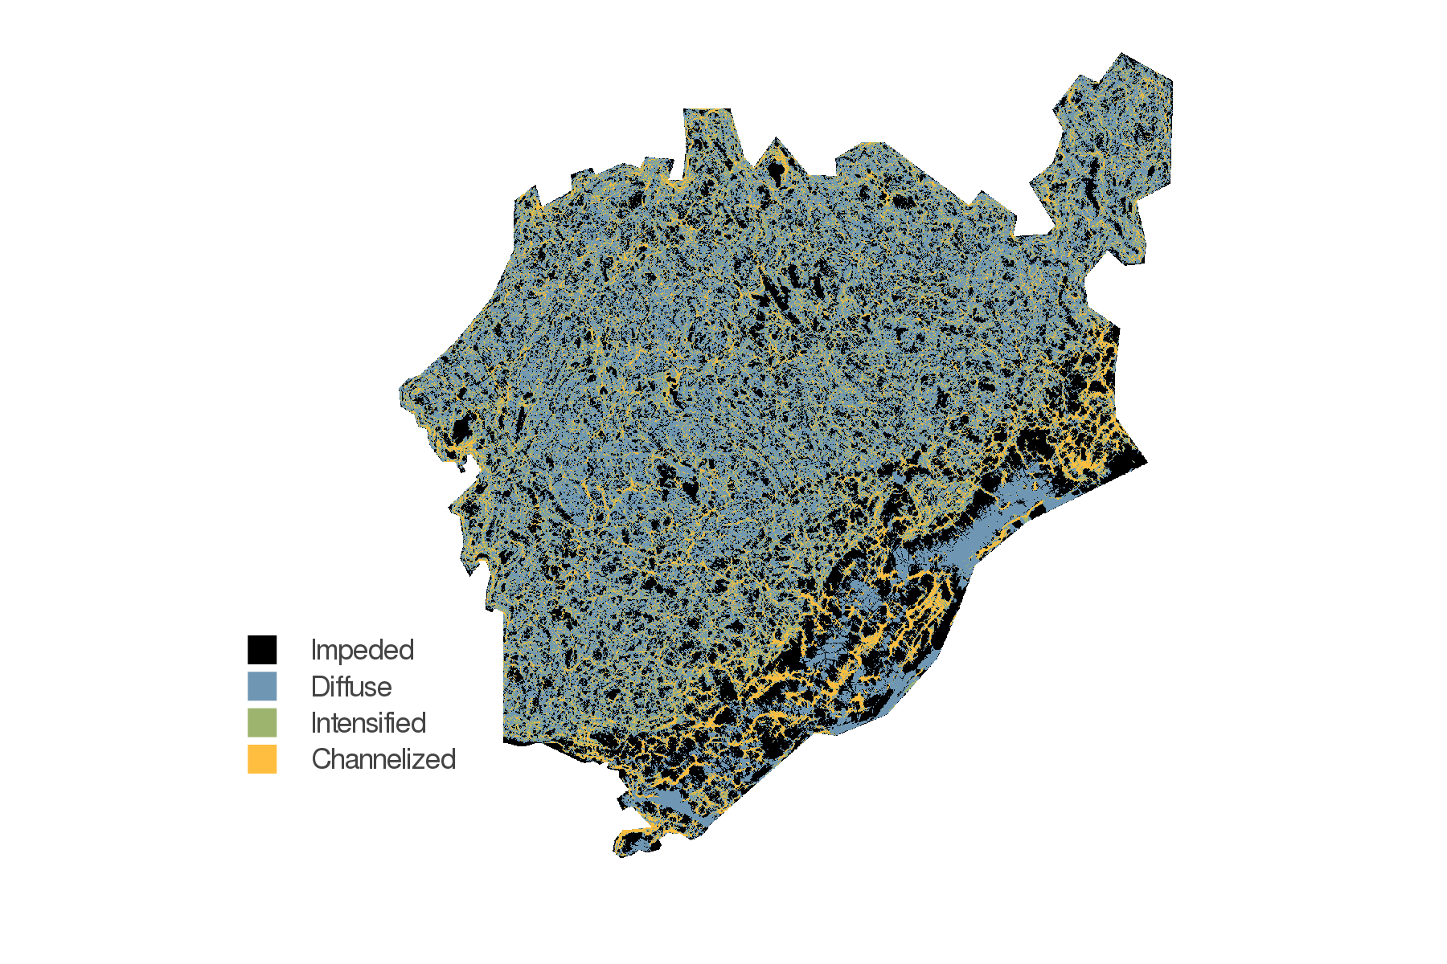
Figure 1: This is the legend of the figure, which will be shown in the margin in preprint mode, and underneath the figure in draft mode. The legend can contain references, etc. It is advised to use a resolution of at least 600dpi for the figures.
We can now use @fig:figure to refer to fig. 1.

Example text
Connectance, defined as the ratio of realized interactions on the total number of potential interactions, is one of the most common descriptor of network structure. In a bipartite network with species at the top, and at the bottom, having a total of interactions, it is defined as . Connectance has a lower bound, as the network cannot have fewer interactions that the number of species in its more speciose level – the minimal connectance is therefore . This makes the connectance of networks of different sizes difficult to compare, especially since bipartite networks tends to have a low connectance. For this reason, we used a corrected version of connectance, defined as

This is a subsection
This takes values between 0 (the network has the minimal number of interactions) and 1 (all species are connected), but is robust to variations in species richness.

This is another subsection
This takes values between 0 (the network has the minimal number of interactions) and 1 (all species are connected), but is robust to variations in species richness.

Some non-standard maths
The phylogenetic reconstruction of and has an associated uncertainty, represented by the breadth of the uniform distribution associated to each of their entries. Therefore, we can use this information to assemble a probabilistic metaweb in the sense of (Poisot2016StrPro?), i.e. in which every interaction is represented as a single, independent, Bernoulli event of probability .
Specifically, we have adopted the following approach. For every entry in and , we draw a value from its distribution. This results in one instance of the possible left () and right () subspaces for the Canadian metaweb. These can be multiplied, to produce one matrix of real values. Because the entries in and are in the same space where and were originally predicted, it follows that the threshold estimated for the European metaweb also applies. We use this information to produce one random Canadian metaweb, .
Because the intervals around some trait values can be broad (in fact, probably broader than what they would actually be), we repeat the above process times, which results in a probabilistic metaweb , where the probability of an interaction (here conveying our degree of trust that it exists given the inferred trait distributions) is given by the number of times where it appears across all random draws , divided by the number of samples. An interaction with means that these two species were predicted to interact in all random draws, etc..

References
Camerano, L. (1880). Dell’equilibrio dei viventi merce la reciproca distruzione. Atti Della R. Accad. Delle Sci. Torino, 15, 393–414.
Elton, C.S. (1927). Animal ecology. University of Chicago Press.

