2024

**Sentiment Analysis on Cryptocurrency-Related Tweets Using Transformer Models**

Final Report

IVAN ZDRAVKOV

1. **Introduction**

* **Purpose:** To develop a sentiment analysis model for tweets related to Bitcoin.
* **Importance:** Exploring the impact of sentiment analysis on understanding market trends.

1. **Data Exploration and Preprocessing**

* The dataset is loaded and inspected to understand its structure, identify missing values, and remove duplicates. Basic exploratory data analysis (EDA) is performed to visualize the distribution of sentiments and other relevant features.
* The text data undergoes cleaning using regular expressions and SpaCy, removing noise such as URLs, mentions, special characters, and converting the text to lowercase. Lemmatization is applied to normalize the words.

1. **Data Preparation and Tokenization**

* The cleaned text is tokenized using a pre-trained tokenizer from the twitter-roberta-base-sentiment-latest model, preparing it for input into the transformer model. The data is then split into training, validation, and test sets to evaluate the model's performance.

1. **Model Fine-Tuning**

* The code implements K-fold cross-validation for robust model evaluation and uses Optuna for hyperparameter tuning, optimizing key parameters like learning rate, batch size, and dropout rates.
* The RoBERTa model is fine-tuned on the tweet dataset, with attention to freezing certain layers to prevent overfitting and improve training efficiency.

1. **Model Evaluation and Interpretation**

* The final model is trained using the best hyperparameters obtained from Optuna optimization. The code includes functions for evaluating the model's performance using metrics such as accuracy, precision, recall, and F1-score.

1. **Application of the model and recommendations for improvement**

* We will take our model from the tagging face repository and with the help of new responses received using the Twitter API, we will try to predict their sentiment.

# 1. Introduction

### **Objective**

This project analyzer a data set containing answers related to Bitcoin. The goal is to study the moods in these tweets and build a model to classify their moods.

We will use the **RoBERTa** model, adapted for analyzing tweets, and conduct a detailed analysis of the data.

### **Purpose of the Report**

This report presents an in-depth sentiment analysis of tweets related to Bitcoin, collected over a period of 18 months. The goal is to understand public sentiment towards Bitcoin, how this sentiment correlates with tweet engagement metrics, and how sentiment trends evolve over time. By analyzing the sentiment behind tweets, we gain valuable insights into public opinion, which can be crucial for investors, analysts, and policymakers. This code represents a comprehensive approach to sentiment analysis using state-of-the-art NLP techniques, ensuring the model is well-prepared to classify the sentiment of tweets accurately.

### **Overview of the Data**

The data used in this analysis consists of tweets mentioning Bitcoin, collected between January 1, 2022, and June 22, 2023. Each tweet in the dataset is accompanied by various engagement metrics such as the number of likes, retweets, replies, and quotes, as well as a sentiment label and sentiment score.

### **Data Source**

The dataset used for this analysis is taken from the Kaggle database **https://www.kaggle.com/datasets/sujaykapadnis/bitcoin-tweets**. This dataset includes various response-related metrics such as likes, retweets, citations, and so on. For faster work, we will use **Kaggle Kernel**, which provides 30 hours of free access per week.

Link to our model on Hugging Face **https://huggingface.co/Poitreqm/poitreqm-model-sentiment-tweets**

# 2. Data Exploration and Preprocessing

## Loading the Dataset and Understanding its structure

This report provides a detailed analysis of the sentiment surrounding Bitcoin as expressed on Twitter. The analysis spans from January 1, 2022, to June 22, 2023, covering a wide range of tweets that include public opinions, news, and discussions related to Bitcoin. Using advanced natural language processing (NLP) techniques, we analyze the sentiment and engagement metrics associated with these tweets to provide insights into public perception and trends in the cryptocurrency space.

# Load the data

df = pd.read_csv("tweets.csv")

**Our table:**

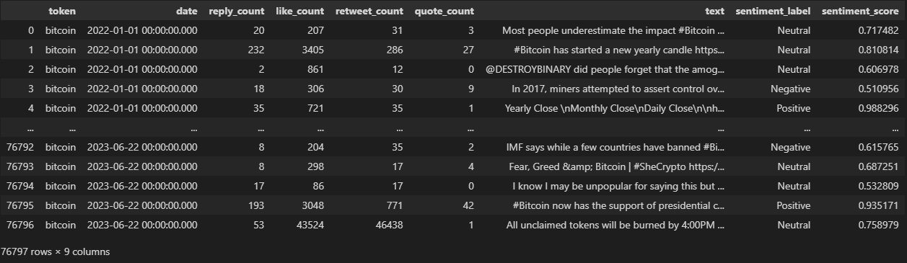

The dataset contains 76,797 rows and 9 columns. Each row represents a tweet, with columns detailing the tweet's text, sentiment label, sentiment score, date, and various engagement metrics such as likes, retweets, replies, and quotes.

**‘token’** - the keyword associated with Bitcoin.

**‘date’** - the date and time of the tweet.

**‘reply_count’**, **‘like_count’**, **‘retweet_count’**, **‘quote_count’** - engagement metrics.

**‘text’** - the content of the tweet.

**‘sentiment_label’** - sentiment label (Neutral, Negative, Positive).

**‘sentiment_score’** - numerical sentiment score.

# We see information about the dimension of our dataframe

df.shape

# Information about the dataset

df.info()

# The number of unique values for each column

df.nunique()

***Conclusion****:*

*The data is well-structured and complete, with no missing values. This ensures that it’s ready for analysis without needing extensive preprocessing, allowing for accurate insights into user behavior and sentiment around Bitcoin.*

## Perform basic exploratory EDA and cleaning tweets

# Check for missing values

df.isnull().sum()

We don't have any missing values.

# Check for duplicates and non-dublicates

df.duplicated().value_counts()

False 76734

True 63

**Removing 63 duplicates:**

# Remove duplicates

df = df.drop_duplicates()

# Sentiment describe

df["sentiment_score"].describe()

**Using the matplotlib library, we visualize our sentiments:**

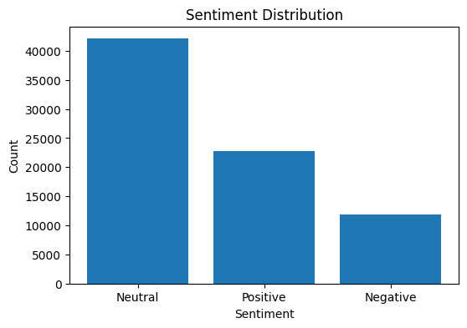

***Conclusion****:*

*As we can see, we have the most neutral tweets. This may have a slightly bad effect on determining positive and negative moods, since our program will recognize them better than others, especially negative ones, since we have the least of them.*

**Tweets are short messages on the social network Twitter, limited to 280 characters. They can contain text, images, videos, and links. The responses often use trends and memes, slang and abbreviations, as well as emotional expressions and relevant hashtags. Tweets are used to share news, opinions, jokes and to communicate with other users. We will process them using models tailored to the English language**

def clean_text(text):

    text = re.sub(r"^RT\s+", "", text)  # Remove 'RT' (re-tweets) at the beginning of the text

    text = re.sub(r"http\S+", "", text)  # Remove URLs

    text = re.sub(r"@\w+", "", text)  # Remove mentions (e.g., @username)

    text = re.sub(r'#', '', text)  # Remove the '#' symbol only (e.g., #hashtag)

    text = re.sub(r"[^\x00-\x7F]+", "", text)  # Remove non-ASCII characters

    text = re.sub(r"[^A-Za-z0-9\s.]+", "", text)  # Remove special characters except periods

    text = re.sub(r"\.{2,}", " ", text)  # Replace multiple periods with a single space

    text = re.sub(r"\s+", " ", text)  # Replace multiple spaces with a single space

    text = text.strip()  # Remove spaces from the beginning and end of the string

    text = text.lower()  # Convert the text to lowercase

**Lemmatization is the process of converting words into their basic or dictionary form, called a lemma. The purpose of lemmatization is to combine different forms of a word into one standard form, which helps to improve the accuracy of text analysis and reduce the size of the dictionary.**

# Lemmatization

    doc = nlp(text)

    lemmas = [token.lemma_ for token in doc if token.lemma_ not in ('-', '', ' ') and len(token.lemma_) > 1]  # Exclude empty lemmas, punctuation marks and single letters

Text cleaning is needed for:

1.Improving Data Quality: Removing errors and noise for accurate analysis.

2.Preparing Data: Standardizing text for analysis and machine learning.

3.Simplifying Processing: Eliminating unnecessary information to streamline further work.

4.Resolving Inconsistencies: Standardizing format and style for consistency.

**Before cleaning After Cleaning**

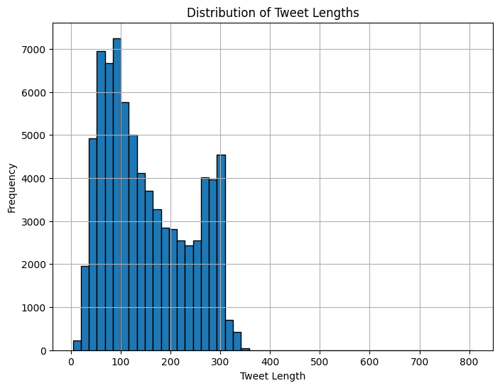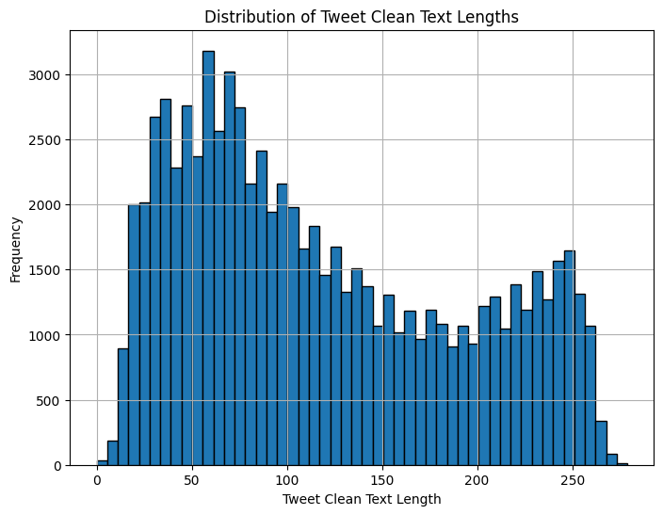

***Conclusion:***

*Almost all the answers were in the range from 0 to 300 - now only up to 250. The length of the cleaned tweets still varies greatly, which indicates that the cleaning has not significantly changed the distribution of tweet lengths, although it is worth recognizing that the number of abnormal tweets has significantly decreased, which will greatly facilitate our work.*

**We find the most common words and visualize them on a graph using the WordCloud library:**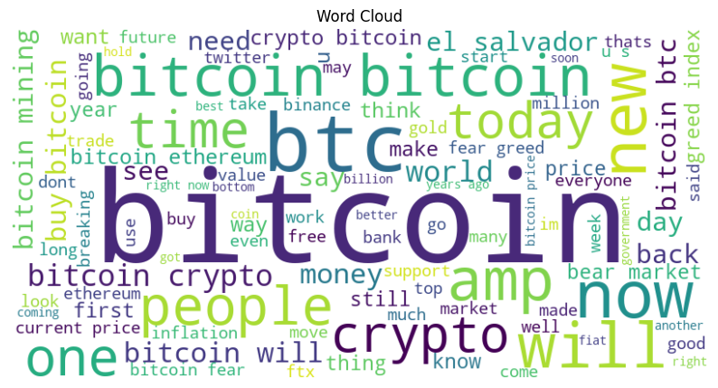

**Top 25 of words:**

bitcoin: 34203 btc: 5713 will: 5450

go: 3974 now: 3540 crypto: 3413

new: 3069 amp: 2928 buy: 2911

people: 2803 make: 2722 time: 2649

see: 2575 one: 2556 break: 2518

say: 2338 use: 2270 today: 2189

world: 2174 money: 2133 buy bitcoin: 1900

think: 1893 need: 1883 day: 1869

bitcoin bitcoin: 1849

***Conclusion****:*

***"Bitcoin"*** *and* ***"BTC":*** *The overwhelming frequency of "bitcoin" and "btc" emphasizes that Bitcoin is the central topic of conversation. The repetition of "****bitcoin bitcoin"*** *suggests intense focus or emphasis on the cryptocurrency.*

***"Crypto":*** *The term "crypto" being frequent alongside Bitcoin indicates discussions often encompass the broader cryptocurrency market, though Bitcoin remains the primary subject.*

***"Will"*** *and* ***"Going":*** *These words highlight that future predictions, plans, or expectations are major themes. People are likely discussing what will happen with Bitcoin, where the market is going, and what actions to take.*

***"New," "Now," "Today," "Year":*** *These terms suggest that tweets are often focused on current events, recent developments, or upcoming trends within the crypto space. There's a clear emphasis on what’s happening at the moment and how it relates to the immediate future.*

***"Buy," "Money," "Time":*** *The frequent mention of "buy" and "money" suggests discussions about investing in Bitcoin, the value of money, and the timing of these investments. It implies a financial motive or interest in the economics of Bitcoin.*

***"First":*** *This word could relate to milestones, achievements, or important events in the Bitcoin or cryptocurrency world, such as first-time investments, first adopters, or key events.*

***"People," "World," "See," "Day":*** *These words indicate a broader discussion that involves not just technical or financial aspects but also social and global implications. Conversations may involve how Bitcoin is perceived worldwide, its impact on people's lives, and how it integrates into daily life.*

*Overall, these words suggest that your tweets are deeply engaged with both the current state and future possibilities of Bitcoin and the broader cryptocurrency market, with a mix of financial analysis, social implications, and global perspectives.*

**Now let's see how our mood changes in tweets according to time, but before that we need to bring the time to the format we need.**

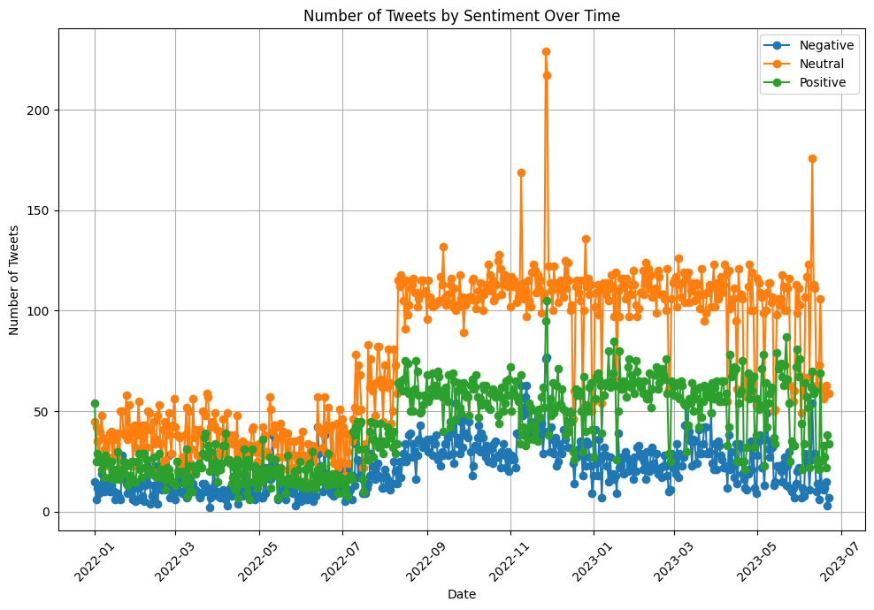

***Conclusion****:*

*The data on tweet counts shows that activity varies daily.*

*Periods with a high number of tweets do not always coincide with periods when the average sentiment was higher or lower. This suggests that tweet activity does not always directly affect the overall sentiment on social media. - A sharp increase or decrease in tweet counts may correspond with specific events that influence the overall sentiment.*

**Our correlation matrix helps us understand the relationships between the various variables in our table:**

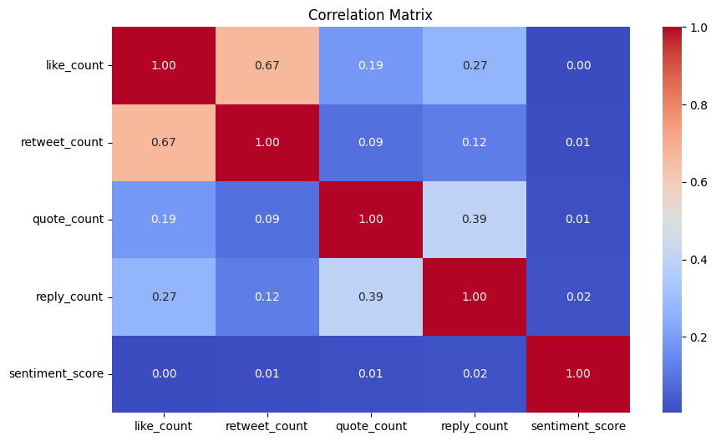

***Conclusion****:*

*There is a moderate correlation between likes and retweets, indicating that tweets with more likes tend to also have more retweets. However, there is little to no relationship between these metrics and the tweet’s sentiment or the number of times the tweet is quoted.*

*Retweets and quotes have a very weak relationship with each other.*

*Sentiment is almost independent of likes, retweets, and quotes.*

*These results suggest that tweet engagement metrics (likes, retweets, and quotes) are generally not strongly related to each other or to the sentiment of the tweets.*

***‘sentiment_score’*** *can be considered as an independent variable that is unlikely to be effectively predicted based on interaction data alone*

# 3. Data Preprocessing and Tokenization

## a. Tokenize the text data and preparation of tokenized data for input into model

**We only need two columns - labels and clean tweets:**

# We conclude that the other columns do not affect anything. We remove all unnecessary columns

df = df[["clean_text", "sentiment_label"]]

**We use Auto Tokenizer to tokenize text using the RoBERTa model, which is specifically configured for Twitter.**

**Tokenization involves trimming and padding to a specified length, which allows you to prepare data for the model.**

# Load the tokenizer for the twitter-roberta-base-sentiment-latest model

tokenizer = RobertaTokenizer.from_pretrained("cardiffnlp/twitter-roberta-base-sentiment-latest", truncation=True, do_lower_case=True)

*If* truncation=True*, the text will be truncated to this maximum length*

*If* do_lower_case=True*, all letters in the text will be converted to small ones*

**Tokenization is a key step in text processing that converts text into a format convenient for analysis and processing by machine models:**

# Apply tokenization to the texts

tokenized_data = tokenizer(df["clean_text"].tolist(),    # tweets

      max_length = 64,                     # Maximum length of tokenized text

      padding = "max_length",              # Adding padding

      truncation = True,                   # Cropping the text if it is longer

      return_tensors = "np",               # Returned NumPy tensors

      return_attention_mask = True,       # Attention mask

**Creating numeric representations and attention mask:**

input_ids = tokenized_data["input_ids"]                 # numeric representations of tokens

attention_masks = tokenized_data["attention_mask"]      # attention mask

***Conclusion****:*

*This code prepares data for sentiment analysis using the RoBERTa model adapted for Twitter. It provides correct text processing (including padding and cropping), data conversion to a NumPy-compatible format, and includes attention masks to improve model performance. This makes it possible to effectively use the model to analyze sentiment based on tweets.*

# Converting moods to numeric labels

label_encoder = LabelEncoder()

df["label"] = label_encoder.fit_transform(df["sentiment_label"])

label = to_categorical(df["label"], num_classes=3)

**To make the cat work so correctly, we will use the Datasets library. We will first need to convert our data to Dataset format, and then use methods from data sets to divide them into training, validation, and test suites.**

# Converting labels in the Dataset format

def create_dataset(input_ids, attention_masks, labels):

    return Dataset.from_dict({

        "input_ids": list(input_ids),

        "attention_mask": list(attention_masks),

        "labels": list(labels)

    })

# Creating a Complete Dataset

dataset = create_dataset(input_ids, attention_masks, label)

***Conclusion:***

*The Dataset format is used in machine learning and data processing libraries such as Hugging Face's datasets to simplify and standardize working with data.*

*The Dataset format provides a unified interface for working with data, which simplifies their loading, preprocessing and use in models.*

*All data in one format makes it easier to work with data, especially when moving from one processing stage to another.*

# Data separation

dataset_split = dataset.train_test_split(test_size=0.4, seed=42, shuffle=True)

test_valid_split = dataset_split["test"].train_test_split(test_size=0.45, seed=42, shuffle=True)

**Why we separate ours data?**

*After you have configured the hyperparameters of the model using KFold cross-validation on training data, you need to have an independent test set on which you can evaluate the final performance of the model.* ***This test set should not be used during the model setup process to avoid overestimating its quality.***

*KFold-cross validation is used to select the best hyperparameters, but even for this process it is useful to divide the data into training and validation parts. For example, you can use one part of the data for cross-validation and hyperparameter selection, and the other part (validation set) to verify that the selected parameters actually work in practice.*

*Pre-partitioning the data and using a fixed test set reduces the impact of randomness on model evaluation and allows you to repeat experiments with the same data to obtain stable results.*

# Creating a DatasetDict

datasets = DatasetDict({

    "train": dataset_split["train"],

    "validation": test_valid_split["train"],

    "test": test_valid_split["test"]

***Conclusion:***

*We have successfully converted our data into a Dataset format and divided it into training, validation and test data. We are ready to fine tune our model and train.*

# 4. Model Fine-Tuning

## Fine-tune a pre-trained transformer model

**Cross-validation is a method of evaluating the performance of a machine learning model, which helps to avoid overfitting and give more reliable estimates of the quality of the model**. **We will use k-fold cross validation. It splits the data into parts (folds) and uses each of them as a test sample, and the remaining k-1 parts to train the model. This process is repeated k times, and the model is tested on each of the parts.**

# Initialize KFold cross-validator

kf = KFold(n_splits=5, shuffle=True, random_state=42)

**We will use metrics to analyze the state of our model.**

# A function that calculates metrics such as accuracy, precision, recall, and F1-score

def compute_metrics(pred):

    labels = np.argmax(pred.label_ids, axis=-1)

    preds = np.argmax(pred.predictions, axis=-1)

    accuracy = accuracy_score(labels, preds)

    precision, recall, f1, _ = precision_recall_fscore_support(labels, preds, average="weighted")

# Return the metrics as a dictionary

    return {

        "accuracy": accuracy,  # Accuracy of the predictions

        "precision": precision,  # Precision of the predictions

        "recall": recall,  # Recall of the predictions

        "f1": f1,  # F1-score of the predictions

    }

**We will create one function for cross-validation and hyperparameters to test them simultaneously. For cross-validation, we will use Sckit-learn and for hyperparameters Optuna**

# Objective function for hyperparameter tuning with Optuna

training_args = TrainingArguments(

output_dir="./results",  # Directory to save the model

num_train_epochs=trial.suggest_int("num_train_epochs", 1, 5),  # epochs

learning_rate=trial.suggest_loguniform("learning_rate", 1e-5, 5e-5),  # speed

per_device_train_batch_size=trial.suggest_categorical("per_device_train_batch_size", [8, 16, 32]),  # Batch size

per_device_eval_batch_size=trial.suggest_categorical("per_device_eval_batch_size", [8, 16, 32]),  # Batch size

warmup_steps=trial.suggest_int("warmup_steps", 0, 1000),  # warmup steps

weight_decay=trial.suggest_uniform("weight_decay", 0.0, 0.1),  # L2 regularization

    logging_dir="./logs",  # Directory for logging

    logging_steps=10,  # Logging frequency (steps)

    evaluation_strategy="epoch",  # Evaluate after each epoch

    save_strategy="epoch",  # Save the model after each epoch

    load_best_model_at_end=True,  # Load the best model at the end of training

    metric_for_best_model="eval_loss",  # Metric to use best model

    max_grad_norm=trial.suggest_uniform("max_grad_norm", 0.5, 1.0), # gradient norm

    gradient_accumulation_steps=trial.suggest_int("gradient_accumulation_steps", 1, 4),  # Number of steps to accumulate gradients

        dataloader_num_workers=4,  # Number of workers for data loading

        run_name="none",  #

        report_to="none",  # Disable integration with W&B and other services

    )

**As a model, we will use Roberta, who was specially trained on these tweets:**

# Load model with Dropout and L2 regularization

    model = RobertaForSequenceClassification.from_pretrained(

        "cardiffnlp/twitter-roberta-base-sentiment-latest",

        num_labels=3,  # Number of output labels

        ignore_mismatched_sizes=True,  # Ignore size mismatches if they occur

    )

    # Set dropout probabilities

    model.config.hidden_dropout_prob = trial.suggest_uniform("hidden_dropout_prob", 0.1, 0.3)  # Dropout probability for hidden layers

    model.config.attention_probs_dropout_prob = trial.suggest_uniform("attention_probs_dropout_prob", 0.1, 0.3)  # Dropout probability for attention layers

**To combat overfitting, we will use the Dropout layer, the nature of which we will set using hyperparameters. It will be a good practice to freeze layers, since RoBERTa model can be very powerful, which is why it will not produce the result we need on our data**

    # Freeze layers based on the trial's suggestion

    freeze_layers = trial.suggest_int("freeze_layers", 0, 12)  # Example for Roberta-base with 12 layers

for param in model.roberta.parameters():

param.requires_grad = False  # Freeze all layers initially

    for i in range(freeze_layers, 12):

        for param in model.roberta.encoder.layer[i].parameters():

            param.requires_grad = True  # Unfreeze specified layers

**Having previously divided the data into training and validation, we can proceed to Trainer modulation.Trainer serves to simplify the learning process and evaluate deep learning models for natural language processing (NLP) tasks.**

# Initialize Trainer with the specified arguments and datasets

        trainer = Trainer(

            model=model,

            args=training_args,

            train_dataset=train_dataset,

            eval_dataset=test_dataset,

            tokenizer=tokenizer,

            compute_metrics=compute_metrics,

            callbacks=[EarlyStoppingCallback(early_stopping_patience=2)]  # Early stopping callback

***Conclusion:***

*This code performs automated configuration of hyperparameters of the RoBERTa For SequenceClassificationmodel using the Optuna library and k-fold cross-validation.*

*- Optuna offers hyperparameter values such as the number of epochs, learning rate, batch size, and other model and learning parameters.*

*- The RobertaForSequenceClassification model is set with the ability to adjust Dropout layers and freeze layers.*

*- Data is divided into training and test sets using k-fold cross validation. The model is trained and evaluated on each partition.*

*- The average loss (eval_loss) is calculated for all folds. If the current model is the best, it is saved.*

**Now you can use this model to make predictions on a test dataset.**

**Before we use our model on real answers, we should test our best parameters using a test dataset.**

**Since our best model will be saved locally, we need to specify a path to it.**

# Path for the best model

best_model_path = best_trial.user_attrs["model_path"]

# Final model with optimized dropout values and layer freezes

# Download the best model

final_model = RobertaForSequenceClassification.from_pretrained(

best_model_path, # OUR BEST MODEL

num_labels=3,

ignore_mismatched_sizes=True)

final_model.config.hidden_dropout_prob = best_params["hidden_dropout_prob"]

final_model.config.attention_probs_dropout_prob = best_params["attention_probs_dropout_prob"]

***Conclusion:***

*This code loads the best model found during the experiments and applies optimal values of hyperparameters such as* ***‘hidden_dropout_prob’*** *and* ***‘attention_probs_dropout_prob’*** *to it to configure the final model before using it in production or for further evaluation.*

**Our best parameters:**

num_train_epochs = 3 # Number of training epochs

learning_rate = 2.3311031477348052e-05 # Small learning rate for fine-tuning

per_device_train_batch_size = 16 # Training batch size per device

per_device_eval_batch_size = 16 # Evaluation batch size per device

warmup_steps = 630 # Warmup steps to gradually increase the learning rate

weight_decay = 0.05180266162382893 # Weight decay rate

max_grad_norm = 0.5757268880209764 # Gradient clipping threshold

gradient_accumulation_steps = 1 # Gradient accumulation steps

hidden_dropout_prob = 0.20787227376469775 # Dropout probability for hidden layers

attention_probs_dropout_prob = 0.2880938516824848 # Dropout probability for attention probabilities

freeze_layers = 7 # Number of layers to freeze in the model

# 5. Model Evaluation and Interpretation

## Training and evaluation

**As we remember, we saved our data in the ‘best_params’ variable, from where we should get our data about the best model. Now we just need to transfer them to our model**

**Fine Tuning our model with best parameters:**

final_training_args = TrainingArguments(

    output_dir="./results",  # Save model/results

    num_train_epochs=best_params["num_train_epochs"],  # Optimized epochs

    learning_rate=best_params["learning_rate"],  # Optimized learning rate

    per_device_train_batch_size=best_params["per_device_train_batch_size"],  #

#Optimized train batch

per_device_eval_batch_size=best_params["per_device_eval_batch_size"],  # #Optimized eval batch

    warmup_steps=best_params["warmup_steps"],  # Optimized warmup

    weight_decay=best_params["weight_decay"],  # Optimized weight decay

    logging_dir="./logs",  # Log directory

    logging_steps=10,  # Log frequency

    evaluation_strategy="epoch",  # Evaluate each epoch

    save_strategy="epoch",  # Save each epoch

    load_best_model_at_end=True,  # Load best model

    metric_for_best_model="eval_loss",  # Best model metric

    max_grad_norm=best_params["max_grad_norm"],  # Optimized grad norm

    gradient_accumulation_steps=best_params["gradient_accumulation_steps"],  # #Optimized gradient accumulation

    dataloader_num_workers=4,  # Data loader workers

    run_name="none",  # No run name

    report_to="none",  # No reporting

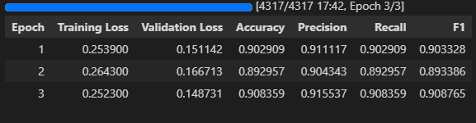

***Conclusion:***

*-The model shows improvement in validation loss from Epoch 1 to Epoch 3 (from 0.151142 to 0.148731), indicating that the model is learning and generalizing better over time.*

*-Accuracy and F1-score both improve from Epoch 2 to Epoch 3, suggesting that the model's predictions are becoming more consistent with the true labels.*

*-The slight dip in these metrics from Epoch 1 to Epoch 2 might indicate temporary overfitting or noise, but the improvement in Epoch 3 suggests recovery.*

*-Precision and recall are fairly stable across epochs, with a slight increase in Epoch 3, which shows the model maintains a balance between false positives and false negatives.*

*- The model appears to be converging, with the best performance observed at Epoch 3, as indicated by the lowest validation loss and highest accuracy, precision, recall, and F1-score.*

*Overall, the tuned hyperparameters led to an* ***effective model*** *that generalizes well to unseen data, as evidenced by the strong validation performance in the final epoch.*

**Now let's predict our test data*:***

# Prediction

predictions = final_trainer.predict(datasets['test'])

preds = np.argmax(predictions.predictions, axis=1)

true_labels = np.argmax(predictions.label_ids, axis=1)

**Classification Report:**

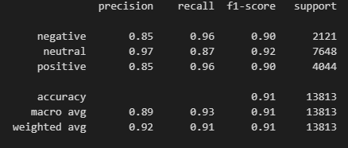

***Conclusion:***

*The model does a* ***good job of classifying reviews into neutral and positive****, but has some problems with accuracy in classifying negative reviews and completeness for positive ones.*

*The* ***Neutral class has the best performance across all metrics****, which may indicate that the model is better trained for this class or that this class prevails in the data.*

*The micro avg and weighted avg indicators confirm that the* ***model is generally balanced****, although there are minor differences between classes.*

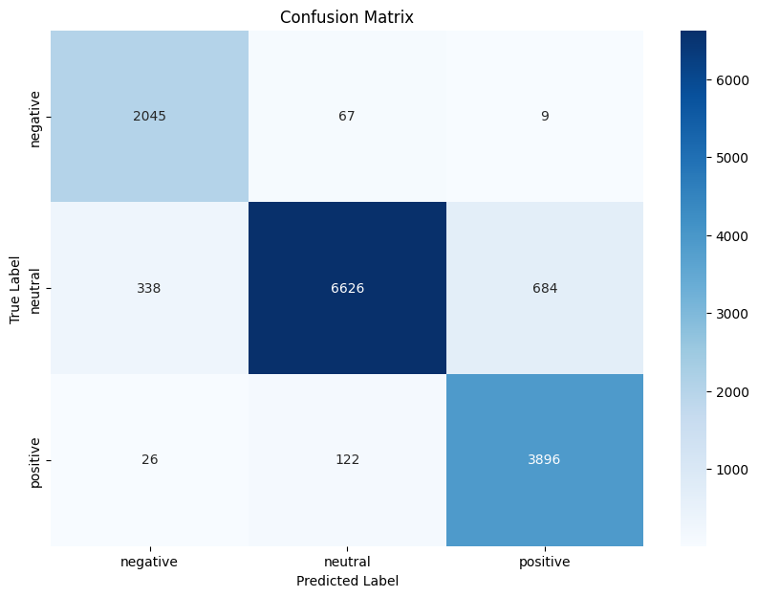

***Conclusion:***

***The model performs well in predicting Class Negative****, with 2045 true positives.*

*Misclassifications are relatively low, with 67 instances being incorrectly classified as Class Neutral and 9 as Class Positive.*

***The model shows strong performance for Class Neutral****, with 6626 true positives.*

*However, there are 338 instances of Class Neutral being misclassified as Class Negative and 684 as Class Positive, indicating some confusion primarily with Class Positive.*

***Class Positive predictions are also strong, with 3896 true positives****.*

*There are 122 instances of Class Positive incorrectly predicted as Class Neutral and only 26 as Class Negative, showing minimal confusion with Class Negative but some with Class Neutral. The model performs well across all classes, with the highest accuracy for Class Neutral but some confusion between Class Neutral and Class Positive. The misclassifications are relatively low, suggesting that the model is generally effective in distinguishing between the three classes.*

**And although all the conclusions speak of our model as very good, How do we know exactly how many correct answers we have received? To do this, we will calculate accuracy and loss error specifically for our predicted data**

# Correct and incorrect prediction

correct_predictions = (df_results['True Labels'] == df_results['Predictions']).sum()

total_predictions = df_results.shape[0]

accuracy = (correct_predictions / total_predictions) * 100

error_rate = 100 - accuracy

# Result

print(f'Accuracy: {accuracy:.2f}%')

print(f'Error Rate: {error_rate:.2f}%')

**Accuracy: 90.98%**

**Error Rate: 9.02%**

**Before downloading our model, we need to get a token from the site and login. Upload our model in Hugging Face.**

# Specify the path to the saved model and tokenize

model_directory = "/kaggle/working/poitreqm-model-sentiment"

#Specify the repository name on Hugging Face

repository_name = "Poitreqm/poitreqm-model-sentiment-tweets"

# Create new repo on Hugging Face

api = HfApi()

api.create_repo(repo_id=repository_name)

# Upload model

final_model.push_to_hub(repository_name)

tokenizer.push_to_hub(repository_name)

***Conclusion:***

*We successfully trainers our model using hyperparameters, tested it on validation data and then later on test data. The result on the test data was 90%. We have successfully uploaded our model to Hugging Face and now we can always use it for our calculations.*

*Link to our model:* **https://huggingface.co/Poitreqm/poitreqm-model-sentiment-tweets**

# 6. Application of the model and recommendations for improvement

## a. Twitter API request

**After all the manipulations and tests, we can finally come to the final stage. Receiving tweets using the Twitter Api. We will need 5 keys to connect. Which can be found in your twitter api account. We will need the tweepy library for queries.**

def fetch_tweets(query, count):

    tweets = tweepy.Paginator(client.search_recent_tweets,

                                       query=query,

                                       tweet_fields=["created_at", "text"],

                                       max_results=100

                                       ).flatten(limit=count)

    tweets_list = [[tweet.created_at, tweet.text] for tweet in tweets]

    return pd.DataFrame(tweets_list, columns=["timestamp", "text"])

df = fetch_tweets("#Bitcoin", 1000) # 1000 tweets

df.to_csv("big-files/crypto_tweets.csv", index=False)

***Conclusion:***

*This request will allow us to pull out 1000 tweets and save them in the crypto_tweets.csv file*

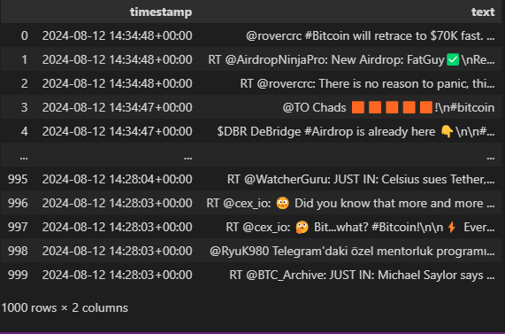

**We are manipulating the received data:**

# Clean tweets

tweets['clean_text'] = tweets['text'].apply(clean_text)

**Now let's predict the sentiment of our new tweets based on our model that we have trained:**

# 'username/repo_name'

model_name = "Poitreqm/poitreqm-model-sentiment-tweets"

# Download model

model = AutoModelForSequenceClassification.from_pretrained(model_name)

# Download tokenizer

tokenizer = AutoTokenizer.from_pretrained(model_name)

# Tokenizing text

tokenized_tweets_pred = tokenizer(tweets['clean_text'].tolist(),

                             max_length=64,  # Need the same line like in train

                             padding='max_length',

                             truncation=True,

                             return_tensors='np',

return_attention_mask=True)

# input_ids and attention_mask

input_ids_pred = tokenized_tweets_pred['input_ids']

attention_masks_pred = tokenized_tweets_pred['attention_mask']

# Our Argiments

tweet_pred_args = TrainingArguments(

    output_dir="./results",

    run_name="none",

    report_to="none",

# Our trainer

trainer = Trainer(model=model,

                 args=tweet_pred_args,)

***Conclusion:***

As we can see, we have to put our new tweets through the same process as with our training data: cleanup, tokenization, fine-tuning, training. All data must also be used in the Dataset type.

# Prediction

predictions = trainer.predict(dataset)

preds = np.argmax(predictions.predictions, axis=1)

We check for duplicates and missing data. this rarely happens, but it won't be superfluous to check:

# Check for missing values

tweets.isnull().sum()

# Check for duplicates and non-dublicates

tweets.duplicated().value_counts()

# Remove duplicates

tweets = tweets.drop_duplicates()

**We found 3 duplicates that we have successfully deleted:**

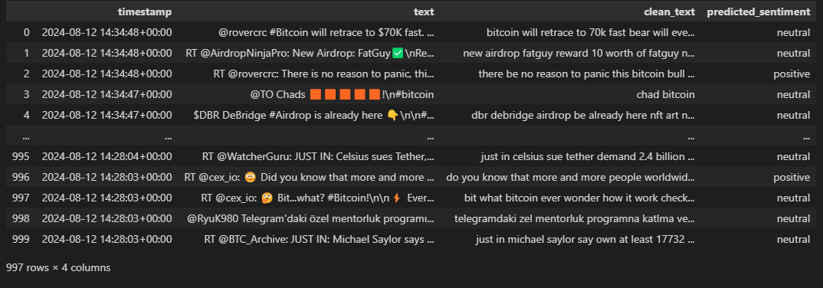

predicted_sentiment

neutral 671

positive 252

negative 74

## Recommendations for improvement

To improve our model, consider the following steps:

**Increase the amount of data:**

Collect more data or apply data augmentation. This will help the model better identify patterns and improve its performance.

**Using linear regression instead of classification:**

If the task requires an assessment of degree or intensity, rather than a simple assignment of classes, try linear regression. This will allow you to obtain quantitative estimates and probabilities.

**Applying multiple models:**

Combining different algorithms can improve the accuracy and reliability of predictions.

**Expanding the range of responses:**

Switch to five classes (negative, neutral-negative, neutral, neutral-positive, positive) to better reflect the gradations in the data. Update the loss function and evaluation metrics for a multi-class task.

**Increase Cross-validation and Hyperparameters**

The increased capacity will allow us to use more parameters in cross-validation and hyperparameters, which in turn will allow a better model.