***Write a blog on Difference between HTTP1.1 vs HTTP2***

Evolution of HTTP(HyperText Tranfer Protocol)

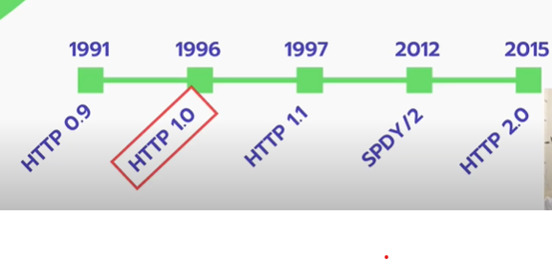

**Why HTTP 1.1 Was introduced?**

1. Constantly changing dynamics of internet with websites becoming more dynamic and heavy.
2. Features like CORS and Keep-alive was introduced.

**Transmission Control Protocol**

|  |  |
| --- | --- |
| HTTP 1.1 | HTTP2.0 |
| Flaws in HTTP 1.1   1. Head on Line Blocking (HoL) , From 1 TCP(Transmission Protocol Control) Connection to 6 TCP Connections. 2. Keep-alive option does not solve the issue completely. 3. Repetition of Header Data , Each request treated as separate from other requests. 4. More focus on Gzip, minifying CSS/JS, Caching etc. | Fast Simple and Robust Protocol   1. One TCP is setup in which HTTP requests are transferred in form of **Streams.** 2. **HPACK**; Header Data is separate from Request Data and be Zipped.    1. It reduces HTTP request Size.    2. Enables reuse-ability of Header Data. 3. **Push Frame:** enables us to send mandatory resources in advance along with an HTTP response. 4. Keep on using Gzip, leverage browser caching, minify CSS/JS etc. to further improve the speed. |

* **“Keep-alive”;** enables using of same TCP connection for multiple HTTP Request.
* **Gzip:** is popular data compression and decompression program.
* **Minification** is the **process of minimizing code and markup in your web pages and script files**. It's one of the main methods used to reduce load times and bandwidth usage on websites. Minification dramatically improves site speed and accessibility, directly translating into a better user experience.

***Blog about Objects and internal representation in JS.***

JavaScript is Object Oriented Programming language. Objects are a real world entity having state as behaviour. JS is template based and we can create object without the need of a class.

3 different ways of creating Objects:

1. Literal based

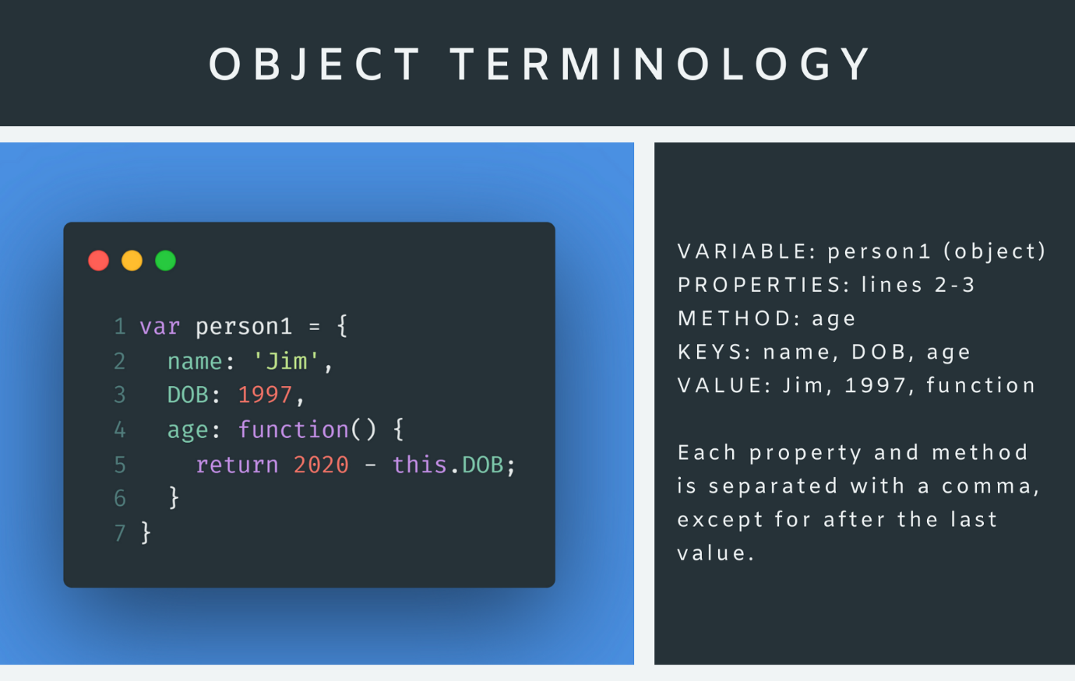

1. Keyword based Objects

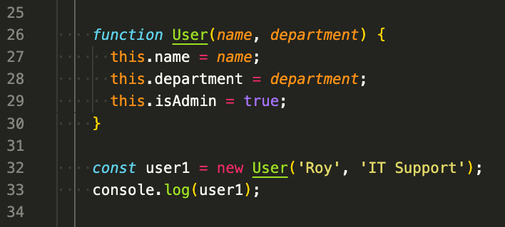

1. Constructor based Object

