Game Design Document

Fill up the Following document

1. Write the title of your project.

Space Shooter Game

1. What is the goal of the game?

Its an endless game , the goal is to defeat the enemies and protect your home.

1. Write a brief story of your game?

Humanity has advanced and became an intergalactic species, now we have spaceships and everything futuristic. But after becoming an intergalactic species we find out that we are not the only ones. Prevent the aliens from invading into our home.

1. Which are the playing characters of this game?

* Playing characters are the ones which respond to the user based on the input from the user
* Cars, monkeys, dinos, wizards etc, are the playing characters in the game.

|  |  |  |
| --- | --- | --- |
| Number | Character Name | What can this character do? |
| 1 | Main Spaceship | Shoot enemy spaceships, can move to avoid enemy bullets |

1. Which are the Non Playing Characters of this game?

* Non Playing characters are the ones which don't have an action or a behaviour when the user interacts with the game.
* Hurdles, stones, bananas, coins, etc are non playing characters in the game.

|  |  |  |
| --- | --- | --- |
| Number | Character Name | What can this character do? |
| 1 | Shotgun Enemy Spaceship | Shoots main character with shotgun bullets |
| 2 | Laser Enemy Spaceship | Shoots main character with lasers |
| 3 | Homing Gun Enemy Spaceship | Shoots main character with Homing bullets |

Draw your imagination of this game. What does this game look like?

* Draw the game either on your computer or on paper,
* Add images of scenes of the game to show each of the playing and non-playing characters at least once.

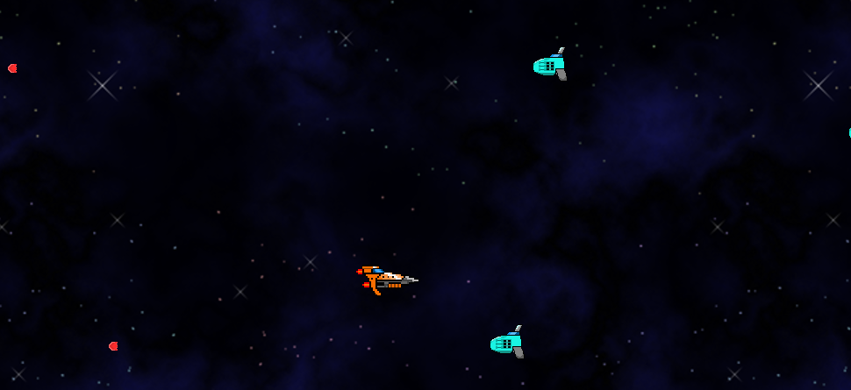

How do you plan to make your game engaging?

To make my game engaging I will make the enemies bullet faster so that they are harder to dodge and not very easy. I will make it so that 2-3 enemies spawn at once in the beginning and later on in the game 4-5 enemies spawn at once and it keeps on increasing and increasing. I will make it so that it takes 2 bullets to destroy one enemy spaceship.