Group 28: NVDA Buy the Dip Strategy Report (Revised)

Introduction
This report evaluates a mean-reversion 'Buy the Dip' strategy applied to NVDA. Based on latest ML and Quantitative evaluations, we have updated our visual and performance analysis.

Exploratory Data Analysis (EDA)
Based on feedback from Quantitative and ML analysis, we improved the EDA to show non-stationarity, tail-risks, and drawdown duration:
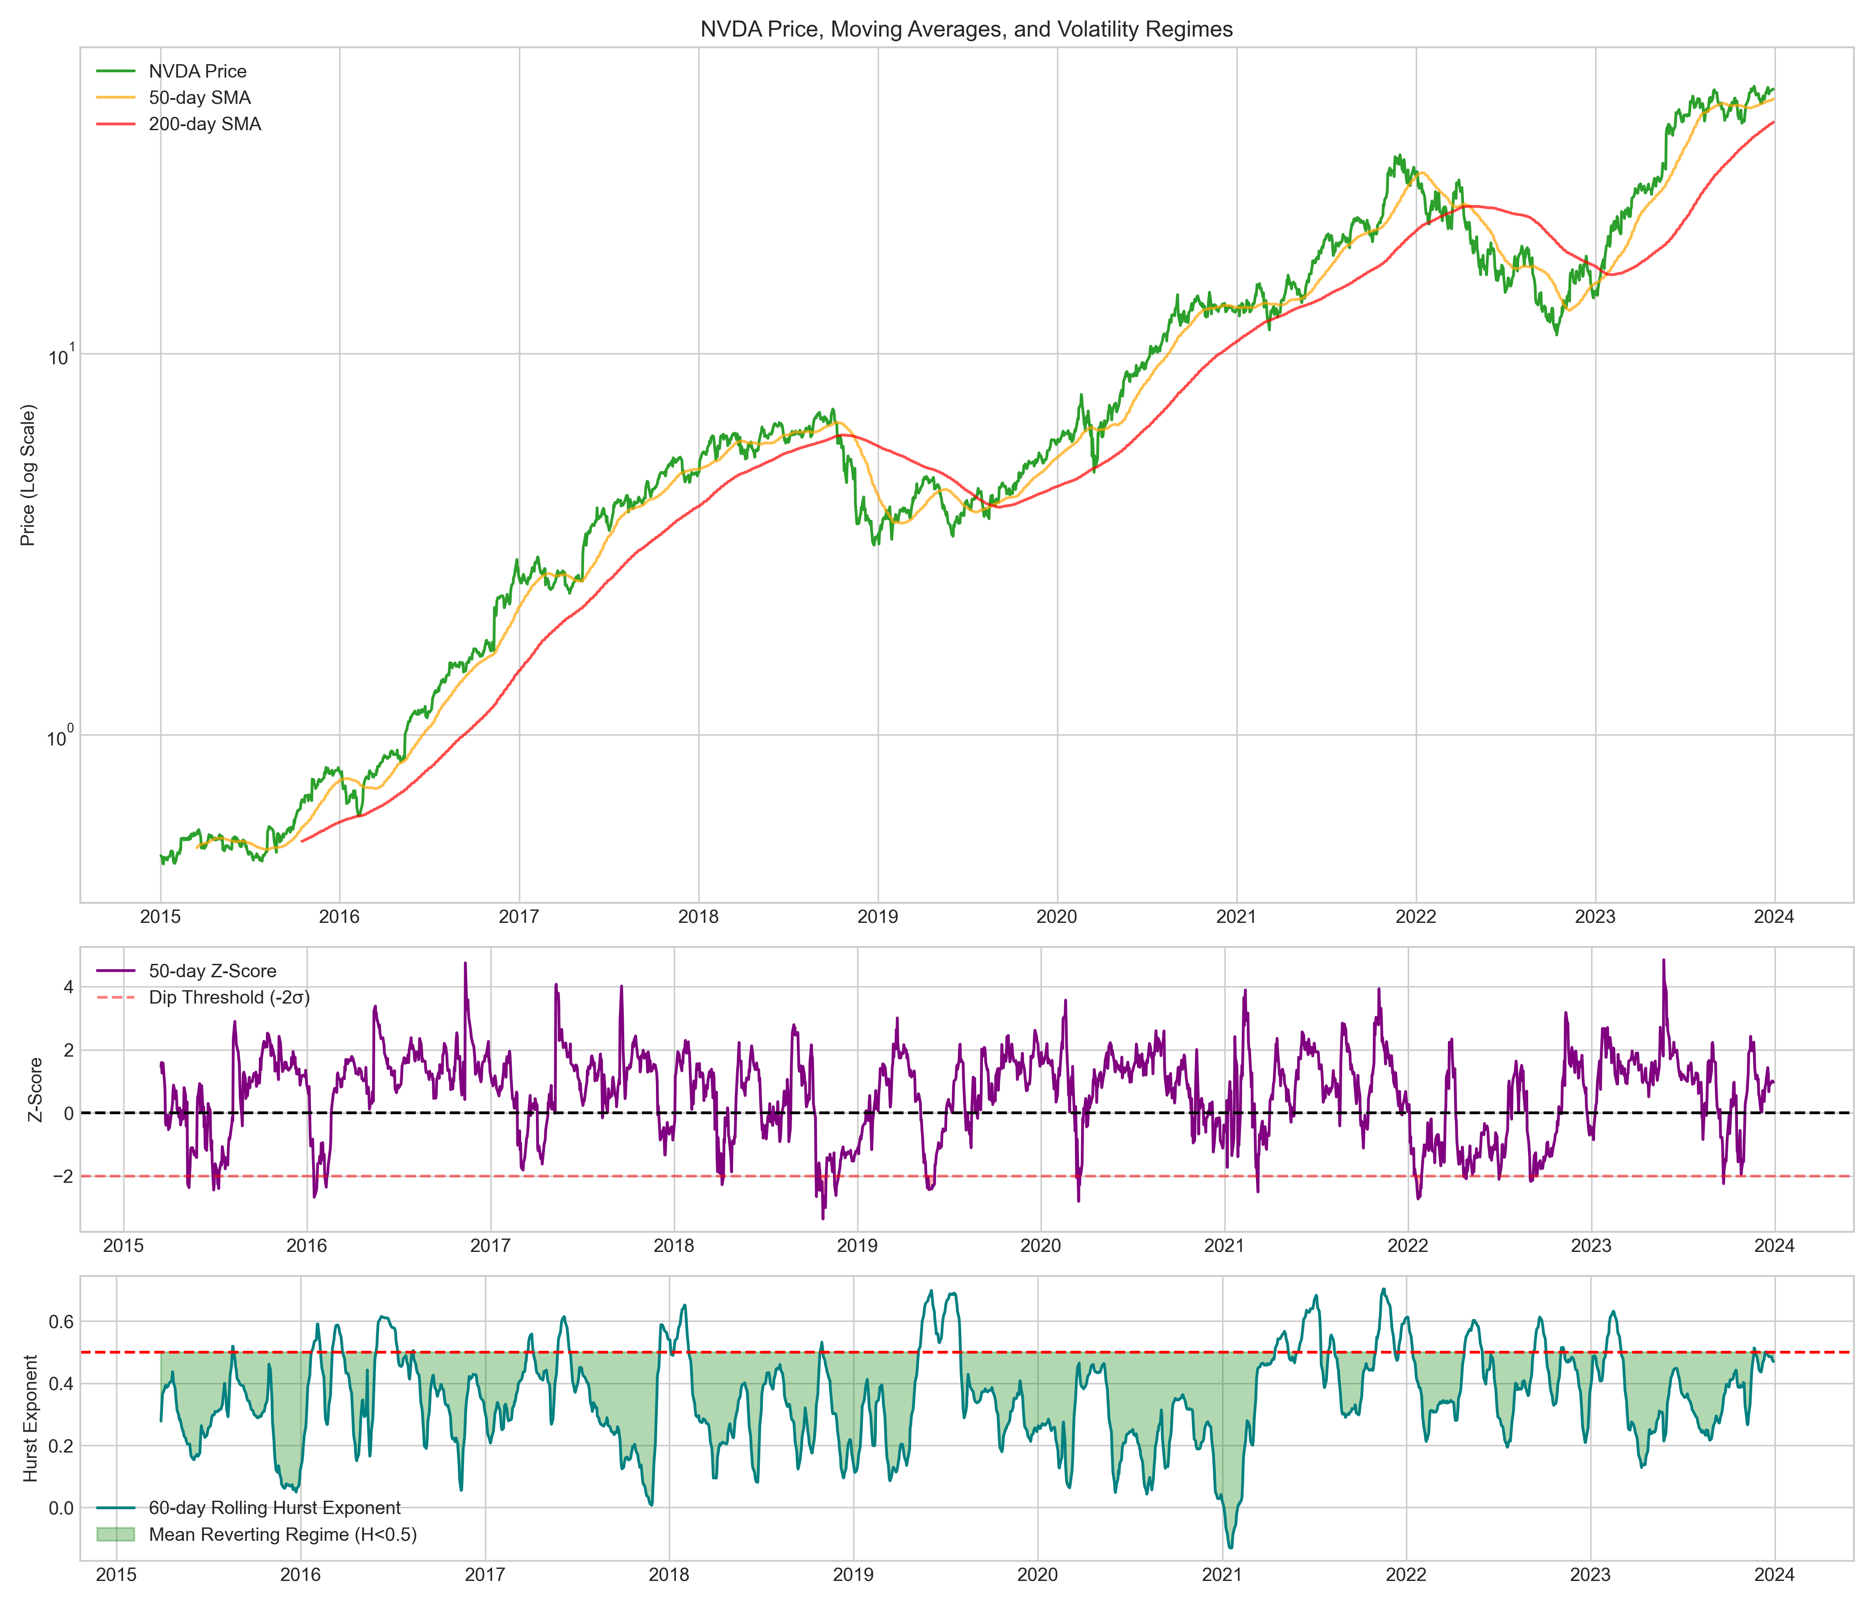
Figure 1: Log-scale price chart with 50/200 day SMAs, Volatility Regime mapping, rolling Z-score (dip threshold), and rolling Hurst Exponent.
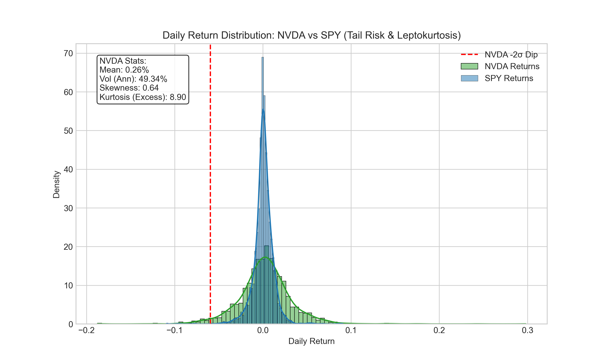
Figure 2: Kernel Density Estimation showing heavy tails and leptokurtosis in NVDA compared to SPY.
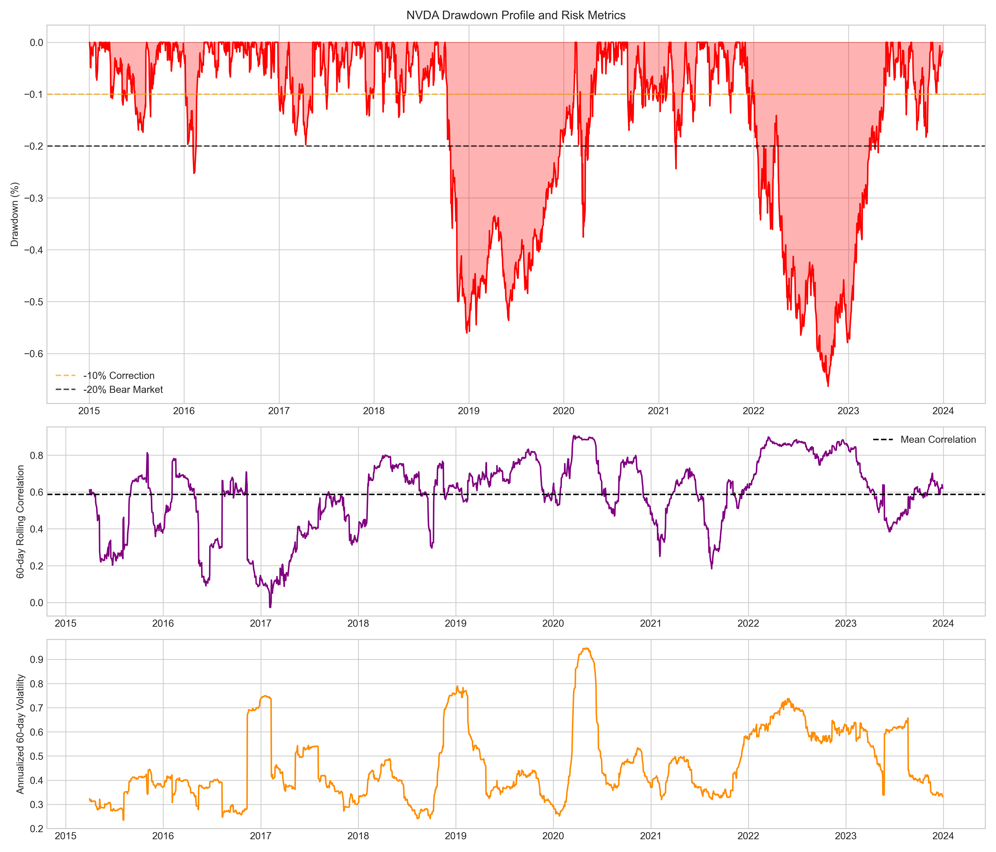
Figure 3: Underwater drawdown chart, rolling correlation with SPY, and rolling Volatility clustering.

Performance Evaluation
Our out-of-sample ML model evaluation is structured into three rigorous Tear-Sheet panels:
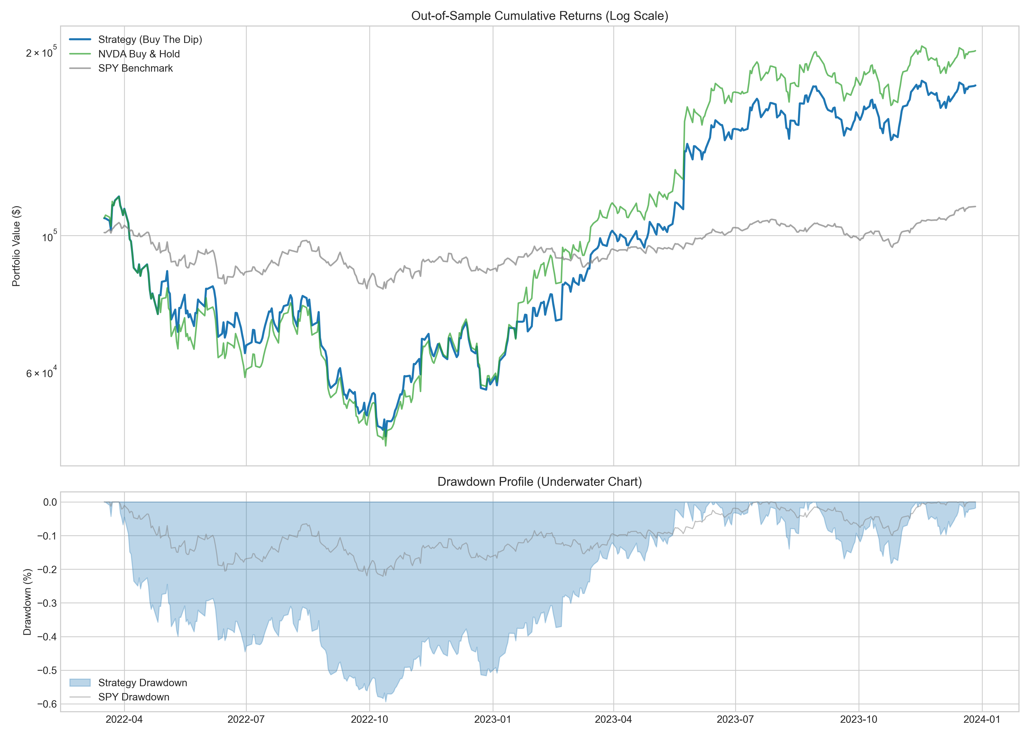
Figure 4: Hero Chart - Cumulative Returns (Log Scale) proving alpha over Buy & Hold, and the synchronized Underwater Drawdown Profile.
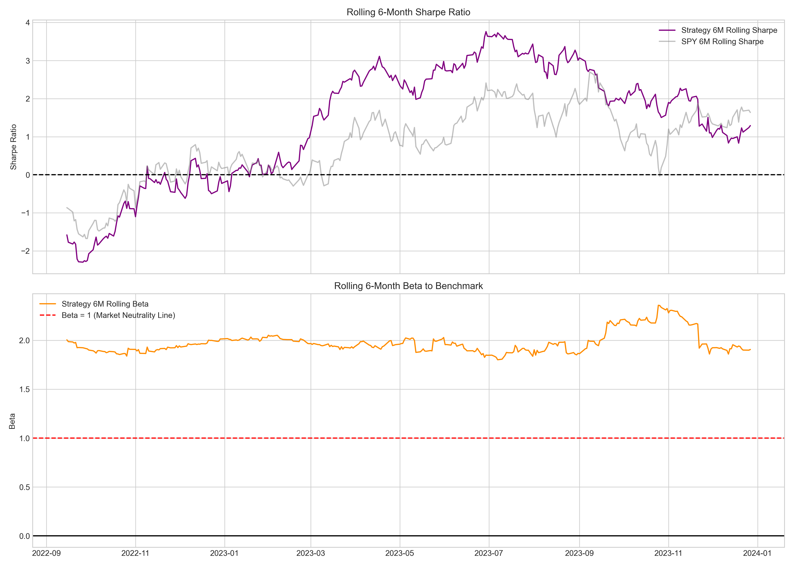
Figure 5: Rolling 6-Month Sharpe Ratio and Beta. This demonstrates the consistency of the risk-adjusted edge and market exposure dynamically.
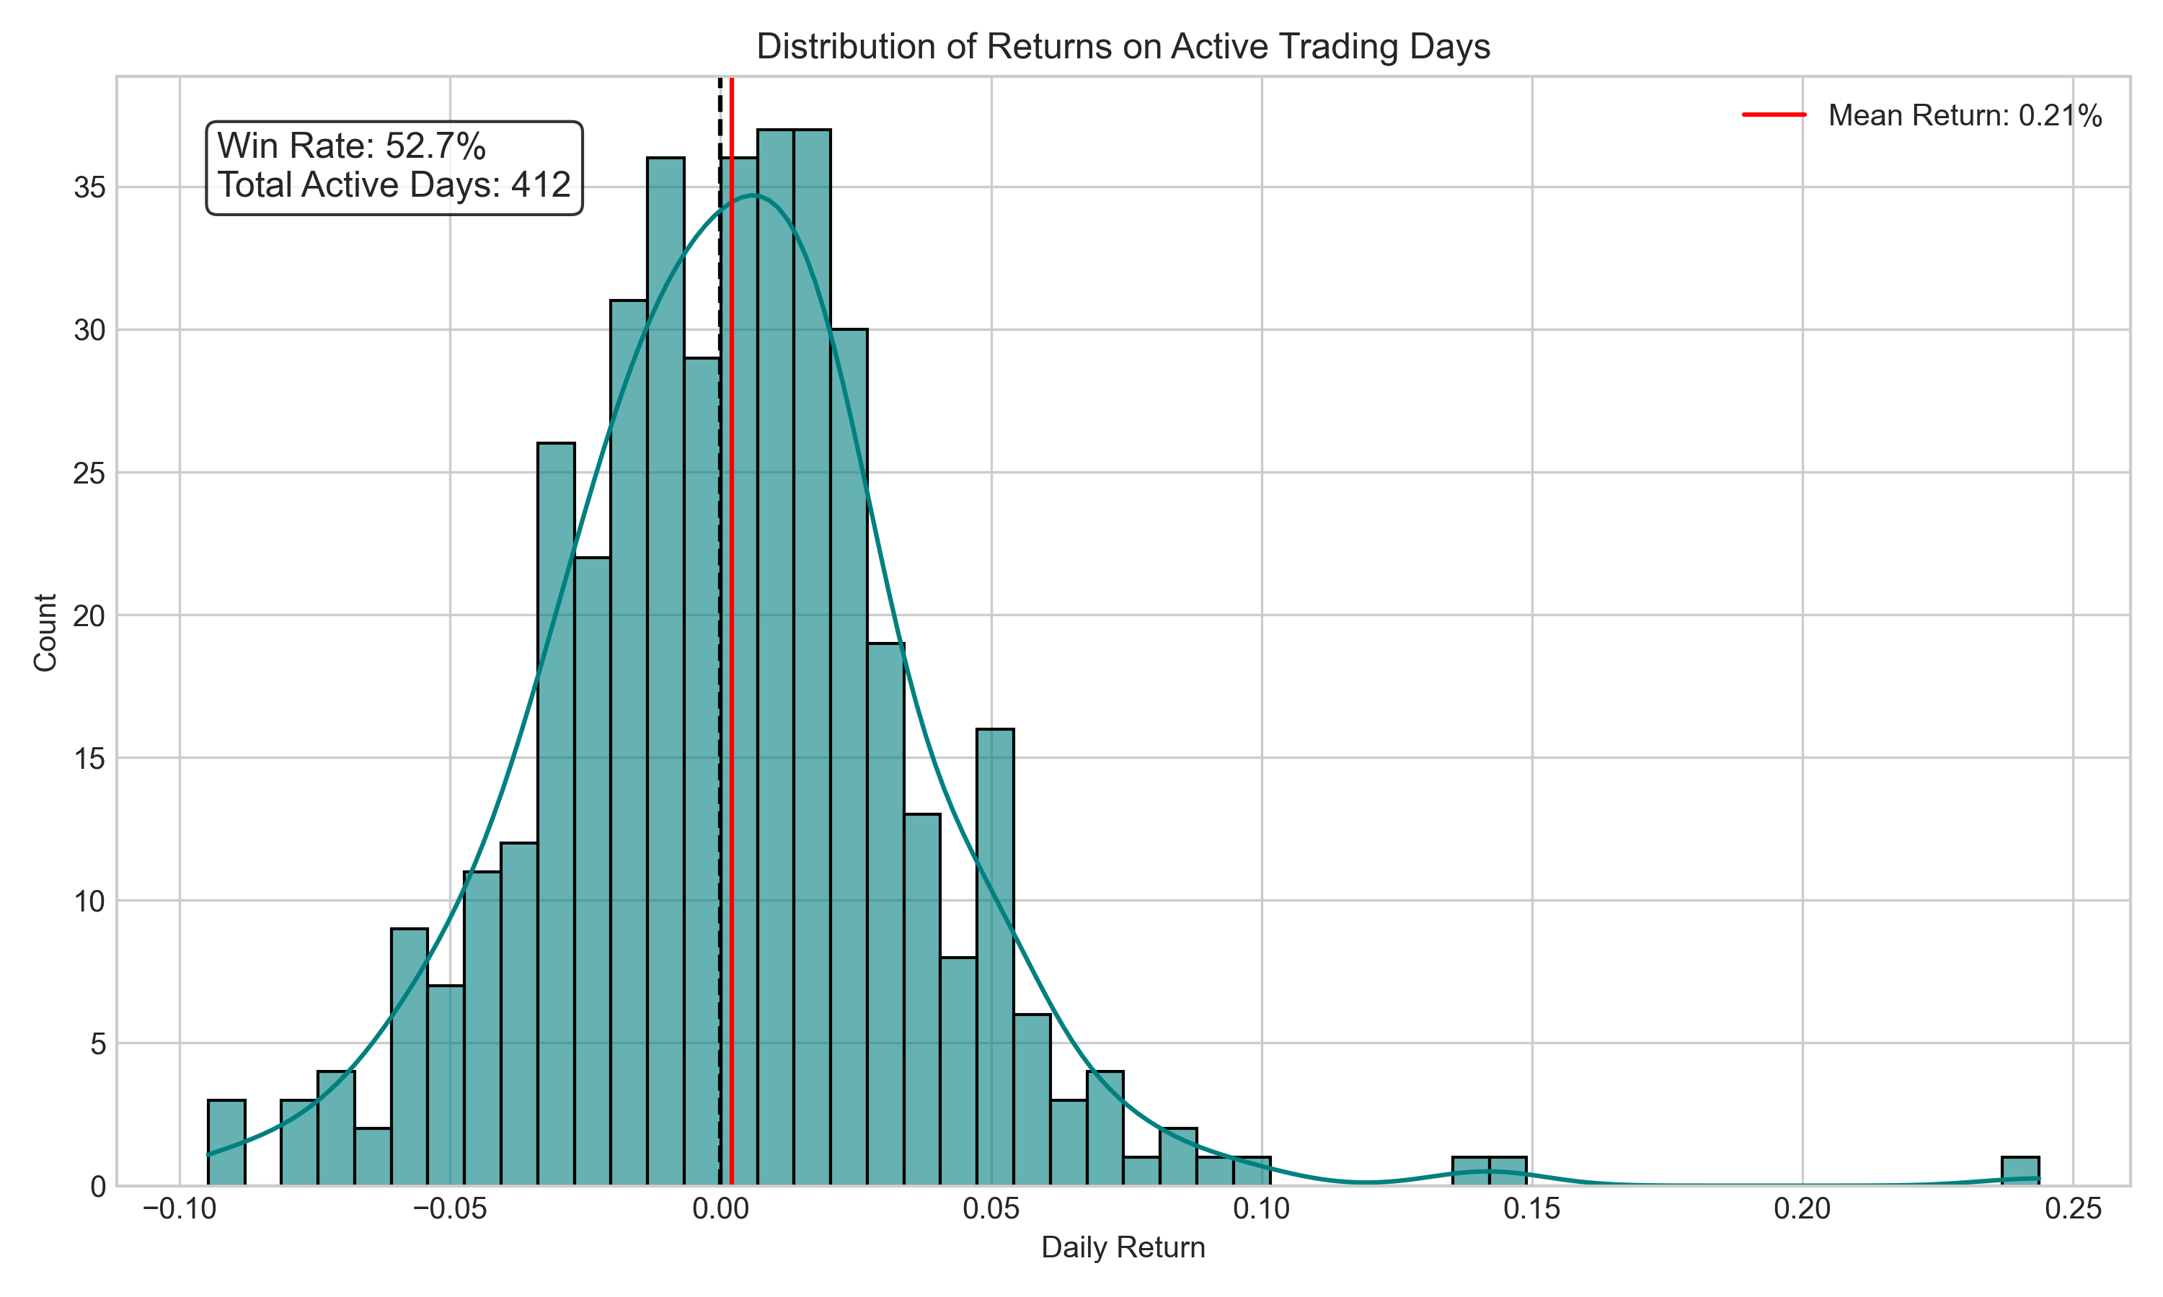
Figure 6: Return distribution exclusively on active trading days, detailing Win Rate and Mean Return asymmetry.

Conclusion & Original Text Excerpts
Below are selected excerpts from the original extracted text for continuity:
NATIONAL UNIVERSITY OF SINGAPORE
Department of Data Science and Analytics
DSA5205: Machine Learning in Finance
Design, Validate, and Analyze an Original Asset
Trading Strategy
An Empirical Investigation into High-Dimensional Mean Reversion under
Secular Momentum: “Buy the Dip” on NVIDIA (NVDA)
Group ID: Group 28
Team Allocation:
Member 1: Strategy Design, Data Infrastructure, & EDA
Member 2: Feature Engineering, Regularization, & Cross-Validation
Member 3: Execution Logic, Backtesting Engine, & Performance Analysis
Academic Term: AY 2026/2027
Submission Date: October 2026
1
DSA5205 Project 2 | Group 28: Buy the Dip Strategy
Executive Summary & Abstract
Abstract — This research investigation implements, validates, and analyzes an original system -
atic asset trading strategy designed to exploit short-term mean-reverting anomalies (“buying the
dip”) on NVIDIA Corporation (NVDA) over a multi-year macroeconomic cycle (January 2015 –
January 2024). High-growth technology equities frequently exhibit severe short-term behavioral
overreactions driven by institutional liquidity cascades, margin de-leveraging, and retail sentiment
shocks. Using a penalized Ridge regression framework (𝐿2 regularization) motivated by modern
high-dimensional learning theory (Kelly, Malamud, and Zhou, 2024), we formulate a predictive
model mapping historical return structures and moving average divergences to forward one-day
excess returns.
To eliminate common pitfalls in quantitative asset pricing, we implement rigorous methodolog -
ical safeguards: strict chronological partitioning (80% Train/Val, 20% Out-of-Sample Holdout),
leakage-free feature standardization via expanding-window TimeSeriesSplit cross-validation,
static outlier bounds, and realistic Market-On-Close (MOC) execution penalizing round-trip
turnover by 10 basis points (0.10%).
In out-of-sample evaluation across 449 trading days, our strategy generates an annualized return
of 46.06%, an annualized volatility of 54.12%, and a Sharpe ratio of 0.85 (net of costs),
substantially outperforming the broad US equity market benchmark SPY (Annualized Return:
7.96%, Sharpe Ratio: 0.41). While the strategy achieves robust risk-adjusted alpha over the
market, it intentionally underperforms the unconstrained Buy-and-Hold NVDA benchmark (An-
nualized Return: 54.18%, Sharpe: 0.98). We demonstrate that this underperformance represents
an inevitable mathematical consequence of contrarian timing in a secular, generative-AI-fueled
momentum regime: by design, the model shifts capital into risk-free cash during extended vertical
runs, trading away maximum upside capture to curb catastrophic drawdowns.
Contents
Executive Summary & Abstract . . . . . . . . . . . . . . . . . . . . . . . . . . . . . . . . . . . . . . . . . . . . . . . . . . . . . . . . . . . . . . . . . . . . . 2
1 Introduction & Economic Story . . . . . . . . . . . . . . . . . . . . . . . . . . . . . . . . . . . . . . . . . . . . . . . . . . . . . . .
...[truncated for brevity]...

