Kathmandu University
Department of Computer Science and Engineering
Dhulikhel, Kavre



A Project Report
on
“altEco”

[Code No: COMP 206]
(For partial fulfillment of II Year/ I Semester in Computer Engineering)

Submitted by
Rochak Adhikari (03)
Suyog Basnet (05)
Aditya Pokharel (32)
Nikunj Pokharel (33)
Nerish Shrestha (51)

Submitted to
Mr. Suman Shrestha
Department of Computer Science and Engineering

Submission Date: 2025/08/05
Bona fide Certificate

This project work on
“altEco”
is the bona fide work of
“Rochak Adhikari” (03)
“Suyog Basnet” (05)
“Aditya Pokharel” (32)
“Nikunj Pokharel” (33)
“Nerish Shrestha” (51)
who carried out the project work under my supervision.

Project Supervisor

________________________
Dr. Rajani Chulyadyo
Assistant Professor
Department of Computer Science and Engineering
Date: 2025/08/05

Acknowledgement
We would like to express our sincere gratitude to our Project Supervisor, for her unwavering support, insightful guidance, and encouragement throughout our project. Her expertise and valuable feedback have been instrumental in helping us navigate challenges and refine our work to achieve the best possible outcome.
We are also deeply grateful to the Department of Computer Science and Engineering (DOCSE) project community for giving us the opportunity to undertake this endeavor. Working on our project has been an enriching experience, allowing us to explore modern development frameworks, design intuitive user interfaces, and implement robust backend solutions. The project has not only strengthened our technical proficiency but has also deepened our understanding of system architecture and real-world application development.
This journey has been an invaluable learning experience, helping us grow both as developers and as a team. We sincerely appreciate the support, resources, and guidance that have contributed to making this project a success.

Abstract
With the increasing global emphasis on environmental sustainability, consumers are seeking reliable ways to make eco-conscious purchasing decisions. However, challenges such as greenwashing, inconsistent labeling, and limited access to trustworthy environmental data hinder the identification of genuinely sustainable products. This project proposes the development of a dedicated platform that leverages machine learning to recommend eco-friendly consumer products based on user preferences and standardized sustainability metrics. The system will analyze diverse data points-including material sourcing, manufacturing practices, and eco certifications to generate personalized recommendations and assign sustainability scores to products. Additional features include educational content, impact tracking, and community-driven insights to promote informed and responsible consumption. By offering accessible, actionable information and alternatives, the platform aims to empower users to reduce their environmental footprint, foster behavioral change toward sustainable lifestyles, and support the broader goals of waste reduction, resource conservation, and decreased carbon emissions.
Keywords: Sustainability, Machine Learning, Greenwashing, Data Analysis

Table of Contents
Acknowledgement ii
Abstract iii
List of Figures v
Acronyms/Abbreviations vi
Chapter 1 Introduction 1
1.1 Background 1
1.2 Objectives 2
1.3 Motivation and Significance 2
Chapter 2 Related Works 3
2.1 Reddit 3
2.2 Slack 3
Chapter 3 Design and Implementation 5
3.1 System Requirement Specifications 11
3.1.1 Software specifications 11
3.1.2 Hardware specifications 11
Chapter 4 Discussion on the achievements 12
4.1 Features 12
Chapter 5 Conclusion and Recommendation 14
5.1 Limitations 14
5.2 Future Enhancement 15
References 16
APPENDIX 17

List of Figures
Figure 2.1.1: Discussion and Content Sharing in Reddit (https://reddit.com) 3
Figure 2.2.1: Communication Features in Slack (https://slack.com) 4
Figure 3.1: Main System Flowchart 6
Figure 3.2: User Navigation Flowchart - Home and Related Pages 7
Figure 3.3: Communication Flowchart - Friends and Messages 8
Figure 3.4: Account Management Flowchart - Settings Page 9
Figure 3.5: Use Case Diagram 10
Figure i: Gantt Chart 17
Figure ii: Home Page 17
Figure iii: Messaging Section 18
Figure iv: Friends Section 18
Figure v: Notifications 19
Figure vi: Saved Posts 19
Figure vii: My Profile Section 20
Figure viii: User Profile Section 20
Figure ix: Settings Section 21
Figure x: Search Section 21

Acronyms/Abbreviations
CSS = Cascading Style Sheet
DB = Database
GB = Gigabyte
GHz = GigaHertz
JS = JavaScript
KU = Kathmandu University
OS = Operating System
RAM = Random Access Memory
UI = User Interface
WYSIWYG = What You See Is What You Get

Introduction

Background
With growing awareness of the environmental impact of consumer habits, individuals are increasingly motivated to make eco-conscious decisions in their daily purchases. (Ashley Reichheld, 2023) The push for sustainability has led to a rising demand for products that are ethically sourced, biodegradable, recyclable, or have a low carbon footprint. However, despite this demand, consumers often face difficulty identifying genuinely sustainable products due to greenwashing, inconsistent labeling, and limited access to reliable environmental data. (Şenyapar, 2024)
Most current e-commerce platforms and product search tools are not equipped to provide detailed insights into the sustainability of the products they feature. While some platforms highlight eco-tags or offer generic filters like “organic” or “vegan,” these features lack depth and consistency. As a result, consumers are left without a comprehensive way to compare the environmental impact of their choices or to discover more responsible alternatives that align with their values. (Emmanuel Mireku, 2024)
This project proposes a dedicated platform that leverages artificial intelligence to assist users in making more sustainable shopping choices. By analyzing a wide range of data points—such as carbon footprint, material sourcing, manufacturing practices, and eco-certifications—the system will generate personalized recommendations for eco-friendly products. The platform will also offer educational content, impact tracking features, and community-driven insights, helping users become more informed and proactive in reducing their environmental footprint. Through this approach, the solution aims to empower everyday consumers to contribute meaningfully to sustainability, not just through awareness but through measurable actions.

Objectives
The major objectives of altEco are listed below:
- To recommend eco-friendly consumer products based on user preferences and sustainability metrics.
- To assign and display sustainability scores for products using standardized environmental criteria.
- To allow customization of recommendations based on ethical and ecological filters.
- To track users’ environmental impact through eco-friendly product choices.

Motivation and Significance

In today’s world, environmental sustainability has become a global priority, yet many individuals remain unaware of the harmful impacts of everyday products they use. (Sousa, 2023) The project altEco is driven by the need to provide accessible and practical information that helps users identify commonly used objects and discover their eco-friendly alternatives. By offering clear, sustainable options, the project encourages more responsible consumption habits and supports a transition toward greener lifestyles. This initiative is significant not only in promoting individual awareness but also in contributing to broader environmental goals such as waste reduction, resource conservation, and decreased carbon footprint.

Related Works
Some existing platforms related to our project are mentioned below:

Yuka
Yuka (Yuka, 2025) is a mobile app that helps users make healthier and safer choices by evaluating food and cosmetic products. It uses a rule-based scoring system to assess nutritional content, additives, and the risk level of ingredients, assigning products a score from 0 to 100 and provides recommendations for healthier or safer alternatives. Based on this score, Yuka recommends healthier alternatives but does not personalize recommendations or focus on environmental sustainability. While Yuka is highly effective in helping users make informed decisions about their health, it primarily focuses on nutrition and ingredient safety.

Figure 2.1.1: Yuka App

Green Choice
Green Choice (Green Choice, 2025) is a mobile application designed to assist users with their food choices. They not only take into consideration the nutritional value of various options but also how eco-friendly they are. Elements such as organic certification and carbon footprint are taken into account. This analysis yields a Green Score, which forms the basis of product recommendations, providing readily accessible replacements with better sustainability profiles. While Green Choice encourages conscious consumption with a broad overview of product impacts, its recommendations are primarily based on the overall Green Score and general product attributes, providing generalized suggestions rather than personalized ones tailored to specific dietary needs or values beyond its core sustainability framework.
Figure 2.2.1: Green Choice App

Design and Implementation
The following outline provides an overview of the sequential process and techniques used during the project:
Step 1: Project Planning
We began by organizing our project workflow, assigning tasks among team members to ensure an efficient development process.
Step 2: System Design and Architecture
After defining the project requirements, we designed the system architecture, including the DB schema, user interface layouts, and overall structure. Flowcharts and system diagrams were created to illustrate data flow and component interactions within the system.
Step 3: Development and Coding
            - Backend: The software was built using Express.js as the backend framework and Python as the , with React handling the frontend development.
            - DB Implementation: The DB was implemented using PostgreSQL, providing an interface for managing and querying data efficiently.
            - User Interface Design: The UI was developed using Tailwind CSS, ensuring a responsive and intuitive user experience.
- Testing and Debugging: Comprehensive testing was conducted, including unit testing, integration testing, and user acceptance testing. A continuous bug-tracking process was followed to maintain application stability.
Step 4: Documentation
A complete set of documentation was prepared, including technical documentation. Throughout the project, regular team communication and collaboration were maintained to align with project goals and user expectations.
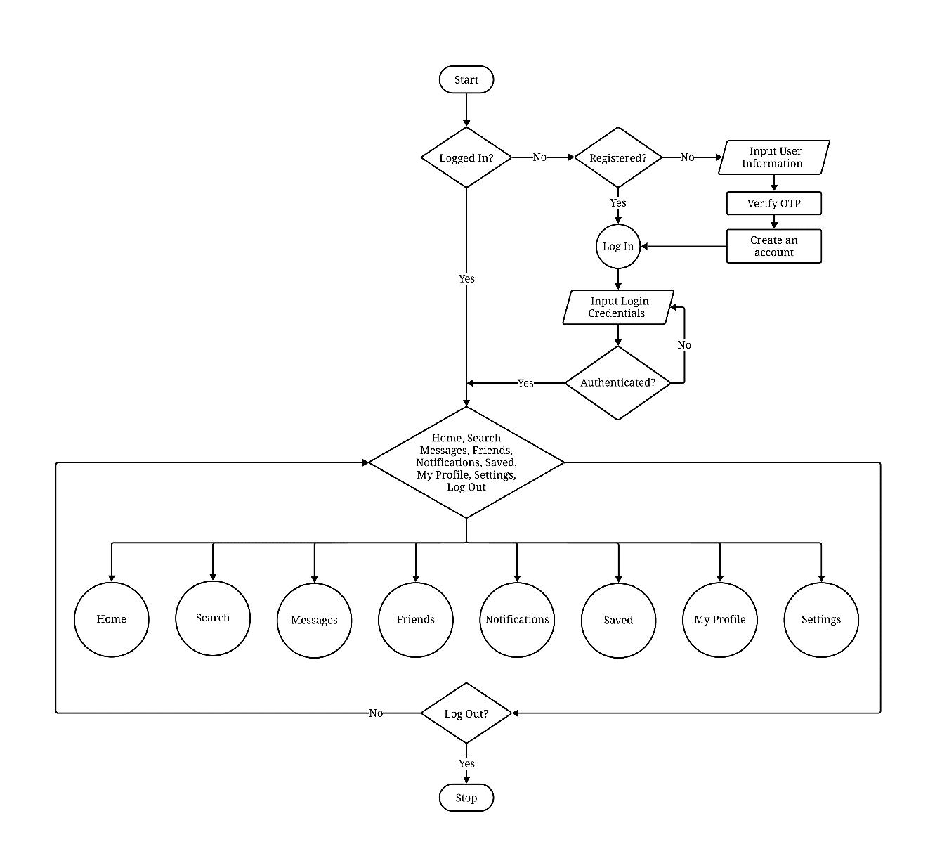
Figure 3.1: Main System Flowchart
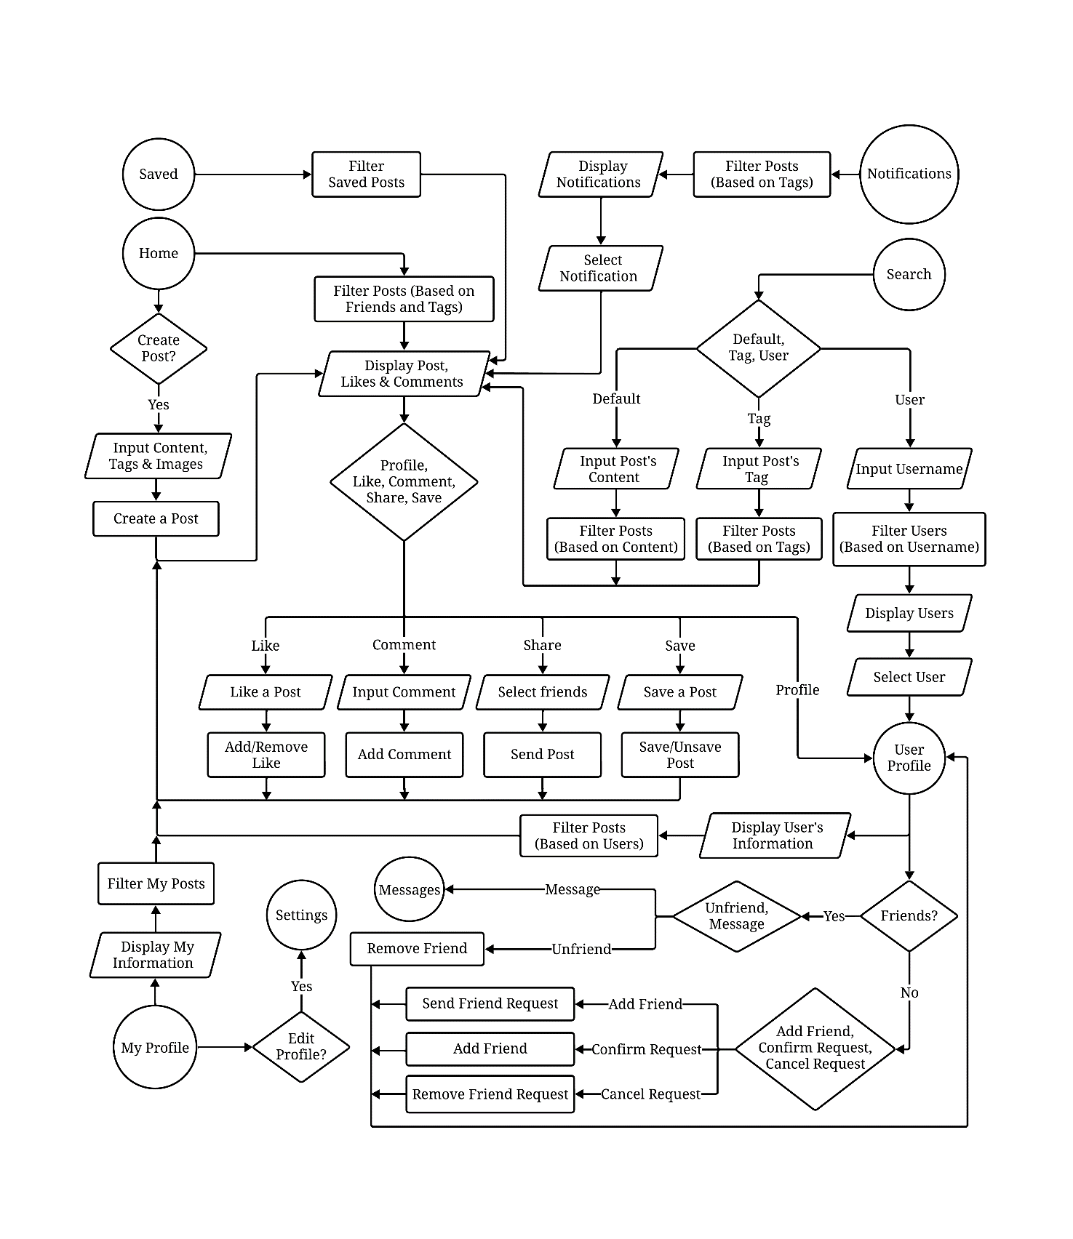
Figure 3.2: User Navigation Flowchart - Home and Related Pages
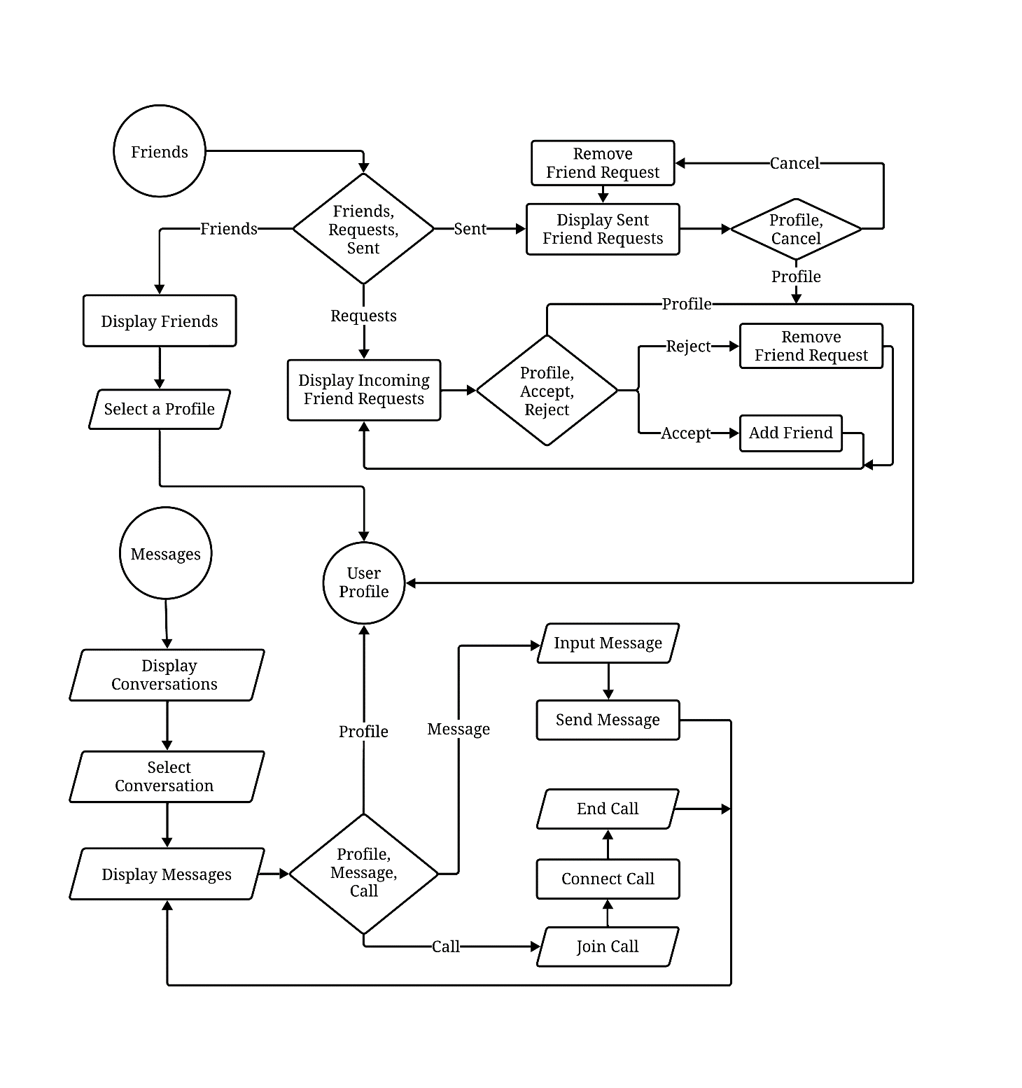
Figure 3.3: Communication Flowchart - Friends and Messages
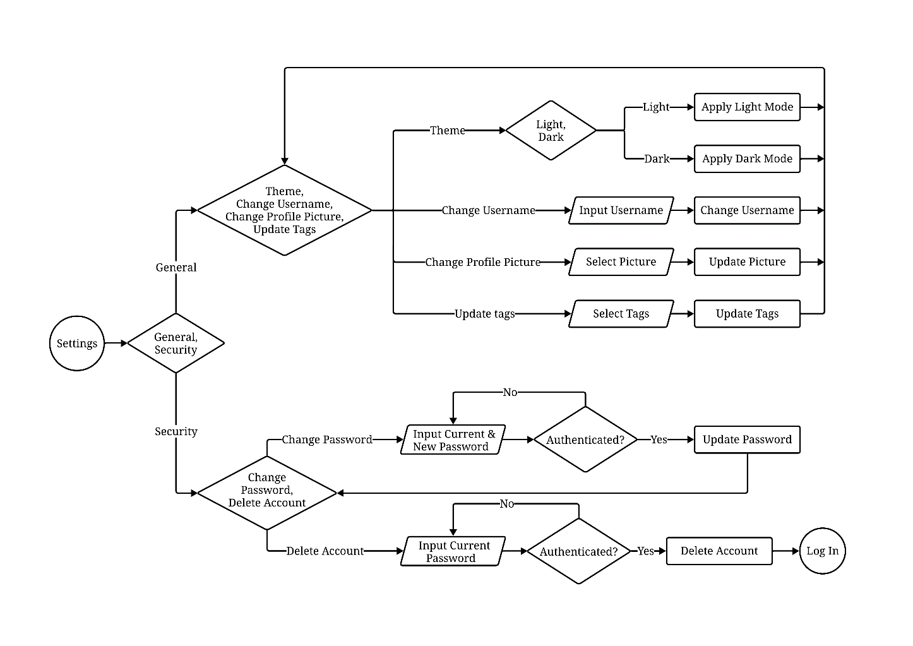
Figure 3.4: Account Management Flowchart - Settings Page
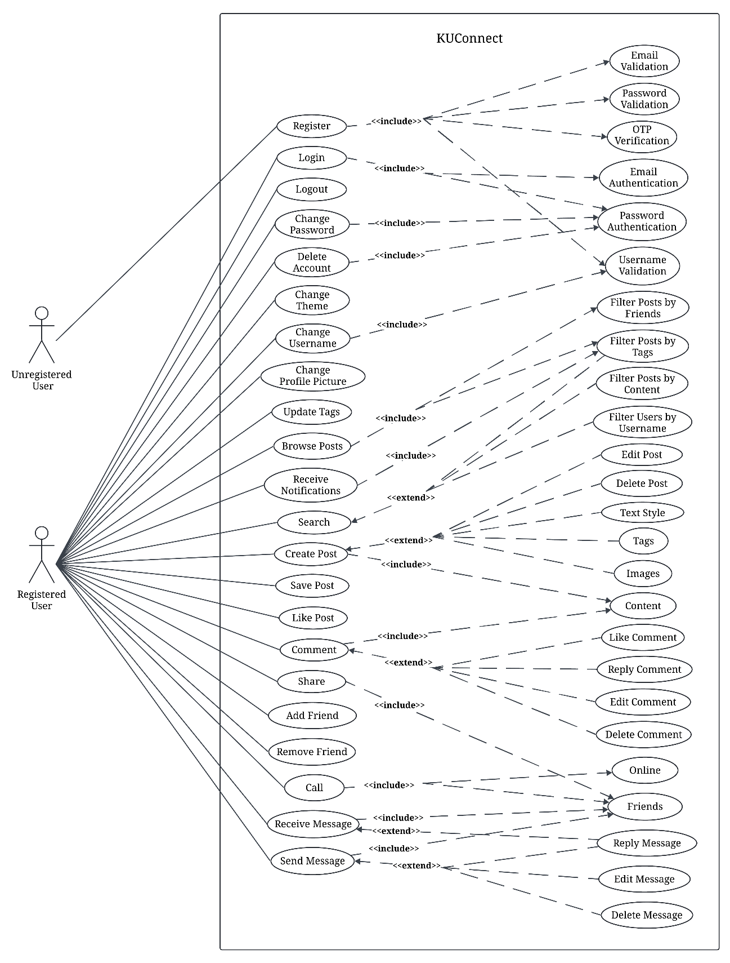
Figure 3.5: Use Case Diagram

System Requirement Specifications

Software specifications
Since this eco-friendly product recommendation system was developed as a web application using TypeScript, the system requirements are aligned with modern web applications built using TypeScript frameworks. The application has utilized PostgreSQL for DB management, React for the user interface, and real-time recommendation using machine learning. The following are the suggested software requirements for altEco:
- Browser Compatibility: The application is supported on modern browsers, including Google Chrome, Firefox, Safari and Microsoft Edge.
- Operating System Compatibility: The web application works across platforms, including Windows, macOS and Linux as long as they support the compatible browsers.
- Internet Connection: A stable internet connection is required, especially for real-time recommendation.

Hardware specifications
To ensure optimal performance, the following hardware specifications are recommended. However, the application is designed to be lightweight and can function on most modern devices. The suggested hardware requirements are:
- Processor: 1.5 GHz dual-core processor or equivalent.
- Memory: 4 GB of RAM.
- Storage: 200 MB for cache and local storage.

Discussion on the achievements

Features
- Login/Registration
- Users can create an account using their email and password or sign in with existing credentials.
- Secure authentication mechanisms, such as password hashing and session/token-based authentication, ensure account security.
- Error handling and validation checks (e.g., duplicate emails, password strength) are implemented for a smooth onboarding experience.
- Create, Edit, and Delete Posts (Including Images, Embedded Videos, and Formatted Text)
- Users can create posts with rich text formatting options, including bold, italics, lists, and links.
- Support for media attachments, allowing users to upload images and embed videos directly into their posts.
- Editable posts enable users to make modifications after publishing, with an option to delete posts if necessary.
- Markdown or a WYSIWYG editor is integrated for an intuitive content creation experience.
- Instant Messaging
- Real-time messaging is implemented using WebSockets, enabling seamless conversations between users.
- Messages are stored in the DB for persistent chat history.
- Typing indicators, read receipts, and notifications enhance the messaging experience.
- A responsive chat UI ensures accessibility across different devices.
- Subscribe to Tags (Topics) You Prefer
- Users can follow specific tags or topics to tailor their content feed.
- Subscribed topics appear in a personalized feed, ensuring users stay updated on discussions that interest them.
- Notifications can be enabled for new posts under ‘followed’ tags.
- User-Friendly Interface
- The UI is designed to be clean, modern, and easy to navigate.
- Responsive design ensures a seamless experience across desktops, tablets, and mobile devices.
- Dark mode and accessibility features, such as adjustable font sizes and keyboard navigation, are incorporated for better usability.
- Functional Search Component
- A search bar allows users to find posts, tags, and users efficiently.
- Advanced filtering options, such as sorting by relevance, date, or popularity, enhance search functionality.
- Full-text search ensures accurate and fast retrieval of relevant results.

Conclusion and Recommendation
The development of KUConnect aims to address the communication gap within Kathmandu University by providing a dedicated platform for academic interactions and campus-related updates. Through features like real-time messaging, categorized posts, and a user-friendly interface, the application ensures that students and faculty members remain informed and connected. Utilizing modern technologies such as React, Tailwind CSS, Express.js and MongoDB, the project demonstrates an efficient integration of frontend and backend systems.
While the application successfully implements core functionalities such as login/registration, post creation, instant messaging, and topic subscriptions, certain limitations remain, particularly in scalability, advanced security measures, and comprehensive accessibility features. Despite these challenges, KUConnect has achieved its objective of creating a centralized and distraction-free environment for university-specific communications, ultimately fostering a more engaged campus community.

Limitations
While the KUConnect project achieved significant milestones, certain limitations remain:
- Scalability Constraints: The current architecture may face performance issues with a significantly large user base.
- Basic Security Measures: Although standard authentication is implemented, advanced security features like two-factor authentication (2FA) and end-to-end encryption are absent.
- Limited Accessibility Features: The application lacks comprehensive accessibility options for users with disabilities, such as screen reader support or voice navigation.
- Absence of a Mobile Application: While the web application is responsive, a dedicated mobile app would enhance usability and accessibility.

Future Enhancement
To improve upon the current version of KUConnect and address the identified limitations, the following recommendations are suggested:
- Enhance Security and Privacy: Implement two-factor authentication and end-to-end encryption to strengthen account and messaging security.
- Improve Scalability and Performance: Optimize backend code and use cloud services for better load handling and faster data processing.
- Develop a Dedicated Mobile Application: Create Android and iOS apps to improve accessibility and increase user engagement.
- Expand Accessibility Features: Add screen reader support, customizable text sizes, and high-contrast modes to cater to diverse users.

References
(n.d.). Retrieved January 1, 2025 from Slack: www.slack.com
(n.d.). Retrieved March 1, 2025 from Reddit: www.reddit.com
Astleitner, H., & Sarah, S. (2024). The social media use of college students: Exploring identity development, learning support, and parallel use. Sage Journals.
Johnson, L. (2020). Blog: Slack. From Slack: https://slack.com/intl/fr-fr/blog/collaboration/universities-keep-class-in-session-with-channels
Ndung'u, J., Vertinsky, I., & Onyango, J. (2023). The relationship between social media use, social media types, and job performance amongst faculty in Kenya private universities. Heliyon.

APPENDIX
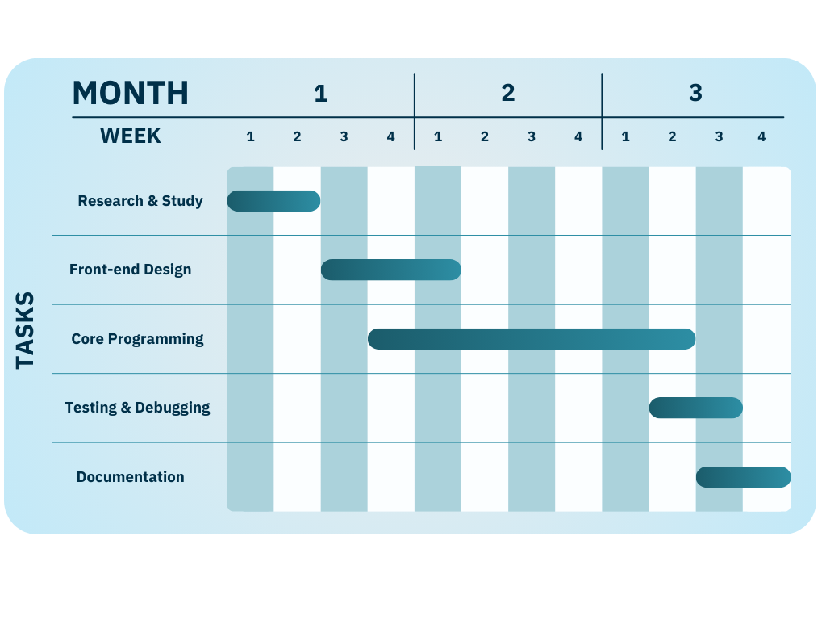
Figure i: Gantt Chart

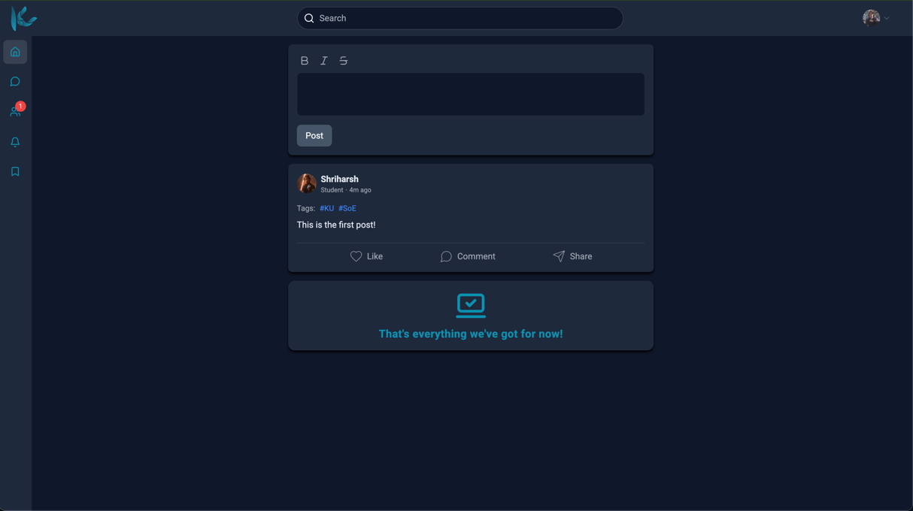
Figure ii: Home Page
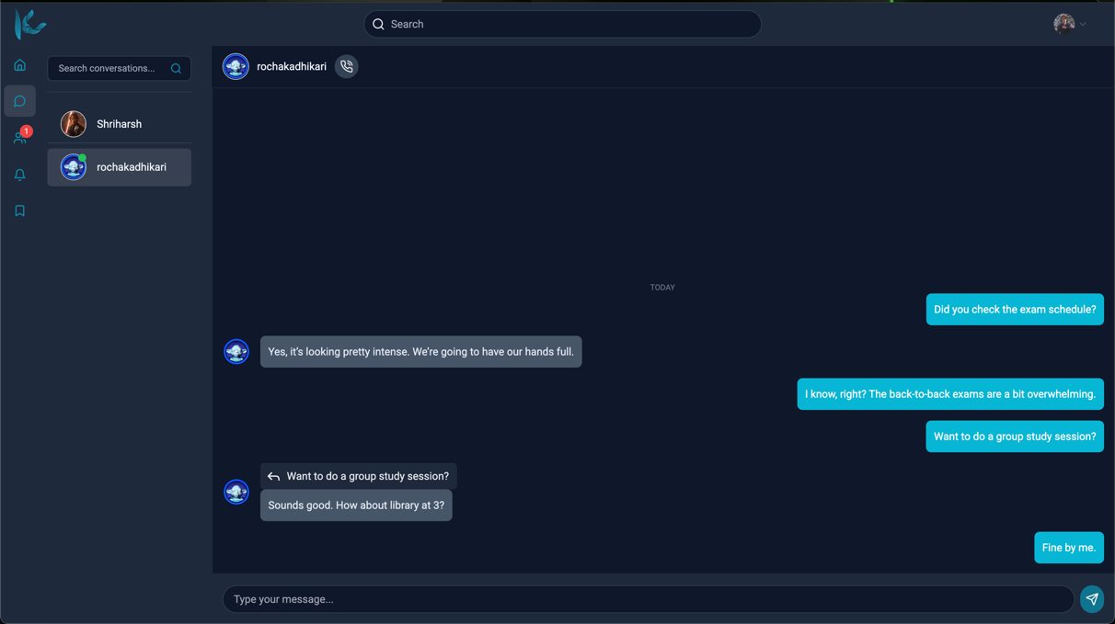
Figure iii: Messaging Section

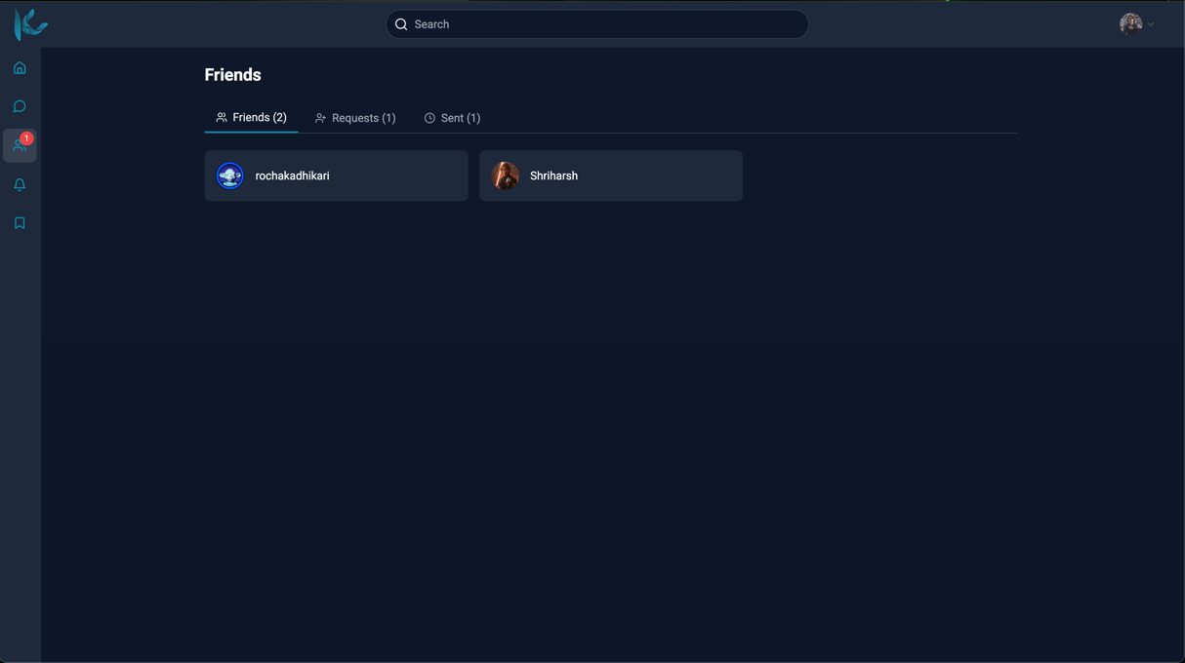
Figure iv: Friends Section

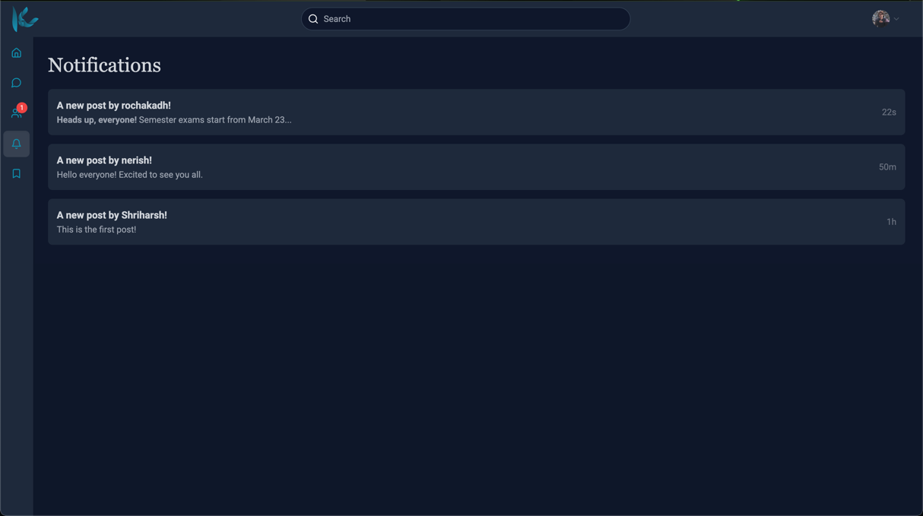
Figure v: Notifications

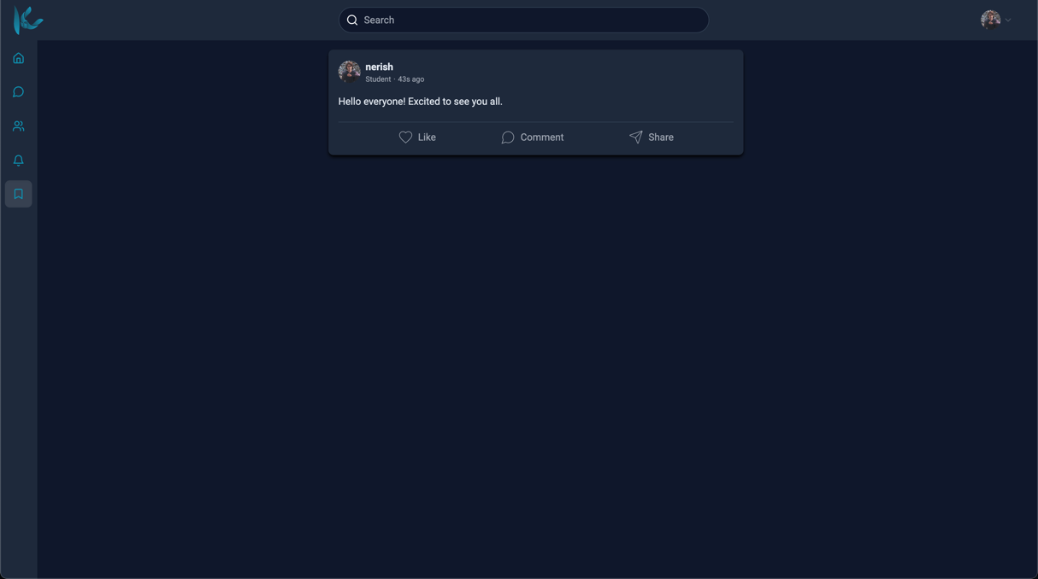
Figure vi: Saved Posts

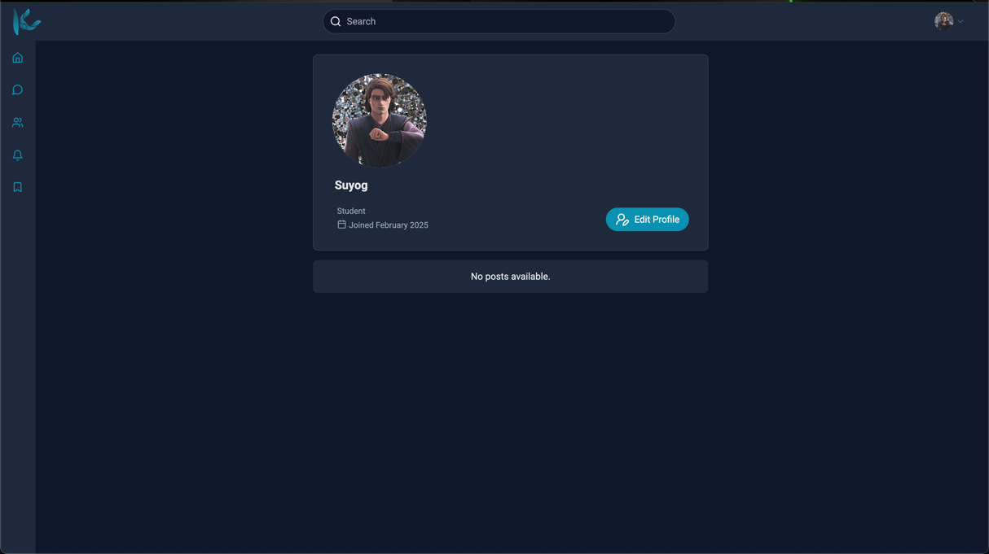
Figure vii: My Profile Section

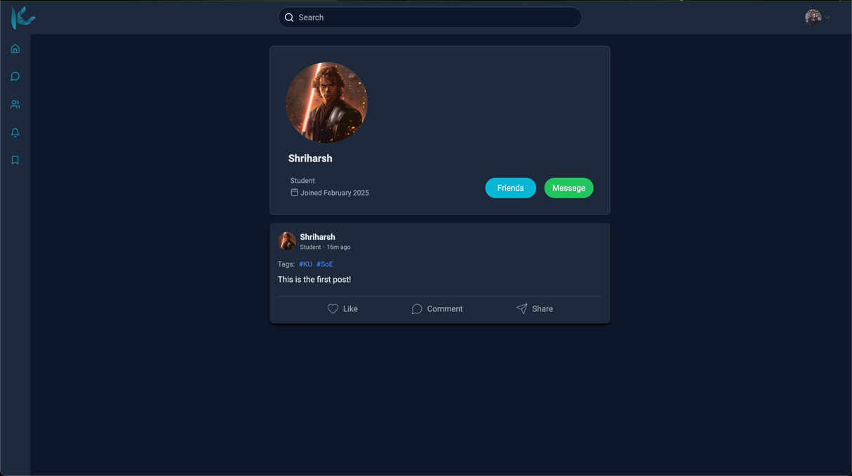
Figure viii: User Profile Section

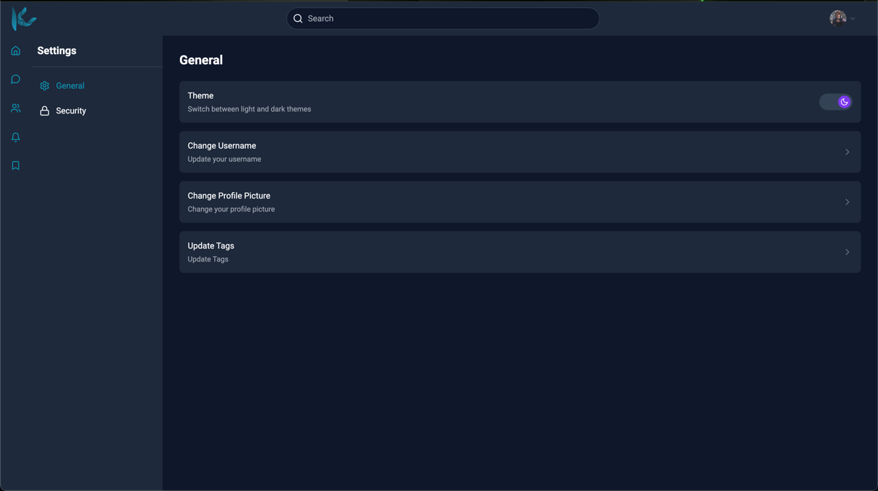
Figure ix: Settings Section

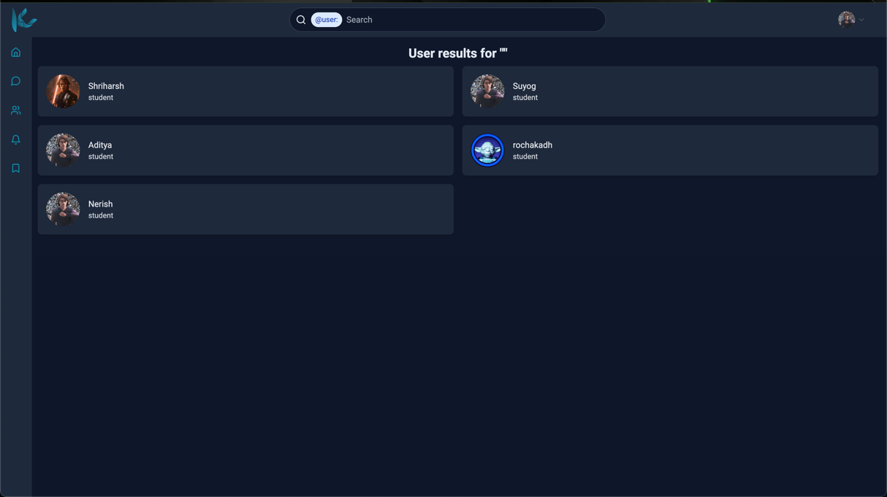
Figure x: Search Section

