# Hadi 150

88b58e4c-c54a-4e33-a9bd-6554bafe9efb Ettehad-1

VMESS CDN

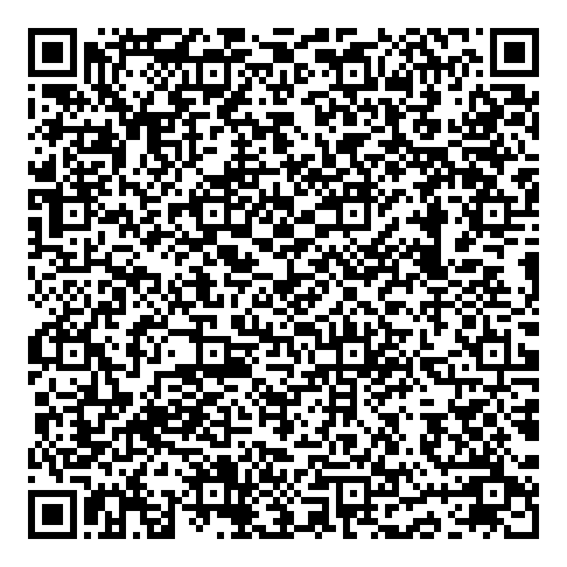

VMESS TLS

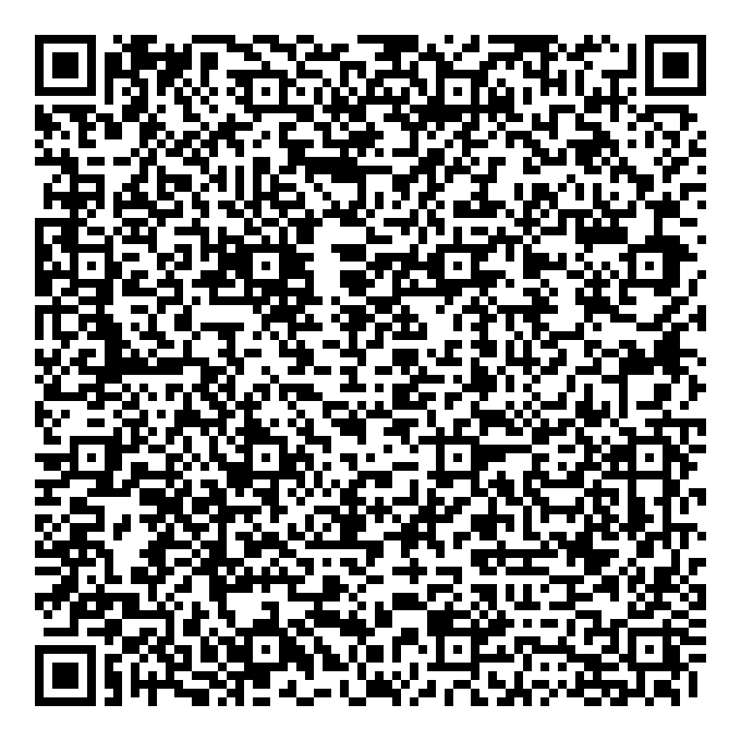

VMESS TLS CDN

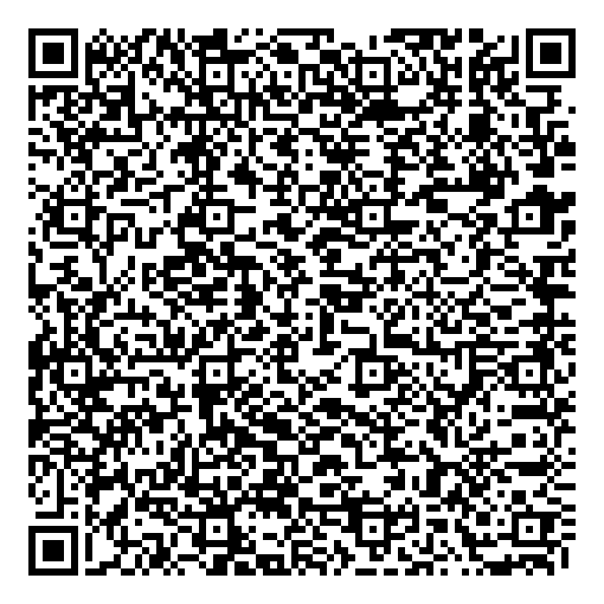

# Hadi 150

d074c8f9-fb65-4078-9db5-08ea569267ef Ettehad-1

VMESS CDN

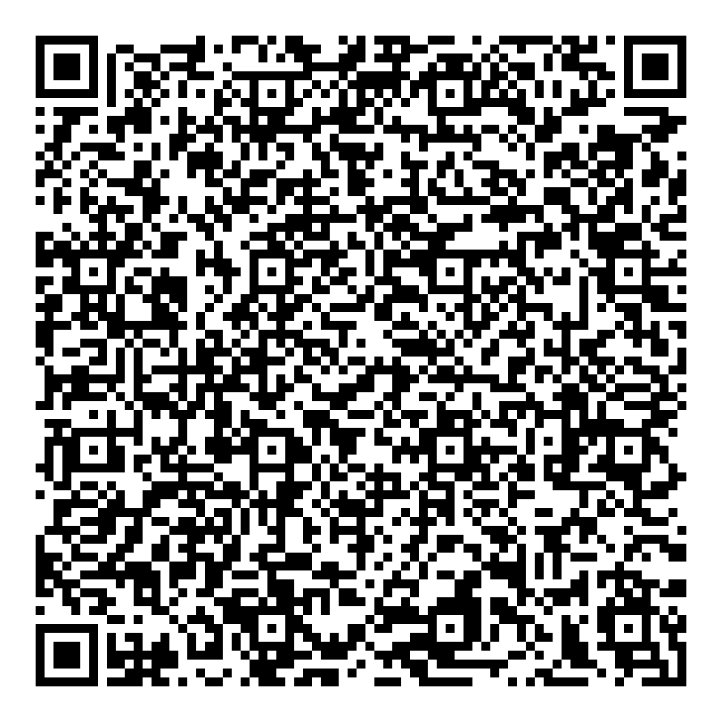

VMESS TLS

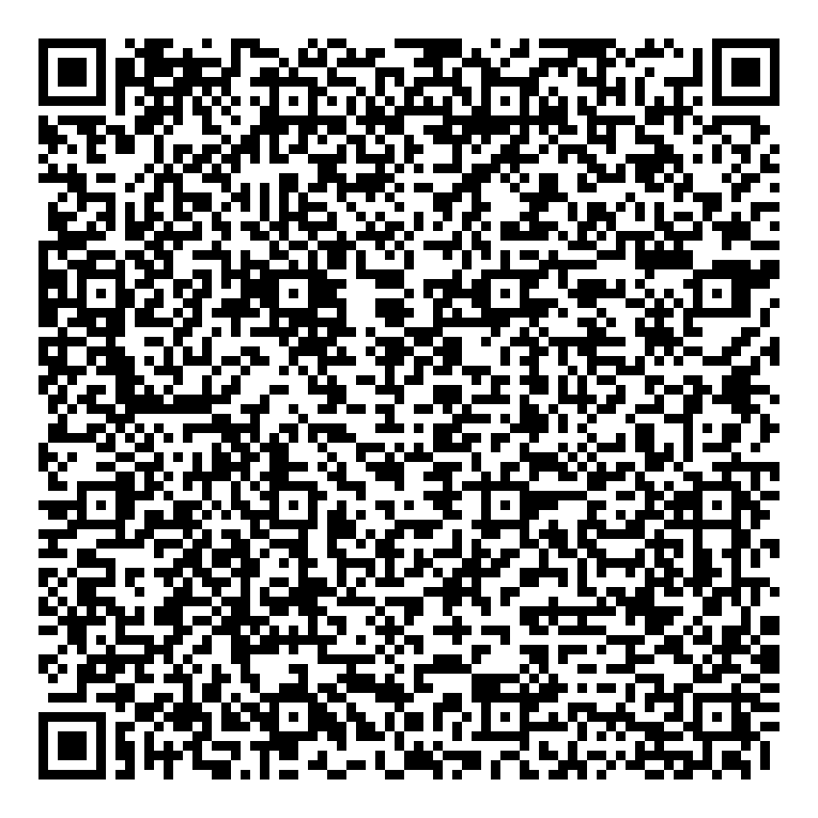

VMESS TLS CDN

