WEB-BASED PUBLIC MARKET BUILDING DIRECTORY AND WAY FINDING KIOSK WITH VENDOR MANAGEMENT SYSTEM

A Capstone Project

Presented to the Faculty of the

Information and Communications Technology Program

STI College General Santos

In Partial Fulfilment

of the Requirements for the Degree

Bachelor of Science in Information Technology

Briar Rose C. Chua

Meil Sheida J. Panaguiton

Prince Jay Mohammad Omar A. Sayre

Reyan Jan B. Samontanes

SEPTEMBER 2024

ENDORSEMENT FORM FOR ORAL DEFENSE

TITLE OF RESEARCH: WEB-BASED PUBLIC MARKET BUILDING DIRECTORY AND WAY FINDING KIOSK WITH VENDOR MANAGEMENT SYSTEM

NAME OF PROPONENTS: Briar Rose C. Chua

Meil Sheida J. Panaguiton

Prince Jay Mohammad Omar A. Sayre

Reyan Jan B. Samontanes

In Partial Fulfilment of the Requirements

for the degree Bachelor of Science in Information Technology

has been examined and is recommended for Oral Defense.

ENDORSED BY:

Ivy Grace C. Laurente

Capstone Project Adviser

APPROVED FOR ORAL DEFENSE:

Ivy Grace C. Laurente

Capstone Project Coordinator

NOTED BY:

Anthony Mark F. Silong, MIT

Program Head

# SEPTEMBER 2024

# APPROVAL SHEET

This capstone project titled WEB-BASED PUBLIC MARKET BUILDING DIRECTORY AND WAY FINDING KIOSK WITH VENDOR MANAGEMENT SYSTEM , prepared and submitted by Briar Rose C. Chua, Meil Sheida J. Panaguiton, Prince Jay Mohammad Omar A. Sayre, and Reyan Jan B. Samontanes, in partial fulfillment of the requirements for the degree of Bachelor of Science in Information Technology, has been examined and is recommended for acceptance and approval.

Ivy Grace C. Laurente

Capstone Project Adviser

Accepted and approved by the Capstone Project Review Panel

in partial fulfillment of the requirements for the degree of

Bachelor of Science in Information Technology

|  |  |
| --- | --- |
| Kristel Joy C. Tulagan, LPT, MIT | Anthony Mark F. Silong, MIT |
| Panel Member | Panel Member |

Dan Henry P. Sales

Lead Panelist

Noted:

|  |  |
| --- | --- |
| Ivy Grace C. Laurente | Anthony Mark F. Silong, MIT |
| Capstone Project Coordinator | Program Head |

SEPTEMBER 2024

# Acknowledgements

The researchers would like to thank the following:

Capstone Project Coordinator, <state his/her contributions to your research>;

Capstone Project Adviser, <state his/her contributions to your research>;

Capstone Project Review Panel, <state their contributions to your research>;

Parents and/or Guardian, <state their contributions to your research>;

Friends and inspirations, <state their contributions to your research>; and

Others <state his/her contributions to your research**>.**

# Abstract

Title of research**: WEB-BASED PUBLIC MARKET BUILDING DIRECTORY AND WAY FINDING KIOSK WITH VENDOR MANAGEMENT SYSTEM**

Researchers: Briar Rose C. Chua

Meil Sheida J. Panaguiton

Prince Jay Mohammad Omar A. Sayre

Reyan Jan B. Samontanes

Degree: Bachelor of Science in Information Technology

Date of Completion: <Month year of graduation>

Keywords: <keywords of your research>

The abstract is a summary of the whole capstone project. It presents all the major elements of your work in a highly condensed form. It must be capable of substituting for the whole capstone project when there is insufficient time and space for the full text. Currently, the recommended size for an abstract is 150 to 350 words. Usually a one-pager abstract is the most ideal. The structure of the abstract should mirror the structure of the capstone project and represent all its major elements. There should be one or more sentences assigned to summarize each chapter of your capstone project.

In the succeeding paragraphs, there should be no indentations, paragraphs are justified with left alignment. Delete this highlighted section and replace it with your Abstract.

# Table of Contents

|  |  |  |
| --- | --- | --- |
|  | | Page |
| Title Page | | i |
| Endorsement form for Oral Defense | | ii |
| Abstract | | iii |
| Approval Sheet | | iv |
| Acknowledgments | | v |
| Table of Contents | | vi |
| List of Figures | | vii |
| List of Tables | | viii |
| List of Notations | | ix |
| Introduction | | 1 |
|  | Project Context |  |
|  | Purpose and Description |  |
|  | Objectives |  |
|  | Scope and Limitations  Review of Related Literature/Studies/Systems |  |
| Methodology | |  |
|  | Requirements Analysis |  |
|  | Requirements Documentation |  |
|  | Design of Software, System, Product, and/or Processes |  |
|  | Development |  |
| Results and Discussion | |  |
|  | Testing |  |
|  | Description of Prototype |  |
|  | Implementation Plan |  |
|  | Implementation Results |  |
| Conclusion | |  |
| References | |  |
| Appendices | |  |
|  | Resource Persons |  |
|  | Relevant Source Code |  |
|  | Evaluation Tool/Test Documents |  |
|  | Sample Input/Output/Reports |  |
|  | User’s Guide |  |
|  | Personal Technical Vitae |  |
|  | |  |

LIST OF FIGURES

*Figure 1. Gantt Chart*

*Figure 2.1 Context Flow Diagram (Manual)*

*Figure 2.2 Context Flow Diagram*

*Figure 3. Data Flow Diagram*

# Introduction

## Project Context

The fast evolution of technology has brought about significant changes in various aspects of society, including commerce and business management. In the field of retail, the efficient management of local marketplaces is essential for ensuring smooth operations and enhancing the overall shopping experience. However, traditional marketplace management often faces challenges such as inefficient space allocation, and limited visibility into store operations.

According to Public Market Development (2017), Public Markets exist to fulfill a public purpose, showcase a community’s unique character and culture while serving its everyday shopping needs. They typically focus on the sale of a full array of fresh, healthful, value added, and prepared foods – often locally grown or produced. They are sometimes rounded out by crafts and/or a variety of needed neighborhood businesses. They focus on businesses that are locally owned and operated which highlight the best of local foods, crafts, music, heritage and culture.

The stallholders or Vendors only rent for the space they are occupying for a period of time indicated in the lease contract they signed. Rentals vary from size and location of the stalls. Income received from the rentals are used for the maintenance and improvements of the market and the annual amortization of the loan to Municipal Development Fund Office (MDFO) who financed the public market's construction. The designated public market administrator oversees the daily status of vendors in the market. All vendors are bound by the rules and regulations set by the Municipality. The municipal government is proposing the transfer of some of the maintenance operations of the public market to the Guinayangan Public Market Vendors Association which includes among others the operation and maintenance of the comfort rooms. Sections of the markets are the fish, meat, dried fish, dry goods, fruits and vegetables, and grocery section (Local Government Unit Site, n.d.-b).

This study revolves around addressing these challenges through the development and implementation of a 2D Store Mapping System tailored for local marketplace particularly on Polomolok’s Public Market with 10 Buildings which are Building A, Building B, Building C, Building D, Building E (Bakery Section), Building F (Meat Section), Building G (Seafood and Dry Fish Section), Building H (Fruits Section), Building I (Vegetables Section), Building J (Thrift Store Section) which has 1,039 stalls. Based on the survey conducted within the local marketplace, it is evident that there is a pressing need for a solution.

## This study can have a significant impact on how effective marketplace management can benefit both business owners and customers. This will also enable customers to easily find stores and preferred stores.

## Purpose and Description

In the modern era, traditional marketplaces are required to keep up with the changing times and incorporate technology to streamline their operations. This capstone project aims to create a cutting-edge 2D Store Mapping System, designed to modernize marketplace management by providing valuable insights on occupancy status and simple transaction monitoring. The system will be a turning point for marketplace business operations, offering a more efficient and effective way to manage the daily activities of their businesses. By utilizing this system, marketplace administrators will be able to monitor all the transactions and also the occupancy status if it is occupied by vendors or not, ensuring compliance with capacity limits and providing a safer environment for shoppers. Additionally, the system will enable displaying 2D Store Map for each section of buildings and shows an information and details of vendors in each stalls.

The Implementation of Web-Based Public Market Building Directory and Way Finding Kiosk with Vendor Management System that allows Municipal Economic Enterprise and Development Office (MEEDO) to manage daily status and transactions, and 2D store map. The use of 2D map function will enable the customers to easily track the location of every store in the Public Market as well as the Vendors can view the location of their store.

In Store Market Management, Vendors can manage their own store and also for Municipal Economic Enterprise and Development Office (MEEDO) to see the current situation of space allocation of each section of building and it will also display the map of Public Market to give visualization of the stores, total number of stores, view their payment transaction history, and show the availability of store. The Municipal Economic Enterprise and Development Office (MEEDO) will collect some basic information and requirements of vendors such as name, contact number, address, age, business permit, contract of lease, DTI, BIR, and health card (in food businesses). The system also allows the staff to manage monthly rental payments, specifically the vendor's payment status like paid, unpaid, and balances for Municipal Economic Enterprise and Development Office (MEEDO) to view it. The system will also offer customers an enhanced shopping experience which allows them to access the map through way finding kiosk. With product offerings and location information, customers can easily navigate the marketplace and find what they're looking for. This will not only save time for customers but also increase their satisfaction.

**Objectives**

To objective of this study is to design, implement, integrate and develop a system: The Implementation of WEB-BASED PUBLIC MARKET BUILDING DIRECTORY AND WAY FINDING KIOSK WITH VENDOR MANAGEMENT SYSTEM

Specific objectives of this study are as follows:

**TO INTEGRATE STORE WAYFIDING TO PROVIDE INSIGHTS INTO THE STORE FOR CUSTOMERS**

This objective will allow customers to easily locate the Public Market. Through wayfinding functionality it will help the customers to identify which buildings that Public Market has.

**TO DEVELOP A SYSTEM `WHERE THE VENDORS AND MUNICIPAL ECONOMIC ENTERPRISE AND DEVELOPMENT OFFICE (MEEDO) HEAD TO VIEW AND MONITOR MONTHLY PAYMENTS**

This objective will help the Municipal Economic Enterprise and Development Office (MEEDO) Head to determine whose and which stores are paid, unpaid, and overdue during that month and will be listed and filtered out in the system. The vendors shall be able to receive a bill or statement of account that will show to their profile module and receive a message that will remind them of the monthly due through application and SMS Notification.

**TO DEVELOP A SYSTEM THAT CAN DISPLAY DIGITAL CASH PAYMENTS RECEIPTS FOR VENDORS**

This objective will allow vendors to view their payment receipt through mobile for their monthly rent. This will also allow them to view their bill and balances as well as tracking their payment transactions.

**TO DEVELOP A SYSTEM WHERE THE VENDORS CAN MANAGE THEIR PROFILES**

This objective will allow vendors to submit their requirements such as vendor’s form and view market policies, contracts, and the monthly payment as well as the payment history and outstanding balances.

**TO DEVELOP A SYSTEM WHERE THE MUNICIPAL ECONOMIC ENTERPRISE AND DEVELOPMENT OFFICE (MEEDO) MANAGES ALL THE REPORTS BASED ON TRANSACTIONS**

This objective will allow the Municipal Economic Enterprise and Development Office (MEEDO) Head to manage all the transactions such as building management, stall management, vendor management, rent management, and the functionality of 2D Map.

**TO INTEGRATE FUNCTIONALITY FOR STAFF AND MUNICIPAL ECONOMIC ENTERPRISE AND DEVELOPMENT OFFICE (MEEDO) TO MANAGE AND TRACK DOWN THE MONTHLY DUE OF VENDORS**

This objective will allow Staff and Municipal Economic Enterprise and Development Office (MEEDO) to navigate the stores using functionality. Through mapping they can easily track down the stores who have been paid or unpaid during that month. Staff shall send a note or reminder to the vendors through application and SMS Notification.

**TO DETERMINE THE AVAILABILITY OF SPACE WITHIN THE LOCAL MARKETPLACE USING A 2D MAP**

This objective will help the Vendors and Municipal Economic Enterprise and Development Office (MEEDO) Head to easily locate the stores. The system will also help them to track who rents the space and view the available stall aisle which is listed, categorized, and filtered out.

## Scope and Limitations

Scope of the study are the follows:

* Development and implementation of PUBLIC MARKET BUILDING DIRECTORY AND VENDOR MANAGEMENT SYSTEM

Target Users:

* Marketplace administrators
  + Municipal Economic Enterprise and Development Office (MEEDO) Head is Responsible for overall management of the system.
    - User Management Module: Allows updating and deleting user information.
    - Rent Application Management Module: Manages and Vendor information, business permits, lease agreements, and store maintenance.
    - Building Management - Managing usage, maintenance, utilities, and operation of building by having maintenance and repairs and managing space.
    - Stall Management - determine the owners, facilitate allocation and relocation of stalls to vendors, monitor the monthly rental fees, and provide operational issues such as maintenance and repair.
    - Mapping Functionality: Provides insights into store availability, occupancy status, and puts prices for stalls/spaces.
    - Monthly Payment Monitoring Module: Tracks monthly payments from vendors.
    - Vendor Approval: Responsible for selecting/providing a stall to the vendor using draw lots upon completion of filling out a form and payment.
    - Communication Module: Sends reminders and notifications to vendors.
* Staff – In the system, they are responsible for a module acknowledge payment and issuing receipts of vendors.
  + - Vendor Payment Processing and Tracking Module: Acknowledge payments, generate statement of account, issues receipts, and monitors monthly payments from vendors.
* Record and Document Financial Transactions: Entering and keep document transactions such as viewing vendors lease of agreements, business permits, invoices, and receipts.
* Communication Module: Sends reminders and notifications to vendors for payments.
* Store Vendors – Manage daily status of their business, providing customer service and products, monitoring their monthly payments.
* Rent Application Management Module: View their information and documents such as contracts, business permits, and lease agreements.
* Allocation and Relocation Management Module - Allow vendors to add new store and update their address details as well as to request a relocation to change their stall.
* Payment Module: View and tracks their monthly payments, balances, view bills, and payment history.
* Communication: Receives reminders and notifications regarding monthly dues and payments.
* Customers – Customer can benefit from the system by having a convenient 2D store mapping.
* Mapping Functionality: Allows them to view the different store or stall in Public Market
* Feedback and Survey Module: Provides spaces for customer feedback and insights for the market.

Limitations of the study:

There is the certain limitation that is needed to be considered and these are the following:

* The study is limited to the implementation of web-based public market building directory and way-finding kiosk with vendor management system in Polomolok Public Market only.
* The survey we gathered is only to the bonafide residence of Polomolok, South Cotabato. We only gather in Vendors, Polomolokians, and in association of MEEDO.
* This study and the system cannot cater overall operations of the municipality of Polomolok.
* The system is designed to cater the needs of the Municipal Economic Enterprise and Development Office (MEEDO) Head, Staff, Vendors, and Customers of the Polomolok Public Market whereas the functionality and features of the system may not be suitable for other users.

## Review of Related Literature/Studies/Systems

## Related Literature

## Online devices in modern era of Marketing (2018)

Marketing has evolved during the past years. From traditional marketing and then transformed into a dynamic one. Today, the internet and the web technologies are used as tools to facilitate marketing activities by business organizations. Nowadays, many business establishments have been using the internet and other electronic media in their market to grow in a very dynamic way. With its sophisticated and dynamic features, the internet could deliver the fastest and the most efficient ways of doing business nearby effortlessly gaining new customers and product exposure.

## Consumer Motivations to Use In- store Mapping Application (2024)

Understanding the customer-environment relationship is essential to the formulation of important marketing decisions such as store layout, design, and merchandising. Studies in environmental psychology highlight consumer orientation as a significant factor that impacts buyer behavior at the point of sale (Donovan & Rossiter, 1982; Eroglu & Harrell, 1986). The existence of physical maps in store environments (e.g., displaying the location of service points, products, escalators) influences customer sentiments concerning shopping convenience (Groeppel-Klein & Bartmann, 2008). These studies also suggest that consumers store mental maps of retail stores. These help consumers internally represent large -scale environments cognitively (Gulliver, 1908; Trowbridge, 1913;

MacKay & Olshavsky, 1975). Consumers use their mental maps to determine the value of traveling a distance to obtain certain products or to create efficiencies in shopping (by combining purchases in one-stop shopping or choosing one location over another for more product variety in a single trip, for example). When consumers have better mental, maps, their ease of orientation can be improved (Groeppel-Klein, Bartmann 2008).

## Rental Management System Market (2024)

The Rental Management System market is experiencing robust growth driven by a combination of factors. Technological advancements are continuously improving Rental Management System products, enhancing their efficiency and versatility across various industries. Increasing consumer awareness of the benefits of Rental Management System, along with a growing emphasis on sustainability, is further fueling market expansion. Sectors such as construction, automotive, and electronics are particularly witnessing significant demand for Rental Management System solutions. Moreover, government initiatives promoting environmentally friendly alternatives are contributing to the market's upward trajectory. Ongoing investments in research and development are expected to drive further innovation and improvement in Rental Management System products, catering to evolving consumer needs and regulatory requirements.

## Market Mapping

Market mapping is the process of visually organizing information about various competitors in a specific industry to understand their positions and identify potential market trends. It's a simple yet powerful technique that helps businesses uncover strategic insights based on the relative standing of their rivals in the market. Also is a strategic analysis tool that involves gathering data on competitors, such as revenue, growth rate, and industry sectors, and subsequently representing this information visually on a graph or chart to discern market trends and derive insights into competitors' relative positioning and potential strategic directions. One of the advantages of perceptual mapping is to provide a visual representation of information.

Customer Retention

According to Zaman et al. (2012), he examined the effect of customer trust on customer retention in a company engaged in cellular service. Their results showed that customer trust affects customer retention.

As stated by Adiati and Dinna (2014) they conducted research in the internet service provider industry and found a positive effect of switching barriers on customer retention. Furthermore, Shamini and Ragel (2018) examined the telecommunications industry and reported a positive effect of switching barriers on customer retention. Ashraf et al. (2018) conducted a case study on five lines of business engaged in services, hotels, hospitals, education, and banks in Pakistan, reporting a significant effect of service quality on customer satisfaction.

According to (Gurviez & Korchia, 2003), customer satisfaction is achieved when a customer receives a product or service that matches his/her expectations, making it more likely that he/she will return to make other purchases. Repeat purchases are an indicator that customers believe in the company (customer trust) because they are satisfied with the product or service they have received. In the long term, customers will recommend the products or services to their closest relatives and will not switch to other companies Nguyen (2019) said on his article that as customer-perceived value has a positive and significant effect on customer satisfaction, insurance service companies must focus on improving service quality and company image to achieve customer satisfaction, which would in turn yield customer loyalty.

Related Studies and/or Systems

Market Systems and Monitoring Activity

(Goentzel, et al., 2016). Introduced system maps that depict the market system for maize, beans, and coffee in Uganda. The maps were developed in order to provide a common understanding of the system that is the focus of the FTF-VC project in Uganda. They are intended to be "living" documents, which are updated regularly and may be used and modified by any organization for its own purposes. Major updates of the maps will be formally released once per year for the duration of the MSM activity. Versions with minor changes may be released as needed in the interim, in the style of software releases. The maps were developed by the MSM activity, with input from many FTF-VC stakeholders. Two types of maps are included in this release: a supply chain role map and a behaviors-relationships-conditions map. The supply chain role map provides an overview of main roles in the system and the most important flows among them (materials, finance, services). The behaviors-relationships-conditions map provides a picture of the potential pathways for change in the system by depicting behavior changes, relationship changes, and system conditions, connected by arrows indicating elements that enable others. It is relevant to the Mapping System of Polomolok Public Market. Wherein, the developers implement and integrate mapping functionality for make it easy to navigate the store.

Local Foodshed Mapping (2015).

The geographical area that provides food for a certain population is known as a foodshed. The phrase refers to a zone where food moves from its production site to its consumption site, taking into account the land it grows on, the path it takes, the marketplaces it visits, the tables it ends up on. The term "foodshed" refers to a "socio-geographic space: human activity embedded in the natural integument of a particular place." Foodsheds and watersheds are similar in that they delineate the movement of food that nourishes a specific population, while watersheds delineate the flow of water that drains to a specific area. By utilizing the conceptual principles of the watershed, foodsheds are seen as a combination of natural and societal structures. The internet can be used to locate foodshed maps of almost any area. Some maps are interactive, where sources in an area can be found for organic produce, microbreweries, farmers’ markets, orchards, cheese makers, or other specific categories within a 100-mile radius. A 100- mile radius is considered "local food" because it is large enough to reach beyond a big city, and small enough to feel truly local. It is also relevant to the mapping functionality of Polomolok Public Market in terms of locating maps. Wherein, it can locate the space rented by the vendors, determine the availability of space, shows the profile of vendors, and also filtered out the unpaid space every month.

Designing In-Store Navigation Systems in Physical Retail (2023)

Physical retail faces the challenge of remaining attractive to customers in the age of e- commerce. In-store navigation systems are one way to mitigate this issue. These software systems allow customers to navigate through the retail store. We derive design requirements (DRs) for in-store navigation systems based on eight interviews with customers and employees of furniture stores. We illustrate the implementation of the DRs in a conceptual prototype designed with the platform “Hololink.” Initial evaluation results (n = 20) show that customers perceive such a solution for physical retail as mainly positive. We contribute to research and practice by showing how to design in-store navigation systems.

In-store navigation systems are digital software products applied in (large) retail stores aiming to simplify locating specific departments or items, which may reduce customers' dissatisfaction with being unable to find what they are searching for (Merkle, 2020). Studies show that the likelihood of customers using search and navigation systems, including in-store navigation, product exploration, and product recommendation, is high (Betzing et al., 2019; Márquez and Ziegler, 2023; Merkle, 2020).

In-store navigation systems could create a convenient customer experience in physical retail. We have derived DRs for in-store navigation systems that aim to support researchers and practitioners in designing them. The evaluation of our conceptual prototype (n = 20) shows that customers perceive such a system mainly positively. We admit the limitations of our study.

PMS: Public Market System

Public markets play an important role in communities because they make basic goods and services accessible to citizens. They also promote small and micro-businesses. Unfortunately, many LGUs have to subsidize the operations of public markets because of high delinquency or non-remittance of fees. Public markets can become viable economic

enterprises and they automates and systematizes the assessment and billing of charges to stallholders and other market occupants. To increase efficiency in collections and monitoring patterns of payment or non-payment, Amellar Public Market System (PMS), includes a digital physical layout of the market, and provides the corresponding information for each stall and stallholder. It also allows supervision of collection activities, and also handles cash ticket implementation and monitoring. The features of Amellar Public Market System (PMS) is to digitizes public market layout, which shows information for each stall, stall holder, and common areas or facilities, Automates the assessment and billing of fees and charges to stallholders, occupants, and vendors, processes online payments of stall rental charges and other market fees, monitors cash ticket flow for ambulant vendors, and to integrates an automated collection and payment validation.

Integrated Stall Rental Management E-government System

This study aimed to develop web-based e-governance system module specifically used for market stall management transactions having the Economic Enterprise and Development Management Office of this city as the pilot organization. This system provides easier and simpler ways of handling operations resulting to an increased throughput and speed of operational processes in the organization. The use of information technology to free movement of information to overcome the physical bounds of traditional paper and physical based systems. The use of technology to enhance the access to and delivery of government services to benefit citizens, business partners and employees It involves the automation or computerization of existing paper-based procedures that will prompt new styles of leadership, new ways of debating and deciding strategies, new ways of transacting business, new ways of listening to citizens and communities, and new ways of organizing and delivering information enterprises and they automates and systematizes the assessment and billing of charges to stallholders and other market occupants.

To increase efficiency in collections and monitoring patterns of payment or non-payment, Amellar Public Market System (PMS), includes a digital physical layout of the market, and provides the corresponding information for each stall and stallholder. It also allows supervision of collection activities, and also handles cash ticket implementation and monitoring. The features of Amellar Public Market System (PMS) is to digitizes public market layout, which shows information for each stall, stall holder, and common areas or facilities, Automates the assessment and billing of fees and charges to stallholders, occupants, and vendors, processes online payments of stall rental charges and other market fees, monitors cash ticket flow for ambulant vendors, and to integrates an automated collection and payment validation.

Synthesis

It is evident that the use of online devices and technologies in marketing has become increasingly important in the modern era. Mobile devices, such as smartphones, tablets, and personal media players, are used for communication, collaboration, and teaching learning activities. They offer dynamic features that can facilitate marketing activities for business organizations, making it easier to reach new customers and gain product exposure. In the context of retail stores, the literature suggests that understanding the customer-environment relationship is crucial in formulating important marketing decisions. Consumers are influenced by physical maps in store environments, as they help to create mental maps of retail stores. Studies show that consumers who have better mental maps of retail stores are more likely to create efficiencies in shopping and determine the value of traveling a distance to obtain certain products.

The Rental Management System market of 2024 is characterized by robust growth propelled by several interconnected factors. Primarily, technological advancements continuously elevate the efficiency and adaptability of Rental Management System products, amplifying their appeal across diverse industries. This technological evolution not only enhances the functionality of these systems but also makes them more accessible and user-friendly.

Market mapping, a strategic analysis tool, involves visually organizing competitor information in an industry to discern market trends and strategic insights. By gathering data on competitors' revenue, growth rate, and industry sectors, and representing it graphically, businesses can understand rivals' positions and potential strategic directions. This technique provides a visual representation of information, aiding in the identification of market trends and competitors' relative positioning, making it a simple yet powerful tool for strategic planning.

Cloud-based technology, such as Curriculum Mapping and Curriculum Management Systems, has become a popular solution for managing curriculum and data management in various fields, including education and business. The literature highlights the benefits of using cloud-based technology for managing curriculum and data, including the ability to systematically demonstrate alignment between course outcomes and other curricula elements.

The concept of foodsheds, which refers to the geographical area that provides food for a certain population, is also relevant in the context of retail stores. Foodsheds can be located using the internet, and some maps are interactive, allowing customers to find sources in a specific area for organic produce, microbreweries, farmers' markets, orchards, cheese makers, or other specific categories.

In-store navigation systems, which are often based on augmented reality (AR), are also becoming increasingly popular in the retail industry. These systems offer a convenient customer experience in physical retail, allowing customers to navigate through the retail store and locate specific departments or items. Studies show that customers are likely to use in- store navigation systems and that they perceive such systems mainly positively.

Public markets serve as vital community hubs by providing access to essential goods and services while fostering the growth of small and micro-businesses. However, many local government units (LGUs) face challenges in sustaining public market operations due to high delinquency or non-remittance of fees. To address these issues and enhance efficiency, the Amellar Public Market System (PMS) offers a comprehensive solution. This system digitizes the public market layout, providing detailed information for each stall and stallholder, and common areas and facilities. By automating the assessment and billing of fees, processing online payments, and monitoring cash ticket flow, the PMS streamlines collection activities and enhances payment validation. Ultimately, the integration of digital tools and automated processes transforms public markets into viable economic enterprises, ensuring better management and sustainability for the benefit of communities.

Integrated Stall Rental Management E-government System endeavors to develop a web-based e-governance system module tailored for managing market stalls, with the Economic Enterprise and Development Management Office of a specific city serving as the pilot organization. By leveraging information technology, the system aims to streamline operations, enhancing throughput and speed of processes within the organization. Through the adoption of technology, the system facilitates the seamless flow of information, transcending the limitations of traditional paper-based systems. Furthermore, it seeks to improve access to and delivery of government services, benefiting citizens, business partners, and employees alike. This entails the automation and computerization of existing paper-based procedures, thereby fostering new approaches to leadership, decision-making, business transactions, citizen engagement, and information management. Ultimately, the integration of technology in governance processes signifies a transformative shift towards efficiency, accessibility, and innovation.

In summary, the integration of online devices and technologies in various sectors, particularly marketing, retail, and governance, has become paramount in the modern era. Mobile devices offer dynamic features that facilitate marketing activities and enhance customer experiences, while cloud-based technologies streamline data management and access. Market mapping aids businesses in understanding market trends and competitors' positions, guiding strategic planning. Mobile web development ensures seamless access to web applications for smartphone users worldwide, contributing to a broader digital reach. In the retail sector, concepts like foodsheds and in-store navigation systems enhance customer convenience and engagement. Moreover, innovative systems like the Amellar Public Market System and Integrated Stall Rental Management E-government System demonstrate the transformative potential of technology in governance processes, improving efficiency and accessibility for citizens and stakeholders. Overall, the convergence of technology and traditional practices signifies a shift towards efficiency, accessibility, and innovation across various sectors, paving the way for a more interconnected and digitally driven future.

# METHODOLOGY

## Technical Background

Overview of Current Technologies to be Used in the System

The introduction of smartphones marked a pivotal moment in technology, transforming the way we communicate and access information. These hand-held devices become our constant companion, enabling us to stay connected through browsing the internet and perform a multitude of tasks. In this modern time today, technologies are evolving continuously which are used for faster, efficient, and paperless methods of management and navigation. The Proponents of the system will utilize cutting-edge technology, both hardware and software in order to develop and implement the web-based platform for Public Market Building Directory and Way Finding Kiosk with Vendor Management System. As the world increasingly digitalizes, Software development drives innovation for the demand of this era. The proponent utilizes the use of Laptops and Computers which provides the necessary computing capability for the development process. In line for software development where it is a vast field with specialize areas and a unique goal to achieve the developmental stage for software implementation. Building, managing, debugging programs and web design with the use of Visual Studio Code IDE, Inkscape, and Bootstrap 5. The use of Database Management System like MySQL in managing the application data. In addition to the web application software management, the XAMPP including PHP, JSON, and perl platforms will be utilizes for database and website testing along with the use of web browsers. For public users who provides sensitive information when using the web-application such as personal detail, payments and receipt reports, and confidential documents. Implementing security measures and using cloud- computing is necessary to safeguard the data in the application from preventing unauthorized access, data loss, and data breach.

**Calendar of Activities**

In the first week, the coordinator had a course orientation, she discussed the groupings, requirements, and who will be the prospect adviser to guide the student for this project.

After a week, she instructed the student to form a group for Capstone 1. The students had to form a group consisting a minimum of two (2) to maximum of four (4) members to make the project. In the third week after forming a group, the proponents prepared several titles based on their areas of interest and presented it to the coordinator to filter out the titles that are common and already existed. During the fifth week after the preparation and filtering out of the titles, the proponents then proceeded to select an adviser that will guide them throughout the project. In the seventh week after the selection of capstone adviser, the proponents were instructed to start creating the Chapter I: Introduction of their potential titles and in the eighth week the proponents were instructed to gather data in order to justify the needs in their project documentation. This activity continued in the ninth week of data gathering and the same week the proponents gathered in one place to discuss the data gathered and proceeded to create Chapter II: Review of Related Literature/Systems and Chapter III: Technical Background in preparation for their upcoming capstone project proposal defense.

After final defense for Capstone 1, the students began in developing the system. It started with the user interface follows the log-in module for the users. Week 1 of class, the developers had a course orientation and the project coordinator discussed the new guidelines. After, they also ahad consultation together with their adviser, asking for suggestions for the system. Week 2 and 3, the developers continue in developing the system as well as revising the documentation and had their first mock defense.

|  |  |  |  |  |  |  |  |  |  |  |  |  |  |  |  |  |  |  |  |  |  |  |  |  |  |  |  |  |  |  |  |  |  |  |  |  |  |  |  |  |
| --- | --- | --- | --- | --- | --- | --- | --- | --- | --- | --- | --- | --- | --- | --- | --- | --- | --- | --- | --- | --- | --- | --- | --- | --- | --- | --- | --- | --- | --- | --- | --- | --- | --- | --- | --- | --- | --- | --- | --- | --- |
| MONTH | FEBRUARY | | | | MARCH | | | | APRIL | | | | MAY | | | | JUNE | | | | JULY | | | | AUGUST | | | | SEPTEMBER | | | | OCTOBER | | | | NOVEMBER | | | |
|  |
| Course Orientation for Capstone 1 |  |  |  |  |  |  |  |  |  |  |  |  |  |  |  |  |  |  |  |  |  |  |  |  |  |  |  |  |  |  |  |  |  |  |  |  |  |  |  |  |
| Formation of Group |  |  |  |  |  |  |  |  |  |  |  |  |  |  |  |  |  |  |  |  |  |  |  |  |  |  |  |  |  |  |  |  |  |  |  |  |  |  |  |  |
| Formation of Capstone Titles |  |  |  |  |  |  |  |  |  |  |  |  |  |  |  |  |  |  |  |  |  |  |  |  |  |  |  |  |  |  |  |  |  |  |  |  |  |  |  |  |
| Selection of Capstone Adviser |  |  |  |  |  |  |  |  |  |  |  |  |  |  |  |  |  |  |  |  |  |  |  |  |  |  |  |  |  |  |  |  |  |  |  |  |  |  |  |  |
| Chapter I : Introduction |  |  |  |  |  |  |  |  |  |  |  |  |  |  |  |  |  |  |  |  |  |  |  |  |  |  |  |  |  |  |  |  |  |  |  |  |  |  |  |  |
| On-site visitation and Data Gathering |  |  |  |  |  |  |  |  |  |  |  |  |  |  |  |  |  |  |  |  |  |  |  |  |  |  |  |  |  |  |  |  |  |  |  |  |  |  |  |  |
| Chapter II: Review of Related Literature |  |  |  |  |  |  |  |  |  |  |  |  |  |  |  |  |  |  |  |  |  |  |  |  |  |  |  |  |  |  |  |  |  |  |  |  |  |  |  |  |
| Chapter III: Technical Background |  |  |  |  |  |  |  |  |  |  |  |  |  |  |  |  |  |  |  |  |  |  |  |  |  |  |  |  |  |  |  |  |  |  |  |  |  |  |  |  |
| Revision of Document |  |  |  |  |  |  |  |  |  |  |  |  |  |  |  |  |  |  |  |  |  |  |  |  |  |  |  |  |  |  |  |  |  |  |  |  |  |  |  |  |
| Capstone 1 Final Defense |  |  |  |  |  |  |  |  |  |  |  |  |  |  |  |  |  |  |  |  |  |  |  |  |  |  |  |  |  |  |  |  |  |  |  |  |  |  |  |  |
| System Development |  |  |  |  |  |  |  |  |  |  |  |  |  |  |  |  |  |  |  |  |  |  |  |  |  |  |  |  |  |  |  |  |  |  |  |  |  |  |  |  |
| Course Orientation for Capstone 2 |  |  |  |  |  |  |  |  |  |  |  |  |  |  |  |  |  |  |  |  |  |  |  |  |  |  |  |  |  |  |  |  |  |  |  |  |  |  |  |  |
| Revision of Documentation |  |  |  |  |  |  |  |  |  |  |  |  |  |  |  |  |  |  |  |  |  |  |  |  |  |  |  |  |  |  |  |  |  |  |  |  |  |  |  |  |
| 1st Mock Defense |  |  |  |  |  |  |  |  |  |  |  |  |  |  |  |  |  |  |  |  |  |  |  |  |  |  |  |  |  |  |  |  |  |  |  |  |  |  |  |  |
| On-site beta and alpha testing |  |  |  |  |  |  |  |  |  |  |  |  |  |  |  |  |  |  |  |  |  |  |  |  |  |  |  |  |  |  |  |  |  |  |  |  |  |  |  |  |
|  |  |  |  |  |  |  |  |  |  |  |  |  |  |  |  |  |  |  |  |  |  |  |  |  |  |  |  |  |  |  |  |  |  |  |  |  |  |  |  |  |
|  |  |  |  |  |  |  |  |  |  |  |  |  |  |  |  |  |  |  |  |  |  |  |  |  |  |  |  |  |  |  |  |  |  |  |  |  |  |  |  |  |
|  |  |  |  |  |  |  |  |  |  |  |  |  |  |  |  |  |  |  |  |  |  |  |  |  |  |  |  |  |  |  |  |  |  |  |  |  |  |  |  |  |
|  |  |  |  |  |  |  |  |  |  |  |  |  |  |  |  |  |  |  |  |  |  |  |  |  |  |  |  |  |  |  |  |  |  |  |  |  |  |  |  |  |

**Figure 1. Gantt Chart**

Legends:

Yellow – Ongoing Green – Complete Activities

Resources

Resources that are neede by the user and being used by the proponents/developers for creating a system:

## Hardware Resources

## Laptop

* + Processor: Intel core i5 or higher
  + OS: Windows 10 Pro
  + RAM: 8GB or higher
  + Disk
    - HDD: 256GB
    - SSD: 256GB
* Printer - used by the developers to print documents or images to present the tangible resources for the project adviser and panelist.

Software Resources

* Google Chrome or any web browser - helps the developers to compare information or data, search for related literature and studies, and find evidence to support the study.
* Visual Code Studio - a development use for building the entire course of development stage.
* XAMPP - MYSQL, PHP, Perl are the platforms can be use by the developer for database and test website application.
* API’s - discoverable catalogs of API collections to be use in the system including google API, jQuery, Geolocation Platform Services (GPS) like google maps API and Mapbox.
* Bootstrap - a free open-source framework for developing front- end web design application.
* SVG API - enables developers use JavaScript and common web technologies to create complex, dynamic, and scalable vector graphics directly within web apps.
* Github - helps the developer to collaborate with members and store their code remotely on Github and accessible from anywhere.
* Google Maps - it provides intuitive navigation, data visualization, and Google Maps API to integrate map into the web that can be used by the developer.
* Hosting – able the developers to test the system live using URL and allows administrators and vendors to access the system.
* Inkscape - used for creating illustrations, icons, logos, diagrams, and other graphical content. helps the developer to design a map for 2D map.

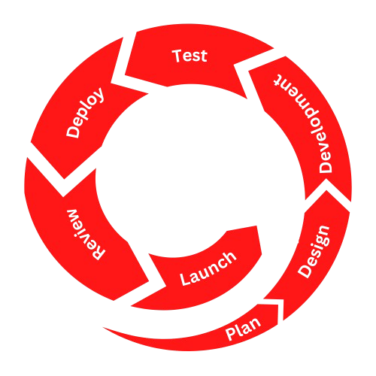Methodology

Figure 1.0 Agile: Spiral Methodology for Web Development

Process

The life cycle of system development consists of five phases: Objectives, Planning, Development, designing, and Deployment.

Objectives:

The phase of discovering and researching determines how the subsequent actions will look like. The most task the developers made in this point is to get a clear understanding of your future website purposes, brainstorming and setting up main goals, and the target host company or audience. By thoroughly gathering all necessary information, it becomes possible to develop an effective strategy for project proposal. This comprehensive understanding allows the proponents to clearly define the project's scope and identify critical details, such as the website's features, the tasks that need to be assigned, the project timeline, the scope of work, and the overall documentation process. By implementing this, it ensures that all aspects of the website are planned and managed efficiently, minimizing potential weaknesses and ensures the project objectives with its intended goals.

Project Plan:

On this process, the developers should gathered all the necessary information needed for the project. The proponents prepared a questions for interviews and survey includes the vendors information, number of buildings and stalls, the price, the rules and regulations, and stall maintenance. The proponents used a Google forms for vendors and customers and personal interview for the administrator and staff under the management.

Project Design:

The developers created a concept and find a design that suit for the user interface and used a Figma to create a prototype to visualize the system. The developers also discussed which programming language and hardware/software resources to be used to support the system and list all the modules should be included for the system. They also used an API that can interact with other existing system where the web application is connect to the front-end with back-end functionality.

Project Development:

When all designs are done, the proponents started coding and used Visual Studio Code and XAMPP to design and to put functionalities of the system. Created log-in module for administrators, staffs, and customers included the sign in and registration. The developers test regularly the every modules they created, add modules for each users, and develop the database wherein all the datas are stored in the database. They also integrate APIs for the SMS, web design, and invoice interaction and integrate mapping functionality for the directory of the customers.

Project Test:

When system is ready for beta and alpha testing. The developers should write a letter to ask permission from their host company and to the vendors and customers to test the system. The developers provide an survey questionnaire for the vendors and customers and evaluation form for the Public Market Management and each of them should has their own rate to the different functionalities of the system.

Deployment:

Following the testing phase, the deployment phase begins. However, this is not the end of the project but, this process will be loops back to the development cycle, which allows for continuous improvement and adaptation. During deployment, the developer ensures that the Web-Based vendor management meets all updated requirements based on feedback from the testing phase. This phase involves implementing necessary changes, fixes, or enhancements that were identified during testing.

A crucial method at this phase is to review any bugs, fixes or challenges encountered and identify areas for improvement. This reflection helps inform the next phase of development, ensuring that the vendor management evolves and improves with each iteration process. By continuously cycled process through these phases, the project remains adaptive and aligned with vendor user and MEEDO admin needs and expectations, leading to a more reliable and efficient final product.

Requirements Analysis

Web-Based Public Market Building Directory and Way Finding Kiosk with Vendor Management System is made for administrators and staff under the Polomolok Public Market Management, vendors, and customers. The goal of developing this system is to enhance the visitor experience by providing effective navigation assistance, while also streamlining the management of vendor data. The business activities of the Public Market are to sell goods and provide services for vendors. Managing vendors, buildings and stalls, rents, maintenance, and payments are the activities performed by the administrators and staff every day in the Public Market. They experienced difficulties in managing documents and they want to store them digitally and make it paperless. The proponents will use the mentioned difficulties to develop a system.

## Requirements Documentation

The Web-Based Public Market Building Directory and Wayfinding Kiosk with Vendor Management System will feature a dynamic online directory storing vendor and market facility information in a relational database. Users will benefit from a 2D map-based wayfinding tool to navigate the market with zoom and pan capabilities, providing clear routes between locations. The vendor management system will handle daily transactions, support adding new vendors, and generate digital receipts. This system will be built with a scalable and responsive technology stack, ensuring smooth operation across devices while adhering to security and accessibility standards. Integration with mapping APIs will enhance functionality, and the project will follow a structured development plan from analysis to maintenance.

## Design of Software, System, Product, and/or Processes

The processes of the system are represented by Context Flow Diagram, Data Flow Diagram, and Entity Relationship Diagram.

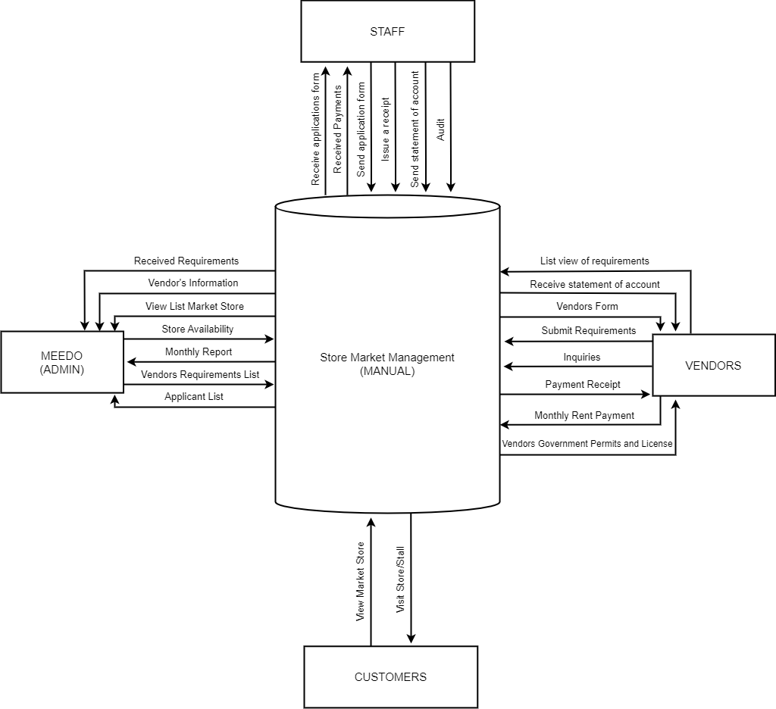**Figure 2.1. Context Flow Diagram (Manual)**

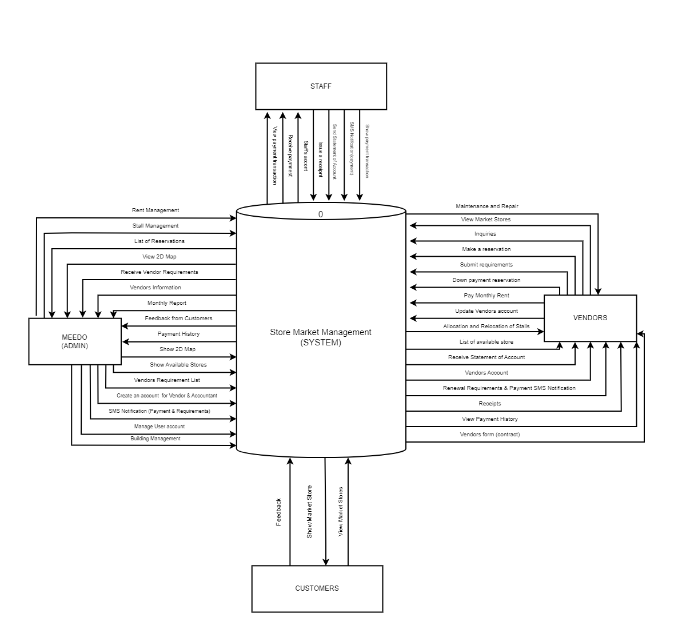**Figure 2.2. Context Flow Diagram**

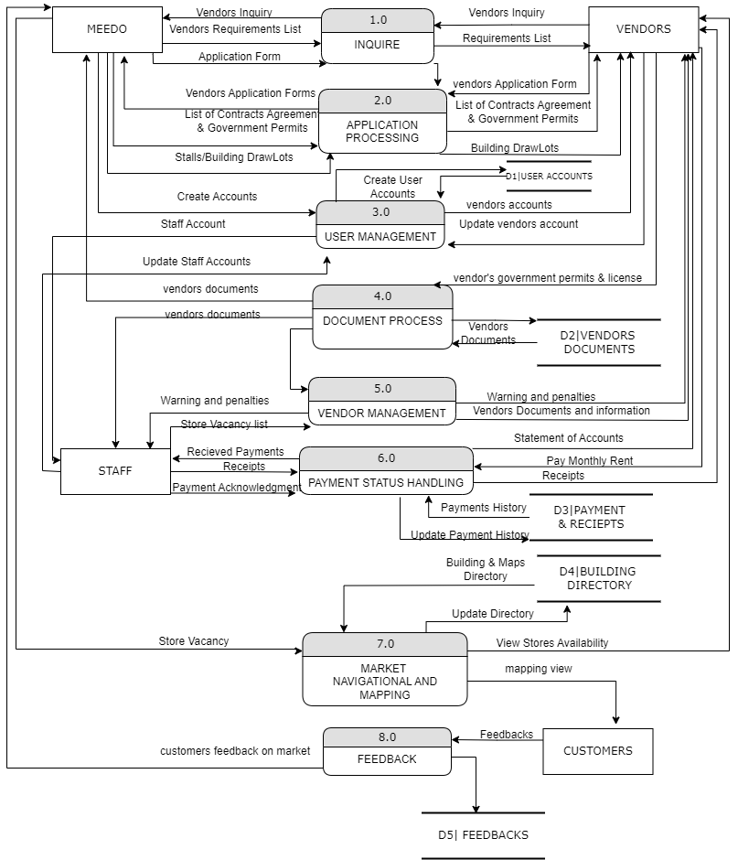 **Figure 3. Data Flow Diagram**

**Figure 4. Entity Relationship Diagram** 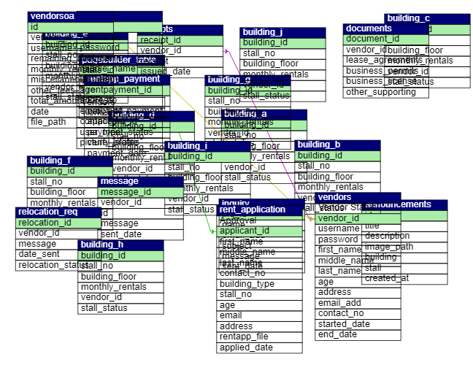

## Development

The development phase of this system started after final defense of Capstone 1, June 2024 until September 2024 but the planning and visualizing the system was started last February 2024. During planning, the developers gather some information from the host company by conducting interviews and survey to them such as the monthly payment, number of stalls, number of buildings, number of occupied stalls, and so on. People on the host company also ask questions and giving suggestions what to put in the system that could help us in development as well as to help them to make their daily transaction easier which is to make their documents paperless. The developers started in creating prototype in Figma to visualize the system. June 2024, the developers began creating a design for user interface and log in form by coding and used Visual Code Studio and XAMPP.

# 

# References

Store IMage and Satisfaction: Evidence Home, N. (2002). Rural consumers' patronage behavior in Finland. Distribution and consumers research.

What is a Public Market? - Public Market Development. (2017, June 1). Public Market Development. https://publicmarketdevelopment.com/what-is-a- public-market-2/

Jayatelleke, et al. (2018). Development Of Mobile Application Through Design- Based Research. Mobile Learning, 13.

Khare, A. (2013, January 01). Retail services quality in small retail sector: the indian experience. Retrieved from Emerald Insights: https://doi.org/10.1108/02632771311307089

Pascual, et al. (2019). Understanding Consumer Buying Behaviours Towards Public Markets And Grocery Stores In Tacloban City, Philippines. Lifestyle, 43.

Patimo, D., & Dollado, R. (2021). Online marketing of small and medium enterprises in Samar, Philippines. 14.

PMS: Public Market System - Amellar Solutions: Enabling E-Local Government since 1994. (n.d.). https://www.amellar.com/amellar_products_pms.php

Techniques, M. R. T. &. (2024b, March 6). Rental Management System Market Analysis: Competitive landscape. https://www.linkedin.com/pulse/rental- management-system-market-analysis-gtlse

Market Mapping: Definition, Examples, benefits StudySmarter. (n.d.). StudySmarter UK. https://www.studysmarter.co.uk/explanations/marketing/marketing- information-management/market-mapping/

Agrimbau, T. (2014, March 11). Mobile App Development vs. Mobile Web Development: When, Why, and How. Toptal Engineering Blog. https://www.toptal.com/app/developing-mobile-web-apps-when-why-and- how

Prezi, D. M. B. O. (n.d.). Integrated Stall Rental Management System. prezi.com. https://prezi.com/yiu1wmqmvpfj/integrated-stall-rental-management-system/

Yesilada, F. (2021). The Moderating Role of Shopping Frequency on the Relationship Between from Cyprus. In F. Yesilada, T. Yesilada, & A. Maslakci, The Moderating Role of Shopping Frequency on the Relationship Between Store IMage and Satisfaction: Evidence from Cyprus (pp. 6-7). International Journal of Businesses.

Dingus, et al. (n.d.). MARKETING MANAGEMENT JOURNAL: An Empirical Study of Consumer Motivations to Use In- store Mapping Application. Retrieved March 27, 2024, https://www.mmaglobal.org/_files/ugd/3968ca_137606eb5dd746ab81317f3 5ae4c7881.p df#page=72

Fischer, L. et al. (2023). Designing In-Store Navigation Systems in Physical Retail. https://aisel.aisnet.org/cgi/viewcontent.cgi?article=1053&context=wi2023

MacGillivray, L (2023). "Everything's Connected": Using Systems Maps for Inquiry Learning from https://eric.ed.gov/?q=mapping+system&id=EJ1400961

APPENDICES

APPENDIX A. RESOURCE PERSON

Full name: Ms. Ivy Grace C. Laurente

Profession: IT Instructor

Department: ICT Department

Name of Institution: STI College – General Santos

E-mail address/Contact numbers: ivygrace.laurente@gensan.sti.edu.ph

APPENDIX B. ACCOMPLISHMENT AND CONSULTATION REPORTS





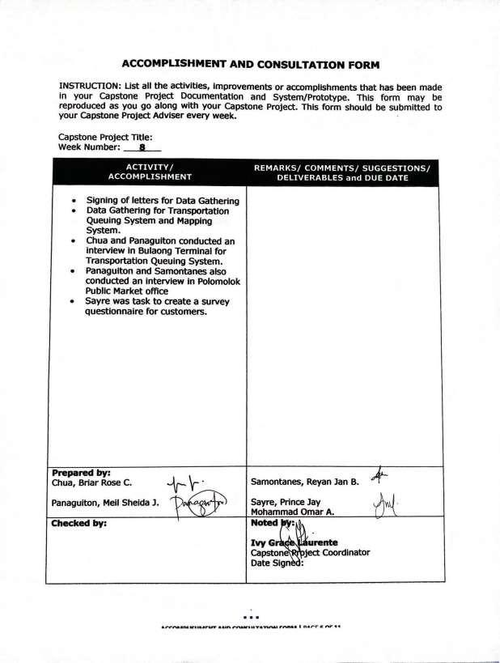

APPENDIX C. REVISION LIST

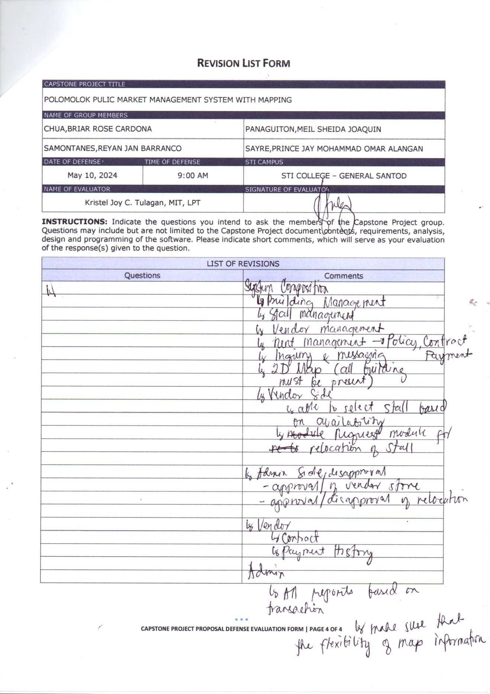

APPENDIX D. DATA GATHERING

