Technical Appendix
Repository: https://github.com/PolTony/Closure_Tests
I use the laboratory to examine how automation changes the relationship between performing professional work, controlling its allocation, and acquiring the expertise needed to perform it independently. These concerns connect jurisdiction and occupational closure (Abbott, 1988; Weeden, 2002) with the Becoming, Doing, and Relating perspectives on occupations (Anteby, Chan, and DiBenigno, 2016). The appendix develops this argument through a worked accounting example and comparisons of execution, supervision, case disclosure, and apprenticeship. Before reporting each comparison, I explain the question it addresses, the information available to the actors, and the assumptions needed to interpret the result. The simulations use a stated reference configuration and identified alternatives. Their parameters are research assumptions informed by the literature, and the findings provide exploratory mechanisms for subsequent independent evaluation.

Contents
1. Research questions and study design
2. A worked example and the information available to each actor
3. How programs and professional agents perform the work
4. Automation, supervision, and statutory sign-off
5. Disclosure of resolved cases and professional control
6. Apprenticeship, promotion, and the reproduction of expertise
7. Competition between occupations and the price of supervision
8. The language-model experiment
9. Robustness, alternative explanations, and external validity
10. Technical specification and reproduction
References

1 Research questions and study design
Professional authority can persist when another actor performs much of the work. Abbott (1988) defines jurisdiction through the relationship between an occupation and its work, including arrangements in which subordinate actors execute tasks under professional control. Weeden (2002) explains how institutional restrictions can sustain occupational rewards. Research on situated learning asks how participation produces the expertise that authority presupposes (Lave and Wenger, 1991; Beane, 2019). I connect these concerns by examining whether delegating execution while retaining supervision also preserves opportunities to learn. The central argument is that authority and competence may diverge when the division of labor changes the experience available to prospective professionals. The experiments identify the conditions under which that divergence occurs in the modeled workplace.
I organize the experiments around the links in this argument. I first establish what a program can perform using written instructions and resolved cases. I then examine how sign-off and liability change supervision and the answers clients receive while technical capability remains fixed. The dynamic experiments ask how publication of resolved cases changes subsequent automation and how the resulting work allocation supplies experience to junior professionals. Competition with adjacent occupations and the pricing of review examine further consequences of that allocation. Finally, language-model agents test whether the same research infrastructure supports document reading, program generation, and professional review beyond the deterministic comparison agents. Together, these comparisons distinguish changes in task performance from changes in jurisdiction and the reproduction of expertise.
I use simulation to develop and examine mechanisms under controlled assumptions (Davis, Eisenhardt, and Bingham, 2007), including experiments with language-model actors (Horton, 2023). In the synthetic workplace, each case has a known correct answer. I can therefore distinguish an incorrect answer from an unfamiliar one and measure errors that clients or regulators fail to observe. I hold the underlying work fixed while varying access to records, error liability, sign-off requirements, publication, and staffing. These interventions identify consequences within the model. Applying the explanation to actual professions requires independent evidence that the tasks, institutions, and learning assumptions represent those settings adequately. This distinction guides the interpretation of both successful comparisons and failed tests.

The occupations and tasks
I represent each of 18 occupations through a routine task, a contested task shared with adjacent occupations, and a core professional task. Task statements and occupational attributes draw on the supplied O*NET-based inputs. I designed the formal workflows to vary information and institutional conditions separately. They represent selected structures of work, and practitioners have not validated them as complete accounts of the occupations named. For example, assigning a clinical calculation to a psychology task creates an analytical comparison across occupational attributes. It does not establish that psychologists perform that calculation. Table A1 therefore identifies the occupational coverage and the formal workflow assigned to each occupation, allowing readers to distinguish empirical attributes from assumptions about the work itself.
Table A1 Occupational coverage
Formal workflow | Occupations represented
Legal allocation | Lawyers; Paralegals
Accounting and tax allocation | Accountants Auditors; Tax Examiners Revenue Agents
Clinical calculations | Nurse Practitioners; Clinical Counseling Psychologists; Registered Nurses
Forecasting and financial constraints | Financial Analysts; Operations Managers; Management Analysts; Economists; Business Teachers Postsecondary
Engineering constraints | Civil Engineers; Architects
Administrative coordination | Software QA Analysts; Systems Analysts; HR Specialists; Executive Secretaries

Each task has 20 fresh evaluation cases, giving 1,080 cases in total. The static learning archive begins with 80 draws per task. Cases requiring private precedents are excluded from the public archive, so the number of available training cases varies across tasks. Training and evaluation cases use separate deterministic random streams. A repeated run therefore produces the same cases, while a different case-universe identifier produces new numerical values without changing the task’s rules. The distribution of routine cases and exceptions differs by task. Routine work is common in the occupational periphery; private-precedent cases are concentrated in core tasks. These frequencies are inputs to the synthetic world. The resulting differences across task zones should therefore be interpreted as consequences of specified mixtures of work, rather than discoveries that core tasks in actual occupations necessarily contain those frequencies of exceptions.
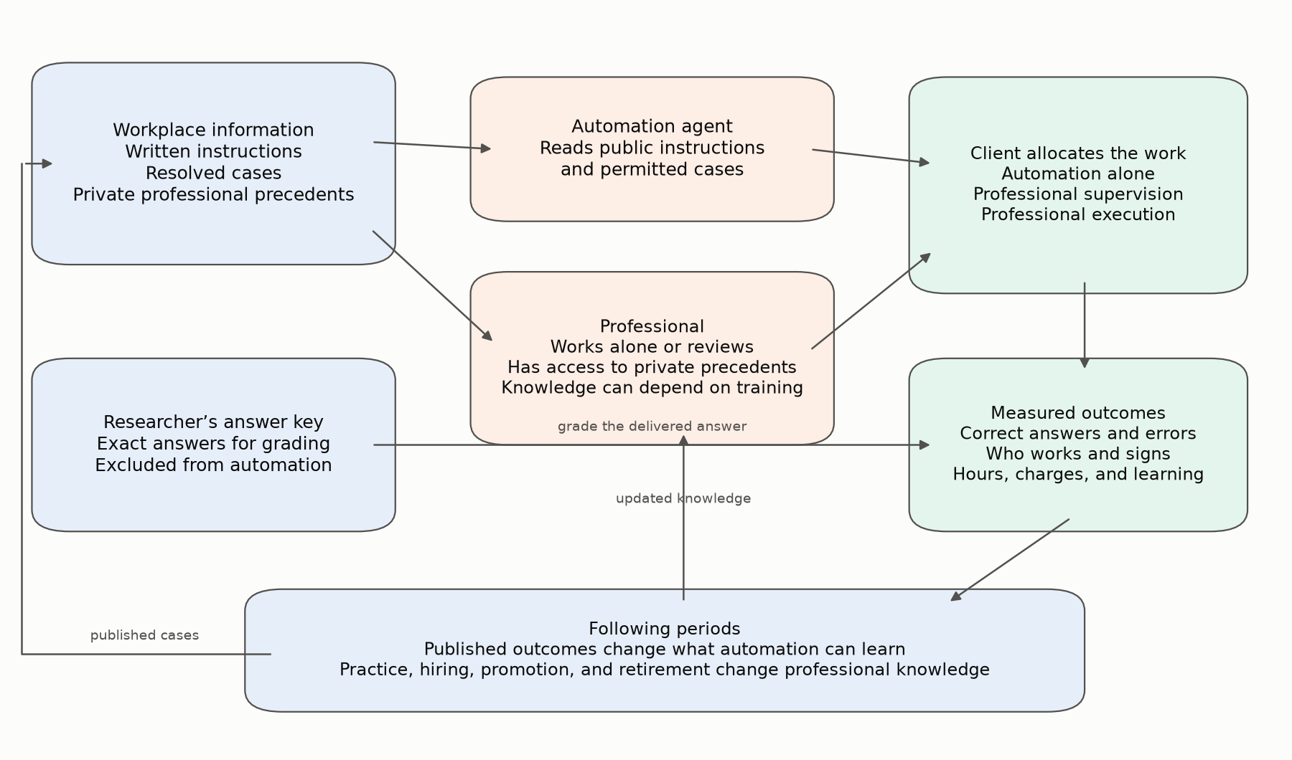
Figure 1. The study follows information into task execution, client allocation, and subsequent professional learning. The automation agent receives only permitted public information. The reference professional is assumed to know the complete rules; the cohort model makes that knowledge depend on practice. Exact answers are used for grading. Published cases and professional experience affect the following period.

2 A worked example and the information available to each actor
I use the accounting task CPA-B2 to show how the information restrictions create different learning problems. The accountant allocates revenue across obligations and adjusts the calculation when an exception applies. The task vocabulary draws on accounting work, while the numerical rules are research specifications. The example therefore supplies an exact answer for comparing agents without claiming to reproduce every judgment involved in applying a professional standard. Following the same quantities through a routine calculation, an unwritten convention, and a private precedent makes clear what each additional source of information contributes.

The four documents
The public instructions define the routine calculation, the diagnostic cutoffs, and one explicit override. The intake document supplies the transaction magnitude, a ratio, a reserve adjustment, and a numerical measure of administrative clutter. The schedule supplies a further allocation parameter. The annex records an explicit exception, a convention-related field, a precedent memo, or routine-looking information. Administrative clutter affects the modeled agents’ attention; it does not change the correct accounting answer.
For one routine case, the intake reports a transaction magnitude of 559.26, a ratio of 0.1193, and a reserve adjustment of 64.49. The schedule parameter is 258.25. The public instructions first calculate the schedule’s share of the combined amount and then allocate revenue:
schedule share = 258.25 / (559.26 + 258.25)
allocated revenue = 559.26 × (0.65 + 0.35 × schedule share)

Because the ratio exceeds the published cutoff of 0.102, the applicable routine adjustment is:
answer = allocated revenue × (1 − 0.40 × 0.1193) + 0.40 × 64.49
= 430.85, rounded to two decimal places

The transaction magnitude also exceeds the published magnitude cutoff of 490. The complete answer therefore contains two diagnostic classifications, the label of the rule applied, and the numerical result. These correspond to diagnosis, inference, and treatment in Abbott’s account of professional work. In this laboratory, the treatment is the numerical action or calculation returned by the rule; the terminology does not imply that all tasks concern medical treatment.

A convention that must be learned
Suppose the same numerical case instead has a convention marker with severity 0.75. The convention is absent from the public instructions. The researcher’s rule is:
convention answer = allocated revenue × (1 − a × severity)
− 1.25 × reserve adjustment + 0.10 × schedule parameter
where a = 0.34 below a ratio of 0.12, and 0.48 at or above 0.12

At the example’s ratio of 0.1193, the convention produces 262.10, while the written routine calculation produces 430.85. Recovering the convention requires three connected inferences. The learner must recognize the annex marker associated with the exception, estimate the formula and its coefficients from resolved cases, and identify the relevant breakpoint. That breakpoint is 0.12, whereas the published diagnostic cutoff is 0.102. The learner receives resolved examples from which to infer this relationship. I assess the resulting program on fresh cases, so success requires the inferred relationship to extend beyond the examples used to construct it.

What makes a case difficult
The same routine calculation can be extended by different kinds of exception. A published override states both when it applies and how to compute the adjustment. An unwritten convention leaves a recognizable field in the annex, but its formula must be inferred from past resolved cases. A private precedent requires additional rules and constants available to the professional. A subset of private-precedent cases has no explicit warning: the annex uses the routine format, but its historical metric and a ratio jointly identify the exception to a professional who knows what to check.
Table A2 Case types and information requirements
Case type | Evaluation cases | What the paperwork shows | Information needed
Routine instructions | 615 | No exception indicated | Written instructions
Published override | 98 | An explicit override and severity | Written instructions plus the override
Unwritten convention | 177 | A convention-related annex field | A rule inferred from resolved cases
Explicit precedent memo | 148 | A memo requests private precedent information | Professional precedent rules and constants
Unflagged precedent | 42 | Routine-format annex with different quantities | Knowledge of the relevant quantitative check and precedent

Private precedents represent institutional and relational knowledge, including how organizations have resolved disputes and interpreted prior obligations. I implement that knowledge as rules and constants so the researcher can compute an exact answer. This specification addresses an information advantage that can be varied independently of the calculation. It leaves disputed judgments without uniquely correct answers for further development. The distinction between explicit and unflagged precedents also separates recognition from resolution. An explicit memo can make the need for help clear even when resolving the case is difficult. An unflagged precedent can yield a plausible routine answer while requiring a different judgment. Professional knowledge therefore affects both recognizing the exception and supplying the rule needed to resolve it.
Table A3 Information available to the actors
Actor | Written instructions | Public resolved cases | Private precedent rules | Other information
Automation compiler | Yes | Yes, after handbook translation | No | Its generated program and the failures returned on training cases
Rule-based novice | Yes | No | No | Intake, schedule, and annex
Reference professional | Yes | Available; full rules assumed known | Yes | Case documents and, when reviewing, the program’s answer
Automated uncertainty monitor | No | No | No | The program’s execution report; the model-based monitor also reads the annex
Adjacent subordinate occupation | Yes | Conventions assumed known | No | Case documents; professional supervision supplies access to private precedents

I restrict the automation agent’s information by excluding imports of the answer interpreter and private registry. Language-model agents receive only the documents and instructions permitted to their roles, with the researcher’s grading fields excluded from their prompts. The reference professional classifies the case from its documents and applies the full rulebook through the interpreter used to construct the answer key. Its performance is therefore conditional on knowing the relevant rules, subject to the attention and arithmetic assumptions described below. The cohort specification relaxes that knowledge assumption. It allows professionals to lack a convention or private precedent even while retaining the authority to sign, which is necessary to examine whether expertise is reproduced over time.

3 How programs and professional agents perform the work

Automation from instructions and examples
The automation experiment compares three conditions within one learning procedure. In the first, a deterministic compiler parses the formal instructions and writes a standalone Python program. It translates field definitions, intermediate calculations, diagnostic comparisons, and ordered rules. It can therefore reproduce written rules exactly without having been given the private answer interpreter. In the second condition, the program is tested on public resolved cases. The learner collects failures, identifies an annex field associated with an exception, and considers candidate equations relating the written calculation, the annex value, and other case quantities to the resolved answer. It solves for the unknown coefficients using small sets of examples, then counts how many archive outcomes each candidate reproduces. A candidate with k unknown coefficients must reproduce at least k + 1 cases, with a minimum of three. Simpler equations win ties. This additional-case consensus is a selection rule within the training archive, not an independent validation test.
In the third condition, the learner examines the errors remaining after the first exception formula is added. It tests whether a single threshold in one observed input separates cases that need different coefficients, and refits the relevant branch. For the accounting convention, for example, an adjustment changes when the ratio crosses an unpublished threshold of 0.12. The learner can estimate a threshold between observed cases, but it cannot infer its exact position when the archive contains no observations close enough to distinguish nearby values. Small archives may also contain too few exceptions to support an equation at all.
The candidate equations were designed with the six workflows’ convention formulas in view. Their performance establishes what this learner can recover within a declared search space. I examine that dependence by removing representable formula families, introducing an additive convention, and testing an interaction outside the candidate set. I also compare archive-based selection with a separate training and validation partition. In the approximately 75/25 partition, validation cases are excluded from discovering exception fields and labels, fitting coefficients and thresholds, and refitting residuals in both learning stages. Validation outcomes can rank or reject candidates, while fresh evaluation cases remain separate under both procedures. The comparisons distinguish learning within the available formulas from performance when information or representation is more restricted.
The reference search considers four forms. Let B be an intermediate calculation obtained from the written rules, S the annex value associated with the exception, and X and Y other observed numerical fields. Lowercase letters denote coefficients to be estimated from the archive:
Candidate form | Interpretation
B × (1 − a × S) + b × X | Adjust the written calculation and add one field
B × (1 − a × S) + b × X + c × Y | Adjust the written calculation and add two fields
B + a × S + b × X + c × Y | Add a severity adjustment and two fields
a × B + b × B × S + c × X + d × Y | Estimate the base weight as well as the adjustment

The fourth form includes the second as a special case. Removing just one of them therefore does not remove the formula family. The precedent-publication experiment adds the interaction form B × (1 − a × S − b × S × ratio) + c × X. These equations explain why a rule may become learnable after its outcomes are published, yet remain beyond a learner whose candidate set cannot represent it.
The program reports the rule it applied and any structured annex fields that no rule consumed. The uncertainty monitor interprets unrecognized fields as a reason for caution. A routine-looking precedent can escape that check because a routine rule produces an answer without leaving an unrecognized field. This explains how a confident execution report can accompany an incorrect answer in the reference design. The resulting errors depend on the implemented parser and monitor. A different detector could recognize the case, which is why Section 9 separately tests detection and the knowledge needed for correction.

The professional and novice comparison agents
The deterministic novice supplies a transparent comparison with limited knowledge and attention. It reads the public instructions with specified cutoff errors and fails to resolve exceptions requiring additional rules. Its overall accuracy is 33.4%. These parameters define a comparison agent and have not been estimated from observed human performance. A language-model novice separately tests what a document-reading system can achieve using the same public materials. Keeping those comparisons distinct prevents the synthetic novice’s errors from being interpreted as an estimate of actual junior workers’ competence.
The reference professional reads the intake and schedule, classifies the annex, and applies the relevant rule. Deep examination includes the quantitative check needed to distinguish an unflagged precedent from routine work. During solo execution, administrative clutter above the stated threshold raises the affected calculation by 3.5%. During review, clutter above an accountability-dependent threshold produces shallow examination, which omits the private quantitative check and can leave an incorrect routine answer uncorrected. These rules operationalize bounded attention. For example, Lebovitz, Lifshitz-Assaf, and Levina (2022) show how diagnostic radiologists differ in their engagement with opaque AI tools. That study motivates attention to professional engagement; the numerical thresholds here remain research assumptions examined through sensitivity comparisons.
In the learning-cohort specification, a professional who lacks a convention applies only the written rule unless an explicit program handler supplies the answer and deference is enabled. A professional who lacks private precedent knowledge cannot apply that precedent. Explicit precedent memos can be routed to a knowledgeable senior while one remains available. The model therefore distinguishes automation accuracy, the knowledge of the signing professional, and the accuracy of the answer ultimately delivered to the client.

Grading
I count a case as correct when both diagnostic classifications and the applied-rule label match the answer key, and the numerical result differs by no more than 0.01. Separate measures record diagnostic and numerical success, while the main tables report the combined criterion. Requiring the classifications and rule label makes the measure sensitive to whether the program applies the specified reasoning, as well as whether it returns a nearby number. The strict tolerance also makes small numerical differences consequential, so the reported accuracy should be interpreted under this grading rule.

4 Automation, supervision, and statutory sign-off
I use the institutional comparison to ask whether statutory sign-off prevents automation or changes who supervises it. After establishing program capability, I hold the cases, programs, and professional answers fixed and change the sign-off and liability conditions. A shift from supervised to unsupervised software use would show that certification and execution can change separately. An increase in error would indicate a protective function for the retained professional review under the modeled information conditions. The test therefore connects the allocation of jurisdiction to the quality of the answer delivered, while separating institutional cost changes from improvements in the software itself.
Table A4 Task accuracy before client allocation
Case type | Cases | Written rules | Archive learning | Refined rule | Professional alone | Program plus review
Routine instructions | 615 | 100.0% | 100.0% | 100.0% | 91.2% | 100.0%
Published override | 98 | 100.0% | 100.0% | 100.0% | 87.8% | 100.0%
Unwritten convention | 177 | 0.0% | 50.8% | 91.5% | 88.1% | 100.0%
Explicit precedent memo | 148 | 0.0% | 0.0% | 0.0% | 92.6% | 100.0%
Unflagged precedent | 42 | 0.0% | 0.0% | 0.0% | 92.9% | 83.3%
All cases | 1080 | 66.0% | 74.4% | 81.0% | 90.6% | 99.4%

Learning from resolved cases raises overall program accuracy from 66.0% to 81.0%, principally through gains on unwritten conventions. Written rules are already executable in the first condition, while private-precedent cases remain unresolved. Professional accuracy depends on access to the complete rules and the specified numerical slips. Combining software with professional review yields 99.4% accuracy because the program supplies reliable arithmetic and the professional supplies missing rules. This comparison assumes every case receives professional review. Clients subsequently choose among different arrangements, so the resulting client error rate must be evaluated separately.

How the client allocates work
Clients choose among direct automation, professional supervision, and professional execution. Direct automation uses the program without a professional signature. Supervision operationalizes Abbott’s (1988) subordination settlement by placing execution under an incumbent’s review and certification. Professional execution assigns the full calculation to the incumbent. For each case, the client compares service charges, expected error costs, and any penalty for unauthorized execution of a reserved task. This is a minimum-cost choice under stated beliefs. Its result depends on what the client expects each arrangement to deliver, including whether a professional can recognize an exception that the program misses.
The expected costs can be read without the software’s notation:
Direct automation = operator charge + unauthorized-sign-off penalty
+ perceived program error × liability cost
Professional supervision = operator charge + review charge
+ perceived residual review error × liability cost
Professional execution = professional charge
+ perceived professional error × liability cost

For the accounting example, the operator charge is normalized to 1.00 and the professional charge is 3.10. The reference review fraction is 0.25 + 0.08 times the occupation’s licensing share, giving a combined operator-and-review charge of approximately 1.93. Error liability is approximately 10.08 and the unauthorized-sign-off penalty is 44.30. The client’s assessment of program uncertainty depends on the execution report: 0.03 for a clean routine result, 0.12 for a published override, 0.19 for a learned convention, and 0.86 for an unrecognized field. These are client beliefs specified by the model; they are not calibrated probabilities inferred from the evaluation outcomes.
Table A5 Expected client costs in the accounting example
Program report | Direct automation | Supervision | Professional execution | Client choice
Clean routine result | 45.60 | 1.94 | 3.18 | Supervision
Published override | 46.51 | 1.97 | 3.18 | Supervision
Learned convention | 47.21 | 2.00 | 3.18 | Supervision
Unrecognized annex field | 53.97 | 6.70 | 3.18 | Professional execution

The sign-off rule makes unsupervised execution costly, so routine and learned work is automated under professional supervision. When the program reports a situation it cannot handle, the expected residual error of supervision is high enough for the client to prefer professional execution. Removing the statutory penalty can make direct automation cheaper. It does not change what the program knows. For an unflagged precedent, however, the client sees the same low uncertainty as on a routine case and can choose automation even though the answer is wrong.

Institutional comparisons
The reference condition retains the occupation’s specified sign-off and error-liability rules. The first counterfactual removes only the sign-off penalty. The second removes both sign-off and error liability. All three conditions use the same cases, programs, and professional outputs. Differences in allocation and error therefore arise from the institutional cost terms rather than a simultaneous change in technical capability.
Table A6 Work allocation and errors under institutional counterfactuals
Task zone | Automation alone | Supervision | Professional alone | Reference error | No sign-off error | No sign-off or liability error
Routine tasks | 96.4% | 1.1% | 2.5% | 0.0% | 0.0% | 2.5%
Contested tasks | 37.2% | 55.3% | 7.5% | 1.1% | 1.1% | 8.3%
Core tasks | 21.7% | 44.7% | 33.6% | 6.4% | 13.6% | 46.1%

Each task zone contains 360 cases. In contested work, supervision is the most common reference arrangement. Removing sign-off increases direct automation from 37.2% to 59.7% without changing error at 1.1%. In core work, direct automation rises from 21.7% to 38.1% and error rises from 6.4% to 13.6%. Total program use is unchanged within each task in this reference comparison because cases move between supervised and unsupervised automation. Removing both liability and sign-off produces a larger core error rate of 46.1%. The 27 reference errors comprise 23 core errors and four contested-task errors. Twelve core errors are unflagged precedents automated without professional review. Four more are unflagged precedents accepted during shallow review. Seven core errors and the four contested-task errors are numerical slips during solo professional execution. Removing sign-off sends all 42 unflagged precedents to direct automation, explaining the larger core error rate. This decomposition identifies the mechanism behind the aggregate percentage rather than treating any professional signature as necessarily protective.
These comparisons identify conditions under which professional authority can have different consequences. When exceptions are recognizable and can be delegated safely, mandatory sign-off can preserve supervision while software performs the calculation. When routine-looking documents conceal a need for another rule, professional review can supply information needed for a correct answer. Applying either explanation to an actual statute requires evidence about the reserved tasks, the relevant exceptions, and the review professionals perform. The model specifies those conditions so they can be examined separately; the magnitude of a real licensing reform’s effect requires independent evidence.
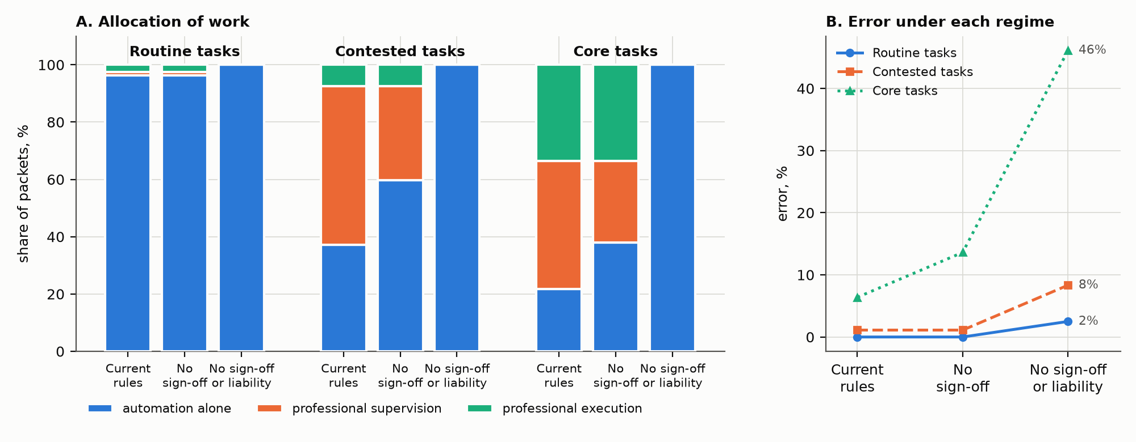
Figure 2. Allocation and error under current rules, removal of the sign-off penalty, and removal of both sign-off and liability. Blue represents automation alone, orange professional supervision, and green professional execution. The task, program, and available professional answers are held fixed across conditions.

5 Disclosure of resolved cases and professional control
I next ask whether professional control over resolved cases changes the opportunities from which automation learns. The static comparison holds the public archive fixed. In the dynamic experiment, a case enters that archive according to who resolved it and whether the responsible actor publishes it. An accountant’s handling of a difficult exception may supply exactly the example the program lacks, yet the example can remain private when publication threatens the accountant’s future work. The experiment therefore examines how the current division of labor changes the information available to a competing system, connecting occupational control with subsequent technical capability.

What happens in a period
Each task begins with 20 archive draws, from which private-precedent cases are excluded. At the start of each period, the program is trained on the cases currently public. A fresh set of evaluation cases is generated, agents produce answers, and the client allocates the work. Eligible resolved cases may then enter the public archive for the next period. Private precedents remain outside that archive in these dynamic runs. Case types are sampled anew each period, so percentages vary with the realized cases as well as the accumulated learning. Three publication arrangements are compared. Under required publication, all resolved routine, explicit-exception, and convention cases are published. Under voluntary publication, publication probabilities are 0.9 for direct automation, 0.5 for supervised automation, and 0.1 for professional execution. Under strategic withholding, the incumbent chooses whether to publish professionally executed cases with probability 0.9 or withhold them. Other publication probabilities remain as in the voluntary condition.
The incumbent chooses whether to publish by comparing expected professional revenue one period ahead, including a small reputational return to publication. It considers how disclosure changes the next program and evaluates that program on an independently generated forecast sample. Current professional knowledge, wages, sign-off rules, and client beliefs remain fixed during this comparison. The incumbent does not observe the future evaluation cases on which performance will be reported. Its decision therefore represents a bounded response to anticipated changes in work allocation. The reference result depends on this one-period objective and the information available for forecasting.
Table A7 Disclosure and learning from conventions
Publication arrangement | Task zone | First period at 90% accuracy | Accuracy in period 16 | Tasks withholding professionally resolved cases in period 16
Required publication | Contested | 3 | 100.0% | 0.0%
Required publication | Core | 3 | 100.0% | 0.0%
Voluntary publication | Contested | 8 | 97.2% | 0.0%
Voluntary publication | Core | 12 | 100.0% | 0.0%
Strategic withholding | Contested | Not reached by period 16 | 32.4% | 66.7%
Strategic withholding | Core | Not reached by period 16 | 62.7% | 33.3%

Required publication reaches 90% convention accuracy within three periods in both contested and core work. Voluntary disclosure takes eight periods in contested work and twelve in the core. The difference arises because difficult unresolved cases are disproportionately executed by professionals, and that arrangement has the lowest publication probability. Publishing routine cases adds volume to the archive but supplies relatively little of the information the learner lacks. Strategic withholding is concentrated in contested tasks, where the program could most readily replace professional execution and statutory protection is weaker. The share of contested tasks withholding professionally executed cases ranges from approximately 61% to 72% across periods. Convention accuracy in that zone reaches only 32.4% by period 16, compared with 100.0% under required publication. The professional can therefore retain work by controlling the experience from which a competing system learns, rather than by preventing use of that system altogether.
I examine the disclosure mechanism by varying publication probabilities, the reputational return, the case sample, and the forecast specification. A comparison using realized future cases supplies an upper benchmark for forecasting. I also vary the outcome recorded when a case is published. Under required and voluntary publication, the archive can contain independently adjudicated outcomes, delivered decisions, a mixture of the two, or adjudication delayed by two periods. Those comparisons test whether learning depends on reliable and timely feedback in the public record. They do not establish the performance of strategic withholding under every labeling condition, which remains outside the evidence reported here.
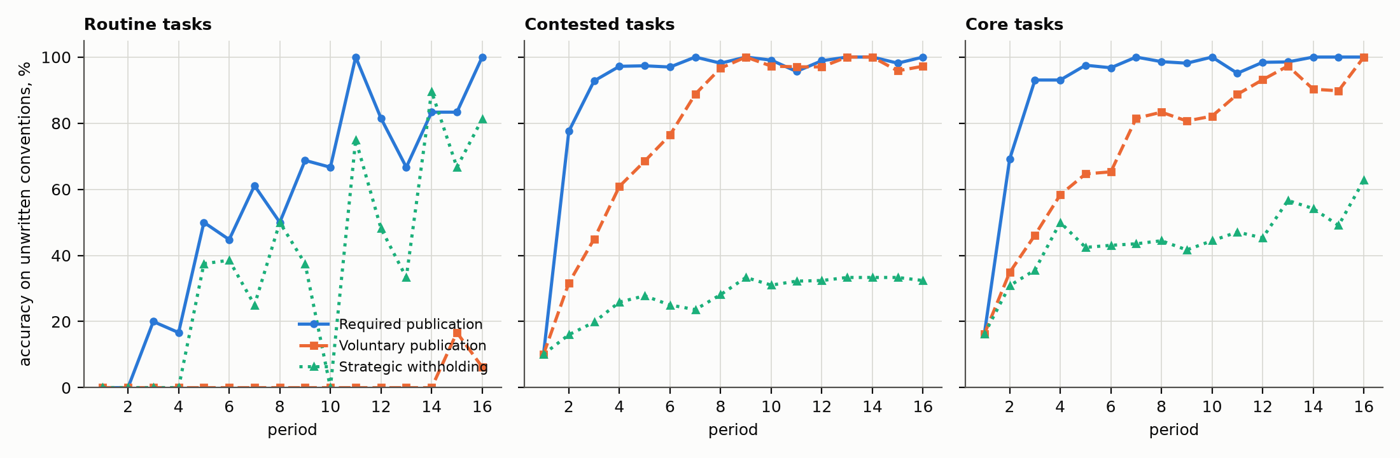
Figure 3. Accuracy on unwritten-convention cases over 16 periods under required publication, voluntary publication, and strategic withholding. A larger public archive helps only to the extent that it contains informative resolved exceptions. Routine, contested, and core task zones have different case mixtures.

Regulation based on what can be observed
A related extension makes regulation respond to observed error. After two consecutive periods with visible error below 1%, the regulator removes an occupation’s sign-off requirements. After two periods above 5%, it restores or imposes core protection. Unflagged errors are absent from the regulator’s information. Wage feedback can separately respond to unfilled vacancies and eligible apprentices waiting for promotion, within stated bounds. These response rules are model assumptions rather than estimates of actual regulatory or wage-setting behavior. With both feedback mechanisms active under required disclosure, sign-off coverage falls from 44% to 11% of contested and core tasks by period 16. Across all 54 tasks, including initially unreserved routine work, the corresponding shares are approximately 30% and 7%. Unflagged core error rises from 3.3% to 9.2%. Visible error and unobserved harm can therefore move in different directions. The substantive point is about the regulator’s information: observing improving performance on recognized exceptions does not ensure that the cases routed away from professionals are safe. Field evaluation would require measures of errors that ordinary reporting systems miss.

6 Apprenticeship, promotion, and the reproduction of expertise

Why distinguish authority from competence?
Retaining a professional signature can protect current clients only if the profession also develops the expertise needed for future review. The static comparison assumes complete professional knowledge and therefore cannot answer that reproduction question. Research on situated learning links expertise to participation (Lave and Wenger, 1991), while Beane (2019) shows how restricted participation in robotic surgery undermines approved training practices. Anthony’s (2021) investment-bank study further distinguishes opportunities to perform calculations from opportunities to interpret them and receive feedback. I therefore make professional knowledge depend on experience within the simulated division of labor. The cohort experiment asks whether the arrangement that produces reliable answers today also gives juniors sufficient experience before they acquire independent authority.
Two separate processes determine a junior’s progress. Eligibility for promotion depends on accumulated experience across difficult cases, relative to a threshold calibrated to the first period’s realized work. Competence requires enough experience of each knowledge component: the unwritten convention and the private precedent rules. Each competence threshold is calibrated to eight periods of practice at the rate that would prevail if juniors worked all difficult cases alongside knowledgeable seniors. A sensitivity analysis multiplies these thresholds by 0.5, 1.5, or 2. These are explicit learning assumptions, not estimated training requirements. This distinction makes failure possible without making it inevitable. Automation may reduce practice and slow eligibility together, allowing juniors to learn before promotion. Conversely, pooled experience may make someone eligible while leaving too little experience of one particular component. A credential and the knowledge needed to exercise it are therefore distinct model outcomes.

Staffing and experience
Senior demand is derived from hours of professional execution and review. Junior demand is derived from operating the tool and assisting professionals. Reference assumptions are 100 hours of capacity per person per period, demand growth of 2% per model period, senior retirement of 5% per period, and an eight-period apprenticeship. Periods are abstract model intervals rather than claims about calendar years. Stocks are continuous quantities, permitting fractions of a worker in this small simulated economy. Junior cohorts accumulate experience, become eligible, and are promoted to fill vacancies, with the most experienced eligible juniors selected first. New juniors replace promotions and respond to junior demand. Seniors retire oldest first. There are no layoffs, external senior hires, or endogenous decisions to enter a profession. Existing cohorts are initialized with different levels of prior experience; the cohort nearest promotion already has both components. This avoids making the first promotions inexperienced merely because the simulation begins. All initial seniors know both components.
I assign learning credit according to participation in a resolved case. Working beside a knowledgeable professional gives a junior one exposure unit, while operating a correctly resolved difficult case under supervision gives half a unit. A senior gains half a unit from deep review of an explicit correct convention handler and one tenth from shallow review. Referring an explicit precedent memo to a knowledgeable colleague can transmit precedent knowledge. Unsupervised program operation receives no knowledge credit because the specification assumes that professional feedback makes this experience educational. Removing junior operation also removes credit for supervised program cases, while participation alongside professionals can still teach. These weights are explicit assumptions about learning opportunities and have not been estimated as human learning rates.
Within a cohort, a component becomes available once cumulative exposure reaches its threshold. For a particular case, the professional’s knowledge is sampled reproducibly from the relevant pool’s share holding that component. An overt precedent memo can be referred to a knowledgeable senior while one remains; an unflagged case cannot rely on that signal. A reviewer who does not know a convention may defer to a program whose explicit handler applied it. Consequently, technical automation can protect the answer even when the signer lacks the relevant knowledge. The outputs record both correctness and whether the professional personally knew the required component.

What happens to knowledge?
Table A8 separates competence at promotion from knowledge among the senior workforce. The licensed and unlicensed groups refer to occupations’ original statutory status, including experiments that change sign-off rules. Promotion competence is weighted by the number promoted over periods 5–16, and senior knowledge is measured at the beginning of period 16. The extended comparison instead covers promotions in periods 5–32 and senior knowledge at the beginning of period 32. Reporting these denominators separately distinguishes what new professionals know when promoted from the knowledge available across the senior pool.
Table A8 Competence at promotion and senior knowledge
Experimental condition | Original occupation group | Promoted with convention knowledge | Promoted with precedent knowledge | Seniors with convention knowledge at final period
Reference learning | Licensed | 95.4% | 100.0% | 99.9%
Reference learning | Unlicensed | 100.0% | 100.0% | 100.0%
Competence requires 1.5 times the experience | Licensed | 60.6% | 97.4% | 86.3%
Competence requires 1.5 times the experience | Unlicensed | 100.0% | 100.0% | 100.0%
Competence requires twice the experience | Licensed | 37.7% | 88.1% | 77.9%
Competence requires twice the experience | Unlicensed | 99.9% | 100.0% | 100.0%
Retirement increased to 10% | Licensed | 34.2% | 99.7% | 69.8%
Retirement increased to 10% | Unlicensed | 100.0% | 100.0% | 100.0%
Demand growth increased to 5% | Licensed | 48.2% | 100.0% | 81.0%
Demand growth increased to 5% | Unlicensed | 100.0% | 100.0% | 100.0%
Slower learning; no statutory sign-off | Licensed | 83.2% | 98.4% | 94.9%
Slower learning; no statutory sign-off | Unlicensed | 100.0% | 100.0% | 100.0%
Slower learning; sign-off everywhere | Licensed | 60.6% | 97.4% | 86.3%
Slower learning; sign-off everywhere | Unlicensed | 99.6% | 100.0% | 100.0%
Reference learning; 32 periods | Licensed | 58.8% | 100.0% | 80.2%
Reference learning; 32 periods | Unlicensed | 100.0% | 100.0% | 100.0%

At the reference learning rate, approximately 95–100% of those promoted in periods 5–16 know the convention. Automation has reduced opportunities to practice, but slower progress toward promotion largely compensates. The model therefore does not imply that every reduction in junior work destroys expertise. When competence requires more experience, or when demand growth or retirement creates vacancies more quickly, promotion can outpace learning. In the principal stress comparisons, convention competence at promotion falls to approximately 34–61%. Professionals can then retain statutory authority while some lack the knowledge needed to exercise it independently. The distinction matters most when supervision is treated as protection for clients: a required signature helps only if someone in the review and referral chain can recognize and resolve the relevant exception.
I extend the reference simulation to 32 periods to examine whether successful short-run transmission depends on initially knowledgeable seniors. Convention competence among those promoted in periods 5–32 falls to 58.8% in originally licensed occupations and remains 100.0% in the unlicensed group. Seniors retire oldest first, and all initial lawyer seniors have retired by period 21 and all initial paralegal seniors by period 15. The longer comparison therefore follows the profession beyond the departure of those initial cohorts. Occupations still differ in task mixtures, allocation, and learning opportunities. Their contrasting outcomes identify a combination of conditions under which transmission weakens, without isolating licensing as the cause of the group difference.
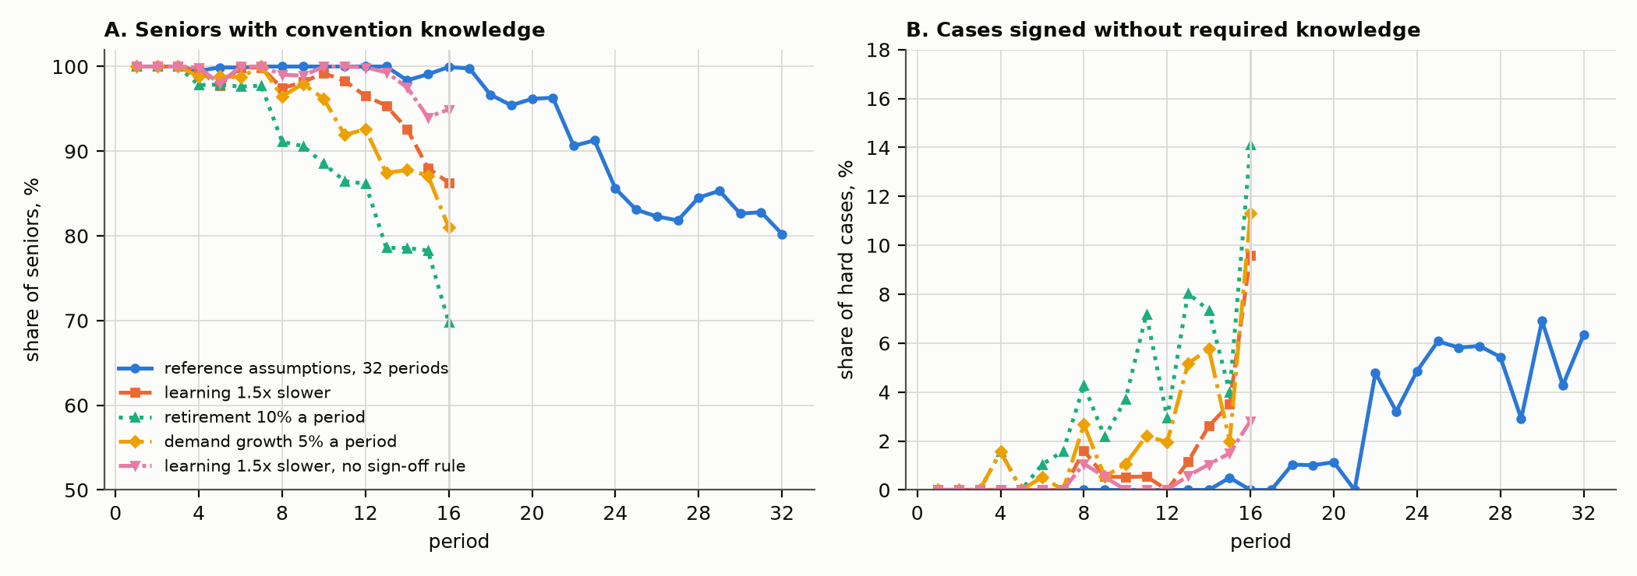
Figure 4. Senior convention knowledge (left) and difficult cases signed by professionals lacking the required component (right), in originally licensed occupations. The reference run spans 32 periods; the alternative learning and staffing conditions span 16. The vertical line marks period 16. Table A8 separately reports competence at promotion.

Replacing junior operation
I remove junior program operation in a further comparison while retaining assistance on difficult cases executed by professionals. The purpose is to distinguish the amount of junior work from the experience that work provides. Table A9 reports demand and competence within this staffing arrangement. Junior demand is indexed to its own first period, and the comparison has no common pre-AI staffing baseline. It therefore describes a conditional demand path and the knowledge acquired along that path. Estimating employment lost because AI was introduced would require a different baseline and additional labor-market assumptions.
Table A9 Junior replacement under required publication
Original occupation group | Junior demand in period 16 (period 1 = 100) | Promoted with convention knowledge | Promoted with precedent knowledge
Licensed | 69.3 | 11.2% | 86.6%
Unlicensed | 75.4 | 6.2% | 95.5%

Junior demand ends near 69–75% of its first-period level, while approximately 6–11% of those promoted hold the convention. Precedent knowledge is better preserved because professionally executed exceptions continue to supply that experience. The comparison shows how demand for junior hours and the acquisition of expertise can change by different amounts. Juniors may continue to have work while receiving fewer opportunities to learn a particular component of professional judgment. Interpreting that difference requires the stated exposure weights, initial cohorts, and promotion rules, which determine which cases teach and when juniors acquire independent authority.

7 Competition between occupations and the price of supervision

Who loses delegated work?
Abbott’s system of professions directs attention to relationships between occupations, including work delegated to subordinate groups. The competition experiment asks whether automating such work reduces the senior profession’s control or instead displaces the adjacent occupation that previously executed it. Before compilation, a client may choose professional execution, subordinate execution alone, or subordinate work supervised by the professional. After compilation, the client can also choose automation alone, automation supervised by the subordinate, or automation supervised by the professional. The subordinate knows the conventions represented in its workflow but lacks the incumbent’s private precedent rules and authority to resolve them through referral. Wage and review-time differences enter the same expected-cost comparison as before. Thus, the experiment models competition over case allocation rather than occupational negotiation or changes in legal scope of practice.
The corpus provides named pairs for lawyers and paralegals, and nurse practitioners and registered nurses. Other pairs are explicit generic subordinate-role assumptions. Results for those generic roles should not be interpreted as observations about an independently specified adjacent occupation. Table A10 reports hours after compilation as a percentage of hours before compilation, using mean hours per case within the displayed task group.
Table A10 Hours after compilation relative to before compilation
Task group or named pair | Incumbent professional hours retained | Subordinate occupational hours retained
Routine tasks | 10.1% | 2.4%
Contested tasks | 64.1% | 2.0%
Core tasks | 73.0% | 11.5%
Lawyers and paralegals | 100.0% | 7.2%
Nurse practitioners and registered nurses | 35.7% | No subordinate work in either condition

Automating delegated execution sharply reduces subordinate hours where professional certification remains valuable. In the lawyer–paralegal comparison, paralegals retain approximately 7% of their earlier hours while lawyer hours remain essentially unchanged. The profession continues to control review even as the actor performing the calculation changes. This extends the analysis of subordination by showing how automation can displace the adjacent occupation that previously supplied execution. The result is conditional on the specified capabilities, charges, and sign-off rules. It describes a division of labor the model can generate, with actual employment effects requiring evidence about demand, adjustment, and the work performed in legal practice.
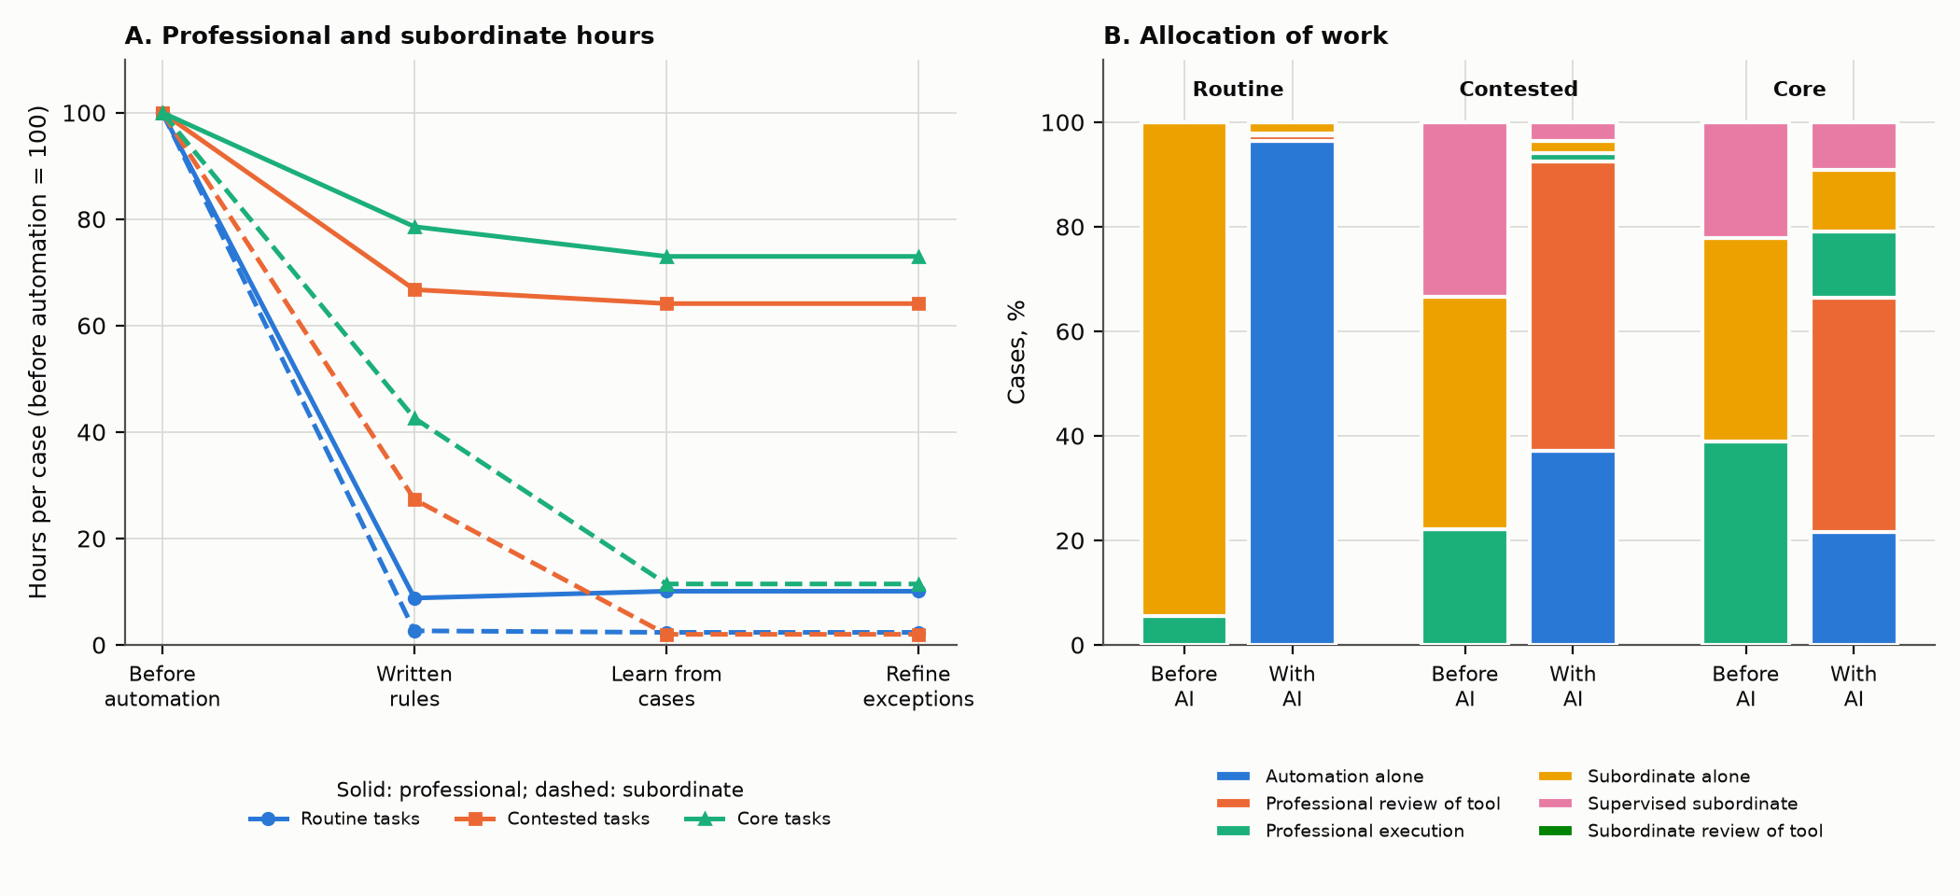
Figure 5. Allocation of cases and hours before and after compilation when a subordinate occupation can compete with the professional and the tool. The curves and bars average across tasks by zone; Table A10 separately reports the named occupation pairs. The reference allocation is based on expected client costs.

Can professionals charge more for reviewing automation?
The reference professional’s review charge is proportional to the physical time required for review. The pricing experiment allows the professional to choose a charge from a grid while holding physical review time fixed. This separates the price of a signature from the labor used to provide it. The professional maximizes current expected gross revenue, anticipating how clients respond. It does not maximize a fully measured economic rent, because opportunity costs, overhead, and asset costs are not estimated. Period 1 uses the reference charge. Subsequent choices are fractions 0.15, 0.25, 0.35, and 0.50 of the full execution charge. Table A11 compares mean charges at the final period and the share of contested tasks withholding professionally resolved cases over all 16 periods. The excess charge is the chosen charge minus the charge implied by unchanged review time, expressed as a fraction of the full execution charge. Table A11 reports this price difference per supervised case; the output field excess_review_charge instead sums excess charges across the task’s reviewed cases.
Table A11 Review pricing and publication
Publication arrangement | Core physical review time / full execution time | Core review charge / full execution charge | Core excess charge / full execution charge | Contested tasks withholding cases (16-period mean)
Required publication | 0.281 | 0.456 | 0.175 | 0.0%
Voluntary publication | 0.281 | 0.456 | 0.175 | 0.0%
Strategic withholding | 0.281 | 0.436 | 0.155 | 58.3%

Core review charges rise to approximately 0.44–0.46 of the full execution charge while physical review time remains near 0.28. The professional’s chosen price therefore exceeds the reference charge implied by unchanged review time. Allowing this pricing response reduces strategic withholding from 67.4% to 58.3% of contested tasks on average over 16 periods. At period 16, the corresponding shares are 66.7% and 55.6%. Higher review revenue makes publication less threatening because the professional can continue receiving revenue when software performs more execution. The comparison identifies that mechanism under the stated client choices. It does not estimate a markup in observed fees or a complete economic rent, because overhead, opportunity costs, and asset costs are unmeasured.
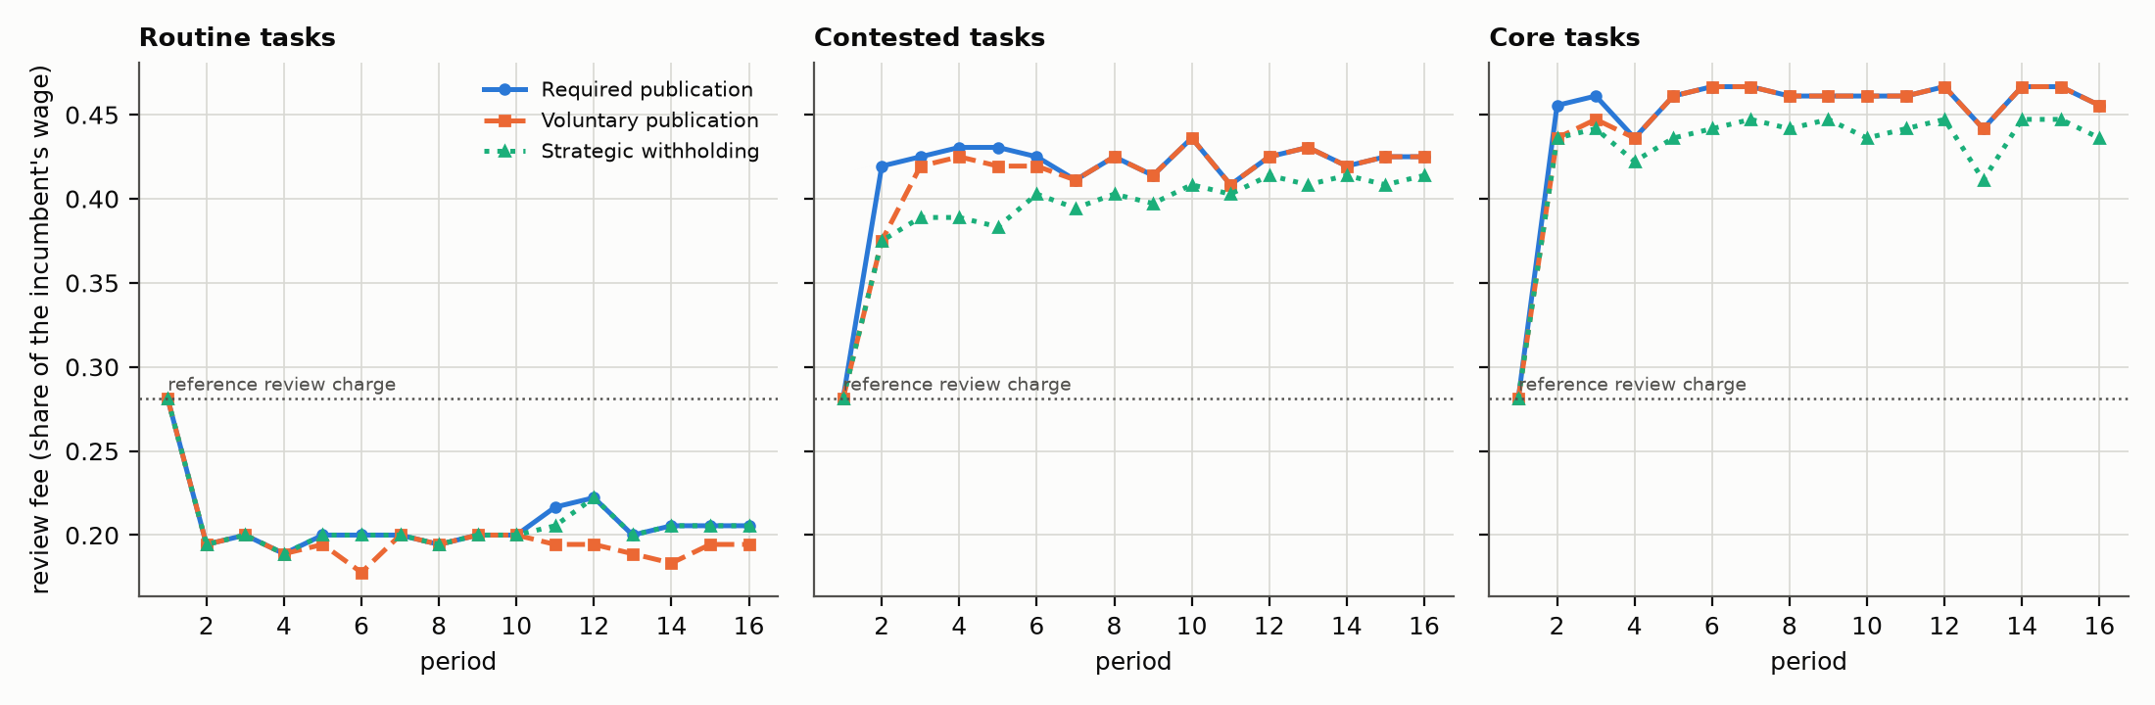
Figure 6. Mean chosen review charges over 16 periods when professionals can price supervision. The dotted reference charge corresponds to the fixed physical review time. Table A11 separately reports publication behavior and the charge above this reference; the difference is not a complete estimate of economic rent.

8 The language-model experiment

What does adding language-model agents test?
The language-model experiment asks whether the research infrastructure can support agents that read workplace documents, generate programs, execute cases, and review answers. Deterministic agents make the mechanism inspectable but use a specified parser and search procedure. I therefore place model-backed actors within the same document interfaces, information restrictions, client choices, and grading system. The comparison establishes what the infrastructure can implement and what each actor achieves under its supplied resources. Differences in archive access and feedback limit comparisons of learner capability, so those resource conditions accompany the reported results.
The reported pilot covers one primary task for each of 18 occupations and ten evaluation cases per task: 180 cases in total. The compiler sees the public instructions and permitted resolved cases; it does not receive the researcher’s interpreter or private professional precedents. The professional agent receives the private professional rulebook. A novice receives only public case materials. A reviewer sees the program’s answer and the information permitted to its role. A separate uncertainty assessor evaluates the case using its allowed materials and can influence the professional’s attention to review; it is not given the correct answer merely to assess uncertainty.
Three successive programs are generated from the instructions, a supplied sample of resolved cases, and feedback on archive errors. In the single-pass condition, feedback presents at most eight failures with some fields omitted, and demonstrations are limited to twelve cases. This differs from the deterministic compiler’s access to the complete eligible archive, so the comparison combines learner and information differences. Generated code runs with restricted inputs in a separate execution process. The operating-system sandbox is available on macOS; the portable subprocess mode used elsewhere has more limited isolation. Live model calls are optional and paid calls are not needed to replay the supplied evidence.

What can be recovered from the archive?
I separate written-rule, convention, and private-precedent cases in Table A12 to identify which information problem generates the errors. An overall score would combine failure to execute a public rule, failure to infer a convention from examples, and absence of private knowledge. The case-level comparison distinguishes those sources and shows whether professional review supplies what the generated program lacks.
Table A12 Accuracy in the language-model pilot
Case type | Cases | Deterministic tool | Model-generated tool | Model professional alone | Model professional reviewing tool
Routine | 103 | 100.0% | 100.0% | 100.0% | 100.0%
Published override | 19 | 100.0% | 100.0% | 100.0% | 100.0%
Unwritten convention | 25 | 92.0% | 0.0% | 100.0% | 96.0%
Private precedent | 33 | 0.0% | 0.0% | 100.0% | 100.0%
All cases | 180 | 80.6% | 67.8% | 100.0% | 99.4%

The model-generated program executes the routine calculation and explicit overrides correctly but resolves none of the 25 fresh convention cases. The deterministic program resolves 23 of those 25. Both programs fail on the 33 private-precedent cases, including seven unflagged cases, because the necessary information is excluded. Supplied with that information, the model professional answers all 180 cases correctly. Professional review yields 179 correct answers, with one convention error accepted. These results locate the performance difference within the supplied information and learning procedures. The pilot’s size and synthetic case structure limit what perfect performance can imply about professional reliability in practice.
I provide an agentic compiler with the complete archive and code-execution tools to examine whether restricted feedback alone explains convention failure. This comparison covers one legal task, permits twelve tool turns, and supplies a 48,000-token budget per turn at high reasoning effort. The compiler uses six turns and tests four candidates. Its best candidate resolves 16 of 28 archive cases, covering routine cases and explicit exceptions but no conventions. The attempted formulas omit an important schedule term and use the published diagnostic cutoff in place of the convention’s distinct breakpoint. This identifies a search failure in the tested task and configuration. A broader comparison requires equal demonstrations, feedback, execution access, and computation across multiple tasks and models.
The uncertainty assessor also illustrates why error measurement matters. The deterministic monitor assigns a 3% error belief to clean reports, yet realized error among those reports is 6.4%, caused by unflagged precedent cases. The model assessor’s lowest-risk group has 3.1% realized error. A report can therefore look confident and complete while the underlying exception remains unresolved. The professional’s access to private knowledge, and its willingness and ability to use it, remain separate from the program’s apparent confidence.

What exactly is reproducible?
The selected pilot consists of 774 recorded requests: 54 compiler requests and 180 each for novice performance, professional performance, professional review, and uncertainty assessment. The transcript identifies the primary served model as claude-opus-5-5 for 761 requests and claude-opus-4-8 for 13; twelve of the latter contain explicit fallback metadata and one names the alternative model without that event field. These are model identifiers recorded in the evidence, not a claim about currently available API models. The selected requests used approximately 1.85 million input tokens and 0.55 million output tokens, with 5,842 model-seconds summed across requests. They were served concurrently, so summed model time is not elapsed runtime.
Saved-event replay selects the recorded requests used by the reported configuration, serves their responses, and executes the saved programs again on the cases. This reproduces the recorded decisions and case traces without contacting a provider. Complete structured histories are unavailable for every original agentic tool interaction, so verification of the multi-turn process is more limited than verification of the responses and program execution. The recording interface captures full request settings and structured histories for experiments that supply those records. Readers can therefore distinguish the case outcomes that can be re-executed from the additional process evidence needed to evaluate an agentic search.

9 Robustness, alternative explanations, and external validity

How dependent is success on the case sample and learning assumptions?
The robustness suite contains the reference run and 41 alternatives. Ten regenerate numerical values under separate seeds; the remaining comparisons vary archive size, candidate formulas, coefficient precision, validation-based selection, liability, statutory penalties, review charges, professional attention, uncertainty beliefs, and case presentation. Each intervention addresses a particular alternative explanation. Stable results across numerical seeds support repeatability within the defined task world; sensitivity to a formula family or information restriction reveals a boundary of the learner rather than a failure of reproducibility. Across ten numerical seeds, overall program accuracy averages 81.1% with a standard deviation of about 0.2 percentage points. Convention accuracy averages 92.0%, with a standard deviation of about 1.3 points. The reference case-type proportions and their arrangement across task zones remain fixed in these seed comparisons. They do not establish robustness to arbitrary occupational case mixtures. Table A13 reports the learning comparisons most directly relevant to the claim that resolved cases make conventions automatable.
Table A13 Learning robustness
Comparison | Convention accuracy | All-case program accuracy
Reference configuration | 91.5% | 81.0%
20 archive draws per task | 19.2% | 69.2%
40 archive draws per task | 78.0% | 78.8%
160 archive draws per task | 98.9% | 82.2%
Reference formula alone | 91.5% | 81.0%
Remove reference formula; retain equivalent family | 90.4% | 80.8%
Remove entire reference formula family | 0.0% | 66.0%
Separate training and validation cases | 52.0% | 74.5%
Restrict coefficients to one decimal place | 0.0% | 66.0%
100 evaluation cases per task | 90.4% | 80.8%

Archive size improves learning when the candidate equations can represent the convention. Accuracy rises from 19.2% with 20 archive draws to 98.9% with 160. Removing one named formula leaves performance nearly unchanged when another candidate is algebraically equivalent, while removing the entire family eliminates convention learning. A one-decimal coefficient grid also fails to represent the specified two-decimal constants under exact matching. These comparisons explain why the reference result depends on both informative cases and a suitable search space. The capability demonstrated here is inference within that declared space, and broader professional reasoning requires further tests.
I reserve every fourth eligible archived case before selecting labels or fields, fitting coefficients, or estimating thresholds to examine the dependence on model selection. Both learning generations fit on training cases and use validation cases to select or reject candidates. This produces an approximately 75/25 partition, with small differences across tasks. On fresh evaluation cases, convention accuracy falls from 91.5% under full-archive consensus selection to 52.0% under the partition, while overall accuracy falls from 81.0% to 74.5%. The contrast shows that allocating some of the small archive to validation materially reduces the reference learner’s performance. The 91.5% result must therefore be interpreted under its full-archive selection procedure.

Could professional precedents also be automated?
I vary access to private-precedent outcomes to examine whether the reference boundary follows from information restrictions or from the learner’s available formulas. The experiment publishes resolved precedent cases, adds an equation capable of representing the relevant interaction, and expands coefficient precision. Comparing these conditions identifies when additional records become usable by the specified learner. It also separates that inference problem from recognizing a precedent in routine-looking documents, which can remain unresolved even when explicitly signaled precedents become learnable.
Table A14 Learning published precedents
Information and search condition | Explicit precedent cases correct | Unflagged precedent cases correct | All precedent cases correct
Private precedents excluded | 0/148 (0.0%) | 0/42 (0.0%) | 0/190 (0.0%)
Resolved precedents published; reference formulas | 0/148 (0.0%) | 0/42 (0.0%) | 0/190 (0.0%)
Published precedents; interaction formula; two-decimal coefficients | 0/148 (0.0%) | 0/42 (0.0%) | 0/190 (0.0%)
Published precedents; interaction formula; expanded precision | 138/148 (93.2%) | 0/42 (0.0%) | 138/190 (72.6%)
Expanded precision and 320 archive draws | 146/148 (98.6%) | 0/42 (0.0%) | 146/190 (76.8%)

Publishing precedents improves performance only when the interaction formula and sufficient coefficient precision are also available. Under those conditions, the program resolves 138 of 148 explicit precedent cases, or 93.2%. Including all 42 unflagged cases gives 138 correct out of 190, or 72.6%. With 320 archive draws, the corresponding counts rise to 146 of 148 (98.6%) and 146 of 190 (76.8%). All 42 unflagged cases remain incorrect. The different denominators identify two distinct requirements for automation. A program must recover a rule from examples and recognize the cases in which that rule applies.
An additional test changes the convention’s mathematical form in two synthetic occupations. An additive convention can be learned using another available formula: all nine contested convention cases and eight core convention cases are solved, while the single routine-zone convention case is missed. Overall accuracy is 37/40 (92.5%) in contested work and 39/40 (97.5%) in routine work. A multiplicative interaction outside the available search space produces no learned handlers. This six-task test confirms that the learner can use more than one supplied formula family, while also exposing its limits. It does not constitute independent validation across actual occupations.

Can an error be detected without being resolved?
I separately test whether the reference monitor’s failure to recognize unflagged cases follows from its implemented checks. A detector learned from archived quantities recognizes all 16 unflagged cases in its diagnostic sample, with false alarms on 17.2% of routine cases. Benign notes with similar quantities reduce recognition to 8/16, and overlap between routine and exceptional metric ranges reduces it to 6/16. False alarms rise to 19.2% in those alternatives. Correction remains zero without the missing precedent rules, including for detected cases. The comparison shows why recognition can support referral while leaving professional knowledge necessary for a correct answer.

Does a simple account explain which occupations obtain statutory protection?
I test the explanation of occupational closure by asking whether the model can generate the supplied licensing pattern before automation. An occupation seeks statutory sign-off when the expected professional revenue gain exceeds its lobbying cost. Alternative regulators approve requests according to lobbying, visible client error, or expected harm. I compare the resulting classifications with the supplied statutory coding for 18 occupations and with chance agreement given the predicted and observed licensing rates. This evaluates the origin of the institutional pattern separately from the consequences of retaining or removing a sign-off rule.
With full client liability, lobbying and the selected public-interest rule each agree with the supplied coding in 44.4% of occupations, against chance agreement of 46.9%. The tested harm rules also fail to outperform their chance benchmarks reliably. The current model therefore provides an account of consequences conditional on a supplied licensing pattern, while leaving its origins unexplained. Political organization, entry institutions, and independently measured third-party harm are candidates for further specification. Reporting this failure limits the institutional claim at the point where the model would otherwise be asked to explain why particular occupations receive protection.
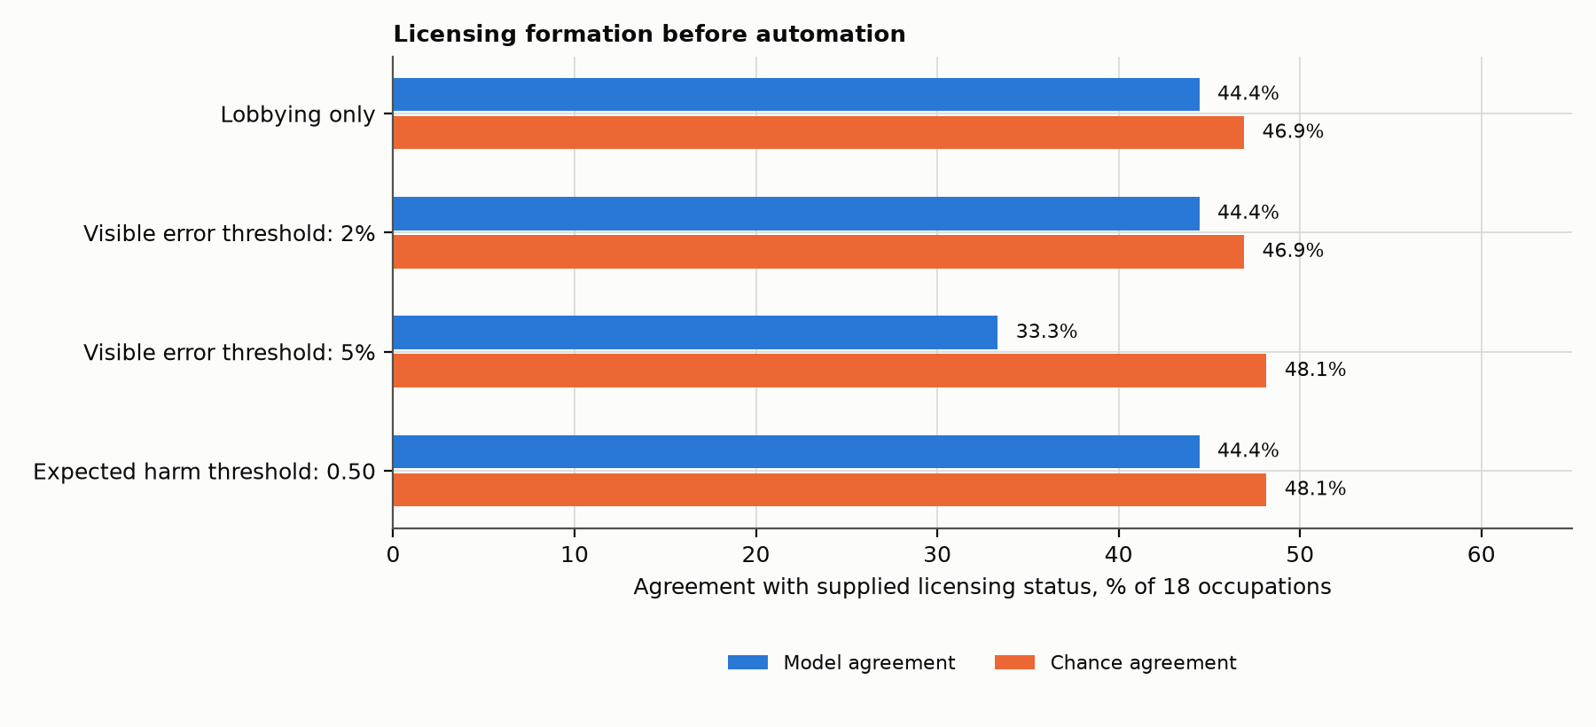
Figure 7. Agreement between predicted and supplied licensing status before automation, with full client liability and a lobbying cost of 5% of professional wages. Chance agreement accounts for predicted and observed licensing rates. Failure to outperform chance limits claims about how occupational closure originates. This experiment is distinct from the effects of changing an existing sign-off rule.

What do the empirical comparisons establish?
The project’s empirical material motivates questions and supplies occupational attributes. It includes cross-occupation platform-use measures, within-occupation institutional comparisons, and coding of regulatory bodies’ AI rules. These observational patterns are not interventions on the mechanisms simulated here. Likewise, similarity between a simulated allocation and a theoretical description of subordination establishes consistency of interpretation, not a matched empirical estimate. The occupation-level comparison between simulated institutional constraints and AI-use outcomes is descriptive. It combines 18 occupation rows mapped to 17 source units, with some outcome values reused across occupations, and mixes differently measured platform outcomes. The simulated difference between technical accuracy and direct automation is strongly correlated with statutory status (R² approximately 0.94). Associations that weaken after statutory status is controlled cannot establish an additional effect of the simulated mechanism. Small-sample robust standard errors or permutation calculations do not resolve mismatched constructs, repeated source units, or the absence of independent validation data.
Independent evaluation will use occupations excluded from development and institutional coding completed without access to model predictions. I will compare the laboratory with licensing-only, harm-only, and base-rate alternatives, align constructs and units across the model and source data, and report failed predictions. The prospective protocol specifies these comparisons and their criteria before new independent evidence is examined. This separates an external test of predictive value from the exploratory comparisons used to develop and interpret the current laboratory.

10 Technical specification and reproduction

Rules, inputs, and grading
Each case has a public task specification and four plain-text documents. Domain rules map those inputs to a diagnostic classification, an inference label, and a numerical action. The renderer prints the documents; the compiler parses that representation. Correctness requires both labels to match and the numerical answer to be within 0.01 of the researcher’s interpreter. A missing field, malformed object, non-finite number, or execution failure counts as an error. This strict criterion makes learning auditable but can exaggerate differences that would be substantively small under a different evaluation metric.
The reference generator draws a primary magnitude from 160–910, a ratio from 0.040–0.210, auxiliary amounts from 20–86 and 90–420, and administrative clutter from 210–790. Exception severity ranges from 0.64–0.91. Routine annex metrics range from 0.12–0.44; benign-decoy alternatives use 0.50–0.91. Reference unflagged cases draw their ratio above the relevant precedent threshold by at least 0.005, up to 0.215. The insufficient-signal alternative relaxes that condition. Draws use reproducible task- and case-specific hashes; this is controlled pseudo-random generation rather than sampling from an estimated occupational distribution.
The compiler’s first generation parses the public rule language and emits standalone Python. Its next generation searches formula templates using exact solutions from small sets of archived failures, rounds candidate coefficients to the declared grid, and requires at least three matching archive outcomes. The third generation considers threshold splits and refits the branch formulas. Candidate complexity and the declared selection rule determine which program is deployed. Fresh evaluation cases never fit the programs. The alternative validation procedure additionally excludes its held-out archive cases from all field, label, coefficient, and threshold fitting.
The analyst can inspect each emitted module, the archive failures it fixes, and per-case traces. A language-model compiler uses the same document and answer interfaces but chooses its own source code. The researcher’s exact-answer interpreter is kept outside the permitted compiler information. This separation is an information restriction in the experimental design; it should not be confused with a universal guarantee that arbitrary generated code is secure on every operating system.

Attention and client costs
In the reference deterministic novice, administrative clutter above 410 + 330 × task overlap can induce an error. The professional working alone uses a threshold of 635 + 22 × job zone; review depth uses 470 + 155 × accountability. Above its relevant threshold the agent applies the specified lapse or shallow-review rule. These are transparent behavioral assumptions, not empirically calibrated human error functions. The professional’s reference arithmetic lapse multiplies the relevant calculation by 1.035. The tool-assisted override condition removes that arithmetic lapse from professional corrections; an alternative uses manual arithmetic.
Let W be the professional’s full charge relative to the automation operator’s unit charge, f the review charge as a share of W, L the task’s error-liability weight, P the statutory penalty, and u the client’s belief that the program is wrong. The client chooses the least costly feasible arrangement:
automation alone: 1 + L × u + P × sign-off requirement
professional supervision: 1 + W × f + L × residual review error belief
professional execution: W + L × professional error belief

The reference liability weight is 5.4 × exp(0.65 × accountability), the statutory penalty is 35 + 15 × licensing share, and the review fraction is 0.25 + 0.08 × licensing share. The professional error belief is 0.008. Residual review error is 0.035 × u when u is no more than 0.30 and 0.55 × u otherwise. The reference uncertainty monitor supplies u = 0.03 for a clean report, 0.12 for a published override, 0.19 for a learned convention handler, and 0.86 for an unconsumed annex field. These beliefs drive allocation; the exact-answer grader measures realized error separately. Client-learning alternatives update beliefs from observed professional errors rather than assuming they are always accurate.

Cohort and disclosure sequence
At each period, programs are learned from the archive available at its start. Cases are then executed, reviewed, and allocated under current prices, rules, and knowledge. The model records realized answers, hours, experience, charges, and errors. Eligible resolved cases are published according to the publication arrangement and labeling rule. Labor demand, retirements, promotions, hires, and knowledge exposures update the next period’s pools. Strategic publication and pricing use independent forecast cases for their one-period comparison. Regulatory and wage responses use the declared lagged outcome rules. This ordering prevents an actor from learning from a realized future evaluation case before making its current decision. Promotion eligibility and component competence use separate thresholds. Initial workforce stocks are calibrated to period 1 of each arrangement, not to a shared pre-AI economy. Demand grows from 1,000 task cases per occupation per period at 2% by default, with no price-elastic response in the reference configuration. Retirement is 5%, capacity is 100 hours per person, and eight periods set the reference eligibility and competence calibrations. The cohort module does not estimate individual careers, endogenous educational entry, forgetting, or migration between occupations.

Reproducing the evidence
The simulation uses Python 3.9 or later and the standard library, while figure generation requires Matplotlib. The supplied Word documents are authoritative, and the document command validates them while preserving manual edits. The package initializes a working directory containing the inputs, saved transcripts, reproduction specification, and final documents. The commands below run the numerical evidence and its recorded checks from the repository.
python3 -m unittest discover -s tests -v
python3 reproduce.py --all --parallel 4
python3 reproduce.py --check

Install Matplotlib in the execution environment before the full run; JURI_FIGURES_PYTHON can select a separate interpreter that has it. Running the full manifest replays the saved model requests and makes no new paid API requests. A fresh installed workspace can be initialized with juri-lab init /path/to/workspace; set JURI_LAB_HOME to that directory for subsequent runner commands.
The 75-job manifest records dependencies and outputs for the numerical experiments, model replay, figures, Word validation, and document checks. Each completed job records hashes of its source code, inputs, dependency outputs, printed log, and output inventory. The integrity check reports files that are missing or changed, as well as differences in source and input inventories. When a selected dependency is rerun, downstream jobs wait for its new completion. The 50-test regression suite covers rule execution, information restrictions, inference statistics, cohort learning, client allocation, held-out fitting, packaging, and dependency records. These controls make the computational evidence inspectable without replacing the substantive evaluation of its assumptions.
There are 96 configuration fields: 80 numerical constants and 16 mode switches. Numerical fields comprise 62 floating-point values, nine integers, and nine range or grid tuples; mode switches comprise eight strings and eight booleans. The runner prints the complete configuration before the experiment. The parameters above explain the main mechanisms; the configuration file and run logs provide the exhaustive values without requiring reviewers to learn a separate vocabulary for every switch.
Table A15 Where the reported evidence is stored
Study | Output or runner
Static capabilities and client allocation | results_extended_18occ_tasks.csv; results_packet_traces_extended_1080.json
Disclosure and professional learning | dynamics_<arrangement>.csv; dynamics_knowledge_<arrangement>_learning.csv
Staffing demand and cohort transitions | dynamics_labor_<arrangement>.csv
Occupational competition | bumping_extended.csv
Review charges | dynamics_<arrangement>_fee.csv
Language-model pilot and program replay | run_llm_arm.py; llm_provenance_summary.csv
Learning assumptions and alternative cases | robustness_summary.csv; archive_boundary.csv; structural_challenge.csv; anomaly_detection.csv
Licensing formation and empirical comparisons | closure_formation_game.csv; validation_ladder.csv; run_live_benchmark.py
Run provenance and detailed printed tables | RUN_MANIFEST.json; run_logs/

References
Abbott, A. (1988). The System of Professions: An Essay on the Division of Expert Labor. University of Chicago Press.
Anteby, M., Chan, C. K., & DiBenigno, J. (2016). Three lenses on occupations and professions in organizations: Becoming, doing, and relating. Academy of Management Annals, 10(1), 183–244. DOI (https://doi.org/10.1080/19416520.2016.1120962).
Anthony, C. (2021). When knowledge work and analytical technologies collide: The practices and consequences of black boxing algorithmic technologies. Administrative Science Quarterly, 66(4), 1173–1212. DOI (https://doi.org/10.1177/00018392211016755).
Beane, M. (2019). Shadow learning: Building robotic surgical skill when approved means fail. Administrative Science Quarterly, 64(1), 87–123. DOI (https://doi.org/10.1177/0001839217751692).
Davis, J. P., Eisenhardt, K. M., & Bingham, C. B. (2007). Developing theory through simulation methods. Academy of Management Review, 32(2), 480–499.
Horton, J. J. (2023). Large language models as simulated economic agents: What can we learn from homo silicus? NBER Working Paper 31122.
Lave, J., & Wenger, E. (1991). Situated Learning: Legitimate Peripheral Participation. Cambridge University Press.
Lebovitz, S., Lifshitz-Assaf, H., & Levina, N. (2022). To engage or not to engage with AI for critical judgments: How professionals deal with opacity when using AI for medical diagnosis. Organization Science, 33(1), 126–148. DOI (https://doi.org/10.1287/orsc.2021.1549).
Weeden, K. A. (2002). Why do some occupations pay more than others? Social closure and earnings inequality in the United States. American Journal of Sociology, 108(1), 55–101.

