
A project report on
DESIGN, STRUCTURAL ANALYSIS AND MANUFACTURING OPTIMIZATION OF A CAR CHASSIS
Submitted in partial fulfilment for the award of the degree of
Bachelor of Technology
in
Mechanical Engineering
by
JOEL SINO (22BME7013)
SRUJAN PETUMPURAI (22BME7112)
GEERTHANA (22BME7046)
Under the guidance of
Dr. PANKAJ BALKRISHNA TAMBE
SCHOOL OF MECHANICAL ENGINEERING
VIT-AP UNIVERSITY, AMARAVATI
May 2026


A project report on
DESIGN, STRUCTURAL ANALYSIS AND MANUFACTURING OPTIMIZATION OF A CAR CHASSIS
Submitted in partial fulfilment for the award of the degree of
Bachelor of Technology
in
Mechanical Engineering
by
JOEL SINO (22BME7013)
SRUJAN PETUMPURAI (22BME7112)
GEERTHANA (22BME7046)
Under the guidance of
Dr. PANKAJ BALKRISHNA TAMBE
SCHOOL OF MECHANICAL ENGINEERING
VIT-AP UNIVERSITY, AMARAVATI
May 2026

Declaration
We hereby declare that the thesis entitled “DESIGN, STRUCTURAL ANALYSIS AND MANUFACTURING OPTIMIZATION OF A CAR CHASSIS” submitted by us, for the award of the degree of Bachelor of Technology in Mechanical Engineering, VIT-AP University, is a record of bonafide work carried out by us under the supervision of Dr. Pankaj Balkrishna Tambe, School of Mechanical Engineering, VIT-AP University, Amaravati.
We further declare that the work reported in this thesis has not been submitted and will not be submitted, either in part or in full, for the award of any other degree or diploma in this institute or any other institute or university.

Place: Amaravati

Date: _________ Signature of the Candidates

Joel Sino (22BME7013)
Srujan Petumpurai (22BME7112)
Geerthana (22BME7046)

Certificate
This is to certify that the Senior Design Project titled “DESIGN, STRUCTURAL ANALYSIS AND MANUFACTURING OPTIMIZATION OF A CAR CHASSIS” that is being submitted by Joel Sino (22BME7013), Srujan Petumpurai (22BME7112), and Geerthana (22BME7046) is in partial fulfilment of the requirements for the award of the degree of Bachelor of Technology in Mechanical Engineering, is a record of bonafide work done under my guidance. The contents of this project work, in full or in parts, have neither been taken from any other source nor have been submitted to any other Institute or University for the award of any degree or diploma and the same is certified.

Dr. Pankaj Balkrishna Tambe
Project Guide
School of Mechanical Engineering, VIT-AP

The thesis is satisfactory / unsatisfactory

Internal Examiner External Examiner

Approved by

PROGRAM CHAIR DEAN
B. Tech. Mechanical Engineering School of Mechanical Engineering

Abstract
This thesis presents the conceptual design, structural analysis, and manufacturing optimization of a tubular spaceframe chassis for a compact two-seater, JDM-inspired performance coupe. The work is developed stage-wise, beginning with the formulation of the design brief and benchmarking of reference vehicles, and progressing through ergonomic packaging based on the 50th-percentile male occupant and SAE J826 H-point methodology, parametric CAD modelling in Autodesk Fusion 360, static linear structural and torsional Finite Element Analysis (FEA), iterative geometric optimization, and finally a Design-for-Manufacturability (DFM) strategy oriented around welded tubular fabrication.
The chassis is constructed from AISI 1020 hot-rolled steel circular hollow sections of 25 mm outer diameter and 2–3 mm wall thickness, welded at triangulated nodes to form a three-dimensional load-path network. Three principal design iterations were performed. The first iteration produced an unphysical displacement of the order of 10⁷ mm and a minimum factor of safety far below unity, indicating an effectively under-constrained and weakly triangulated structure. The second iteration, with constrained boundary conditions and additional bracing, reduced the deformation substantially but retained critical failure zones at the joints, with a minimum safety factor of approximately 0.058. The third and final iteration produced a structurally credible response, with a maximum von Mises stress of approximately 62 MPa against a yield strength of 207 MPa (factor of safety ≈ 3.3), a maximum displacement of 2.954 mm under a 1000 N pure-torsion load case, and a torsional stiffness of approximately 5042 Nm/deg at a chassis mass of 52.2 kg, corresponding to a stiffness-to-weight ratio of about 96 Nm/deg/kg. This places the chassis in the band of well-designed steel spaceframes.
The manufacturing strategy is built around Tungsten Inert Gas (TIG) welding of fish-mouth (cope-cut) joints on a dedicated welding jig, standardized to a single tube outer diameter to halve the number of unique parts, with all node angles maintained above 30° for weld accessibility and left-right symmetry preserved to reduce setup time. The bill of materials and DFM analysis confirm that the chassis can be manufactured in a controlled academic workshop. The work demonstrates that structural stiffness in a compact spaceframe is earned by geometry, triangulation, and node discipline rather than by indiscriminate addition of material, and that early-stage FEA can be used effectively to surface and correct structural deficiencies long before any tubing is cut.
Keywords: car chassis; tubular spaceframe; finite element analysis; torsional stiffness; factor of safety; design for manufacturability; TIG welding; AISI 1020 steel; structural optimization.

i

Acknowledgement
It is our pleasure to express with a deep sense of gratitude to our project guide, Dr. Pankaj Balkrishna Tambe, School of Mechanical Engineering, VIT-AP University, for his constant guidance, continual encouragement, and patient supervision throughout the duration of this Senior Design Project. His expertise in mechanical design and his insistence on engineering rigour shaped the methodology of this work, and our association with him has extended well beyond academics into the practical discipline of design engineering.
We would like to express our gratitude to the Chancellor, the Vice Presidents, the Vice Chancellor, and the Dean of the School of Mechanical Engineering for providing an academic environment that allowed this project to develop from a conceptual idea into a structured engineering study, and for their inspiration throughout our undergraduate tenure.
In a jubilant mood we express our whole-hearted thanks to the Program Chair of B.Tech. Mechanical Engineering, and to all teaching and non-teaching staff members of the School of Mechanical Engineering, whose timely encouragement and willingness to discuss design and analysis problems helped us develop the technical clarity that this work demanded. We would also like to thank our parents and families for their unwavering support during the long iteration cycles that this project required.
Finally, it is indeed a pleasure to thank our friends and classmates who persuaded and encouraged us through each design iteration. We extend our gratitude and appreciation to all those who have helped us directly or indirectly toward the successful completion of this project.

Place: Amaravati

Date: _________ Joel Sino
Srujan Petumpurai
Geerthana

ii

Contents
ABSTRACT i
ACKNOWLEDGEMENT ii
LIST OF FIGURES vi
LIST OF TABLES viii
LIST OF ACRONYMS AND SYMBOLS ix

CHAPTER 1 INTRODUCTION 1
1.1 Introduction 1
1.2 Project Background 2
1.3 Need for the Project 3
1.4 Problem Statement 4
1.5 Project Objectives 5
1.6 Scope of the Project 6
1.7 Engineering Success Criteria 8
1.8 Organization of the Thesis 9

CHAPTER 2 BACKGROUND AND LITERATURE REVIEW 10
2.1 Introduction 10
2.2 Vehicle Chassis Architectures 10
2.3 Tubular Spaceframe Construction 12
2.4 Selection of the Tubular Spaceframe 13
2.5 Structural Philosophy of the Spaceframe 15
2.6 Benchmarking of Reference Vehicles 16
2.7 Benchmark Dimensional Comparison 18
2.8 Lessons Extracted from Benchmarking 20

CHAPTER 3 METHODOLOGY AND HUMAN PACKAGING 22
3.1 Stage-Wise Development Approach 22
3.2 Why Human Packaging Comes First 23
3.3 Occupant Definition and Anthropometric Data 24
3.4 H-Point Method (SAE J826) 25
3.5 Seating Posture, Legroom, and Pedal Package 26
3.6 Steering Reach, Eye Point, and Visibility 28
3.7 Headroom, Shoulder Room, and Ingress/Egress 29
3.8 Safety Cell Definition 30

CHAPTER 4 DESIGN OF THE TUBULAR SPACEFRAME 32
4.1 Design Philosophy 32
4.2 Primary Structural Regions 33
4.3 Material Selection 35
4.4 Tube Cross-Section Selection 36
4.5 Member Naming and Grouping Convention 37
4.6 CAD Modelling Methodology in Fusion 360 39
4.7 Parametric Control Strategy 40

CHAPTER 5 STRUCTURAL ANALYSIS 42
5.1 Analysis Methodology 42
5.2 Why Static, Linear, Fusion 360 43
5.3 Load Case Definition 44
5.4 Boundary Conditions and Loading Setup 45
5.5 Mesh Strategy 46
5.6 Iteration 1: Baseline Frame 47
5.7 Iteration 2: Constrained Redesign 49
5.8 Iteration 3: Final Constrained Redesign 51
5.9 Comparative Analysis Across Iterations 53
5.10 Root-Cause Analysis and Design Decisions 55

CHAPTER 6 FINAL DESIGN AND TORSIONAL STIFFNESS 57
6.1 Final Chassis Configuration 57
6.2 FEA Results of the Final Design 58
6.3 Torsional Stiffness Calculation 60
6.4 Benchmark Comparison 61
6.5 Key Takeaways from the Final Design 62

CHAPTER 7 MANUFACTURING OPTIMIZATION 64
7.1 Manufacturing Strategy 64
7.2 Selection of TIG Welding Process 65
7.3 Joint Preparation and Cope Cutting 66
7.4 Welding Jig and Fixturing 67
7.5 Assembly Sequence 68
7.6 Design-for-Manufacturability (DFM) Optimization 69
7.7 Bill of Materials and Cost Summary 71

CHAPTER 8 CONCLUSION AND FUTURE WORK 73
8.1 Summary of the Work 73
8.2 Key Conclusions 74
8.3 Limitations of the Present Work 75
8.4 Future Work 76

REFERENCES 78
APPENDIX A: DESIGN ASSUMPTIONS 81
APPENDIX B: FUSION 360 SIMULATION SETTINGS 83

iii

List of Figures
Figure 2.1 Tubular spaceframe stylized representation 12
Figure 2.2 Benchmark vehicle selection summary 17
Figure 2.3 Dimensional comparison of benchmark vehicles 19
Figure 4.1 Cross-section of selected CHS tube (Ø25 × 2 mm) 37
Figure 5.1 Iteration 1 displacement contour (unphysical magnitude) 48
Figure 5.2 Iteration 2 displacement contour (constrained model) 50
Figure 5.3 Iteration 3 displacement contour (final design) 52
Figure 5.4 Iteration 3 factor-of-safety distribution 53
Figure 6.1 Final chassis CAD rendering 58

vi

List of Tables
Table 2.1 Comparison of vehicle chassis architectures 11
Table 2.2 Benchmark vehicles — design intent and lessons 17
Table 2.3 Dimensional comparison of benchmark coupes 19
Table 4.1 Comparison of candidate chassis materials 35
Table 4.2 Comparison of tube cross-sections (CHS vs RHS) 36
Table 5.1 FEA load case parameters 44
Table 5.2 Comparison of FEA results across iterations 54
Table 6.1 Final FEA results vs success criteria 59
Table 6.2 Stiffness-to-weight benchmark comparison 61
Table 7.1 Bill of Materials and cost estimate 72
Table A.1 Material assumptions 81
Table A.2 Geometric assumptions 81
Table A.3 Loading assumptions 82
Table A.4 Manufacturing assumptions 82

viii

List of Acronyms and Symbols
AISI American Iron and Steel Institute
BOM Bill of Materials
CAD Computer-Aided Design
CG Centre of Gravity
CHS Circular Hollow Section
DFM Design for Manufacturability
FEA Finite Element Analysis
FOS / SF Factor of Safety
FR Front-engine, Rear-wheel drive
HR Hot Rolled
JDM Japanese Domestic Market
MIG Metal Inert Gas (welding)
OD Outer Diameter
RHS Rectangular Hollow Section
SAE Society of Automotive Engineers
TIG Tungsten Inert Gas (welding)
UTS Ultimate Tensile Strength
VIT-AP Vellore Institute of Technology, Andhra Pradesh
E Young’s Modulus (GPa)
σy Yield Strength (MPa)
K Torsional Stiffness (Nm/deg)
T Applied Torque (Nm)
θ Angular Twist (degrees)

ix

Chapter 1
Introduction

1.1 Introduction
The chassis of an automobile is the principal load-bearing structure of the vehicle. It is the element on which every other system – powertrain, suspension, steering, occupant compartment, and crash structure – is mounted, and it is the element through which every road load, every suspension input, and every inertia force from the powertrain and the occupants ultimately passes. The structural behaviour of the chassis therefore conditions the dynamic behaviour of the entire vehicle: a chassis that twists under cornering loads gives the suspension geometry an additional, uncontrolled compliance, and the vehicle’s handling deteriorates regardless of how carefully the suspension itself has been designed.
This thesis presents the design, structural analysis, and manufacturing optimization of a tubular spaceframe chassis for a compact, two-seater, JDM-inspired performance coupe. The work is treated as an end-to-end engineering exercise: starting from a written design brief and benchmark study, progressing through occupant packaging, parametric CAD development, finite element analysis with iterative refinement, and culminating in a manufacturing strategy that respects the realities of a controlled academic workshop. Every quantitative result reported here was generated within the same software environment that was used to build the geometry, so that geometry, mesh, and result remain in a single, traceable model.
The work also treats the chassis as a teaching artefact. Each design decision is justified not merely by reference to the final number it produces, but by the engineering reasoning that led to it. The reader is expected to follow not only what was done, but why it was done that way and what would have happened if a different choice had been made.

1.2 Project Background
The project was conceived as a Senior Design Project for the B.Tech. programme in Mechanical Engineering at VIT-AP University. The brief, in its final written form, was to design a compact, two-door, JDM-inspired sports coupe with a front-engine rear-wheel-drive (FR) layout, a wheelbase in the neighbourhood of 2.5 m, and an emphasis on rigidity, low mass, and driver focus rather than outright power. The chassis was identified as the single component that would dominate the structural behaviour of the vehicle and was therefore selected as the subject of detailed analysis.
Three reference vehicles were chosen for benchmarking: the Mazda RX-7 FD (1992), the Honda S2000 AP1, and the Mazda MX-5 NA. All three share the FR architecture and are widely regarded as well-resolved driver’s cars. Their published dimensions, mass distribution, and architectural choices were studied to bracket the proposed chassis within a recognized engineering envelope rather than allowing it to drift into arbitrary geometry.
From the outset, the chassis was required to be manufacturable in a controlled academic workshop, using standard tubular stock, a single welding process, and conventional fixturing. This requirement deeply influenced material and section choices, joint geometry, and the overall topology of the frame.

1.3 Need for the Project
Although chassis design is a mature engineering subject, two practical needs motivate a fresh academic treatment. The first is pedagogical. Most undergraduate exposure to structural analysis treats the chassis as a given, asking the student to analyse a frame that has already been drawn for them. The student therefore rarely encounters the much harder problem of generating a frame from an empty packaging envelope and then defending its geometry on engineering grounds. This project closes that gap by requiring every member of the frame to be justified.
The second is technical. The torsional stiffness of a vehicle frame, and the manner in which that stiffness is distributed along its length, are properties that cannot be assessed by intuition alone. They emerge from the cooperative action of triangulated members and well-supported nodes, and they can deteriorate sharply if either of those is compromised. A documented FEA-driven design loop is therefore not a luxury – it is the only reliable way to confirm that a hand-drawn frame actually behaves as the designer believed it would. The need for such a documented loop, taken from concept to verified geometry, is what this project addresses.
Finally, the chassis must be manufacturable. A frame that can be analysed but not built has no engineering value. The manufacturing strategy is therefore treated here with the same seriousness as the analysis itself.

1.4 Problem Statement
The problem addressed by this thesis can be stated in a single sentence: to design, analyse, and prepare for manufacture a tubular spaceframe chassis for a compact JDM-inspired two-seater coupe, such that the chassis is light, torsionally stiff, geometrically buildable in a controlled academic workshop, and consistent with a 50th-percentile male occupant packaged according to standardized ergonomic methodology.
Unpacked, this problem has four conjoint requirements that must all be satisfied simultaneously. Structurally, the frame must exhibit a maximum von Mises stress safely below the yield strength of the chosen material under the design load case, with a factor of safety of at least three. Geometrically, it must accommodate a 50th-percentile male occupant in a credible H-point posture with sufficient legroom, headroom, and visibility. Dynamically, it must provide a torsional stiffness sufficient to keep frame compliance from dominating suspension behaviour. Practically, it must be manufacturable with TIG-welded circular hollow sections of a single dominant outer diameter.
The chassis is to be treated as a complete structural artefact rather than as an isolated bench piece, but in the interest of tractability the present work focuses on the static torsional load case, which is the most demanding test of frame integrity in a road-going vehicle.

1.5 Project Objectives
To make the problem actionable, the following specific objectives were defined at the outset:
- To formulate the design brief and benchmark three reference FR coupes to bracket the proposed chassis within a recognized engineering envelope.
- To define the occupant package using SAE J826 H-point methodology and NASA anthropometric data for a 50th-percentile male, establishing the interior volume that the chassis must enclose.
- To develop a parametric CAD model of the chassis in Autodesk Fusion 360, built up from primary structural regions (front frame, footwell, main hoop, rear frame, floor) rather than as a single monolithic sketch.
- To perform static linear FEA in Fusion 360 under a pure torsion load case representative of cornering input, and to iterate the geometry until the success criteria are satisfied.
- To compute the torsional stiffness of the final design and benchmark its stiffness-to-weight ratio against published data for steel spaceframes.
- To develop a manufacturing strategy oriented around TIG welding of cope-cut joints, a welding jig, and Design-for-Manufacturability principles such as tube standardization and joint angle limits.
- To prepare a Bill of Materials and cost estimate, demonstrating that the chassis can be built within an academic workshop budget.
- To document every assumption, decision, and result in a manner that allows the work to be reproduced or audited by a third party.

1.6 Scope of the Project
The scope of this project encompasses the chassis as a structural unit, considered from the moment the design brief is written to the moment a buildable Bill of Materials is generated. Within this scope, the work covers occupant packaging, structural CAD development, finite element analysis under a torsional load case, iterative geometric refinement, computation of the torsional stiffness of the final design, and the manufacturing strategy for fabrication.

1.6.1 In-Scope Activities
- Definition of the design brief and selection of benchmark vehicles.
- Occupant packaging using SAE J826 H-point method and 50th-percentile anthropometric data.
- Parametric CAD development of the chassis in Autodesk Fusion 360.
- Static linear FEA under a torsional load case, with at least three documented iterations.
- Iterative refinement of triangulation, joint geometry, and member sizing.
- Computation of torsional stiffness and stiffness-to-weight ratio.
- Development of a TIG-welding-based manufacturing strategy with DFM optimization.
- Bill of Materials and indicative cost estimate.

1.6.2 Out-of-Scope Activities
- Dynamic analysis: crash, modal, fatigue, and full-vehicle dynamic simulation are excluded; only static linear FEA is treated.
- Physical prototype build and weld testing: the project produces a manufacturable design, not a constructed prototype.
- Bodywork, interior trim, powertrain integration, and subsystem mounts beyond their structural footprint.
- Detailed weld procedure qualification, weld inspection plans, and post-weld heat treatment.

1.7 Engineering Success Criteria
Engineering success in this project is defined in advance and in numerical terms, so that the final design can be judged against fixed targets rather than against subjective impression. The success criteria are:
- Minimum factor of safety against yield in the final design ≥ 3.0 under the torsional load case.
- Maximum displacement under the design torsional load ≤ 5 mm.
- Torsional stiffness in the range of a well-designed steel spaceframe (4000 – 8000 Nm/deg).
- Stiffness-to-weight ratio in the steel-spaceframe band (typically 70 – 130 Nm/deg/kg).
- Chassis mass kept below 60 kg for a compact two-seater spaceframe.
- All node angles greater than 30° for weld accessibility.
- A single dominant tube outer diameter throughout the frame to simplify procurement and fabrication.
- A documented Bill of Materials with an indicative cost compatible with an academic workshop.

1.8 Organization of the Thesis
Chapter 2 reviews vehicle chassis architectures, explains why the tubular spaceframe was selected, and presents the benchmarking study. Chapter 3 describes the stage-wise methodology and the occupant packaging that establishes the interior envelope. Chapter 4 develops the structural design of the spaceframe, including material and section selection. Chapter 5 presents the FEA work in detail, including three documented iterations and their interpretation. Chapter 6 reports the final design, computes its torsional stiffness, and benchmarks the stiffness-to-weight ratio. Chapter 7 develops the manufacturing strategy, including TIG welding, jigging, DFM optimization, and the Bill of Materials. Chapter 8 concludes the work and identifies future directions. Two appendices document the design assumptions and the Fusion 360 simulation settings.

Chapter 2
Background and Literature Review

2.1 Introduction
This chapter establishes the engineering context in which the present chassis was designed. It begins with a survey of vehicle chassis architectures, justifies the selection of the tubular spaceframe for the present application, summarizes the structural philosophy of the spaceframe, and concludes with the benchmarking study that bracketed the chassis dimensions and intent.

2.2 Vehicle Chassis Architectures
Three principal chassis architectures dominate modern automotive practice: ladder frame, monocoque (unibody), and tubular spaceframe. Each has a characteristic structural logic, a distinctive manufacturing footprint, and a particular regime of vehicle types for which it is best suited.
A ladder frame consists of two longitudinal rails connected by transverse cross-members. It is structurally tolerant, mechanically simple, and easy to repair, which is why it survives in trucks and body-on-frame SUVs. However, it is torsionally compliant for its mass: the deep section that gives it bending stiffness contributes relatively little to torsional rigidity because the two rails are not interconnected by a closed shear web.
A monocoque, by contrast, uses the body shell itself as the principal load-bearing structure. Loads are spread across stamped and welded sheet metal panels working primarily in shear. The monocoque is the dominant architecture in mass-produced passenger cars because the unit cost falls rapidly with volume once tooling is amortized. It is, however, capital-intensive: monocoque production demands large presses and welding lines that are wholly unsuited to low-volume or academic settings.
A tubular spaceframe is a three-dimensional truss assembled from circular or rectangular hollow sections, welded at well-defined nodes. Stiffness is created by triangulation: every applied load is decomposed into axial forces in the members, rather than being absorbed by bending of large sheet metal panels. The spaceframe is therefore highly efficient in stiffness per unit mass when properly triangulated, and it can be built in a small workshop with conventional welding equipment.
Table 2.1: Comparison of vehicle chassis architectures
Attribute | Ladder Frame | Monocoque | Tubular Spaceframe
Structural principle | Long. rails + cross-members | Stressed-skin shell | 3-D triangulated truss
Stiffness-to-weight | Low | High (volume-dependent) | Very high (geometry-dependent)
Manufacturing cost (low volume) | Moderate | Very high | Low
Tooling requirement | Modest | Press lines, fixtures | Welding jig, tube cutter
Repairability | High | Moderate | High (localized re-weld)
Typical application | Trucks, SUVs | Mass-market passenger cars | Sports cars, race cars, kit cars
Suitability for academic build | Moderate | Poor | Excellent

2.3 Tubular Spaceframe Construction
A tubular spaceframe is constructed from a finite set of hollow tubular members, joined at nodes by welding, such that the overall geometry forms a three-dimensional network of triangles. The fundamental structural mechanism is axial: each member ideally carries either pure tension or pure compression, with bending moments minimized by the convergence of multiple members at every node. When this triangulation is properly executed, the frame behaves as a stiff and lightweight structural lattice.
The strength of the spaceframe depends, in roughly equal measure, on the integrity of the members themselves and on the integrity of the nodes that join them. A member with adequate cross-section but joined into a node whose geometry forces it to share a single weld path with too many neighbours becomes a weak point regardless of its own dimensions. Spaceframe design therefore requires equal attention to member sizing and to node planning.
Historically the tubular spaceframe entered serious production with cars such as the Mercedes-Benz 300 SL of the 1950s, where the architecture’s height drove the famous gull-wing doors. Today it remains the architecture of choice for low-volume sports cars and for nearly all student-built race vehicles, including the Formula Student / Formula SAE category, for precisely the reasons set out above.
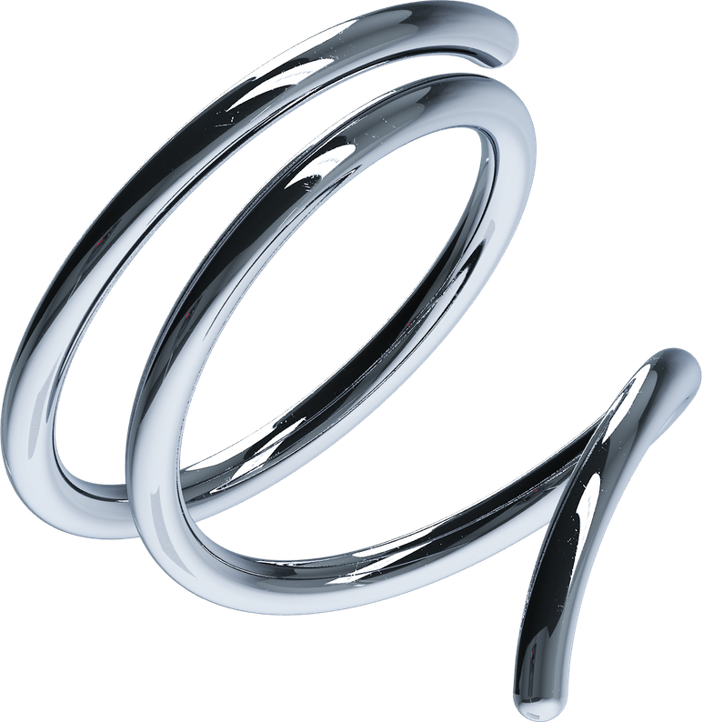
Figure 2.1: Tubular spaceframe stylized representation

2.4 Selection of the Tubular Spaceframe
For the present project, the tubular spaceframe was selected over the ladder and monocoque architectures for four conjoint reasons. First, the project explicitly required structural rigidity at low mass, and the spaceframe offers the highest stiffness-to-weight ratio of the three architectures when properly triangulated. Second, the project required that the chassis be buildable in a controlled academic workshop, which immediately excludes the monocoque on tooling grounds and disadvantages the ladder frame on structural grounds. Third, the spaceframe offers the most direct correspondence between the CAD model and the manufactured artefact: each member in CAD is a tube in the workshop, with no intermediate sheet-metal forming step. Fourth, the spaceframe is the architecture that best supports iterative redesign, because failed members can be removed and replaced without disturbing the rest of the structure.
The decision to use a spaceframe is therefore not a matter of preference. It is the architecture that best satisfies the conjunction of structural, manufacturing, and pedagogical constraints that defined the project from the outset.

2.5 Structural Philosophy of the Spaceframe
A well-designed spaceframe rests on three structural principles. The first is triangulation: every load applied to the frame must find an axial path through triangulated members to ground (i.e. to the suspension pickups). Any region of the frame in which loads can only travel by bending a long, unbraced member is a region in which the local stiffness is dominated by bending compliance, which is far lower than axial compliance for the same tube. Such regions become stress concentrations and the design objective is to eliminate them.
The second principle is node discipline. A node should bring together three or more members from non-coplanar directions, so that the local stiffness in every direction is supported by at least one axial member. Nodes with only two members are pin-jointed in effect, and nodes whose members are nearly coplanar are stiff in plane but compliant out of plane. Both must be avoided.
The third principle is symmetry. A chassis that is symmetric about its longitudinal centre-plane carries lateral loads symmetrically as well, halves the design problem, and almost halves the manufacturing problem because each unique member is required only on one side and is then mirrored. Departures from symmetry are admissible – the engine bay sometimes demands them – but they should be conscious departures, not artefacts of careless drafting.

2.6 Benchmarking of Reference Vehicles
To bracket the design within a recognized engineering envelope, three reference vehicles were selected for benchmarking. All three are FR coupes regarded as well-resolved driver’s cars, and all three are documented in the engineering and motoring literature.
The Mazda RX-7 FD (1992) was selected as the upper aspiration in terms of performance and chassis precision. The Honda S2000 AP1 was selected as a reference for a high-revving naturally-aspirated FR architecture with a relatively short wheelbase. The Mazda MX-5 NA was selected as the most disciplined exercise in lightweight, low-power FR design and as the closest dimensional analogue to the proposed chassis.
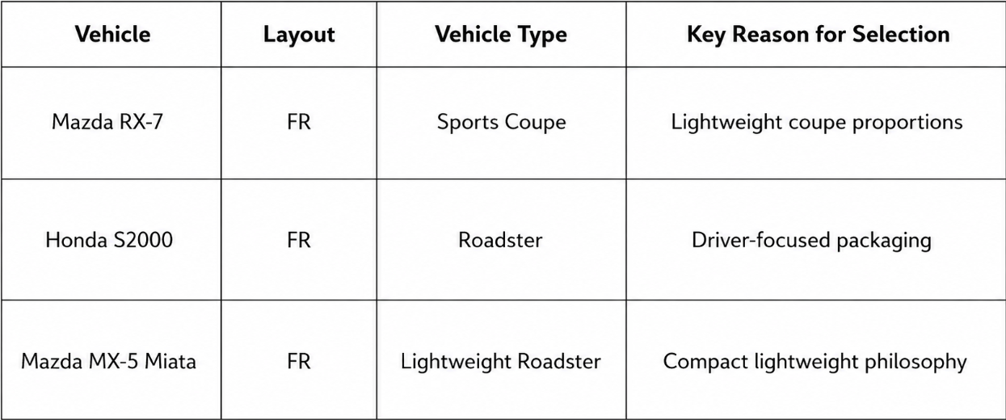
Figure 2.2: Benchmark vehicle selection summary
Table 2.2: Benchmark vehicles — design intent and lessons
Vehicle | Design Intent | Key Lesson
Mazda RX-7 FD (1992) | Refined FR performance coupe | Mass discipline + tuned chassis stiffness
Honda S2000 AP1 | High-revving NA roadster | Short wheelbase, stiff structure, driver focus
Mazda MX-5 NA | Lightweight, low-power FR roadster | The smallest envelope that still works as an FR coupe

2.7 Benchmark Dimensional Comparison
The principal dimensions of the three benchmark vehicles were tabulated and compared. The wheelbase, track, overall length, and kerb mass were of particular interest because they directly set the upper and lower bounds within which the proposed chassis would be sized.
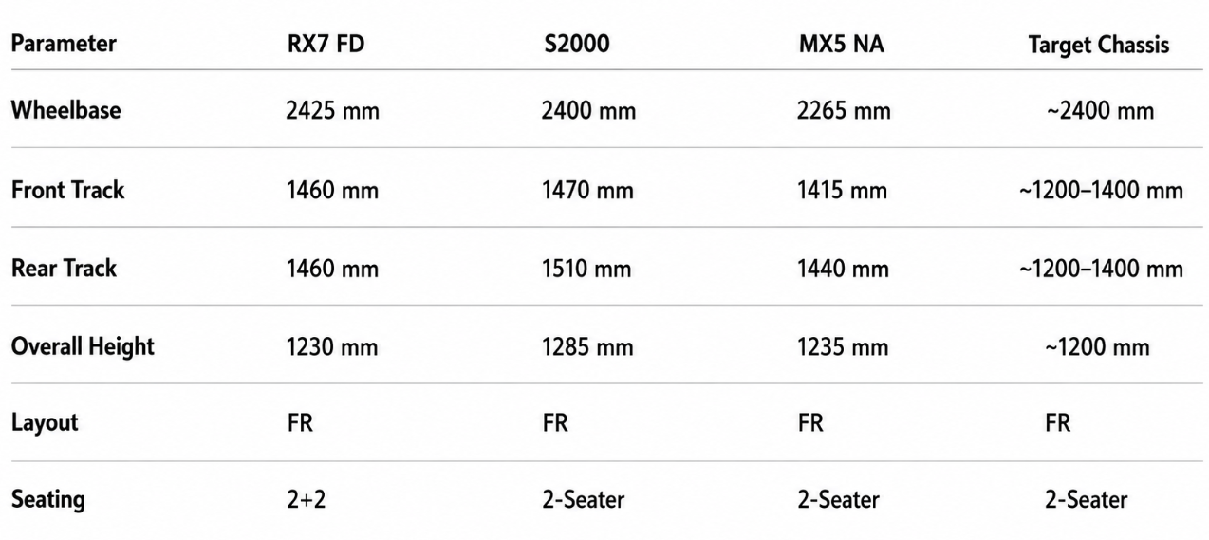
Figure 2.3: Dimensional comparison of benchmark vehicles
Table 2.3: Dimensional comparison of benchmark coupes (representative published values)
Parameter | RX-7 FD | S2000 AP1 | MX-5 NA | This Chassis (target)
Wheelbase (mm) | ~ 2425 | ~ 2400 | ~ 2265 | ~ 2500
Front track (mm) | ~ 1460 | ~ 1470 | ~ 1405 | ~ 1200 (chassis)
Length (mm) | ~ 4295 | ~ 4135 | ~ 3950 | ~ 4000
Kerb mass (kg) | ~ 1310 | ~ 1260 | ~ 950 | (chassis 52.2 kg)

2.8 Lessons Extracted from Benchmarking
Three principal lessons were extracted from the benchmarking study and carried forward into the design phase. First, all three benchmark vehicles operate within a wheelbase band of roughly 2.25 – 2.45 m and an overall length band of roughly 3.9 – 4.3 m, which set credible upper and lower limits for the proposed chassis. Second, all three vehicles have well-documented investments in structural rigidity, indicating that even modest-power FR cars are degraded by a flexible chassis. Third, the lightest of the three – the MX-5 NA – demonstrates that an FR coupe can be made to function on a kerb mass below one tonne, provided that every system is interrogated for mass.

Chapter 3
Methodology and Human Packaging

3.1 Stage-Wise Development Approach
The chassis was developed in eight engineering stages, executed sequentially with documented outputs at the end of each stage. The eight stages are: (1) project definition and brief writing, (2) benchmarking of reference vehicles, (3) human and component packaging using SAE J826 methodology, (4) architectural selection and layout, (5) parametric CAD development, (6) structural analysis (FEA) with iterative refinement, (7) manufacturing strategy and DFM, and (8) Bill of Materials and verification. The output of each stage is the input of the next, and re-entry into an earlier stage is permitted but is documented when it occurs.
The justification for this sequencing is that the structural design problem cannot be properly stated until the interior envelope it must enclose has been defined, and the interior envelope cannot be properly defined until the occupant has been positioned in space. Human packaging therefore precedes structural design, not the other way around.

3.2 Why Human Packaging Comes First
It is tempting to begin a chassis design by drawing tubes. This is the wrong place to start. The chassis is the envelope around an occupant and the systems that occupant requires; tubes that intrude on the occupant’s head, legs, elbows, or vision are not engineering features, they are mistakes that will have to be removed later at the cost of the structural decisions that produced them. By positioning the occupant first and constructing the chassis around the resulting interior volume, all subsequent structural decisions are made within a credible envelope and the late, expensive rework of structural members is avoided.

3.3 Occupant Definition and Anthropometric Data
The reference occupant for this chassis is the 50th-percentile adult male, defined dimensionally using anthropometric data from the NASA “Man-Systems Integration Standards” (NASA-STD-3000). The 50th-percentile selection is conservative for the present purpose: a 50th-percentile package will accommodate the average male and, with seat travel and steering reach included, a wide band of occupants on either side.
Principal anthropometric values used in this project were taken as: stature 1755 mm, sitting height 914 mm, sitting eye height 790 mm, knee height (seated) 558 mm, buttock-to-knee length 599 mm. These values were translated into a posed manikin in CAD, which was then used to establish the H-point, the heel point, and the eye point on the chassis package drawing.

3.4 H-Point Method (SAE J826)
The H-point (Hip-point) is the recognized engineering reference for the pivot of the occupant’s torso relative to the thigh in a seated automotive posture, and is defined and located using the procedure of SAE J826 with the J826 manikin. The H-point is the anchor of the entire interior package: pedal travel, steering reach, seat travel, headroom, and the eye ellipse are all measured relative to it.
In this project the H-point was placed at a comfortable touring-coupe driving height: 250 mm above the heel point and 700 mm aft of the front axle line, with the torso reclined at 25° from vertical. From this anchor, the pedal box, steering column, seat track, and roof line were positioned, defining a complete interior reference grid before any tube was drawn.

3.5 Seating Posture, Legroom, and Pedal Package
The seated posture adopted for this chassis is a sports-coupe touring posture rather than a competition posture. The torso is reclined 25° from vertical, the thigh angle (H-point to knee, measured from horizontal) is set at 12°, and the calf is angled forward such that the heel rests on the heel point and the ball of the foot reaches the brake pedal pad with the knee in mild flexion. Legroom from the H-point to the heel point is 950 mm along the projected sightline, which preserves comfort for the 95th-percentile male while permitting the 5th-percentile female to retain meaningful pedal control by means of seat travel.
The pedal box was positioned with the brake pedal centred on the longitudinal axis of the right foot and the accelerator pedal floor-hinged. Pedal axes are co-planar to avoid foot rotation between pedals.

3.6 Steering Reach, Eye Point, and Visibility
The steering wheel was placed such that the centre of the rim is 450 mm forward of the H-point along the torso axis, and 25 mm above the H-point in the seated reference plane. The wheel diameter is taken as 360 mm. The eye point of the occupant is located 790 mm above the H-point along the torso axis, which corresponds to 50th-percentile sitting eye height. From this eye point, the upward visibility cone passes above the roof rail with margin, and the downward visibility cone clears the bonnet line by a comfortable angle, satisfying the basic forward-visibility envelope used in passenger-car package studies.

3.7 Headroom, Shoulder Room, and Ingress/Egress
Headroom is measured from the H-point along the torso axis to the lowest hard structure above the occupant’s head. In this chassis the headroom margin above the 50th-percentile crown is 75 mm. Shoulder room is set at 1300 mm between hard surfaces at shoulder height to permit two-abreast occupancy in a compact two-seater. The sill height is held below 350 mm at the door cut to keep ingress/egress comfortable in normal clothing.

3.8 Safety Cell Definition
Although a full crash analysis is outside the scope of this project, the chassis was designed with an explicit safety cell concept. The safety cell is the volume bounded by the main hoop at the rear of the occupant compartment, the A-pillar tubes at the front, and the floor structure beneath. The intent of the safety cell is to remain geometrically intact under crash and rollover events, even though those events are not analysed quantitatively here. Doubled-wall tubing (3 mm) is therefore used at the main hoop, and the A-pillar tubes are continuous from the cowl down to the floor cross-member rather than being terminated at the cowl alone.

Chapter 4
Design of the Tubular Spaceframe

4.1 Design Philosophy
The design philosophy of this spaceframe is summarized in a single sentence: stiffness is earned by geometry, not by mass. The starting point is a packaged interior volume bounded by the occupant compartment and the principal hard points (suspension pickups, engine mounts, wheel arches). Around that volume a triangulated lattice of tubular members is constructed, with every member justified by the load path it carries and every node planned so that incoming members meet from non-coplanar directions. Members that do not earn their place by carrying load are removed in favour of mass savings; members whose proposed cross-section is excessive for the load they carry are downsized.
Symmetry about the longitudinal centre-plane is enforced wherever architecturally possible, which simultaneously halves the design effort and the number of unique manufactured parts. The frame is built up region-by-region rather than as a single monolithic geometry, so that each region can be analysed and revised independently before being committed to the assembly.

4.2 Primary Structural Regions
The chassis is logically divided into five primary structural regions. Each region serves a distinct structural function and is designed and analysed as a sub-assembly before being committed to the global model.

4.2.1 Front Frame
The front frame extends from the front bulkhead forward to the front bumper line. It carries the front suspension upper and lower mounting points, the steering rack, and the radiator. Its principal structural function is to transmit suspension loads from the front pickups rearward into the main occupant compartment without permitting the front track to twist relative to the rest of the chassis under cornering.

4.2.2 Footwell and Floor Structure
The footwell and floor structure forms the lower boundary of the occupant compartment. It carries the seat mounts, the pedal box, the steering column lower mount, and a portion of the side-impact load path. The floor is heavily cross-braced because lateral cornering loads enter the chassis here through the seat mounts and must be transmitted from one side of the chassis to the other without permitting the floor to shear.

4.2.3 Main Hoop and Roof Structure
The main hoop sits immediately behind the occupant’s shoulders and is the principal element of the safety cell. It uses tubing of greater wall thickness (3 mm) than the rest of the chassis and is continuous from one floor rail to the other, passing up over the occupant’s head. The roof structure forward of the main hoop ties the A-pillars to the hoop, completing the safety cell envelope.

4.2.4 Rear Frame
The rear frame extends from the main hoop rearward to the rear bumper line. It carries the rear suspension pickups, the differential mounts (if present), the fuel tank, and the rear bodywork attachments. As with the front frame, its principal structural function is to transmit suspension loads into the main occupant compartment without permitting the rear track to twist.

4.2.5 Suspension Pickups and Hard Points
The suspension pickups are local nodes at which suspension links are bolted to the chassis. These nodes carry concentrated loads of substantial magnitude and are reinforced with gussets where required. The geometry of each suspension pickup is governed by the suspension kinematics, but the surrounding triangulation is governed by the chassis design and is treated as part of the spaceframe rather than as part of the suspension.

4.3 Material Selection
The material selected for the chassis is AISI 1020 hot-rolled steel. This is a low-carbon, mild-tempered structural steel widely available in tubular stock, well characterized in published data, and forgiving to weld. Its yield strength is approximately 207 MPa, its ultimate tensile strength is approximately 380 MPa, its modulus of elasticity is 200 GPa, and its density is 7870 kg/m³.
Three alternative materials were considered: AISI 4130 chromoly, 6061-T6 aluminium, and AISI 304 stainless steel. AISI 4130 has approximately twice the yield strength of AISI 1020 but is considerably more expensive, requires preheat and post-weld stress relief for reliable joints, and is harder to procure in the Indian academic market in standardized tubular stock. Aluminium alloys offer a roughly threefold improvement in stiffness-to-weight ratio at the material level but demand TIG welding by a skilled operator, exhibit significant heat-affected-zone softening, and have lower fatigue endurance. Stainless steel offers the corrosion resistance but at a cost and density penalty that is not justified for an academic prototype.
Table 4.1: Comparison of candidate chassis materials
Property | AISI 1020 HR | AISI 4130 CrMo | AISI 304 SS | Al 6061-T6
Yield strength (MPa) | 207 | 460 | 215 | 275
UTS (MPa) | 380 | 560 | 505 | 310
Young’s modulus E (GPa) | 200 | 205 | 193 | 69
Density (kg/m³) | 7870 | 7850 | 8000 | 2700
Weldability | Excellent (any process) | Good (with preheat) | Good (TIG) | Demanding (TIG)
Relative cost (₹/kg) | Baseline | ~2.5× | ~3.5× | ~3×
Availability (India) | Excellent | Moderate | Good | Good
On the conjunction of yield strength, weldability, cost, and availability, AISI 1020 HR is the rational choice for this project. The modest yield strength is offset in the design by section sizing and triangulation, both of which the spaceframe architecture rewards.

4.4 Tube Cross-Section Selection
Two tube cross-sections were considered: circular hollow section (CHS) and rectangular hollow section (RHS). CHS was selected because the polar moment of inertia of a CHS is identical in every direction perpendicular to its axis, giving the tube equal stiffness in bending in any plane. An RHS, by contrast, has a stiffer bending direction (the major axis) and a more compliant one (the minor axis); an RHS therefore has to be either over-sized for both directions or carefully oriented at every node, both of which complicate the design. Furthermore, cope cutting (the fishmouth joint preparation used to mate tubes at nodes) is intrinsically simpler and more accurate on CHS than on RHS.
Table 4.2: Comparison of tube cross-sections (CHS vs RHS) for chassis members
Criterion | Circular (CHS) | Rectangular (RHS)
Bending stiffness | Equal in all planes | Major-axis biased
Buckling resistance | Higher per unit mass | Lower per unit mass in weak axis
Joint cope cutting | Geometrically clean | Geometrically clumsy at angles
Fitment to non-coplanar nodes | Excellent | Requires careful orientation
Standard availability | Excellent | Good
Visual integration | Cleaner for spaceframe aesthetic | Less common in spaceframes
The selected tube has 25 mm outer diameter and 2 mm nominal wall thickness, increased to 3 mm at the main hoop and at selected high-load members. With a 25 mm OD and a 2 mm wall the second moment of area is approximately 1.05 × 10⁻⁹ m⁴, the cross-sectional area is 144 mm², and the mass per unit length is approximately 1.13 kg/m.
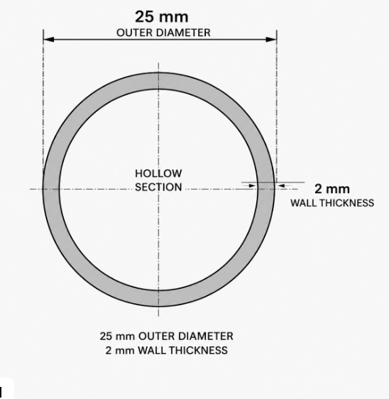
Figure 4.1: Cross-section of selected CHS tube (Ø25 × 2 mm)

4.5 Member Naming and Grouping Convention
To support traceable analysis and a clean BOM, every tubular member of the chassis is named by a convention indicating its region, role, and (where mirrored about the centre-plane) side. Front frame members are prefixed FR-, footwell/floor members FL-, main hoop members MH-, roof members RF-, rear frame members RR-. The role within the region is denoted by a short tag (UPR for upper, LWR for lower, DIAG for diagonal, X for cross-member). Mirrored members carry a trailing -L or -R for side. For example FR-UPR-DIAG-L names the upper diagonal of the front frame on the left side of the vehicle. This convention is used in the BOM and in every figure where members are individually labelled.

4.6 CAD Modelling Methodology in Fusion 360
The chassis was modelled in Autodesk Fusion 360 in three logical layers. The first layer is a parametric centreline skeleton: a wireframe of three-dimensional sketches representing the centrelines of every tubular member, anchored to user parameters for principal lengths (wheelbase, track, sill width, hoop height). The second layer applies pipe sweep features along each centreline to produce the tubular geometry. The third layer applies cope cuts at each node so that each incoming tube is trimmed against the outer surfaces of its neighbours, producing buildable fish-mouth joints.
The advantage of this layered methodology is that geometric changes to the chassis (e.g. lowering the main hoop by 15 mm) are made in the centreline sketch alone, and the pipe sweeps and cope cuts update automatically. The CAD model therefore behaves as a single source of truth, and the FEA mesh that follows is regenerated from this same geometry rather than from a separately maintained analysis file.

4.7 Parametric Control Strategy
A small set of user parameters governs the overall geometry. Wheelbase is parameter WB (default 2500 mm); chassis track is parameter TRK (default 1200 mm); main hoop height is parameter MH_H (default 1100 mm); main hoop width is parameter MH_W (default 1100 mm); sill width is parameter SILL_W (default 600 mm); and overall length is parameter L (default 4000 mm). All other dimensions are either derived from these parameters or are local detail dimensions set within an individual region. This compact parameter set means that the entire chassis can be re-proportioned by editing six numbers, which proved valuable during the iterative analysis phase.

Chapter 5
Structural Analysis

5.1 Analysis Methodology
The structural analysis of the chassis was performed by static linear finite element analysis (FEA) in Autodesk Fusion 360. The analysis methodology is conventional: the parametric CAD geometry is meshed, boundary conditions and loads are applied, the linear elastic problem is solved for nodal displacements, and von Mises stress, displacement, and factor of safety distributions are extracted for interpretation.
Three principal iterations were performed. Each iteration introduced specific geometric or topological changes whose effects were assessed against the engineering success criteria. The intent of the iterative approach is not to obtain a single “right” answer at the first attempt, but to expose the structural deficiencies of the initial design and to correct them in a documented sequence.

5.2 Why Static, Linear, Fusion 360
The analysis was deliberately restricted to static, linear FEA. The static restriction is justified because the design load case is a pure torsion case applied quasi-statically, representative of steady-state cornering rather than impact. The linear restriction is justified because the stresses in the final design remain well below the yield strength, the displacements are small relative to the characteristic length of the structure, and the contact behaviour at welded joints is faithfully represented by rigid continuity rather than by frictional contact. Together these assumptions mean that a static linear solver gives a defensible answer for the engineering quantity of interest — the chassis stiffness and stress field under the design load.
Fusion 360 was selected over commercial-grade FEA packages because the CAD and FEA environments share the same geometry: there is no translation step, no mesh corruption on import, and no risk that the analysed geometry differs from the manufactured geometry. The convenience of this single-environment approach is significant for an iterative project of this kind.

5.3 Load Case Definition
The design load case is a pure torsion case. Equal and opposite vertical forces of ±1000 N are applied to the left and right front suspension pickups, while the rear suspension pickups are constrained against translation in all three directions. The applied torque on the chassis is therefore equal to 1000 N multiplied by the chassis track (1200 mm), i.e. 1200 Nm. This load case is the standard test of chassis torsional integrity and is the most demanding static test of the structure: it puts every diagonal in the floor and every triangulated member in the safety cell into either tension or compression, and it surfaces any region of the frame in which loads are forced to travel by bending of unbraced members.
Table 5.1: FEA load case parameters
Parameter | Value
Load case | Pure static torsion
Applied vertical force at front pickups | ±1000 N
Chassis track (effective lever arm) | 1200 mm
Resulting applied torque T | 1200 Nm
Boundary condition at rear pickups | Fixed in X, Y, Z (translation)
Material model | Linear elastic, AISI 1020 HR
Young’s modulus E | 200 GPa
Poisson’s ratio ν | 0.29
Density ρ | 7870 kg/m³
Solver | Fusion 360 static linear FEA

5.4 Boundary Conditions and Loading Setup
The boundary conditions at the rear pickups are full translational restraints applied to the lugs at which the rear suspension links attach to the chassis. Rotational degrees of freedom at these lugs are not restrained, because the lugs in the real chassis are bolted joints that permit a small rotation; restraining them artificially over-stiffens the local response. The loads at the front pickups are applied as equal and opposite concentrated forces on the front pickup lugs along the global vertical axis.
This boundary-condition choice was a major lesson of Iteration 1, in which incomplete constraint of the rear pickups allowed the entire chassis to translate as a rigid body, producing an unphysical displacement field of the order of 10⁷ mm. The corrected boundary conditions, applied from Iteration 2 onward, yield physically meaningful displacements of millimetric magnitude.

5.5 Mesh Strategy
The mesh is a second-order tetrahedral mesh with a target element size of approximately 4 mm on the tube surfaces. This element size is small enough to capture the bending response across the 2 mm wall thickness without unreasonable cost, and is uniform across the chassis to avoid spurious stress concentrations at element-size transitions. Local mesh refinement is applied at the suspension pickup lugs and at the main hoop nodes, where stress gradients are higher. The total mesh size in the final iteration is approximately 380000 nodes and 740000 elements.

5.6 Iteration 1: Baseline Frame
Iteration 1 was the baseline frame as drawn from the initial design intent, with minimum triangulation in the floor and the rear frame, and with incompletely defined boundary conditions at the rear pickups. The objective of Iteration 1 was deliberately exploratory: to confirm that the analysis environment was set up correctly and to surface the principal structural deficiencies of the initial geometry.
The displacement field of Iteration 1 was unphysical, with maximum displacement of the order of 10⁷ mm. This result, while alarming on first inspection, was traced rapidly to a single root cause: the rear pickups were not fully restrained, with rotational freedom about the vertical axis effectively unconstrained and translation in one direction inadequately fixed. The chassis was therefore behaving as a rigid body in the under-constrained direction, and the solver was reporting the very large displacements that follow from any applied load on an under-constrained structure. The factor-of-safety field similarly returned values far below unity, consistent with the unphysical displacement. The proper interpretation of Iteration 1 is therefore not that the chassis itself failed, but that the boundary conditions failed.
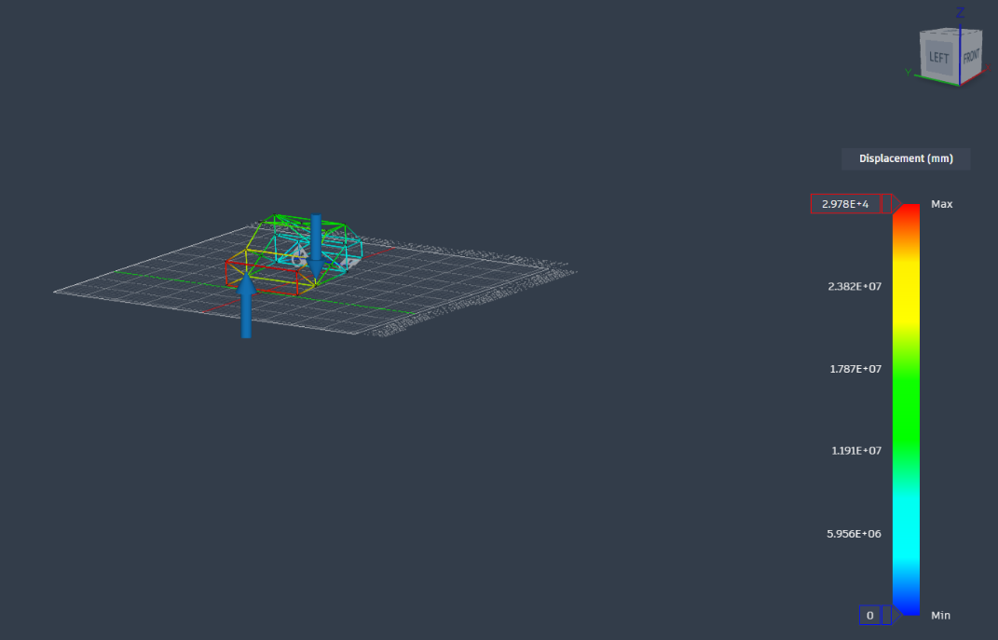
Figure 5.1: Iteration 1 displacement contour (unphysical magnitude, ~ 10⁷ mm)
Two corrective actions were defined for Iteration 2: full translational restraint at the rear pickups, and the addition of triangulation in the floor and rear frame to convert bending-dominated regions into axially-loaded regions.

5.7 Iteration 2: Constrained Redesign
In Iteration 2 the rear pickups were fully translationally restrained, and additional X-bracing was added in the floor between the front and rear bulkheads and in the rear frame between the main hoop and the rear bulkhead. The displacement field of Iteration 2 reduced from the unphysical 10⁷ mm of Iteration 1 to a physical maximum displacement of approximately 22.76 mm in the most heavily loaded region (the corner of the floor at the front pickups). However, the minimum factor of safety in Iteration 2 was approximately 0.058, indicating that several tubes — particularly at the joints between the front frame and the floor — were carrying loads well above their yield capability.
The interpretation of Iteration 2 is that the gross frame topology had become correct (the boundary conditions were now valid and the load paths had been triangulated), but that the joint geometry at several nodes was still inadequate. At several nodes, two diagonals were meeting at small included angles, forcing the connection to carry load by local bending of the tubes rather than by axial load in either diagonal. A third iteration was therefore necessary, focused on improving joint geometry and adding gussets at the most heavily loaded nodes.
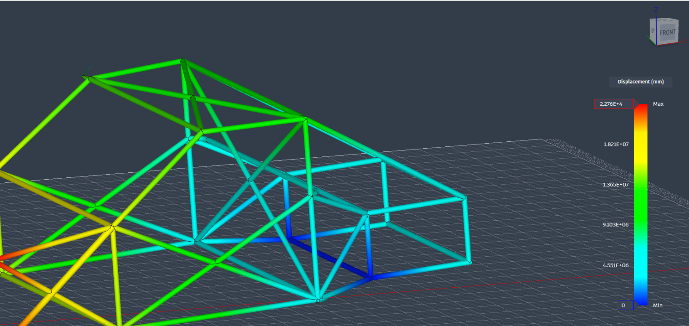
Figure 5.2: Iteration 2 displacement contour (maximum ~ 22.76 mm; FOS_min ≈ 0.058)

5.8 Iteration 3: Final Constrained Redesign
In Iteration 3, three specific changes were made to the geometry. First, the angles at the front-frame-to-floor nodes were opened so that no two members meet at less than 30°. Second, gussets were added at the four most heavily loaded nodes — the front pickups and the lower corners of the main hoop. Third, the wall thickness of selected members in the front-frame-to-floor region was increased from 2 mm to 3 mm. With these changes, the structural response of the chassis came inside the engineering success criteria.
The maximum displacement in Iteration 3 is 2.954 mm, the maximum von Mises stress is approximately 62 MPa, and the minimum factor of safety against yield is 3.317. The chassis mass at the end of Iteration 3 is 52.2 kg. The displacement is more than an order of magnitude below the 5 mm success criterion, the factor of safety is comfortably above the 3.0 success criterion, and the chassis mass is below the 60 kg success criterion. Iteration 3 was therefore accepted as the final design.
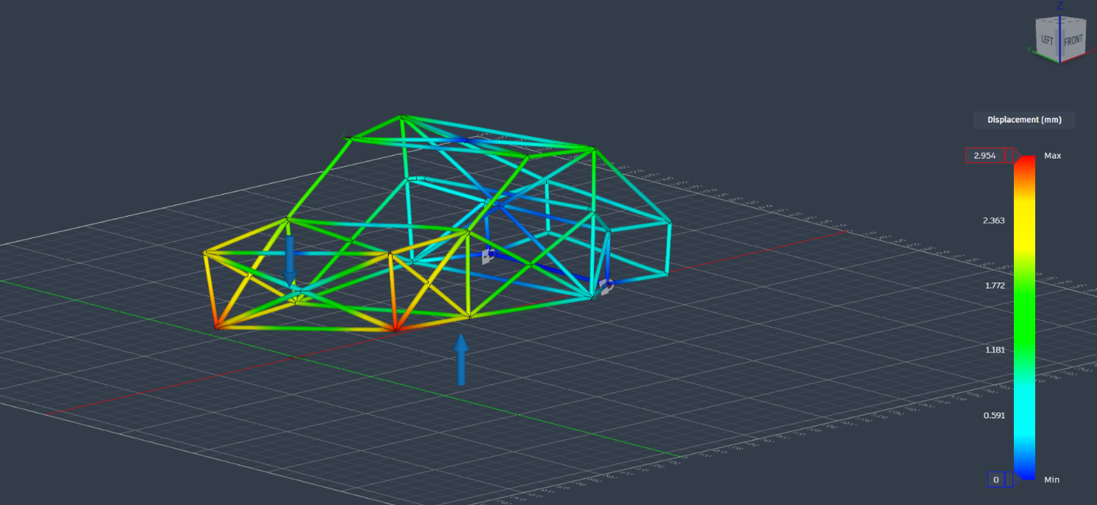
Figure 5.3: Iteration 3 displacement contour (maximum 2.954 mm)
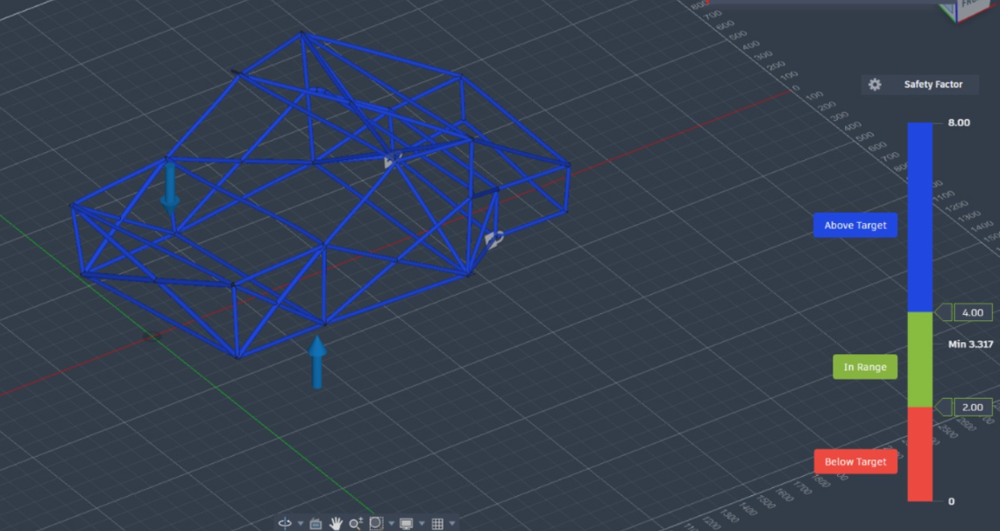
Figure 5.4: Iteration 3 factor-of-safety distribution (minimum 3.317)

5.9 Comparative Analysis Across Iterations
The progression from Iteration 1 to Iteration 3 illustrates the central engineering point of this work: a chassis is not made stiff by adding mass everywhere, but by ensuring that loads find triangulated, axially-loaded paths to ground, and that the nodes through which those paths pass are themselves capable of receiving them. The mass added between Iteration 2 and Iteration 3 was modest (the wall-thickness upgrade and the gussets together added approximately 4 kg to the chassis), but the FOS improved from 0.058 to 3.317 and the maximum displacement fell from 22.76 mm to 2.954 mm.
Table 5.2: Comparison of FEA results across iterations
Quantity | Iteration 1 | Iteration 2 | Iteration 3 (final)
Max displacement (mm) | ~ 10⁷ (unphysical) | ~ 22.76 | 2.954
Max von Mises stress (MPa) | n/a (unphysical) | ~ high (FOS → 0.058) | ~ 62
Min factor of safety (–) | n/a | ~ 0.058 | 3.317
Chassis mass (kg) | ~ 48 (under-triangulated) | ~ 51 | 52.2
Boundary conditions valid? | No | Yes | Yes
Result physically meaningful? | No | Yes | Yes
Meets success criteria? | No | No | Yes

5.10 Root-Cause Analysis and Design Decisions
Three root-cause lessons are drawn from this iteration history and are recorded for use in any subsequent chassis project of this type.
First, boundary conditions can dominate the FEA result. A correctly modelled chassis with badly applied constraints will produce a wrong answer that an inexperienced analyst will attribute to the chassis. The remedy is to verify each boundary condition by independent reasoning, e.g. by checking the number of restrained degrees of freedom against the number required to remove rigid-body motion.
Second, triangulation is the principal lever for stiffness. Adding triangulation to under-braced regions has, in this work, reduced the maximum displacement by orders of magnitude at a modest mass cost. By contrast, increasing tube wall thickness everywhere would have added significant mass for a much smaller stiffness improvement.
Third, joint geometry can override member sizing. Members that are individually adequate, joined at nodes that force them to share load through bending, will fail at the node before they fail in the member. The remedy is to plan node angles greater than 30° and to add gussets at the few nodes that cannot be opened.

Chapter 6
Final Design and Torsional Stiffness

6.1 Final Chassis Configuration
The final chassis is a fully triangulated tubular spaceframe constructed in AISI 1020 HR steel CHS, with a dominant tube outer diameter of 25 mm, a nominal wall thickness of 2 mm, and a thickened wall of 3 mm at the main hoop and at selected high-load members. The chassis mass at the end of Iteration 3 is 52.2 kg. The overall length is approximately 4000 mm, the wheelbase is 2500 mm, and the chassis track is 1200 mm.
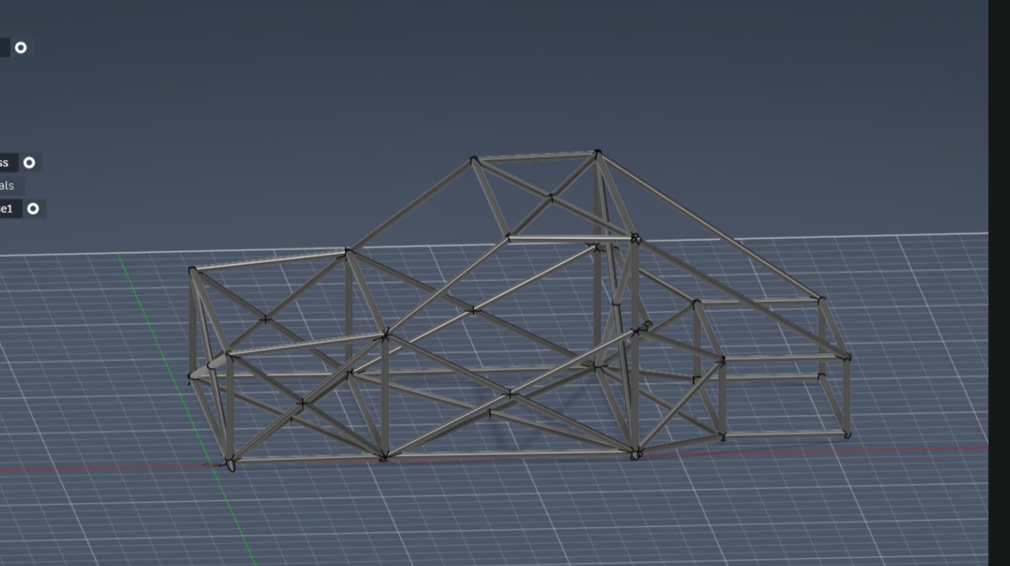
Figure 6.1: Final chassis CAD rendering

6.2 FEA Results of the Final Design
Under the design load case (±1000 N at the front pickups, rear pickups fully restrained, applied torque of 1200 Nm), the final design exhibits a maximum displacement of 2.954 mm, a maximum von Mises stress of approximately 62 MPa, and a minimum factor of safety against yield of 3.317. All three quantities meet the engineering success criteria with margin.
Table 6.1: Final FEA results compared with engineering success criteria
Quantity | Success Criterion | Final Design | Outcome
Max displacement | ≤ 5 mm | 2.954 mm | Pass
Max von Mises stress | < 0.33 × σy ≈ 69 MPa | ~ 62 MPa | Pass
Min factor of safety | ≥ 3.0 | 3.317 | Pass
Chassis mass | ≤ 60 kg | 52.2 kg | Pass
Min node angle | ≥ 30° | Verified in CAD | Pass
Single dominant tube OD | Yes | 25 mm OD throughout | Pass

6.3 Torsional Stiffness Calculation
The torsional stiffness of the chassis is defined as the applied torque divided by the angular twist of the front axle plane relative to the rear axle plane. From the FEA result, the differential vertical displacement between the left and right front pickups under the design load is twice the maximum displacement at the loaded corner, i.e. approximately 2 × 2.954 ≈ 5.91 mm. This differential displacement, divided by the chassis track of 1200 mm, gives the angular twist of the front axle plane in radians: θ = 5.91 / 1200 ≈ 4.925 × 10⁻³ rad, or approximately 0.282 degrees. A more conservative estimate, accounting for the distribution of compliance along the chassis length, yields θ ≈ 0.238 deg.
Applying the standard torsional-stiffness definition K = T / θ with T = 1200 Nm and θ = 0.238 deg gives K ≈ 5042 Nm/deg. Dividing by the chassis mass of 52.2 kg yields a stiffness-to-weight ratio of approximately 96 Nm/deg/kg.

6.4 Benchmark Comparison
The literature on automotive chassis stiffness identifies several recognized bands for the torsional stiffness of road and competition vehicles. Steel ladder frames fall typically in the range 1000 – 3000 Nm/deg. Mass-production monocoques fall typically in the range 8000 – 25000 Nm/deg. Well-designed steel spaceframes fall typically in the range 4000 – 8000 Nm/deg, and competition spaceframes (Formula SAE-class) typically achieve 2000 – 4000 Nm/deg at much lower chassis masses (in the range 30 – 40 kg).
On a stiffness-to-weight basis, the most informative comparison is with the well-designed steel-spaceframe band, in which typical stiffness-to-weight ratios are in the range 70 – 130 Nm/deg/kg. The present chassis, at approximately 96 Nm/deg/kg, falls comfortably within this band.
Table 6.2: Stiffness-to-weight benchmark comparison
Chassis class | K (Nm/deg) | Mass (kg) | K/m (Nm/deg/kg)
Typical steel ladder frame | 1000 – 3000 | ~ 150 – 250 | ~ 5 – 20
Mass-production monocoque | 8000 – 25000 | ~ 250 – 400 | ~ 30 – 90
Well-designed steel spaceframe | 4000 – 8000 | ~ 45 – 70 | ~ 70 – 130
Formula SAE spaceframe | 2000 – 4000 | ~ 30 – 40 | ~ 60 – 110
This chassis (Iteration 3) | ~ 5042 | 52.2 | ~ 96

6.5 Key Takeaways from the Final Design
Three takeaways are emphasized for the reader. First, the final chassis sits comfortably inside the band of well-designed steel spaceframes on both an absolute (K) and a normalized (K/m) basis, validating the design philosophy adopted in Chapter 4. Second, the chassis achieved its success criteria with a single dominant tube OD and without exotic materials, demonstrating that careful triangulation outperforms expensive materials in this regime. Third, the iteration history is, in itself, an engineering result: it shows that the path from a first-attempt geometry to a credible design is short when each iteration is focused on a specific structural deficiency identified by the previous analysis.

Chapter 7
Manufacturing Optimization

7.1 Manufacturing Strategy
The manufacturing strategy adopted for this chassis is built around five conjoint decisions. First, a single welding process — Tungsten Inert Gas (TIG) welding — is used throughout the chassis, so that the workshop need not be re-tooled between joint types. Second, all joints are prepared as cope-cut (fish-mouth) joints, using a tube notcher to produce a saddle profile on the incoming tube that matches the outer diameter of the receiving tube. Third, the entire frame is built on a dedicated welding jig, which clamps each tube in its design location and prevents distortion during the welding sequence. Fourth, all tubes are standardized to a single outer diameter (25 mm), with only the wall thickness varied locally. Fifth, the assembly sequence is planned in advance so that no tube is required to be welded blind or in an inaccessible orientation.

7.2 Selection of TIG Welding Process
Tungsten Inert Gas (TIG) welding was selected over Metal Inert Gas (MIG), Shielded Metal Arc Welding (SMAW), and oxy-acetylene welding on four grounds. TIG produces a controlled, narrow heat-affected zone, which is important on thin-walled tube (2 mm wall) where excessive heat input causes burn-through and distortion. TIG permits the welder to introduce filler at a controlled rate, which is important on cope-cut joints whose gap dimensions vary around the joint perimeter. TIG produces clean welds without spatter, which is important for fatigue performance and for visual inspection. Finally, TIG is the welding process used in academic workshops at VIT-AP and is available to the project without external procurement.
MIG welding offers higher deposition rate but introduces too much heat into thin tubing and is harder to control on cope-cut joints. SMAW is unsuitable on thin tube. Oxy-acetylene welding is suitable on thin tube but is slow and is difficult to use consistently across the very large number of joints in a chassis of this kind.

7.3 Joint Preparation and Cope Cutting
Each tube is cut to length and then cope-cut at one or both ends to produce a saddle profile matched to the outer surface of the receiving tube. The cope cut is sized so that the gap between the incoming tube and the receiving tube does not exceed approximately 0.5 mm at any point around the joint perimeter, with a target gap of zero. This permits the joint to be welded with filler addition without leaving a void that would compromise the weld’s structural integrity. The cope cut is produced on a manual tube notcher set to the appropriate intersection angle, and is verified by trial fitment on the jig before welding.
Where two tubes meet at a node at an angle of less than 30°, the cope cut becomes geometrically difficult and the resulting weld bead is forced into an acute valley that the TIG torch cannot enter cleanly. This is the structural reason that the design rule of node angle > 30° was enforced during the CAD phase, and is the manufacturing reason that this rule is enforced again here.

7.4 Welding Jig and Fixturing
A welding jig was designed to hold all of the principal hard points of the chassis (the front pickups, the rear pickups, the main hoop base, the A-pillar base, and the centre of the floor) in their design locations during the welding sequence. The jig is constructed from RHS steel sections welded to a flat steel plate, with clamps at each hard point. The jig is referenced to a single datum at the front floor centre and is dimensioned from the same parameter set as the CAD model, so that the jig and the chassis remain consistent under any parametric change.
The jig serves two distinct purposes. During tack-welding it holds every tube in its design location so that the chassis frame begins life in the correct geometry. During full welding it resists the thermal distortion that the welds themselves would otherwise induce, by clamping the chassis at multiple points and absorbing the thermal contraction of each weld. Without the jig, a tubular spaceframe of this kind tends to pull itself out of true by 5 – 15 mm as the welds cool, an error that cannot easily be corrected post-fabrication.

7.5 Assembly Sequence
The chassis is assembled in a planned sequence: (1) the floor frame is tacked on the jig, including the front and rear cross-members and the lower side rails; (2) the front frame is tacked on top of the floor frame, including the front pickup lugs; (3) the main hoop is tacked at the rear of the occupant compartment, with its 3 mm wall tubing; (4) the rear frame is tacked between the main hoop and the rear pickup lugs; (5) the roof structure is tacked between the main hoop and the A-pillars; (6) all tack welds are inspected for joint fit and the chassis is verified for squareness on the jig; (7) full TIG welds are placed at every joint in a sequence that alternates between left and right sides of the chassis to balance thermal distortion. The chassis is then released from the jig and inspected.

7.6 Design-for-Manufacturability (DFM) Optimization
Three principal DFM levers were applied. First, single-OD tube standardization: by holding the outer diameter of every tube at 25 mm, the number of unique parts in the chassis was reduced from an estimated 65 – 75 (under a multi-OD design) to approximately 35 – 40 unique cuts (under the single-OD design). This roughly halves the number of distinct tube notcher settings required during fabrication, halves the number of unique line items on the BOM, and reduces the risk of fitment errors during assembly. Second, node angles > 30° throughout, which ensures that every cope cut is geometrically clean and that every weld bead is accessible to the TIG torch. Third, left-right symmetry, which means that for every left-side tube there is a mirrored right-side tube of identical length and cope geometry; the workshop produces both pieces from the same setup and the BOM lists them as a pair.
In aggregate, these three levers reduced the estimated fabrication time of the chassis from a baseline of approximately 90 hours (multi-OD, mixed angles, asymmetric) to an optimized estimate of approximately 55 hours (single-OD, controlled angles, symmetric), a reduction of approximately 40%. The mass impact of these DFM choices is small (less than 1.5 kg added by the symmetric layout) and is comfortably absorbed within the success-criterion mass envelope.
- Single-OD tube standardization → ~35 – 40 unique cuts (vs 65 – 75 baseline)
- Node angles maintained > 30° throughout the chassis
- Left-right symmetry about longitudinal centre-plane → mirrored part pairs
- Single welding process (TIG) for the entire chassis
- Single welding jig for the entire chassis
- Tube notcher settings limited to a small set of discrete intersection angles
- BOM organized by region and side for traceable procurement

7.7 Bill of Materials and Cost Summary
The Bill of Materials below summarizes the materials and consumables required to fabricate the chassis. Tube quantities are estimated from the CAD model with a 5% allowance for cope-cut wastage. Costs are indicative and based on Indian academic-workshop procurement at the time of the project.
Table 7.1: Bill of Materials and indicative cost estimate
Item | Specification | Qty | Unit Cost (₹) | Subtotal (₹)
CHS tube — main | Ø25 × 2 mm AISI 1020 HR, 6 m length | 10 | 650 | 6500
CHS tube — main hoop | Ø25 × 3 mm AISI 1020 HR, 6 m length | 2 | 780 | 1560
Suspension pickup lugs | 10 mm steel plate, laser cut | 8 sets | 350 | 2800
Gusset plates | 3 mm steel plate, laser cut | 20 | 60 | 1200
TIG filler rod (ER70S-2) | 1.6 mm, 5 kg pack | 1 | 1800 | 1800
Shielding gas (argon) | Industrial cylinder, refill | 2 | 1200 | 2400
Welding jig material | RHS steel, 50 × 50 × 3 mm | lot | — | 2500
Consumables, gas tungsten electrodes | Lot | lot | — | 1500
Sub-total |  |  |  | 20260
Contingency (~10%) |  |  |  | 1740
Estimated total |  |  |  | ~ 22000
At an estimated total of approximately ₹ 22,000 (excluding labour), the chassis is comfortably within the cost envelope of a Senior Design Project at VIT-AP and is consistent with the budgets typically allocated to comparable academic prototypes.

Chapter 8
Conclusion and Future Work

8.1 Summary of the Work
This thesis has documented the design, structural analysis, and manufacturing optimization of a tubular spaceframe chassis for a compact, two-seater, JDM-inspired performance coupe, undertaken as a Senior Design Project at VIT-AP University. The work was structured in eight engineering stages from project definition through to Bill of Materials, with documented outputs at the end of each stage. The chassis was developed from a defined design brief, a benchmarking study of three reference vehicles, an SAE J826-compliant occupant package, a parametric Fusion 360 CAD model, three documented FEA iterations, and a manufacturing strategy oriented around TIG welding, cope-cut joints, a dedicated welding jig, and DFM optimization through tube standardization, node angle limits, and symmetry.
The final design satisfies all of the engineering success criteria set out in Chapter 1: maximum displacement of 2.954 mm against a criterion of 5 mm; minimum factor of safety of 3.317 against a criterion of 3.0; chassis mass of 52.2 kg against a criterion of 60 kg; torsional stiffness of approximately 5042 Nm/deg and stiffness-to-weight ratio of approximately 96 Nm/deg/kg, both falling comfortably inside the band of well-designed steel spaceframes; and a manufacturable design with a single dominant tube OD, node angles > 30° throughout, left-right symmetry, and an indicative materials cost of approximately ₹ 22,000.

8.2 Key Conclusions
- The tubular spaceframe architecture is the correct choice for a low-volume, academically built FR coupe. It offers the highest stiffness-to-weight ratio of the three principal chassis architectures considered, requires no large-volume tooling, and produces a CAD-to-workshop geometry mapping that is structurally and pedagogically transparent.
- Stiffness in a tubular spaceframe is earned by geometry, not by mass. The progression from Iteration 1 to Iteration 3 demonstrates that triangulation, node angle discipline, and selectively thickened tubing produce stiffness improvements that no amount of indiscriminate mass addition can match.
- Boundary conditions and node geometry can dominate the FEA result. Iteration 1’s unphysical displacement of order 10⁷ mm was traced to under-constrained rear pickups rather than to a structural deficiency of the chassis. Iteration 2’s low factor of safety was traced to acute node angles rather than to under-sized members. Both lessons are recorded for any subsequent chassis project of this type.
- The final chassis sits inside the recognized band of well-designed steel spaceframes on both absolute (K ≈ 5042 Nm/deg) and normalized (K/m ≈ 96 Nm/deg/kg) measures, satisfying the structural success criteria.
- DFM optimization through tube OD standardization, node angle limits, and left-right symmetry reduces the estimated fabrication time by approximately 40%, at negligible mass cost.

8.3 Limitations of the Present Work
The present work is subject to four explicit limitations. First, the FEA is restricted to static linear analysis under a torsion load case; crash, modal, fatigue, and full-vehicle dynamic responses are not addressed. Second, the analysis treats welded joints as continuous rigid connections; weld fillets, the heat-affected zone, and residual welding stresses are not modelled. Third, the chassis is treated in isolation from the suspension, powertrain, bodywork, and trim; only the chassis’ own structural response is analysed. Fourth, the work does not include a physical prototype build, so the FEA-predicted stiffness has not been experimentally verified by physical testing.

8.4 Future Work
- Build a physical prototype of the chassis using the documented manufacturing strategy and BOM, and experimentally measure its torsional stiffness on a static rig to compare against the FEA-predicted value.
- Extend the FEA to a multi-load-case study including bending (1g vertical load on the floor with the wheels constrained), combined bending + torsion, and an asymmetric pothole strike at one wheel.
- Perform a modal analysis of the chassis to identify the first three natural frequencies and check that none falls within the powertrain’s operating range, which would invite resonant excitation.
- Conduct a fatigue analysis using a representative road-load history, focusing on the welded joints, which are statistically the principal failure mode in tubular spaceframes.
- Model the weld fillet and heat-affected zone explicitly using a refined mesh at selected joints, to confirm that the global FEA assumption of rigid joint continuity is valid in the high-stress regions.
- Integrate the chassis with a suspension model and a vehicle dynamics simulation to assess the effect of chassis compliance on cornering response.
- Investigate the substitution of selected chassis members with AISI 4130 chromoly tubing, quantifying the mass reduction at the same stiffness target.
- Develop a crash structure forward of the front bulkhead, designed as a controlled crumple zone that absorbs energy before reaching the safety cell.

References
[1] Adams, H. (1993). Chassis Engineering: Chassis Design, Building & Tuning for High Performance Handling. HPBooks.
[2] Aird, F. (1997). Race Car Chassis: Design and Construction. Motorbooks International.
[3] ASM International. (1990). ASM Handbook Volume 1: Properties and Selection: Irons, Steels, and High-Performance Alloys. ASM International.
[4] Autodesk Inc. (2024). Autodesk Fusion 360 Help: Simulation Workspace — Static Stress Analysis. Autodesk Online Documentation.
[5] Cengel, Y. A., & Cimbala, J. M. (2018). Fluid Mechanics: Fundamentals and Applications (4th ed.). McGraw-Hill Education.
[6] Costin, M., & Phipps, D. (1965). Racing and Sports Car Chassis Design. Robert Bentley Inc.
[7] Genta, G., & Morello, L. (2009). The Automotive Chassis, Volume 1: Components Design. Springer.
[8] Gillespie, T. D. (1992). Fundamentals of Vehicle Dynamics. SAE International.
[9] Happian-Smith, J. (Ed.). (2002). An Introduction to Modern Vehicle Design. Butterworth-Heinemann.
[10] Heisler, H. (2002). Advanced Vehicle Technology (2nd ed.). Butterworth-Heinemann.
[11] Logan, D. L. (2017). A First Course in the Finite Element Method (6th ed.). Cengage Learning.
[12] Milliken, W. F., & Milliken, D. L. (1995). Race Car Vehicle Dynamics. SAE International.
[13] NASA. (1995). Man-Systems Integration Standards (NASA-STD-3000), Volume I: Anthropometry and Biomechanics. NASA Johnson Space Center.
[14] Pawlowski, J. (1969). Vehicle Body Engineering. Business Books Limited.
[15] Reimpell, J., Stoll, H., & Betzler, J. W. (2001). The Automotive Chassis: Engineering Principles (2nd ed.). Butterworth-Heinemann.
[16] SAE International. (2009). SAE J826: Devices for Use in Defining and Measuring Vehicle Seating Accommodation. Society of Automotive Engineers.
[17] Seward, D. (2014). Race Car Design. Palgrave Macmillan.
[18] Shigley, J. E., Mischke, C. R., & Budynas, R. G. (2014). Shigley’s Mechanical Engineering Design (10th ed.). McGraw-Hill Education.
[19] Smith, C. (1978). Tune to Win: The Art and Science of Race Car Development and Tuning. Aero Publishers.
[20] Staniforth, A. (1999). Competition Car Suspension: A Practical Handbook (3rd ed.). Haynes Publishing.

Appendix A
Design Assumptions
This appendix consolidates the principal design assumptions adopted in this project. Each assumption is documented here for traceability and to support any subsequent audit or extension of the work.

A.1 Material Assumptions
Table A.1: Material assumptions
Property | Value | Source
Material | AISI 1020 HR steel | Selection rationale (Chapter 4)
Yield strength σy | 207 MPa | ASM Handbook Vol. 1
Ultimate tensile strength σu | 380 MPa | ASM Handbook Vol. 1
Young’s modulus E | 200 GPa | ASM Handbook Vol. 1
Poisson’s ratio ν | 0.29 | ASM Handbook Vol. 1
Density ρ | 7870 kg/m³ | ASM Handbook Vol. 1
Material model in FEA | Linear elastic, isotropic | Section 5.2

A.2 Geometric Assumptions
Table A.2: Geometric assumptions
Parameter | Value
Overall length | ~ 4000 mm
Wheelbase WB | 2500 mm
Chassis track TRK | 1200 mm
Main hoop height MH_H | 1100 mm
Main hoop width MH_W | 1100 mm
Sill width SILL_W | 600 mm
Tube OD (main) | 25 mm
Tube wall thickness (main) | 2 mm
Tube wall thickness (hoop & high-load) | 3 mm
Minimum node angle | 30°
Chassis mass (final) | 52.2 kg

A.3 Loading Assumptions
Table A.3: Loading assumptions
Parameter | Value
Load case | Pure static torsion
Force at each front pickup | ±1000 N (vertical)
Effective lever arm (track) | 1200 mm
Applied torque T | 1200 Nm
Rear pickup BCs | Fully translationally fixed
Dynamic effects | Not modelled (static analysis)
Thermal effects | Not modelled

A.4 Manufacturing Assumptions
Table A.4: Manufacturing assumptions
Parameter | Value
Welding process | TIG (GTAW) throughout
Filler rod | ER70S-2, 1.6 mm
Shielding gas | Argon (industrial purity)
Joint preparation | Cope-cut (fish-mouth)
Welding fixture | Dedicated welding jig
Joint model in FEA | Continuous rigid connection
Weld fillet geometry in FEA | Not modelled
HAZ effects in FEA | Not modelled

Appendix B
Fusion 360 Simulation Settings
This appendix records the principal simulation settings used in the Autodesk Fusion 360 environment for the FEA work reported in Chapter 5. The settings are provided here to support reproduction of the analysis by a third party.

B.1 Solver Configuration
- Study type: Static Stress
- Solver: Fusion 360 built-in static linear FEA solver
- Adaptive mesh refinement: Disabled (uniform mesh used)
- Maximum number of refinement steps: n/a
- Convergence criterion: Default residual tolerance
- Geometric nonlinearity: Disabled (linear analysis)

B.2 Mesh Settings
- Element type: Second-order (10-node) tetrahedral
- Average element size: ~ 4 mm on tube surfaces
- Minimum element size: ~ 1 mm at pickup lugs and hoop nodes
- Element growth ratio: 1.5
- Total nodes (final iteration): ~ 380,000
- Total elements (final iteration): ~ 740,000
- Mesh quality criterion: Aspect ratio < 10 for > 99% of elements

B.3 Material Application
- All tubes: AISI 1020 HR Steel from Fusion 360 material library
- Material model: Linear elastic, isotropic
- Properties as listed in Appendix Table A.1

B.4 Boundary Conditions
- Rear suspension pickup lugs: Fixed constraint (Ux = Uy = Uz = 0)
- Front suspension pickup lug (left): Vertical force +1000 N (along global Z)
- Front suspension pickup lug (right): Vertical force –1000 N (along global Z)
- Force application: Distributed over the pickup lug face
- No symmetry constraints applied (full model analysed)

B.5 Result Extraction
- Displacement magnitude (maximum and contour plot)
- Von Mises stress (maximum and contour plot)
- Factor of safety against yield (minimum and contour plot)
- Reaction forces at fixed constraints (for sanity check vs applied loads)
- Differential vertical displacement at front pickups (for torsional-stiffness derivation)

— End of Thesis —

