3D Data Visualizer Program Structure

- Program Structure

- File and Folder Structure
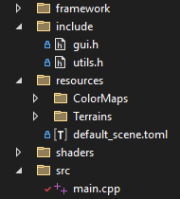
- “framework”: folder containing the framework code, taken from the template.
- “include”: folder containing header files with helper methods and variables.
- “resources”: folder containing the program resources:
  - “default_scene.toml”: file describing the default program configuration.
  - “Terrains”: folder containing image files to use for the 3D visualization.
  - “ColorMaps”: folder containing the color maps that can be used to visualize the data.
- “shaders”: folder containing all the GLSL shader files used by this program.
- “src”: folder containing the main.cpp file, the code of the code.

- Resource Files Type and Format:
- Color maps: they should be in PNG format, with either 8bits or 16bits RGBA. The program loader automatically detects the resolution. During the loading, it converts 8bit images into 16bit images such that everything is stored as 16bits images in the program. The following color maps are available:

In order: magma, inferno, plasma, viridis and rainbow color maps.

All those gradients are luminant gradients, except the rainbow, which is used to illustrate the shortcomings of using rainbow gradients to visualize data. Those files are 2048x128 PNG files to have a high-resolution gradient. New gradients can be added in the folder with the same format: it must be horizontal! The height of the image does not matter.

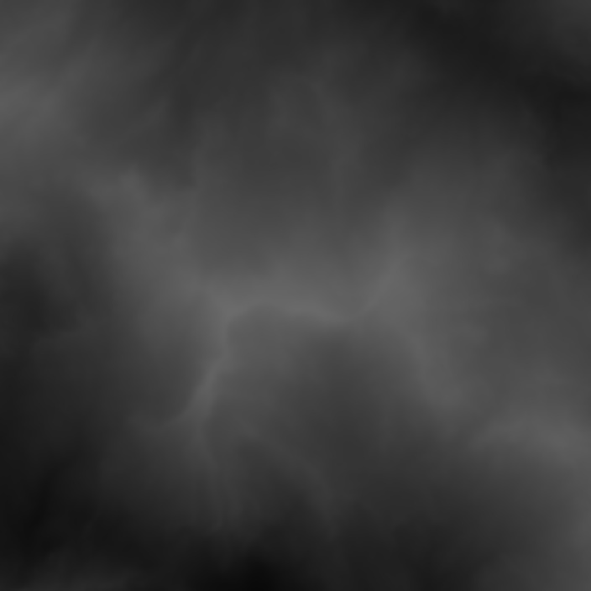
- Terrain images: They are loaded in the same way as color maps. They can be 8bit or 16bit PNG images. (It is recommended to use 16bits and high-resolution images to create smooth terrains.) They must be square! The program is made for images with identical width are height. Grayscale images are more suited, since the height map is computed based on the luminosity of pixels, but colored images are supported.
Example terrain image: Mountains

The luminance of a pixel is computed using L = 0.2126×R + 0.7152×G + 0.0722×B.

- default_scene.toml: TOML config file that defines what image is used for data visualization and what the default parameters value.

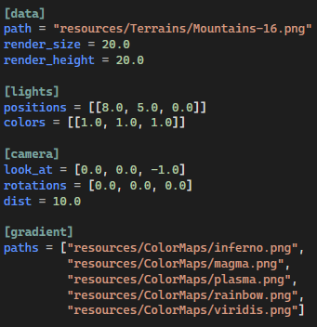

This is the list of parameters configurable in the TOML file.
- image path to use for the data visualization
- rendering size and height for the data
- list of light positions and colors
- camera position and orientation
- list of image paths to use as color map gradients.

- Usage

- User Interface
The UI allows the user to choose which feature is enabled and to customize the available parameters. When enabling a feature, the UI shows the parameters that can be modified, which were otherwise hidden. It has 2 main tabs: Rasterization and Raytracing.
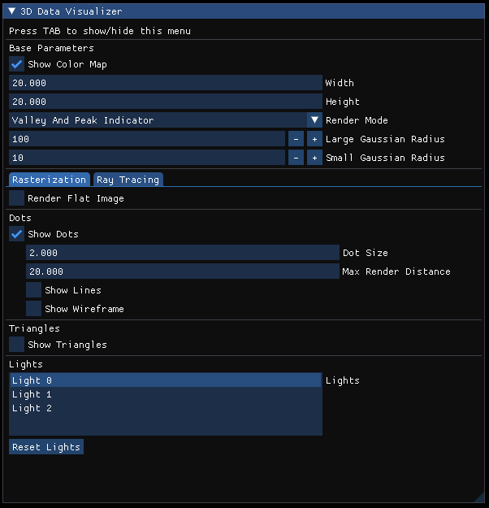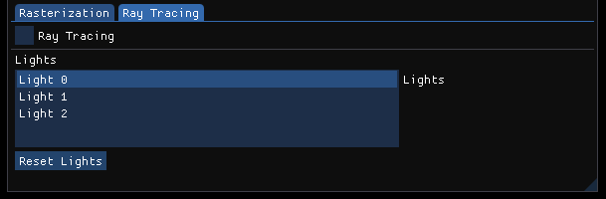

- Keyboard Shortcuts

Key | Action
TAB | Show/Hide UI menu.
H | Show help.
C | Apply the next color map.
L | Place the light source at the current camera position.
Shift + L | Add an additional light source at the current camera position.
Down Arrow | Select the next light source.
Up Arrow | Select the previous light source.
Del | Delete the selected light source.
N | Clear all light sources and reinitialize to a default light.
R | Add 0.1 to the red channel of the selected light.
G | Add 0.1 to the green channel of the selected light.
B | Add 0.1 to the blue channel of the selected light.
Shift + R | Substract 0.1 from the red channel of the selected light.
Shift + G | Substract 0.1 from the green channel of the selected light.
Shift + B | Substract 0.1 from the blue channel of the selected light.

- Code Outline

- Helper Files

- utils.h (general utils file)

This file contains the definition of the program structs and enums, to store 16bit color pixels, images and light sources.
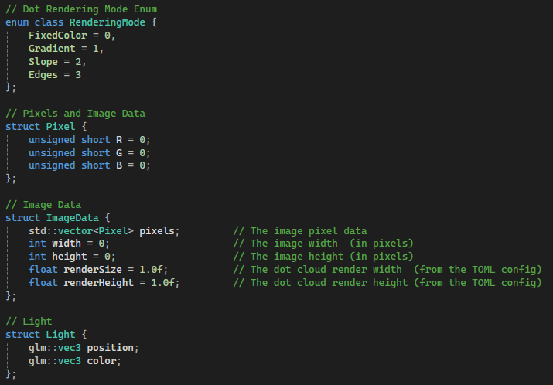

It also contains the global variables of the program, that cannot be changed through the UI menu.
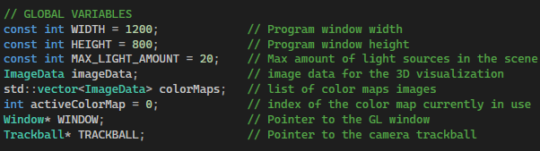
This file also has helper functions to load the default config and relevant image files.
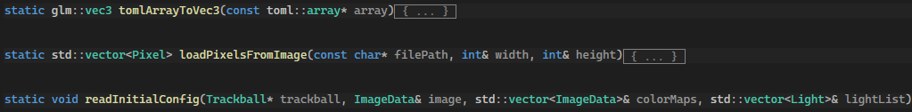

- gui.h (GUI utils file)

This file contains all parameters and variables that can be controlled from the UI.
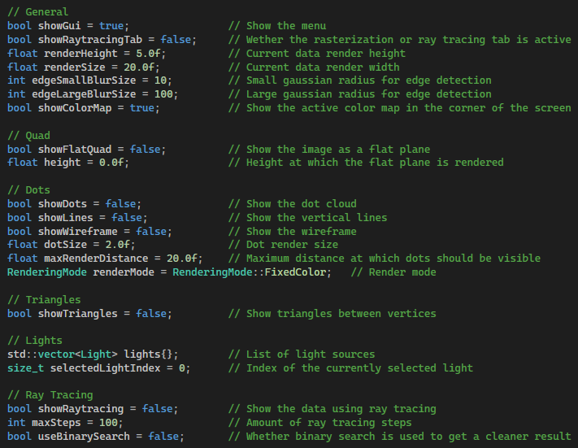

gui.h also contains the function rendering the UI and some UI-related helper functions for the help menu, the lights, the color maps, debugging and keyboard shortcuts.
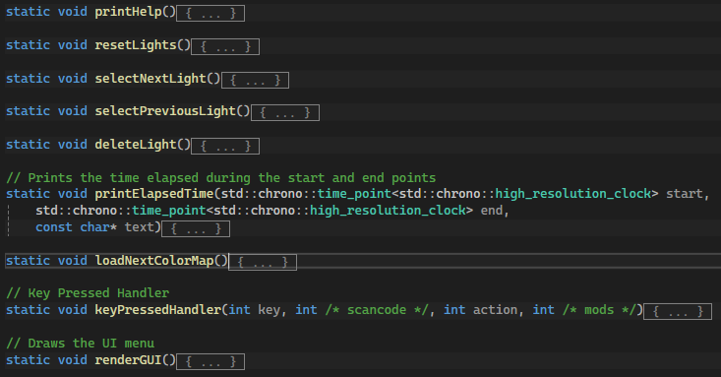

- glutils.h (OpenGL utils file)

This file contains references to all the OpenGL objects (arrays, buffers, textures, etc.) used throughout the program, as well as some useful constants to render quads and triangles on the screen.
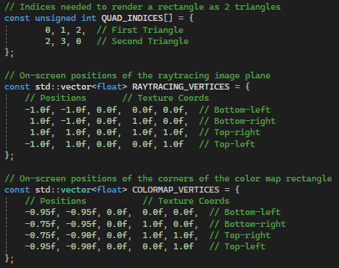
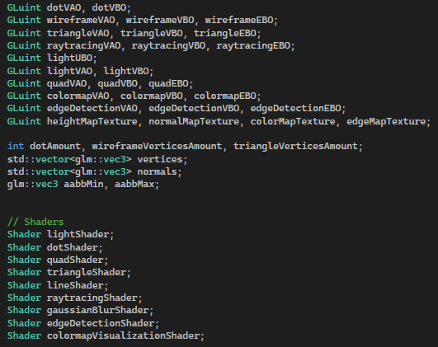

This file also contains some basic OpenGL helper functions to initialize the shaders, create textures from images and normal maps, as well as computing the vertex position corresponding to a specific pixel, based on its position and luminance value, with respect to the rendering width and height. It also has functions to handle the loading of vertices and indices into OpenGL arrays and buffers.
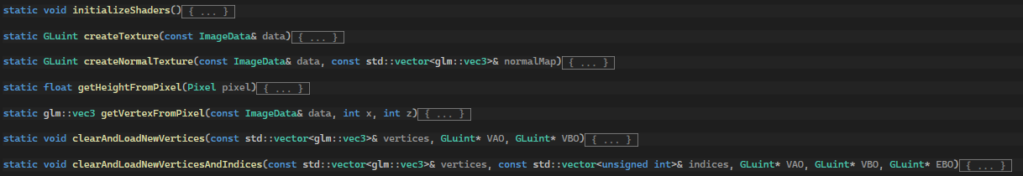

- Main File

The main file (main.cpp) contains the functions initializing the OpenGL objects and buffers, computing the vertices and triangles, and rendering the data. Each feature will be explained in detail later. The main function has the following structure:
- Create OpenGL window object
- Read initial config
- Compute list of vertices, and setup buffers and arrays
- Compute height, normal and edge maps and create textures
- Create OpenGL buffer for lights
- While loop:
  - Update window, inputs and clear screen viewport
  - Check if rendering dimensions changed in the UI and recompute vertices and the normal and edge maps.
  - Compute MVP
  - Create a UBO for the lights
  - Bind all the relevant textures
  - For each feature, bind the shader and render
  - Show buffer to screen
- Clear the buffers

- GLSL Shader Files
The Excel spreadsheet is a detailed overview of the shader files, with their inputs, outputs and descriptions. It also contains the list of the shader programs used, with their stages.

- Detailed Features

In this section, the C++ code used to implement the different features will be explained in detail, following the logical sequence of the features.

- Height Map and Normal Map
Code Snippets | 1, 2

The heightmap image is stored in an ImageData struct, containing the array of pixel RGB values, and the dimensions of the image. We will now go over the function createTexture, which creates an OpenGL 2D texture from an ImageData. This function is used to create a texture for the heightmap, which is then used to render the heightmap as a flat image, or to perform raytracing.
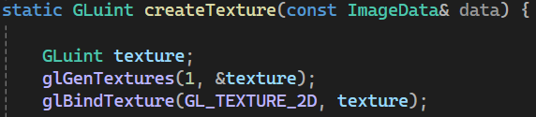
The first step is to generate a new texture, which is stored in a GLuint variable, corresponding to the texture id. The function glGenTextures is used to generate new texture ids at the given location. The first parameter specifies that we only want to generate one new texture.

Next, we define the texture parameters. Here, we specify how the texture should wrap. We choose here the value GL_CLAMP_TO_EDGE, which says that the texture coordinates should be clamped to the edges of the texture.

The next texture parameter we define is the filter that should be applied to the function when scaled up (GL_TEXTURE_MAG_FILTER) or down (GL_TEXTURE_MIN_FILTER). Here, we use linear interpolation in both cases.

This line specifies what the actual content of the texture will be. Let’s go through each argument:
- GL_TEXTURE_2D tells that we are configuring a 2D texture.
- 0: this is the mipmap level. It is set to 0 as we are configuring the original texture.
- GL_RGB: this is the data format that OpenGL will use to store the texture data. We want RGB.
- data.width, data.height: the dimensions of the texture (in pixels)
- 0: must be set to 0 for modern OpenGL.
- GL_RGB, GL_UNSIGNED_SHORT: the format of the data that we will give to the texture. Here, the data is an array of pixels, each storing RGB values as 16bits integers, so unsigned short.
- data.pixels.data(): the pointer to the actual pixel data the texture will use.

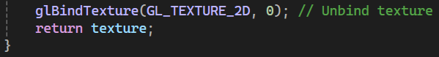
We unbind the texture (by binding zero) as we are done configuring it, and we return the texture id. This function is the empty code snippet 1, in the glutils.h file.

Let’s see now how the normal map is created.
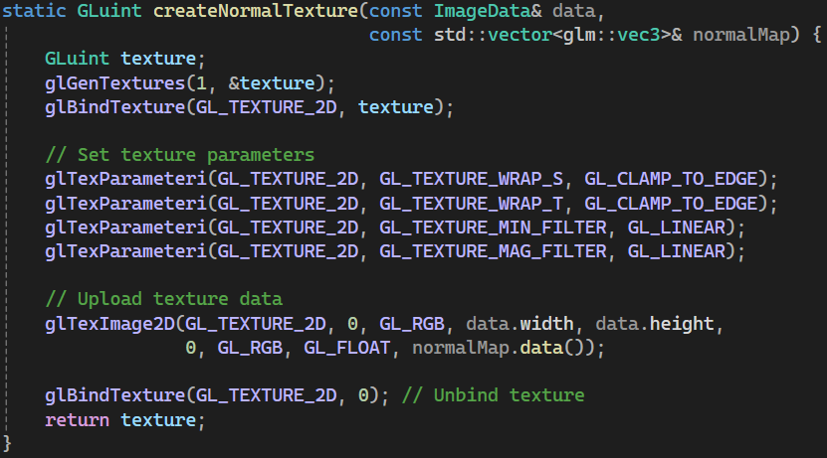
The function follows the exact same structure. The only difference is the type of data we pass to the texture. Now, we want to pass normals, which are 3D vectors (therefore made of 3 floats). Therefore, when uploading data to the texture, we specify the data type to be GL_FLOAT. This function is the empty code snippet 2, in the glutils.h file.

- Dots
Code Snippets | 3, 12

The first to render a cloud of dots representing the height map is to compute the array of 3D positions of the dots. This is done in the following function.
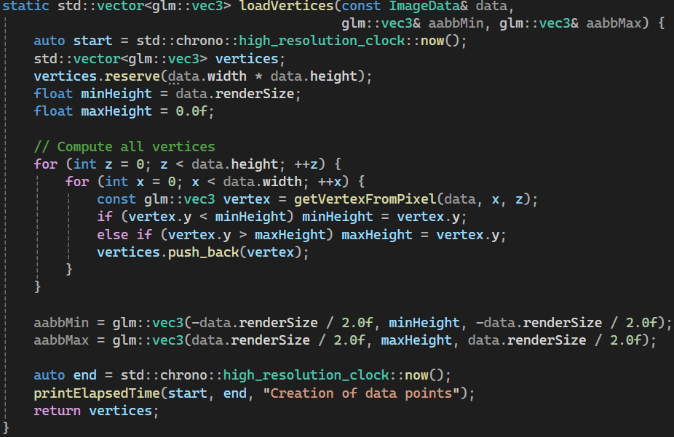

In short, this function iterates over all the pixels in the height map, and for each it computes the 3D position of the corresponding dot. It returns all the positions as a vector of vec3. This will serve as a list of vertices.

Then, we need to set up a Vertex Array Object, and Vertex Buffer Object to represent and store this list of vertices. This is done in the clearAndLoadNewVertices function.
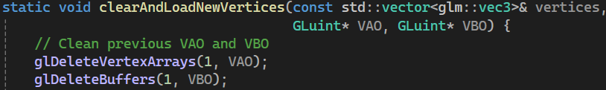

This function takes in the list of vertices, and a pointer to a VAO and VBO. The first step is to delete the VAO and VBO (in case the pointers were referencing other objects)

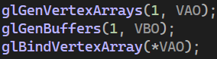
Then we generate a new VAO and a new VBO at the given location. Similarly to how we generate textures, here we specify we want one of each. We then bind the VAO so that all the configurations done afterwards are applied to it.

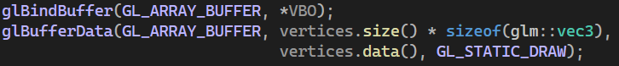
We bind the VBO, and then we upload the vertices to it. Let’s go over the arguments:
- GL_ARRAY_BUFFER says that we are configuring a VBO
- vertices.size() * sizeof(glm::vec3) is the size of the vertex data.
- vertices.data() is the pointer to the actual vertex data.
- GL_STATIC_DRAW this is the usage pattern of the data, static means that the data will mostly not change and be rendered many times.

Then, we specify the vertex attribute and enable it. In this case, each vertex has a 3D position, represented by 3 floats. Let’s go over the arguments of the glVertexAttribPointer function:
- 0: we specify the attribute at index 0.
- 3, GL_FLOAT: the attribute has 3 elements of type float (here a 3D position)
- GL_FALSE: the attribute should not be normalized when passed to the shader
- sizeof(glm::vec3) : the attribute has a size of glm::vec3 (that is 3 float values)
- (void*)0 : the attribute has an offset of 0 in the buffer.

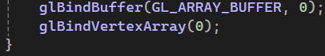
Finally, you unbind the VBO and VAO as the configuration is complete. This function is the empty code snippet 3, in the glutils.h file.

The last step is to render the dot cloud on the screen using the shader. This is done in the main loop of the program.
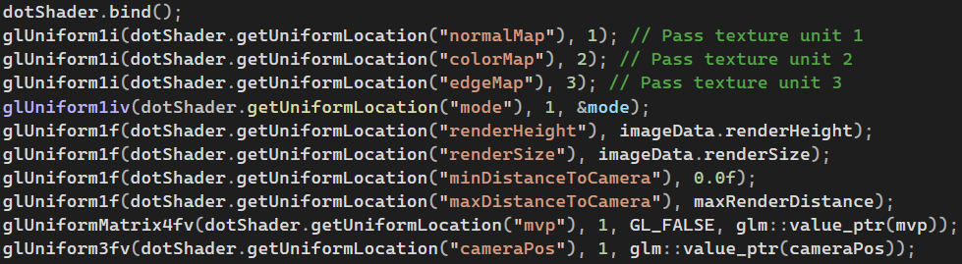
Here, we bind the shader we will use and specify all the uniform parameters that it will use. Uniform parameters can either be set to direct values, like here:
Or it can be specified using a pointer to a value. In that case, it is important to also set the number of values (in our case 1)
When specifying a matrix parameter, an additional flag is used to tell OpenGL whether we want to transpose the matrix or not.

Once all the parameters have been set, we can render the vertices in the dotVAO as points on the screen.
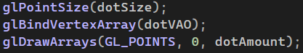
Here, we specify the point size and the VAO that will be rendered, then we render a given number of vertices as GL_POINTS, meaning that vertices will be processed one by one. This code snippet is the empty code snippet 12, in the main.cpp file.

- Lines
Code Snippets | 14

Rendering lines is done in the same way as dots, as all the special processing is handled by the shader itself, which will convert points into vertical lines. We just need to bind another shader and set all the parameters in the main loop. We tell OpenGL to render the vertices as points, that means to process the vertices one by one, as the shader will handle the conversion from a single point to a vertical line between 2 points. This function is the empty code snippet 14, in the main.cpp file.
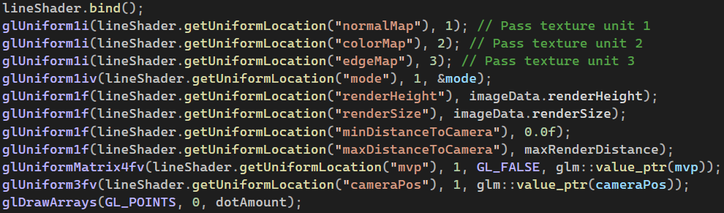

- Wireframe
Code Snippets | 4, 5, 13

To render a wireframe for all the dots, we must arrange the vertices in a special way. There must be a line between every pair of neighboring vertices. Instead of storing the vertex positions for each line, we store the indices of both ends of the line, referencing vertices in the array. The vertices are stored in a VBO, and the list of indices in an EBO.

The first step is to create a list of indices from the list of vertices. Then, we can set up a VAO, a VBO and an EBO to store both lists. This is done in 2 functions.

This function takes in the dimensions of the height map and the list of vertices, as well as pointers to a VAO, VBO and EBO that will be configured to render a wireframe.

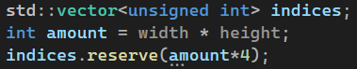
First, initialize a list that will store the indices as unsigned integers.

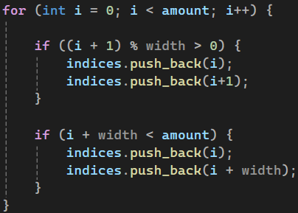
Then, for each vertex, create a line to its top and right neighbors (if they exist) and add the corresponding indices to the list.

Then, the function clearAndLoadNewVerticesAndIndices is called to load the vertices and indices to the VAO, VBO and EBO, and the size of the index list is returned. This function is the code snippet 5, in the main.cpp file.

Let’s now analyze the function clearAndLoadNewVerticesAndIndices. It is very similar to the clearAndLoadNewVertices function, containing the same lines configuring the VAO and VBO. In addition, the following lines configure the EBO:

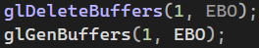
These lines delete any existing EBO and generate a new one.

Here, we bind the EBO as an element array buffer, and fill it with the indices, similarly to how the VBO is filled with vertices. This function is the code snippet 4, in the glutils.h file.

In the main loop, the wireframe is rendered using the dot shader. It is configured with the exact same parameters.
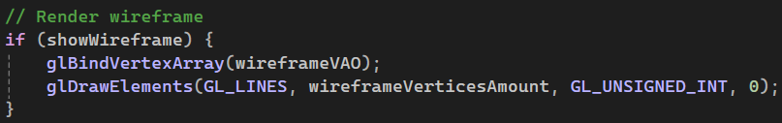
The difference is that we bind the wireframeVAO and tell OpenGL to render the VAO as lines. Since we use the glDrawElements function, we need to specify the type of elements to render. The EBO contains indices pointing to vertices, so we use unsigned int as the type. By specifying GL_LINES, we tell OpenGL to process the vertices 2 by 2, to render lines. The final argument is the offset in the buffer at which OpenGL should start rendering. It is set to 0 as we want to render everything.

- Flat Quad
Code Snippets | 7, 11

To render the height map as a flat image on the XZ plane, we render it as a square quad, made of 2 triangles. It is then rendered using a VAO, VBO and EBO.

This image takes in the height map image, containing the rendering dimensions of the terrain and references to a VAO, VBO and EBO that will contain the quad data to render.

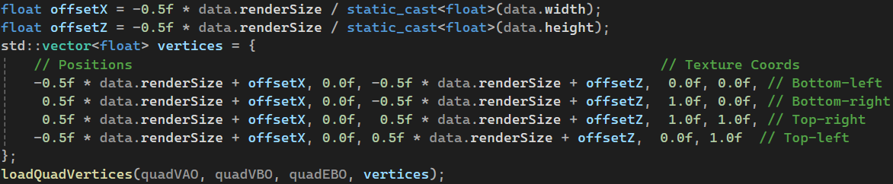
It then computes the 4 vertices that form the flat image, along with their corresponding texture coordinates, and calls loadQuadVertices to create the VAO, VBO and EBO.

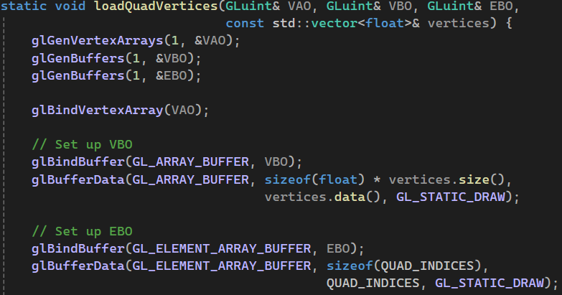
This function works in the same way as the clearAndLoadNewVerticesAndIndices function, and it uses the QUAD_INDICES array as index array. This array contains the fixed values [0, 1, 2, 2, 3, 0] forming the 2 triangles needed to render a rectangular image between 4 vertices.

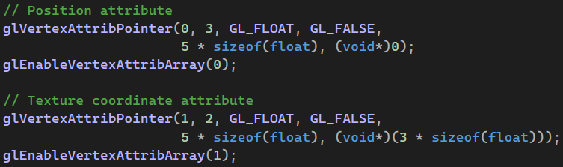
It then specifies that each vertex is made of 5 float values. The first 3 form the 3D position and are set as vertex attribute 0. The last 2 form the 2D texture coordinates and are set as vertex attribute 1. Both attributes are then enabled, so that the shaders can access both. This function is the empty code snippet 7, in the main.cpp file.

In the main loop, the flat image is rendered as follows:
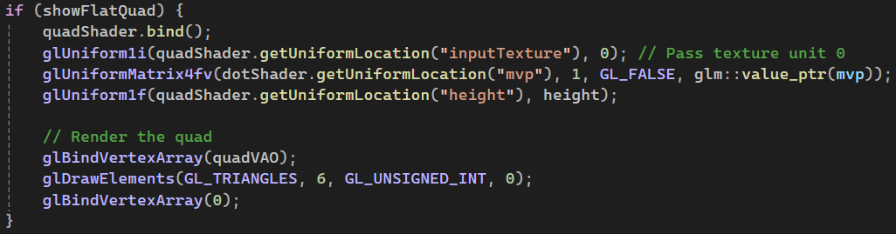
We bind the quad shader and set the uniform parameter values and then render the quad VAO as triangles. We specify to OpenGL that we render 6 unsigned int, as the QUAD_INDICES array contains 6 indices, corresponding to the 2 triangles forming the flat rectangular image. These lines form the empty code snippet 11, in the main.cpp file.

- Light UBO
Code Snippets | 8

When rendering the terrain using triangles or raytracing, diffuse lighting is used to create a more realistic effect. The number of light sources can vary, and therefore a Uniform Buffer Object is needed to pass the dynamic light data to the shaders. The UBO is filled with the light data in the loadLightsToUBO function, which takes in the array of light objects and the UBO as input.

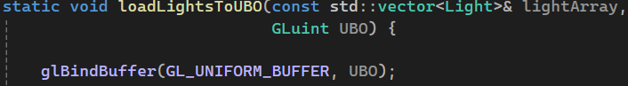
The first step is to bind the buffer.

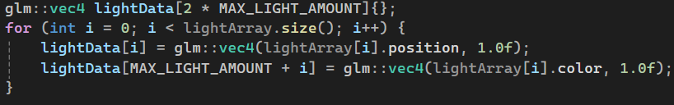
Then, the light data is arranged in an array of vec4. This is needed as a UBO uses aligned memory, and therefore all the 3D vectors (light positions and colors) must be converted into vec4 (the 4th component is a dummy value) and aligned.

Then, the light data is uploaded to the UBO, and we unbind the buffer. This is a breakdown of the arguments of the glBufferSubData function:
- GL_UNIFORM_BUFFER: this specifies that we are uploading data to a UBO
- 0: the offset at which we will start uploading data, here 0 as we start at the beginning of the buffer.
- Size: the size of the data, which is here the size of the lightData array.
- lightData: the pointer to the data that we want to upload.
- Triangles
Code Snippets | 6, 15

To render the triangles, we need to pass vertices 4 by 4 to the shader. The shader takes in 4 adjacent vertices, forming a “square”, and computes what triangles there should be between the vertices. The first step is to construct a VAO, VBO and EBO containing the vertices arranged in such a way that the shader can process them 4 by 4. This is done in the loadTriangleVertices function.
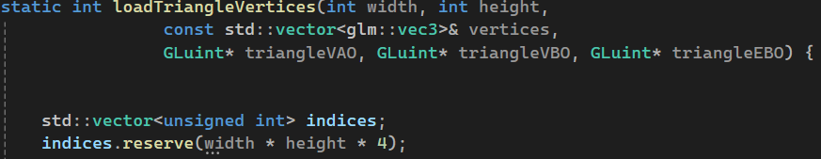
This function takes in the list of vertices and the height map dimensions, and will store a VAO, VBO and EBO in the given pointers. The first step is to initialize a list that will contain the indices to store in the EBO.
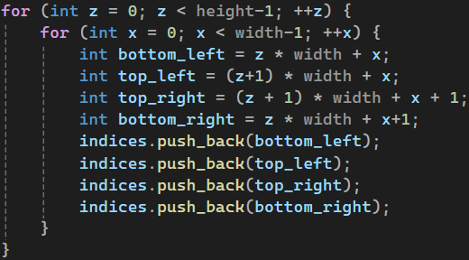
Then, we add the indices of vertices 4 by 4, covering the entire grid of vertex.

Finally, we generate the VAO, VBO and EBO for the vertices and the indices computed, and we return the number of indices. This function is the empty code snippet 6, in the main.cpp file.

To render the triangles, the main loop uses the following code:
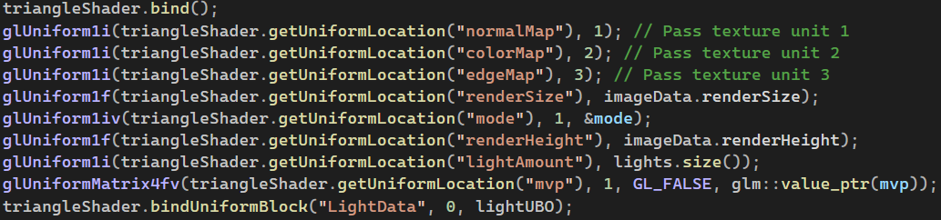
It binds the triangle shader and sets the values for all the uniform parameters. This shader also uses the UBO containing the light sources, which is also set as a uniform parameter.

We then bind the triangle VAO and tell OpenGL to render it as GL_LINES_ADJACENCY. This means that OpenGL will process vertices 4 by 4. The shader will then handle the conversion from 4 vertices into 2 triangles. These lines form the empty code snippet 15, in the main.cpp file.

- Raytracing
Code Snippets | 10

The raytracing is handled by the raytracing shader. This means that we only need to pass a quad to the shader covering the screen, it will automatically perform ray traces for every pixel. The quad is created in the same way as for the flat image, but the vertices cover the screen in the projective space rather than a flat square in the world space.
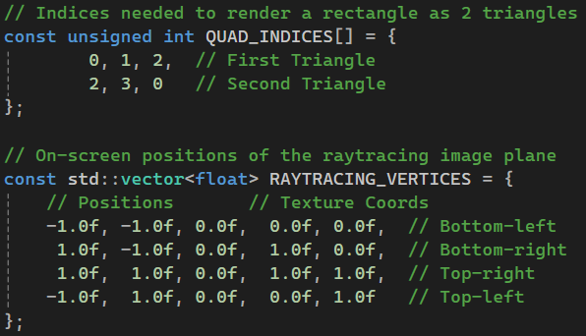

Then, similarly to the flat image, the raytraced terrain is rendered in the main loop by first setting all the uniform parameters of the raytracing shader and then rendering the raytracingVAO as 2 triangles.
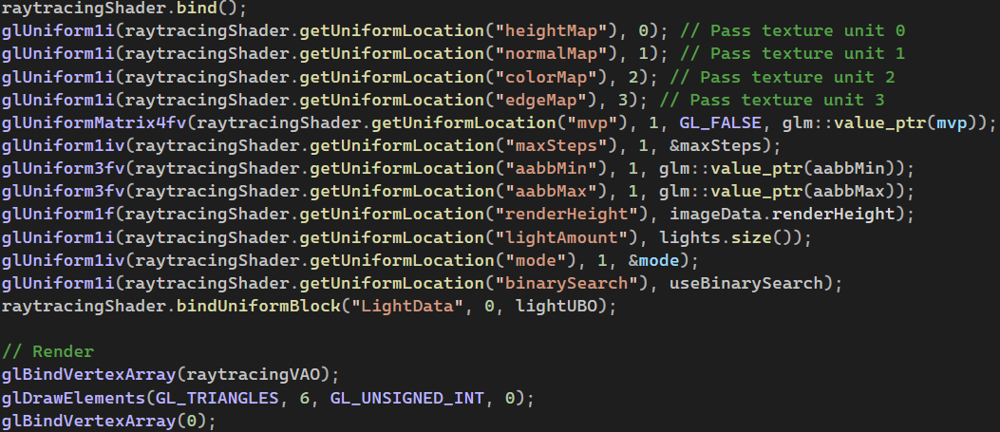
These lines form the empty code snippet 10, in the main.cpp file.

- Edge Map
Code Snippets | 9

The edge map is created by using texture pingponging and the difference of Gaussian technique. Multiple Gaussian filters are applied to the height map using frame buffer objects (FBOs) to store the intermediate results.

The edge map is created in this function, which takes in the height map and the radius of the two Gaussian filters and returns the texture containing the edge map computed.

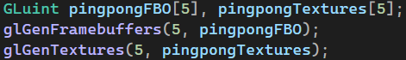
First, we generate 5 FBOs and 2D textures that will be used to generate the edge map.

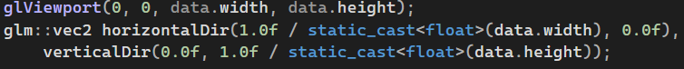
We set the viewport size to the dimensions of the height map, so that the edge map is rendered to the same size. Since the Gaussian filters will be applied in 2 passes, horizontally then vertically, we compute 2 direction vectors which will be used by the shader to perform the filter.

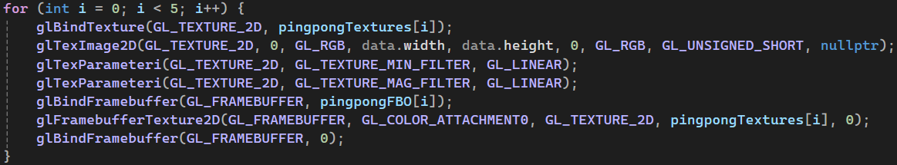
For each FBO, we bind it to a texture. In that way, the result of the rendering to a FBO will be put inside a texture, which will then be used as an input for the next rendering pass. We set the texture data to be null for now.

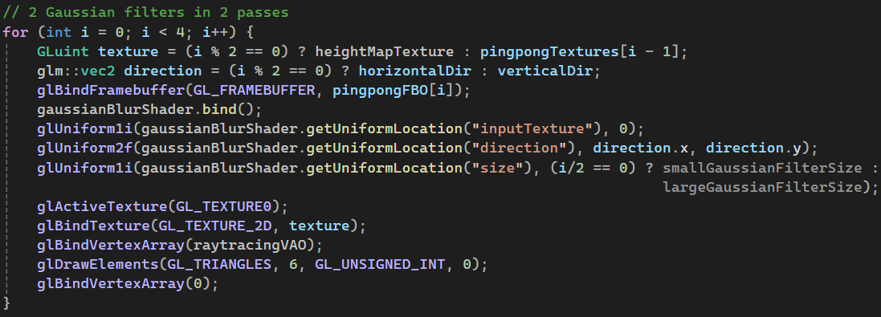
We then perform the large and the small Gaussian filters in 2 passes each, using the Gaussian blur shader. We reuse the raytracingVAO for the rendering as it consists of 4 vertices covering the entire viewport and this is exactly what we need. The table below summarizes the rendering passes:

Input Texture | Filter applied | Result Stored
Height map | Small filter (horizontally) | FBO 0
Height map | Large filter (horizontally) | FBO 2
FBO 0 | Small filter (vertically) | FBO 1
FBO 2 | Large filter (vertically) | FBO 3

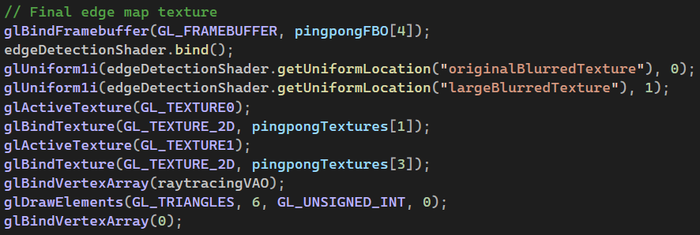
Then, the resulting textures from FBOs 1 and 3, are then used for a final render pass to compute the final edge map using the edge detection shader, stored in FBO 4. We will now copy the result into a brand-new texture.

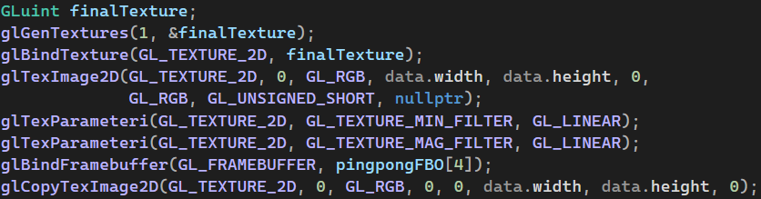
What we do here is to create a new texture, initially with null data. We set its scaling behavior to be linear interpolation. We then bind FBO 4 and copy its content to the new texture. This is a breakdown of the arguments of the glCopyTexImage2D function:
- GL_TEXTURE_2D: specifies the target texture type.
- 0: specifies the mipmap level, here 0 as we set the original texture.
- GL_RGB: tells the texture to store the data in the RGB format.
- 0, 0: the starting pixel position in the FBO from which the pixels should be copied.
- data.width, data.height: the dimensions of the portion of the buffer we want to copy (here we want everything)
- 0: must be 0 in modern OpenGL.

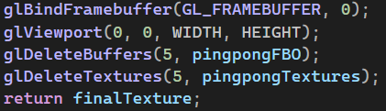
The last step is the cleanup. We unbind any FBO and set the viewport dimensions back to the dimensions of the program window. We delete the FBOs and textures that were used and return the final texture.

