3D Data Visualizer Program Structure

- Program Structure

- File and Folder Structure
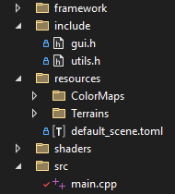
- “framework”: folder containing the framework code, taken from the template.
- “include”: folder containing header files with helper methods and variables.
- “resources”: folder containing the program resources:
  - “default_scene.toml”: file describing the default program configuration.
  - “Terrains”: folder containing image files to use for the 3D visualization.
  - “ColorMaps”: folder containing the color maps that can be used to visualize the data.
- “shaders”: folder containing all the GLSL shader files used by this program.
- “src”: folder containing the main.cpp file, the code of the code.

- Resource Files Type and Format:
- Color maps: they should be in PNG format, with either 8bits or 16bits RGBA. The program loader automatically detects the resolution. During the loading, it converts 8bit images into 16bit images such that everything is stored as 16bits images in the program. The following color maps are available:

In order: magma, inferno, plasma, viridis and rainbow color maps.

All those gradients are luminant gradients, except the rainbow, which is used to illustrate the shortcomings of using rainbow gradients to visualize data. Those files are 2048x128 PNG files to have a high-resolution gradient. New gradients can be added in the folder with the same format: it must be horizontal! The height of the image does not matter.


- Terrain images: They are loaded in the same way as color maps. They can be 8bit or 16bit PNG images. (It is recommended to use 16bits and high-resolution images to create smooth terrains.) They must be square! The program is made for images with identical width are height. Grayscale images are more suited, since the height map is computed based on the luminosity of pixels, but colored images are supported.
Example terrain image: Mountains

The luminance of a pixel is computed using L = 0.2126×R + 0.7152×G + 0.0722×B.

- default_scene.toml: TOML config file that defines what image is used for data visualization and what the default parameters value.

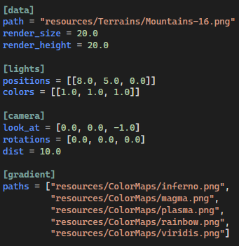

This is the list of parameters configurable in the TOML file.
- image path to use for the data visualization
- rendering size and height for the data
- list of light positions and colors
- camera position and orientation
- list of image paths to use as color map gradients.

- Code Outline

- Helper Files

- utils.h (general utils file)

This file contains the definition of the program structs and enums, to store 16bit color pixels, images and light sources.
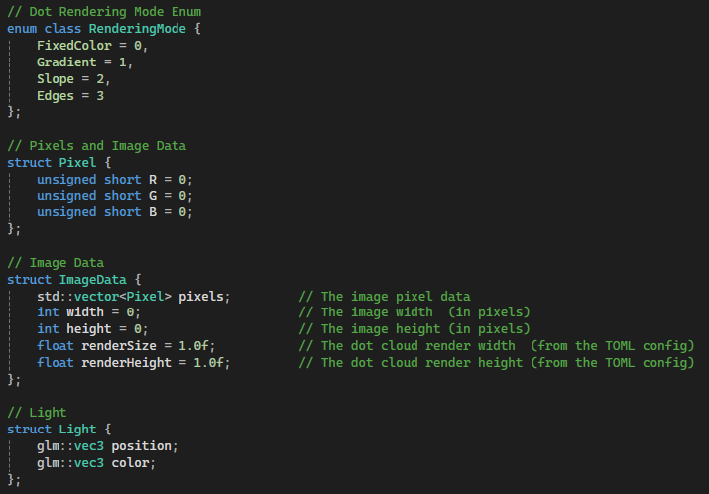

It also contains the global variables of the program, that cannot be changed through the UI menu.
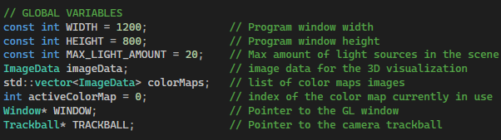
This file also has helper functions to load the default config and relevant image files.
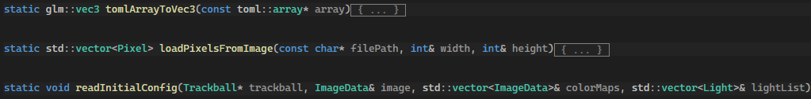

- gui.h (GUI utils file)

This file contains all parameters and variables that can be controlled from the UI.
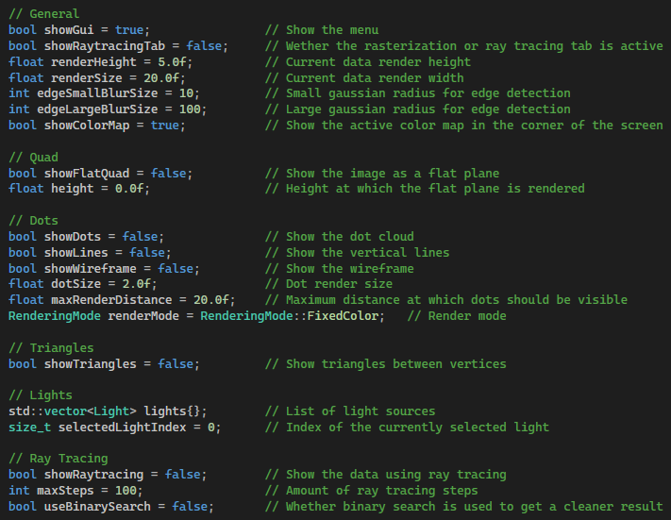

gui.h also contains the function rendering the UI and some UI-related helper functions for the help menu, the lights, the color maps, debugging and keyboard shortcuts.
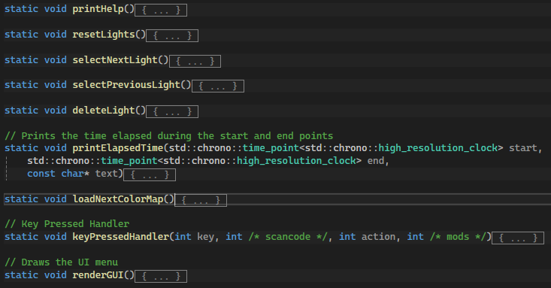

- glutils.h (OpenGL utils file)

This file contains references to all the OpenGL objects (arrays, buffers, textures, etc.) used throughout the program, as well as some useful constants to render quads and triangles on the screen.
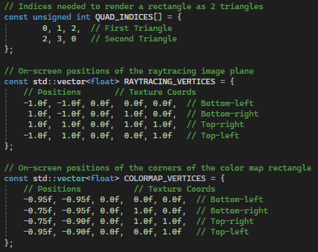
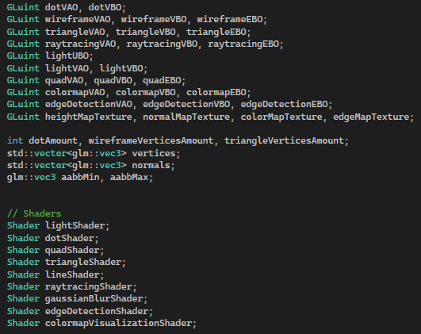

This file also contains some basic OpenGL helper functions to initialize the shaders, create textures from images and normal maps, as well as computing the vertex position corresponding to a specific pixel, based on its position and luminance value, with respect to the rendering width and height. It also has functions to handle the loading of vertices and indices into OpenGL arrays and buffers.
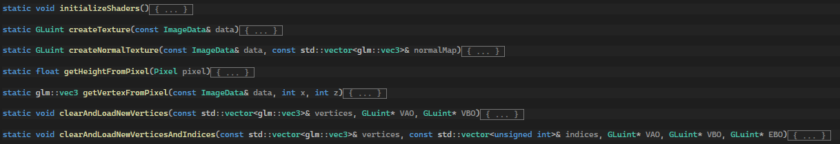

- Main File

The main file (main.cpp) contains the functions initializing the OpenGL objects and buffers, computing the vertices and triangles, and rendering the data. Each feature will be explained in detail later. The main function has the following structure:
- Create OpenGL window object
- Read initial config
- Compute list of vertices, and setup buffers and arrays
- Compute normal and edge maps
- Create OpenGL buffer for lights
- While loop:
  - Update window, inputs and clear screen viewport
  - Check if rendering dimensions changed in the UI and recompute vertices and the normal and edge maps.
  - Compute MVP
  - Create a UBO for the lights
  - Bind all the relevant textures
  - For each feature, bind the shader and render
  - Show buffer to screen
- Clear the buffers

- GLSL Shader Files
The Excel spreadsheet is a detailed overview of the shader files, with their inputs, outputs and descriptions. It also contains the list of the shader programs used, with their stages.

- Detailed Features

