#problem1  
n=int(input())  
def T(n):  
 if n in [1,2]:  
 return 1  
 elif n==0:  
 return 0  
 else:  
 return T(n-1)+T(n-2)+T(n-3)  
print(T(n))

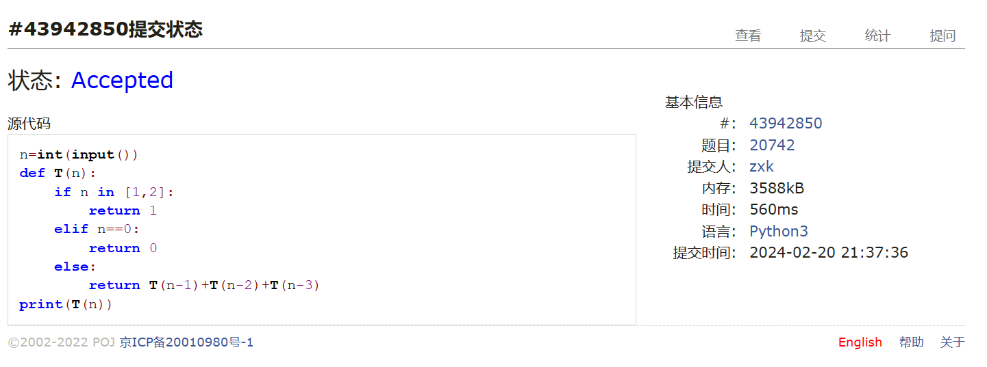

#problem2  
s=list(input())  
ans="NO"  
if "h" in s:  
 while s[0]!="h":  
 del s[0]  
 del s[0]  
 if "e" in s:  
 while s[0]!="e":  
 del s[0]  
 del s[0]  
 if "l" in s:  
 while s[0]!="l":  
 del s[0]  
 del s[0]  
 if "l" in s:  
 while s[0]!="l":  
 del s[0]  
 del s[0]  
 if "o" in s:  
 ans ="YES"  
print(ans)

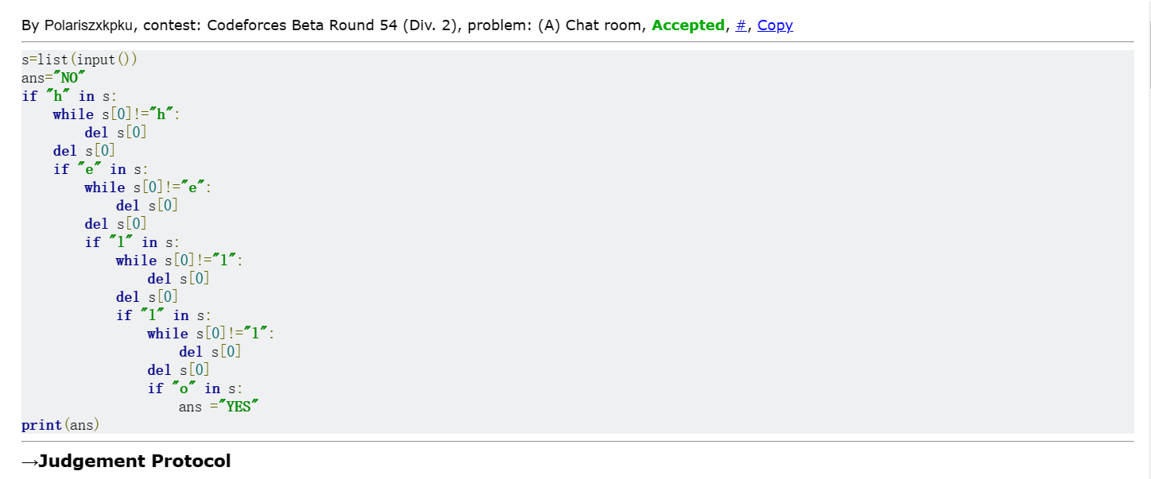

#problem3

astr=list(input().lower())  
dlt=["a","e","i","o","u","y"]  
bstr=[]  
while astr!= []:  
 if astr[0] not in dlt:  
 bstr.append(".")  
 bstr.append(astr[0])  
 del astr[0]  
print("".join(bstr))

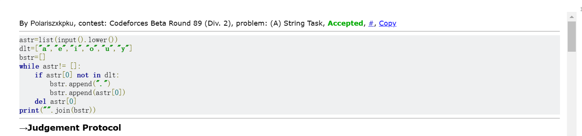

#problem4

n = int(input())  
def find_prime(x):  
 for i in range(2, int(x ** 0.5)+1):  
 if x % i == 0:  
 return "no"  
 else:  
 return "yes"  
ans=[]  
for i in range(2,n):  
 if find_prime(i) == "yes" and find_prime(n-i) == "yes":  
 ans=[str(i),str(n-i)]  
 break  
print(" ".join(ans))

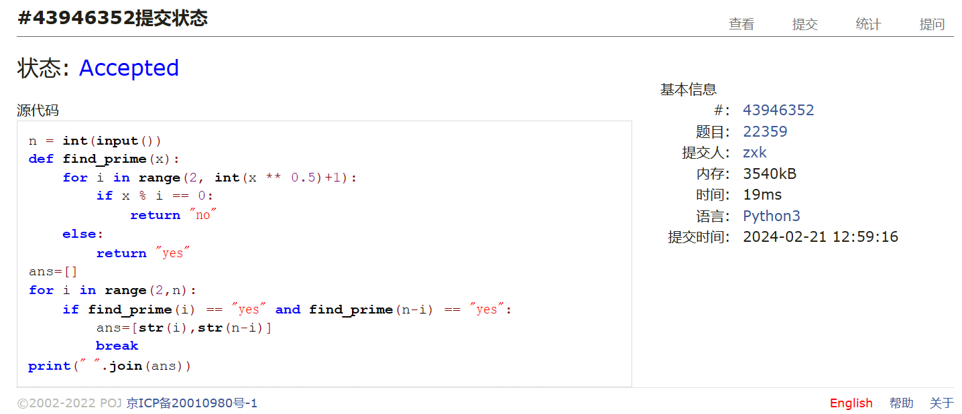

#problem5  
alist=list(input().split('+'))  
clist=[]  
for i in range(len(alist)):  
 if "^" not in alist[i]:  
 alist[i]=str(alist[i]+"n^0")  
 if alist[i][0]=="0":  
 alist[i]="n^0"  
for i in range(len(alist)):  
 blist=[i for i in alist[i]]  
 p=blist.index("^")  
 del blist[0:p+1]  
 clist.append(int("".join(blist)))  
print(f"n^{max(clist)}")

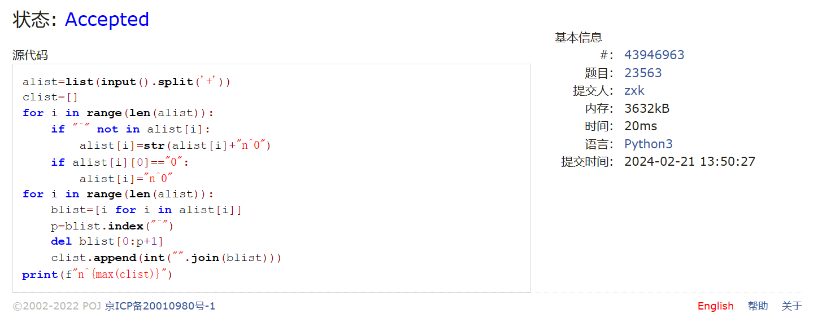

#problem6

vote=[]  
inp=input().split()  
for i in range(len(inp)):  
 vote.append(int(inp[i]))  
vote.sort()  
have_vote=set(vote)  
adict={}  
for i in have_vote:  
 adict[i]=vote.count(i)  
max_vote=adict[max(adict,key=lambda x: adict[x])]  
anslist=[]  
for i in adict.keys():  
 if adict[i]==max_vote:  
 anslist.append(i)  
anslist.sort()  
for i in range(len(anslist)):  
 anslist[i]=str(anslist[i])  
print(" ".join(anslist))

