Animatronic National Park: Sense, Decide, Move

Overview
Your teaching team has partnered with Acadia National Park (unbeknownst to the leadership there or any other official person) to temporarily extend their footprint into Needham, Mass. where we pop-up a PIEcadia extension just for PIE students. Read below to see how you can “cook-up” bio-inspired animatronic animal projects into our offshoot of the Park’s Baker Island OR add fantastical creatures to our extension of Acadia’s Wonderland Trail. Feel free to explore the Acadia Map and propose other connections for the PIEcadia annex.

Objectives
- Continue developing shop and studio skills (through additional trainings or one that is new to you) to level up.
- Multi-part design process, plan thoughtfully, scope realistically, integrate early, react to testing results (adjusting scope if needed), appropriately, documenting decisions and directions
- Design and build a small electromechanical animal that senses an attribute of its external environment and responds with mechanical motion (minimally required) and other feedback (optional).
- Characterize a low-cost sensor, use its measurements to make decisions in Arduino code, and drive at least one actuator.
- Integrate mechanical design, electronics circuitry, and software into a reliable system whose behavior can be demonstrated and measured.
- Communicate the animal behavior through a sign that hangs at the entrance of your part of the Park to let visitors know what they may expect to see - how your animatronic invention interacts with its environment, other animals, humans, or objects. We will create the signs, you provide the text in the Canvas pitch assignment, then refine closer to the National Park opening.

Partnering Process
- Work in pairs of two.
- Partners must be in the same class/studio time slot.
- If you choose a partner, both of you have to let us know by clicking to join the same MP3 Pair number in that group under the Canvas people tab. You must join the team number that matches the kit number you received.
  - You should not leave the MP1 Pairs or MP2 Pairs group that you're a part of (that will make getting graded for previous work difficult).
- We encourage you to work with someone whose background or working style differs from your own; integrated engineering benefits from complementary perspectives
- Each student, regardless of background, is expected to contribute to mechanical design, electronics circuitry, and software development. This is a continuous integration project, not two separate sub-projects joined at the end.
- At the MP3 launch, 30 minutes before the end of class, the teaching team will form the remaining pairs.
- Once paired, read the full project description, discuss possible animal behaviors with your partner, an appropriate scope for your project, and document ideas.
- Prepare a one-paragraph pitch to the teaching team around an idea you’d like to move forward with upon approval.
- Once your pair has an approved path, collect the starting materials you need following the steps below.

Introduction
By this point in the course, you should be comfortable with (or at least aware of) how to:
- read and write digital signals;
- read and convert analog signals;
- use sensor input to change the behavior of an Arduino-controlled system;
- control a servo or DC motor; and
- design a mechanical structure that supports electrical and mechanical components.

The purpose of this mini-project is to bring those skills together in a more open-ended integrated engineering design challenge that involves collaborative scoping and triage.

Sensors are devices that transduce a physical quantity in the world (light, sound, distance, temperature, moisture, magnetic field, force, vibration, etc.) into a signal that can be measured electronically. Actuators transform electrical energy into physical action. Your animal will take in information from the outside world through one or more sensors, interpret that information with an Arduino, and act on the world through mechanical motion and optionally other means.
The “environment” may include human actions, nearby objects, natural conditions, or another animal. To prepare you for the final project, this project is intentionally more open-ended; different teams may build very different animals while meeting the same core learning objectives.

Materials

Items supplied by your team
- Arduino
- USB cable
- Laptop for running the Arduino IDE
- Any additional items you would like to incorporate into your animal
  - Incorporate what you can find at no cost
  - PIE cannot reimburse any purchases or expenses for this Mini-Project
Items supplied by the PIE teaching team
- 1x 12V power supply
- 1x Adafruit v2.3 Motor Shield
- 1x pre-assembled wire harness to send power from power supply to Arduino and motor shield. This contains:
  - 4x 5' of 24AWG stranded, silicone-insulated wire
  - 1x pair of barrel jack connectors
  - (some harnesses given out may have) 1x Four pin Molex wire-to-wire connector
  - (some harnesses given out may have) 4x universal crimp terminals (for crimping to wires and inserting in the Molex connector)
- 2x gearmotor (Digikey page and CAD)
- 2x large wheel that attaches to gearmotor housing
- 1x caster wheel
- 1x acrylic chassis platform with caster (Illustrator fileDownload Illustrator file---not a perfect match for all chassis designs, so measure your physical part and update file as needed)
- 2x motor mounting tabs
- 4X M3x8mm bolt and nut for attaching caster to robot body
- 4X M3x30mm bolt and nut for attaching gearmotor to robot body
- Some additional materials may be available from the MechProto Store. Check with the Lead instructor for supplies or a CA
- The box itself - it is your dimensions for your animal - taken apart, all components must be stored inside the box (while operating, it can be larger).

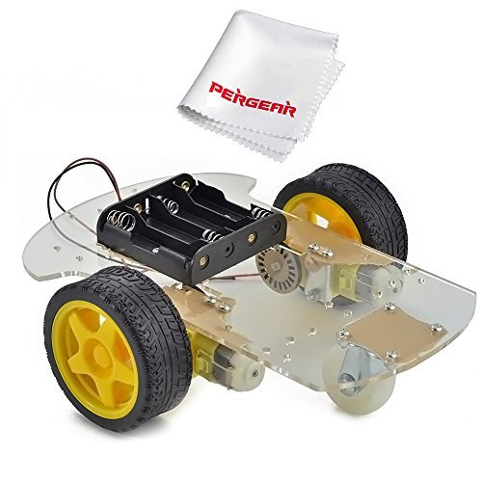
Figure 1. A standard robot chassis that you will receive parts for.

Sensing and actuating elements
Sensor and actuator selection is part of the design task. Consider measurement range, sensitivity, repeatability, noise, response time, interface requirements, and environmental limitations.

Sensing and actuating elements available from PIE (no check-out required)
Environmental attribute | Possible animal behavior | Example sensor | Sensor link provided by PIE
Sensing
Light intensity | Hide from bright light; turn toward a lamp | Phototransistor/diode | https://www.amazon.com/HiLetgo-Phototransistor-Photosensitive-Sensitive-Sensors/dp/B00M1PMHO4/?th=1
Object proximity | Back away from a hand or follow an object | IR reflective sensor | Option 1: https://www.digikey.com/product-detail/en/TCRT5000L/751-1034-5-ND/1681168  Option 2: https://cdn-shop.adafruit.com/product-files/3930/ITR20001-T.pdf
Touch | React when petted, pressed, or bumped | Limit switch | https://www.amazon.com/Ruiwaer-KW4-3Z-3-Terminals-Momentary-Straight/dp/B0BB6VVFTR/
Magnetic field | Respond to a magnet or another animal carrying one | Hall effect sensor | https://www.digikey.com/en/products/detail/allegro-microsystems/APS11700LUAA-0PL/9808812
Magnetic field | Respond to a magnet or another animal carrying one | Reed switch | https://www.sparkfun.com/reed-switch.html
Actuating
 | Light up | LEDs | See spec sheets from MP1
 | Move joint | Servos | See spec sheets from MP2
 | Make sound | Piezo element | https://www.adafruit.com/product/1739
 | Make sound | Piezo buzzer | https://www.adafruit.com/product/160
 | Vibrate/purr | Vibration motor | https://www.adafruit.com/product/1201?srsltid=AfmBOoo1ngU-iDur_GRZP4tue2tkXYoee7FyTNIL-5agDnyjbHaZk-WRkyg

Sensing elements available from PIE (check-out required)
Environmental attribute | Possible animal behavior | Example sensor | Sensor link provided by PIE
Sensing
Object proximity | Back away from a hand or follow an object | IR reflective sensor | See spec sheet from MP2
Linear and rotational motions | Follow the motion patterns of the host | Accelerometer (ADXL345) | https://www.amazon.com/dp/B08VD7325C?ref=clp_hp_h_pc&th=1
Touch/force | React when petted, pressed, or bumped | Force-sensitive resistor (FSR) | https://www.adafruit.com/product/166
Touch | React when petted, pressed, or bumped | Flex sensor | https://www.adafruit.com/product/1070?srsltid=AU7gw4XDsvxN1Ne_tKTRVzGEO2WZNN28HpxGc-4DALGmMEA0AtjH-MgM
Distance | Move faster/slower as another object approaches | Ultrasonic sensor | https://www.sparkfun.com/ultrasonic-distance-sensor-3-3v-hc-sr04.html
Sound level | Startle, move, or flap when sound exceeds a threshold | Electret microphone amplifier | https://www.adafruit.com/product/1063

Requirements
Your animal/animatronic creation:
- Is controlled by an Arduino
- Uses power that is distributed by a motor shield
- Senses at least one attribute of the external environment
- Produces two clearly observable mechanical responses
  - The two responses can rely on the same hardware (e.g., sensor, actuator, circuitry), but each person in the pair is responsible for the computing for the different responses (ideally, the pair can integrate code into the same file, but if an animal requires 2 different code uploads to show its full feature set, that can suffice if a reason for doing so is given in the write-up
  - Additional responses are optional, but the required ones must be demonstrated before you work on these additional secondary responses
  - Implement a graded response (e.g., motor speed or servo angle changing with sensor input) rather than only ON/OFF behavior
- Has mechanical motion as an output
  - Examples include rotating an arm, opening/closing a flap, moving a pointer, spinning a wheel, changing wheel speed, moving forward/backward, shaking a structure, moving a linkage, etc.
- May optionally have secondary outputs, such as LEDs, a buzzer, or a display
  - These do not replace the required mechanical response
- Uses 1-3 sensors of the same type to measure one attribute of the external environment.
  - You may select sensors provided by the instructors
  - You may use sensors you acquire on your own, but prior approval from an instructor is required
- Is designed for service, disassembly, and reuse of course-provided components
  - Avoid permanent attachment methods such as epoxy, hot glue, superglue, and items that embody the spirit of these adhesives
- Is stored in the base kit box between classes (the animal can be larger when operated)
- Is safe and repeatable for classroom operation

You must:
- Characterize your sensor experimentally before finalizing response thresholds or control parameters. Do not choose all thresholds only by trial-and-error after full system assembly.
- Provide updated text that explains the final set of animal behaviors in simple, imaginative language. The teaching team will create the signs. What you tell us should be a narrative explaining what the animal/creation can do, what it senses, what it “likes” or “dislikes,” and how it reacts to people, objects around it, or its surroundings.
  - The sign should help define the intended sensing-and-action behavior of your system
  - Example: “Felix the Fox likes quiet, shady places. When bright light shines on him, he becomes nervous. If the light gets very bright—or if he hears a sudden loud noise—he squeaks and runs toward a darker place.”
- Develop approximately 5–8 measurable engineering requirements for your animal, including at least one requirement related to sensing and one related to mechanical response.
  - Backstory need: Anteater Alex “smells” where ants are and moves his snout closer to ant hills and begins sucking when he gets close.
  - Specification: ant scents are approximated by magnetic fields. A hall effect sensor gets a higher reading in volts as it approaches the south pole of magnets - that represent ant hills.
  - Metric: As the analogRead gets within 1V of the 5V supply voltage, it triggers Alex’s sucking (ant slurping) sound.
  - Unit of measurement: tesla (magnetic field/flux strength) translated to voltage
  - Rank the requirements with numbers showing each requirements importance to you - so you know which features can be omitted when the deadline approaches if you have not gotten to them.
  - The requirements you make should be documented in a table of requirements with columns for backstory, specification, metric, and unit of measurement. Example elements:
- Each partner must contribute to and describe contributions to mechanical design, electronics circuitry, and software development (see section below)
Notable Constraints
- You must record the video of what you have working 30 hours before the write-up due date and submit it to Canvas. You'll base your write-up on this version on the animal. Our goal is not to have you achieve full functionality within 2 weeks. We explain why in the video Canvas assignment and a little below.
- There's a cap to the amount of 3D printer material you can use for this project. Avoid infilling of prints (no solid parts when you can help it). Don't iterate more than 3 times if the first three prints don't yield what you were looking for.

Suggested Steps
Part 0: Community Clean up from MP2
Part 1: Develop a backstory, strategy, and system architecture (by second class session after MP3 launch)
- Brainstorm at least three possible animal characters or behaviors. For each idea, identify what the animal would sense and what mechanical action it would take.
- Write a preliminary 3–8 sentence national park sign for your favorite concept. Use it as a guide to clarify what environmental events matter to the animal.
- Develop 5–8 quantitative or testable engineering requirements. Put this in a table of requirements. Examples include sensing range, response time, minimum motion, repeatability, or operating conditions.
- Sketch a system architecture showing the flow: Environment → Sensor → Signal Conditioning / Arduino → Decision Logic → Motor Driver (if needed) → Actuator → Mechanical Response.
- Generate at least three system concepts and compare them using criteria such as cost, complexity, reliability, fabrication effort, sensing quality, mechanical performance, and demonstration value.
- Review your proposed sensor, actuator, and mechanical concept with instructors (per the connected Canvas assignment) before committing significant design, assembly, or fabrication time. Instructors and CA teams will host MP3 tabletop check-ins/reviews during the second class period after MP3 is launched.
  - The tabletop check-ins can be done with just one partner from a pair. There are no extensions for the MP3 class 2 visit. If no one can represent your partner pair, instructors will assign requirements to your pair.

Part 2: Test and characterize the sensor and actuator during early integration
- Connect the selected sensor to the Arduino and verify that you can obtain stable readings. Use the Arduino Serial Monitor or another agreed-upon tool to observe the data.
- Collect sensor readings under at least five representative environmental conditions when practical (for example, no sound or loud ambient noise). Record both the applied condition and the corresponding sensor output.
- Characterize sensor sensitivity, useful range, noise, repeatability, and any important limitations. If a reference measurement is available, create a calibration plot or response curve.
- Choose response thresholds, gains, or decision rules based on your characterization data and the behavior required by your story. For example, if it takes a lot of light to wake up your animal because it is a sleepyhead, then your threshold will be an analog reading of >800 out of 1023. If your animal is prey and can only be a light sleeper, you might set a threshold of >400 instead.
- Test your servo or DC motor separately from the sensor. Determine the usable range of motion, speed, direction, and any need for a transistor/MOSFET driver, flyback diode, or separate power supply.
- Integrate the sensors and motors into a mock-up of your animal’s shape so that you can get a sense of whether the physical shapes change the nature of your sensing or movements due to things such as: blocked input (a beak blocks direct light from reaching the enclosed sensor) or speed causing parts to jiggle out of their expected placements etc.
- Put together some test code to connect sensor readings to actuator output as an early integrated minimum viable product of your animal in preparation for a visit from the teaching team. A connected Canvas assignment will describe the nature of the Midpoint MVP visit. Instructors and CAs will advise and approve possible paths forward for each team, which could include redefining goals to right-size a pair’s scope to make the second week of work more likely to yield a functional system. The visit can also chart stretch goals that allow for additional learning that can augment students’ skill sets in ways that unlock possibilities for final project explorations with new systems or techniques.

Part 3: Build and test the polished integrated system
- Design and fabricate the mechanical structure, actuator mounts, sensor mounts, and supports to the degree of polish that you and your partner discussed as being your target. Build the higher priority requirements first, based on how you ranked them. Review the rubric to see how processes such as paying attention to scoping and adjusting are weighted as much as functionality. Form, or the beauty of what you create is not our focus for grading. We leave the fidelity of how closely what you produce matches its animal inspiration for you to decide.
- Regardless of how your animal looks, it should remain stable during operation and allow the sensor to “experience” the intended environment.
- Create Arduino code that reads the sensor, processes the signal, applies your behavioral rules, and commands the actuator for your full set of desired behaviors (or the minimum required by the assignment if you choose to jettison some ideas for the sake of time).
- Integrate subsystems incrementally: sensor → sensor + code → actuator → mechanism → complete animal. Do not wait until the end to test the whole system.
- Tune the system using measured data. When you change thresholds, gains, geometry, or timing, record why you made the change and whether performance improved.
- Design a system-level experiment using at least five input conditions when practical. Measure the corresponding animal response (for example, servo angle, motion state, travel distance, motor duty cycle, or response time).
- Demonstrate that the final animal behavior is consistent with the narrative you submitted for us to print up your national park sign. If the intended engineered behavior changed during development, explain why the final behavior differs in the write-up.

Authentic engagement in each area
As noted above, each partner must have an authentic engagement with each of the three integrated engineering areas (mechanical design, electronics circuitry, and software development) in this mini-project. You will document these contributions in your write-up, so we recommend planning who will do what beforehand. Authentic engagements push your understanding or creativity relative to your individual pre-project baseline, so they may look different for each person. Please talk to instructors and CAs if you have questions about the authenticity of a proposed engagement.
 | Example authentic engagements | Engagements unlikely to be authentic on their own  (these may support the project but are not deep enough by themselves)
Mech  Design | • Designed and CADed a sensor or actuator mount and iterated it after testing.  • Designed a linkage, cam, wheel, or body feature that converts motor motion into the behavior required by the story.  • Assembled the system, evaluated stability/DFMA, and documented specific design improvements.  • Performed a mechanical analysis (travel, torque, lever arm, speed, etc.) that informed the design. | • Clicked “print” on a 3D printer for a part your partner designed.  • Cut a simple decorative body shape without making a mechanical design decision.  • Attached parts to a base exactly as directed by a partner.
Electronics  circuitry | • Designed and documented the sensor interface circuit (e.g., divider, pull-up, filtering, amplification, or protection).  • Selected and implemented a safe motor-driver circuit for a DC motor, including required diode/protection components.  • Read the sensor/actuator datasheet and used electrical limits to make a design decision.  • Diagnosed noisy or unstable sensor readings and implemented a hardware improvement. | • Retrieved a sensor from the parts bin.  • Plugged wires into locations specified by a partner without understanding the circuit.  • Strain-relieved or bundled wires only.
Software  dev | • Authored code that converts sensor data into multiple animal behaviors or a graded response.  • Implemented filtering, calibration, hysteresis, timing logic, or state-based behavior to improve reliability.  • Built a test/data-logging routine and used its results to tune the animal.  • Debugged a partner's code and made substantive corrective changes.  • Designed and carried out experiment to characterize quantitative relationship between external environmental input and specified sensor measurements. | • Provided a laptop and Arduino IDE for use.  • Copied an example sketch without meaningful modification or explanation.  • Corrected syntax errors of partner’s code.

Submission details
Mini-Project 3 Write-up
- Please read the MP3 write-up format guide carefully before starting your write-up, as this one has specific requirements.

  - Your write-up builds up from text you submit for the early and midpoint deliverables and is not a task to begin once your animal behavior is perfected. 30 hours prior to the write-up deadline posted in Canvas, we will put a freeze on building - to provide time and space for writing what you did, what happened with your process, and what you might have done with more time. The hard stop establishes that projects rarely conclude - rather, they hit their ship date and anything after that becomes version 1.1 or 2.
- Submit one joint mini-project write-up as a PDF file by the deadline specified in Canvas.
- The course late policies apply.

Your write-up should include the following elements:
- Your national park sign text (approximately 3–8 sentences) from an early sub-deliverable updated to include a brief explanation of how what you wrote maps to the animal’s ultimate sensing and mechanical behavior.
- The 5–8 engineering requirements your team established updated to note which of the priorities you implemented from your ranked list.
  - A requirement-verification table indicating which requirements were met, partially met, or not met, with evidence. Understand that MP3 grading is more about doing this process than having every requirement fully functional.
- A system architecture/block diagram showing the flow from environmental input through sensing, computation, actuation, and mechanical response of the built system, noting how it may differ from the expected architecture..
- A description of sensor selection and the process used to test and characterize the sensor.
- A calibration/response plot or a data table showing sensor output over representative environmental conditions, plus an explanation of how the data informed thresholds or control parameters.
- A circuit schematic diagram of the complete system, including any motor-driver circuitry and separate power connections.
- A drawing, CAD image, or annotated photograph of the mechanical design showing the actuator, mechanism, sensor location, and relevant motion.
- A description of the control logic. Include a flowchart, pseudocode, state diagram, or equivalent representation where helpful.
- System-level experimental results demonstrating the relationship between environmental input and animal response under at least three conditions - five is preferable.
- A breakdown outlining each teammate's authentic engagement across mechanical design, electronics circuitry, and software development.
- An explanation of what parts of the design worked well, what could be improved, and one significant design iteration that resulted from testing.
- All source code, including comments/documentation sufficient for another student to understand the behavior. For this write-up, a link to a repo can replace full code pasting into appendices. We will not look at code on github with timestamps after your Canvas submission.
- An accounting of anything used beyond the starting Bill of Materials (BOM).
- A video recording (featuring audio) of your animal interacting with humans or its surroundings.

Final Demonstration (in person and/or in video form)
- Apply the environmental stimulus and demonstrate the animal’s mechanical response.
- Explain the sensing-to-action signal path in approximately one minute.
- Show at least one quantitative result from sensor characterization or system testing.
- Read or summarize your animal’s short story, then demonstrate at least two behaviors that connect clearly to the story.

Individual reflections
Each partner will submit an individual reflection as directed in Canvas. The reflection should address what you personally learned about integrated engineering design in this expanded scope mini-project. The reflection for the final mini-project will ask you to think back about your experiences across all-three mini-projects. You’ll be asked to look ahead noting things you learned about yourself, scoping, partnering, and integrating that you will take with you into the final project.

Complete the MP3 Kit Return Assignment.
This project is considered complete and gradable when a separate Mini-Project 3 Kit Return Assignment is completed.

Appendix
Here is a photo that helps you understand how the power cables you receive distributes current to different parts of the set up. We're sharing Figure 2 here to aid in diagraming where data and power go.

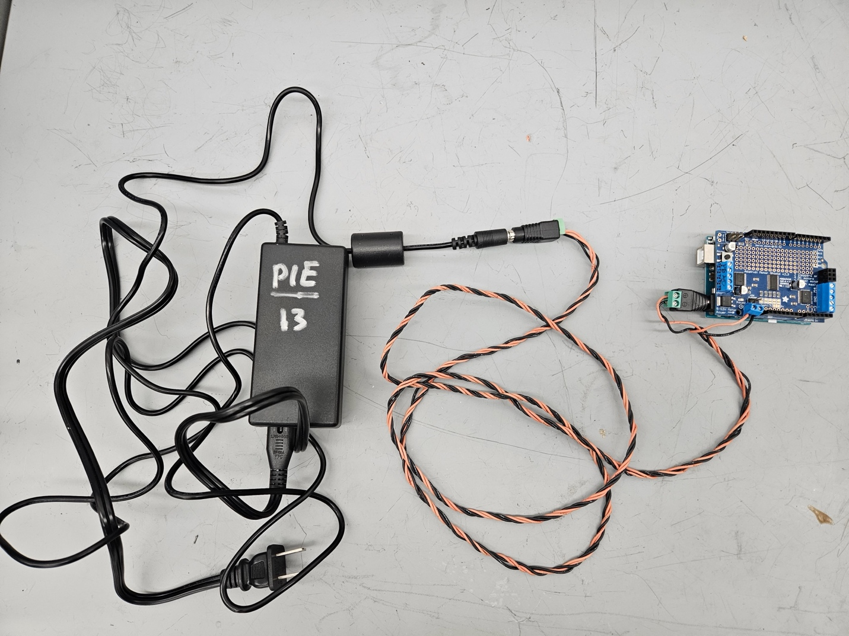
Figure 2. A power cable connection reference.

One end of the red and black twisted cable you received ends in a barrel jack receiving socket. As shown in the middle of Figure 3, you plug the barrel jack connector plug from the wall power supply adapter into that receiving socket. Plugging the adapter into the wall provides power/current that gets sent to the other side of the cable. The opposite end of the cable splits two pairs of red/black wires. One pair ends with stripped exposed wires, they are screwed into the Arduino motor shield - black into the side labeled with a negative/minus symbol and red secured into the screw terminal labeled with a positive/plus symbol. The barrel jack connector plug that is attached to the other pair of split out red/black cables goes into the Arduino itself under the shield. Plugging these cables in as they're shown in Figure 2 provides a different amount current to the shield to provide to motors plugged into it as compared to the power that is required to run an Arduino. If there is any back current from the motor shield or other spikes, this splitting of the cable helps spare the Arduino from seeing damage from such spikes.

Phase 1 - MP3 Write-up Rubric
Criteria | Ratings | Points
Write-up Professionalism, Presentation, and Voice  view longer description | Full Marks  0.4 pts  Partial  0.2 pts  No Marks  0 pts | /0.4 pts
Design Discussion  view longer description | Full Marks  0.8 pts  Partial  0.4 pts  No Marks  0 pts | /0.8 pts
Project Scoping and Adjusting  view longer description | Full Marks  0.8 pts  Partial  0.4 pts  No Marks  0 pts | /0.8 pts
Implementation of sensing and calibrating aspects considering constraints:  view longer description | Full Marks  1 pts  Partial  0.5 pts  No Marks  0 pts | /1 pts
Implementation of physical and mechanical aspects considering constraints  view longer description | Full Marks  1 pts  Partial  0.5 pts  No Marks  0 pts | /1 pts
Experimentation  view longer description | Full marks  1 pts  Partial  0.5 pts  No marks  0 pts | /1 pts
Circuit Diagram  view longer description | Full Marks  0.5 pts  Partial  0.25 pts  No Marks  0 pts | /0.5 pts
Code Style and Documentation  view longer description | Full Marks  0.5 pts  Partial  0.25 pts  No Marks  0 pts | /0.5 pts
Mechanical Design Documentation  view longer description | Full Marks  0.5 pts  Partial  0.25 pts  No Marks  0 pts | /0.5 pts
Bill of Materials  view longer description | Full Marks  0.5 pts  Partial  0.25 pts  No Marks  0 pts | /0.5 pts
Engineering requirements  view longer description | Full marks  0.6 pts  Partial  0.3 pts  No marks  0 pts | /0.6 pts
System architecture/block diagram  view longer description | Full marks  0.4 pts  Partial  0.2 pts  No marks  0 pts | /0.4 pts
Authentic engagement  view longer description | Full marks  1 pts  Partial  0.5 pts  No marks  0 pts | /1 pts
Keep in mind, this submission will count for everyone in your MP3 Pairs group.
Choose a submission type
Drag a file here, orChoose a file to uploadFile permitted: PDF
or

