**Remade Oak – Remade Oak Planked Vinyl Flooring**  
Measured: 6/10/2021

**Contact**

Meredith Kupinski  
Research Professor  
Wyant College of Optical Sciences  
University of Arizona  
520.626.3985  
[meredith@optics.arizona.edu](mailto:meredith@optics.arizona.edu)

**Measured by:**

Caroline Humphreys

**File Types**

.cmmi – Mueller matrix data

.png – Rendered Mueller matrix images

.rmmd – Raw camera images

**Naming Convention**

The files are named with the date, sample number, wavelength in nm, exposure time in ms, f-number, angle of incidence, and angle of camera axis:

YYYYMMDD_sampleNumber_λλλ_exposure_fno_AOI_AOC.cmmi

**Description**

This sample is a piece of vinyl flooring (Remade Oak) above another piece of vinyl flooring (Remade Oak Planked).

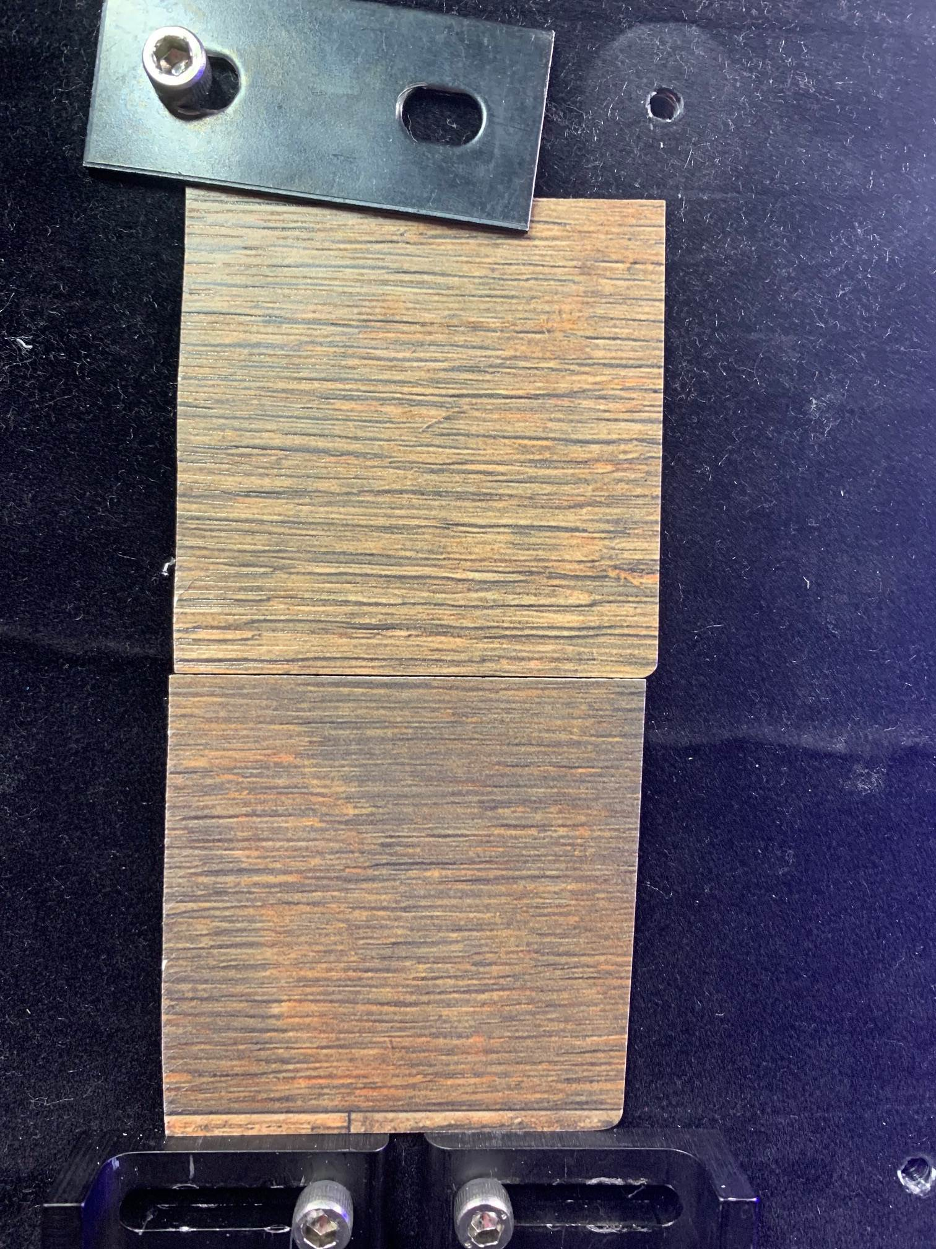

**Experiment Details**

*Instrument*: RGB950 (GitHub: <https://github.com/Polarization-Lab/RGB950>)

*Camera Settings:*

|  |  |  |  |
| --- | --- | --- | --- |
| Wavelength (nm) | 451 | 524 | 662 |
| Exposure Time (ms) | 700 | 950 | 300 |
| F/# | 16 | 11 | 16 |

* note all scattering geometries have the same exposure time and F/#

**Geometry of acquisition:**

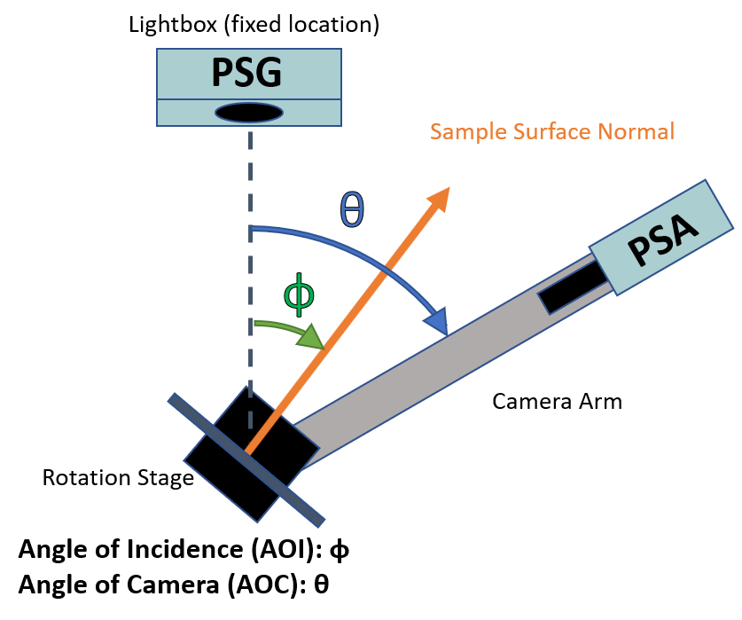

|  |  |  |  |  |  |  |  |  |  |
| --- | --- | --- | --- | --- | --- | --- | --- | --- | --- |
| Angle of Planar Sample's Surface Normal (AOI) **ɸ** (°) | | | | | | | | | |
|  | 10 | | 25 | | 40 | | 55 | | 70 |
| Angle of PSA Camera's Optical Axis (AOC) **θ** (°) | | | | | | | | | |
| Off Specular - 40 |  |  | |  | |  | | 100 | |
| Off Specular - 30 |  |  | |  | | 80 | | 110 | |
| Off Specular - 20 |  |  | | 60 | | 90 | | 120 | |
| Off Specular - 10 |  | 40 | | 70 | | 100 | | 130 | |
| **Specular** | **20** | **50** | | **80** | | **110** | | **140** | |
| Off Specular + 10 | 30 | 60 | | 90 | | 120 | | 150 | |
| Off Specular + 20 | 40 | 70 | | 100 | | 130 | |  | |
| Off Specular + 30 | 50 | 80 | | 110 | |  | |  | |
| Off Specular + 40 | 60 | 90 | |  | |  | |  | |
| Off Specular + 50 | 70 |  | |  | |  | |  | |

**Notes**

These two vinyl flooring samples are very similar in appearance and texture. They have an overall smooth finish but one can feel the manufactured wood grains in both samples. Both samples are from Wilsonart.