**White Classic Leather**  
Measured: 7/12/2021

**Contact**

Meredith Kupinski  
Research Professor  
Wyant College of Optical Sciences  
University of Arizona  
520.626.3985  
[meredith@optics.arizona.edu](mailto:meredith@optics.arizona.edu)

**Measured by:**

Caroline Humphreys

**File Types**

.cmmi – Mueller matrix data

.png – Rendered Mueller matrix images

.rmmd – Raw camera images

**Naming Convention**

The files are named with the date, sample number, wavelength in nm, exposure time in ms, f-number, angle of incidence, and angle of camera axis:

YYYYMMDD_sampleNumber_λλλ_exposure_fno_AOI_AOC.cmmi

**Description**

This sample consists of a piece of white leather.

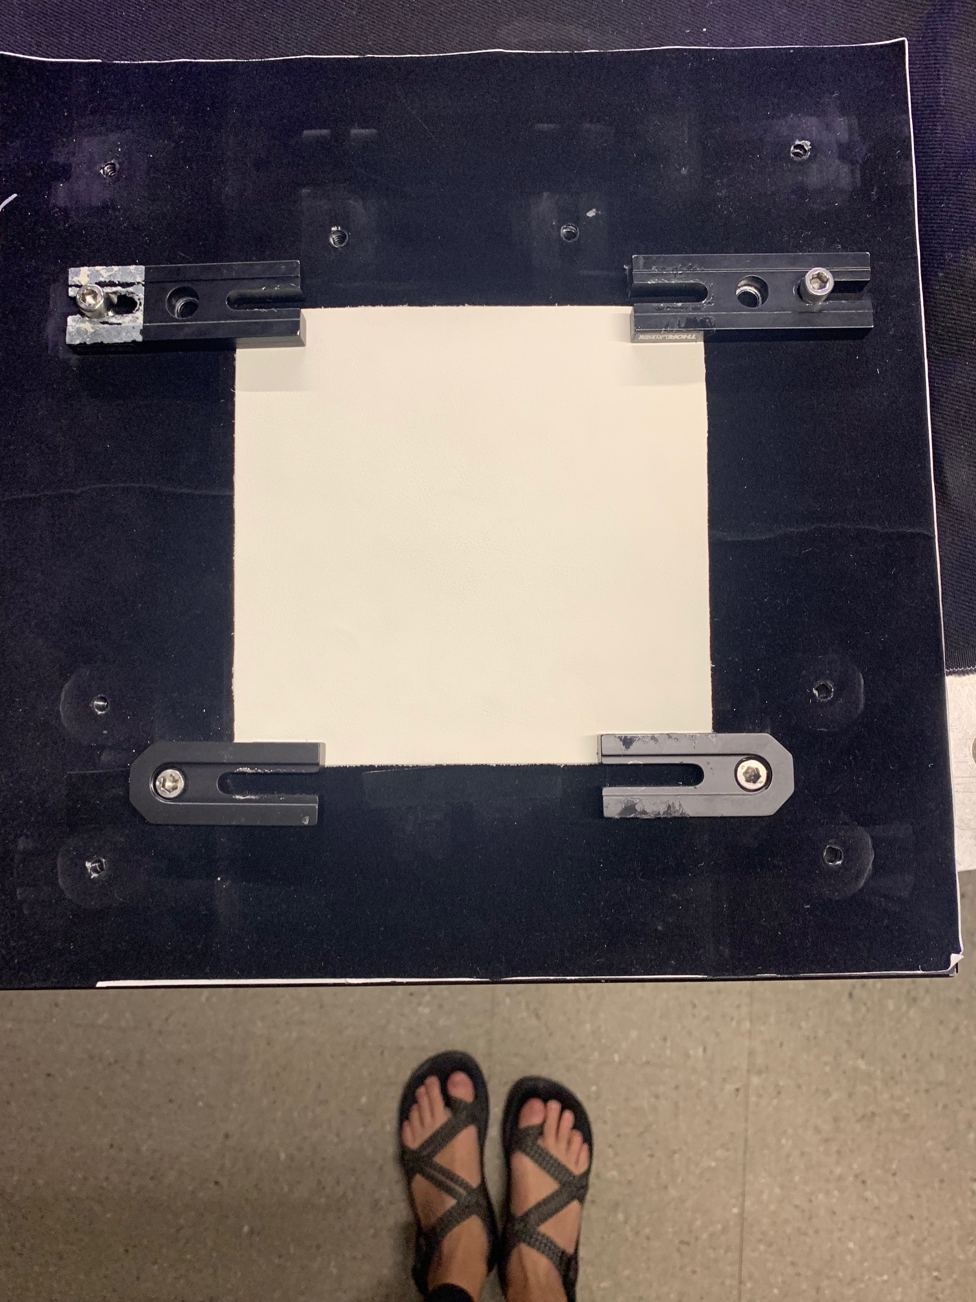

**Experiment Details**

*Instrument*: RGB950 (GitHub: <https://github.com/Polarization-Lab/RGB950>)

*Camera Settings:*

|  |  |  |  |
| --- | --- | --- | --- |
| Wavelength (nm) | 451 | 524 | 662 |
| Exposure Time (ms) | 615 | 620 | 540 |
| F/# | 8 | 5.6 | 16 |

* note all scattering geometries have the same exposure time and F/#

**Geometry of acquisition:**

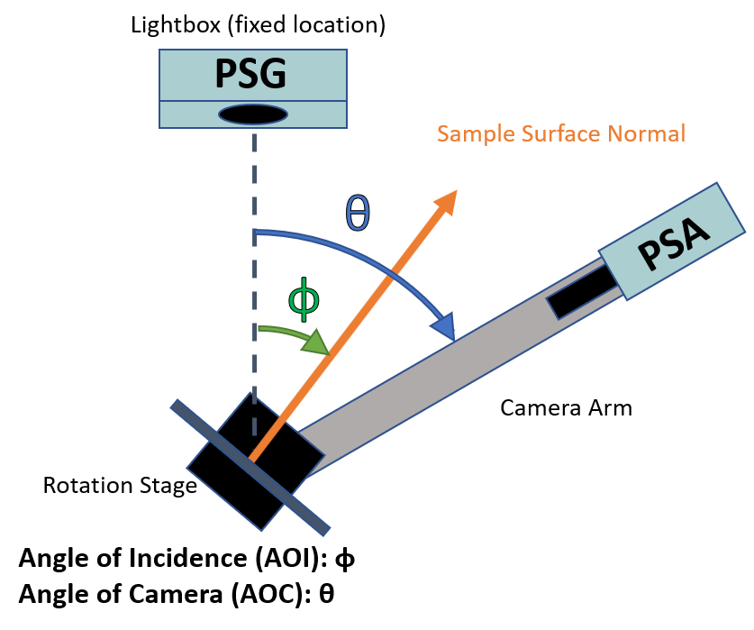

|  |  |  |  |  |  |  |  |  |  |
| --- | --- | --- | --- | --- | --- | --- | --- | --- | --- |
| Angle of Planar Sample's Surface Normal (AOI) **ɸ** (°) | | | | | | | | | |
|  | 10 | | 25 | | 40 | | 55 | | 70 |
| Angle of PSA Camera's Optical Axis (AOC) **θ** (°) | | | | | | | | | |
| Off Specular - 40 |  |  | |  | |  | | 100 | |
| Off Specular - 30 |  |  | |  | | 80 | | 110 | |
| Off Specular - 20 |  |  | | 60 | | 90 | | 120 | |
| Off Specular - 10 |  | 40 | | 70 | | 100 | | 130 | |
| **Specular** | **20** | **50** | | **80** | | **110** | | **140** | |
| Off Specular + 10 | 30 | 60 | | 90 | | 120 | | 150 | |
| Off Specular + 20 | 40 | 70 | | 100 | | 130 | |  | |
| Off Specular + 30 | 50 | 80 | | 110 | |  | |  | |
| Off Specular + 40 | 60 | 90 | |  | |  | |  | |
| Off Specular + 50 | 70 |  | |  | |  | |  | |

**Notes**

This sample is white classic leather. It has the normal texture of leather and is white in color. This sample is slightly reflective.