**The following pages illustrate the use of napari-LF to deconvolve the simulated light field images of hedgeHog objects, interpreting the retardance light field image as generated by an isotropic fluorescent object.**

hedgeHog4_GT.h5 hedgeHog4_GT_RetLFMathSS3.tif

hedgeHog4 is embedded in a rasterized volume of 45 by 189 by 189 voxels, meant to be imaged with a super sample of 3. The original object is composed of birefringent bundles or rods that extend from the center of the volume to the corners of a cube. The rod-diameter is one microlens diameter and its length is 9.2µm or 5 microlens diameters. Its birefringence is 0.01 and the optic axis runs parallel to the rod-axis. The empty volume in the center of the object corresponds in size to one microlens diameter cubed.

The image on the right is the retardance light field image of the object, generated with the Mathematica Notebook PolRayTraceBirefrImagingJuly2023.nb and the following optical parameters:

Number of microlenses: 31

Pixels per microlens: 16

Number of voxels per microlens (super sample): 3

Magnification: 60

NA of objective: 1.2

Wavelength of light: 0.55 µm

camera pixel size: 6.5 µm

refractive index of medium: oil n=1.35

The Streamlit/Python code produces almost identical light field images with the one difference of 17 pixels behind each microlens, instead of 16 in the Mathematica code. The codes also produce an orientation light field image, which is not shown.

Next, I took the retardance light field image, interpreted it as generated by isotropic fluorescent emitters and used the napari-LF plugin to reconstruct the object volume as if it consisted of isotropic emitters.

**Deconvolving the retardance light field image of hedgeHog4 using napari-LF and the radiometry and dark field images taken from**

**/Users/rudolfo/Software/GitHub/LF-examples/GUVSimul2/**

The files Radiometry_GUVSimul2.tif and DarkFrame_GUVSimul2.tif happen to have the same number of microlenses in Y- and Z-direction and the radiometry image was computed with a thin sheet of isotropic fluorescence projected by the same optical parameters as the hedgeHog objects. The dark frame is just zero everywhere.

napari-LF settings:

In Optional, Skip alignment and Skip subpixel alignment were set.

Below is the result of deconvolving the light field image hedgeHog4_GT_RetLFMathSS3.tif into a volume spanning 45 voxels along X, 93 along Y and Z using napari-LF.

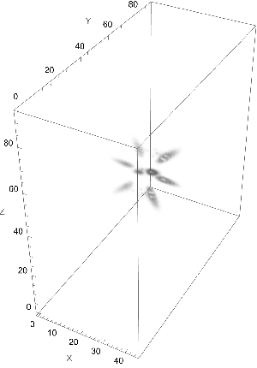

hedgeHog4_GT_RetLFMathSS3_Decon1.tif

Curiously, the maximum voxel value in this deconvolved volume is 3•10-20. While most voxel values are zero, the values representing the rods are very low, between 10-21 and 3•10-20.

Next, I deconvolved a light field image that was generated using the same hedgeHog4 object, but voxels represent isotropic fluorescent emitters. For generating its light field image that represents fluorescence intensity, I used ray tracing code for isotropic fluorescent emission available in Mathematica Notebook RayTracingFluorIsotropicJuly2023.nb

hedgeHog4_GT.h5 hedgeHog4_GT_FluorIsoLFMathSS3.tif

Below is the result of deconvolving the above light field image using napari-LF into a volume spanning 45 voxels along X, 93 along Y and Z. Based on a light field image with 31 by 31 microlenses and assuming a super sample of 3, napari-LF produces 93 by 93 voxels in Y- and Z-direction, and I asked for 45 slices in X-direction with 0.58µm per slice to make the voxel size a cube.

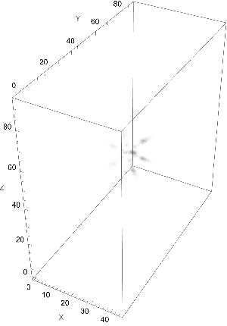

hedgeHog4_GT_FluorIsoLFMathSS3_Decon1.tif

Here, the maximum voxel value in the deconvolved volume is 8•10-16.