AI Interactive Storyteller
Stage 1 Project Design Report
EECS 3311 Software Design, Section A, Fall 2026
Shane Marcelo
221114749
https://github.com/Polarralop/EECS3311Project
October 9th, 2026
Contents
1. Project Overview 4
1.1 Problem and Motivation 4
1.2 Target Users 4
1.3 Agent Description 4
1.4 AI/LLM Model(s) 4
1.5 Overall Architecture 5
2. Detailed Feature Specifications 6
2.1 Feature Summary 6
2.2 Feature Details 7
3. UML Class Diagram 16
4. Design Pattern Explanations 25
4.1 Adapter 25
4.2 Command 25
4.3 Facade 26
4.4 MVC 26
4.5 Observer 27
4.6 Strategy 27
5. Use-Case Diagram 28
5.1 Actors 28
6. Detailed Use-Case Descriptions 29
6.1 UC01: Create a story 29
6.2 UC02: Manage lore 29
6.3 UC03: Manage characters 29
7. Sequence Diagrams 31
7.1 SD01 31
7.2 SD02 31
7.3 SD03 31
8. Feature-to-Design Traceability Table 33
9. Feature Implementation Explanations 35
F01: Scenario Setup 35
F02: Lore Entry Management 35
F03: Character Management 35
F04: Story Turn 36
F05: Pivotal Events 36
F06: Plot Steering 36
F07: Lore Proposals 37
F08: Consistency Check 37
F09: Story Memory Summarization 37
F10: Undo / Retry / Edit Turn 38
F11: Save and Load Session 38
F12: Ending Generation 38

1. Project Overview

1.1 Problem and Motivation
It is fundamentally impossible for users to be surprised by a story when users write the story themselves. If users were to use an ordinary chatbot for this problem, they would find success for only the first couple of writing rounds. Hand the chatbot lore to manage and a long story with an overarching plotline and it soon starts to fall apart, becoming inconsistent or outright contradicting established points. In this project, the AI Interactive Storyteller serves to track lore, character descriptions and overall world status, resulting in a consistent, lore-rich story for users to interact with. It also plans pivotal events that are kept hidden from users, so that the story is still able to surprise them.

1.2 Target Users
The target users for this application are solo role-players who would like to generate their own longer, cohesive pieces of fiction and would like to immerse themselves in a world where the story cooperates with their actions.

1.3 Agent Description
Agent activities
In this application, the agent will be able to set up and maintain a story that is then displayed to the user. The agent will be able to manage specific entries of information like lore and characters with the user’s approval, while writing a story guided by the generated list of hidden, pivotal events.
Why use an agent?
This application requires an agent rather than a single LLM API call because the agent is doing more than generating text. Within a single story-writing turn, the agent needs to look up the relevant lore and characters, check the list of pivotal events and the pinned canon facts, and decide whether to continue towards the next pivotal event or revise the list to fit what the user has done.
The agent also needs to keep a long story coherent by summarizing earlier events, propose new lore for the user to approve, and ensure that its outputs and actions are all consistent with what is happening in the story and what is planned to happen.

1.4 AI/LLM Model(s)
This project will use Claude Sonnet 5.5 by Anthropic (priced at $2/million input tokens; $10/million output tokens).

This decision comes from the model’s intelligence, reliable tool-calling and support for structured output. This comes with a trade-off as Claude will not generate certain content in the application (no sexually explicit material or glorifying graphic violence/gore). It will, however, still portray dark fantasy elements if users desire such themes.

Claude Fable 5.1 would be an excellent fit here, as it is a model that was built for long-running tasks where continuity matters (Anthropic), but the cost is too great for something on this scale ($10/million input tokens; $50/million output tokens). This app will use the Adapter pattern so other models can be added easily.

1.5 Overall Architecture
In this application, the user will be able to interact with the agent through either a GUI or a CLI. Both will send the user’s actions to the same controller, which means that every major feature is available from either one. The controller then works with two things: the story’s state, which is stored and enforced by the application, and the agent, which decides what happens next in the story.
The agent will communicate with Claude Sonnet 5.5 through an adapter, which allows the model to be swapped out without changing the rest of the app. The agent will not be able to change the story’s state on its own. When it needs to read or change something like a lore entry or a character, it makes a tool call that the application checks and carries out before returning the result. This comes with the benefit of keeping lore and characters under the user’s control, as any new entries are only saved with the user’s approval.
The list of pivotal events is kept hidden from the user so that the story is still able to surprise them. If the user wishes to supply a basis for a story’s setting or flow, the agent will be able to discreetly generate pivotal events that fit within the supplied basis, still allowing the user to be surprised by any sudden twists.
The code and agent work together to keep continuity in the story. The following table highlights the main points:
Owned and enforced by the app | Decided by the agent
Lore entries, characters and relationships | Which entries are relevant to the current turn
Pivotal events and status | Whether to revise the plot or nudge the story back
Pinned canon facts | What to narrate
Turn history, saves and undo | What new lore to propose
User approval of proposed lore | When the story is ready to end
Note: the app’s pinned canon facts will take precedence over the user’s actions attempting to override within the role-playing chat.

2. Detailed Feature Specifications

2.1 Feature Summary
ID | Feature | Type
F01 | Scenario Setup | Hybrid
F02 | Lore Entry Management | Deterministic
F03 | Character Management | Deterministic
F04 | Story Turn | Hybrid
F05 | Pivotal Events | Hybrid
F06 | Plot Steering | AI
F07 | Lore Proposals | Hybrid
F08 | Consistency Check | Hybrid
F09 | Story Memory Summarization | AI
F10 | Undo / Retry / Edit Turn | Deterministic
F11 | Save and Load Session | Deterministic
F12 | Ending Generation | AI

2.2 Feature Details

F01: Scenario Setup
Feature ID and Name | F01: Scenario Setup
Description | The user creates a scenario (title, premise, tone, setting, opening situation) by writing it directly or by having the agent generate one from a short prompt.
User Interaction (GUI) | Accessed after clicking a plus button in the storylist, bringing up a form with six fields (5 for user scenario, 1 for user’s plot basis), prompt text box with a generate button and a start button.
Input | Requires text input from the user:  Can be five fields from the user (title, premise, tone, setting and openingSituation) [premise and setting mandatory; title made if left empty]  OR  Simple short prompt that agent uses to generate the fields  Can contain a plot basis from the user, but is optional
Output | Creates a Scenario object and a new StorySession that contains the Scenario once the story starts.
AI Involvement | Hybrid
Expected Workflow | If user inputs fields manually: fields are filled -> inputs are validated -> scenario created -> story starts.  If agent generates fields from prompt: prompt is given -> agent returns a draft scenario -> user approves -> inputs are validated -> scenario created -> story starts
Error / Alternative Cases | - Prompt Refused: show a message and let the user rephrase or write the scenario by hand  - Failed Model Call: show a message; allow the user to write by hand  - Invalid Fields (manual input; mandatory fields are empty): show a message to the user  - Generated Draft Rejected: user can edit the generated draft or redo it with another prompt (can also be the same).

F02: Lore Entry Management
Feature ID and Name | F02: Lore Entry Management
Description | The user adds, edits, tags and searches lore entries.
User Interaction (GUI) | Lore Panel beside the story, listing lore entries. A button opens a form to add an entry; clicking an entry opens the form to edit it. Users can filter the list by using a search box at the top of the panel.
Input | Adding an entry: title, content, tags (all strings) and a pinned status (Boolean; displayed via checkbox)
Output | Entries (both new and edited) are saved in the story’s Lore panel and shown in the list.  If searching, matching entries are shown.
AI Involvement | Deterministic
Expected Workflow | - Add or edit: form is filled, inputs are validated, entry is saved to the lore book, list refreshes.  - Search: query is entered, matching entries are listed.
Error / Alternative Cases | - Empty title/content: show message and name field  - Search finds nothing: empty list shown with a message  - No story open: panel cannot be selected

F03: Character Management
Feature ID and Name | F03: Character Management
Description | The user creates and edits character profiles, including traits and relationships between characters.
User Interaction (GUI) | A Characters panel beside the story, listing characters by name. A button opens a form to add a character, and clicking a character opens the same form to edit it. The form has a relationships section where the user picks another character and describes the link.
Input | Name, description, and traits.  For each relationship: the target character, a type (such as ally, rival, sibling), and optional notes.
Output | The character is saved in the story and shown in the list with its relationships.
AI Involvement | Deterministic
Expected Workflow | - Add/edit: form is filled, inputs are validated, character is saved to the story, list refreshes.  - Add a relationship: a target character is chosen, type and notes are entered, the relationship is attached to the character and saved with it.  - Note: this is intentionally one-directional and doesn’t automatically list the relationship as mutual.
Error / Alternative Cases | - Empty name: show a message.  - Name already used by another character: show a message.  - Relationship with no target or pointing at the character itself: show a message.  - No story open: the panel is unavailable.

F04: Story Turn
Feature ID and Name | F04: Story Turn
Description | The user submits input in Do, Say or Story mode and the agent narrates what happens next.
User Interaction (GUI) | Used from the main story screen. A text box under the story takes the user’s input, with a selector for the mode (Do, Say or Story) and a send button. The agent’s narration is added to the story above it.  After a turn, the lore entries the agent drew on are listed under that turn’s narration, and clicking one opens it in the Lore panel.
Input | Text input from the user.  A mode: Do (an action the user’s character attempts), Say (a line of dialogue) or Story (narration written by the user for the agent to continue).
Output | A new turn added to the story, holding the user’s input and the agent’s narration.  A record on the turn of which lore entries were used.  Any consistency warnings (F08) and lore proposals (F07) raised during the turn.
AI Involvement | Hybrid
Expected Workflow | Input and mode are submitted, the input is framed according to the mode, the agent looks up the relevant lore entries and characters through tool calls that the application validates and runs, the agent draws on the story summary (F09) and checks the pivotal events (F06), the agent writes the narration, the narration is checked for consistency (F08), the turn is saved with the lore entries it used, the story display refreshes.
Error / Alternative Cases | Empty input: show a message; nothing is sent.  Agent declines: show a message; no turn is added and the user can rephrase.  Failed model call: show a message; no turn is added and the input stays in the text box so it can be resent.  Nothing relevant found in the lore: the agent continues without it and the used-entries list is empty.  Invalid tool request: the application rejects it and reports the error back to the agent.  No story open: the input box is unavailable.

F05: Pivotal Events
Feature ID and Name | F05: Pivotal Events
Description | An overarching plot is kept as a set of story beats, built from a basis the user supplies or generated entirely by the agent.
User Interaction (GUI) | No screen of its own, because the pivotal events are never shown to the user. The optional plot basis is entered in the new-story form (F01). While the events are being planned, the story screen shows a short message that the story is being prepared.
Input | The scenario from F01.  An optional plot basis from the user.
Output | A hidden, ordered list of pivotal events stored with the story, each marked as pending.
AI Involvement | Hybrid
Expected Workflow | The story is started, the agent generates the pivotal events from the scenario (and the plot basis, if one was given), the events are saved with the story as pending, the story opens for the first turn.  As the story goes on, events are marked as reached or revised (F06).
Error / Alternative Cases | No plot basis given: the agent generates the events from the scenario alone.  Agent declines or the model call fails: show a message; the story is not started and the user can try again or change the scenario.  No events returned: treated as a failed model call.

F06: Plot Steering
Feature ID and Name | F06: Plot Steering
Description | When the user takes the story off-script, the agent revises the outline or nudges the story back toward it.
User Interaction (GUI) | No control of its own; it runs inside every story turn (F04). The user only sees its effect in the narration.
Input | Taken automatically: the user’s input for the turn, the recent story, and the pivotal events with their status.
Output | A decision for the turn: continue towards the next pivotal event, nudge the story back towards it, or revise the pending events to fit what the user has done.  Updated pivotal events, when one is reached or the pending ones are revised.
AI Involvement | AI
Expected Workflow | The turn begins, the agent compares the user’s input with the next pending pivotal event, the agent decides to continue, nudge or revise, any change to the events is requested through a tool call, the application validates and applies it, the decision shapes the narration for the turn.
Error / Alternative Cases | All pivotal events reached: there is nothing to steer towards, and the agent may suggest ending the story (F12).  Invalid update (unknown event): the application rejects it, the events stay as they were and the turn continues.  Turn undone: the pivotal events return to how they were before that turn (F10).

F07: Lore Proposals
Feature ID and Name | F07: Lore Proposals
Description | The agent proposes new lore entries from story events, and the user approves or rejects each one.
User Interaction (GUI) | A proposals list in the Lore panel shows each suggested entry with Approve and Reject buttons. A count on the panel shows how many are waiting.
Input | Taken automatically: what happened in the latest turn.  From the user: a decision on each proposal (approve or reject).
Output | A pending proposal with a title and content.  If approved: a new entry in the lore book.  If rejected: the proposal is marked as rejected and nothing is added.
AI Involvement | Hybrid
Expected Workflow | A turn is narrated, the agent notices a new fact worth keeping, the agent proposes an entry through a tool call, the application saves it as pending and shows it in the proposals list, the user approves or rejects it, an approved proposal becomes a lore entry.
Error / Alternative Cases | Proposal left unanswered: it stays pending and the story continues.  Invalid proposal (empty title or content): the application rejects the tool call and nothing is shown to the user.  User wants to change the wording: approve it, then edit the entry in the Lore panel (F02).  Turn undone: proposals raised during that turn stay in the list.

F08: Consistency Check
Feature ID and Name | F08: Consistency Check
Description | New narration is checked against established lore and pinned canon facts, and contradictions are flagged.
User Interaction (GUI) | When a contradiction is found, a warning appears under that turn’s narration and names the lore entry or pinned fact involved. Facts are pinned with the checkbox in the lore form (F02).
Input | Taken automatically: the new narration, and the story’s lore entries including the pinned canon facts.
Output | A list of contradictions for the turn, which is empty when none are found.  Warnings shown with the turn.
AI Involvement | Hybrid
Expected Workflow | The narration is written, the agent compares it with the lore and the pinned canon facts, any contradictions are recorded on the turn, warnings are shown to the user, the user may retry or edit the turn (F10).
Error / Alternative Cases | No contradictions: nothing is shown.  No lore entries yet: the check is skipped.  Check fails (model call fails): the narration is still shown, with a note that it was not checked.  User’s own input contradicts a pinned fact: the pinned fact takes precedence and the narration does not adopt the change.  Warning the user disagrees with: it can be ignored; the narration is not blocked.

F09: Story Memory Summarization
Feature ID and Name | F09: Story Memory Summarization
Description | Older events are summarized so long stories stay within the model’s context, and a recap is shown when a session is loaded.
User Interaction (GUI) | Runs automatically, with no control needed during play. When a saved story is loaded, a recap of the story so far is shown at the top of the story screen.
Input | Taken automatically: the story’s turns and its existing summary.
Output | An updated summary stored with the story.  A recap shown when a story is loaded.
AI Involvement | AI
Expected Workflow | After a turn: the application checks whether the story has grown past the recent-turn limit, the agent summarizes the older turns, the summary is saved with the story, later turns send the summary and the recent turns to the agent.  On load: the story is loaded, the agent writes a recap from the summary and the recent turns, the recap is shown.
Error / Alternative Cases | Story still short: nothing is summarized.  Summarization fails: the previous summary is kept and it is tried again after the next turn.  Recap fails: the story still loads, without a recap.

F10: Undo / Retry / Edit Turn
Feature ID and Name | F10: Undo / Retry / Edit Turn
Description | The user undoes, regenerates or edits the most recent turn.
User Interaction (GUI) | Three buttons under the most recent turn: Undo, Retry and Edit. Edit turns the narration into an editable text box with Save and Cancel.
Input | Undo and Retry: nothing beyond the button press.  Edit: the user’s replacement text for the narration.
Output | Undo: the last turn is removed and the pivotal events return to how they were before it.  Retry: the last turn is replaced by a newly generated one for the same input.  Edit: the last turn’s narration is replaced by the user’s text.
AI Involvement | Hybrid: retry calls model again
Expected Workflow | Undo: the button is pressed, the last turn is removed, the pivotal events are restored, the story display refreshes.  Retry: the button is pressed, the last turn is undone, the same input is sent again as a new turn (F04).  Edit: the text is changed and saved, the narration is replaced, the story display refreshes.
Error / Alternative Cases | Nothing to undo: the buttons are unavailable.  Retry fails (agent declines or the model call fails): the turn stays undone, a message is shown and the input is put back in the text box.  Edit left empty: show a message; the narration is unchanged.  Edit cancelled: nothing changes.  Undo after an edit: the original narration is restored.

F11: Save and Load Session
Feature ID and Name | F11: Save and Load Session
Description | The user saves a story session and loads it again later.
User Interaction (GUI) | A Save button on the story screen. The story list on the main screen shows saved stories by title, and clicking one loads it.
Input | Save: nothing beyond the button press.  Load: the story chosen from the list.
Output | Save: the whole story (scenario, lore, characters, pivotal events, turns, proposals and summary) written to a file.  Load: the story restored and shown, with a recap (F09).
AI Involvement | Deterministic
Expected Workflow | Save: the button is pressed, the story is written to a file, a confirmation is shown.  Load: a story is chosen, its file is read, the story is restored, the recap is shown, play continues from the last turn.
Error / Alternative Cases | Save fails (file cannot be written): show a message; the story stays open.  File missing or damaged: show a message and return to the story list.  Another story is open with unsaved changes: ask the user to save it first.  No saved stories: the list shows a message.  Undo history: not kept across a save and load.

F12: Ending Generation
Feature ID and Name | F12: Ending Generation
Description | The agent writes an ending that draws on the plot outline, lore and story history.
User Interaction (GUI) | An End Story button on the story screen. When the agent judges that the story is ready to end, a prompt suggests it, which the user can accept or dismiss.
Input | The user’s request to end the story, or their acceptance of the agent’s suggestion.  Taken automatically: the pivotal events, the lore and the story so far.
Output | A closing passage shown at the end of the story.
AI Involvement | AI
Expected Workflow | The agent suggests an ending once the pivotal events have been reached, or the user presses End Story; the agent writes an ending from the pivotal events, the lore and the story so far; the ending is shown at the end of the story.
Error / Alternative Cases | Requested early (pivotal events still pending): the user is asked to confirm, and the agent writes an ending from the current point.  Suggestion dismissed: the story continues.  Agent declines or the model call fails: show a message; the story is unchanged and the user can try again.

3. UML Class Diagram
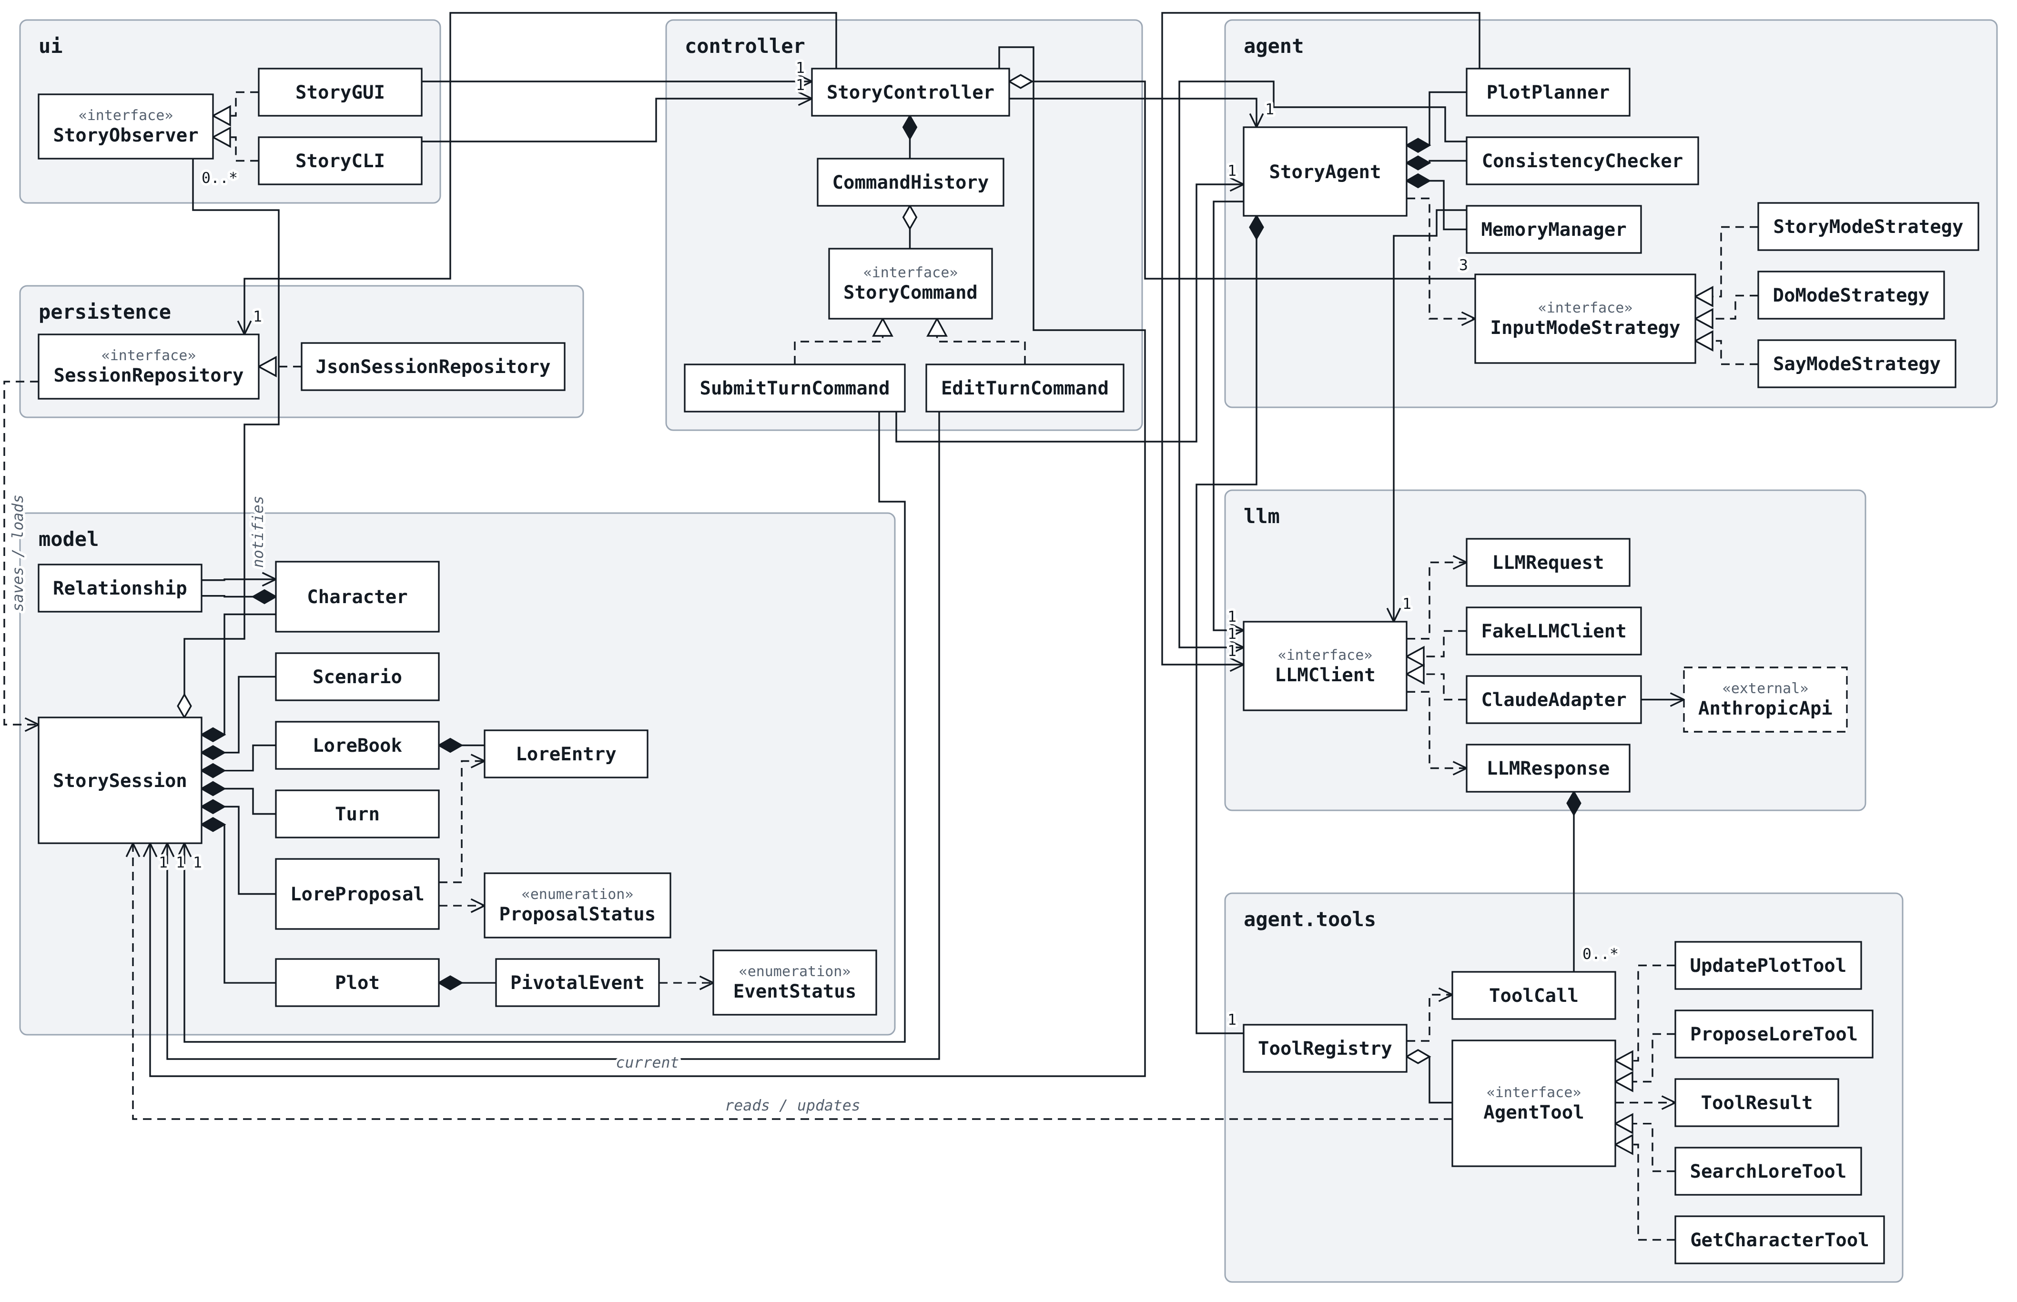
Figure 1. Class diagram overview: all classes by name with relationship arrows. Attributes and methods shown in Figures 2 to 9.
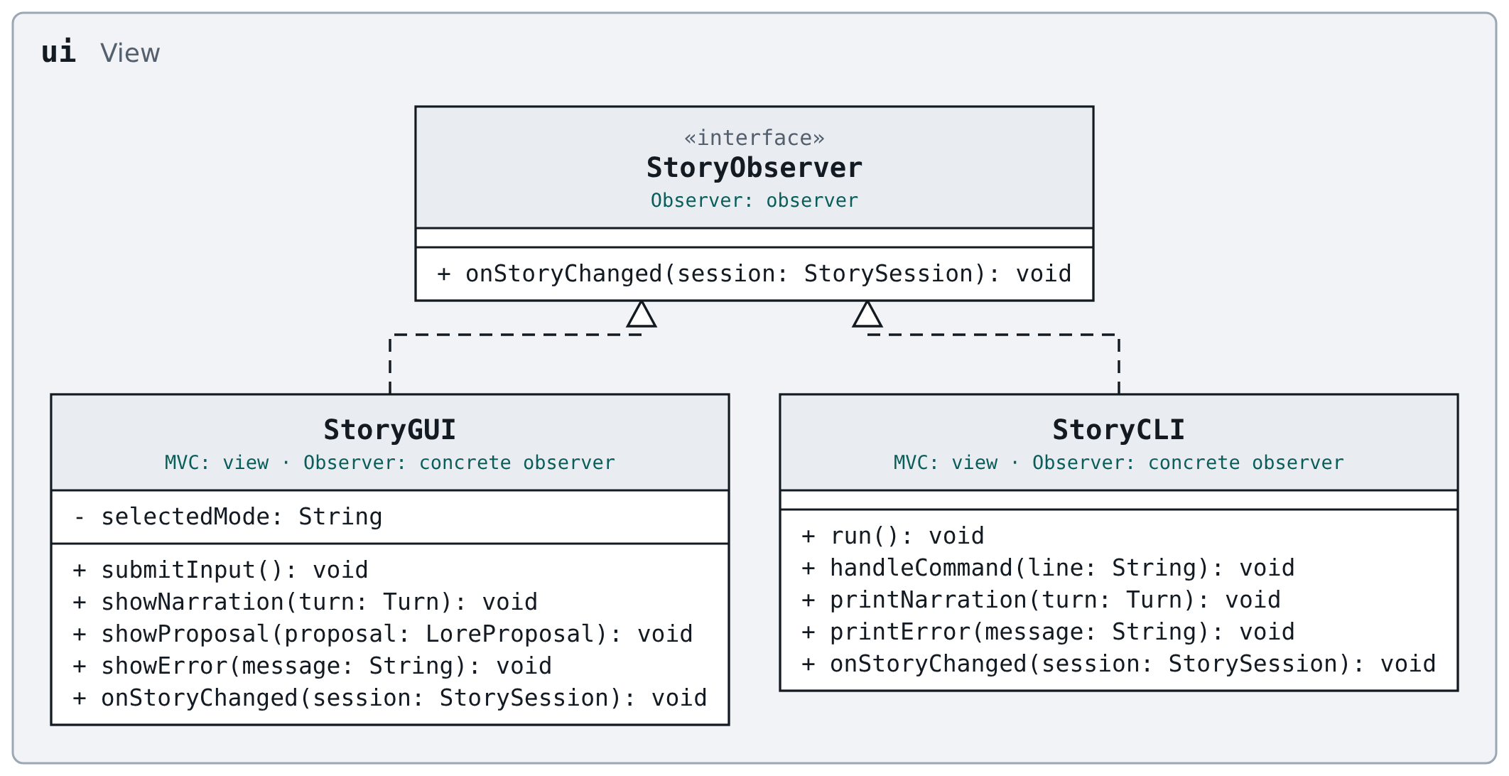
Figure 2. Package ui: the two front ends and the observer interface they implement.
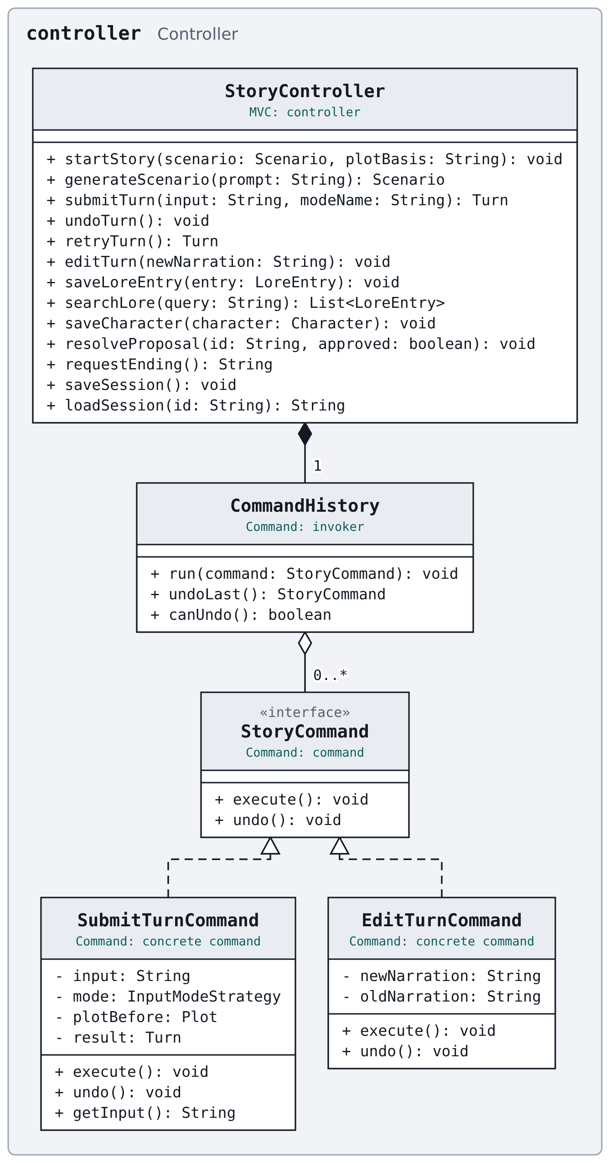
Figure 3. Package controller: the single entry point and the undoable commands.
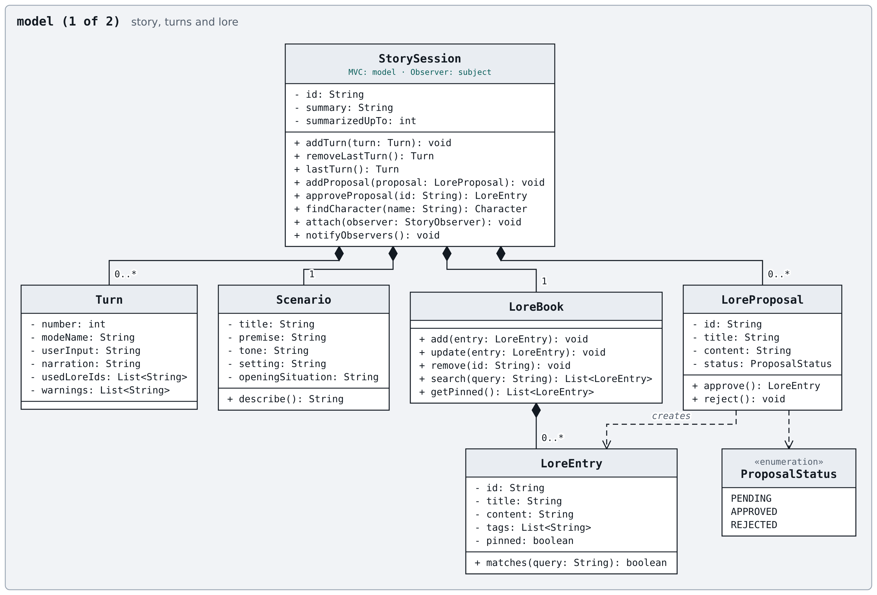
Figure 4. Package model, part 1: the session, its turns, and lore.
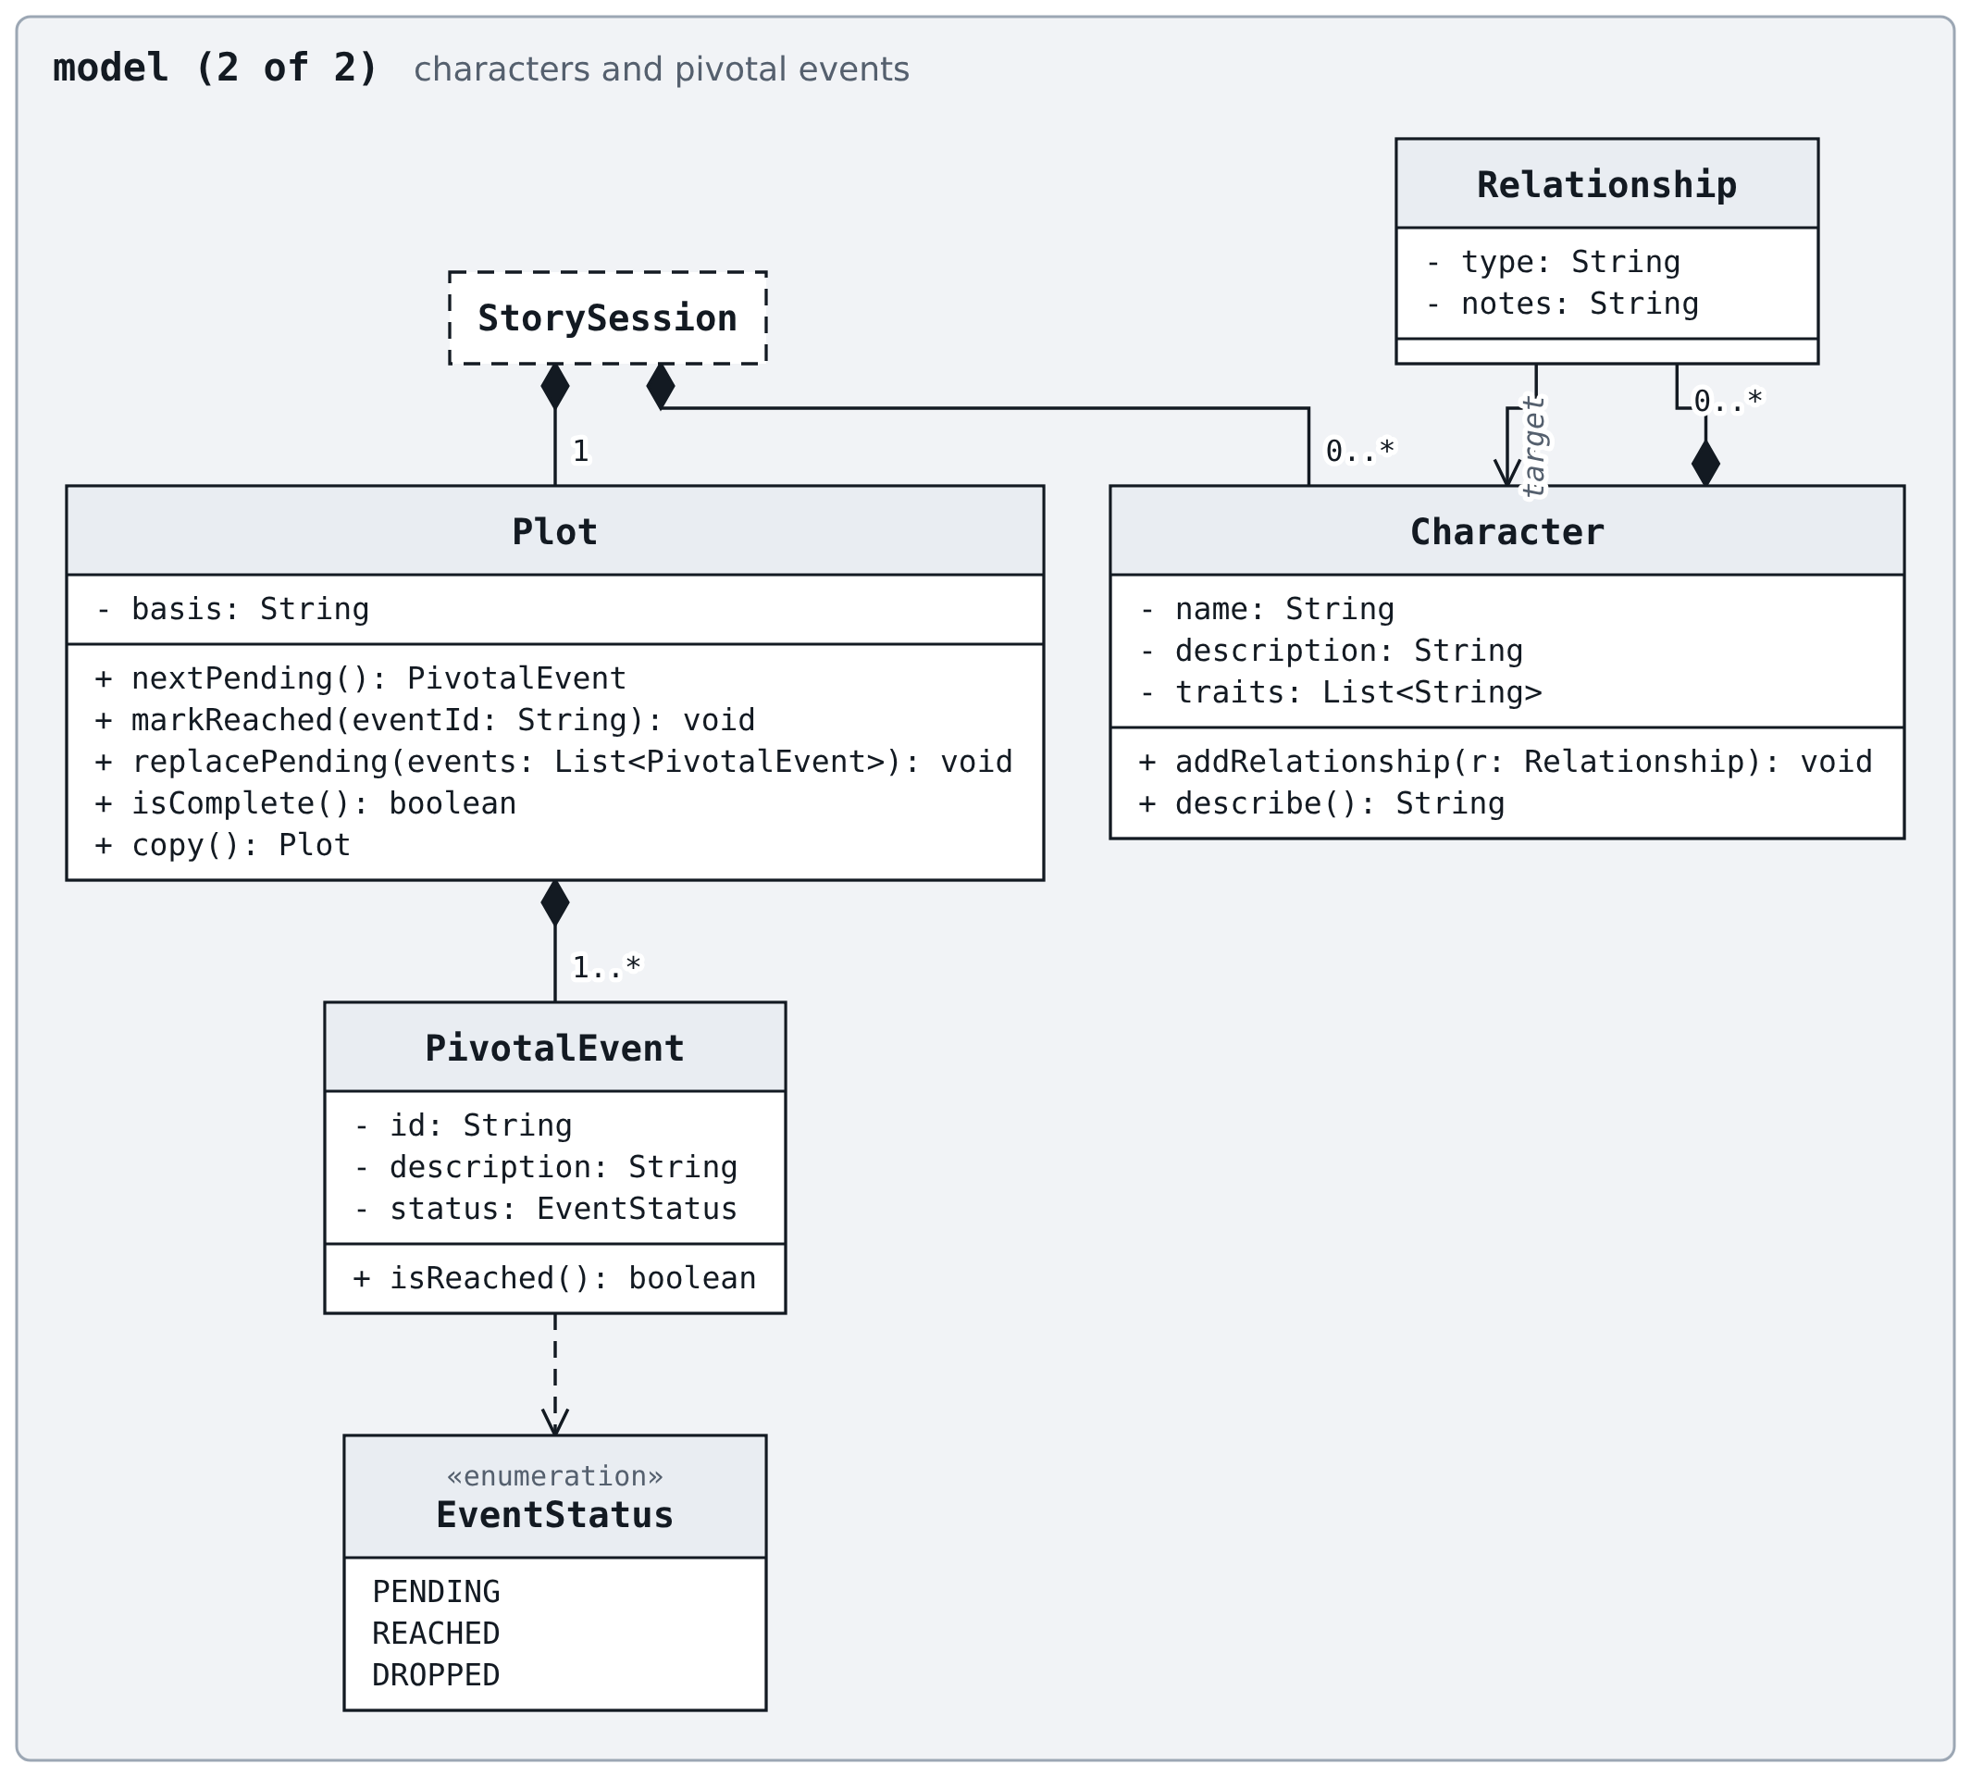
Figure 5. Package model, part 2: characters and the hidden pivotal events. StorySession is detailed in Figure 4.
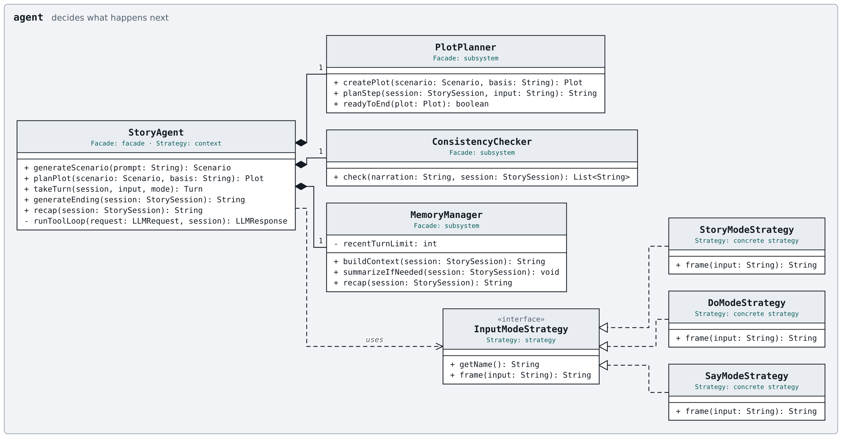
Figure 6. Package agent: the facade, its subsystem classes, and the input-mode strategies.
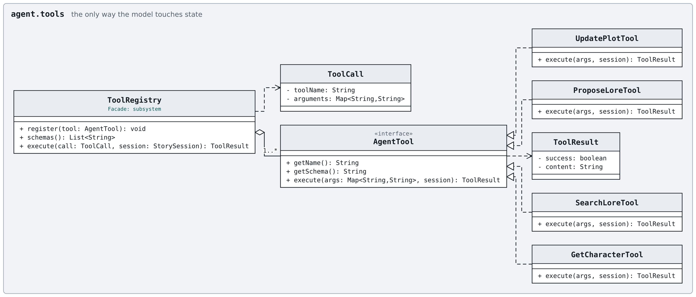
Figure 7. Package agent.tools: the operations the model may request.
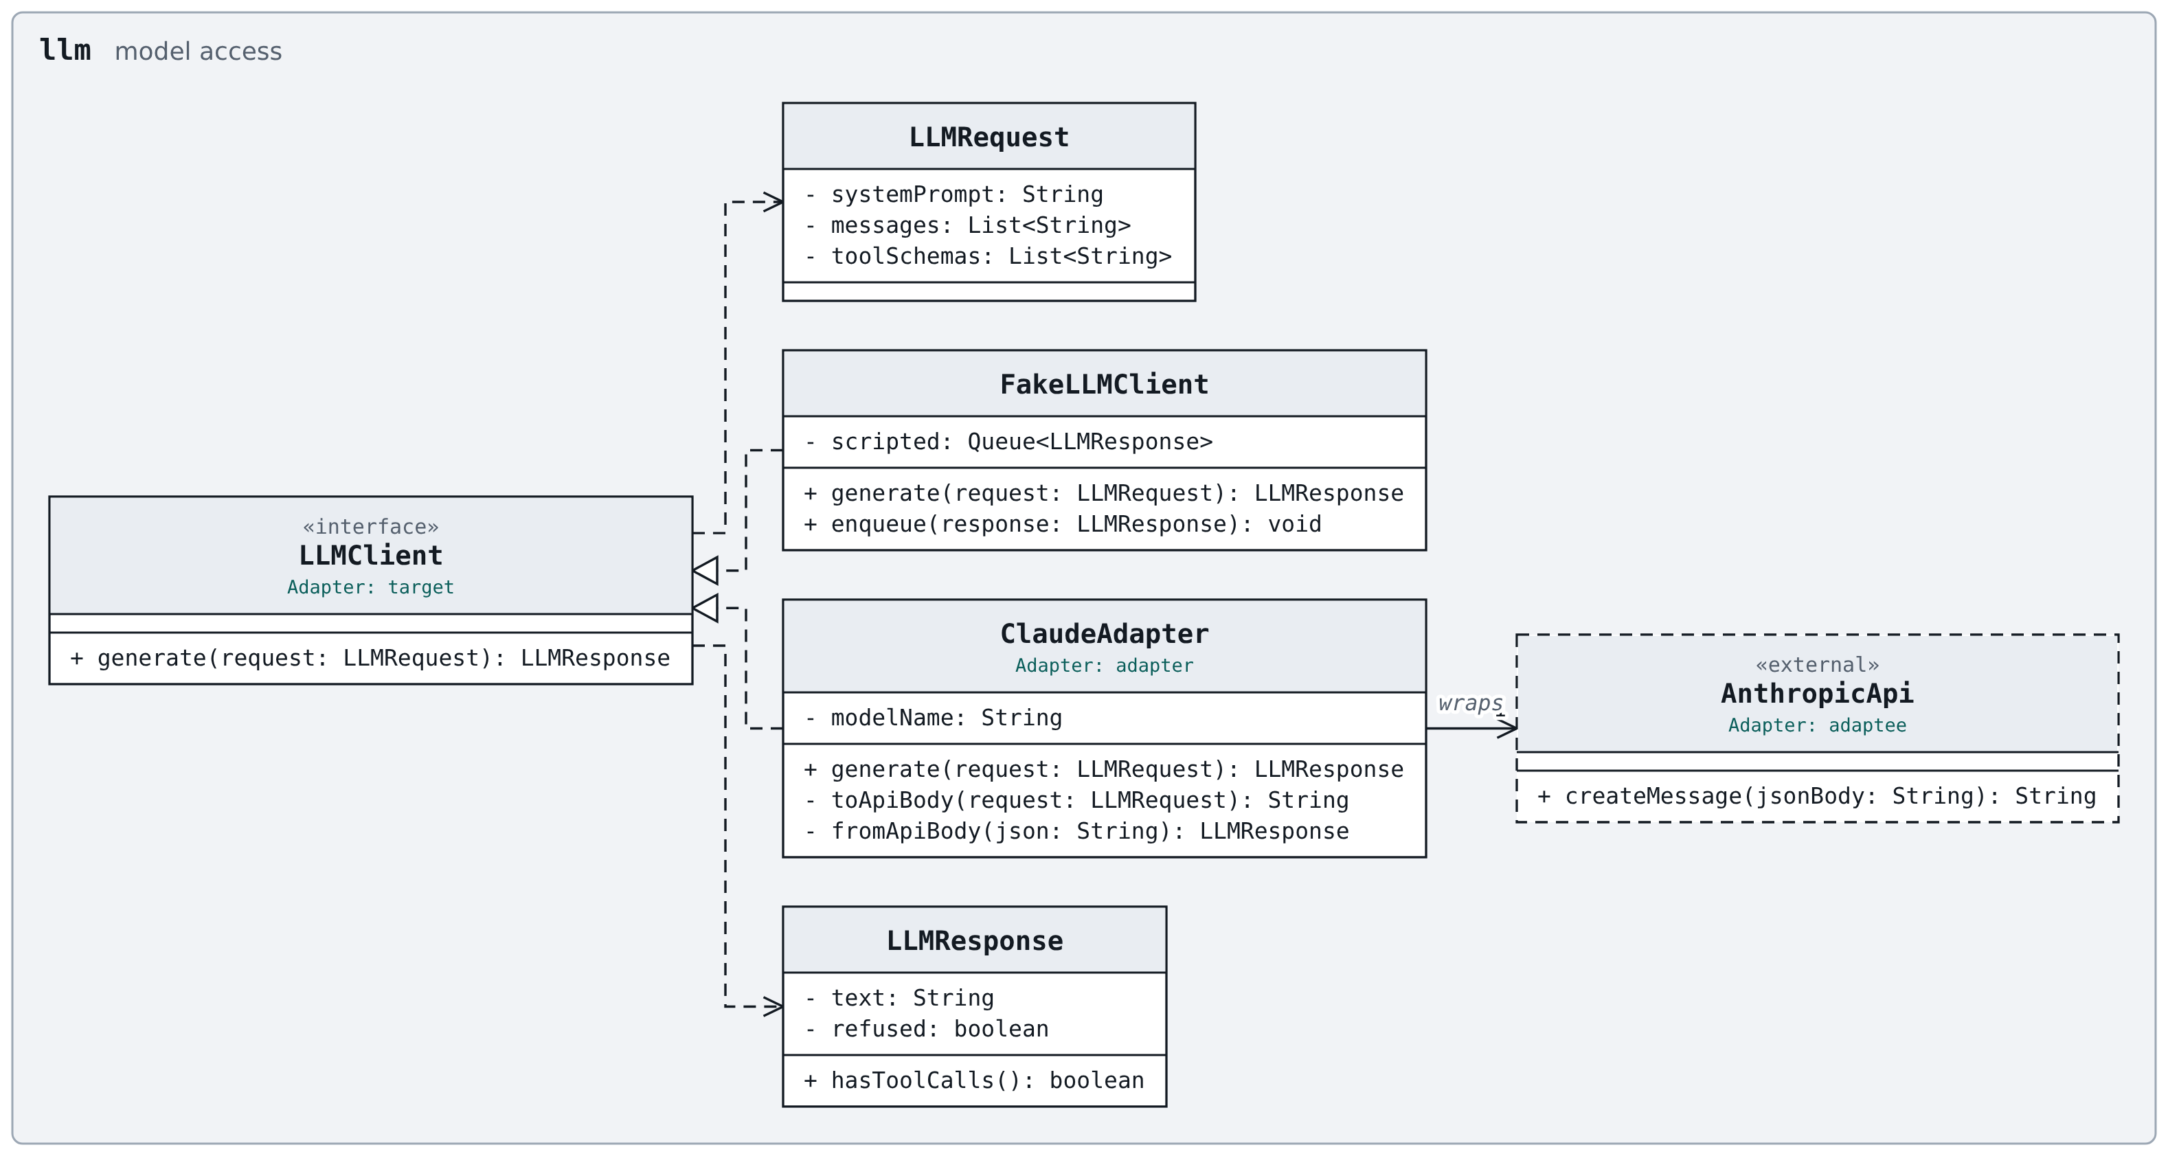
Figure 8. Package llm: the client interface, the adapter for Claude, and the test double.
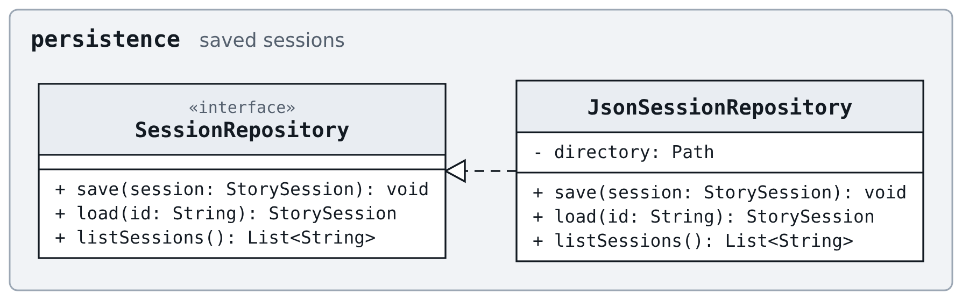
Figure 9. Package persistence: saving and loading sessions.

4. Design Pattern Explanations
This project will use six design patterns: Adapter, Command, Facade, MVC, Observer and Strategy. The role each class plays in a pattern is marked under its name in Figures 2 to 9.

4.1 Adapter
Pattern | Adapter
Design problem addressed | Anthropic’s API has its own request and response format, which the agent should not depend on.
Participating classes and roles | Target: LLMClient  Adapter: ClaudeAdapter  Adaptee: AnthropicApi (Anthropic’s Messages API, which is external to this project)  Clients: StoryAgent, PlotPlanner, MemoryManager and ConsistencyChecker  FakeLLMClient is a second implementation of the target, used for testing.
Why it is appropriate | The API is a third-party interface that this project cannot change, and the agent needs only one operation from it: generate a response to a request. An adapter does the translation between the two in a single class, so the rest of the application is written against LLMClient alone.
Without the pattern | Provider-specific request and response handling would spread through the agent classes; switching models would mean editing each of them, and the agent could not be tested without live, paid calls.
Related features | Every feature that calls the model: F01, F04, F05, F06, F07, F08, F09, F12

4.2 Command
Pattern | Command
Design problem addressed | The most recent turn has to be undoable, retryable and editable, including the changes it made to the pivotal events.
Participating classes and roles | Command: StoryCommand  Concrete commands: SubmitTurnCommand, EditTurnCommand  Invoker: CommandHistory  Client: StoryController, which creates the commands  Receivers: StorySession, StoryAgent
Why it is appropriate | Each turn is a self-contained action with a clear inverse. Wrapping it in an object lets the command remember what it changed (the turn it added, and the pivotal events as they were before), which is what undo needs. Retry reuses the same mechanism: undo, then run a new command with the same input.
Without the pattern | Undo logic would be scattered through the controller with no record of what each turn changed, and restoring the pivotal events after an undo would have to be handled separately.
Related features | F04, F10

4.3 Facade
Pattern | Facade
Design problem addressed | A single turn involves planning, memory, tools, a consistency check and the model. The controller should not have to orchestrate that.
Participating classes and roles | Facade: StoryAgent  Subsystem classes: PlotPlanner, MemoryManager, ConsistencyChecker, ToolRegistry, LLMClient  Clients: StoryController, SubmitTurnCommand
Why it is appropriate | The controller needs only a few operations from the agent (generate a scenario, plan the pivotal events, take a turn, write an ending, write a recap) and has no reason to know how they are carried out. A facade offers those operations and keeps the order of the steps in one place.
Without the pattern | The controller would depend on five agent classes and on the order they have to be called in, so any change to how a turn is produced would also change the controller.
Related features | F01, F04, F05, F06, F07, F08, F09, F11, F12

4.4 MVC
Pattern | MVC
Design problem addressed | Two front ends, a GUI and a CLI, must reach the same functionality without duplicating logic.
Participating classes and roles | Model: StorySession and the classes it owns (Scenario, LoreBook, LoreEntry, Character, Relationship, Plot, PivotalEvent, Turn, LoreProposal)  View: StoryGUI, StoryCLI  Controller: StoryController
Why it is appropriate | The project has to offer both a GUI and a CLI over the same features. Keeping the story state and the logic separate from the two front ends means each front end only displays state and forwards the user’s actions.
Without the pattern | Each front end would carry its own copy of the story logic, and the two would drift apart as features were added.
Related features | All features (F01 to F12)

4.5 Observer
Pattern | Observer
Design problem addressed | The story state changes from several places (a turn, an approved proposal, an undo, a load), and every open front end has to refresh.
Participating classes and roles | Subject: StorySession  Observer: StoryObserver  Concrete observers: StoryGUI, StoryCLI
Why it is appropriate | The state changes as a result of the agent’s actions as well as the user’s, since the agent raises proposals and warnings during a turn. A front end therefore cannot tell when to refresh from what the user did. The session notifies whichever observers are registered, without knowing which front end they are.
Without the pattern | Every method that changes state would need to know about, and call, each front end, which would tie the model to the views that MVC keeps apart.
Related features | F02, F03, F04, F07, F08, F10, F11

4.6 Strategy
Pattern | Strategy
Design problem addressed | Do, Say and Story input are handled the same way, except for how the input is framed for the model.
Participating classes and roles | Strategy: InputModeStrategy  Concrete strategies: DoModeStrategy, SayModeStrategy, StoryModeStrategy  Context: StoryAgent  StoryController holds the three strategies and selects one by the mode the user chose.
Why it is appropriate | The three modes differ in one step only, and the user chooses between them at run time for every turn. Making each mode a small interchangeable object means the rest of the turn does not depend on which one is in use.
Without the pattern | The agent would branch on the mode name wherever input is framed, and adding a mode would mean editing the agent.
Related features | F04, F10

5. Use-Case Diagram
Eight use cases cover all twelve features. Each numbered use case is something the user sets out to do. The shaded use cases are behaviour that runs inside them: four are included, and one extends UC01 when the user chooses to generate a scenario.
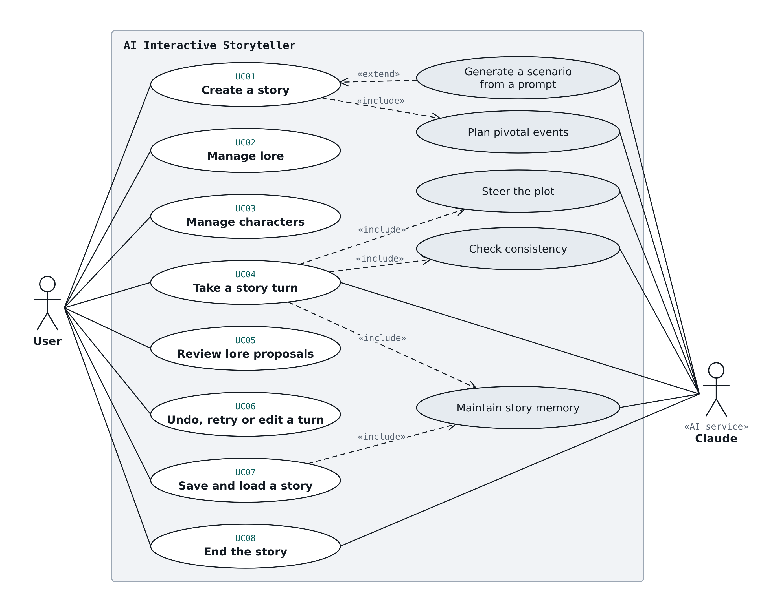
Figure 10. Use-case diagram. Shaded use cases are included in, or extend, the numbered ones.

5.1 Actors
Actor | Kind | Description
User | Primary actor | A solo role-player who creates stories, plays turns, and manages the lore and characters.
Claude | AI service | Claude Sonnet 5.5, reached through the adapter. It writes scenarios, pivotal events, narration, summaries, recaps and endings, and requests tool calls.

6. Detailed Use-Case Descriptions
Alternative and exception flows are numbered by the step of the main scenario they branch from. A feature in brackets marks the step where that feature does its work.

6.1 UC01: Create a story
Use Case ID | UC01
Use Case Name | Create a story
Actor(s) | User (primary), Claude (AI service)
Goal | Start a new story from a scenario the user wrote or had generated.
Preconditions | The application is open.
Trigger | The user clicks the plus button in the story list.
Main Success Scenario | 1. The user opens the new-story form.  2. The user fills in the scenario fields (title, premise, tone, setting, opening situation) and, optionally, a plot basis.  3. The user presses Start.  4. The application validates the fields.  5. The application creates the scenario and a new story.  6. The agent plans the hidden pivotal events from the scenario and the plot basis (F05).  7. The story screen opens, ready for the first turn.
Alternative / Exception Flows | 2a. The user generates the scenario from a prompt: the user enters a short prompt and presses Generate, and the agent returns a draft that fills the form. The user edits it or generates again, and the flow continues at step 3.  2b. Claude declines the prompt, or the call fails: a message is shown, and the user can rephrase or fill in the form by hand.  4a. A mandatory field (premise or setting) is empty: a message names the field, and the flow returns to step 2.  4b. The title is empty: the application makes one.  6a. Planning the pivotal events fails: a message is shown and the story is not started. The user can try again or change the scenario.
Postconditions | A new story exists with its scenario and a hidden list of pending pivotal events.  That story is the open story.
Related Feature(s) | F01: Scenario Setup  F05: Pivotal Events

6.2 UC02: Manage lore
Use Case ID | UC02
Use Case Name | Manage lore
Actor(s) | User (primary)
Goal | Keep the story’s lore up to date so the agent can draw on it, and mark the facts that must not be contradicted.
Preconditions | A story is open.
Trigger | The user opens the Lore panel.
Main Success Scenario | 1. The Lore panel lists the story’s lore entries.  2. The user presses the add button, or clicks an existing entry.  3. The form opens, empty for a new entry or filled in for an existing one.  4. The user enters or changes the title, content and tags, and sets whether the entry is pinned.  5. The user saves.  6. The application validates the entry and stores it in the lore book.  7. The list refreshes to show the entry.
Alternative / Exception Flows | 2a. The user searches instead: the user types a query in the search box and the list shows the matching entries. If nothing matches, an empty list is shown with a message.  6a. The title or content is empty: a message names the field, and the flow returns to step 4.
Postconditions | The lore book contains the new or changed entry.  A pinned entry is treated as a canon fact from the next turn on.
Related Feature(s) | F02: Lore Entry Management

6.3 UC03: Manage characters
Use Case ID | UC03
Use Case Name | Manage characters
Actor(s) | User (primary)
Goal | Record who is in the story and how they relate to one another.
Preconditions | A story is open.
Trigger | The user opens the Characters panel.
Main Success Scenario | 1. The Characters panel lists the story’s characters by name.  2. The user presses the add button, or clicks an existing character.  3. The form opens, empty for a new character or filled in for an existing one.  4. The user enters or changes the name, description and traits.  5. The user adds a relationship by choosing another character and entering a type and optional notes.  6. The user saves.  7. The application validates the character and stores it with the story.  8. The list refreshes to show the character.
Alternative / Exception Flows | 5a. The user adds no relationship: the flow continues at step 6.  7a. The name is empty, or already used by another character: a message is shown, and the flow returns to step 4.  7b. A relationship has no target, or points at the character itself: a message is shown, and the flow returns to step 5.
Postconditions | The story contains the new or changed character with its relationships.  Each relationship is recorded in one direction only.
Related Feature(s) | F03: Character Management

6.4 UC04: Take a story turn
Use Case ID | UC04
Use Case Name | Take a story turn
Actor(s) | User (primary), Claude (AI service)
Goal | Move the story forward by one turn in response to the user’s input.
Preconditions | A story is open.
Trigger | The user submits input from the story screen.
Main Success Scenario | 1. The user types input and chooses a mode (Do, Say or Story).  2. The user presses Send.  3. The application frames the input according to the mode.  4. The agent looks up the relevant lore entries and characters through tool calls, which the application validates and runs.  5. The agent draws on the story summary and the recent turns (F09).  6. The agent compares the input with the next pending pivotal event and decides to continue towards it, nudge the story back, or revise the pending events (F06).  7. The agent writes the narration.  8. The agent checks the narration against the lore and the pinned canon facts (F08).  9. The application saves the turn, with the lore entries it used.  10. The story screen shows the narration, the lore entries used, and any warnings.
Alternative / Exception Flows | 2a. The input is empty: a message is shown and nothing is sent.  4a. Nothing relevant is found: the agent continues without lore.  4b. A tool request is invalid: the application rejects it and reports the error to the agent, and the turn continues.  7a. Claude declines, or the call fails: a message is shown, no turn is added, and the input stays in the text box.  7b. The agent notices a new fact worth keeping: it proposes a lore entry, which joins the proposals list as pending (see UC05).  8a. A contradiction is found: it is recorded on the turn and shown as a warning. The narration is not blocked.  8b. The check itself fails: the narration is shown with a note that it was not checked.  9a. The story has grown past the recent-turn limit: the agent summarizes the older turns and the summary is saved (F09).  10a. All pivotal events have been reached: the agent suggests ending the story (see UC08).
Postconditions | The story has one more turn.  The pivotal events reflect any change made during the turn.  Any proposals or warnings raised are visible to the user.
Related Feature(s) | F04: Story Turn  F06: Plot Steering  F08: Consistency Check  F09: Story Memory Summarization

6.5 UC05: Review lore proposals
Use Case ID | UC05
Use Case Name | Review lore proposals
Actor(s) | User (primary)
Goal | Decide which of the agent’s suggested lore entries become part of the story’s lore.
Preconditions | A story is open.  At least one proposal is pending.
Trigger | The user opens the proposals list in the Lore panel.
Main Success Scenario | 1. The proposals list shows each pending proposal with its title and content.  2. The user reads a proposal and presses Approve.  3. The application adds it to the lore book as a new entry and marks the proposal as approved.  4. The Lore panel refreshes, and the count of waiting proposals goes down.
Alternative / Exception Flows | 2a. The user presses Reject: the proposal is marked as rejected and nothing is added.  2b. The user leaves the proposal unanswered: it stays pending and the story continues.  3a. The user wants different wording: after approving, the user edits the entry (see UC02).
Postconditions | Each proposal the user answered is approved or rejected.  Approved proposals are lore entries, available to the agent from the next turn.
Related Feature(s) | F07: Lore Proposals

6.6 UC06: Undo, retry or edit a turn
Use Case ID | UC06
Use Case Name | Undo, retry or edit a turn
Actor(s) | User (primary)
Goal | Correct the most recent turn.
Preconditions | A story is open.  The story has at least one turn.
Trigger | The user presses Undo, Retry or Edit under the most recent turn.
Main Success Scenario | 1. The user presses Undo.  2. The application removes the most recent turn.  3. The application restores the pivotal events to how they were before that turn.  4. The story screen refreshes.
Alternative / Exception Flows | 1a. The user presses Retry: the application undoes the turn (steps 2 and 3), then sends the same input again as a new turn. The flow continues as UC04 from step 3.  1b. The user presses Edit: the narration becomes an editable text box. The user changes the text and presses Save, the application replaces the narration, and the story screen refreshes.  1c. The retried turn fails: the turn stays undone, a message is shown, and the input is put back in the text box.  1d. The edited text is empty: a message is shown and the narration is unchanged. If the user cancels the edit, nothing changes.  2a. The last action was an edit: undo restores the original narration and does not remove the turn.
Postconditions | The most recent turn is removed, replaced by a newly generated one, or carries the user’s text.  Proposals raised during an undone turn remain in the proposals list.
Related Feature(s) | F10: Undo / Retry / Edit Turn

6.7 UC07: Save and load a story
Use Case ID | UC07
Use Case Name | Save and load a story
Actor(s) | User (primary), Claude (AI service)
Goal | Keep a story between sessions and pick it up again later.
Preconditions | To save: a story is open.  To load: at least one saved story exists.
Trigger | The user presses Save on the story screen, or clicks a story in the story list.
Main Success Scenario | 1. The user presses Save.  2. The application writes the whole story (scenario, lore, characters, pivotal events, turns, proposals and summary) to a file.  3. A confirmation is shown.
Alternative / Exception Flows | 1a. The user loads a story: the user clicks a saved story in the story list. The application reads its file and restores the story, the agent writes a recap from the summary and the recent turns (F09), and the story screen shows the recap and the story, ready to continue from the last turn.  1b. Another story is open with unsaved changes when loading: the user is asked to save it first.  1c. The file to load is missing or damaged: a message is shown and the user is returned to the story list.  1d. The recap fails: the story still loads, without a recap.  2a. The file cannot be written: a message is shown and the story stays open.
Postconditions | After saving: a file holds the story as it was at that moment.  After loading: that story is the open story.  Undo history is not kept across a save and load.
Related Feature(s) | F11: Save and Load Session  F09: Story Memory Summarization

6.8 UC08: End the story
Use Case ID | UC08
Use Case Name | End the story
Actor(s) | User (primary), Claude (AI service)
Goal | Bring the story to a close with an ending that fits what has happened.
Preconditions | A story is open.
Trigger | The user presses End Story, or accepts the agent’s suggestion to end.
Main Success Scenario | 1. The user presses End Story.  2. The agent writes an ending from the pivotal events, the lore and the story so far.  3. The story screen shows the ending at the end of the story.
Alternative / Exception Flows | 1a. The agent suggests ending, because all pivotal events have been reached: the user accepts and the flow continues at step 2, or dismisses the suggestion and the story continues.  1b. Pivotal events are still pending: the user is asked to confirm, and on confirmation the agent writes an ending from the current point.  2a. Claude declines, or the call fails: a message is shown, the story is unchanged, and the user can try again.
Postconditions | The story has a closing passage.
Related Feature(s) | F12: Ending Generation

7. Sequence Diagrams
Each diagram should show the initiating actor, GUI/boundary objects, controllers, domain objects, AI/agent components, external tools or services, important method calls, returned results and alternative/error flows. Closely related features can share a diagram, but every important behaviour must be covered. Use the class and method names from Section 3.

7.1 SD01
Title: [TODO: diagram title]
Features covered: [TODO: F## list]
Related use case(s): [TODO: UC## list]
[TODO: insert sequence diagram SD01 here]
Figure 11. SD01

7.2 SD02
Title: [TODO: diagram title]
Features covered: [TODO: F## list]
Related use case(s): [TODO: UC## list]
[TODO: insert sequence diagram SD02 here]
Figure 12. SD02

7.3 SD03
Title: [TODO: diagram title]
Features covered: [TODO: F## list]
Related use case(s): [TODO: UC## list]
[TODO: insert sequence diagram SD03 here]
Figure 13. SD03

8. Feature-to-Design Traceability Table
One row per feature. Every entry must match the class diagram, use cases and sequence diagrams exactly.
Feature | Description | Type | Related Use Case | Classes | Key Methods | Sequence Diagram | Design Pattern(s)
F01 | Scenario Setup | Hybrid | UC01 Create a story | [TODO: classes] | [TODO: methods] | [TODO: SD##] | [TODO: patterns]
F02 | Lore Entry Management | Deterministic | UC02 Manage lore | [TODO: classes] | [TODO: methods] | [TODO: SD##] | [TODO: patterns]
F03 | Character Management | Deterministic | UC03 Manage characters | [TODO: classes] | [TODO: methods] | [TODO: SD##] | [TODO: patterns]
F04 | Story Turn | Hybrid | UC04 Take a story turn | [TODO: classes] | [TODO: methods] | [TODO: SD##] | [TODO: patterns]
F05 | Pivotal Events | Hybrid | UC01 Create a story | [TODO: classes] | [TODO: methods] | [TODO: SD##] | [TODO: patterns]
F06 | Plot Steering | AI | UC04 Take a story turn | [TODO: classes] | [TODO: methods] | [TODO: SD##] | [TODO: patterns]
F07 | Lore Proposals | Hybrid | UC05 Review lore proposals | [TODO: classes] | [TODO: methods] | [TODO: SD##] | [TODO: patterns]
F08 | Consistency Check | Hybrid | UC04 Take a story turn | [TODO: classes] | [TODO: methods] | [TODO: SD##] | [TODO: patterns]
F09 | Story Memory Summarization | AI | UC04 Take a story turn  UC07 Save and load a story | [TODO: classes] | [TODO: methods] | [TODO: SD##] | [TODO: patterns]
F10 | Undo / Retry / Edit Turn | Deterministic | UC06 Undo, retry or edit a turn | [TODO: classes] | [TODO: methods] | [TODO: SD##] | [TODO: patterns]
F11 | Save and Load Session | Deterministic | UC07 Save and load a story | [TODO: classes] | [TODO: methods] | [TODO: SD##] | [TODO: patterns]
F12 | Ending Generation | AI | UC08 End the story | [TODO: classes] | [TODO: methods] | [TODO: SD##] | [TODO: patterns]

9. Feature Implementation Explanations
For each feature: the classes involved and their roles, the important methods, and a short walk-through of how they collaborate at runtime.

F01: Scenario Setup
Related Use Case: [TODO: UC## and name]
Related Sequence Diagram: [TODO: SD## and name]
Classes involved
- [TODO: ClassName: its role in this feature]
- [TODO: ClassName: its role in this feature]
Important methods
- [TODO: ClassName.method()]
- [TODO: ClassName.method()]
Execution
[TODO: Short paragraph walking through what happens from the user action to the returned result.]

F02: Lore Entry Management
Related Use Case: [TODO: UC## and name]
Related Sequence Diagram: [TODO: SD## and name]
Classes involved
- [TODO: ClassName: its role in this feature]
- [TODO: ClassName: its role in this feature]
Important methods
- [TODO: ClassName.method()]
- [TODO: ClassName.method()]
Execution
[TODO: Short paragraph walking through what happens from the user action to the returned result.]

F03: Character Management
Related Use Case: [TODO: UC## and name]
Related Sequence Diagram: [TODO: SD## and name]
Classes involved
- [TODO: ClassName: its role in this feature]
- [TODO: ClassName: its role in this feature]
Important methods
- [TODO: ClassName.method()]
- [TODO: ClassName.method()]
Execution
[TODO: Short paragraph walking through what happens from the user action to the returned result.]

F04: Story Turn
Related Use Case: [TODO: UC## and name]
Related Sequence Diagram: [TODO: SD## and name]
Classes involved
- [TODO: ClassName: its role in this feature]
- [TODO: ClassName: its role in this feature]
Important methods
- [TODO: ClassName.method()]
- [TODO: ClassName.method()]
Execution
[TODO: Short paragraph walking through what happens from the user action to the returned result.]

F05: Pivotal Events
Related Use Case: [TODO: UC## and name]
Related Sequence Diagram: [TODO: SD## and name]
Classes involved
- [TODO: ClassName: its role in this feature]
- [TODO: ClassName: its role in this feature]
Important methods
- [TODO: ClassName.method()]
- [TODO: ClassName.method()]
Execution
[TODO: Short paragraph walking through what happens from the user action to the returned result.]

F06: Plot Steering
Related Use Case: [TODO: UC## and name]
Related Sequence Diagram: [TODO: SD## and name]
Classes involved
- [TODO: ClassName: its role in this feature]
- [TODO: ClassName: its role in this feature]
Important methods
- [TODO: ClassName.method()]
- [TODO: ClassName.method()]
Execution
[TODO: Short paragraph walking through what happens from the user action to the returned result.]

F07: Lore Proposals
Related Use Case: [TODO: UC## and name]
Related Sequence Diagram: [TODO: SD## and name]
Classes involved
- [TODO: ClassName: its role in this feature]
- [TODO: ClassName: its role in this feature]
Important methods
- [TODO: ClassName.method()]
- [TODO: ClassName.method()]
Execution
[TODO: Short paragraph walking through what happens from the user action to the returned result.]

F08: Consistency Check
Related Use Case: [TODO: UC## and name]
Related Sequence Diagram: [TODO: SD## and name]
Classes involved
- [TODO: ClassName: its role in this feature]
- [TODO: ClassName: its role in this feature]
Important methods
- [TODO: ClassName.method()]
- [TODO: ClassName.method()]
Execution
[TODO: Short paragraph walking through what happens from the user action to the returned result.]

F09: Story Memory Summarization
Related Use Case: [TODO: UC## and name]
Related Sequence Diagram: [TODO: SD## and name]
Classes involved
- [TODO: ClassName: its role in this feature]
- [TODO: ClassName: its role in this feature]
Important methods
- [TODO: ClassName.method()]
- [TODO: ClassName.method()]
Execution
[TODO: Short paragraph walking through what happens from the user action to the returned result.]

F10: Undo / Retry / Edit Turn
Related Use Case: [TODO: UC## and name]
Related Sequence Diagram: [TODO: SD## and name]
Classes involved
- [TODO: ClassName: its role in this feature]
- [TODO: ClassName: its role in this feature]
Important methods
- [TODO: ClassName.method()]
- [TODO: ClassName.method()]
Execution
[TODO: Short paragraph walking through what happens from the user action to the returned result.]

F11: Save and Load Session
Related Use Case: [TODO: UC## and name]
Related Sequence Diagram: [TODO: SD## and name]
Classes involved
- [TODO: ClassName: its role in this feature]
- [TODO: ClassName: its role in this feature]
Important methods
- [TODO: ClassName.method()]
- [TODO: ClassName.method()]
Execution
[TODO: Short paragraph walking through what happens from the user action to the returned result.]

F12: Ending Generation
Related Use Case: [TODO: UC## and name]
Related Sequence Diagram: [TODO: SD## and name]
Classes involved
- [TODO: ClassName: its role in this feature]
- [TODO: ClassName: its role in this feature]
Important methods
- [TODO: ClassName.method()]
- [TODO: ClassName.method()]
Execution
[TODO: Short paragraph walking through what happens from the user action to the returned result.]

