**JavaScript/HTML/CSS Developer Test**

**Description**

Create a page that looks as close as possible to the design provided in ***./mockups*** folder.

Assets are provided inside the images and font folders.

**Time Duration**

Get as much done as you can in 3.5 hours.

**Required Features**

* Attention to detail is key! (Follow mockups)
* The “links bar”



should be at the bottom of the screen **when you scroll all the way to the top**, like so:

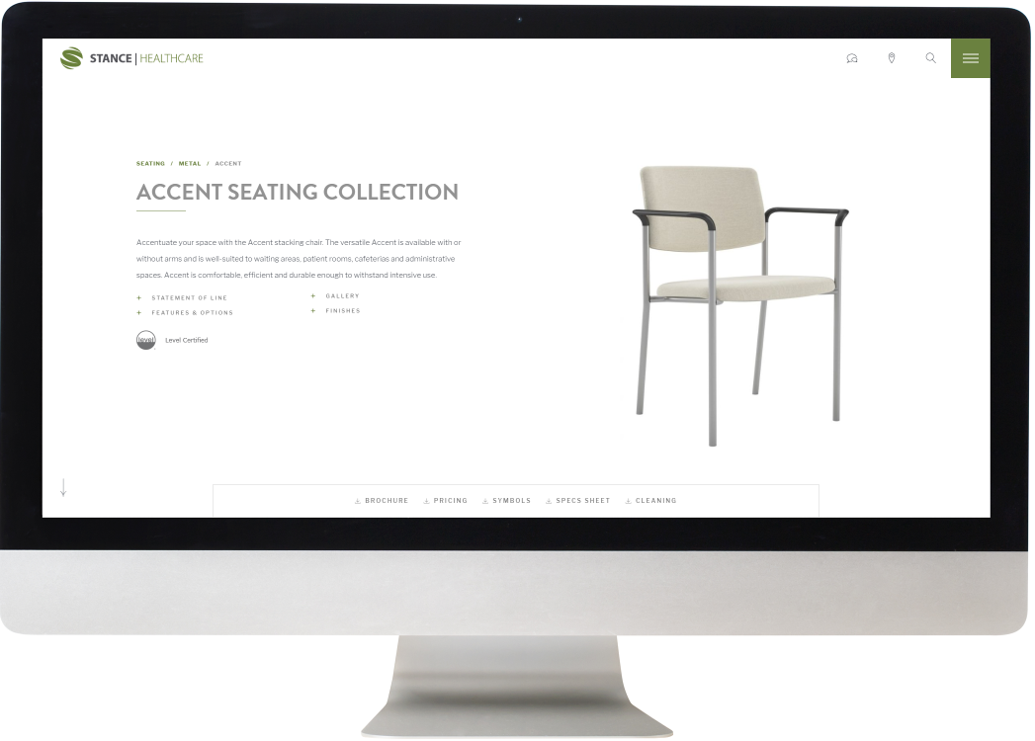

**Required Features continued…**

* The site should be responsive
* All links and icons should turn green on hover
* Gallery images: On hover – add a zoom effect
* All hover effects should have a smooth transition with easing
* Make sure the site looks as identical as possible in Firefox and Chrome

**Bonus**

* Use JavaScript to scroll to the gallery section when clicking on arrow ().

**Important: Don’t** add click functionality (menu button, breadcrumbs, links) **except** for the Arrow (which is a bonus).

**Icons**

All the icons use font-family ‘Linearicons’ which is already included in your index.html.

Use the following classes for icons

* lnr lnr-bubbles
* lnr lnr-map-marker
* lnr lnr-magnifier
* lnr lnr-download2
* lnr lnr-expand2

Example: <div class=”lnr lnr-magnifier”></div>

**Theme Colors**

Grey: #434851

Green : #6A813F

Light Grey: #929292

**Fonts**

Regular Text: libre-franklin

Headers/Titles: brandon-grotesque

**After completion**

* Zip all the files, upload to either Google Drive or WeTransfer and e-mail us the URL