**USER ACCEPTANCE TESTING – KOJ TICKET PLAN AUTOMATION**

**Single OMC with Full Entitlement**

Scene: Only one OMC is eligible and has full entitlement for the product.

Loaded Values:

MSP : 2,500 m3

Requested: MSP : 1,300 m3

Excess: 1,800 m3

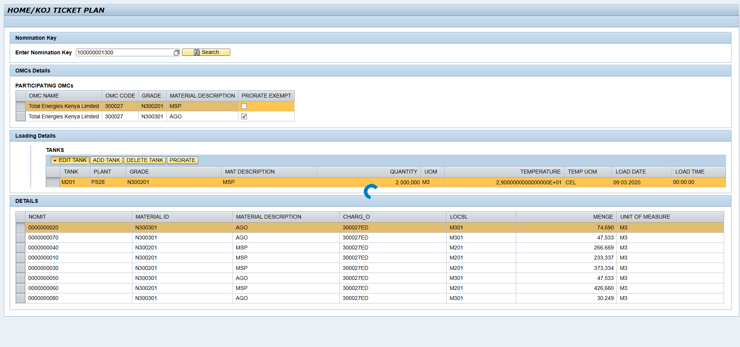

Ticket:

MSP : 2,500 m3

Omc receives total loaded excess with

|  |  |
| --- | --- |
| Test | Expected |
| **Single OMC with Full Entitlement** | ✅ |

**One OMC with Full Entitlement, Another with Partial Entitlement**

Scene: One OMC has full entitlement, while another has partial entitlement.

**Excess Quantity Less Than Total Entitlement**

Scene: The total excess quantity is less than the sum of all entitlements.

**Loaded Values:**

*OLA Energy*

MSP : 800 L

Requested: MSP 600.192 L

*Total Energies Kenya*

MSP : 57,000 L

Requested: MSP 56,999.838 L

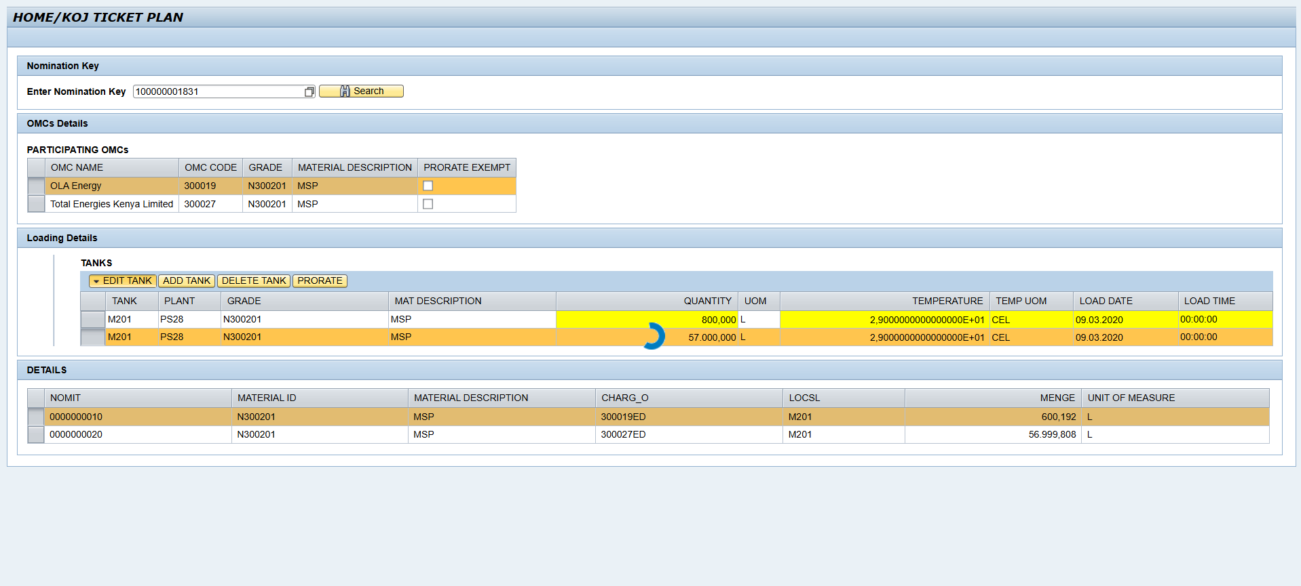

Ticket:

*OLA Energy*

MSP 602.276 L

*Total Energies Kenya*

MSP : 57,197.72 L

Requested: MSP 56,999.838 L

The two omc share the excess based on their requested quantities.



|  |  |
| --- | --- |
| Test | Expected |
| Excess less than total Entitlement | ✅ |

**Excess Quantity Greater Than Total Entitlement**

Scene: The total excess quantity is greater than the sum of all entitlements.

Loaded Values:

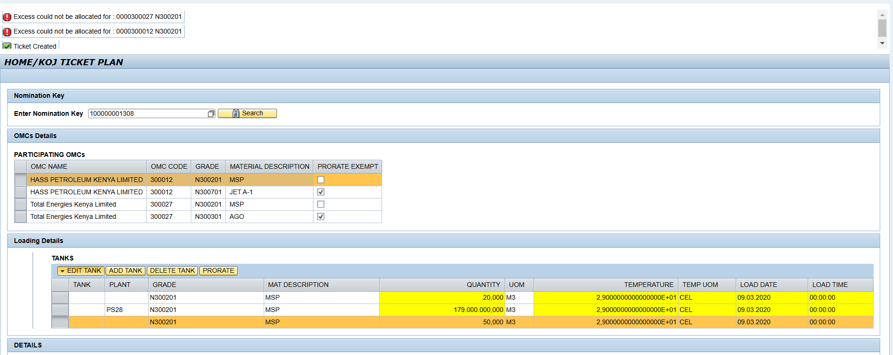

Ticket:

Loaded values are the default requested as omcs have no sufficient entitlement



**No Excess Quantity**

Scene: There is no excess quantity to distribute.

**Loaded Values:**

*OLA Energy*

MSP : 400 m3

Requested: MSP 400m3

*Total Energies Kenya*

MSP : 30,200 m3

Requested: MSP 30,200 m3

Ticket:

*OLA Energy*

MSP : 400 m3

*Total Energies Kenya*

MSP : 30,200 m3

Omcs receive exact quantity requested



|  |  |
| --- | --- |
| Test | Expected |
| **No Excess Quantity** | ✅ |

**Entitlement Based on Multiple Products**

Scene: Entitlement is determined based on multiple products.

**Loaded Values.**

*Total Energies Kenya*

MSP: 500 m3

Requested: MSP 480 m3

AGO : 500 m3

Requested: 344 m3

IK : 200 m3

Requested: 150 m3

Ticket:

Total Energies Kenya

MSP : 500 m3

AGO : 500 m3

IK : 200 m3



|  |  |
| --- | --- |
| Test | Expected |
| **Entitlement Based on Multiple Products** | ✅ |

**SIGN OFF/APPROVAL**

|  |  |  |  |
| --- | --- | --- | --- |
| Full Names | Station | Designation | Date & Signature |
| Robert Ojukwu | PS28 - Kisumu |  |  |
|  |  |  |  |

