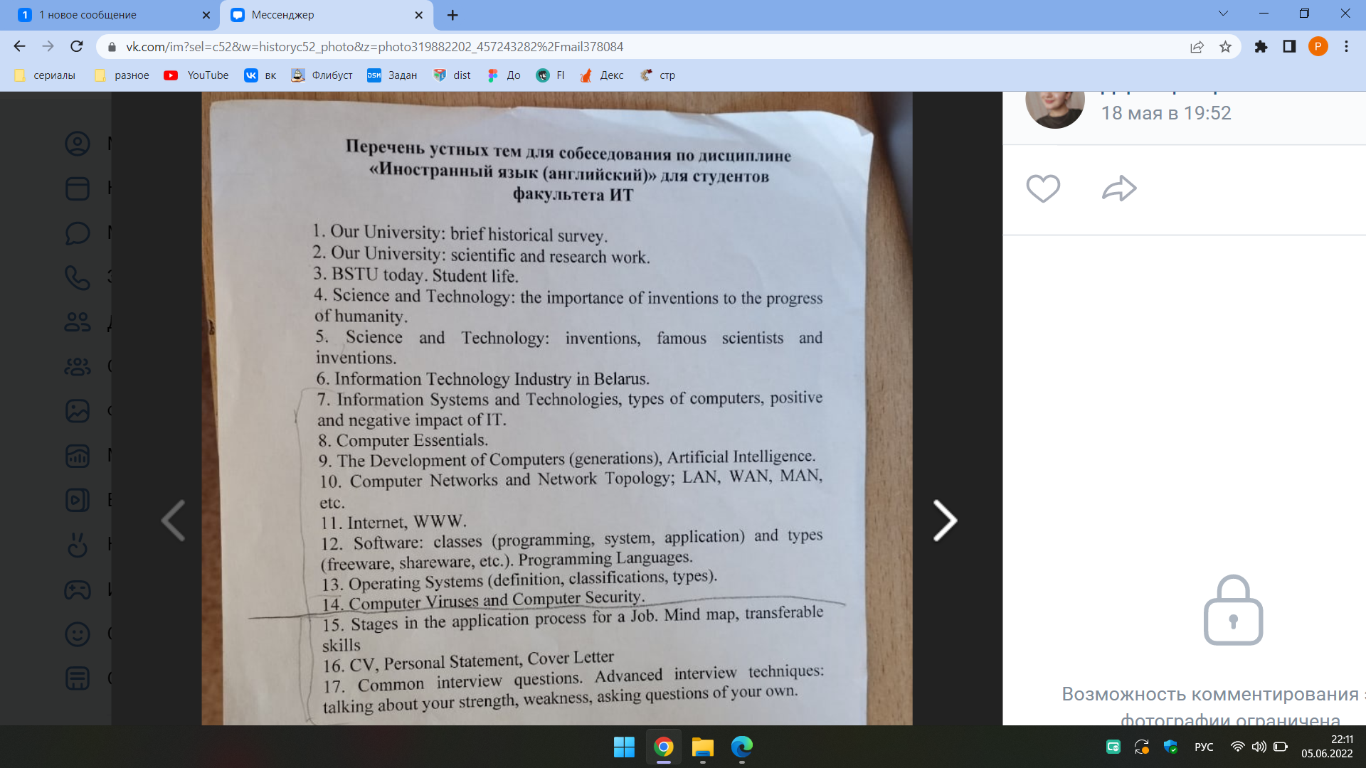

**1.Our University: brief historical survey**

The early history of the University began on the 8th of December, 1859, when the Gory-Goretsky Agricultural Institute welcomed the first students of the Forestry program. Forestry faculties were established in 1919 at the Gory-Goretsky Agricultural Institute and in 1920 in Minsk Polytechnic Institute. They further became a basis for the foundation of the Forestry Institute in Gomel on June 1, 1930.

In 1934 the Forestry Institute was renamed into the Belarusian Forestry Engineering Institute. In 1941 at the beginning of the Great Patriotic War the Institute was evacuated to the city of Sverdlovsk and became a part of the Ural Forestry Engineering Institute. After liberation of Gomel from German fascist invaders the Institute was re-evacuated to Gomel. In August 1946 the Institute was transferred to Minsk. Its reformation in 1961 into the Belarusian Technological Institute was inspired by an intensive development of the Republic’s chemical industry.

Real flourishing of the Technological Institute started at the end of the 80s and was brought about by intensive development of science. In 1993 it was renamed into Belarusian State Technological University. The scope of the University competence has enlarged dramatically. The University began training specialists for the careers in landscape architecture, glass and glass ceramics production, chemical sources of current and functional electroplating, polymer and mould products design, industrial ecology, bio-ecology, certification, automation of 34 technological processes, biotechnology of energy carriers, fine organic synthesis, medicines, information systems and technologies, management, marketing, tourism and nature management, etc.

The Belarusian State Technological University was granted the status of a leading higher educational institution in the fields of forestry and forest industry. In 2011 the BSTU was accredited as research organization and became a member of Belarusian-Kazakhstan educational-scientific consortium. In 2012 the University was reorganized into an educational, research and production centre in line with lifelong learning principles.

**2.Our University: scientific and research work.**

The BSTU is a major scientific and research centre actively developing fundamental and applied research trends. The University focuses on high quality, exploitable research that has the potential to have an impact on the real world around us. Our research sets out to provide solutions to the vital concerns faced by humankind. Research is of central importance in everything we do, as it supports our teaching process and allows the staff to translate findings into impact, which makes a difference to business, industry and society as a whole.

The University scholars are active participants of scientific and technical programs of various scope. For instance, over the last years they have contributed to different national and regional research and technical projects. The Belarusian State Technological University has been the leading partner of national research and technical program “Forests of Belarus – Productivity, Sustainability, Efficiency”. Currently the University is a partner of the state research and technical program “Monitoring”, international Belarusian-Lithuanian program, Belarusian-Kazakhstan research and educational consortium, etc.

The University researchers collaborate with over 400 international and national partners within commercial research contracts. The scope of research trends developed by the University is highly diverse, i.e. organic and petrochemical synthesis, technology of building materials, glass and ceramics, synthesis, properties and application of nanomaterials , resource-saving electrochemical production, electronic engineering materials, chemical technology of inorganic substances, woodworking machines and tools, woodworking, furniture manufacturing, machines and mechanisms for forest complex, chemical wood processing, biotechnology, medicinal drugs, industrial ecology, resource- and energy-saving processes and technology, printing and publishing technology and equipment, information systems and technology, information security software for mobile systems, design of electronic and web-publications.

Annually the University researchers publish over 2,500 papers and abstracts. Scientific journal “Proceedings of BSTU” has been included into the list of scientific periodicals of the Republic of Belarus authorized to publish the results of thesis research and into Russian Science Quotation Index. The journal is published annually and welcomes contributions in Russian, Belarusian and English by international scholar community. Only for the past 5 years the University has been received more than 240 patents for inventions and useful models.

Over 88 international and republican conferences have been hosted by the BSTU.

**3. BSTU today(импровизация из первых 2-х). Student life**

Student life is the most exciting and challenging time for students to explore new horizons and set a course for the future. The Belarusian State Technological University gives the chance to make new friends and enjoy new hobbies or sports, to explore opportunities and gain experiences that can change your life.

The student campus houses five dormitories where students can rest and study. The dormitories are conveniently located within a walking distance from the University’s academic buildings and provide excellent opportunities to feel part of the community the students are joining. All rooms are equipped with modern furniture and facilities. Student Councils are responsible for social and cultural and educational activities of students.

The BSTU students are engaged in multiple interests. The student organizations in campus enrich the social, cultural and educational experiences of students. Students interested in the arts participate in a variety of visual and performing art groups, dance groups, choirs, student theatre. Various festivals such as “Student Spring”, “Student Autumn”, “Mother’s Day”, contests, meetings, discotheques, sport events in six kinds of sports are arranged at the dormitories. Students go in for football, volleyball, basketball and other sports. There are international club “Unity” and a room for social activities at the campus; students can develop their creative individual abilities in such groups as “Magical Needles”, “Needlewoman”, “Do It Yourself”, “Golden Boat”, “Hostess”, the club of decorative arts, etc.

It’s hard to imagine student life without sport. One of the conditions for harmonious development of personality is physical training, promoting a healthy lifestyle, which the University pays great attention to. The University possesses a modern sports complex with a gym for team sports, wrestling, eurhythmics and aerobics, medical gymnastics, as well as a stadium with running tracks, football grounds, 2 tenniscourts, basketball and 4 volleyball-courts with synthetic covering. Among the BSTU students there are winners of the international competitions and world championships. The University teams in chess, arm-wrestling, weight lifting have repeatedly become prize winners of national student competitions. Interfaculty competitions in various kinds of sport are held at the University annually. University sport club comprises such sport groups as: swimming, athletics, tourism, football, unarmed combat, Greco-Roman wrestling, sambo, karate, judo, volleyball, table tennis, basketball, arm-wrestling, and weight lifting. The Student Union organizes numerous events for students every year; they invite students to experience new places and countries, to join students’ volunteering network and to engage in various activities. Youth student leisure centre unites creative students and helps to reveal their abilities in the club of intellectual games, in artistic groups, social events, discotheques. The youth information group and a number of volunteer teams are working successfully at the University.   
 In conclusion I would like to say that u shouldn’t spent you free time in vain.

**4.Science and technology: the importance of inventions to the progress of humanity.**

Modern civilization is everything that has been achieved thanks to science. We can’t but agree that science is very important and that it develops our world. But what is science? Science is systemized knowledge derived through experimentation, observation, and study. In its widest sense it is formulated knowledge, knowledge of structure, laws, and operations.

In recent years, **scientific and technological developments have drastically changed life** on our planet as well as our **views** both of ourselves as individuals in society and of **the Universe** as a whole.

Today, science and technology **are closely related**. Many modern technologies such as **nuclear power** and **space flights** depend on science and the **application of scientific knowledge and principles**. Each **advance in pure science creates new opportunities for** the development of new ways of making things to be used in daily life. In turn, technology provides science with new and more accurate **instruments for its investigation and research**.

Technology refers to the ways in which people use discoveries to **satisfy needs and desires**, to **alter the environment**, to **improve their lives**. **Throughout human history**, men and women **have invented tools, machines, materials and techniques**, to **make their lives easier**.

Of course, when we speak of technology today, we **are looking at it in a much narrower sense**. Generally, we mean **industrial technology**, or the technology that began about 200 years ago with the **development of power-driven machines, growth of the factory system**, and **mass production of goods** that **has created the basis for** our modern society. Today we often say that we live in **an age of science and technology**. **According to one estimate**, 90% of all the scientists who ever lived, were alive and active in the 1970-s. This **increased scientific activity** has brought new ideas, processes, and **inventions** in ever-growing amount.

**The scientific revolution** that began in the 16th century was the first time that science and technology began to work together. Thus, Galileo, who **made revolutionary discoveries in astronomy** and **physics**, also built an improved telescope and **patented** a system of lifting water. However, it was not until the 19th century that technology truly **was based on science** and **inventors** began **to build on the work of scientists**. For example, Thomas Edison built on the **early experiments** of Faraday and Henry in his invention of the first practical system of **electrical lighting**. So too, Edison **carried on** his **investigations** until he found the carbon filament for the **electric bulb** in a **research laboratory**. This was the first true **modern technological research**.

In a sense, the history of science and technology is the history of all humankind.

**5.Science and technology: inventions, famous scientists and inventions.**

Modern civilization is everything that has been achieved thanks to science. We can’t but agree that science is very important and that it develops our world. But what is science? Science is systemized knowledge derived through experimentation, observation, and study. In its widest sense it is formulated knowledge, knowledge of structure, laws, and operations.

The seventeenth century saw the development of scientific thinking on entirely new scale. Scientific ideas were tested by experiments. Isaac Newton developed the theory of Gravity in 1687. The discovery of blood circulation and its mechanism by William Harvey, Robert Boyle and Robert Hooke in 1628 led to great advances in medicine and in the study of the human body.

The nineteenth and twentieth centuries are notable for the discoveries and inventions which were a real breakthrough in the world science. Among them are the discovery of the law of chemical elements by Dmitry Mendeleev in 1869; of the invention of the telephone by Alexander Bell in 1876; the invention of the electric light bulb by Thomas Edison in 1879; the invention of a petrol driven car by Karl Benz in 1885; the discovery of radium made by Marie Curie in 1911; the invention of radio by Alexander Popov; the first practical helicopter built up by Igor Sikorski; the invention of television in 1926; the discovery of penicillin by Alexander Fleming in 1928; the discovery of nuclear fission by Lise Meitner in 1939 and many others.

Scientific explorations, discoveries and inventions were made by outstanding people like Leonardo de Vinci, Galileo, Newton, Lomonosov, Edison, Einstein. In most cases the genius of the scientist played the decisive role in creating the invention or discovery of scientific laws.

**Isaac Newton**

Isaac Newton was one of the world’s greatest scientists. He did research in mathematics, physics, astronomy and many other fields. Newton was born in 1642. He worked on his family’s farm but was not really interested in farming. His father died before Isaac was born. In his childhood he spent much time with his grandmother. Newton didn’t have many friends and never married.

Newton was an astronomer, who studied the Earth, the planets and stars. He became well-known for theories of gravity. He also showed that planets move around the sun in ellipses. His theory of gravity dominated physics for some time.

He also conducted experiments with light and found out that normal light is made up of many colors. He used prisms to break up light into a rainbow of colors. Newton invented a new kind of telescope that used lenses. It made objects look bigger.

Newton was not only theorist but a great inventor, too: he invented a mirror telescope

**Albert Einstein**

Albert Einstein was a famous scientist who completely changed the way that people saw our world and the universe. Einstein created many theories which proved that things like gravity, light, energy and matter were connected with each other. At first, very few scientists could understand Einstein’s theories but as time passed other scientists showed that he was correct.

Albert Einstein was born in Ulm, Germany in 1879 and grew up in Munich. He wasn’t a good student at school and only did things he was interested in, like science and mathematics. At the very early age young Albert started wondering about the mysteries of the universe.

He lived in Berlin for a long time and there he developed many of his scientific theories. In 1921 he received the Nobel Prize for Physics.

One of the most famous equations ever written came from Albert Einstein: E = mc2.