Product Requirements Document
Pulsanti

Issued by | Role/Department | Date
Alessandro Zingaretti | Electronics Team Member | 03/10/2025

REVISION TABLE

Version | Date | Issued by | Description
A-1
A-2
A-3
B-1
B-2
B-3
B-4

TABLE OF CONTENTS
GENERAL PRODUCT DESCRIPTION 3
DESIGN 3
INTERFACE 3
ELECTRICAL HARDWARE AND SENSORS 3
TEST DA FARE 3
BOM 3
REPORT 3

GENERAL PRODUCT DESCRIPTION

Product Description
Key Features/ Functionality | Custom function when pressed
Software | Yes, connected to DASHBOARD’ software
Other components Compatibility,  Ecosystem, etc. | Hardware: Steering Wheel
Working conditions | Installation: inside the steering wheel
Rules
Dimensions and Tolerances | Panel drilling diameter: 13.6x13.6 (mm)  Outsite: 17.5x17.5 (mm)
Weight
Produzione
Connections

DESIGN
Schematico
Renderings | 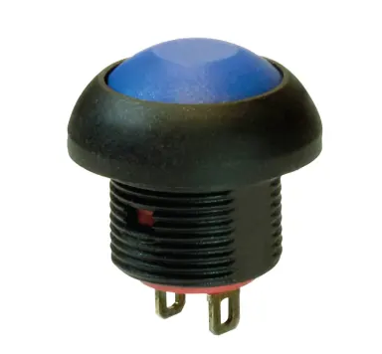

INTERFACE
User Interface | Switch
Communication protocol | GPIO
Communication Input
Communication output | Digital
Connector
Visual Interface  (Screen size and type, LEDs) | Button level down
External Software interface | Yes

ELECTRICAL HARDWARE AND SENSORS

Block Diagram of Electrical Hardware
Supply Voltage | 3.3V
Supply Current | 50mA
Input/Sensor Requirements
Output/Actuator Requirements
OverVoltage/ OverCurrent / Short Circuit Protection on power supply
OverVoltage/ OverCurrent / Short Circuit Protection on output

BOM

Bill of material
BOM
Financials
BOM Cost

