- Click File > Make a copy for each component > Save
- Replace the blue text in your copy with your own answers.
- Mark unknown cells with TBD (to be discussed) and make a plan to answer.
- Create your own sections as needed.
- Update, share, and enjoy designing efficiently!

Product Requirements Document
Display Software

Issued by | Role/Department | Date | Signature
 |  | 04/10/2022

Approved by | Role/Department | Date | Signature
 |  | 04/10/2022

REVISION TABLE

Version | Date | Issued by | Description
A-1 | 04/10/2022
A-2
A-3
B-1
B-2
B-3
B-4

TABLE OF CONTENTS
GENERAL PRODUCT DESCRIPTION 3
RULES 4
ENVIRONMENT 4
INDUSTRIAL DESIGN 5
SOFTWARE ARCHITECTURE AND DATA PROCESSING 5
ELECTRICAL HARDWARE AND SENSORS 5
DURABILITY 7
SERVICEABILITY 7
PRODUCT VALIDATION / QUALIFICATION 7
REPORT 7

GENERAL PRODUCT DESCRIPTION

Product Description
Key Features/ Functionality | Showing car parameters on the steering wheel (car speed, motor speed, critical temperatures, tire temperature, SOC and power consuption)
Signal Source | Serial communication with a microcontroller placed on PCB that acquires messages from the CAN
Software language | Nextion language
User Interface | Display graphical interface and buttons placed on the steering wheel

INPUT AND OUTPUT
Product Description
Input | - HV Battery voltage  - LV Battery Voltage  - HV Power  - HV Battery Current  - HV Battery Temperature  - H20 Temperature  - Tires Temperatures  - Motors RPM  - Vehicle speed  - Acceleration  - Motor Map  - Lap Energy Consumption  - Ambient Temperature & Humidity  - % Throttle  - % Brake  - Errors & Problems  - DRS ON/OFF  - TSAL State  - FAN/PUMP Speed
Output | - NO OUTPUT

SOFTWARE ARCHITECTURE AND DATA PROCESSING

Block Diagram of Data Flow
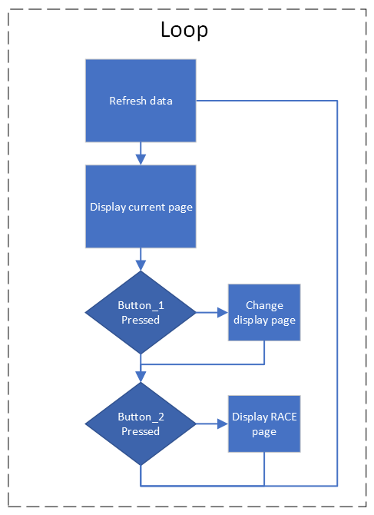

ARCHITECTURE

Software Mission
All the input will be supplied by Dashboard PCB powered by an STM32 microcontroller via serial communication
The mission of the software is displaying on the screen all the parameters that are useful for the driver.
Driver can switch pages pressing buttons placed on the steering wheel.

Parameters Definition
Race Screen | TBD
Other Screens | TBD

ERRORS AND MESSAGES PRIORITY
Other pages

PRODUCT VALIDATION / QUALIFICATION
Data Test
Visualization Test
Ergonomics Test
Utility Test

REPORT
Inserire tutta la storia della progettazione del componente in tutte le sue varie versioni, spiegando bene i parametri utilizzati nei calcoli/simulazioni, i software usati, i risultati ottenuti (inserire in modo chiaro i dati inserendo un foglio excel allegato). In caso di cambiamenti durante la progettazione, spiegarne i motivi.

