**Final Exam**

**NE 0407459-Nuclear Fuel Cycle**

**University of Sharjah – Nuclear Engineering Program**

**Fall 2024-2025**

* You have 60 minutes to complete the questions below.
* Be sure you put your name and UOS ID #.
* Write neatly and clearly.
* Illegible responses will not be graded.
* Divide your time carefully between the questions.
* *Academic dishonesty will result in* ***a zero mark*** *for the midterm exam and potential* ***F*** *in the course.*
* *Justify your assumptions and answers scientifically.*

**Good luck!**

**Name: ID:**

|  |  |  |  |  |  |  |
| --- | --- | --- | --- | --- | --- | --- |
| **Question** | **Q1** | **Q2** | **Q3** | **Q4** | **Q5** | **Total** |
| **Score** | **/30** | **/10** | **/30** | **/15** | **/15** | **/100** |

**Q1)** **[30%]**

1. Which of the following isotopes is a common fission product and a significant contributor to radioactivity of spent nuclear fuel?
2. Uranium-235
3. Plutonium-239
4. Cesium-137
5. Thorium-232

**Answer: C. Cesium-137**

1. In the nuclear fuel cycle, the PUREX process is used for:

a) Enriching uranium

b) Fabricating fuel elements

c) Reprocessing spent nuclear fuel

d) Disposing of high-level waste

**Answer: C. Reprocessing spent nuclear fuel**

1. Which of the following is an advantage of using a closed nuclear fuel cycle over an open nuclear fuel cycle?

a) Less nuclear waste is generated

b) No enrichment of uranium is required

c) No need for spent fuel storage

d) No possibility of nuclear weapons proliferation

**Answer: A. Less nuclear waste is generated**

1. What is the minimum percentage of U-235 enrichment generally considered to be weapons-grade?

a) 20%

b) 50%

c) 75%

d) 90%

**Answer: D. 90%**

1. Which international organization is primarily responsible for monitoring and verifying the peaceful use of nuclear technology and ensuring compliance with nonproliferation agreements?

A. International Atomic Energy Agency (IAEA)

B. United Nations Security Council (UNSC)

C. Comprehensive Nuclear-Test-Ban Treaty Organization (CTBTO)

D. North Atlantic Treaty Organization (NATO)

**Answer: A. International Atomic Energy Agency (IAEA)**

1. Why is plutonium considered a very dangerous material in the realm of non-proliferation and SNF reprocessing?

**Answer:**

1. Weapons-grade material: Plutonium-239, an isotope of plutonium, can be used to make nuclear weapons. It has a relatively low critical mass, which means that only a small amount of it is needed to produce a nuclear explosion. Reprocessing SNF can separate plutonium from the other radioactive materials, creating a proliferation risk if the plutonium is diverted for weapon production.
2. Proliferation risk: In the context of reprocessing, there is a risk that the separated plutonium could be diverted to unauthorized uses, such as the development of nuclear weapons by states or non-state actors. This is a significant concern for the international community and one of the reasons why many countries opt for an open fuel cycle (direct disposal of SNF) instead of reprocessing.

**Q2) [10%]**

1. What are the benefits of the Reprocessing and Recycling ? **[5%]**

**Answer:**

* + - 1. Better utilize the “limited” resource.
      2. Lower long term Back-end fuel management costs.
      3. Lower the perceived proliferation risk posed by reprocessing operations and plutonium separation.
      4. Reduce the number of waste streams.

1. What are the advantages of the Thorium fuel cycle? **[5%]**

**Answer:**

1. Thorium is estimated to be about three to four times more abundant than uranium in Earth's crust.
2. Although the thermal neutron fission cross section (σf) of the resulting 233  
   U is comparable to 235-U and 239-Pu, it has a much lower capture cross section (σγ) than the latter two fissile isotopes, providing fewer non-fissile neutron absorptions and improved neutron economy.
3. Lower proliferation concerns.

**Q3)** A nuclear power plant has a capacity of 1000 MWe and operates at a capacity factor of 80%. The reactor requires 3.2% enriched uranium as fuel. The enrichment process has a tails assay of 0.25%. Calculate the amount of natural uranium (in tons) needed to fuel the reactor for one year assuming that the reactor’s burnup is 1 GWd/MTU? **[30%]**

**Solution:**

First, we need to calculate the energy generated by the reactor in one year.

Energy output = Capacity × Capacity Factor × Hours in a year

Energy output = 1000 MWe × 0.8 × (365 × 24) MWh = 7,008,000 MWh

Next, we need to find out how many tons of enriched uranium is needed for the reactor.

1 GWd/ton = 24,000 MWh/ton

Energy output in GWd = 7,008,000 MWh ÷ 24,000 MWh/ton = 292 GWd

Tons of enriched uranium required = 292 GWd ÷ 1 GWd/ton = 292 tons

This requires **1868** MTU of natural uranium or **2763** MT of UF6

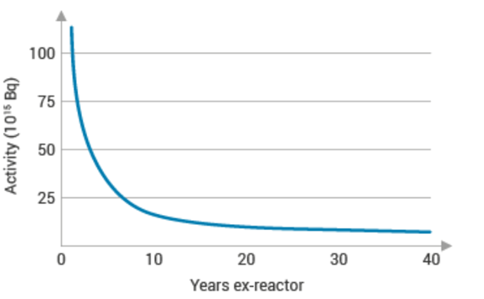**Q4)** The figure below crudely shows the decay of SNF activity overtime. Estimate the overall effective half-life of this spent nuclear fuel pile assuming that the best fit for this curve is an exponential function? **[15%]**

**Solution:**

T1/2 = ln(2) / λ

T1/2 = ln(2) / 0.2311 year^(-1) ≈ 3 years

So, the effective half-life of the material is approximately 3 years.Top of Form

Figure 1. Activity Decrease over time (in units of 10^15 Bq)

**Q5)** Question: A 1000 MWe maximum rating nuclear power plant has been operating for a period of 120 days with the following power history:

| Day | Power Output (MWe) |

|------------|--------------------|

| Day 1-10 | 600 |

| Day 11-30 | 900 |

| Day 31-70 | 750 |

| Day 71-100 | 800 |

| Day 101-120| 950 |

Calculate the effective full power days (EFPD) burnup of the nuclear power plant for this period. **[15%]**

**Solution:**

To calculate the effective full power days (EFPD) burnup, we need to find the equivalent number of days the reactor would have operated at full power (1000 MWe, in this case). We do this by calculating the ratio of actual power output to the full power for each period and then summing up the results.

For Day 1-10:

EFPD1 = (600 MWe / 1000 MWe) * 10 days = 6 EFPD

For Day 11-30:

EFPD2 = (900 MWe / 1000 MWe) * 20 days = 18 EFPD

For Day 31-70:

EFPD3 = (750 MWe / 1000 MWe) * 40 days = 30 EFPD

For Day 71-100:

EFPD4 = (800 MWe / 1000 MWe) * 30 days = 24 EFPD

For Day 101-120:

EFPD5 = (950 MWe / 1000 MWe) * 20 days = 19 EFPD

Now, sum up the EFPD values for all periods:

Total EFPD = EFPD1 + EFPD2 + EFPD3 + EFPD4 + EFPD5

Total EFPD = 6 + 18 + 30 + 24 + 19 = 97 EFPD

Thus, the effective full power days burnup for the nuclear power plant over the 120-day period is **97 EFPD**.