**College of Engineering**

**Department of Mechanical and Nuclear Engineering**

**Nuclear Engineering Materials**

**0407305**

**Final Exam**

**Fall Semester 2024-2025**

**Date: December 16, 2024**

**Time: 13:30 – 15:30**

**Location: W10-105**

**Instructor: Dr. Thanh Mai Vu**

|  |  |
| --- | --- |
| **Student ID** | **Student Name** |
|  |  |

**Grading**

|  |  |  |  |  |  |  |  |
| --- | --- | --- | --- | --- | --- | --- | --- |
| **Q1** | **Q2** | **Q3** | **Q4** | **Q5** | **Q6** | **Q7** | **Total** |
| **6** | **8** | **7** | **6** | **6** | **6** | **6** | **45** |
|  |  |  |  |  |  |  |  |

**Question One (6 points)**

1. (2 points) Which of the following undergoes radiation growth (check all those apply).

|  |  |  |  |  |  |  |
| --- | --- | --- | --- | --- | --- | --- |
| Metallic fuel | -U | -U | -Pu | -Pu | -Th | -Th |
| Check √ all those apply | **√** | **√** | **√** | **√** |  |  |

1. (2 points) Advantages of metallic fuels (check all those apply)

Complete table 1 below, for the comparison between metallic and ceramic fuels.

Table 1 (comparison between metallic and ceramic fuels)

|  |  |  |
| --- | --- | --- |
| Parameters | **Metallic fuels** | **Ceramic fuels** |
| Neutron economy | higher | lower |
| Thermal conductivity | higher | lower |
| strength | Low at high temperatures | Very high |
| Thermal expansion | high | low |
| Corrosion resistance | low | high |
| Radiation stability | Poor (irradiation swelling, creep deformation | Good (due to the absence of polymorphic phase transformation) |
| Melting point | lower | higher |

1. (2 points) What are basic requirements of nuclear fuel?

* Fuel costs must be minimal

🡺 to maintain profitability in the power production

* Adequate thermal conductivity

🡺 To ensure that it can withstand the generated thermal gradients

🡺 Transfer heat quickly out of the fuel center

* Resist repeated thermal cycling due to the reactor shutdowns and start-ups
* Adequate corrosion resistance against the reactor fluids
* Free from constituent elements or impurities with high neutron capture cross section

🡺 To maintain adequate neutron economy

* Able to sustain mechanical stresses
* Amenable for reprocessing or disposal

**Question Two (8 points)**

1. (2 points)True or False Questions:

( F ) Creep occurs in structures subjected to dynamic mechanical stresses while maintaining the temperature constant.

( T ) Fatigue failure occurs at a stress level considerably lower than the tensile or yield strength for a static load.

( F ) The volume of materials undergo void swelling remains constant.

( T ) The smaller the grain size the less a material’s resistance to creep.

2. (6 points) An 8.0 mm diameter cylindrical rod fabricated from a red brass alloy (see figure) is subjected to reversed tension–compression load cycling along its axis. If the maximum tensile and compressive loads are +7500 N and −7500 N, respectively, determine

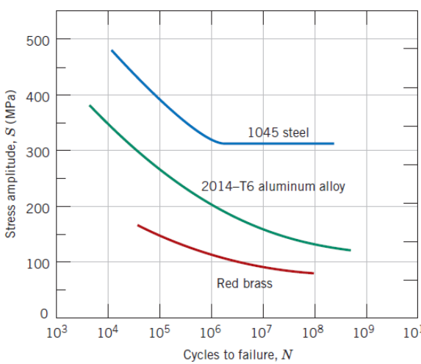

a. (3 points) Mean Stress

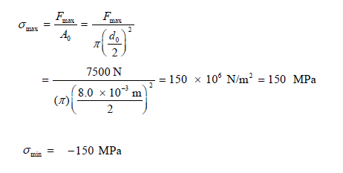

$σ_{m}=\frac{σ_{max}+σ_{min}}{2}=0$

b. (1 point) Stress Range

$σ_{r}=σ_{max} - σ_{min}=300 MPa$

c. (1 point) The stress amplitude in MPa

$$σ_{a}=\frac{σ_{r}}{2}= 150 MPa$$

d. (1 point) Its fatigue life

From the red brass curve, the fatigue life is 1x105 cycles.

**Question Three (7 points)**

1. (2 point). State the differences between Frenkel Defect and Schottky Defect:

Answer:

* The Frenkel defect consists in the displacement of an atom from its lattice position to an interstitial site, creating a vacancy at the original site and an interstitial defect at the new location. This defect does not have any impact on the density of the solid as it involves only the migration of the ions within the crystal, thus preserving both the volume as well as mass.
* The Schottky defect is caused if some of the lattice sites remain unoccupied. The number of missing negative ions equals to that of positive ions. Thus, the crystal remains electrically neutral. Schottky Defect causes density decrease of the substance.

1. (2 points) State the difference of edge dislocation and screw dislocation?

Answer:

* Edge dislocation:
  + extra half-plane of atoms inserted in a crystal structure
  + b perpendicular (⊥) to dislocation line
* Screw dislocation:
  + spiral planar ramp resulting from shear deformation
  + b parallel (||) to dislocation line

1. (3 points) Calculate the number of vacancies per cubic meter in copper at 7500C. The energy for vacancy formation is 0.74 eV/atom. The density and atomic weight for Fe are 8.96 g/cm3 and 63.54 g/mol, respectively.

$$N_{V}=\frac{(\frac{6.023×{10}^{23}}{mol})(\frac{8.96×{10}^{-6}g}{{cm}^{3}})}{(\frac{63.54g}{mol})}exp⁡(\frac{-0.74\frac{eV}{atom}}{(8.617×{10}^{-5}\frac{eV}{K})(750+273)K})$$

= $1.92×{10}^{25}$

**Question Four (6 points)**

1. (4 points) A hypothetical element has a cubic structure with a lattice constant of 7.6084 Å. If its atomic weight is 1646.56 g/mol and the mass density is 12.42 g/cm3. Calculate how many atoms does its unit cell have? What kind of crystal structure it would be?

a=3.8042 A0

A=1646.56 g/mol

ρ=12.42 g/cm3

n=?

Answer:

V=(7.6084 ×10-8)3=4.40×10-22 (cm3)

matom==2.734×10-21 (g)

(atoms)

Crystal structure: BCC

2. (2 points) Using the data in the table below, which ones have higher mobility:

a. Interstitials and Vacancies of Al

b. Interstitials of Cu and Interstitials of Pt

Answer: Harder to make, easier to move

1. Interstitials of Al
2. Interstitials of Pt

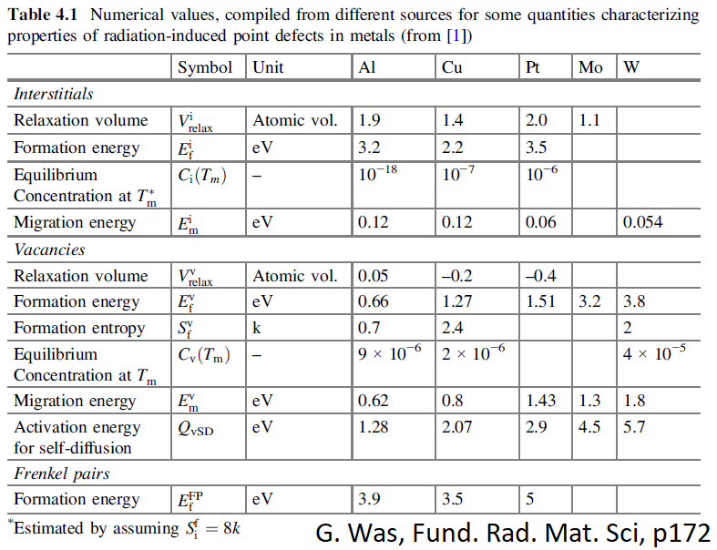

**Question Five (6 points)**

1. (3 points) The figure below shows the relationship between stress and strain. Fill out the table below:

Table 2 (Stress and Strain Curve)

|  |  |
| --- | --- |
|  | Stress and Strain Curve |
| a | Yield Strength |
| b | Young Modulus |
| c | Elastic Deformation |
| d | Uniform Plastic Deformation |
| e | Non-uniform Plastic Deformation |
| f | Tensile Strength |
| g | Fracture |
| h | Necking |

3

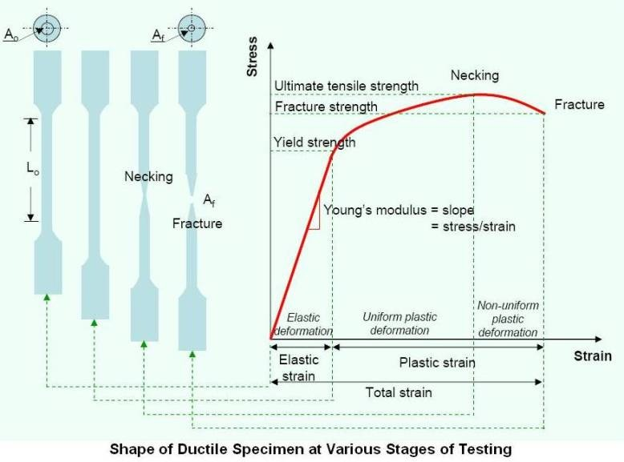

a

b

c

d

e

Strain

f

g

2. (3 points) A piece of copper with 150 mm long is pulled in tension with a stress of 250 MPa. E of copper is 110 GPa. If the deformation is entirely elastic, what will be the resultant elongation?

$$σ=ϵE=(\frac{∆l}{l_{0}})E$$

$$∆l=ϵE=\frac{σl_{0}}{E}$$

$$∆l=\frac{250*150}{110*{10}^{3}}$$

$$∆l=0.341 (mm)$$

**Question Six (6 points)**

1. (3 points) State the definition of:

1. Primary knock-on atom

The atom that was knocked off by the incoming high-energy particle

1. Thermal spikes

Regions with atoms in high energy states

1. Depleted zones

Regions with vacancy clusters

1. Cavities

Voids stabilized by filled gases such as He.

1. Displacement threshold energy

The minimum energy that must transferred to a lattice atom in order to be removed from its lattice site.

2. (3 points)

The figure shows the creep strain as a function of time for different applied stresses. Write down three observations you notice from the figure with increasing the stress values.

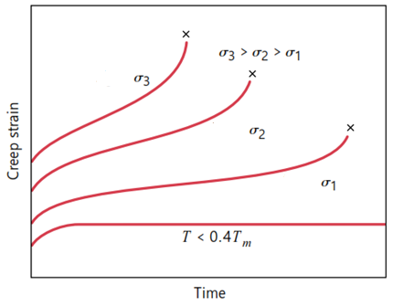

* Instantaneous strain increases
* Steady-state creep rate is increased
* The rupture lifetime is reduced

**Question Seven (6 points)**

The metal iridium has an FCC crystal structure with lattice constant of 3.835 Å. If the angle of diffraction for the (*h k l*) set of planes occurs at 69.20° (first-order reflection) when a monochromatic x-radiation having a wavelength of 1.54 Å is used,

1. (3 points) Calculate the interplanar spacing d*hkl* for this set of planes.
$$nλ=2dsin$$

$$d=\frac{nλ}{2sin}=\frac{1*1.54}{2sin⁡(\frac{69.2}{2})}=1.356 (A^{0})$$

2. (3 points) Determine the miller indices of this set of planes (*h k l*).

$$d_{hkl}=\frac{a}{\sqrt{h^{2}+k^{2}+l^{2}}}$$

$$h^{2}+k^{2}+l^{2}={\left(\frac{a}{d}\right)}^{2}{=\left(\frac{3.835}{1.356}\right)}^{2}=8.0$$

(hkl) must be all even or odd for FCC

(h k l): (2 2 0)