

**Final Examination**

**NE 0407401**

**Fall 2024-2025**

* You have 120 minutes to complete the solution of the questions below.
* Be sure you put your name and UOS ID #.
* Write neatly and clearly.
* Illegible responses will not be graded.
* Divide your time carefully between the questions.
* *Academic dishonesty will result in a zero mark for the midterm exam and potential F in the course.*
* *Justify your assumptions and answers scientifically. Show detailed steps of your calculations*

**Name: ID:**

|  |  |  |  |  |  |  |
| --- | --- | --- | --- | --- | --- | --- |
| **Question** | **Q1** | **Q2** | **Q3** | **Q4** | **Q5** | **Overall** |
| **Score** | /10 | /20 | /20 | /30 | /20 | /100 |

**Q1)** A **BWR** core consists of 30,000 fuel rods; each fuel rod has an active length of 12 feet. The core is producing 1,800 MW of thermal power. If the total peaking factor for a node is 2.0, what is the maximum local linear power density being produced in the node? **[10%]**

Answer:

10.0 kW/ft

**Q2) Economics of NPPs [20%]-General**

1. Estimate the cost per kWh of the energy unit generated from a reactor unit with 60 years life expectancy, 1400 MWe maximum power rating and a gross capital cost of 5 billion USD, O&M overall cost 1 billion USD, fuel cost 0.5 billion USD and availability factor of 95%. **[10%]**

**Answer:**

Cost = 0.0093 $/kWh

1. Why it is advisable to run the NPP at its full capacity. Plot the approximate relation between the efficiency and NPPs power output? **[10%]**

**Answer:**

Because the maximum NPP’s thermal efficiency is achievable at maximum plant power rating.

**Load (MWe)**

**ηNPP (%)**

**Rated Capacity**

**Max. efficiency**

**Q3)** Given the data below, answer the questions A through C **[20%]**:

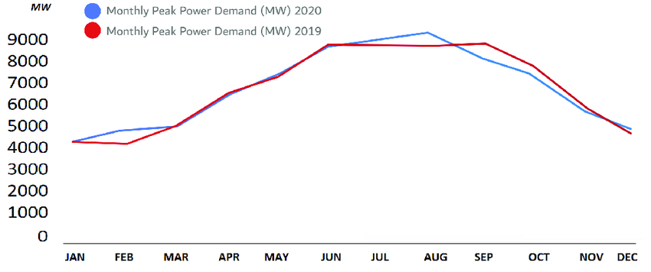

Figure 1. Dubai Monthly Peak Power Demand Curve.

1. Explain the high demand in Dubai during the months May-OCT? **[5%]**

**Answer:** these months represent the summertime in Dubai, therefore and due to the harsh weather conditions and high temperatures, the cooling load becomes high during those months.

1. Estimate the monthly base load in Dubai ?**[5%]**

**Answer:** Around 4000 MWe for both 2019 and 2020.

1. Estimate the peak loads for both 2019 and 2020 based on the data represented in the figure? **[10%]**

**Answer:**

2019: ≈ 8000 MWe

2020: ≈ 9000 MWe

**Q4)** A BWR operating under 7 MPa pressure and 1200 kg/s of saturated steam with feed water at 200 oC and downcomer recirculation mass flow rate of 10800 kg/s. Answer the following: **[30%]**

1. Sketch a full BWR power cycle [5%]

**Answer:**

1. The recirculation ratio? [5%]

**Answer:**

R= 9

1. Average exit quality of the core coolant [5%]

**Answer:**

AEQ=10%

1. The core inlet water thermodynamic quality [5%]

**Answer:**

IQ = -2.74%

1. If the power plant has an efficiency of 1500 MWth to the condenser cooling water with a thermal capacity of 4.18 kJ/kg°C. The mass flow rate in the condenser is about 30,000 kg/s and the reservoir water temperature is 25 oC. What is the estimated temperature increase in the condenser’s cooling water?[10%]

**Answer:**

11.9 oC

**Q5)** **[20%]**

1. List 3 applications for the the high outlet temperature of the helium coolant (in VHTGR) makes it possible to? **[5%]**

**Answer:**

1. deliver electricity
2. produce hydrogen
3. process heat with high efficiency.
4. Explain the difference between breeder, converter and burner reactors **[5%]**

**Answer:**

Breeder: Conversion ratio >1

Converter: Conversion ratio = 1

Burner: Conversion ratio < 1

1. Why Cs and I isotopes are considered of special environmental concern if radioactive released due to an accident **[5%]**

**Answer:**

Cs: it is airborne and it has a significant diffusion coefficient which allows it to disperse to large distances.

I : airborne and can be absorbed in biological organisms.

1. Explain the ALARA principle and what is its purpose? **[5%]**

**Answer:**

Regulations are set for the maximum permissible discharge of effluents to the environment.

However, licensees of nuclear power plants are required to keep radioactivity “as low as reasonably achievable”

ALARA interpretation

As low as reasonably achievable taking into account the state of technology and the economics of improvements in relation to the benefits to the public health and safety.

**Equations & Data Sheet**

Carnot cycle efficiency = $1-\frac{T_{C}}{T_{H}}$



$$Q=\dot{m}Cp∆T$$

where,

C = Total cost of electricity produced from one nuclear unit in kWh

A = Total capital cost by the end of the unit lifetime (including interests if there is a loan).

F = Total fuel cost by the end of the unit life time

O&M = Total operating and maintenance cost including impact of outages

|  |  |  |
| --- | --- | --- |
| Property | Value | Unit |
| medium : | water, fluid |  |
| pressure : | 70 | [ bar ] |
| temperature : | 200 | [ Celsius ] |
| density : | 868.754 | [ kg / m3 ] |
| specific inner energy : | 846.579 | [ kJ / kg ] |
| specific enthalpy : | 854.637 | [ kJ / kg ] |
| specific entropy : | 2.322 | [ kJ / kg K ] |
| specific isobar heat capacity: cp | 4.463 | [ kJ / kg K ] |
| specific isochor heat capacity : cv | 3.313 | [ kJ / kg K ] |

|  |  |  |
| --- | --- | --- |
| Property | Value | Unit |
| medium : | saturated steam |  |
| pressure : | 70 | [ bar ] |
| boiling temperature : (calculated) | 285.830 | [ Celsius ] |
| density water : | 739.724 | [ kg / m3 ] |
| density steam : | 36.524 | [ kg / m3 ] |
| specific enthalpy water : | 1267.437 | [ kJ / kg ] |
| specific enthalpy steam : | 2772.569 | [ kJ / kg ] |