

**Department of Mechanical and Nuclear Engineering**

**Reactor Thermal-Hydraulics**

**0407302**

**Final Examination**

**Spring 2024-2025**

**Name: ID:**

**Rules:**

1. Begin by writing your name and student ID.
2. Closed-book exam, only a calculator is allowed.
3. Having mobile phone and smart device during exam is cheating.
4. Any academic dishonesty will result in *“F”* for your final grade.
5. Total points are 100 points.
6. Write the answer in the separate answer sheet neatly and clearly.
7. The result should be written with sufficient significant numbers and unit.
8. **Circle or underline the final answer.**
9. Justify your assumptions

**For Instructor:**

|  |  |  |  |  |  |
| --- | --- | --- | --- | --- | --- |
| **Question** | **1** | **2** | **3** | **4** | **Total** |
| **Grade** |  |  |  |  |  |
| **Out of** | 25 | 25 | 25 | 25 | 100 |

**Question 1.**  **Two Phase Flow (25 points)-BWR**

The figure below shows a flow through two parallel horizontal pipes branching and ending at the same points (points a and b respectively). The average pressure in the system is about **70 bar**.

Pipe 1 carries single-phase liquid water at **286oC** while Pipe 2 carries mixture of water and steam at the same temperature with **void fraction 80%.**



Derive a relationship between **the liquid mass flow rate** in pipe 1 and **the mixture flow rate** in pipe 2. Assume homogeneous flow.

**Solution:  
  
**

**Question 2.**  **CHF PWR [25 points]** - **PWR**

Water flow rate of **0.0754 kg/s** is pumped through a uniformly heated vertical pipe. The heat is supplied by an electric heater of 1 MW/m2 capacity. The water pressure inside the pipe is 100 bar (assumed constant) and the inlet temperature is 265oC. The pipe diameter and length are 8 mm and 2.1 m, respectively. Determine if dryout is precluded or not. Find the following values:



1. **(4 points)** Mass flux (kg/m2s )
2. **(4 points)** Inlet quality
3. **(6 points)** Exit enthalpy
4. **(4 points)** Exit quality
5. **(4 points)** CHF value from loop-up table below
6. **(3 points)** Is dryout precluded or not?

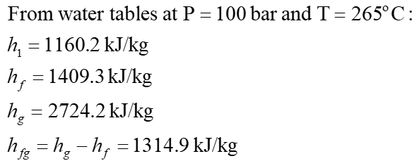

Look-up table for CHF (kW/m2)



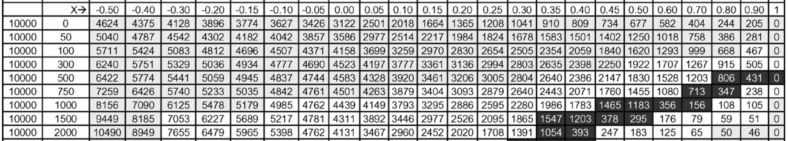

Solution)





**Question 3.**  **Fuel rod analysis [25 points]** - **PWR**

For a fuel rod with length 3.7 m, pellet diameter 10 mm, no center hole, clad inner diameter 10.1 mm, and clad thickness 0.65 mm.

(a) **(18 points)**  **Derive the change of the fuel temperature with time** if the generated heat is 60 kW/m and the rod is cooled by light water at 630oC and the clad to coolant HTC is 1.6 kW/m2K. Use the Lumped approach assuming the fuel initial temperature is equal to the coolant temperature.

(b) **(7 points)** According to the safety analysis report, the cladding starts to oxidize when the cladding temperature is higher than 1200 oC. **What is the fuel steady-state temperature(oC)** when coolant temperature reaches at 630 oC. **Is fuel damaged or not?** The UO2 and Zircaloy specific heats are 0.3 and 0.4 kJ/kgK, respectively. The density of UO2 without pores and Zircaloy are 10980 and 6550 kg/m3, respectively.





Solution)







250oC

3.7 m

10 mm

10.1 mm

0.65 mm





















The fuel is damaged because the fuel temperature exceeded 1200 deg C.

**Question 4 Natural Circulation - Thermosiphoning [25 points]**

**Calculate the mass flow rate** for the thermosiphon loop shown below if all pipes have length of 3 m and inner diameter of 1 cm. Pipes 1 and 3 are vertical while pipes 2 and 4 are horizontal. The loop is filled with water at atmospheric pressure (0.1 MPa) and the water temperature is 100oC in all pipes. Q1 was sufficient to cause boiling in pipe 1 with average quality 20% over pipe 1 length. The steam bubbles continued to flow in pipes 2 but completely condensed at the beginning of pipe 3. We assume homogeneous flow in the two-phase region. Remember for steam-water flow the two-phase density is: 

* At P = 0.1 MPa and T = 100oC, ρ_water = 958.47 kg/m3 , ρ_steam = 0.58967 kg/m3
* In pipes 1 & 2 (boiling = Two phase flow), x = 20%, homogeneous flow
* In pipes 3 & 4 (Single phase flow)
* The friction coefficient for all pipes is 0.02.

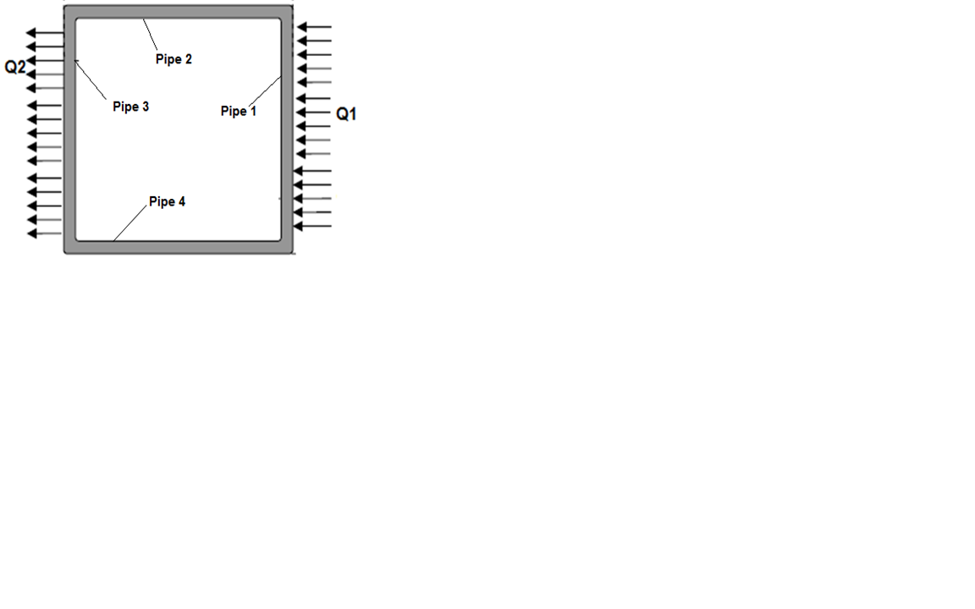

**3 m**

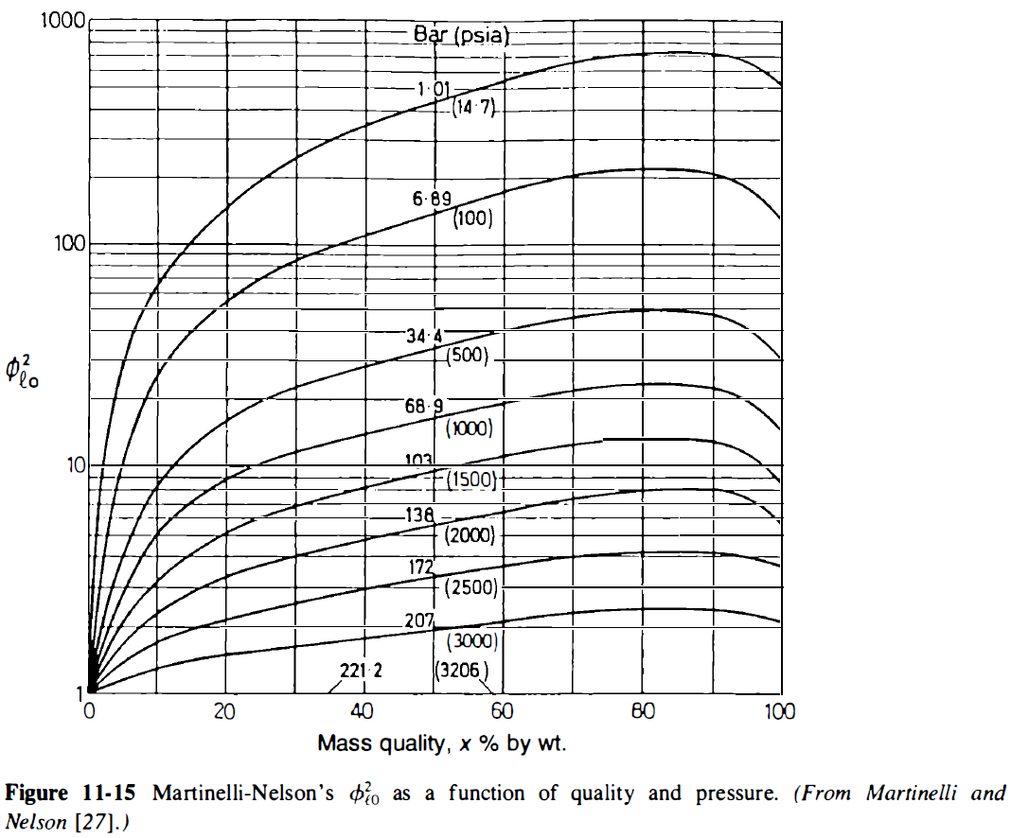

Solution)

For pipes 1 & 2

Homogeneous: S = 1



ρ*mix*=(1-α)ρ_water +αρ_steam

= (1- 0.99754)(958.47)+(0.99754)(0.58967) = 2.946055 kg/m3

For pipes 3 & 4, ρwater = 958.47 kg/m3

Flow Driving Force = (ρgh)ColdLeg - (ρgh)HotLeg

= (958.47 ×9.81×3)-(2.946055 ×9.81×3) = 28121.0697 Pa













**Equation Sheet:**

**Two Phase flow Equations:**







🡪





