**Department of Mechanical & Nuclear Engineering**

**Reactor Thermal-Hydraulics (0407302)**

**Midterm Examination**

**Spring 2024/2025**

**Name:_________________________________ ID:_______________________________**

**Rules:**

1. Begin by writing your name and student ID.
2. **Allowed to use the calculator**
3. **Answer should be given in sufficient significant value.**
4. Using electronic devices except a calculator during the exam is not allowed. Any academic dishonesty will result in *“F”* for your final grade.
5. Total points are 100 points.
6. Write the answer neatly and clearly.

**For Instructor:**

|  |  |  |  |  |
| --- | --- | --- | --- | --- |
| **Question** | **1** | **2** | **3** | **Total** |
| **Grade** |  |  |  |  |
| **Out of** | 30 | 30 | 40 | 100 |

**Q1) Heat Transfer** (30 points) A hot cylindrical rod with 12 mm diameter, 4 m length and constant surface temperature of 310oC is placed in flowing water. The water temperature and HTC were 60oC and 35 kW/m2K, respectively.

Note that thermal resistance:

1. Calculate the heat transfer rate in kW from the rod to the water.







Q= 1319kW

1. If the rod was placed in flowing air at the same water temperature, would the heat transfer will be larger or smaller? and why?

Gases have lower HTC than liquids, so the rod is expected to lose less heat if placed in air.

(c) If the same hot rod which has surface temperature of 310 oC is placed inside a hollow copper cylinder (known as a sleeve) that has the same length as the rod (4 m) and its inner diameter equal to the rod outer diameter (12 mm) and its outer diameter is 100 mm. The sleeve outer surface temperature was kept at 60oC. Calculate the heat transfer from the rod. Note that the copper thermal conductivity is 54 W/mK.









**Q2) Single phase pressure drop** (total 30 points)

Calculate the expected steady-state value of the flow rate

* Assuming the flow was initially at rest given that the pump head at steady state is 85.3 m
* assuming that the form loss coeff. at reactor ( KR) and SG (KSG) are 18 and 52, respectively, and the friction loss coeff. at pipe ( f ) is 0.015.
* Assume the pump inlet and outlet are at the same elevation and have the same area.
* assume compressible flow.
* Density = 1,000 kg/m3

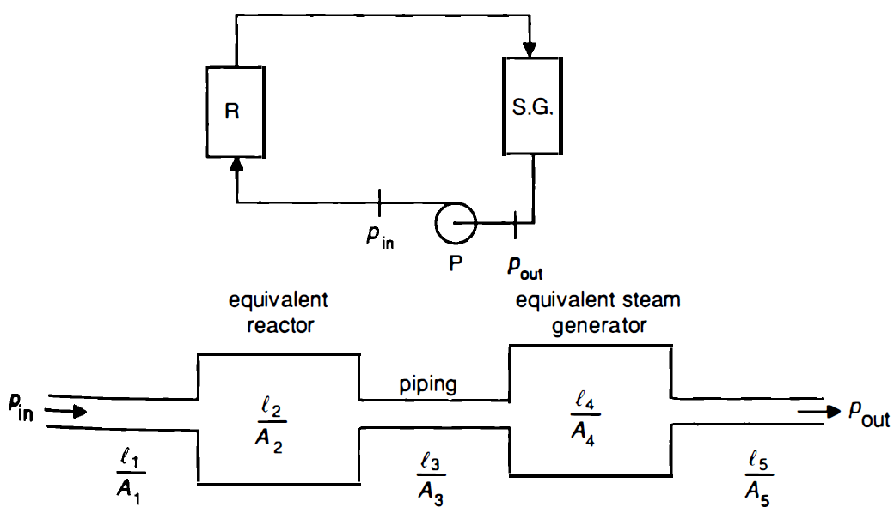

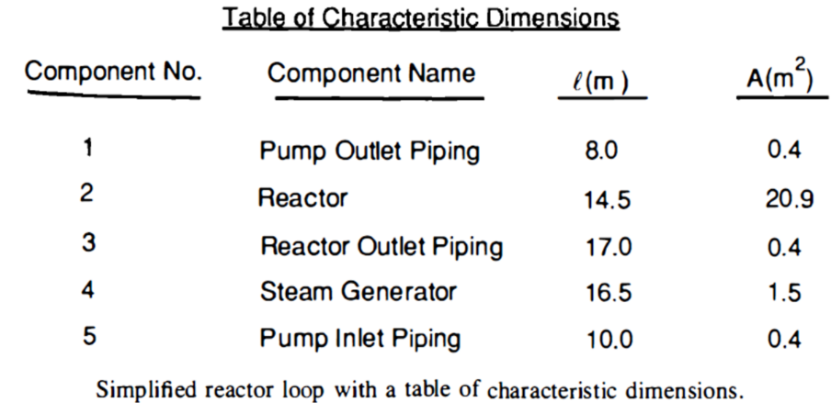

















**Q3) Two-phase flow** (40 points) Water enters an evaporator with a quality of 20% and flows through a vertical pipe with a diameter of 20 mm and length of 4.5 m. Heat is added uniformly along the pipe length with a gradient of 15 kW/m. The pressure at the pipe inlet was 7 MPa and the mass flux is 600 kg/m2∙s. Please assume that pressures at inlet and exit are same and use the data below.

1. (15 points) Determine the flow regime at the inlet using Taitel et al. map flow regime map. Please draw the line in the figure at the answer sheet and mark the exact points.
2. (15 points) Calculate the void fraction at the pipe exit

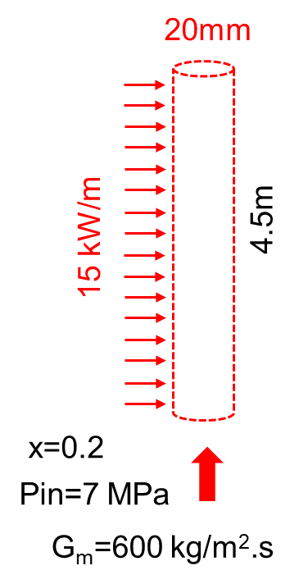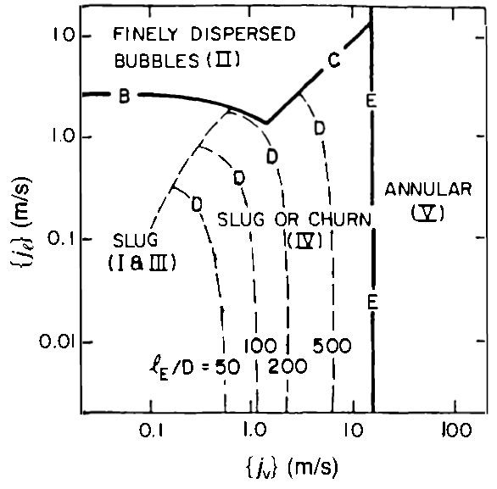

Flow regime map of Taitel et al. for air-water at 25°C

and 0.1 MPa in 25 mm diameter tube.













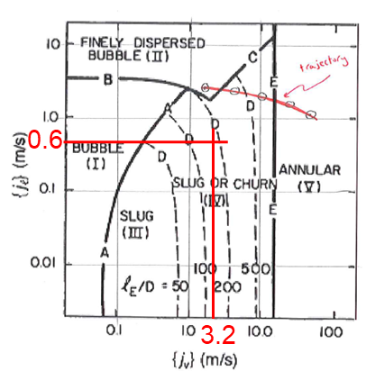

b)



 , 



Hewitt and Roberts map for vertical upward flow.

**Equation and Data Sheets**

* thermal resistance for convection and conduction



* Pressure losses









* Quality vs Void fraction

 

* Partial fraction:



* Integration of fraction:



* volumetric flux (or superficial velocity) of phase:

$$J_{l}=J_{f}=\frac{\left.{\dot{m}}_{m}^{}(1-x\right)}{ρ_{f}A}=\frac{{\dot{m}}_{f}^{}}{ρ_{f}A}, J_{v}=J_{g}=\frac{{\dot{m}}_{m}^{}x}{ρ_{g}A}=\frac{{\dot{m}}_{g}^{}}{ρ_{g}A}$$