By creating and running a python script:

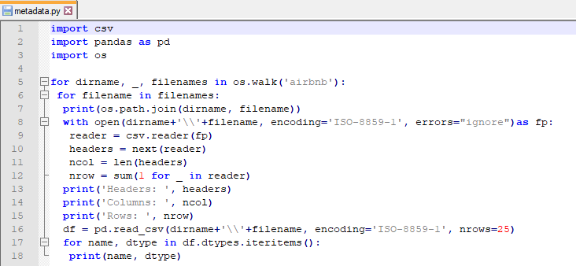

We were able to retrieve the following metadata:

**airbnb\airbnb-reviews.csv**

**Headers:** ['listing_id', 'id', 'date', 'reviewer_id', 'reviewer_name', 'comments']

**Columns:** 6

**Rows:** 14856578

listing_id int64

id int64

date object

reviewer_id int64

reviewer_name object

comments object

**airbnb\airbnb_ratings_new.csv**

**Headers:** ['Listing ID', 'Name', 'Host ID', 'Host Name', 'Host Response Rate', 'Host Is Superhost', 'Host total listings count', 'Street', 'City', 'Neighbourhood cleansed', 'State', 'Country', 'latitude', 'longitude', 'Property type', 'Room type', 'Accommodates', 'Bathrooms', 'Bedrooms', 'Amenities', 'Price', 'Minimum nights', 'Maximum nights', 'Availability 365', 'Calendar last scraped', 'Number of reviews', 'Last Review Date', 'Review Scores Rating', 'Review Scores Accuracy', 'Review Scores Cleanliness', 'Review Scores Checkin', 'Review Scores Communication', 'Review Scores Location', 'Review Scores Value', 'Reviews per month']

**Columns:** 35

**Rows:** 1048575

Listing ID int64

Name object

Host ID int64

Host Name object

Host Response Rate object

Host Is Superhost bool

Host total listings count int64

Street object

City object

Neighbourhood cleansed object

State object

Country object

latitude float64

longitude float64

Property type object

Room type object

Accommodates int64

Bathrooms float64

Bedrooms int64

Amenities object

Price float64

Minimum nights int64

Maximum nights int64

Availability 365 int64

Calendar last scraped object

Number of reviews int64

Last Review Date object

Review Scores Rating float64

Review Scores Accuracy float64

Review Scores Cleanliness float64

Review Scores Checkin float64

Review Scores Communication float64

Review Scores Location float64

Review Scores Value float64

Reviews per month float64

**airbnb\LA_Listings.csv**

**Headers:** ['Listing ID', 'Name', 'Host ID', 'Host Name', 'Host Response Rate', 'Host Is Superhost', 'Host total listings count', 'Street', 'City', 'Neighbourhood cleansed', 'State', 'Country', 'latitude', 'longitude', 'Property type', 'Room type', 'Accommodates', 'Bathrooms', 'Bedrooms', 'Amenities', 'Price', 'Minimum nights', 'Maximum nights', 'Availability 365', 'Calendar last scraped', 'Number of reviews', 'Last Review Date', 'Review Scores Rating', 'Review Scores Accuracy', 'Review Scores Cleanliness', 'Review Scores Checkin', 'Review Scores Communication', 'Review Scores Location', 'Review Scores Value', 'Reviews per month']

**Columns:** 35

**Rows:** 59865

Listing ID int64

Name object

Host ID int64

Host Name object

Host Response Rate float64

Host Is Superhost bool

Host total listings count int64

Street object

City object

Neighbourhood cleansed object

State object

Country object

latitude float64

longitude float64

Property type object

Room type object

Accommodates int64

Bathrooms float64

Bedrooms int64

Amenities object

Price int64

Minimum nights int64

Maximum nights int64

Availability 365 int64

Calendar last scraped object

Number of reviews int64

Last Review Date object

Review Scores Rating int64

Review Scores Accuracy int64

Review Scores Cleanliness int64

Review Scores Checkin int64

Review Scores Communication int64

Review Scores Location int64

Review Scores Value int64

Reviews per month float64

**airbnb\NY_Listings.csv**

**Headers:** ['Listing ID', 'Name', 'Host ID', 'Host Name', 'Host Response Rate', 'Host Is Superhost', 'Host total listings count', 'Street', 'City', 'Neighbourhood cleansed', 'State', 'Country', 'latitude', 'longitude', 'Property type', 'Room type', 'Accommodates', 'Bathrooms', 'Bedrooms', 'Amenities', 'Price', 'Minimum nights', 'Maximum nights', 'Availability 365', 'Calendar last scraped', 'Number of reviews', 'Last Review Date', 'Review Scores Rating', 'Review Scores Accuracy', 'Review Scores Cleanliness', 'Review Scores Checkin', 'Review Scores Communication', 'Review Scores Location', 'Review Scores Value', 'Reviews per month']

**Columns:** 35

**Rows:** 75749

Listing ID int64

Name object

Host ID int64

Host Name object

Host Response Rate float64

Host Is Superhost bool

Host total listings count float64

Street object

City object

Neighbourhood cleansed object

State object

Country object

latitude float64

longitude float64

Property type object

Room type object

Accommodates int64

Bathrooms float64

Bedrooms int64

Amenities object

Price int64

Minimum nights int64

Maximum nights int64

Availability 365 int64

Calendar last scraped object

Number of reviews int64

Last Review Date object

Review Scores Rating int64

Review Scores Accuracy int64

Review Scores Cleanliness int64

Review Scores Checkin int64

Review Scores Communication int64

Review Scores Location int64

Review Scores Value int64

Reviews per month float64