**МИНИСТЕРСТВО ОБРАЗОВАНИЯ И НАУКИ РОССИЙСКОЙ ФЕДЕРАЦИИ**

###### ФЕДЕРАЛЬНОЕ ГОСУДАРСТВЕННОЕ БЮДЖЕТНОЕ ОБРАЗОВАТЕЛЬНОЕ УЧРЕЖДЕНИЕ ВЫСШЕГО ОБРАЗОВАНИЯ

###### КЕМЕРОВСКИЙ ГОСУДАРСТВЕННЫЙ УНИВЕРСИТЕТ

**ИНСТИТУТ ЦИФРЫ**

**ОТЧЁТ**

**О ВЫПОЛНЕНИИ ЛАБОРАТОРНОЙ РАБОТЫ**

«IDispatch»

Студентки 2 курса, ФИТ-211 группы

**Колесник Полины Олеговны**

Направление 02.03.02 – «Фундаментальная информатика и информационные технологии»

Руководитель:

Доцент Иванов К. С.

Работа защищена

« »

“ ” 2023 г.

Кемерово 2023 г.

**ОТЧЁТ О ПРОДЕЛАННОЙ РАБОТЕ**

**Файл client.cpp**

#include <objbase.h>

#include <stdio.h>

#include "Interfaces.h"

*// typedef HRESULT __stdcall (*GetClassObjectType) (const CLSID& clsid, const IID& iid, void** ppv);*

*int* main() {

    printf("Client::Main::Start\n");

    try {

*// GetClassObjectType GetClassObject;*

*// HINSTANCE h;*

*// h = LoadLibrary("./build/manager/main.dll");*

*// if (!h) {*

*//  throw "No manager";*

*// }*

*// GetClassObject = (GetClassObjectType)GetProcAddress(h,"GetClassObject");*

*// if (!GetClassObject) {*

*//  throw "No manager method";*

*// }*

        CoInitialize(NULL);

*// {91A42CAA-5777-4E80-934E-07DE64502FD6}*

*// const CLSID CLSID_Server = {0x91A42CAA,0x5777,0x4E80,{0x93,0x4E,0x07,0xDE,0x64,0x50,0x2F,0xD6}};*

*// const CLSID CLSID_Server_2 = {0x91A42CBA,0x2577,0x4E80,{0x93,0x4E,0x07,0xDE,0x64,0x50,0x2F,0xD7}};*

        CLSID CLSID_Server_2_ProgID;

        {

*const* *wchar_t*\* progID = L"IKS.Application";

            HRESULT resCLSID_ProgID = CLSIDFromProgID(progID,&CLSID_Server_2_ProgID);

            if (!(SUCCEEDED(resCLSID_ProgID))) {

                throw "No CLSID form ProgID";

            }

            else {

                printf("CLSID form ProgID OK!");

                printf("\n");

            }

        }

        IClassFactory* pCF = NULL;

*// HRESULT resFactory = CoGetClassObject(CLSID_Server2,CLSCTX_INPROC_SERVER,NULL,IID_IClassFactory,(void**)&pCF);*

        HRESULT resFactory = CoGetClassObject(CLSID_Server_2_ProgID,CLSCTX_INPROC_SERVER,NULL,IID_IClassFactory,(*void*\*\*)&pCF);

        if (!(SUCCEEDED(resFactory))) {

            throw "Client::Main::No factory";

        }

        IGet_Array* pGA = NULL;

        HRESULT resInstance = pCF->CreateInstance(NULL,IID_IGet_Array,(*void*\*\*)&pGA);

        if (!(SUCCEEDED(resInstance))) {

            throw "Client::Main::No instance";

        }

        printf("Client::Main::Success IGet_Array: \n");

        pGA->InputMas1();

        pGA->InputMas2();

        printf("Client::Main::QueryInterface IGet_Array->ISample_Processing\n");

        ISample_Processing* pSP = NULL;

        HRESULT resQuery = pGA->QueryInterface(IID_ISample_Processing,(*void*\*\*)&pSP);

        if (!(SUCCEEDED(resQuery))) {

          throw "Client::Main::No query";

        }

        ISumma* is = NULL;

        resQuery = pGA->QueryInterface(IID_ISumma,(*void*\*\*)&is);

        if (!(SUCCEEDED(resQuery))) {

            throw "Client::Main::No query_2";

        }

        printf("Client::Main::Success ISample_Processing:\n");

        pSP->Sample_Average();

        pSP->Sample_Variance();

        pSP->Corrected_Sample_Variance();

        is->summ();

        IDispatch* pDisp = NULL;

        HRESULT resQueryDisp = pGA->QueryInterface(IID_IDispatch,(*void*\*\*)&pDisp);

        if (!(SUCCEEDED(resQueryDisp)))

        {

            throw "No query dispatch";

        }

        DISPID dispid;

*int* namesCount = 1;

        OLECHAR** names = new OLECHAR*[namesCount];

        OLECHAR* name = const_cast<OLECHAR*>(L"summ");

        names[0] = name;

        HRESULT resID_Name = pDisp->GetIDsOfNames(

                                                    IID_NULL_,

                                                    names,

                                                    namesCount,

                                                    GetUserDefaultLCID(),

                                                    &dispid

                                                );

        if (!(SUCCEEDED(resID_Name))) {

            printf("No ID of name\n");

        }

        else {

            DISPPARAMS dispparamsNoArgs = {

                                            NULL,

                                            NULL,

                                            0,

                                            0,

                                        };

            HRESULT resInvoke = pDisp->Invoke (

                                                dispid, *// DISPID*

                                                IID_NULL_,

                                                GetUserDefaultLCID(),

                                                DISPATCH_METHOD,

                                                &dispparamsNoArgs,

                                                NULL,

                                                NULL,

                                                NULL

                                            );

            if (!(SUCCEEDED(resInvoke))) {

                printf("Invoke error\n");

            }

        }

        pDisp->Release();

        pSP->Release();

        pGA->Release();

        is->Release();

        pCF->Release();

    }

    catch (*const* *char*\* str) {

        printf("Main::Error: \n");

        printf(str);

        printf("\n");

    }

    catch (...) {

        printf("Main::Error::Unknown\n");

    }

    CoUninitialize();

    printf("Main::Finish\n");

    return 0;

}

**Файл Interfaces.h**

#ifndef Interfaces_H_INCLUDED

#define Interfaces_H_INCLUDED

#include <windows.h>

*const* IID IID_NULL_ = {0x00000000,0x0000,0x0000,{0x00,0x00,0x00,0x00,0x00,0x00,0x00,0x00}};

*const* IID IID_IUnknown = {0x00000000,0x0000,0x0000,{0xC0,0x00,0x00,0x00,0x00,0x00,0x00,0x46}};

*const* IID IID_IClassFactory = {0x00000001,0x0000,0x0000,{0xC0,0x00,0x00,0x00,0x00,0x00,0x00,0x46}};

*const* IID IID_IDispatch = {0x00020400,0x0000,0x0000,{0xC0,0x00,0x00,0x00,0x00,0x00,0x00,0x46}};

*const* IID IID_IGet_Array = {0x00000101,0x0000,0x0000,{0x00,0x00,0x00,0x00,0x00,0x00,0x00,0x46}};

*const* IID IID_ISample_Processing = {0x00000102,0x0000,0x0000,{0x00,0x00,0x00,0x00,0x00,0x00,0x00,0x46}};

*const* IID IID_ISumma = {0x00000103,0x0000,0x0000,{0x00,0x00,0x00,0x00,0x00,0x00,0x00,0x46}};

*class* ISample_Processing: *public* IUnknown {

*public:*

*virtual* HRESULT *__stdcall* Sample_Average()=0; *//выборочное среднее*

*virtual* HRESULT *__stdcall* Sample_Variance()=0; *//выборочная дисперсия*

*virtual* HRESULT *__stdcall* Corrected_Sample_Variance()=0; *//исправленная выборочная дисперсия*

};

*//интерфейс с методами для считывания из файла*

*class* IGet_Array: *public* IUnknown {

*public:*

*virtual* HRESULT *__stdcall* InputMas2() = 0;

*virtual* HRESULT *__stdcall* InputMas1() = 0;

};

*class* ISumma: *public* IUnknown {

*public:*

*virtual* *void* *__stdcall* summ() = 0;

};

#endif *// Interfaces_H_INCLUDED*

**Файл Components.h**

#ifndef COMPONENTS_H_INCLUDED

#define COMPONENTS_H_INCLUDED

#include <windows.h>

void println(const char* str);

HRESULT __stdcall GetClassObject(const CLSID& clsid, const IID& iid, void** ppv);

#endif // COMPONENTS_H_INCLUDED

**Файл Interfaces.h**

#ifndef Interfaces_H_INCLUDED

#define Interfaces_H_INCLUDED

#include <windows.h>

const IID IID_IUnknown = {0x00000000,0x0000,0x0000,{0xC0,0x00,0x00,0x00,0x00,0x00,0x00,0x46}};

const IID IID_IClassFactory = {0x00000001,0x0000,0x0000,{0xC0,0x00,0x00,0x00,0x00,0x00,0x00,0x46}};

const IID IID_IGet_Array = {0x00000101,0x0000,0x0000,{0x00,0x00,0x00,0x00,0x00,0x00,0x00,0x46}};

const IID IID_ISample_Processing = {0x00000102,0x0000,0x0000,{0x00,0x00,0x00,0x00,0x00,0x00,0x00,0x46}};

class ISample_Processing: public IUnknown {

    public:

     virtual void __stdcall Sample_Average()=0;  //выборочное среднее

     virtual void __stdcall Sample_Variance()=0; //выборочная дисперсия

     virtual void __stdcall Corrected_Sample_Variance()=0; //исправленная выборочная дисперсия

};

//интерфейс с методами для считывания из файла

class IGet_Array: public IUnknown {

    public:

     virtual void __stdcall InputMas2() = 0;

     virtual void __stdcall InputMas1() = 0;

};

#endif // Interfaces_H_INCLUDED

**Файл main.cpp**

#include <stdio.h>

#include "Components.h"

extern "C" __declspec(dllexport) HRESULT __stdcall DllGetClassObject(const CLSID& clsid, const IID& iid, void** ppv) {

    println("Container::DllGetClassObject");

    return GetClassObject(clsid,iid,ppv);

}

BOOL APIENTRY DllMain(HINSTANCE hinstDLL, DWORD fdwReason, LPVOID lpvReserved) {

    switch (fdwReason) {

        case DLL_PROCESS_ATTACH:

            // attach to process

            // return FALSE to fail DLL load

            println("Container_Simple::DLL_PROCESS_ATTACH");

            break;

        case DLL_PROCESS_DETACH:

            // detach from process

            println("Container_Simple::DLL_PROCESS_DETACH");

            break;

        case DLL_THREAD_ATTACH:

            // attach to thread

            break;

        case DLL_THREAD_DETACH:

            // detach from thread

            break;

    }

    return TRUE; // succesful

}

**Файл server.cpp**

#include "server.h"

#include <iostream>

#include <fstream>

#include <math.h>

using *namespace* std;

Server::Server() {

  fRefCount = 0;

  volume = 0;

  Sample_average = 0;

  println("Server::Constructor");

}

Server::~Server() {

  println( "Server::Destructor");

}

HRESULT *__stdcall* Server::QueryInterface(*const* IID*&* *iid*, *void\*\** *ppv*) {

    println("Server::QueryInterface");

    if (*iid*==IID_IUnknown) {

      \**ppv* = (IUnknown*)(ISample_Processing*)*this*;

    }

    else if (*iid* == IID_ISample_Processing) {

      \**ppv* = (ISample_Processing*)*this*;

    }

    else if (*iid* == IID_IGet_Array) {

      \**ppv* = (IGet_Array*)*this*;

    }

    else {

      \**ppv* = NULL;

      return E_NOINTERFACE;

    }

*this*->AddRef();

    return S_OK;

}

ULONG *__stdcall* Server::AddRef() {

   println("Server::AddRef");

   fRefCount++;

   cout << "Server::Current references: " << fRefCount << endl;

   return fRefCount;

}

ULONG *__stdcall* Server::Release() {

   println("Server::Relese");

   fRefCount--;

   cout << "Server::Current references: " << fRefCount << endl;

   if (fRefCount==0) {delete *this*;}

   return fRefCount;

}

*//----------------------------------------------------------*

*//методы интерфайса IGet_Array*

*void* *__stdcall* Server::InputMas2() {

  println("Server::InputMas2");

  fstream f;

  f.open("GetX.txt");

  if(f.is_open()) {

    for (*int* i = 0; i < 5; i++) {

      f >> x[i];

    }

  }

  else {

    println("No file opened");

  }

  f.close();

}

*void* *__stdcall* Server::InputMas1() {

  println("Server::InputMas1");

  fstream f;

  f.open("GetN.txt");

  if(f.is_open()) {

    for (*int* i = 0; i < 5; i++) {

      f >> n[i];

    }

  }

  else {

    println("No file opened");

  }

  f.close();

}

*//-------------------------------------------------------*

*//методы интерфайса ISample_Processing*

*void* *__stdcall* Server::Sample_Average() {

  println("Server::Sample_Average");

*float* sum = 0;

  for(*int* i = 0; i < 5; i++) {

    volume += n[i];

    sum += x[i] * n[i];

  }

  Sample_average = round(sum / volume * 100) / 100;

  cout<< "Server::Sample_Average = " << Sample_average << endl << endl;

}

*void* *__stdcall* Server::Sample_Variance() {

  println("Server::Sample_Variance");

*float* sum = 0;

  for(*int* i=0; i< 5; i++) {

    sum += pow((x[i]- Sample_average), 2) * n[i];

  }

  cout << "Server::Sample_Variance = " <<  round(sum / volume * 100) / 100 << endl;

}

*void* *__stdcall* Server::Corrected_Sample_Variance() {

  println("Server::Corrected_Sample_Variance");

*float* sum = 0;

  for(*int* I = 0; I < 5; i++) {

    sum += pow((x[i] - Sample_average), 2) * n[i];

  }

  cout << "Server::Corrected_Sample_Variance = " << round(sum / (volume-1) * 100) / 100 << endl << endl;

}

*//--------------------------------------------------------------*

ServerFactory::ServerFactory() {

  println("ServerFactory::Constructor");

  fRefCount = 0;

}

ServerFactory::~ServerFactory() {

  println("ServerFactory::Destructor");

}

HRESULT *__stdcall* ServerFactory::QueryInterface(*const* IID*&* *iid*, *void\*\** *ppv*) {

  println("ServerFactory::QueryInterface");

  if (*iid*==IID_IUnknown) {

    \**ppv* = (IUnknown*)(IClassFactory*)(*this*);

  }

  else if (*iid* == IID_IClassFactory) {

    \**ppv* = (*void*\*\*)(IClassFactory*)(*this*);

  }

  else {

    \**ppv* = NULL;

    return E_NOINTERFACE;

  }

*this*->AddRef();

  return S_OK;

}

ULONG *__stdcall* ServerFactory::AddRef() {

  println("ServerFactory::AddRef");

  fRefCount++;

  cout << "ServerFactory::Current references: " << fRefCount << endl;

  return fRefCount;

}

ULONG *__stdcall* ServerFactory::Release() {

  println("ServerFactory::Relese");

  fRefCount--;

  cout << "ServerFactory::Current references: " << fRefCount << endl;

  if (fRefCount==0) {delete *this*;}

  return fRefCount;

}

HRESULT *__stdcall* ServerFactory::CreateInstance(IUnknown*\** *pUnknownOuter*, *const* IID*&* *iid*, *void\*\** *ppv*) {

  println("ServerFactory::CreateInstance");

  if (*pUnknownOuter*!=NULL) {

    return E_NOTIMPL;

  }

  Server* p = new Server();

  return p->QueryInterface(*iid*,*ppv*);

}

HRESULT *__stdcall* ServerFactory::LockServer(BOOL *bLock*) {

  println("ServerFactory::LockServer");

  return S_OK;

}

*void* println(*const* *char\** *str*) {

  printf(*str*);

  printf("\n");

}

HRESULT *__stdcall* GetClassObject(*const* CLSID*&* *clsid*, *const* IID*&* *iid*, *void\*\** *ppv*) {

  println("Component::GetClassObject");

  CLSID CLSID_Server_ProgID;

  {

*const* *wchar_t*\* progID = L"App.Application";

    HRESULT resCLSID_ProgID = CLSIDFromProgID(progID,&CLSID_Server_ProgID);

    if (!(SUCCEEDED(resCLSID_ProgID))) {

      throw "No CLSID form ProgID";

    }

    else {

      printf("CLSID form ProgID2 OK!");

      printf("\n");

    }

  }

  if (*clsid*==CLSID_Server_ProgID) {

    ServerFactory* fa = new ServerFactory();

    return fa->QueryInterface(*iid*,*ppv*);

  }

  else {

    \**ppv* = NULL;

    return E_NOTIMPL;

  }

}

**Файл server.h**

#ifndef SERVER_H_INCLUDED

#define SERVER_H_INCLUDED

#include "interfaces.h"

#include "Components.h"

//компонент

class Server: public ISample_Processing, IGet_Array {

    private: //обработка выборки

      int fRefCount;

     int x[5];

     int n[5];

     float volume;

     float Sample_average;

    public:

     Server();

     ~Server();

     virtual HRESULT __stdcall QueryInterface(const IID& iid, void** ppv);

     virtual ULONG __stdcall AddRef();

     virtual ULONG __stdcall Release();

     virtual void __stdcall Sample_Average();

     virtual void __stdcall Sample_Variance();

     virtual void __stdcall Corrected_Sample_Variance();

     virtual void __stdcall InputMas1(); //n

     virtual void __stdcall InputMas2(); //x

};

class ServerFactory: public IClassFactory {

    int fRefCount;

    public:

     ServerFactory();

     ~ServerFactory();

     virtual HRESULT __stdcall QueryInterface(const IID& iid, void** ppv);

     virtual ULONG __stdcall AddRef();

     virtual ULONG __stdcall Release();

     virtual HRESULT __stdcall CreateInstance(IUnknown* pUnknownOuter, const IID& iid, void** ppv);

     virtual HRESULT __stdcall LockServer(BOOL bLock);

};

#endif // SERVER_H_INCLUDED

**Server Super**

**Файл Components.h**

#ifndef COMPONENTS_H_INCLUDED

#define COMPONENTS_H_INCLUDED

#include <windows.h>

void println(const char* str);

HRESULT __stdcall GetClassObject(const CLSID& clsid, const IID& iid, void** ppv);

#endif // COMPONENTS_H_INCLUDED

**Файл Interfaces.h**

#ifndef Interfaces_H_INCLUDED

#define Interfaces_H_INCLUDED

#include <windows.h>

*const* IID IID_IUnknown = {0x00000000,0x0000,0x0000,{0xC0,0x00,0x00,0x00,0x00,0x00,0x00,0x46}};

*const* IID IID_IClassFactory = {0x00000001,0x0000,0x0000,{0xC0,0x00,0x00,0x00,0x00,0x00,0x00,0x46}};

*const* IID IID_IDispatch = {0x00020400,0x0000,0x0000,{0xC0,0x00,0x00,0x00,0x00,0x00,0x00,0x46}};

*const* IID IID_IGet_Array = {0x00000101,0x0000,0x0000,{0x00,0x00,0x00,0x00,0x00,0x00,0x00,0x46}};

*const* IID IID_ISample_Processing = {0x00000102,0x0000,0x0000,{0x00,0x00,0x00,0x00,0x00,0x00,0x00,0x46}};

*const* IID IID_ISumma = {0x00000103,0x0000,0x0000,{0x00,0x00,0x00,0x00,0x00,0x00,0x00,0x46}};

*class* ISample_Processing: *public* IUnknown {

*public:*

*virtual* *void* *__stdcall* Sample_Average() = 0; *//выборочное среднее*

*virtual* *void* *__stdcall* Sample_Variance() = 0; *//выборочная дисперсия*

*virtual* *void* *__stdcall* Corrected_Sample_Variance() = 0; *//исправленная выборочная дисперсия };*

};

*class* IGet_Array: *public* IUnknown {

*public:*

*virtual* *void* *__stdcall* InputMas2() = 0;

*virtual* *void* *__stdcall* InputMas1() = 0;

};

*class* ISumma: *public* IUnknown {

*public:*

*virtual* *void* *__stdcall* summ() = 0;

};

#endif *// Interfaces_H_INCLUDED*

**Файл main.cpp**

#include <stdio.h>

#include "Components.h"

extern "C" __declspec(dllexport) HRESULT __stdcall DllGetClassObject(const CLSID& clsid, const IID& iid, void** ppv) {

    println("Container::DllGetClassObject");

    return GetClassObject(clsid,iid,ppv);

}

BOOL APIENTRY DllMain(HINSTANCE hinstDLL, DWORD fdwReason, LPVOID lpvReserved) {

    switch (fdwReason) {

        case DLL_PROCESS_ATTACH:

            // attach to process

            // return FALSE to fail DLL load

            println("Container_Super::DLL_PROCESS_ATTACH");

            break;

        case DLL_PROCESS_DETACH:

            // detach from process

            println("Container_Super::DLL_PROCESS_DETACH");

            break;

        case DLL_THREAD_ATTACH:

            // attach to thread

            break;

        case DLL_THREAD_DETACH:

            // detach from thread

            break;

    }

    return TRUE; // succesful

}

**Файл server.cpp**

#include "server.h"

#include <objbase.h>

#include <iostream>

#include <fstream>

#include <math.h>

using *namespace* std;

Server_2::Server_2() {

   a = 5;

   b = 8;

   px1=123;

   println("Server_2::Server_2");

   fRefCount = 0;

*// CoInitialize(NULL);*

*//   HINSTANCE h;*

*//   h=LoadLibrary("./build/manager/main.dll");*

*//   if (!h) {*

*//      throw "No manager";*

*//   }*

*//   CreateInstanceType CreateInstance = (CreateInstanceType) GetProcAddress(h,"CreateInstance");*

*//   if (!CreateInstance) {*

*//      throw "No manager method";*

*//   }*

*//Getting manager method (End)*

  CLSID CLSID_Server_ProgID;

  {

*const* *wchar_t*\* progID = L"App.Application";

*//mbstowcs;*

*//wcstombs*

      HRESULT resCLSID_ProgID = CLSIDFromProgID(progID,&CLSID_Server_ProgID);

      if (!(SUCCEEDED(resCLSID_ProgID))) {

         throw "No CLSID form ProgID";

      }

      else {

         printf("CLSID form ProgID2 OK!");

         printf("\n");

      }

   }

*// const CLSID CLSID_Server = {0x91A42CAA,0x5777,0x4E80,{0x93,0x4E,0x07,0xDE,0x64,0x50,0x2F,0xD6}};*

*// HRESULT resFactory = CoGetClassObject(,CLSCTX_INPROC_SERVER,NULL,IID_IClassFactory,(void**)&pCF);*

*// println("Server_2::LYYYYYYYYY DA SCOLKO MOSHNO");*

*// if (!(SUCCEEDED(resFactory))) {*

*//    throw "Server_2::No factory";*

*// }*

   HRESULT resInstance = CoCreateInstance(CLSID_Server_ProgID,NULL,CLSCTX_INPROC_SERVER,IID_IGet_Array,(*void*\*\*)&ig_Simple);

   if (!(SUCCEEDED(resInstance))) {

      throw "Server_2::No instance";

   }

   HRESULT resY = ig_Simple->QueryInterface(IID_ISample_Processing,(*void*\*\*)&is_Simple);

   if (!(SUCCEEDED(resY))) {

      throw "Server_2::No query";

   }

*//Injecting component (End)*

}

Server_2::~Server_2() {

   println( "Server_2::Destructor");

   ig_Simple->Release();

   is_Simple->Release();

*// pCF->Release();*

*// CoUninitialize();*

}

HRESULT *__stdcall* Server_2::QueryInterface(*const* IID*&* *iid*, *void\*\** *ppv*) {

   println("Server_2::QueryInterface");

   if (*iid* == IID_IUnknown) {

      \**ppv* = (IUnknown*)(IGet_Array*)*this*;

   }

   else if (*iid* == IID_IGet_Array) {

      \**ppv* = (IGet_Array*)*this*;

   }

   else if (*iid* == IID_ISample_Processing) {

      \**ppv* = (ISample_Processing*)*this*;

   }

   else if (*iid* == IID_ISumma) {

      \**ppv* = (ISumma*)*this*;

   }

   else if (*iid* == IID_IDispatch){

      \**ppv* = (IDispatch*)*this*;

   }

   else {

      \**ppv* = NULL;

      return E_NOINTERFACE;

   }

*this*->AddRef();

   return S_OK;

}

ULONG *__stdcall* Server_2::AddRef() {

   println("Server_2::AddRef");

   fRefCount++;

   cout << "Server_2::Current references: " << fRefCount << endl;

   return fRefCount;

}

ULONG *__stdcall* Server_2::Release() {

   println("Server_2::Release");

   fRefCount--;

   cout << "Server_2::Current references: " << fRefCount << endl;

   if (fRefCount==0) {delete *this*;}

   return fRefCount;

}

*//методы компонента*

*void* *__stdcall* Server_2::InputMas1() {

   println("Server_2::InputMas1:Full delegating to the server component ");

   ig_Simple->InputMas1();

}

*void* *__stdcall* Server_2::InputMas2() {

   println("Server_2::InputMas2:Full delegating to the server component");

   ig_Simple->InputMas2();

}

*void* *__stdcall* Server_2::Sample_Average() {

   println("Server_2::Sample_Average:Full delegating to the server component");

   is_Simple->Sample_Average();

}

*void* *__stdcall* Server_2::Sample_Variance() {

   println("Server_2::Sample_Variance:Full delegating to the server component");

   is_Simple->Sample_Variance();

}

*void* *__stdcall* Server_2::Corrected_Sample_Variance() {

   println("Server_2::Corrected_Sample_Variance:Full delegating to the server component");

   is_Simple->Corrected_Sample_Variance();

}

*void* *__stdcall* Server_2::summ(){

   cout<< "Server_2::summ = " << a + b << endl;

}

*//-------------------------------------------------*

HRESULT *__stdcall* Server_2::GetTypeInfoCount(UINT*\** *pctinfo*)

{

   println("Server_2:GetTypeInfoCount");

   return S_OK;

}

HRESULT *__stdcall* Server_2::GetTypeInfo(UINT *iTInfo*, LCID *lcid*, ITypeInfo*\*\** *ppTInfo*)

{

   println("Server_2:GetTypeInfo");

   return S_OK;

}

HRESULT *__stdcall* Server_2::GetIDsOfNames(REFIID *riid*, LPOLESTR*\** *rgszNames*, UINT *cNames*,

                                    LCID *lcid*, DISPID*\** *rgDispId*)

{

   println("Server_2:GetIDsOfNames");

   if (*cNames*!=1) {return E_NOTIMPL;}

   if (wcscmp(*rgszNames*[0], L"summ") == 0) {

*rgDispId*[0] = 1;

   }

   else if (wcscmp(*rgszNames*[0], L"Px1") == 0) {

*rgDispId*[0] = 2;

   }

   else if (wcscmp(*rgszNames*[0], L"InputMas1") == 0) {

*rgDispId*[0] = 3;

   }

   else if (wcscmp(*rgszNames*[0], L"InputMas2") == 0) {

*rgDispId*[0] = 4;

   }

   else if (wcscmp(*rgszNames*[0], L"Sample_Average") == 0) {

*rgDispId*[0] = 5;

   }

   else if (wcscmp(*rgszNames*[0], L"Sample_Variance") == 0) {

*rgDispId*[0] = 6;

   }

   else if (wcscmp(*rgszNames*[0], L"Corrected_Sample_Variance") == 0) {

*rgDispId*[0] = 7;

   }

   else {

      return E_NOTIMPL;

   }

   return S_OK;

}

HRESULT *__stdcall* Server_2::Invoke(DISPID *dispIdMember*, REFIID *riid*, LCID *lcid*, WORD *wFlags*, DISPPARAMS*\** *pDispParams*, VARIANT*\** *pVarResult*,

                             EXCEPINFO*\** *pExcepInfo*, UINT*\** *puArgErr*) {

   println("Server_2:Invoke");

   if (*dispIdMember*==1) {

      summ();

   }

   else if(*dispIdMember*==2) {

      if((*wFlags*==DISPATCH_PROPERTYGET) || (*wFlags* == 1) || (*wFlags* == 3)) {

         if(*pVarResult*!=NULL) {

*pVarResult*->vt = VT_INT;

*pVarResult*->intVal = px1;

         }

      }

      else if (*wFlags*==DISPATCH_PROPERTYPUT) {

         DISPPARAMS param = \**pDispParams*;

         VARIANT arg = (param.rgvarg)[0];

         VariantChangeType(&arg,&arg,0,VT_INT);

         px1 = arg.intVal;

      }

      else {

         return E_NOTIMPL;

      }

   }

   else if(*dispIdMember*==3){

      InputMas1();

   }

   else if(*dispIdMember*==4){

      InputMas2();

   }

    else if(*dispIdMember*==5){

      Sample_Average();

   }

    else if(*dispIdMember*==6){

      Sample_Variance();

   }

    else if(*dispIdMember*==7){

      Corrected_Sample_Variance();

   }

   else {

      return E_NOTIMPL;

   }

   return S_OK;

}

*//\*\*\*\*\*\*\*\*\*\*\*\*\*\*\*\*\*\*\*\*\*\*\*\*\*\*\*\*\*\*\*\*\*\*\*\*\*\*\*\*\*\*\*\*\*\*\*\*\*\*\*\*\*\*\*\*\*\*\*\*\*\*\*\*\*\*\*\*\*\*\*\*\*\*\*\*\*\*\*\*\*\*\*\*\*\*\*\*\*\**

ServerFactory_2::ServerFactory_2() {

   println("ServerFactory_2::Constructor");

   fRefCount = 0;

}

ServerFactory_2::~ServerFactory_2() {

   println("ServerFactory_2::Destructor");

}

HRESULT *__stdcall* ServerFactory_2::QueryInterface(*const* IID*&* *iid*, *void\*\** *ppv*) {

   println("ServerFactory_2::QueryInterface");

   if (*iid*==IID_IUnknown) {

      \**ppv* = (IUnknown*)(IClassFactory*)*this*;

   }

   else if (*iid* == IID_IClassFactory) {

      \**ppv* = (IClassFactory*)*this*;

   }

   else {

      \**ppv* = NULL;

      return E_NOINTERFACE;

   }

*this*->AddRef();

   return S_OK;

}

ULONG *__stdcall* ServerFactory_2::AddRef() {

   println("ServerFactory_2::AddRef");

   fRefCount++;

   cout << "ServerFactory_2::Current references: " << fRefCount << endl;

   return fRefCount;

}

ULONG *__stdcall* ServerFactory_2::Release() {

   println("ServerFactory_2::Release");

   fRefCount--;

   cout << "ServerFactory_2::Current references: " << fRefCount << endl;

   if (fRefCount==0) {delete *this*;}

   return fRefCount;

}

HRESULT  *__stdcall* ServerFactory_2::CreateInstance(IUnknown*\** *pUnknownOuter*, *const* IID*&* *iid*, *void\*\** *ppv*) {

   println("ServerFactory_2::CreateInstance");

   if (*pUnknownOuter*!=NULL) {

      return E_NOTIMPL;

   }

   Server_2* p = new Server_2();

   return p->QueryInterface(*iid*,*ppv*);

}

HRESULT *__stdcall* ServerFactory_2::LockServer(BOOL *bLock*) {

   println("ServerFactory_2::LockServer");

   return S_OK;

}

*void* println(*const* *char\** *str*) {

   printf(*str*);

   printf("\n");

}

*// 91A42CBA-2577-4E80-934E-07DE64502FD7*

*// const CLSID CLSID_Server_2= {0x91A42CBA,0x2577,0x4E80,{0x93,0x4E,0x07,0xDE,0x64,0x50,0x2F,0xD7}};*

HRESULT *__stdcall* GetClassObject(*const* CLSID*&* *clsid*, *const* IID*&* *iid*, *void\*\** *ppv*) {

   println("Component Server_2::GetClassObject");

   CLSID CLSID_Server_2_ProgID;

      {

*const* *wchar_t*\* progID = L"IKS.Application";

         HRESULT resCLSID_ProgID = CLSIDFromProgID(progID,&CLSID_Server_2_ProgID);

         if (!(SUCCEEDED(resCLSID_ProgID))) {

            throw "No CLSID form ProgID";

         }

         else {

            printf("CLSID form ProgID OK!");

            printf("\n");

         }

      }

   if (*clsid*==*/*CLSID_Server_2*/*CLSID_Server_2_ProgID) {

*// try {*

         ServerFactory_2* fa  = new ServerFactory_2();

         return fa->QueryInterface(*iid*, *ppv*);

*// }*

*// catch(...) {*

*//    *ppv = NULL;*

*//    return E_UNEXPECTED;*

*// }*

   }

   else {

      \**ppv* = NULL;

      return E_NOTIMPL;

   }

}

**Файл server.h**

#ifndef SERVER_H_INCLUDED

#define SERVER_H_INCLUDED

#include "Interfaces.h"

#include "Components.h"

#include <stdio.h>

*//компонент*

*class* Server_2: *public* ISample_Processing, IGet_Array, ISumma, IDispatch {

*private:*

*int* a;

*int* b;

*int* fRefCount;

*int* px1;

     IGet_Array* ig_Simple = NULL;

     ISample_Processing* is_Simple = NULL;

*//  IClassFactory* pCF = NULL;*

*public:*

     Server_2();

*virtual* ~Server_2();

*virtual* HRESULT *__stdcall* QueryInterface(*const* IID*&* *iid*, *void\*\** *ppv*);

*virtual* ULONG *__stdcall* AddRef();

*virtual* ULONG *__stdcall* Release();

*virtual* *void* *__stdcall* InputMas2();

*virtual* *void* *__stdcall* InputMas1();

*virtual* *void* *__stdcall* Sample_Average(); *//выборочное среднее*

*virtual* *void* *__stdcall* Sample_Variance(); *//выборочная дисперсия*

*virtual* *void* *__stdcall* Corrected_Sample_Variance(); *//исправленная выборочная дисперсия*

*virtual* *void* *__stdcall* summ();

*virtual* HRESULT *__stdcall* GetIDsOfNames(REFIID *riid*, LPOLESTR*\** *rgszNames*, UINT *cNames*, LCID *lcid*, DISPID*\** *rgDispId*);

*virtual* HRESULT *__stdcall* Invoke(DISPID *dispIdMember*, REFIID *riid*, LCID *lcid*, WORD *wFlags*, DISPPARAMS*\** *pDispParams*,VARIANT*\** *pVarResult*,

                                    EXCEPINFO*\** *pExcepInfo*, UINT*\** *puArgErr*);

*virtual* HRESULT *__stdcall* GetTypeInfoCount(UINT*\** *pctinfo*);

*virtual* HRESULT *__stdcall* GetTypeInfo(UINT *iTInfo*, LCID *lcid*, ITypeInfo*\*\** *ppTInfo*);

};

*class* ServerFactory_2: *public* IClassFactory {

*int* fRefCount;

*public:*

     ServerFactory_2();

*virtual* ~ServerFactory_2();

*virtual* HRESULT *__stdcall* QueryInterface(*const* IID*&* *iid*, *void\*\** *ppv*);

*virtual* ULONG *__stdcall* AddRef();

*virtual* ULONG *__stdcall* Release();

*virtual* HRESULT *__stdcall* CreateInstance(IUnknown*\** *pUnknownOuter*, *const* IID*&* *iid*, *void\*\** *ppv*);

*virtual* HRESULT *__stdcall* LockServer(BOOL *bLock*);

};

#endif *// SERVER_H_INCLUDED*

**Файл clsidSimple32.reg**

Windows Registry Editor Version 5.00

[HKEY_LOCAL_MACHINE\SOFTWARE\Classes\CLSID\{91A42CAA-5777-4E80-934E-07DE64502FD6}]

[HKEY_LOCAL_MACHINE\SOFTWARE\Classes\WOW6432Node\CLSID\{91A42CAA-5777-4E80-934E-07DE64502FD6}\InprocServer32]

@="C:\\Users\\2003k\\Desktop\\2.4\\4_term\\COM\\Сomponent\\build\\server\\simple.dll"

**Файл clsidSimple64.reg**

Windows Registry Editor Version 5.00

[HKEY_LOCAL_MACHINE\SOFTWARE\Classes\ CLSID\{91A42CAA-5777-4E80-934E-07DE64502FD6}]

[HKEY_LOCAL_MACHINE\SOFTWARE\Classes\ CLSID\{91A42CAA-5777-4E80-934E-07DE64502FD6}\InprocServer32]

@="C:\\Users\\2003k\\Desktop\\2.4\\4_term\\COM\\Сomponent\\build\\server\\simple.dll"

**Файл clsidSuper32.reg**

Windows Registry Editor Version 5.00

[HKEY_LOCAL_MACHINE\SOFTWARE\Classes\CLSID\{91A42CBA-2577-4E80-934E-07DE64502FD7}]

[HKEY_LOCAL_MACHINE\SOFTWARE\Classes\CLSID\{91A42CBA-2577-4E80-934E-07DE64502FD7}\InprocServer32]

@="C:\\Users\\2003k\\Desktop\\2.4\\4_term\\COM\\Сomponent\\build\\server\\super.dll"

**Файл clsidSuper64.reg**

Windows Registry Editor Version 5.00

[HKEY_LOCAL_MACHINE\SOFTWARE\Classes\WOW6432Node\CLSID\{91A42CBA-2577-4E80-934E-07DE64502FD7}]

[HKEY_LOCAL_MACHINE\SOFTWARE\Classes\WOW6432Node\CLSID\{91A42CBA-2577-4E80-934E-07DE64502FD7}\InprocServer32]

@="C:\\Users\\2003k\\Desktop\\2.4\\4_term\\COM\\Сomponent\\build\\server\\super.dll"

**Файл progid.reg**

Windows Registry Editor Version 5.00

[HKEY_CLASSES_ROOT\IKS.Application]

[HKEY_CLASSES_ROOT\IKS.Application\CLSID]

@="{91A42CBA-2577-4E80-934E-07DE64502FD7}"

**Файл progid2.reg**

Windows Registry Editor Version 5.00

[HKEY_CLASSES_ROOT\App.Application]

[HKEY_CLASSES_ROOT\App.Application\CLSID]

@="{91A42CAA-5777-4E80-934E-07DE64502FD6}"

**Файл script.vbs**

*set* app = CreateObject("IKS.Application")

  app.summ

  app.Px1 = 11

  p = app.Px1()

  WScript.Echo(p)

  app.Px1 = 111

  p = app.Px1

  WScript.Echo(p)

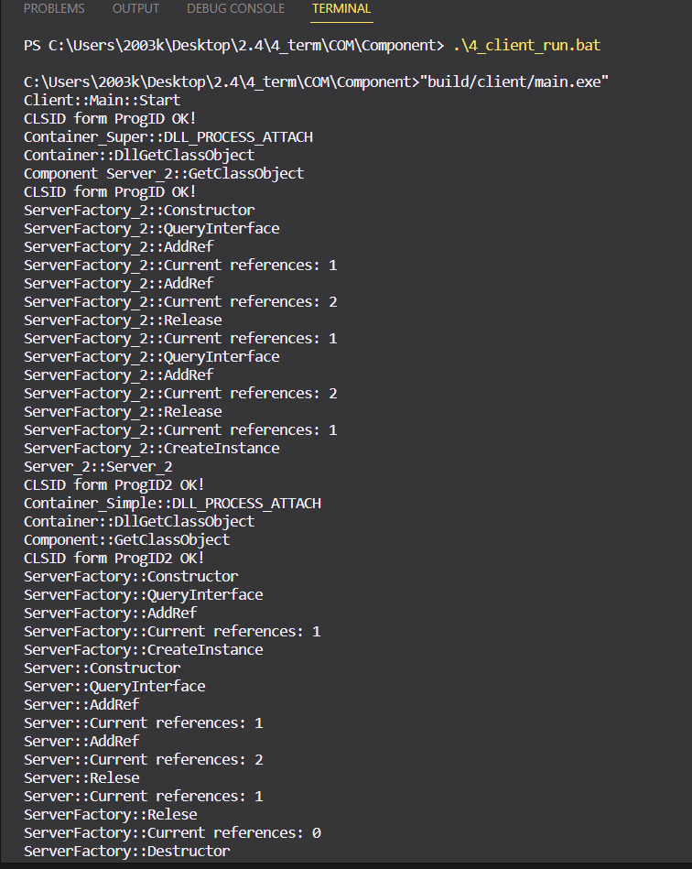

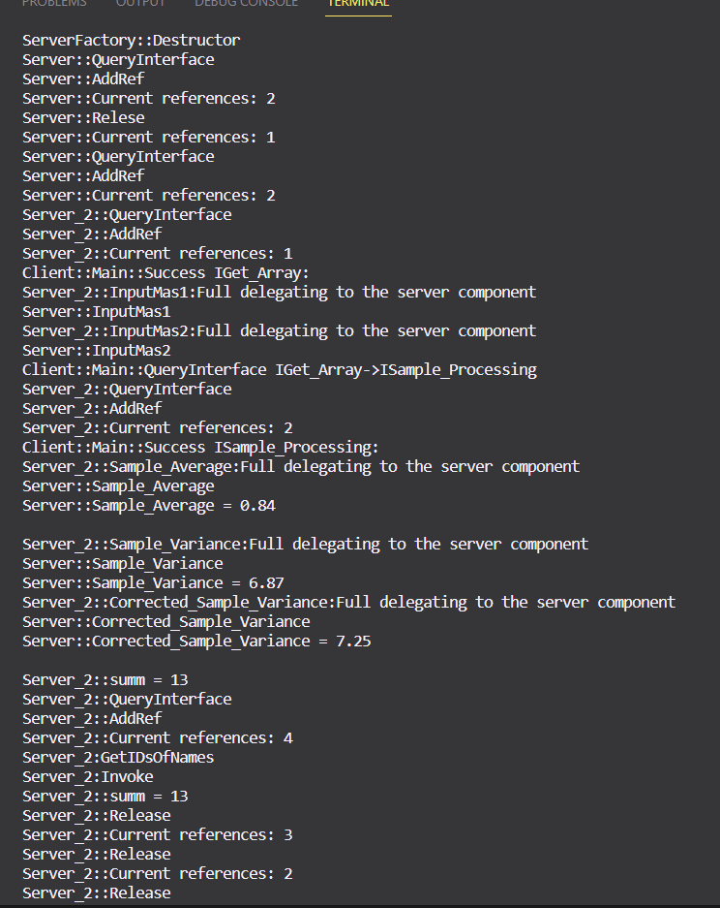 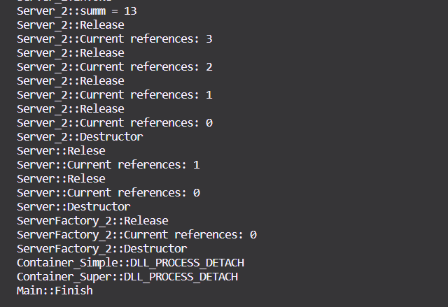

**Запуск script.vbs**



