select c.id, c.name, c.credit_rating

from s_customer c

where c.credit_rating LIKE 'GOOD'

and c.region_id LIKE 5

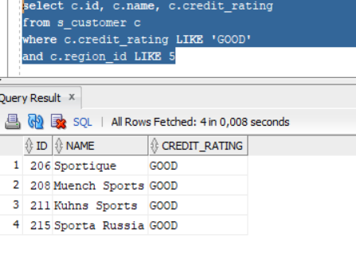

2 задание

select o.id, to_char(o.date_ordered, 'Day') "Week"

from s_ord o

order by to_char(o.date_ordered, 'D')

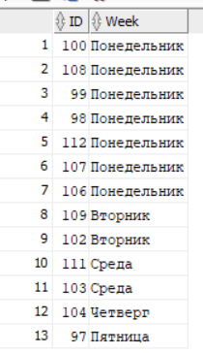

3 pflfybt

select o.id, o.total

from s_ord o

where o.total NOT BETWEEN 500 and 2500

and to_date(o.date_ordered)

BETWEEN TO_DATE('11.02.1988') and ('01.09.1992')

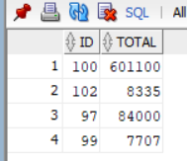

4 pflfybt

select c.name

from s_customer c

where length(c.name) > 5

and lower(c.name) like '%i%'

and lower(c.name) like '%s%'

Order by c.region_id

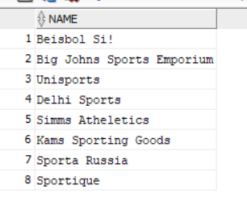

5 pflfybt

SELECT region_id, COUNT(*)

FROM s_dept

WHERE name LIKE '%s' OR name LIKE '%n'

GROUP BY region_id

HAVING COUNT(*) > 1

ORDER BY COUNT(*)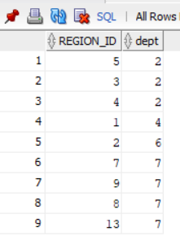

6 задание

select to_char(o.date_ordered, 'YYYY') || '(год) --- ' || count(*) || ' заказов' "Принятые заказы"

from s_ord o

group by to_char(o.date_ordered, 'YYYY')

order by "Принятые заказы"

