# Lypnytsky Denys, PhD

application architect, technical trainer, i-Klass Center LLC.

Е-mail: denis.lipnitsky@i-klass.com https://orcid.org/0000-0002-4616-7936

# Lypnytska Polina

partner, Up2Date Learn Online Courses

E-mail: [kumpersina@gmail.com](mailto:kumpersina@gmail.com), <https://orcid.org/>0000-0003-1722-1697

# MONEY SUPPLY IMPACT ON INVESTMENT AND GDP:

# STATISTICAL ANALYSIS

Introduction

Since the beginning of the 20th century, the world economy has faced two great challenges - the global financial crisis of 2007-2008 and the COVID-19 pandemic. To mitigate their impact, the world-leading money authorities lowered interest rates to the historical minimum and took non-traditional measures. This new monetary policy helped to maintain financial stability and support business activity. However, as a result, the top developed countries fell into a "liquidity trap" with interest rates close to zero and unprecedented public debt raising. Such a policy means, that the central banks and monetary authorities directly finance government spending (unacceptable in the orthodox economic theory) via the constant expansion of the monetary base [1]. In such circumstances, the emerging economies met new problems, including a strong need to maintain economic growth together with the high probability of increasing exchange rates and imported inflation.

The situation is getting even more complicated, since the world is experiencing the fundamental transformations brought by the 4th Industrial Revolution. Many of its technologies are still at the initial phase, which means that the further steps would require active government support [2], including new monetary policy measures. In this regard, an increase in money supply, long and cheap liquidity provision might have a positive impact on investment and real GDP growth. Whether this is the case and what preconditions are required for a positive scenario, is a matter of great theoretical and practical importance.

How the changes in money supply influence investment and GDP has been studied intensively in recent history. However, not all aspects of this impact have been sufficiently researched. In particular, in the presence of the “new normality” that has evolved in recent years. Which limits the use of well-known classical concepts and models in monetary policy, especially for emerging economies to which Ukraine belongs.

In this regard, the subject of the study is to assess the relationship between monetary aggregates, investment, and GDP by the world economic data analysis using mathematical statistics. The goal is to identify the elements of this relationship and describe their differences for various economies at the current stage of world development.

The article is structured as follows. First, it presents a brief predecessor studies overview and substantiates the research methods. Then the analysis of the relationship between money supply, investment, and GDP in different countries is given. The applied statistical methods are used in this part. After discussing the results, the paper makes inferences, draws conclusions, and suggests the directions for further research.

Review

Among the different goals that economic policy pursues, the most important one is GDP growth, which is highly dependent on many factors. If we put aside for a while the influence of commodity markets, labor migration, innovation, etc., then the money supply will perhaps have the strongest influence on GDP. Although as shown below, a change in the money supply directly or indirectly affects the discarded factors, causing even more complex effects. And the main transmission mechanisms of influence are aggregate demand and investments (gross volume and structure).

The impact of money supply on GDP growth is non-linear. The rise in the money supply (if it is uncontrolled) leads to inflation, which, by creating additional costs for economic entities leads to a reduction in working capital, income, and investment. At the same time, distortions of information caused by inflation provoke systematic errors in making economic and, especially, investment decisions. As a result, structural problems in the economy get worse. Negative dynamics of GDP may happen as a result.

It seems that the containment of emissions and the "sterilization" of the money supply should curb inflation and promote GDP growth. But the balance between surplus and scarcity is very delicate. A lack of money supply causes no less painful consequences, than money excess. This issue will be discussed in more detail below. For now, it suffices to mention that the presence of slight inflation driven by the growth of monetary aggregates is beneficial for the economy [3], and under certain conditions, a negative non-linear relationship between inflation and unemployment can be observed [4].

Since interdependencies between GDP and other macroeconomic factors are complex, economic policy uses many levers of control simultaneously. In addition to GDP growth, they are moderate inflation, control of unemployment, limiting the budget deficit and maintaining an acceptable trade balance. The multidimensional criterion of success, which takes into account the above-mentioned factors, has been called the "magic" quadrangle. It usually demonstrates the impossibility of achieving all four goals simultaneously (Fig. 1).

Therefore, economic policy is often forced to count on higher priority tasks, sacrificing the rest. During a severe economic downturn, inflation and budget deficits are usually sacrificed to recover and accelerate GDP growth. The entire quantitative easing policy pursued by the United States is proof of this. Low-interest rates and "helicopter" money allowed the US to restore stock indices and return GDP growth, but at the cost of inflation rising. The consumer price index in the United States increased by 2021 to a record level for 40 years – 6.8% [6]

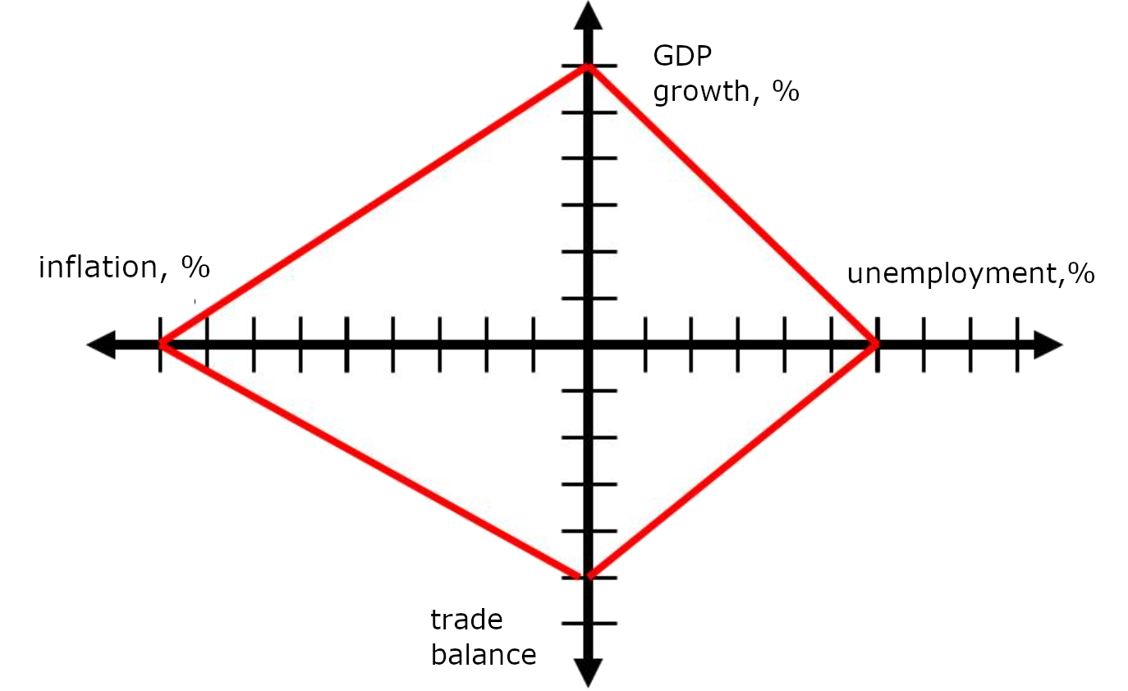

Figure 1. «Magical» quadrangle [5].

However, as you know, quad licet iovi, non licet bovi. The financial authorities of the other countries (Russia, China, Brazil, etc.), on the contrary, kept the interest rates at a high level since 2008. Their surge in inflation was mainly caused by non-emission factors. And despite the measures taken, the cancellation of the next stage of quantitative easing in the leading countries was followed by the expected outflow of capital from less developed economies to the USA, England, and Central Europe [7]. The external debt of individual countries like Ukraine, Turkey, India, and some others increased significantly. The monetization of these economies has suffered a decline. It resulted in a natural "sterilization" of their finances.

Regardless of its cause, "money hunger" is considered by many economists no less evil than uncontrolled inflation [8]. But despite this, people continue to believe in inflation targeting as the most useful vaccine against any economic disease. And the reason is not only the apparent simplicity of this recipe but its imposition by the world's leading financial institutions.

Inflation targeting performed through regulating monetary aggregates and/or discount rates is considered by the economists differently. The character of their assessment largely depends on the state of the economy under study [9]. For technologically and economically developed countries with huge capital stock, such targeting may have a positive impact on GDP growth. On the contrary, for less developed countries with low capitalization or suppressed aggregate demand, statistical data proved the neutrality of the targeting policy or even its negative impact on GDP.

At the same time, despite the statistical analysis, the very logic of economic mechanisms suggests that the excessive pressure on inflation by restraining the money supply causes a corresponding pressure on demand and investment. As a counterargument, it is argued that it will be risky to allow inflation to rise to 6% and above. Since beyond this line, price volatility, which is difficult to control, begins [10].

However, even if a “green corridor” is set within 4-5%, effective targeting is still difficult to implement. In particular, the macroeconomic information required for the regulator is distributed unevenly over time. Prices, production statistics, budget revenue, and the like data come to decision-making centers in different periods, which causes policy inaccuracies [11; 12]. Delays in the arrival of information lead targeting to the blind pursuit of an elusive target. And the most likely consequence of this is the excessive "sterilization" of the money supply up to the aforementioned "money hunger".

The negative consequences of long-term compaction of monetary aggregates are numerous. Some researches show that "money hunger" is especially aggressive towards the industries with a complex technological structure, and a high share of added value [13]. As a result, the first consequence of money's "evaporation" from the economy is the primitivization of its structure, which is obviously the case in Ukraine.

The monetary deficit also leads to a simplification of the structure of households consumption. The savings, and as a result, investments are going down. Investment strategies also boil down to the minimum need for survival, ignoring innovative, high-tech, and, especially, venture capital assets.

The reduction of high-tech industries and jobs causes an outflow of labor resources from the most promising sectors of the economy. As a result, labor migration may increase, and specifically, the outflow of the most qualified staff. All these factors, multiply reinforcing each other, cause multiple effects. Thus, the impact of the real money supply contraction on the decline in GDP becomes non-linear. Its influence on GDP growth is just as non-linear, but how exactly is a separate question.

# Econometric analysis

# *Problem formulation*

S. Blinov (2016) [13, p.9] describes the reasons why GDP growth requires not just recovery but an outstripping growth of the money supply. According to the author, "linear growth of real GDP requires exponential growth of real money supply." Among the reasons for this phenomenon is the structural complexity of the economy. It means that an increase in the growth of the money supply leads first to a rise in the number of transactions required to recreate (or form) this complex structure. Only then, to an increase in value-added, which is only a part of the total cost of transactions. Thus, figuratively speaking, monetary resources first fill all the buffers and channels of the "reclamation system" of the economy, and only then lead to "fertility".

This somewhat simplified logic ignores the life cycle of technologies. Which is of strong importance in the time of the 4th Industrial Revolution. Not only an increase in the money supply and aggregate demand can secure the growth of breakthrough technologies. It is especially the truth for the microchips industry, which is the base of the modern digital economy. The microchips industry's development requires many other conditions and actions that go beyond the scope of the actual monetary policy.

Nevertheless, under certain conditions, the effects mentioned in [13] can take place. If we consider the state of the Ukrainian economy against the background of the problems discussed, we can get a good illustration of what has been said.

The trend of the monetary aggregate M3 of Ukraine is shown in the chart below (Fig. 2) [14]. Fig. 3 also shows an increase in the inflation rates and prices for construction work, which illustrates the inflation of investment opportunities [15].

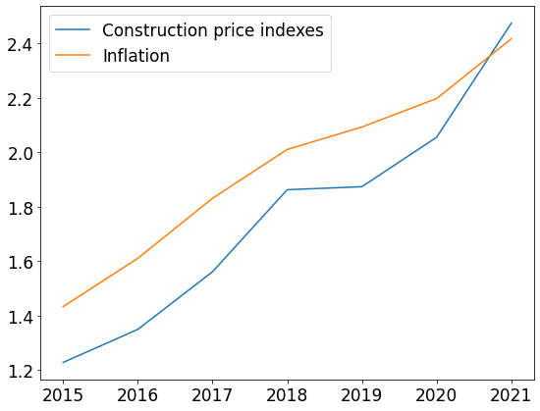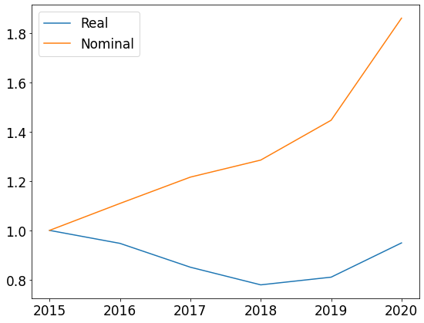

|  |  |
| --- | --- |
| Figure 2. Broad money (M3) index, UAH (Ukraine) | Figure. 3. Inflation and construction works price base indexes (Ukraine) |

From the illustrations above it is obvious, that the fall in the real money supply was about 10% between 2015 and 2020. Against the background of a long-term decline in real M3, its notable growth happened only in recent years (about 20% in 2020), while the inflation rate was much higher throughout the entire period under consideration.

The correspondence between the money supply and the productivity of the economy is usually measured by the monetization coefficient [16]:

Km = М / GDP, (1)

where: M – monetary supply aggregate, M2 or M3 (broad money);

GDP – gross domestic product.

Following the formula (1), monetization coefficients have been calculated for Ukrainian and several foreign economies. The results are shown in Table. 2.

Table 2.

Global monetization coefficients, 2020

|  |  |  |  |  |  |  |
| --- | --- | --- | --- | --- | --- | --- |
| Ukraine | Russia | Japan | India | China | USA | Brazil |
| 44% | 60% | 258% | 73% | 205% | 95% | 96% |

It is worth mentioning, that the GDP boosting by expanding the money supply is a task far from having a simple solution for a particular economy. It is obvious that the monetization of the Ukrainian economy is insufficient for long-term and productive economic growth. Even more, for the increasing complexity of the domestic economy. But the question remains, what coefficient might be considered sufficient?

Take Japan and China, for example, where monetization coefficients are 258% and 205%, respectively. Both of these countries do not have a liquidity crisis. However, it is only China where the cash flow turns the “millstones” of economic growth. In Japan, the problems, piled up in economy and finance during the “lost decade” [17], inhibit now investment activity even in presence of a significant increase in liquidity. China, whose investment channels are more straightforward than its neighbor's, is showing more progress. However, China also runs the risk of facing similar difficulties in the future due to accumulating “bad debts” [18].

To what extent should monetary aggregates be built up without excessive inflation? F. Kartaev, says that the level of harmless inflation can be "a little more than 10% for developing economies" [19]. Then, he insists that inflation must be kept substantially lower even for such countries. The author favors inflation targeting over money supply expansion, insisting that the long-term impact on GDP growth from the first is more robust than from the second. Thus, the opinions of F.Kartaev and S.Blinov are opposed.

Some authors study the differences in monetary policy and its impact on inflation and GDP growth for countries with distinct economic or socio-cultural conditions. F. Kartaev explores the countries with different ethnolinguistic diversity [20]. O. Klochkova analyzes inflation in countries with different levels of economic freedom [21]. However, these studies do not provide any universal conclusions.

Thus, the following points were taken as a theoretical basis for the study: firstly, the hypothesis concerning the positive impact of the expansion of the real money supply and monetization of the economy on the growth of investment and, as a result, GDP growth. Secondly, the alleged ambiguity of the criteria and approaches for stimulating GDP growth by “calming down” exchange rates and inflation. Thirdly, there is a wide variety of economies of individual countries, which highly differ in sectoral structure, trade balance, debt burden, global cooperation, etc. This diversity, however, is desirable to be reduced to certain patterns. Taking into account the foregoing facts and hypotheses, a statistical analysis of the World Bank data time series was conducted [22]. Its results are shown and explained below.

## Analysis of relationship between the real money supply and investment

As the information base for the study, the official statistics of the World Bank were taken (including M3 – broad money, gross capital formation, GDP, and population for individual countries) for the period 2006–2020. The period was chosen deliberately from the year before the real-estate bubble burst to the year, when the "COVID-19" crisis began. The influence of the latter one on the world economy has not yet ceased, and in certain markets, for example, electronics, it is only increasing these days [23].

The calculations were accomplished using the statistics and machine learning library Scikit-learn [24] in Python programming language. The code and its execution results are given as an interactive notebook and are available at the following GitHub link [25].

By the authors cited above [10; 11; 13], the relationship between monetary aggregates and GDP is considered to be confirmed. Investments are acknowledged as an intermediate agent for such influence. However, the impact of monetization on the investment itself has not been sufficiently and quantitively studied by them. Therefore, as a complement to the above-mentioned works, the impact of M3 money aggregate on gross capital formation was studied (to isolate the investment influence on GDP growth and examine it in its pure form).

The relationship between broad money and investment was measured by computing the Pearson correlation coefficients [26] for all countries from the World Bank report. Then the empirical threshold for the Pearson coefficient was set at 65%. This threshold helped to separate the countries with a proven relationship between broad money and investment activity. Table 3 below shows a fragment of the top-list, sorted by the correlation strength.

The list turned out to be quite heterogeneous. In addition to India, China, the United States, and England, it includes some countries from a completely different division, like Peru and Cambodia. However, 71% of all investigated countries showed a significant relationship between broad money and gross investment. The histogram of Pearson correlation coefficients (Fig. 4) indicates that most countries naturally fall into the "core", that is, a group with the highest degree of correlation.

And if the observation of time series for individual countries itself only displays a probable similarity in M3 and gross investment tendencies (Fig. 5), then regression analysis proves the existence of a significant relationship between them.

Table 3.

TOP countries by correlation between

М3 and gross capital formation (2020)

|  |  |  |
| --- | --- | --- |
| **Country**  Figure 4. Histogram of correlation between broad money and gross capital formation | **Correlation coefficients** | **GDP per**  **capita , USD** |
| Kazakhstan | 0,956351 | 26 352 |
| Sweden | 0,956661 | 52 850 |
| Peru | 0,958855 | 12 854 |
| Cambodia | 0,962369 | 4 389 |
| Turkey | 0.963198 | 28 385 |
| Kyrgyzstan | 0,971727 | 5 258 |
| S.Korea | 0,974348 | 42 719 |
| India | 0,983017 | 6 717 |
| China | 0,992802 | 16 411 |
| USA | 0,869843 | 60 162 |
| UK | 0,835022 | 41 627 |

The Turkey example below illustrates this relationship, including the linear regression equation shown in Fig. 6, (the coefficient of determination equals 71%). This judgment applies equally to all countries that have passed the determined threshold of 65% for the Pearson correlation coefficient. Thus, the relationship between the two factors is proven.

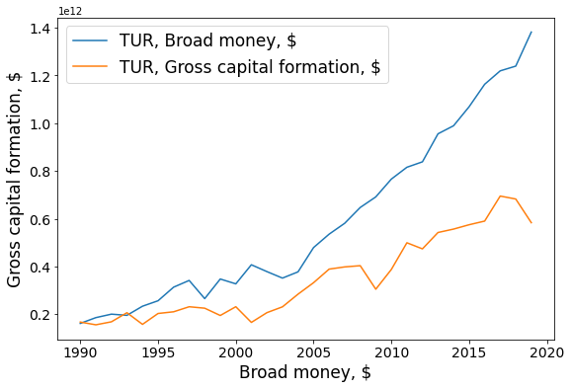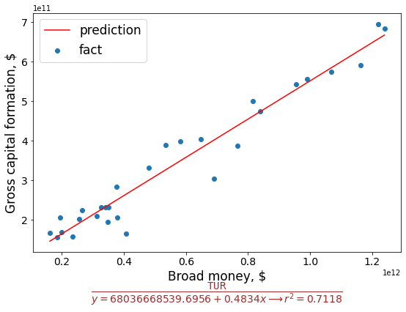

|  |  |
| --- | --- |
| Figure 5. Broad money and gross capital formation (Turkey) | Figure 6. Regression analysis (Turkey) |

## Further analysis and discussion

It is believed that the influence of the money supply on investment and via investment on GDP depends significantly on the level of the country's economic development. At the same time, in less developed and poor countries, the expansion of the money supply can only cause excessive inflation and thus harm the GDP. Thus, the practicality of inflation targeting is supposed to be confirmed.

To clarify this hypothesis, the next stage of the study was accomplished. The "nearest neighbors" were chosen as an analytical method [27]. The classification of countries was carried out using it. As a result, the countries were separated in a two-dimensional feature space. Namely, per capita income (1) and the tightness (Pearson coefficient) of the relationship between broad money and gross capital formation (2). The outcomes of the classification are shown in Fig. 6.

The dividing of countries into two groups was done with 91% accuracy. The fulfilled statistical analysis (together with its results and conclusions) partly conflict with the opinions of the above-mentioned authors. As expected, countries with the highest GDP per capita ended up in a strongly correlated class (blue labels in Fig. 6).

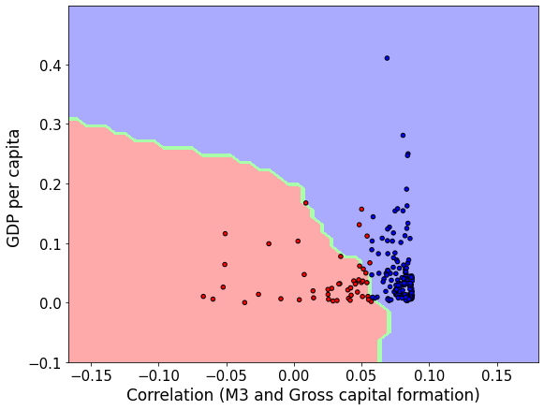

Figure 6. “Nearest neighbors” classification

However, the biggest number of poor countries also belongs to that class. The figure shows them as a dense cluster of blue dots in the lower right corner. At the same time, some middle-income countries (as well as poor ones) are found to belong to the class with a low correlation between broad money and gross investment. Therefore, we can talk about the incorrectness of the hypothesis that the growth of the money supply has a positive effect on investment and GDP growth only for developed and rich countries.

That the vast majority of the analyzed countries ended up in the class with a provable correlation regardless of their wealth and development. The share of such countries was 79%. On the contrary, among the remaining 21%, there are countries with predominantly middle and low per capita income.

To expand the study, countries cluster analysis was executed in the same feature space. These heterogeneous indicators (GDP per capita and correlation coefficient) were also normalized, as in the classification method shown above. The “mean shift” method was applied for this cluster analysis [28.]. The internal parameters of the “mean shift” method were selected based on cross-validation, maximizing the accuracy of separating the countries in the feature space. The results of the analysis are illustrated in Fig. 7. The countries were divided into five clusters, marked in the figure in different colors (with the centers of the clusters marked with larger circles).

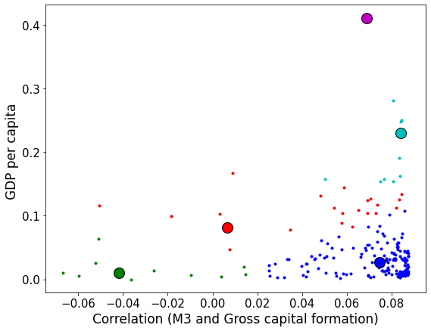

Figure 7. “Mean shift” clustering

The analysis showed that the largest group, marked in blue in the lower right corner, included 78% of the total number of the countries. And these are precisely the countries with a relatively low level of GDP per capita but at the same time a high correlation between broad money and investment. For such countries, the increase of monetization is strongly linked with GDP growth.

Economic logic itself suggests that the low savings ratio and weak financial institutions in such countries make them very susceptible to money supply decrease and decline in monetization. Up to very negative consequences for their economy. These countries' group includes India, Turkey, China, Brazil, Mexico, and several other Latin American countries.

Rich countries in the upper right quadrant of the figure (consisting of two relatively small clusters) have shown, as expected, the strong positive relationship between the broad money supply and investment growth.

In contrast, the green cluster (low correlation and low per capita income) in the lower-left quadrant predictably includes countries ravaged by war or poverty, such as Ethiopia and Libya.

However, there is also a small group of countries where the relationship between M3 and gross investment does not depend on wealth. They are represented by the red cluster in the figure. Among the countries in this group are Japan, Switzerland, and Panama. These are three clear examples of how different economic destinies brought them to this neighborhood. Japan is still unable to resurrect the economy and the financial institutions' normal functioning after the “lost decade”. The other two countries are offshore havens whose economies are weakly dependent on domestic monetary policy.

**Conclusions**

Money is not just a "blanket" thrown over economy to warm it up. They can and do work, but only with varying degrees of success. Monetary policy is the tool that helped overcome two global crises, but it also created new problems. Namely, uncontrolled price increases and "financial bubbles" inflating.

As shown by the statistical analysis, money is important, but not always the decisive factor for the growth of investment and GDP. Moreover (and it should be emphasized), this conclusion does not directly depend on the level of economic development. In most world countries (both developed and developing), a strong relationship exists between real money supply and investment. This relationship leads to GDP growth. But at the same time, there are certain rich economies, where the growth of the real money supply is weakly related to the increase of investments. There are also those lagging, where the dependence is almost functional (but until the possibilities of extensive growth are exhausted).

Despite the importance of monetary variables, key factors that influence the "real money supply-investment-GDP" chain should be investigated outside the monetary sphere. The conclusion has long been known but is relatively new for the current conditions. The sustained expansion of the monetary base and the growth of the real money supply do matter. But they cannot by themselves solve the fundamental problems of modernizing economic institutions and bridging technological gaps. Concerning the Ukrainian economy, the regulator has to maintain a stable growth of real money supply. It is essential for solving the accumulated problems, providing that the government creates preconditions for accelerating the national technical and technological development and raising the general level of the economy. Such complex rules for economic policy should be considered a priority for further research in this subject area.

# References

1. Damiano, Sandri, Itai Agur, Damien Capelle, Giovanni Dell'Ariccia (2022). Monetary Finance: Do Not Touch, or Handle with Care? International Monetary Fund. Retrieved from *https://www.imf.org/en/Publications/Departmental-Papers-Policy-Papers/Issues/2022/01/11/Monetary-Finance-Do-Not-Touch-or-Handle-with-Care-464862*
2. Vishnevsky, V. (2022). Digital technologies and problems of industrial development. Economics of Ukraine. № 1. P. 47—66. DOI: *https://doi.org/10.15407/economyukr.2022.01.047*, с. 63. [in Ukrainian].
3. Adam, K., Weber, H. (2019). Optimal Trend Inflation. American Economic Review. 2019. Vol. 109. № 2. P. 702–737.
4. Phillips, A.W. (1958). The Relation Between Unemployment and the Rate of Change of Money Wage Rates in the United Kingdom, 1861-1957. Economica. P. 283-299.
5. Kaldor, N. (1971). Conflicts in National Economic Objectives. [Economic Journal](https://econpapers.repec.org/article/ecjeconjl/). vol. 81, issue 321, pp. 1-16.
6. Inflation in the US accelerated to a record since 1982. (2021). Economic truth. [in Russian].
7. Zaiko N. (2015). Quantitative Easing in the United States: Implications for Developing Countries. Regional problems of economic transformation, (6 (56)), 96-100. [in Russian].
8. Krugman, P. (2010). Why Is Deflation Bad. The New York Times.
9. Stiglitz, J. (2008). Inflation Targeting: A Test of Reality. News №. 88.
10. Perevyshina, E.A. (2017). Influence of inflation on the pace of economic growth. Finance and credit. №9. [in Russian].
11. Kartaev, F. (2017). Is inflation targeting good for economic growth? Voprosy Ekonomiki. №2. [in Russian].
12. Stiglitz, J. (2008, May 6)). The Failure of Inflation Targeting. Project Sindicate. Retrieved from .[*http://www.project-sindicate.org*](http://www.project-sindicate.org/)
13. Blinov, S. (2015). Real money and economic growth. Munich Personal RePEc Archive. Retrieved from [*https://mpra.ub.uni-muenchen.de/id/eprint/67256*](https://mpra.ub.uni-muenchen.de/id/eprint/67256). [in Russian].
14. National Bank of Ukraine. Retrieved from https://bank.gov.ua.
15. Price index for construction works. Ministry of Finance. Retrieved from [*https://index.minfin.com.ua/economy/index/buildprice/*](https://index.minfin.com.ua/economy/index/buildprice/)
16. Pshinko, A., Myamlin, V., Myamlin, S. (2012). Influence of the velocity of circulation of the money supply on the efficiency of the national economy. Science and progress of transport. Bulletin of the Dnepropetrovsk National University of Railway Transport. № 42. [in Ukrainian].
17. Fumio Hayashi. (2001). The 1990s in Japan: A Lost Decade. University of Tokyo. DOI: [*https://doi.org/10.1006/redy.2001.0149*](https://doi.org/10.1006/redy.2001.0149)*.*
18. China's Potential Loss From NPLs Estimated At $1 Trillion. (2016). RBC. Retrieved from *https://www.rbc.ru/finances/06/05/2016/572c79239a7947861367effd*
19. Kartaev, F. (2019). How inflation targeting influences economic growth. Ekons. Retrieved from [*https://econs.online/articles/opinions/kak-inflyatsionnoe-targetirovanie-vliyaet-na-rost/*](https://econs.online/articles/opinions/kak-inflyatsionnoe-targetirovanie-vliyaet-na-rost/) [in Russian].
20. Kartaev, F. (2018). Assessment of the impact of monetary policy on economic growth for various groups of countries. Finance: theory and practice. T. 22, №1. [in Russian].
21. Klochkova, O. (2017). Modeling the impact of inflation on economic growth for countries with different levels of economic freedom. Economic policy. Т. 12. № 5. p. 22–41.
22. World Bank. Retrieved from *https://www.worldbank.org*
23. Kelion, L. (2021, February 5). The world is running out of chips. What does the coronavirus have to do with it and what will happen to electronics now. BBC. Retrieved from [*https://www.bbc.com/russian/news-55950090*](https://www.bbc.com/russian/news-55950090) [in Russian].
24. Scikit-learn. Retrieved from [*https://scikit-learn.org/*](https://scikit-learn.org/)
25. Lypnytska, P. [Invest2M2World](https://github.com/Polinden/Invest2M2World). GitHub. Retrieved from https://github.com/Polinden/Invest2M2World.
26. All of Statistics: A Concise Course in Statistical Inference. (2004). Springer. New York. P. 434.
27. Hastie, T. (2017). The Elements of Statistical Learning. Springer. New York. P. 745.
28. Comaniciu, D., Meer, P. (2002). Mean Shift: A Robust Approach toward Feature Space Analysis. EEE Transactions on Pattern Analysis and Machine Intelligence.