# **Lypnytsky Denys**, **PhD**

application architect, technical trainer, i-Klass Center LLC.

Е-mail: denis.lipnitsky@i-klass.com https://orcid.org/0000-0002-4616-7936

# **Lypnytska** **Polina**

_________________________________________________________________

_______________________ https://orcid.org/__________________

# MONEY SUPPLY INFLUENCE ON INVESTMENT AND GDP:

# STATISTICAL ANALYSIS

Introduction

Since the beginning of the twentieth century, the world economy has faced two challenges - the global financial crisis of 2007-2008 and the COVID-19 pandemic. To mitigate their impact, the world-leading money authorities lowered interest rates to the historical minimum and took non-traditional measures. A new monetary policy helped to maintain financial stability and support business activity. However, as a result, the top developed countries fell into a "liquidity trap" with interest rates close to zero and unprecedentedly rase of public debt. To continue such a policy means the central banks and monetary authorities direct participation in financing government expenditures (unacceptable in the orthodox economic theory) via the constant expansion of the monetary base [1]. In such circumstances, the emerging economies faced a few new problems, including the heavy need to maintain economic growth along with the risk of a high probability of increasing exchange rates and imported inflation.

The situation is getting more difficult since the world is experiencing the fundamental transformations towards the Fourth Industrial Revolution. Many of its technologies are still at the initial phase of the life cycle, which means that the further steps may require active government support [2], including the monetary policy measures. In this regard, an increase in money supply and long cheap liquidity provision may have a positive impact on investment and real GDP growth. Whether this is the case and what preconditions are required for such a positive outcome, is a matter of great theoretical and practical importance.

As you know, the impact of changes in the money supply on investment and GDP has been studied actively in recent history. However, not all aspects of this relation have been sufficiently researched. In particular, in the presence of the “new normality”, that has evolved in recent years. Which limits the use of well-known classical concepts and models for an effective monetary policy formation, especially in emerging economies to which Ukraine belongs.

In this regard, the subject of this work is to determine the relationship between monetary aggregates, investment, and GDP in the new conditions by analyzing the time series of economic data for countries around the world using mathematical statistics. Its purpose is to identify the elements and differences of these relations for various economies at the present stage of world development.

The article is structured as follows. First, it presents a brief overview of the work of precursors and substantiates research methods. Then the analysis of the connection between money supply, investment, and GDP in different countries using statistical methods is given. In the end, after discussing the results, the paper suggests judgments and directions for further research.

Analytical review

Among the long-term goals of economic policy, one of the most important is GDP growth, which is closely related to many factors. If we put aside for a while the influence of commodity markets, labor migration, innovation, etc., then the money supply will, perhaps, have the strongest influence on GDP. Although, as shown below, a change in the money supply directly or indirectly affects the discarded factors, causing even more complex effects. And the main transmission mechanisms of influence are aggregate demand, volume, and structure of investments.

The impact of money supply on GDP growth is non-linear. The uncontrolled rise in the money supply leads to inflation, which, by creating additional costs for economic entities, leads to a reduction in working capital, income, and investment. At the same time, distortions of information caused by inflation provoke systematic errors in making economic and, especially, investment decisions. As a result, structural problems in the economy were exacerbated. The result may be a negative dynamics of GDP.

It would seem that the containment of emissions and the "sterilization" of the money supply should curb inflation and promote GDP growth. But the balance between surplus and scarcity is very delicate. And the easily occurring lack of money supply causes no less painful processes in the economy than their excess, which will be discussed in more detail below. For now, it suffices to mention that the presence of slight inflation caused by the growth of monetary aggregates is considered beneficial for the economy [3], although under certain conditions a negative non-linear relationship between inflation and unemployment can be observed [4].

Since there are complex interdependencies between GDP and other macroeconomic indicators, economic policy tries to simultaneously use many levers. Among them, in addition to GDP growth, there are moderate inflation, control of unemployment, limiting the budget deficit, and maintaining an acceptable trade balance. The complex criterion of success, taking into account the above, has been called the "magic" quadrangle. It usually demonstrates the impossibility of simultaneously achieving all four goals (Figure 1).

Therefore, economic policy is often forced to count on higher priority tasks, sacrificing the rest. During a severe economic downturn, inflation and budget deficits are usually sacrificed to recover and accelerate GDP growth. The entire quantitative easing policy pursued by the United States is proof of this. Low-interest rates and "helicopter" money allowed the US to restore stock indices and return GDP growth, but at the cost of inflation rising. The consumer price index in the United States increased by 2021 to a record level for 40 years - 6.8% [6]

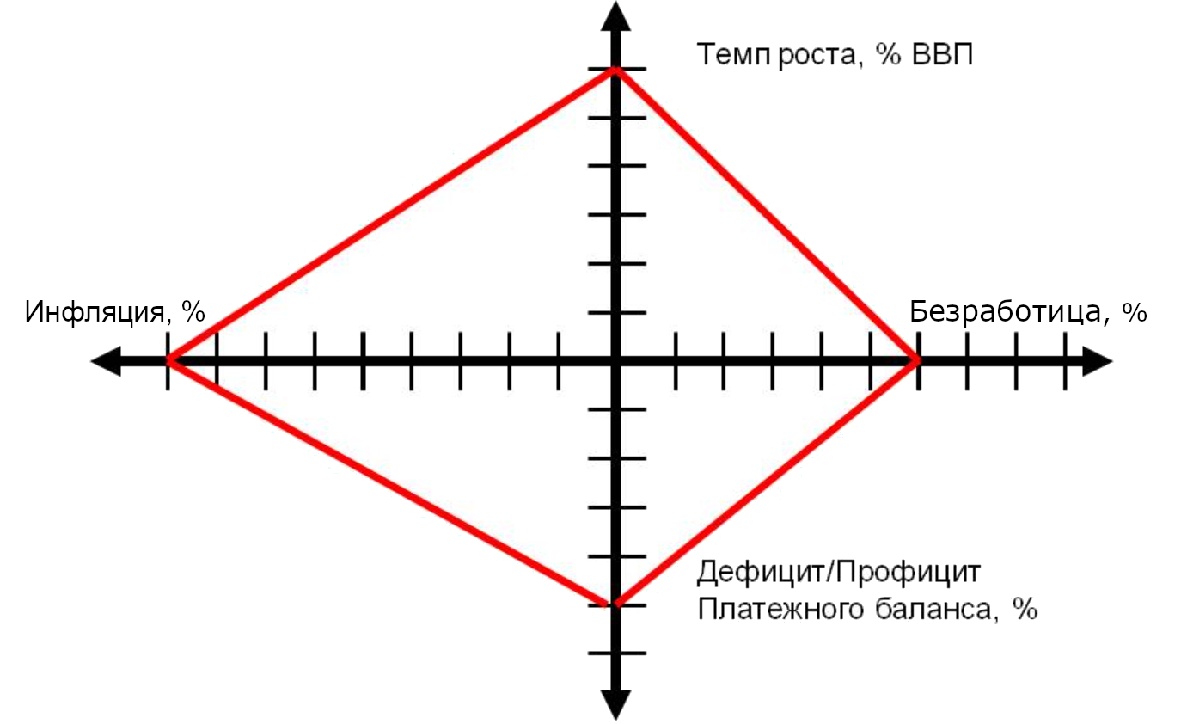

Figure 1. «Magical» quadrangle [5].

However, as you know, quad licet iovi, non licet bovi. The financial authorities of the other countries (Russia, China, Brazil, etc.), on the contrary, kept interest rates at a high level since 2008. Their surge in inflation was mainly caused by non-emission factors. Despite the measures taken, the cancellation of the next stage of quantitative easing was followed by the expected outflow of capital from developing economies to the USA, England, and Central Europe [7]. The external debt of individual countries like Ukraine, Turkey, India, and some others increased significantly. Economy monetization of these economies has declined significantly. It resulted in a natural "sterilization" of their finances.

Regardless of the causes, "money hunger" is considered by many economists no less evil than the loss of control over inflation [8]. But despite this, people continue to believe in inflation targeting as a vaccine against many diseases of the economy. And the reason is not only the apparent simplicity of this recipe but also its imposition by the world's leading financial institutions.

At the same time, inflation targeting by regulating monetary aggregates and discount rates is assessed by economists in different ways. The character of the assessment largely depends on the state of the economy under study [9]. For technologically and economically developed countries with large capital stock, such targeting had a positive impact on GDP growth. On the contrary, for less developed countries with low capitalization or suppressed aggregate demand, statistical data showed the neutrality of the targeting policy or even its negative impact on GDP.

At the same time, despite the statistical analysis, the very logic of economic mechanisms suggests that the excessive regulators pressure on inflation by restraining the money supply causes a corresponding pressure on demand and investment. As a counterargument, it is argued that it will be a big risk to allow inflation to rise to 6% and above, since beyond this line high price volatility begins, which is difficult to control [10].

However, even if a “green corridor” is set within 4-5%, effective targeting remains difficult to implement. In particular, this is since the macroeconomic information necessary for the regulator is unevenly distributed over time. Prices, production statistics, budget revenue, etc, data come to decision-making centers in different periods, which causes policy inaccuracies [11; 12]. Delays in the arrival of information lead targeting to the blind pursuit of an elusive target. And the most likely consequence of this is the excessive "sterilization" of the money supply up to the aforementioned "money hunger".

The negative consequences of a prolonged contraction of monetary aggregates are numerous. Some researches show that "money hunger" is most aggressive in respect to industries with a complex technological structure, with a high share of added value [13]. As a result, the first consequence of the "evaporation" of money from the economy is the primitivization of its structure, which is observed in Ukraine.

The monetary deficit also leads to a simplification of the structure of consumption among households. The volume of savings, and as a result, investments are reduced. Investment strategies are also simplified to investments in the simplest areas, ignoring innovative, high-tech, and, especially, venture capital assets.

The reduction of high-tech industries and jobs causes an outflow of labor resources from the most promising sectors of the economy. As a result, labor migration may increase, and more specifically, the outflow of the most qualified personnel. All these factors, multiply reinforcing each other, cause multiple effects. Thus, the impact of the reduction in the real money supply on the decline in GDP becomes non-linear. Its influence on GDP growth is just as non-linear, but how exactly is a separate question.

# Econometric analysis

# *Problem formulation*

S. Blinov (2016) [13, p.9] describes the reasons why GDP growth requires not just recovery, but an outstripping growth of the money supply. According to the author, "linear growth of real GDP requires exponential growth of real money supply." Among the reasons for this phenomenon was the structural complexity of the economy. This means that an increase in the growth of the money supply leads first to an increase in the number of transactions required to recreate or form a complex structure, and then to an increase in value-added, which is only a part of the total cost of transactions. Thus, figuratively speaking, monetary resources first fill all the buffers and channels of the "reclamation system" of the economy, and only then lead to "fertility".

This is a somewhat simplified logic that ignores the factor of technological development and the life cycle of technologies, which is of strong importance in the conditions of the Fourth Industrial Revolution. No increase in the money supply and consumer demand can in itself ensure the development and development of breakthrough technologies, for example, in the production of microchips, on which the entire modern digital economy is based. This requires many other conditions and actions that go beyond the scope of the actual monetary policy.

Nevertheless, under certain conditions, the effects noted in [13] can take place. If we consider the state of the Ukrainian economy against the background of the problems discussed, we can get a good illustration of what has been said.

The dynamics of the important monetary aggregate M2 of Ukraine are shown in the chart below (Fig. 1) [14]. Fig. 2 also shows an increase in the inflation rates and prices for construction work, which well illustrate the inflation of investment opportunities [15].

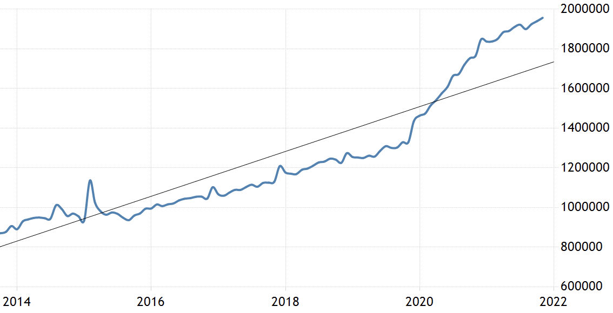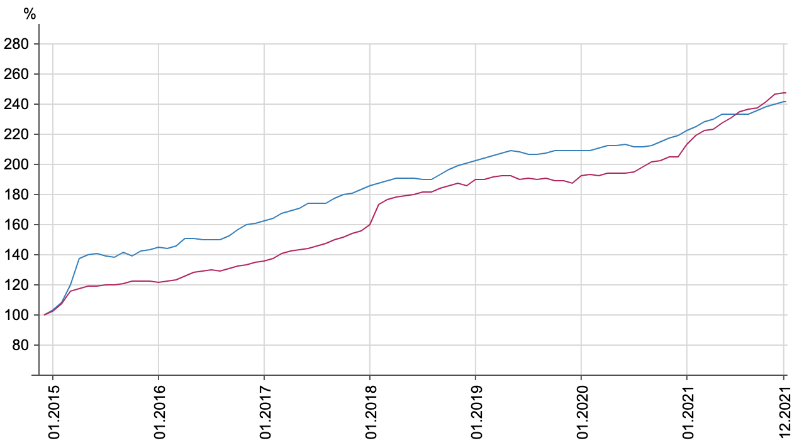

Figure. 2. Inflation rates and construction works price indexes

Figure 1. Ukraine M2, UAH mln.

It is obvious from the illustrations above that the fall in the real money supply from 2015 to 2021 was about 10%. Against the background of a long-term decline in real M2, its notable growth happened only in recent years (about 20% in 2020), while the inflation rate was approximately the same throughout the entire period under consideration.

The correspondence between the money supply and the productivity of the economy is usually measured by the monetization coefficient [16.]:

Km = М2 / GDP, (1)

where: M2 is the monetary supply aggregate;

GDP – gross domestic product.

Following the formula (1), monetization coefficients were calculated for Ukrainian and several foreign economies, the results are shown in Table. 2.

Table 2.

Global monetization coefficients, 2020

|  |  |  |  |  |  |  |
| --- | --- | --- | --- | --- | --- | --- |
| Украина | Россия | Япония | Индия | Китай | США | Бразилия |
| 43% | 60% | 258% | 73% | 205% | 95% | 96% |

It is worth to be mentioned, that boosting GDP growth by expanding the money supply is a task far from having a simple solution for a particular economy. It is obvious that the monetization of the Ukrainian economy is insufficient for economic growth and even more, for the economic complexity increasing. But the question remains, what coefficient might be considered sufficient?

Take Japan and China, for example, where monetization coefficients are 258% and 205%, respectively. Both of these countries do not have a liquidity crisis. However, it is only in China where the cash flow turns the “millstones” of economic growth. In Japan, the problems, piled up in economy and finance during the “lost decade” [17], inhibit now investment activity even in presence of a significant increase in liquidity. China, whose investment channel is more straightforward than its neighbor's, is showing more progress. However, China also runs the risk of facing similar difficulties in the future due to accumulating “bad debts” [18].

To what extent should monetary aggregates be built up without excessive inflation? F. Kartaev, says that the level of harmless inflation can be "a little more than 10% for developing economies" [19]. Then, he insists that inflation must be kept substantially lower even for such countries. The author favors inflation targeting over money supply expansion, insisting that the long-term impact on GDP growth from the first is more robust than from the second. Thus, the opinions of F.Kartaev and S.Blinov are opposed.

Some authors study the differences in monetary policy and its impact on inflation and GDP growth for countries with distinct economic or socio-cultural conditions. So F. Kartaev explores the countries with different ethnolinguistic diversity [20]. O. Klochkova analyzes inflation in countries with different levels of economic freedom [21]. However, these studies do not provide any universal conclusions.

Thus, the following points were taken as a theoretical basis for the study: firstly, the hypothesis concerning the positive impact of the expansion of the real money supply and monetization of the economy on the growth of investment and, as a result, GDP. Secondly, the alleged ambiguity of the criteria and approaches for stimulating GDP growth by “calming down” exchange rates and inflation. Thirdly, there is a wide variety of economies of individual countries, which highly differ in sectoral structure, trade balance, debt burden, global cooperation, etc. This diversity, however, is desirable to be reduced to certain patterns. Taking into account the foregoing facts and hypotheses, a statistical analysis of the World Bank data time series was conducted [22]. Its results are shown and explained below.

## *A*nalysis of real money supply and investment relationship

The official statistics of the World Bank for individual countries including M2 monetary aggregate, gross investment, GDP, and population for the period 2006–2020 were chosen as the information base for the study. That is, from the moment before the start of the "real estate" crisis to the beginning of the "COVID-19" crisis. However, the influence of the latter on the world economy has not yet ended, and in certain markets, for example, electronics, it is only increasing these days [23].

The calculations were accomplished using the statistics and machine learning library Scikit-learn [24] in Python programming language. The program code and the results of its execution are presented as an interactive notebook and are available at the following link [25].

By the authors cited above [10; 11; 13], the relationship between monetary aggregates and GDP is considered to be confirmed. Investments are acknowledged as an intermediate agent for such influence. However, the impact of monetization on the investment itself has not been sufficiently and quantitively studied by them. Therefore, as a complement to the above-mentioned works, the impact of the M2 money aggregate on gross investment was studied to isolate the investment influence on GDP growth and examine it in its pure form.

The relationship between the M2 money aggregate and gross investment was measured by computing the Pearson correlation coefficients [26] for all countries in the World Bank report. Then the empirical threshold for the Pearson coefficient was set at 65%. This threshold helped to select the countries with a proven relationship between M2 and investment activity. Table 3 below shows a fragment of the top of the list, sorted by the strength of correlation.

The list turned out to be quite heterogeneous. In addition to India, China, the United States, and England, it includes some countries from a completely different division, like Peru and Cambodia. However, 71% of all investigated countries showed a significant relationship between M2 and gross investment. The histogram of Pearson correlation coefficients (Fig. 3) indicates that most countries naturally fall into the "core", that is, a group with the highest degree of correlation.

And if the observation of time series for individual countries itself only displays a probable similarity in M2 and gross investment tendencies (Fig. 4), then regression analysis proves the existence of a significant relationship between them.

Table 3.

between

М2 and gross investments (2020)

|  |  |  |
| --- | --- | --- |
| **Country** | **Correlation coefficients** | **GDP per**  **capita , USD** |
| Казахстан | 0,956351 | 26 352 |
| Швеция | 0,956661 | 52 850 |
| Перу | 0,958855 | 12 854 |
| Камбоджа | 0,962369 | 4 389 |
| Турция | 0.963198 | 28 385 |
| Киргизия | 0,971727 | 5258 |
| Корея | 0,974348 | 42 719 |
| Индия | 0,983017 | 6 717 |
| Китай | 0,992802 | 16 411 |
| США | 0,869843 | 60 162 |
| Англия | 0,835022 | 41 627 |

Figure 3. Histogram of correlation between M2 and gross investment

The Turkey example below illustrates this relationship, including the linear regression equation shown in Fig. 5, (the coefficient of determination equals 71%). This judgment applies equally to all countries that have passed the determined threshold of 65% for the Pearson correlation coefficient. Thus, the relationship between the two factors is proven.

Figure 5. M2 and gross investment

regression analysis (Turkey)

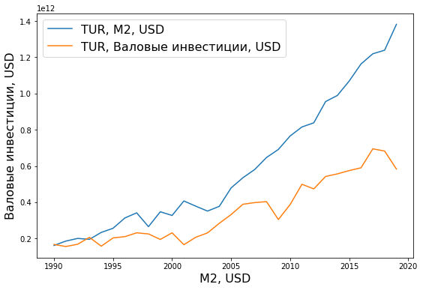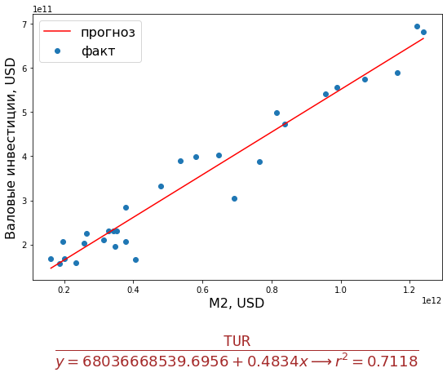

Figure 4. M2 and GDP time

series (Turkey)

## Further analysis and discussion

It is believed that the influence of the money supply on investment and via investment on GDP depends significantly on the level of the country's economic development. At the same time, in less developed and poor countries, the expansion of the money supply can only cause excessive inflation and thus harm the GDP. Thus, the practicality of inflation targeting is supposed to be confirmed.

To clarify this hypothesis, the following stage of the study was accomplished. The "nearest neighbors" were chosen as a method for analysis [27.]. On its basis, the classification of countries participating in the study was carried out. As a result, the countries were separated in a two-dimensional feature space, namely, per capita income (1) and the tightness (Pearson coefficient) of the relationship between M2 and investment (2). The outcomes of the classification are shown in Fig. 6.

The dividing of countries into two groups was done with 91% accuracy. The interpretation of the results of this statistical analysis is partly contradicting the judgments of the authors mentioned above. Indeed, as expected, countries with high GDP per capita ended up in a highly correlated class (blue labels in Figure 6).

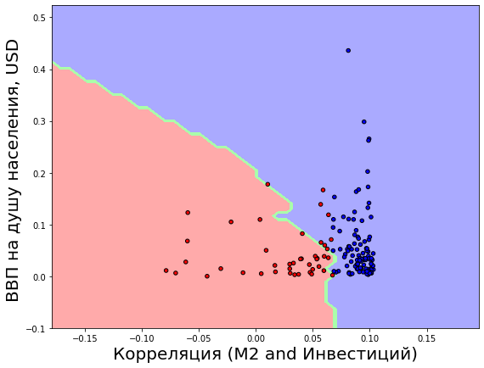

Figure 6. “Nearest neighbors” classification

However, most of the relatively poor countries also belong to the same class, as seen in the dense cluster of blue dots in the lower right corner of the figure. At the same time, some middle-income countries, as well as poor ones, were found to belong to the class with a low correlation between M2 and gross investment. Therefore, we can talk about the incorrectness of the hypothesis that the growth of the money supply has a positive effect on investment and GDP growth only in developed and rich countries.

It is also obvious that the vast majority of all analyzed countries ended up in the class with a provable correlation, and regardless of their level of wealth and development. The share of such countries was 79%. On the contrary, among the remaining 21%, there are countries with predominantly middle and low per capita income.

To complement and expand the study, a cluster analysis of countries in the same feature space was also executed - GDP per capita and correlation coefficient (GDP and M2). These heterogeneous indicators were also normalized, as in an explained above classification method. For cluster analysis, the “mean shift” method was utilized [28.]. The parameters of the method were selected based on cross-validation maximizing the accuracy of separating the countries in the feature space. The results of the analysis are illustrated in Fig. 7. The consequence of the analysis was the division of countries into five clusters, marked in the figure in different colors with the center of the cluster in the feature subspace marked with a larger circle.

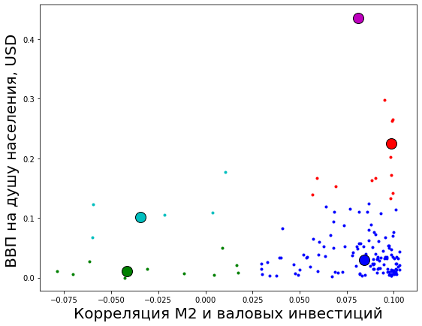

Figure 7. “Mean shift” clustering

The analysis showed that the largest group, indicated in blue in the lower right corner, included 78% of the total number of countries. And these are precisely the countries with a relatively low level of GDP per capita but at the same time a high correlation between M2 and investment. For such countries, the expansion of the economy monetization is associated with GDP growth.

Economic logic suggests that the low savings ratio and weak financial institutions in such countries make them very susceptible to a decline in the money supply and in the monetization, up to the most negative consequences for their economy. Among these countries are India, Turkey, China, Brazil, Mexico, and several other Latin American countries.

Rich countries in the upper right quadrant of the figure (and consisting of two relatively small clusters) showed the expected strong positive relationship between the M2 money supply and investment growth.

In contrast, the green cluster (low correlation and low per capita income) in the lower-left quadrant predictably includes countries ravaged by war or poverty, such as Ethiopia and Libya.

However, there is also a small group of countries for which the degree of relationship between M2 and gross investment does not depend on their level of wealth, they are represented by the red cluster in the figure. Among the countries in this group are Japan, Switzerland, and Panama. These are three clear examples of how different economic destinies brought them to this neighborhood. Japan is still unable to resurrect the economy and the functioning of financial institutions after the “lost decade”, and the other two countries are offshore havens whose economies are weakly dependent on domestic monetary policy.

**Conclusions**

Money is not just a "blanket" thrown over economic processes. They can and do work, but only with varying degrees of success. Monetary policy is the tool that helped overcome two global crises, but it also created new problems that are fraught with uncontrolled price increases and inflating "financial bubbles".

As shown by the statistical analysis, money is important, but not always the decisive factor in the growth of investment and GDP. Moreover - and this should be emphasized - this conclusion does not directly depend on the level of economic development. In most countries of the world, both developed and developing, there is a strong relationship between real money supply and investment leading to GDP growth. But at the same time, there are certain rich economies, where the growth of the real money supply is weakly related to the growth of investments, and there are also those lagging, where their dependence is almost functional (but until the possibilities of extensive growth are exhausted).

This means that, despite the importance of monetary variables, the key factors influencing the links in the "real money supply-investment-GDP" chain should be sought outside the actual monetary sphere. The conclusion has long been known, but relatively new for modern conditions. The sustained expansion of the monetary base and the growth of the real money supply do matter, but by themselves, they cannot solve the fundamental problems of modernizing economic institutions and bridging technological gaps. It follows from this that it is important for the regulator in the Ukrainian economy to maintain a stable growth of real money supply, but it will be essential for solving the accumulated problems, provided that the government can create preconditions for accelerating the national technical and technological development and raising its general level. It is this complex direction of economic policy that should be considered a priority for further research in this subject area.