Dataset for TrackNet

The dataset is composed of clips/frames from 10 broadcast videos. The resolution and frame rate of videos are 1280×720 and 30 fps, respectively. Each clip is the record of a rally starting from serving to score. Each clip has about 2,000 frames in average. There are 19,842 frames in total. The information of the videos is given in Table 1.

Table 1: Descriptions of each video
Seq. | Players | Game | Court Color  (inside/outside) | # of Clips | # of Frames
1 | Roger Federer vs Novak Djokovic | Shanghai 2014 Semi-Final | Purple / Green | 13 | 1978
2 | Novak Djokovic vs Gael Monfils | Eastbourne 2017 Final | Grass / Grass | 8 | 2222
3 | Andy Murray vs Novak Djokovic | 2017 Doha Final | Purple / Green | 9 | 1888
4 |  | Final ITF Future CIT 2014 | Red / Red | 7 | 2238
5 | Checa vs Rumenov |  | Dark Green / Green | 15 | 1971
6 | David Ferrer vs Fabio Fognini | ATP Buenos Aires 2014 Final | Red / Red | 4 | 1989
7 | Roger Federer vs Nick Kyrgios | Laver Cup 2017 | Gray (black) / Gray (black) | 9 | 1881
8 | Maria Sharapova vs Roberta Vinci | 2017 R1 | Red / Red | 9 | 1958
9 | Maria Sharapova vs Simona Halep | 2017 US Open | Blue / Green | 9 | 1573
10 | Jung Jason vs Hong Seongchan | 2017 Summer Universiade men’s singles final | Dark Blue / Blue | 12 | 2144

The frame files and label file of each video are saved in a separate folder that is named by game1, game2, …, game10. In each game directory, there are folders named by Clip1, Clip2, etc. for each clip. In each clip folder, image files and label file can be found. The folder structure is illustrated below:
Dataset/
├── Readme.docx
├── game1/
│ ├── Clip1/
│ │ ├── 0000.jpg
│ │ ├── 0001.jpg
│ │ ├── 0002.jpg
│ │ ├── …
│ │ └── Label.csv
│ ├── Clip2/
│ │ ├── 0000.jpg
│ │ ├── 0001.jpg
│ │ ├── 0002.jpg
│ │ ├── …
│ │ └── Label.csv
│ ├──
│ │ $⋮$
│ └──
├── game2/
├── game3/
├── game4/
├── game5/
├── game6/
├── game7/
├── game8/
├── game9/
└── game10/

Label files
Each line of the label files is corresponding to a frame and contains the following attributes of the frame: “File Name”, “Visibility Class”, “X”, “Y”, and “Trajectory Pattern”. Table 2 gives a segment of label files.

Table 2: Segments of label files
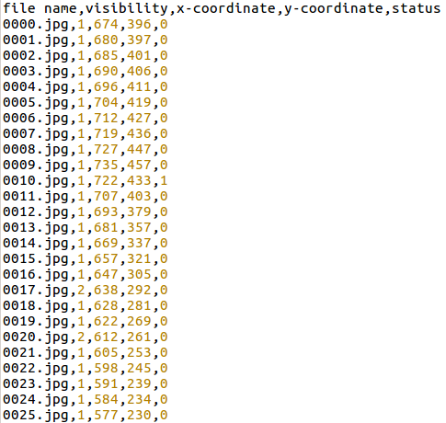

“File Name” is the name of the frame image files. “Visibility Class”, VC for short, indicates the visibility of the ball in the image. The possible values are 0, 1, 2, and 3. Table 3 describes the meanings of VC and gives examples.

Table 3: Visibility class and meanings
Visibility Class | Description and Examples
0 | The ball is not within the image.
1 | The ball can be easily identified.
2 | The ball is in the frame but can not be easily identified.  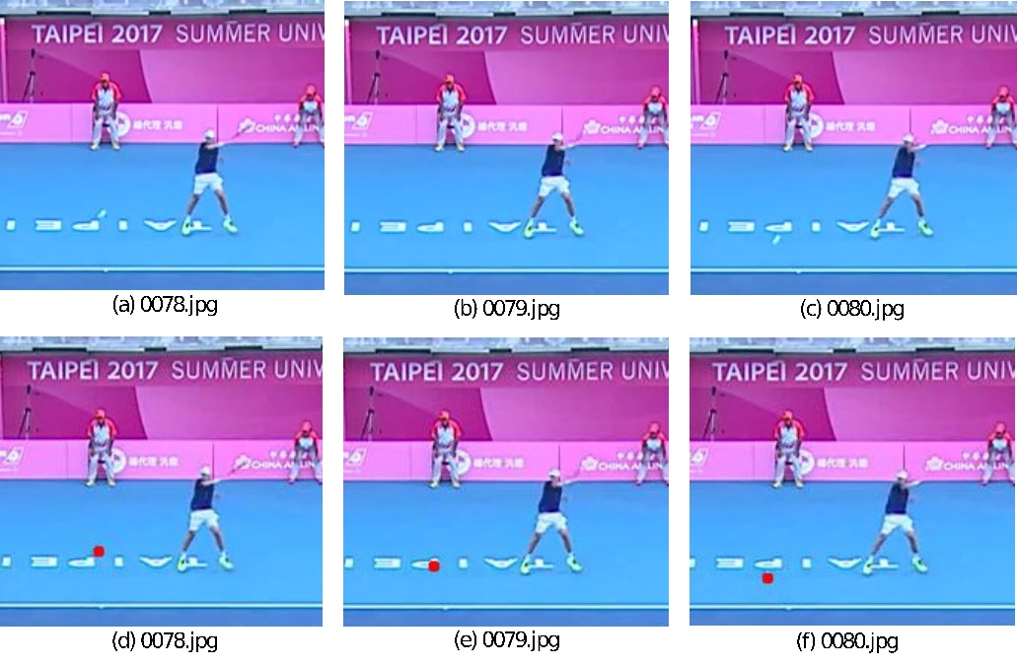  Figure 1: The ball in 0079.jpg is hardly visible.
3 | The ball is occluded.  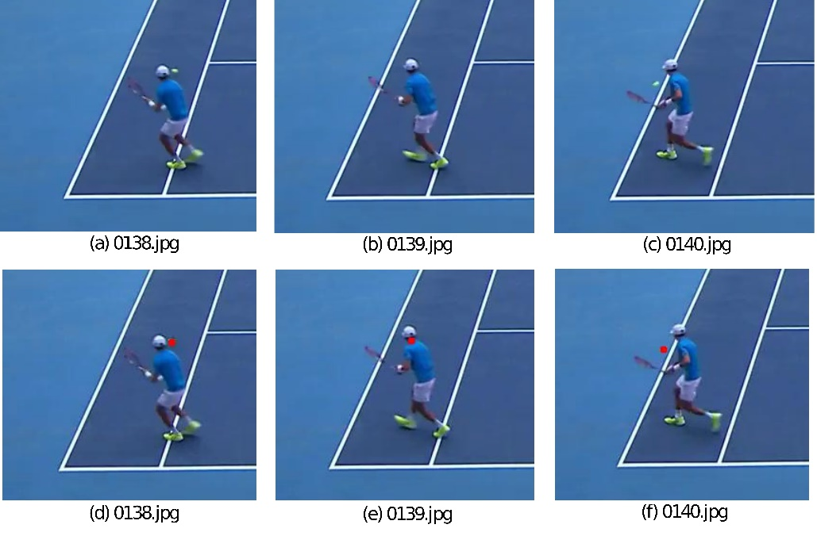  Figure 2: The ball in 0139.jpg is occluded by the player.

“X” and “Y” indicate the coordinate of the tennis in the pixel coordinate. Due to high moving speed, tennis images in the broadcast video may be blurry and event have afterimage trace. In such cases, “X” and “Y” are considered as the latest position of the ball’s trace. Figure 3 shows the prolonged trace that the ball is flying from Player1 to Player2 and the red dot indicates the labeled coordinate.

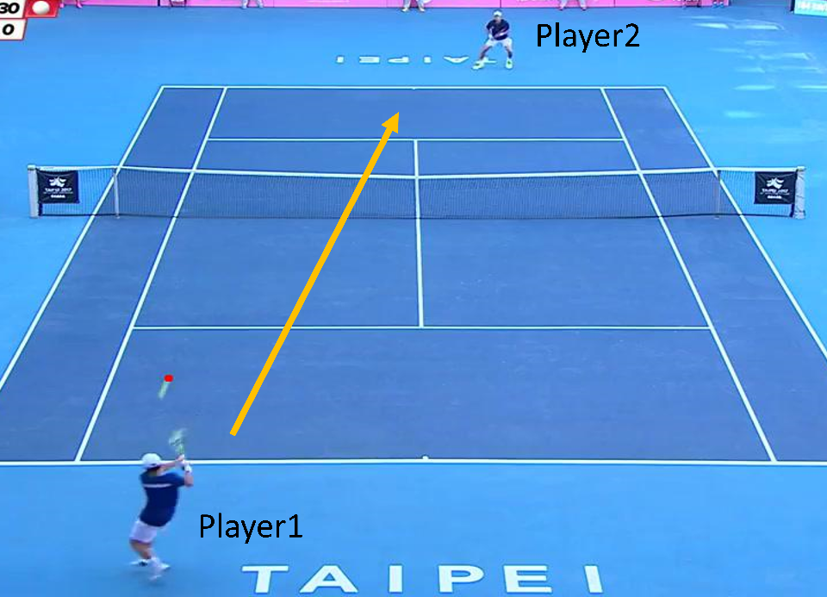
Figure 3: An example of the prolonged tennis trace.

“Trajectory Pattern” indicates the moving types of the ball, that are classified into three categories: flying, hit, and bounding. They are labeled by 0, 1, and 2, respectively. Figure 4 is an example of the hit case, and Figure 5 is an example of the bouncing case.
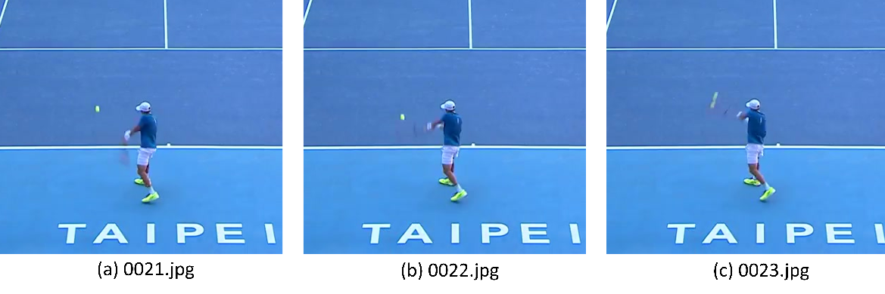
Figure 4: A hit case: (a) and (b) are labeled as flying, (c) is labeled as hit.

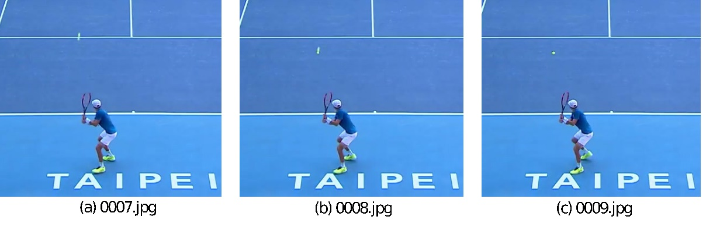
Figure 5: A bouncing case: (a) and (b) are labeled as flying, (c) is labeled as bouncing.

