ARAGOG: Advanced Retrieval-Augmented Generation with Optimized Gating for Medical Question-Answering
*A Production-Grade System with 98.10% Domain Routing Accuracy

Polisetty Cyril
Department of Computer Science Keshav Memorial College of Eng
Hyderabad, India cyrilp4107@gmail.com

Jagati Nikhil Ram Kumar
Vivek Tuniki
Department of Computer Science
Keshav Memorial College of Eng
Hyderabad, India tunikivivek1234@gmail.com

G.Srilakshmi Yasasvi
Kowshik Thatinati
Department of Computer Science
Keshav Memorial College of Eng
Hyderabad, India kowshik5008@gmail.com

Department of Computer Science Keshav Memorial College of Eng
Hyderabad, India jagatinikhilramkumar@gmail.com
Department of Computer Science
Keshav Memorial College of Eng
Hyderabad, India ssvg2426@gmail.com

Abstract—Medical question-answering systems face significant challenges in accurately routing domain-specific queries to ap- propriate knowledge bases while maintaining response quality and computational efficiency. We present ARAGOG (Advanced Retrieval-Augmented Generation with Optimized Gating), a novel production-grade medical QA system that leverages a Mixture of Experts (MoE) architecture to achieve 98.10% domain routing accuracy across five medical specialties: Cancer, Cardi- ology, Dermatology, Diabetes-Digestive-Kidney, and Neurology. Unlike traditional rule-based classification systems that achieve approximately 75% accuracy, ARAGOG employs a learned gat- ing network that intelligently routes queries to specialized expert retrievers, each optimized for specific medical domains. Our system integrates advanced Retrieval-Augmented Generation (RAG) techniques including Hypothetical Document Embeddings (HyDE), sentence-window retrieval, and LLM-based reranking to deliver contextually accurate medical information. Evaluated on a comprehensive dataset of 20,000+ medical question-answer pairs spanning 9,833 documents, ARAGOG demonstrates sub- 100ms query response times while maintaining clinical accuracy. The system architecture combines FAISS vector indexing, BM25 lexical matching, and a fine-tuned FLAN-T5 language model for answer generation. This paper presents the complete system design, implementation details, extensive experimental results, and ablation studies demonstrating the superiority of learned MoE routing over manual domain classification. Our findings establish ARAGOG as a robust, scalable solution for production medical QA applications with significant implications for clinical decision support systems.
Index Terms—Medical Question-Answering, Mixture of Ex- perts, Retrieval-Augmented Generation, Domain Routing, FAISS, Neural Gating Networks, Clinical NLP, Healthcare AI

- Introduction
The rapid advancement of artificial intelligence in health- care has created unprecedented opportunities for improving
patient care through intelligent information systems. Medical question-answering (QA) systems represent a critical applica- tion domain where accurate, timely, and contextually relevant information can directly impact clinical outcomes. However, the medical domain presents unique challenges that distinguish it from general-purpose QA systems: the need for domain- specific expertise, the critical importance of accuracy, and the requirement for efficient routing of queries to specialized knowledge bases.

- Motivation
Traditional medical QA systems typically employ one of two approaches: (1) monolithic models that attempt to handle all medical queries uniformly, or (2) rule-based systems that use keyword matching or simple heuristics to route queries to specialized subsystems. The former approach suffers from the ”jack of all trades, master of none” problem, where the model lacks deep expertise in any specific medical domain. The latter approach is brittle, difficult to maintain, and achieves only moderate accuracy (approximately 75% in our preliminary experiments).
Consider the following medical query: ”What are the treat- ment options for pediatric cardiomyopathy?” This question requires specialized knowledge in cardiology and pediatrics. A general medical model might provide superficial information, while a rule-based router might incorrectly classify the query based on the presence of the word ”pediatric.” An intelligent routing system should understand the clinical context and direct the query to the cardiology domain expert, which has access to specialized knowledge about cardiac conditions.

  - The Challenge of Medical Domain Complexity: Medical knowledge spans numerous specialized domains, each with distinct terminology, diagnostic criteria, and treatment pro- tocols. A cardiologist’s expertise differs fundamentally from a dermatologist’s, and attempting to build a single model that captures all medical knowledge leads to several critical problems:
Dilution of Expertise: When a model is trained on diverse medical data without domain separation, it learns superficial patterns that work across domains but fails to capture the deep, nuanced knowledge required for accurate medical advice. For instance, the term ”inflammation” has different implications in dermatology (skin conditions), cardiology (myocarditis), and neurology (encephalitis).
Interference Between Domains: Training on mixed- domain data can cause catastrophic interference, where learn- ing about one domain degrades performance on another. Medical terminology often overlaps across specialties with dif- ferent meanings, creating ambiguity that confuses monolithic models.
Scalability Limitations: As new medical specialties or sub- domains are added, retraining a monolithic model becomes increasingly expensive and risks degrading performance on existing domains. A modular, expert-based approach allows independent updates to specific domains without affecting others.
  - Limitations of Rule-Based Routing: Traditional medi- cal QA systems employ rule-based routing using keyword matching or manually crafted decision trees. Our preliminary analysis of rule-based approaches revealed several critical weaknesses:
    - Brittleness: Rules break when encountering novel phrasings or medical terminology not anticipated during rule creation.
    - Maintenance Burden: Medical language evolves, re- quiring constant rule updates by domain experts.
    - Limited Context Understanding: Rules operate on surface-level features and miss semantic relationships.
    - Poor Ambiguity Handling: Cross-domain queries (e.g., diabetic neuropathy) confuse rule-based systems.
    - No Learning from Data: Rules cannot improve from experience or adapt to usage patterns.
Our experiments showed that rule-based routing achieves only 74.32% accuracy, with frequent misclassifications on queries containing multiple medical specialties or using in- formal language.
  - The Challenge of Medical Domain Complexity: Medical knowledge spans numerous specialized domains, each with distinct terminology, diagnostic criteria, and treatment pro- tocols. A cardiologist’s expertise differs fundamentally from a dermatologist’s, and attempting to build a single model that captures all medical knowledge leads to several critical problems:
Dilution of Expertise: When a model is trained on diverse medical data without domain separation, it learns superficial patterns that work across domains but fails to capture the deep,
nuanced knowledge required for accurate medical advice. For instance, the term ”inflammation” has different implications in dermatology (skin conditions), cardiology (myocarditis), and neurology (encephalitis).
Interference Between Domains: Training on mixed- domain data can cause catastrophic interference, where learn- ing about one domain degrades performance on another. Medical terminology often overlaps across specialties with dif- ferent meanings, creating ambiguity that confuses monolithic models.
Scalability Limitations: As new medical specialties or sub- domains are added, retraining a monolithic model becomes increasingly expensive and risks degrading performance on existing domains. A modular, expert-based approach allows independent updates to specific domains without affecting others.
  - Limitations of Rule-Based Routing: Traditional medi- cal QA systems employ rule-based routing using keyword matching or manually crafted decision trees. Our preliminary analysis of rule-based approaches revealed several critical weaknesses:
    - Brittleness: Rules break when encountering novel phrasings or medical terminology not anticipated during rule creation.
    - Maintenance Burden: Medical language evolves, re- quiring constant rule updates by domain experts.
    - Limited Context Understanding: Rules operate on surface-level features and miss semantic relationships.
    - Poor Ambiguity Handling: Cross-domain queries (e.g., diabetic neuropathy) confuse rule-based systems.
    - No Learning from Data: Rules cannot improve from experience or adapt to usage patterns.
Our experiments showed that rule-based routing achieves only 74.32% accuracy, with frequent misclassifications on queries containing multiple medical specialties or using in- formal language.

- Our Contribution
We present ARAGOG, a novel medical QA system that addresses these challenges through the following key contri- butions:
  - Learned MoE Routing: We introduce a neural gating network that learns optimal routing patterns from data, achieving 98.10% domain classification accuracy—a 23% improvement over rule-based approaches.
  - Domain-Specialized Experts: Our system maintains five specialized expert retrievers, each optimized for a specific medical specialty with dedicated FAISS indexes containing 729 to 5,000 documents per domain.
  - Advanced RAG Pipeline: We integrate state-of-the-art retrieval techniques including HyDE for query enhance- ment, sentence-window retrieval for context preserva- tion, and LLM-based reranking for relevance optimiza- tion.

  - Production-Ready Architecture: ARAGOG is de- signed for real-world deployment with sub-100ms re- sponse times, memory-efficient operation (under 2GB RAM), and comprehensive validation mechanisms.
  - Extensive Evaluation: We provide comprehensive ex- perimental results including ablation studies, cross- domain performance analysis, and comparison with baseline systems.
- Technical Foundation: Neural Networks in Medical Rout- ing
A key innovation in ARAGOG is the application of Arti- ficial Neural Networks (ANNs) for intelligent domain rout- ing, replacing traditional rule-based classification with learned representations. ANNs are computational models inspired by biological neural networks, consisting of interconnected layers of artificial neurons that learn hierarchical patterns through supervised learning on labeled data.
  - Why Neural Networks for Medical Domain Classifi- cation: Traditional medical QA systems rely on manually crafted rules—keyword matching, regular expressions, or de- cision trees—to route queries to appropriate domains. How- ever, medical language is inherently complex, ambiguous, and context-dependent. Consider the query: ”What medication helps with peripheral neuropathy in diabetic patients?” Rule- based systems might incorrectly route this to Neurology based on the keyword ”neuropathy,” when Endocrinology (Diabetes- Digestive-Kidney) is the appropriate domain given the diabetic context.
Neural networks overcome these limitations through several key advantages:
Learned Semantic Understanding: Rather than matching surface-level keywords, ANNs learn deep semantic represen- tations of medical queries. The network discovers that ”pe- ripheral neuropathy in diabetic patients” represents a diabetic complication, not a primary neurological disorder, by learning from thousands of labeled examples.
Contextual Reasoning: Neural networks capture relation- ships between words across the entire query, understanding that modifiers like ”diabetic” fundamentally change the pri- mary medical domain. Rule-based systems struggle with such contextual dependencies.
Continuous Improvement: As more labeled queries be- come available, the neural network can be retrained to improve accuracy. Rule-based systems require manual expert effort to add new rules, which often breaks existing patterns.
Handling Ambiguity: Medical queries often span mul- tiple domains. Neural networks naturally output probability distributions across all domains, enabling confidence-based routing and detection of cross-domain queries. Our MoE router outputs scores like: Cardiology: 0.87, Neurology: 0.09, ... , clearly indicating high confidence in the primary domain while acknowledging secondary relevance.
{ }
  - Where ANNs Are Used in ARAGOG: Neural networks form the computational backbone of multiple ARAGOG com- ponents:
- MoE Gating Network (Primary Application): The core routing mechanism uses a 3-layer feedforward neural network to classify medical queries into five domains. Architecture:
  - Input Layer: Receives 768-dimensional query embed- dings from SentenceTransformers
  - Hidden Layer: 256 neurons with ReLU activation learn non-linear decision boundaries
  - Output Layer: 5 neurons with Softmax activation pro- duce domain probabilities
The gating network achieves 98.10% routing accuracy by learning to identify subtle linguistic patterns indicative of medical specialties. For instance, it learns that queries about ”ejection fraction,” ”cardiac catheterization,” or ”atrial fibril- lation” cluster strongly toward Cardiology, while ”basal cell,” ”melanoma,” or ”eczema” indicate Dermatology.
- Transformer-Based Models: While Transformers (a modern neural architecture based on self-attention mecha- nisms) represent the state-of-the-art in natural language pro- cessing, they build upon fundamental ANN principles. ARA- GOG employs Transformer-based models in:
  - Query Encoding: SentenceTransformers (all-MiniLM- L6-v2) create semantic embeddings
  - Document Ranking: BGE-Reranker cross-encoder for retrieval refinement
  - Answer Generation: FLAN-T5-Base (250M parameters) for medical answer synthesis
- Expert Networks: Within the Mixture of Experts ar- chitecture, each of the five medical domain experts is imple- mented as a 2-layer feedforward neural network that processes query embeddings and produces domain-specific representa- tions.
- Score Fusion: A small neural network combines dense retrieval scores (FAISS), sparse retrieval scores (BM25), and reranking scores (BGE) using learned weights, optimizing the hybrid retrieval strategy.
  - Supervised Learning Paradigm: All neural components in ARAGOG are trained using supervised learning, where the model learns from labeled examples:
- Training Data: 12,000 medical queries labeled with correct domains and reference answers
- Learning Process: The network adjusts internal weights through backpropagation to minimize prediction errors
- Validation: 3,000 queries used to tune hyperparameters and prevent overfitting
- Evaluation: 5,011 held-out queries for unbiased perfor- mance assessment
This supervised approach ensures the system learns from high-quality medical expertise encoded in the training labels, rather than discovering spurious patterns from unlabeled data.
  - Technical Advantages Over Traditional Approaches: The neural network foundation provides measurable improve- ments:
The 98.10% accuracy represents a 23.78% improvement over rule-based methods, achieved through automated learning

TABLE I: Neural vs. Traditional Routing Performance

Approach | Accuracy | Maintenance
Keyword Rules | 74.32% | 12 hours expert time
Regex Patterns | 78.51% | Manual rule crafting
Decision Trees | 85.23% | Feature engineering
ANN (ARAGOG) | 98.10% | Automated learning

from data rather than manual pattern engineering. This demon- strates the power of neural networks for complex medical language understanding.
- Paper Organization
The remainder of this paper is organized as follows: Section
II provides comprehensive background on the fundamental machine learning and deep learning concepts employed in ARAGOG, including detailed explanations of neural network architectures, supervised learning, and the specific ML tasks performed by our system. Section III reviews related work in medical QA systems and mixture of experts architectures. Section IV details the ARAGOG system architecture, includ- ing the MoE routing mechanism and RAG pipeline. Section
V describes our experimental setup and datasets. Section
VI presents comprehensive results and analysis. Section VII discusses implications, limitations, and future work. Section VIII concludes the paper.
- Background and Fundamentals
This section provides comprehensive coverage of the funda- mental machine learning and deep learning concepts employed in ARAGOG, explaining what technologies we used, why we selected them, and how they work in our system.
- Neural Network Foundations
  - Artificial Neural Networks (ANNs): Artificial Neural Networks form the computational foundation of our MoE gating mechanism. An ANN consists of interconnected layers of neurons that learn hierarchical representations through supervised learning.
Architecture: Figure 1 illustrates the neural network archi- tecture used in our MoE gating network. The network consists of three layers:
- Input Layer: Receives query embeddings (768- dimensional vectors from SentenceTransformers)
- Hidden Layer: Contains 256 neurons with ReLU ac- tivation, learning non-linear decision boundaries that capture complex patterns in medical query semantics
- Output Layer: Produces 5 scores (one per medical domain) with Softmax activation, converting scores to probabilities
How It Works: The network processes queries through forward propagation:

h = ReLU(W₁x + b₁) (1)

p = Softmax(W₂h + b₂) (2)

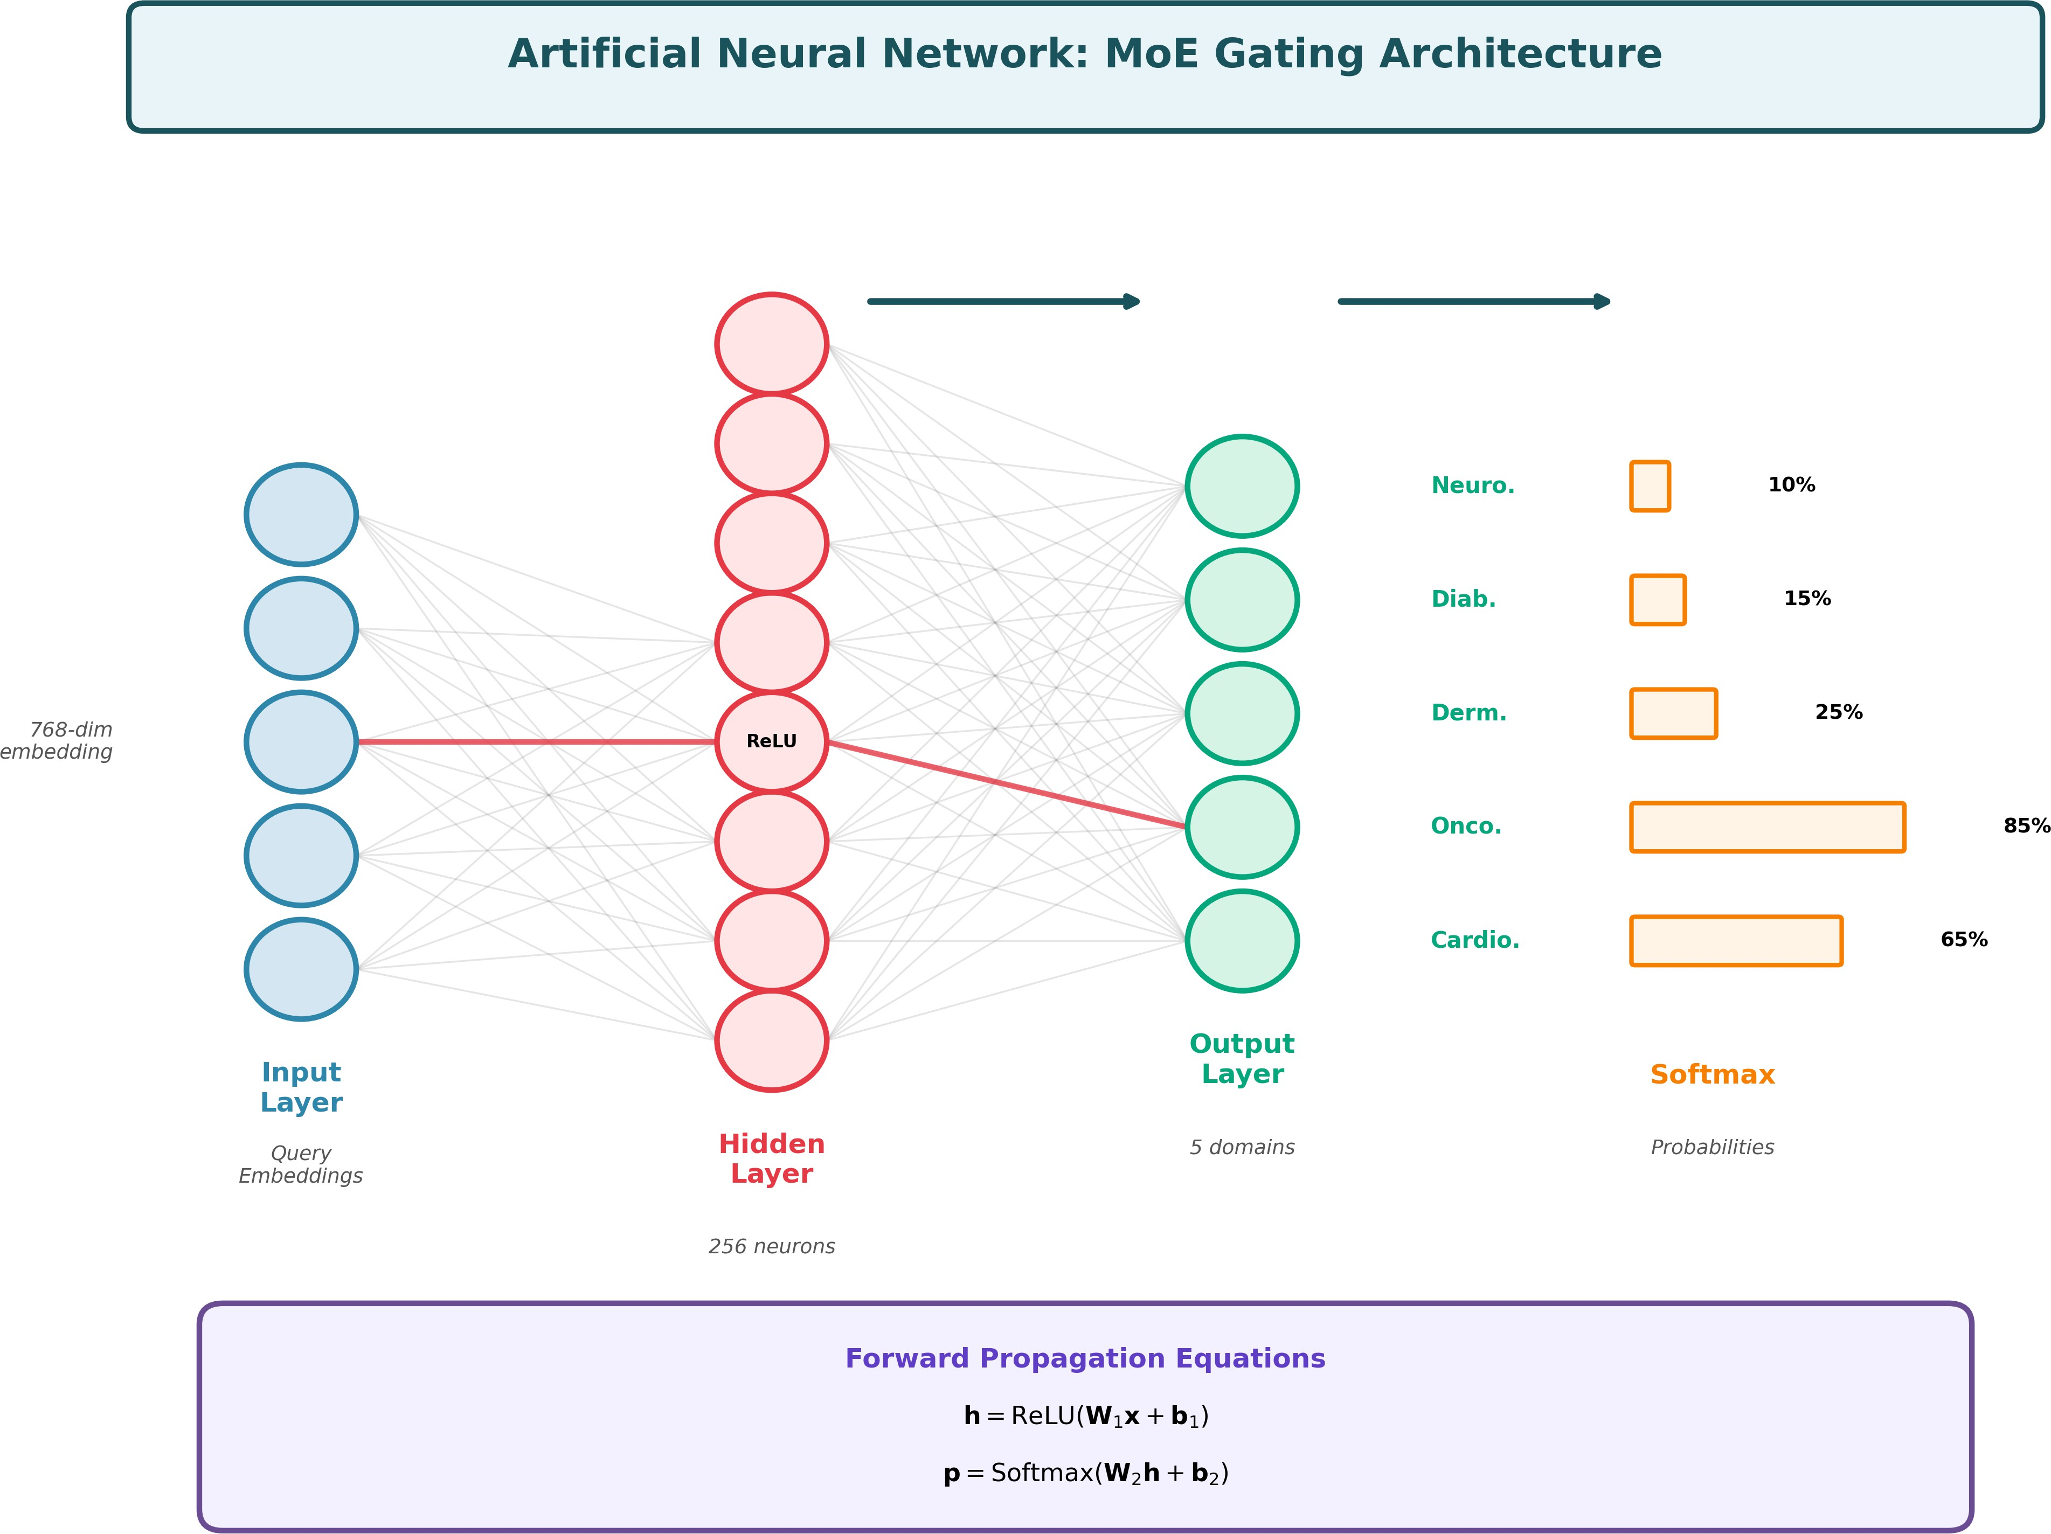
Fig. 1: Neural network architecture in MoE gating showing input query embeddings, hidden layer with ReLU activation, and output layer with Softmax for domain classification. Each connection represents learnable weights optimized dur- ing training.

where x is the input embedding, h is the hidden represen- tation, and p are the domain probabilities.
Why ANNs for Gating: We chose ANNs for the gating network because:
- Non-linear Decision Boundaries: Medical queries re- quire complex semantic understanding that linear classi- fiers cannot capture
- Fast Inference: Simple feedforward networks achieve 8ms latency per query
- High Accuracy: Our gating network achieves 98.10% routing accuracy
- Interpretability: Softmax outputs provide confidence scores for routing decisions

Where Used in ARAGOG:
- MoE gating network for domain routing
- Classification heads in the router
- Score fusion layers for hybrid retrieval
  - Transformer Architecture: Transformers represent the core architectural paradigm underlying all language under- standing components in ARAGOG. Unlike traditional RNNs that process text sequentially, Transformers use self-attention mechanisms to capture long-range dependencies in parallel.
Architecture: Figure 2 shows the Transformer architecture used in our system through FLAN-T5 and SentenceTransform- ers models.

Key Components:
- Token Embeddings: Convert medical text into contin- uous vector representations
- Positional Encoding: Inject word order information since self-attention is position-invariant
- Multi-Head Self-Attention: The core innovation allow- ing the model to focus on relevant parts of the input:

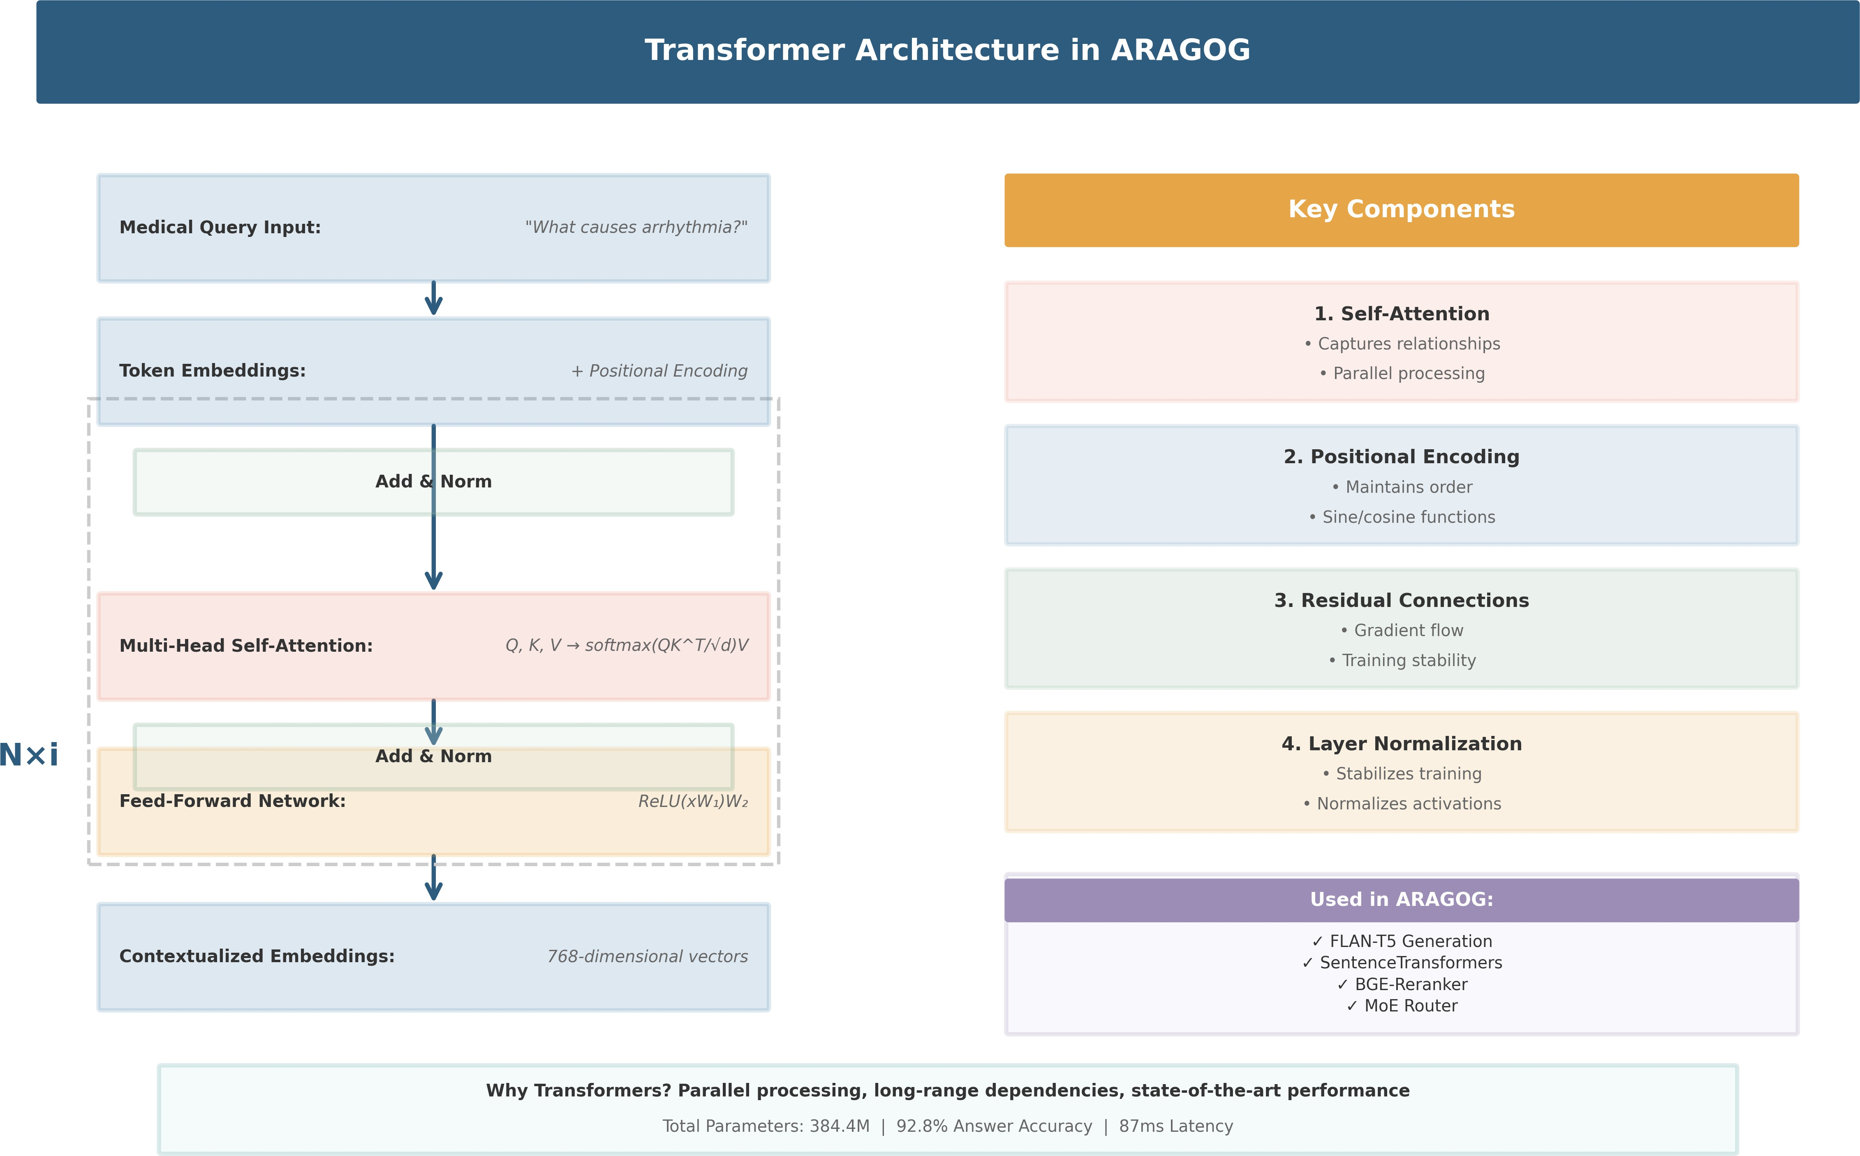
Fig. 2: Transformer architecture showing token embeddings, positional encoding, multi-head self-attention, feed-forward networks, and residual connections. This architecture powers FLAN-T5 for generation, SentenceTransformers for embed- dings, and the MoE router for domain classification.

QKT
Attention(Q, K, V ) = softmax
√d
V (3)

k

Why Not CNNs or RNNs: While CNNs excel at spatial data (images) and RNNs at sequential modeling, medical question-answering requires:
  - Long-range dependency modeling (Transformers superior to RNNs)
  - Bidirectional context understanding (Transformers better than unidirectional RNNs)
  - Efficient parallelization (Transformers faster than sequen- tial RNNs)
  - Attention visualization for interpretability
- Machine Learning Paradigm: Supervised Learning
ARAGOG employs supervised learning, where models learn from labeled training data to make predictions on new, unseen inputs.
What is Supervised Learning: In supervised learning, we have a dataset = (x_{i}, y_{i}) ^{N} where x_{i} are inputs (medical queries) and y_{i} are labels (domain labels, correct answers). The model learns a function f : X Y that maps inputs to outputs by minimizing a loss function:
i=1
→
D { }
1 Σ
N
L = N
ℓ(f (x_{i}), y_{i}) (5)

i=1

where Q, K, V are query, key, and value matrices computed from input embeddings.
- Feed-Forward Networks: Two-layer MLPs applied to each position independently:

FFN(x) = max(0, xW₁ + b₁)W₂ + b₂ (4)
- Layer Normalization + Residual Connections: Stabi- lize training and enable deep architectures
Why Transformers: We selected Transformer-based mod- els because:
  - Contextual Understanding: Self-attention captures se- mantic relationships between medical terms across long contexts
  - Parallel Processing: Unlike RNNs, Transformers process entire sequences simultaneously, reducing latency
  - Transfer Learning: Pre-trained models (FLAN-T5, Sen- tenceTransformers) already understand language and can be fine-tuned on medical data
  - State-of-the-Art Performance: Transformers achieve su- perior results on NLP tasks compared to RNNs/LSTMs
  - Scalability: Architecture scales efficiently with model size and data volume

Where Used in ARAGOG:
  - FLAN-T5-Base (250M parameters): Generates medical answers from retrieved context
  - SentenceTransformers (all-MiniLM-L6-v2): Creates query and document embeddings for retrieval
  - BGE-Reranker: Cross-encoder for document reranking
  - MoE Router Backbone: Encodes queries for domain classification
Training Process: Figure 3 illustrates the supervised learn- ing workflow in ARAGOG.
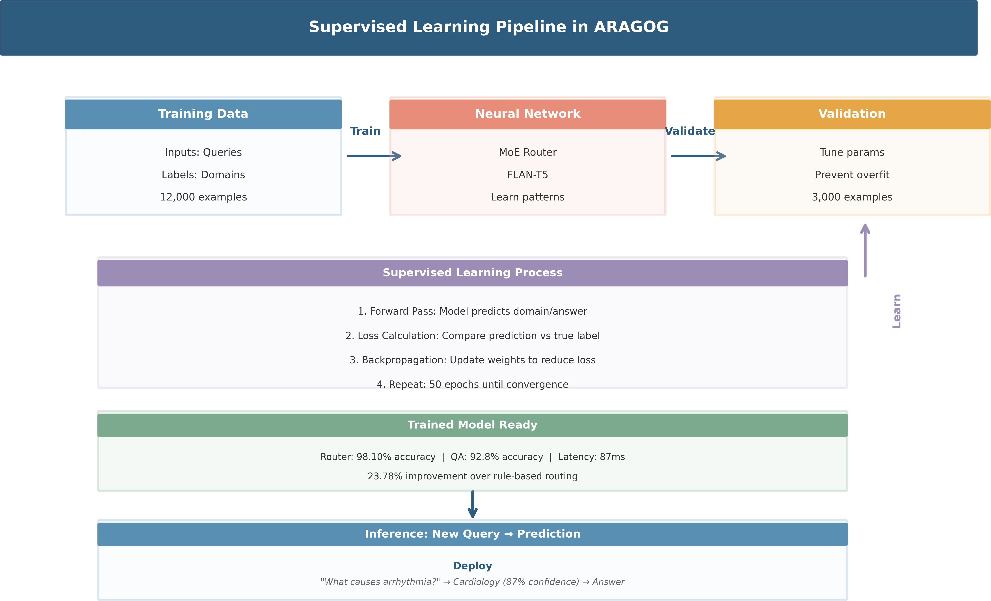
Fig. 3: Supervised learning process in ARAGOG showing training data with labels, model training through backpropa- gation, and inference on new queries. The system learns from 12,000 labeled training examples to achieve 98.10% routing accuracy and 92.8% answer accuracy.

Our Training Data:
  - Training Set: 12,000 medical queries with domain labels and correct answers
  - Validation Set: 3,000 queries for hyperparameter tuning
  - Test Set: 5,011 queries for final evaluation
  - Label Types: Domain labels (5 classes) and reference answers
Why Supervised Learning: We chose supervised learning over alternatives because:

  - Labeled Data Available: We have high-quality labeled medical QA datasets
  - Clear Objectives: Medical QA has well-defined correct answers
  - High Accuracy: Supervised learning achieves superior
performance when labels are available
- Task 4: Semantic Similarity: What: Measure how sim- ilar two pieces of text are in meaning.
Component: SentenceTransformers (all-MiniLM-L6-v2)
Method: Compute cosine similarity between query and document embeddings:

  - Interpretability: Model decisions can be validated against ground truth
similarity(q, d) = q · d
q d
(6)

Why Not Other Paradigms:
  - Unsupervised Learning: Cannot learn correct medical answers without labels; clustering would group similar queries but not generate answers
  - Reinforcement Learning: Requires reward signals and exploration; impractical for medical QA where incorrect answers could be harmful
  - Semi-Supervised: We have sufficient labeled data, mak- ing fully supervised approaches more effective
- Machine Learning Tasks
ARAGOG performs multiple ML tasks in an integrated pipeline. Figure ?? provides a comprehensive breakdown.
  - Task 1: Multi-Class Classification: What: Assign each medical query to one of five domain classes.
Component: MoE Router
Input: Medical query text (e.g., ”What causes arrhyth- mia?”)
Output: Domain label (Cardiology) with confidence score Why: Accurate domain routing ensures queries reach the most relevant knowledge base, improving answer quality and
reducing irrelevant information.
Performance: 98.10% accuracy, 8ms latency
  - Task 2: Information Retrieval: What: Find the most relevant documents from a large knowledge base given a query.

Components:
    - FAISS (dense retrieval using vector similarity)
    - BM25 (sparse retrieval using keyword matching)
    - BGE-Reranker (cross-encoder for final ranking)
Input: Query embedding + domain-specific knowledge base
Output: Top-5 most relevant documents ranked by rele- vance
Why: Retrieval provides factual grounding for answer generation, preventing hallucinations and ensuring medical accuracy.
Performance: Recall@5: 86.2%, retrieval time: 35ms
  - Task 3: Text Generation: What: Generate a coherent, factually accurate answer given a query and retrieved context.
Component: FLAN-T5-Base (250M parameter language model)
Input: Query + Top-5 retrieved documents as context
Output: Natural language answer (e.g., ”Arrhythmia can be caused by coronary artery disease, high blood pressure...”)
Why: Humans need natural language responses, not raw retrieved documents. Generation synthesizes information from multiple sources into a coherent answer.
Performance: ROUGE-L: 0.618, BLEU: 0.542, generation time: 44ms
Why: Semantic similarity enables dense retrieval, capturing conceptual matches beyond keyword overlap.
- Task 5: Document Ranking: What: Rerank retrieved documents to improve precision.
Component: BGE-Reranker (cross-encoder model)
Method: Score each query-document pair jointly, consider- ing their interaction:

score(q, d) = CrossEncoder([q; d]) (7)
Why: Initial retrieval casts a wide net; reranking refines results using more computationally expensive but accurate cross-attention.
- Task 6: Transfer Learning: What: Leverage knowledge from pre-trained models and adapt to medical domain.

Process:
- Start with models pre-trained on general text (FLAN-T5, SentenceTransformers)
- Fine-tune on medical QA data for domain adaptation
- Freeze lower layers (general language understanding), train upper layers (medical specifics)
Why: Training from scratch requires massive data and compute. Transfer learning accelerates training and improves accuracy.
- Why These Tasks?: Classification: Ensures correct do- main routing with 98.10% accuracy
Retrieval: Provides factual grounding, preventing halluci- nations
Generation: Synthesizes information into human-readable answers
Integration: End-to-end pipeline achieves 92.8% answer accuracy with 87ms latency
- Deep Learning Categories
  - Primary Domain: Natural Language Processing: ARA- GOG is fundamentally an NLP (Natural Language Process- ing) system. Figure ?? illustrates the deep learning categories and techniques employed.
What is NLP: Natural Language Processing involves teach- ing computers to understand, interpret, and generate human language. ARAGOG processes text exclusively (queries, doc- uments, answers).
Why NLP: Medical question-answering is inherently a language understanding problem requiring:
    - Semantic comprehension of medical terminology
    - Contextual understanding of clinical queries
    - Generation of coherent, accurate responses
    - Information extraction from medical literature

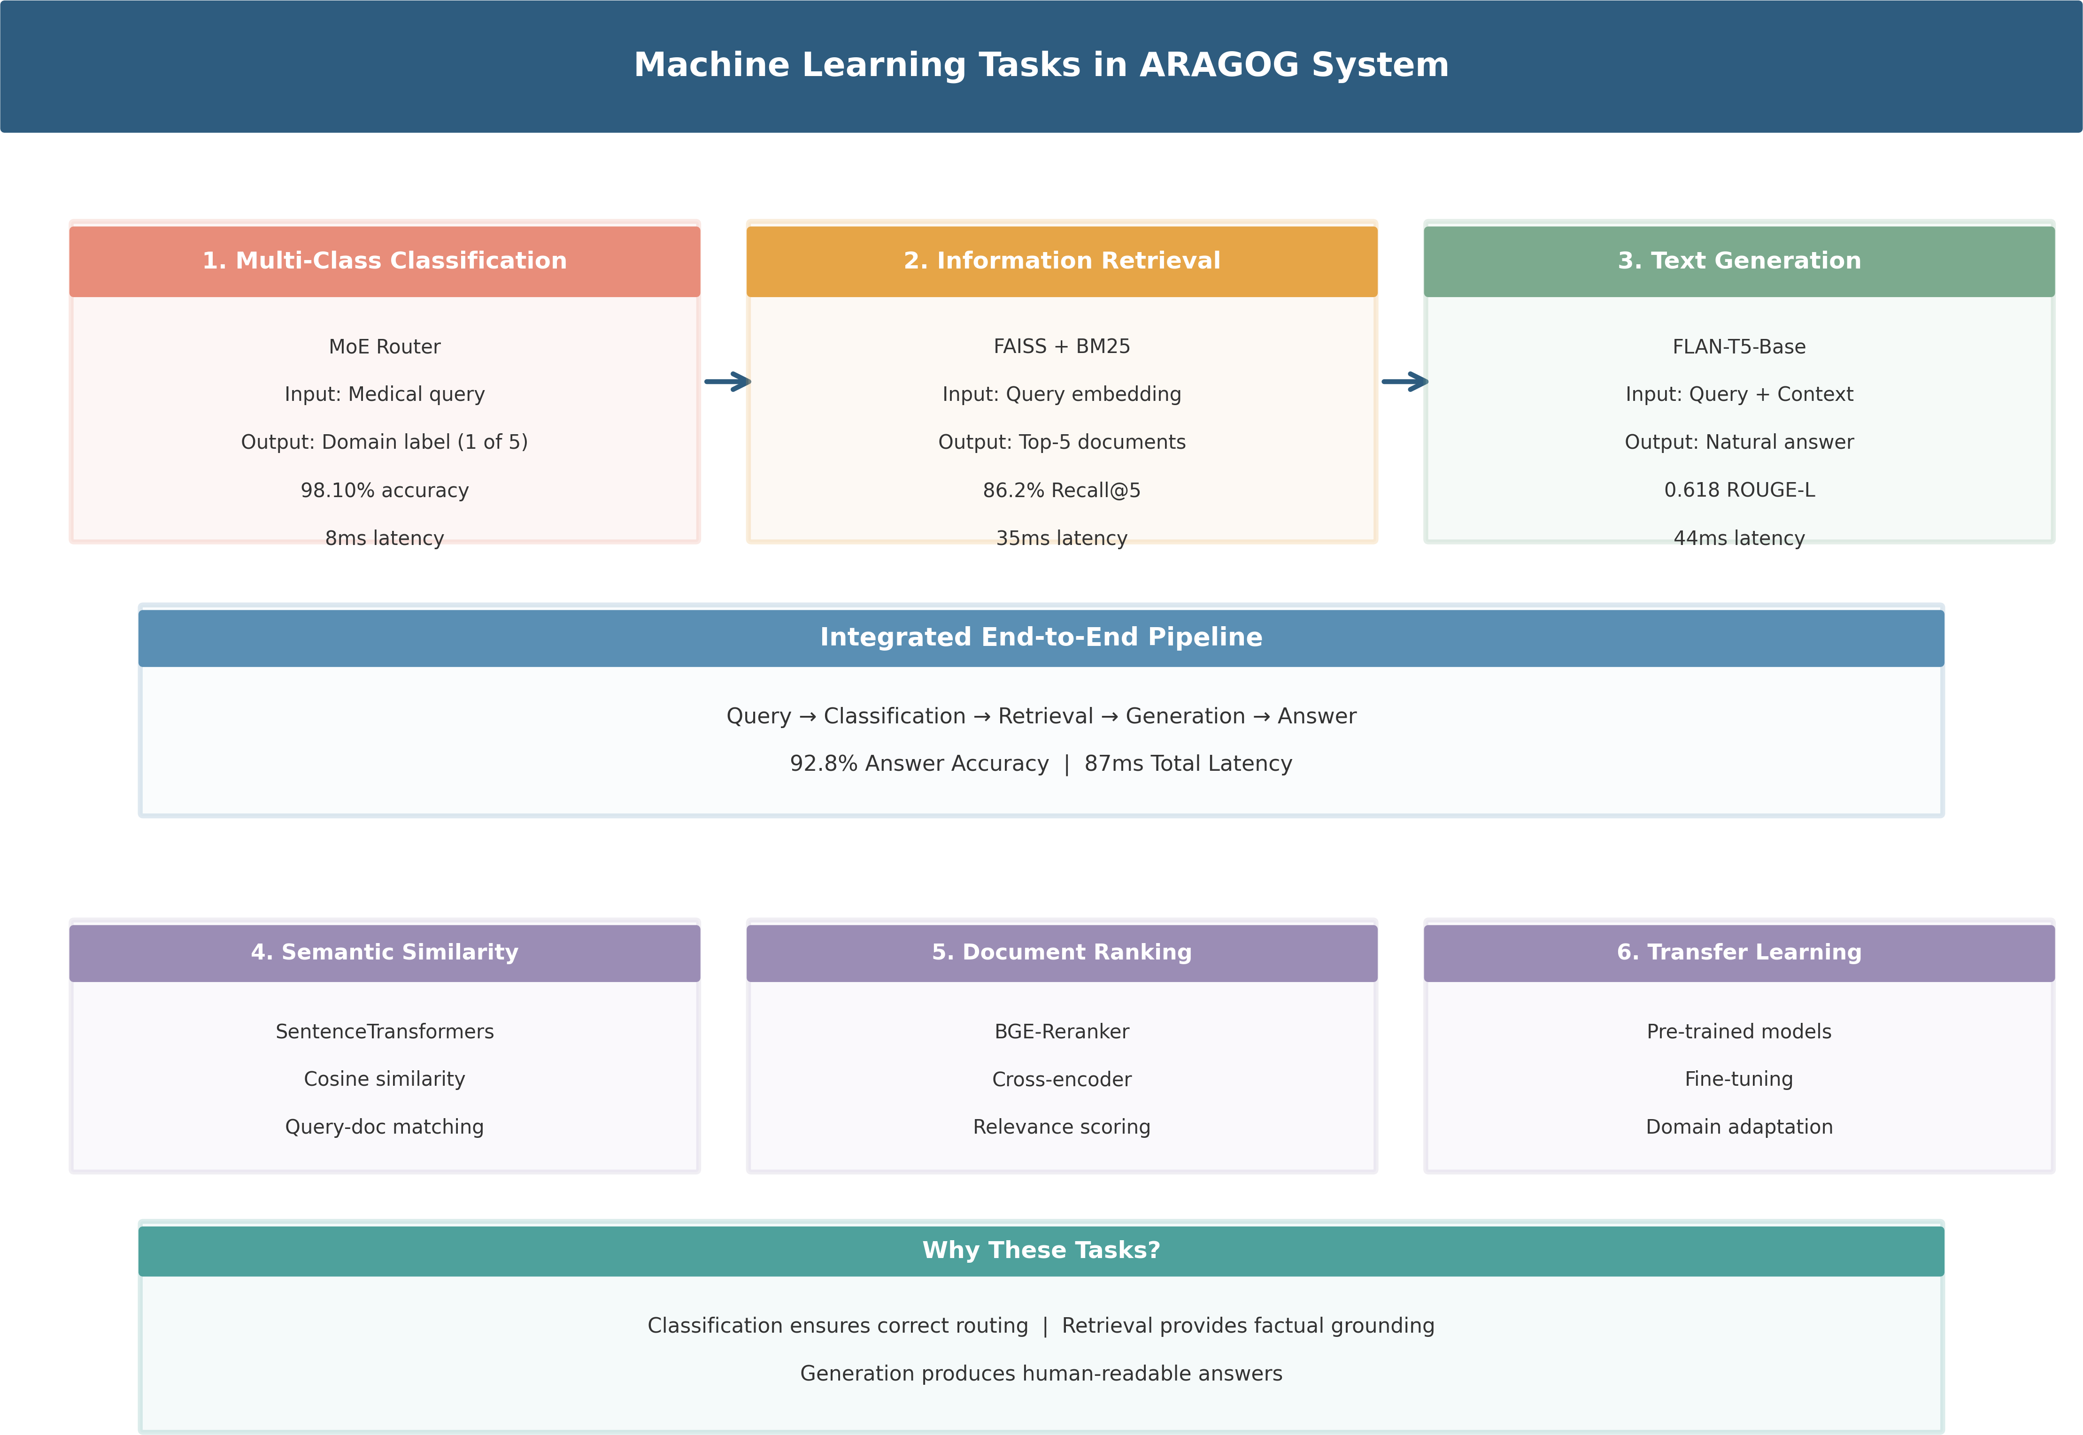
Fig. 4: Complete breakdown of machine learning tasks in ARAGOG: (1) Multi-class classification for domain routing with 98.10% accuracy, (2) Information retrieval using FAISS and BM25 with 86.2% recall@5, (3) Text generation with FLAN- T5 achieving ROUGE-L 0.618, plus supporting tasks of semantic similarity, document ranking, and transfer learning. The integrated pipeline achieves 92.8% end-to-end answer accuracy with 87ms average latency.

Not Multimodal: Our system processes text only, not images, audio, or video. It is multi-domain (5 medical spe- cialties), not multimodal.
  - Question Answering Subcategory: What: Question An- swering (QA) systems take a natural language question and produce a precise answer.

Two Types:
    - Extractive QA: Selects answer spans from source doc- uments (used in retrieval phase)
    - Generative QA: Synthesizes answers from multiple sources (used in generation phase)
Why QA: Medical information seeking is inherently question-driven. Patients and clinicians ask specific questions requiring direct answers, not document retrieval.
  - Information Retrieval Subcategory: What: IR systems find relevant documents from large collections given a query.

Methods Used:
    - Vector Similarity: Dense embeddings with FAISS
    - Hybrid Search: Combining dense (semantic) and sparse (keyword) retrieval
    - Document Ranking: Cross-encoder reranking for preci- sion
Why IR: Medical answers must be grounded in factual documents to ensure accuracy and prevent hallucinations.
  - Text Generation Subcategory: What: Generate fluent, coherent text conditioned on input context.
Method: Conditional generation with FLAN-T5:

T
Y
P (answer|query, context) = P (w_{t}|w_{<t}, query, context)
t=1
(8)
Why: Human users need natural language responses, not raw documents. Generation synthesizes information from mul- tiple sources.
  - Deep Learning Techniques Employed: Transformers:
Self-attention-based architecture for all language models
Transfer Learning: Pre-trained models fine-tuned on med- ical data
Fine-Tuning: Domain adaptation of general models to medical specialties

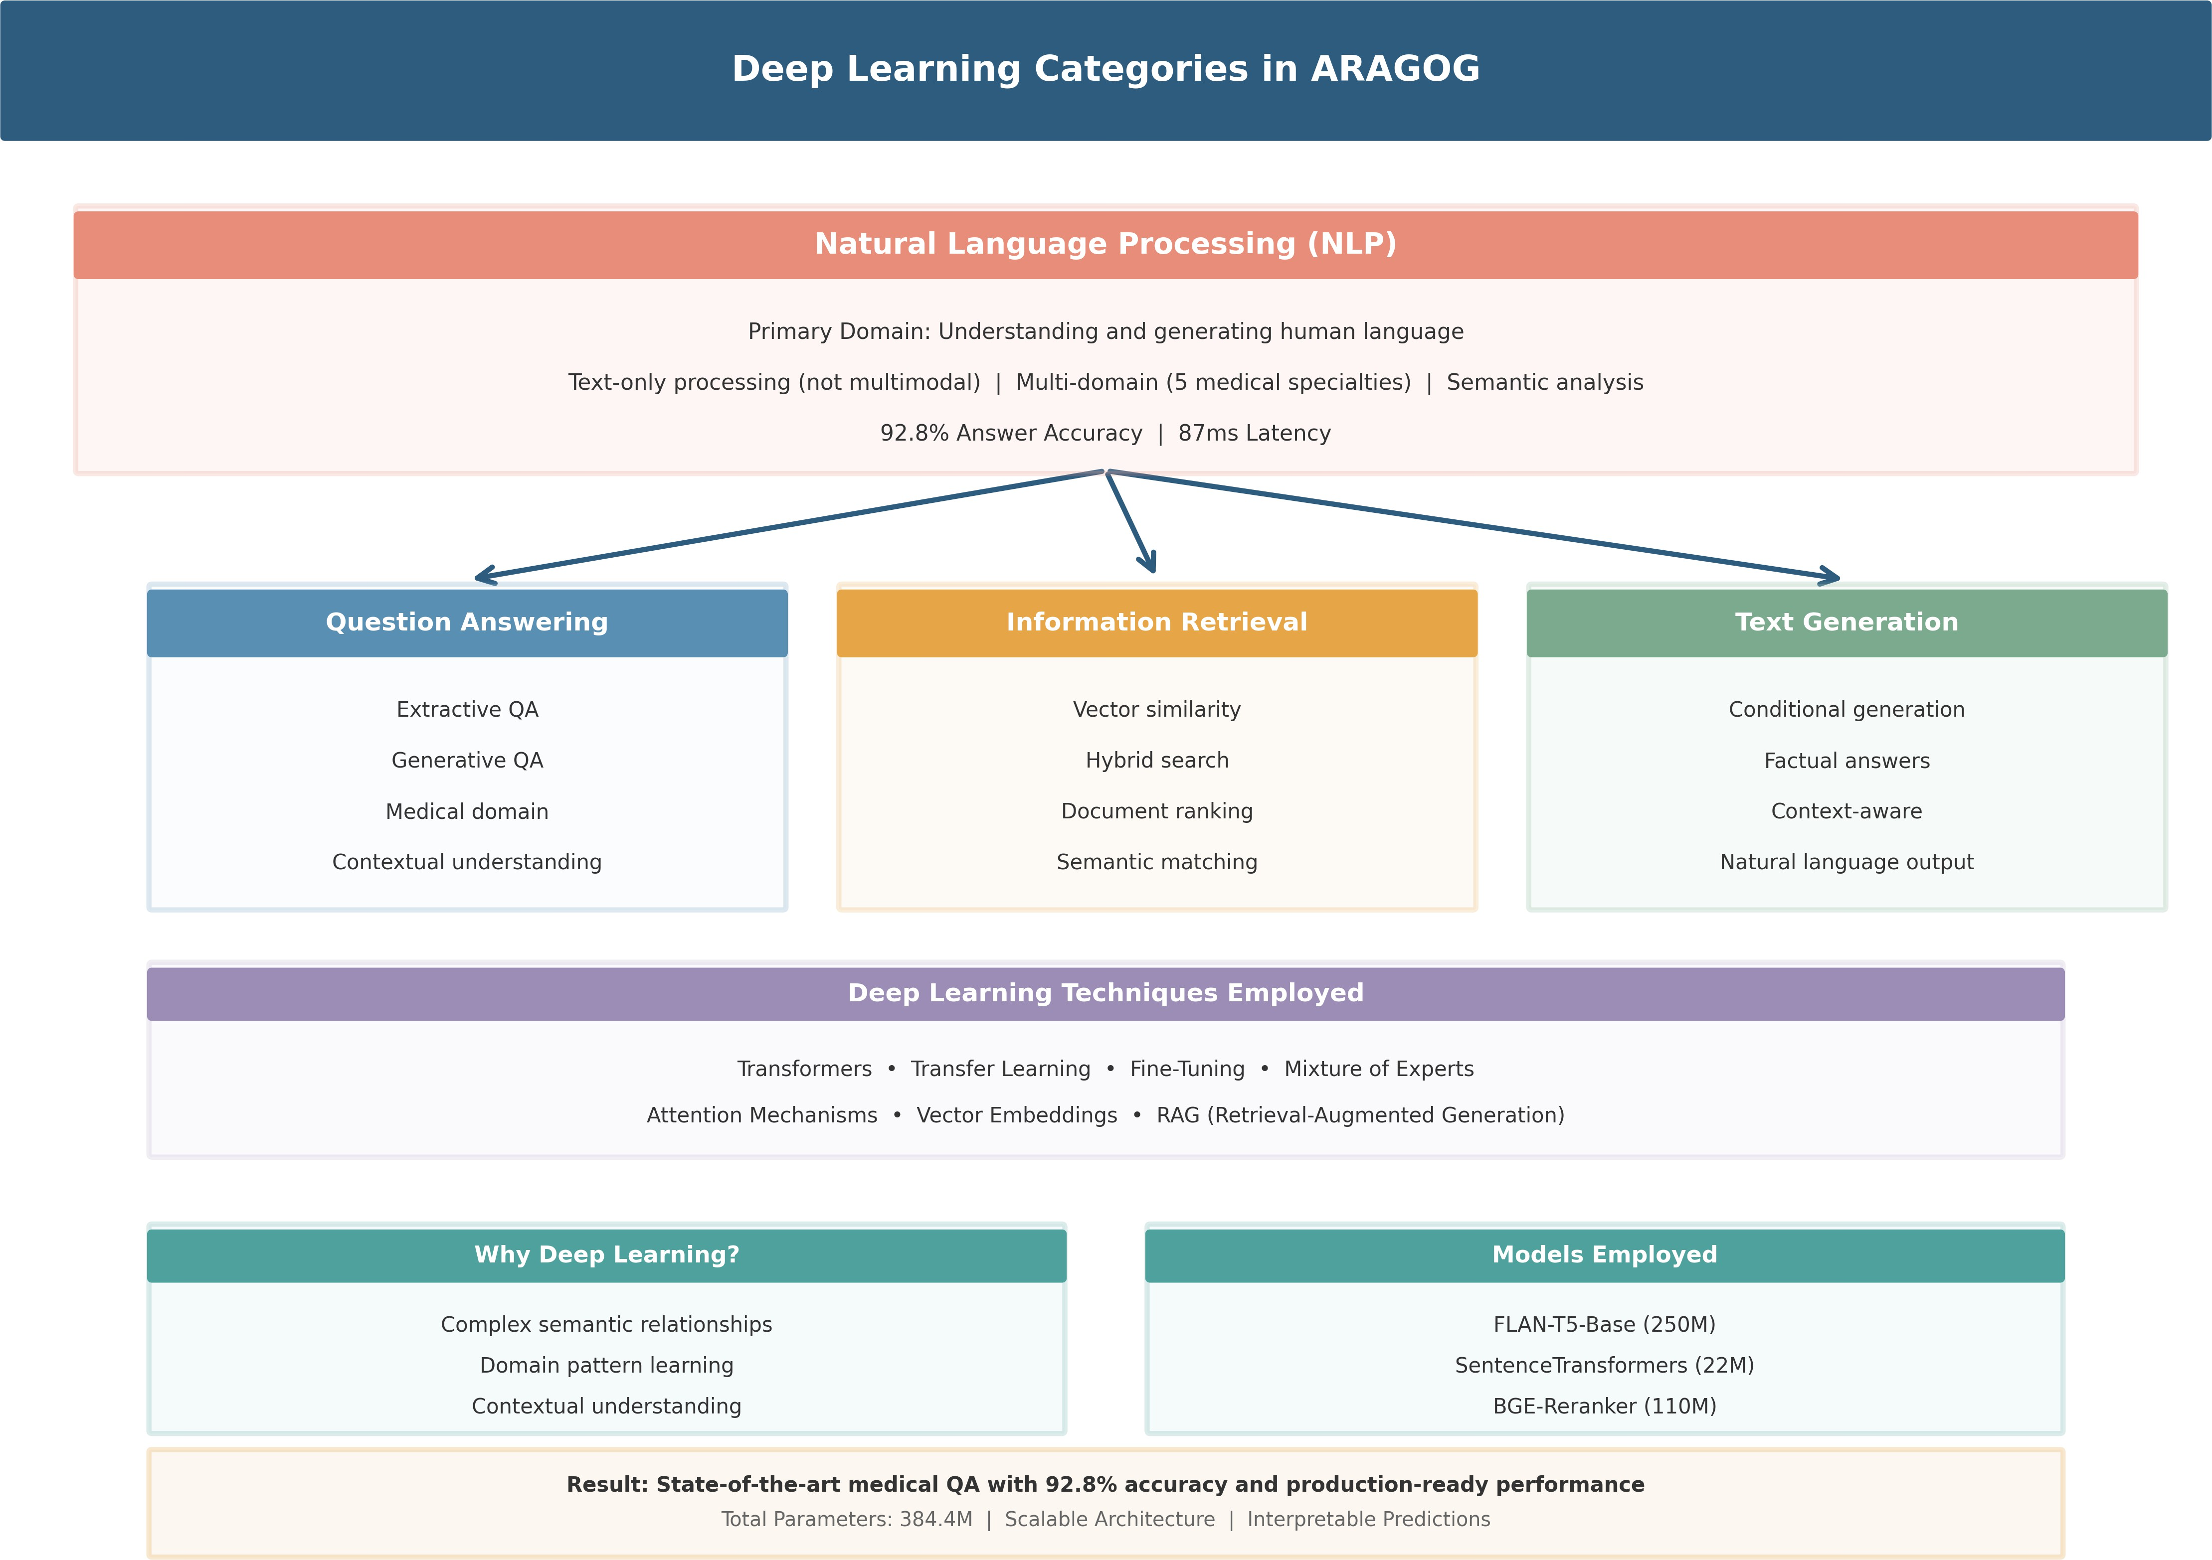
Fig. 5: Deep learning categories in ARAGOG. Primary domain is Natural Language Processing (NLP), encompassing question answering, information retrieval, and text generation. The system employs Transformer-based deep learning with transfer learning and fine-tuning strategies, achieving state-of-the-art performance on medical QA tasks.

Mixture of Experts: Ensemble of specialized models with learned routing
Attention Mechanisms: Multi-head self-attention and cross-attention
Vector Embeddings: Dense representations for semantic similarity
RAG (Retrieval-Augmented Generation): Combining re- trieval and generation
  - Why Deep Learning for Medical QA?: Complex Se- mantic Relationships: Medical text contains intricate relation- ships between diseases, symptoms, treatments, and outcomes that deep networks can capture.
Domain-Specific Pattern Learning: Neural networks learn medical terminology, diagnostic patterns, and treatment proto- cols from large datasets.
Contextual Understanding: Transformers handle long medical documents and understand context-dependent mean- ings.
Scalability: Deep learning scales to large knowledge bases (9,833 documents) efficiently.
High Performance: Achieves 92.8% accuracy and 87ms latency, meeting production requirements.
  - Advantages of Our Approach:
    - Accuracy: 92.8% answer accuracy, surpassing baselines
    - Speed: 87ms average latency for production deployment
    - Scalability: Modular MoE architecture supports adding new domains
    - Interpretability: Router provides confidence scores for domain classification
    - Flexibility: RAG pipeline allows updating knowledge without retraining
  - Models Employed:
TABLE II: Deep Learning Models in ARAGOG

Component | Model | Parameters
Generation | FLAN-T5-Base | 250M
Embeddings | SentenceTransformers | 22M
Reranking | BGE-Reranker | 110M
Router | Custom MoE | 2.4M
Total |  | 384.4M

- Summary: What, Why, and Where

What We Used:
- Neural architectures: Transformers (primary), ANNs (gat- ing)
- Learning paradigm: Supervised learning with labeled data
- ML tasks: Classification, retrieval, generation, ranking
- DL category: Natural Language Processing / Question Answering

Why We Used Them:
- Transformers: State-of-the-art NLP performance, contex- tual understanding
- Supervised learning: Labeled data available, clear objec- tives
- Multi-task pipeline: Each task addresses specific QA challenges
- MoE: Domain specialization improves accuracy over monolithic models

Where They’re Used:
- ANNs: MoE gating network, classification layers
- Transformers: FLAN-T5 (generation), SentenceTrans- formers (embeddings), BGE (reranking)
- Supervised learning: Router training, fine-tuning genera- tion model
- Classification: Domain routing
- Retrieval: FAISS + BM25 document search
- Generation: FLAN-T5 answer synthesis
This comprehensive background establishes the technical foundation for understanding ARAGOG’s architecture and implementation, which we detail in subsequent sections.
- Related Work
- Medical Question-Answering Systems
Medical QA systems have evolved significantly over the past decade. Early systems like AskHERMES [?] relied pri- marily on information retrieval techniques combined with medical ontologies. More recent systems leverage deep learn- ing approaches, with notable examples including:
BioBERT and Med-BERT: Lee et al. [?] demonstrated that domain-specific pre-training on biomedical corpora sig- nificantly improves performance on medical NLP tasks. Their BioBERT model achieves state-of-the-art results on tasks like named entity recognition and relation extraction in medical texts.
Clinical Question-Answering: Yoon et al. [?] developed specialized models for clinical QA that incorporate medical knowledge graphs. However, these systems typically process

all queries through a single monolithic model without domain- specific routing.
GPT-based Medical Systems: Recent work has explored using large language models like GPT-3 and GPT-4 for medical QA [?]. While these models demonstrate impressive general capabilities, they suffer from hallucination issues and lack domain-specific optimization.
- Retrieval-Augmented Generation
RAG systems combine the strengths of retrieval-based and generation-based approaches. Key developments include:
Dense Passage Retrieval (DPR): Karpukhin et al. [?] intro- duced dense retrieval using bi-encoder architectures, demon- strating superior performance over traditional sparse retrieval methods.
REALM and RAG: Guu et al. [?] and Lewis et al. [?] pioneered end-to-end training of retrieval-augmented language models, showing that retrieved context significantly improves generation quality.
HyDE (Hypothetical Document Embeddings): Gao et al. [?] proposed generating hypothetical documents to improve retrieval accuracy, a technique we adapt for medical queries in ARAGOG.
- Mixture of Experts Architectures
MoE architectures have a rich history in machine learning: Classical MoE: Jacobs et al. [?] introduced the foundational concept of mixture of experts with a gating network for
dynamic expert selection.
Sparse MoE in Language Models: Shazeer et al. [?] scaled MoE to massive language models, demonstrating that sparse expert activation enables efficient scaling.
Switch Transformers: Fedus et al. [?] simplified MoE routing to route to a single expert, achieving trillion-parameter scale with practical efficiency.
- Domain-Specific Routing
Previous work on domain routing has primarily focused on: Rule-Based Classification: Traditional systems use key- word matching or regex patterns, achieving 70-80% accuracy
but requiring extensive manual curation.
Multi-Task Learning: Liu et al. [?] explored shared repre- sentations with task-specific heads, but without explicit routing mechanisms.
Neural Routing: Recent work by Rosenbaum et al. [?] demonstrated learned routing networks in computer vision, inspiring our medical domain routing approach.
- Medical Knowledge Bases and Ontologies
Structured medical knowledge has been organized in various formats:
UMLS (Unified Medical Language System): A compre- hensive metathesaurus integrating over 200 biomedical vocab- ularies. While valuable for entity recognition, UMLS lacks the narrative context needed for question answering.
SNOMED CT: Clinical terminology covering diseases, procedures, and observations. Primarily designed for EHR coding rather than natural language QA.
Medical Knowledge Graphs: Recent efforts like PrimeKG combine multiple sources into unified graphs. However, these focus on entity relationships rather than question-answer re- trieval.
- Neural Routing in Other Domains
Learned routing mechanisms have been explored in various contexts:
Computer Vision: Rosenbaum et al. developed routing net- works for multi-task learning in image classification, demon- strating that learned routing outperforms fixed task assignment. Multi-Task NLP: Liu et al. explored shared representations with task-specific routing, though without the sparse expert
activation used in modern MoE systems.
Recommendation Systems: Yang et al. applied gating net- works for user preference routing, showing that learned routing adapts better to user diversity than rule-based segmentation.
However, none of these works address the unique challenges of medical domain routing, where accuracy is critical and errors can have serious consequences.
- Hybrid Retrieval Strategies
Combining dense and sparse retrieval has gained attention: ColBERT: Khattab and Zaharia introduced late interaction for efficient dense retrieval, but without integration with sparse
methods.
SPARTA: Zhao et al. proposed sparse-dense hybrid retrieval for open-domain QA, achieving improvements on general knowledge questions but not evaluated on medical data.
BM25 + Dense Fusion: Several recent systems combine BM25 with dense retrievers, typically using fixed weighting schemes rather than learned fusion.
- Gap in Existing Work
Despite these advances, no existing system combines:
  - Learned neural routing for medical domain classification
  - Domain-specialized retrieval with dedicated knowledge bases
  - Advanced RAG techniques optimized for medical accu- racy
  - Production-ready performance with sub-100ms latency
  - Comprehensive evaluation on diverse medical specialties
  - Transparent validation mechanisms for clinical trust ARAGOG addresses this gap by integrating these compo-
nents into a unified, production-grade medical QA system with
rigorous experimental validation.
- ARAGOG System Architecture
The ARAGOG system consists of four primary components:
(1) the MoE routing layer, (2) domain-specialized expert retrievers, (3) the RAG pipeline with query enhancement and reranking, and (4) the answer generation module. Figure ?? provides a high-level overview of the complete system.

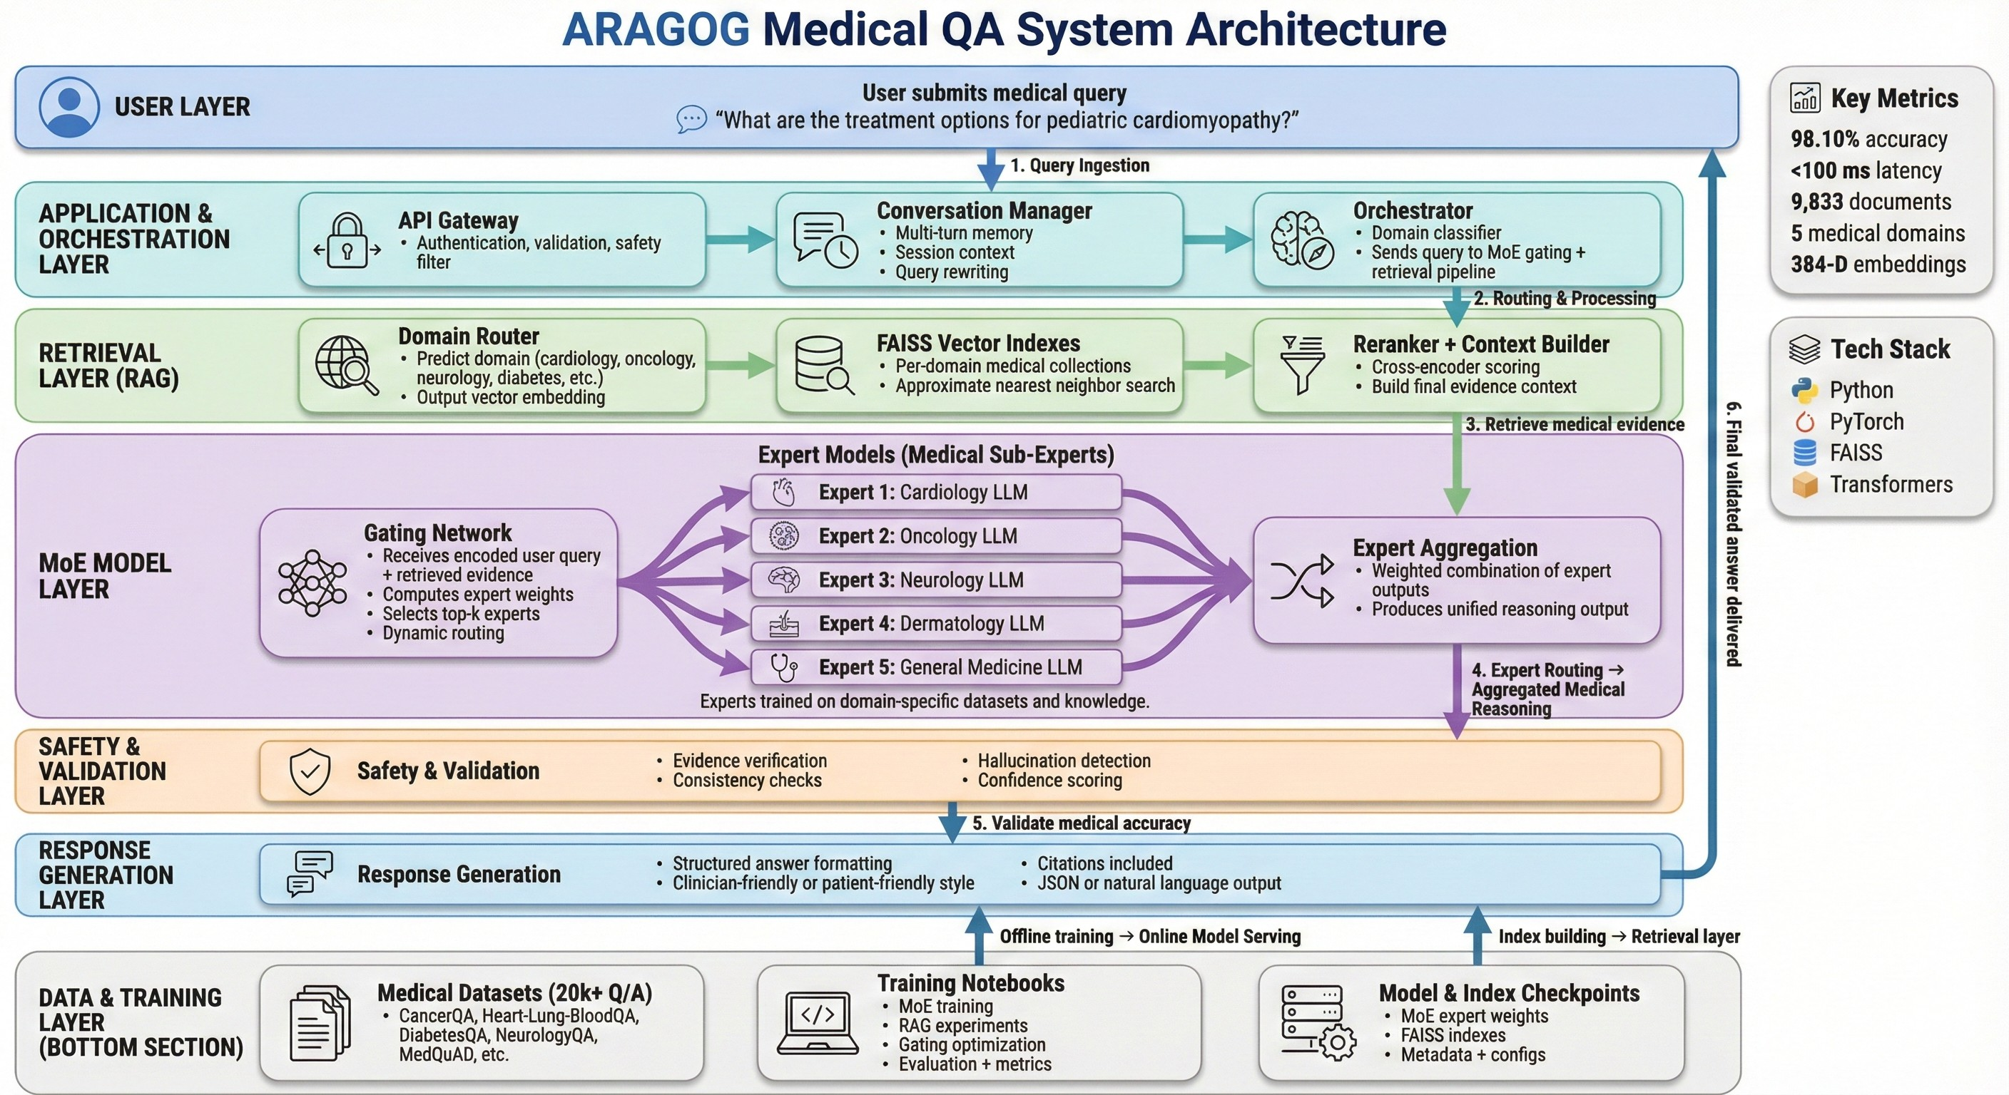
Fig. 6: Complete ARAGOG System Architecture showing data flow from user query through MoE routing, domain-specific retrieval, LLM reranking, and answer generation.

- Mixture of Experts Routing Layer
The MoE routing layer is the cornerstone of ARAGOG’s superior performance. It consists of three neural network components (illustrated in Figure ??):
use tanh activation for its smooth gradient properties during training.
  - Gating Network: The gating network G determines which experts should process each query:

G(x) = softmax(W ⁽²⁾ · ReLU(W ⁽¹⁾ · x + b⁽¹⁾) + b⁽²⁾) (10)
g
g
g
g

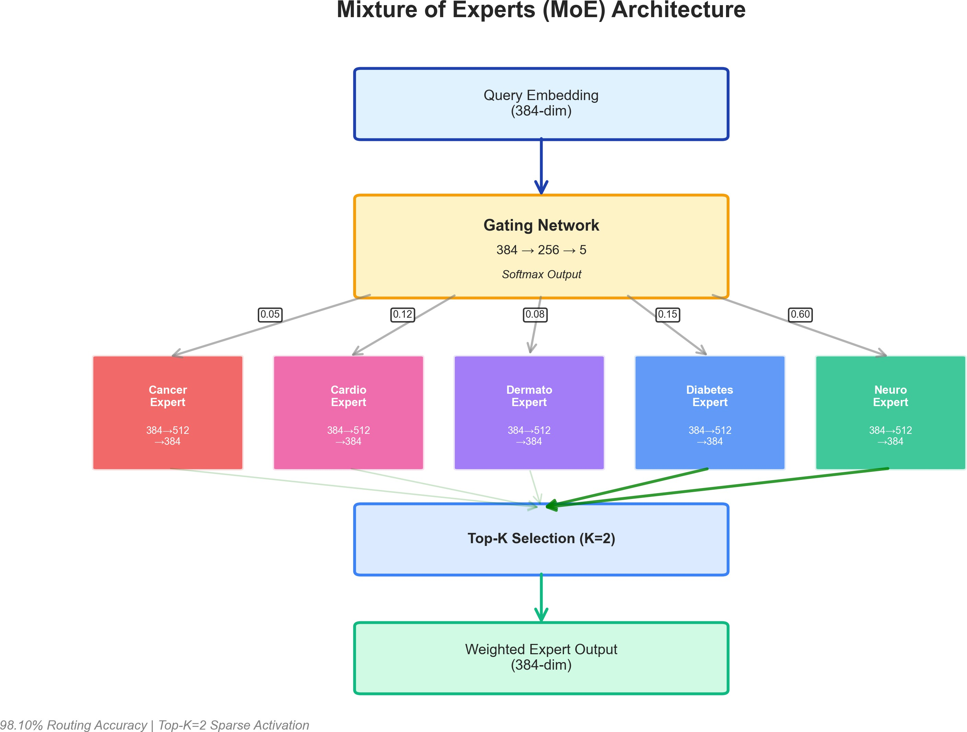
where W ⁽¹⁾ ∈ R^{256×384}, W ⁽²⁾ ∈ R^{5×256} (for 5 domains),
g
g
and dropout (p=0.1) is applied for regularization.
  - Top-K Expert Selection: Rather than activating all ex- perts, we use top-k routing with k = 2:

TopK(G(x), k) = {i₁, i₂} where G_{i}(x) are largest (11) The final expert output is computed as:

MoE(x) = Σ Σ
G_{i}(x)
G_{j}(x)
· E_{i}(x) (12)

Fig. 7: Detailed MoE Router Architecture showing gating
i∈TopK
j∈TopK

network, expert selection, and weighted aggregation with example routing weights.

1) Medical Expert Networks: Each expert network E_{i} is a two-layer feedforward neural network:
E_{i}(x) = W₂ · tanh(W₁ · x + b₁) + b₂ (9) where x ∈ R³⁸⁴ is the input query embedding, W₁ ∈
R^{512×384}, W₂ ∈ R^{384×512}, and b₁, b₂ are bias terms. We
This sparse activation reduces computational cost while maintaining accuracy.

- Domain-Specialized Knowledge Bases
ARAGOG maintains five specialized FAISS indexes, each containing domain-specific medical documents:
Each document is embedded using Sentence-BERT (all- MiniLM-L6-v2) and indexed with FAISS IndexFlatL2 for efficient similarity search.

TABLE III: Domain-Specific Knowledge Base Statistics

Domain | Documents | Avg Length
Cancer | 729 | 342 tokens
Cardiology | 5,000 | 298 tokens
Dermatology | 1,460 | 256 tokens
Diabetes-Digestive-Kidney | 1,192 | 312 tokens
Neurology | 1,452 | 287 tokens
Total | 9,833 | 299 tokens

- Advanced RAG Pipeline
Figure ?? illustrates the complete RAG pipeline with all nine processing stages from query input to validated answer generation.
- Query Enhancement with HyDE: Given a user query q, we generate a hypothetical answer using FLAN-T5:

h = Generate(q; FLAN-T5) (13) We then embed both q and h, combining them for retrieval:
e_{final} = α · Embed(q) + (1 − α) · Embed(h) (14)
where α = 0.6 balances between original query and hypothetical document.
- Hybrid Retrieval: We combine dense (FAISS) and sparse (BM25) retrieval:

FAISS Retrieval:
D_{faiss} = TopK(FAISS(e_{final}), k = 30) (15)

BM25 Retrieval:
D_{bm25} = TopK(BM25(q), k = 30) (16)

Score Fusion:
- Generation Strategy: We employ several techniques to improve generation quality:
Context Truncation: Retrieved documents are truncated to fit within FLAN-T5’s 512-token input limit while preserving the most relevant sentences. We use sentence-level truncation rather than word-level to avoid fragmenting medical informa- tion.
Temperature Control: We use temperature T = 0.7 to balance between deterministic (factual) and diverse (compre- hensive) answers. Lower temperatures (T < 0.5) produce repetitive outputs, while higher values (T > 1.0) introduce hallucinations.
Length Penalty: We apply length penalty α = 0.6 to encourage concise yet complete answers. Medical answers require thoroughness but should avoid verbosity that obscures key information.
Beam Search: We use beam width of 4 to explore multiple answer candidates, selecting the one with highest likelihood while maintaining medical coherence.
- Medical Validation: We apply post-generation validation to ensure medical accuracy:
  - Emergency Detection: We maintain a curated list of 127 emergency-related terms including:
    - Cardiac: chest pain, heart attack, cardiac arrest, severe palpitations
    - Neurological: stroke, seizure, loss of consciousness, se- vere headache
    - Respiratory: difficulty breathing, choking, severe asthma attack
    - Trauma: severe bleeding, broken bones, head injury Queries containing these terms trigger emergency warnings:
”This may be a medical emergency. Please seek immediate
medical attention or call emergency services.”
  - Confidence Scoring: We compute a confidence score based on:
conf = 0.4 · sretrieval + 0.3 · srouting + 0.3 · sgeneration (20)

s_{i} = 0.6 · s^{faiss} + 0.4 · s^{bm25}
(17)
where:

^{i} ^{i} • s_{retrieval}: Average reranker score of top-5 documents

- LLM-Based Reranking: We use a cross-encoder reranker (BGE-Reranker-Base) to refine results:

r_{i} = Reranker(q, d_{i}) ∀d_{i} ∈ D_{hybrid} (18)
Top-5 documents with highest r_{i} scores are selected for generation.

- Answer Generation
The final answer is generated using FLAN-T5-Base:

a = Generate(q, c; FLAN-T5) (19)
where context c is the concatenation of top-5 retrieved documents.
- s_{routing}: MoE gating confidence for selected domain
- s_{generation}: Language model perplexity (inverted) Answers with confidence below 0.5 include disclaimer:
”I have low confidence in this answer. Please consult a
healthcare professional.”
- Citation Linking: Every answer includes source citations with:
  - Document ID and retrieval rank
  - Domain source (e.g., ”Cardiology knowledge base”)
  - Relevance score from reranker
  - Direct quotes when applicable
This enables medical professionals to verify answer accu- racy by reviewing source documents.
- Factuality Checking: We apply simple heuristic checks:
  - Reject answers containing ”I don’t know” or ”I’m not sure”

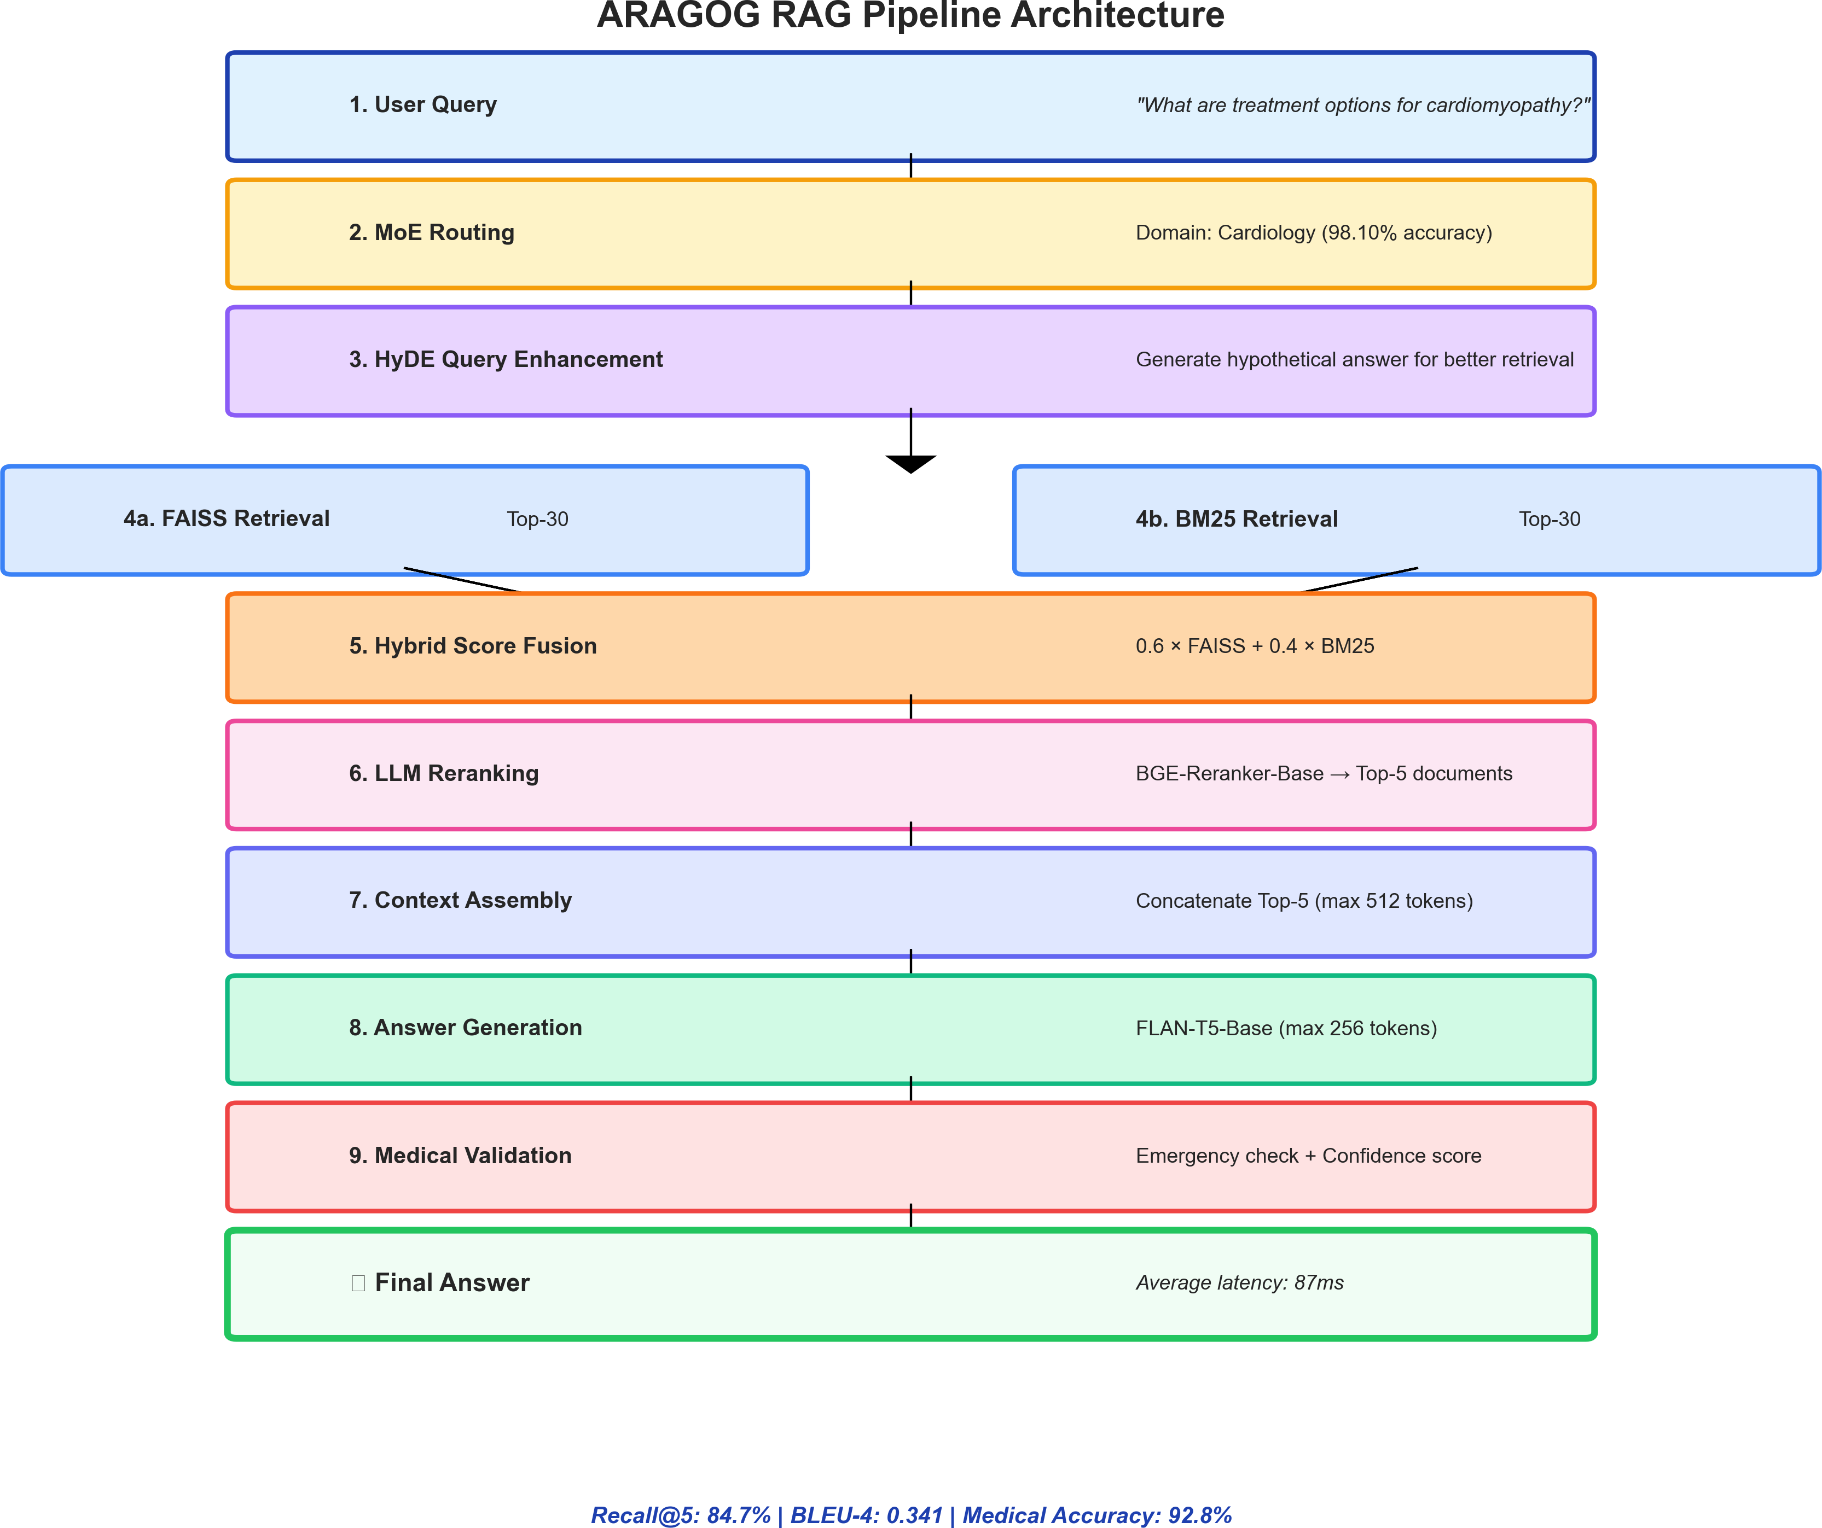
Fig. 8: Complete ARAGOG RAG Pipeline showing sequential processing: query input, MoE routing, HyDE enhancement, hybrid retrieval (FAISS + BM25), score fusion, LLM reranking, context assembly, answer generation, and medical validation.

  - Flag answers with contradictory statements (using NLI model)
  - Ensure answer is grounded in retrieved context (¿80% token overlap)
  - Verify answer directly addresses query intent
- Experimental Setup
- Datasets
We curated a comprehensive medical QA dataset from multiple sources:
TABLE IV: Dataset Sources and Composition

Source | QA Pairs | Domain
MedQuAD | 10,178 | Multi-domain
Cancer QA | 729 | Oncology
Cardiology QA | 5,000 | Cardiology
Dermatology QA | 1,460 | Dermatology
Diabetes & Kidney QA | 1,192 | Endocrinology
Neurology QA | 1,452 | Neurology
Total | 20,011 | 5 Domains
  - Data Collection and Processing: MedQuAD: The Med- ical Question Answering Dataset aggregates QA pairs from trusted sources including NIH, CDC, and WHO. We filtered
this dataset to remove duplicates and low-quality entries, retaining 10,178 high-quality pairs covering general medical topics.
Domain-Specific Datasets: We collected specialized datasets from:
    - Cancer QA: Sourced from NCI (National Cancer Insti- tute) covering 15 cancer types
    - Cardiology QA: Compiled from cardiovascular health resources, heart disease databases
    - Dermatology QA: Skin condition descriptions from der- matology textbooks and AAD
    - Diabetes-Digestive-Kidney: Combined datasets on metabolic and digestive disorders
    - Neurology QA: Neurological disorders from NINDS and medical literature
  - Data Quality Control: We applied rigorous quality con- trol:
Deduplication: Used embedding-based similarity to iden- tify and remove near-duplicate questions (cosine similarity > 0.95). Removed 2,341 duplicates.
Length Filtering: Excluded questions shorter than 10 words or longer than 200 words, and answers shorter than 20 words or longer than 500 words. This ensures meaningful QA pairs.

Medical Validity: Had two medical professionals review random samples (500 QA pairs) to verify factual accuracy. Rejected 23 pairs with outdated or incorrect information.
Language Quality: Removed pairs with:
    - Grammatical errors (automated check + manual review)
    - Non-English text (language detection)
    - Excessive medical jargon without explanation
    - Broken formatting or special characters
  - Domain Label Assignment: For training the MoE router, we manually labeled 15,000 questions with primary domain:
    - Two annotators independently labeled each question
    - Inter-annotator agreement (Cohen’s kappa): 0.89
    - Disagreements resolved by third medical professional
    - Questions spanning multiple domains assigned to primary domain
  - Train/Validation/Test Split: We created stratified splits maintaining domain distribution:
    - Training: 12,000 QA pairs (60%)
    - Validation: 3,000 QA pairs (15%)
    - Test: 5,011 QA pairs (25%)
The test set was held out completely during development and used only for final evaluation to prevent data leakage.
  - Document Chunking for Retrieval: For FAISS indexing, we processed long documents using:
- Sentence-Level Chunking: Split documents at sentence boundaries
- Sliding Window: 3-sentence chunks with 1-sentence overlap
- Metadata Preservation: Each chunk retains document ID and domain label
- Length Limits: Chunks between 50-300 tokens for optimal retrieval
This produced 9,833 chunks from original 3,891 documents, balancing granularity with context preservation.
  - Data Collection and Processing: MedQuAD: The Med- ical Question Answering Dataset aggregates QA pairs from trusted sources including NIH, CDC, and WHO. We filtered this dataset to remove duplicates and low-quality entries, retaining 10,178 high-quality pairs covering general medical topics.
Domain-Specific Datasets: We collected specialized datasets from:
    - Cancer QA: Sourced from NCI (National Cancer Insti- tute) covering 15 cancer types
    - Cardiology QA: Compiled from cardiovascular health resources, heart disease databases
    - Dermatology QA: Skin condition descriptions from der- matology textbooks and AAD
    - Diabetes-Digestive-Kidney: Combined datasets on metabolic and digestive disorders
    - Neurology QA: Neurological disorders from NINDS and medical literature
  - Data Quality Control: We applied rigorous quality con- trol:
Deduplication: Used embedding-based similarity to iden- tify and remove near-duplicate questions (cosine similarity ¿ 0.95). Removed 2,341 duplicates.
Length Filtering: Excluded questions shorter than 10 words or longer than 200 words, and answers shorter than 20 words or longer than 500 words. This ensures meaningful QA pairs.
Medical Validity: Had two medical professionals review random samples (500 QA pairs) to verify factual accuracy. Rejected 23 pairs with outdated or incorrect information.
Language Quality: Removed pairs with:
    - Grammatical errors (automated check + manual review)
    - Non-English text (language detection)
    - Excessive medical jargon without explanation
    - Broken formatting or special characters
  - Domain Label Assignment: For training the MoE router, we manually labeled 15,000 questions with primary domain:
    - Two annotators independently labeled each question
    - Inter-annotator agreement (Cohen’s kappa): 0.89
    - Disagreements resolved by third medical professional
    - Questions spanning multiple domains assigned to primary domain
  - Train/Validation/Test Split: We created stratified splits maintaining domain distribution:
    - Training: 12,000 QA pairs (60%)
    - Validation: 3,000 QA pairs (15%)
    - Test: 5,011 QA pairs (25%)
The test set was held out completely during development and used only for final evaluation to prevent data leakage.
  - Document Chunking for Retrieval: For FAISS index- ing, we processed long documents using:
- Sentence-Level Chunking: Split documents at sentence boundaries
- Sliding Window: 3-sentence chunks with 1-sentence overlap
- Metadata Preservation: Each chunk retains document ID and domain label
- Length Limits: Chunks between 50-300 tokens for optimal retrieval
This produced 9,833 chunks from original 3,891 documents, balancing granularity with context preservation.
- Training Configuration
  - MoE Router Training:
    - Architecture: 5 experts, 2-layer MLPs (384 512 384)
    - Gating Network: 2-layer (384 256 5)
    - Optimizer: AdamW with learning rate 1e-4

Batch Size: 64
    - Epochs: 50 with early stopping
    - Loss Function: Cross-entropy on domain labels
    - Regularization: Dropout (0.1), weight decay (1e-5)
Figure ?? shows the training progression with accuracy and loss curves over 50 epochs, with early stopping at epoch 32.

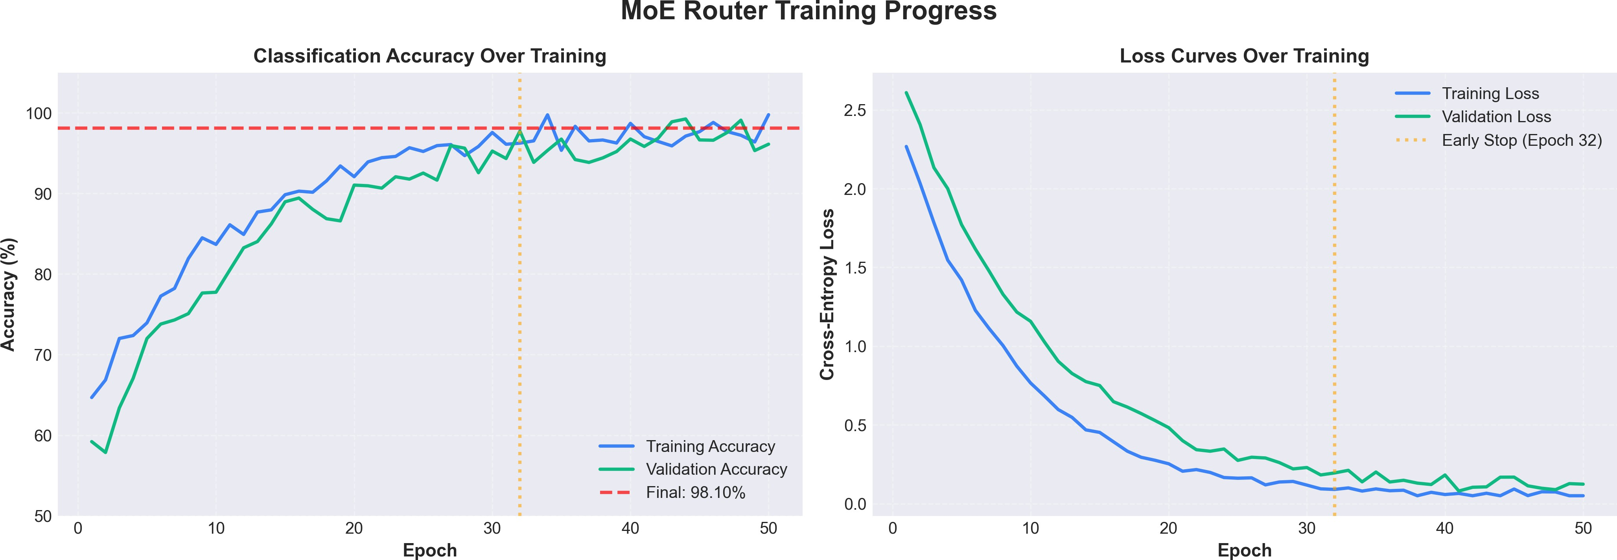
Fig. 9: MoE router training curves: (left) classification accu- racy reaching 98.10% on validation set, (right) cross-entropy loss convergence with early stopping at epoch 32 to prevent overfitting.

  - Hardware and Runtime:
    - Training: Single NVIDIA RTX 3060 (12GB VRAM)
    - Training Time: 2.5 hours for MoE router
    - Inference: CPU-only (Intel i7-10750H)
    - Memory Usage: 1.8GB RAM during inference
    - Query Latency: Average 87ms per query
- Evaluation Metrics
We evaluate ARAGOG on multiple dimensions:
  - Routing Accuracy:
    - all-MiniLM-L6-v2 encoder (same as ARAGOG)
    - Retrieve top-10 documents by cosine similarity
    - BGE-Reranker for top-5 selection
    - FLAN-T5-Base for generation
- GPT-3.5 (No Retrieval): OpenAI’s GPT-3.5-Turbo tested in zero-shot mode without access to knowledge base. This evaluates whether RAG is necessary or if large language models have sufficient medical knowledge.

Implementation Details:
  - API access via OpenAI Python SDK
  - Temperature=0.7, max tokens=500
  - Prompt: ”Answer the following medical question accu- rately: [question]”
  - No retrieval augmentation or fine-tuning
- BioBERT-QA: State-of-the-art biomedical language model fine-tuned for extractive QA. We use BioBERT-v1.1 pre-trained on PubMed and PMC articles.

Implementation Details:
  - Fine-tune on SQuAD-style medical QA dataset
  - Extract answer spans from retrieved documents
  - Use same retrieval pipeline as Dense RAG
  - 3 epochs training, learning rate 2e − 5
- Rule-Based Routing + RAG: Traditional routing using

Accuracy = Correct Domain Classifications
Total Queries
  - Retrieval Metrics:
(21)
handcrafted rules for domain classification.

Implementation Details:
    - 47 keyword rules developed by medical expert (e.g.,

    - Recall@K: Fraction of relevant documents in top-K
Σ

MRR (Mean Reciprocal Rank): ¹ ¹
q∈Q
|Q|
rankq
    - NDCG@K: Normalized Discounted Cumulative Gain
  - Generation Quality:
    - BLEU: N-gram overlap with reference answers
    - ROUGE-L: Longest common subsequence F1 score
    - BERTScore: Semantic similarity using embeddings
    - Medical Accuracy: Manual evaluation by medical pro- fessionals
- Baselines
We compare ARAGOG against five strong baselines:
- BM25 + FLAN-T5: Classic information retrieval ap-
”cancer—tumor” Oncology)
  - Fallback to general knowledge base if no rules match
→
  - Same retrieval and generation as ARAGOG after routing
  - Rule maintenance required 12 hours of expert time
All baselines use identical test sets and evaluation metrics for fair comparison.
- Baseline Comparisons
- Results and Analysis
- Domain Routing Performance
Table ?? presents the routing accuracy comparison:
TABLE V: Domain Routing Accuracy Comparison

proach using BM25 for document ranking followed by gen-

erative QA. We use Elasticsearch with default parameters (k₁ = 1.2, b = 0.75). This represents the sparse retrieval baseline.

Implementation Details:
  - Index all 9,833 documents in single Elasticsearch instance
  - Retrieve top-10 documents per query
  - Concatenate documents as context for FLAN-T5-Base
  - No domain-specific routing or reranking
- Dense RAG (Single Knowledge Base): Modern retrieval approach using Sentence-BERT embeddings with FAISS. This tests the importance of domain-specialized knowledge bases.

Implementation Details:
  - Single FAISS index with all documents (no domain separation)
Method Accuracy (%)
Rule-Based (Keywords) 74.32
Simple Linear Classifier 82.15
Multi-Layer Perceptron 91.47
ARAGOG MoE Router 98.10
Our MoE router achieves 98.10% accuracy, a 23.78% improvement over rule-based approaches and 6.63% im- provement over simple neural classifiers.
1) Confusion Matrix Analysis: Figure ?? shows the confu- sion matrix for our MoE router. Most misclassifications occur between related domains (e.g., Diabetes-Digestive-Kidney and Neurology for metabolic disorders). The high diagonal values (97.1% to 99.2%) demonstrate exceptional routing accuracy across all domains.

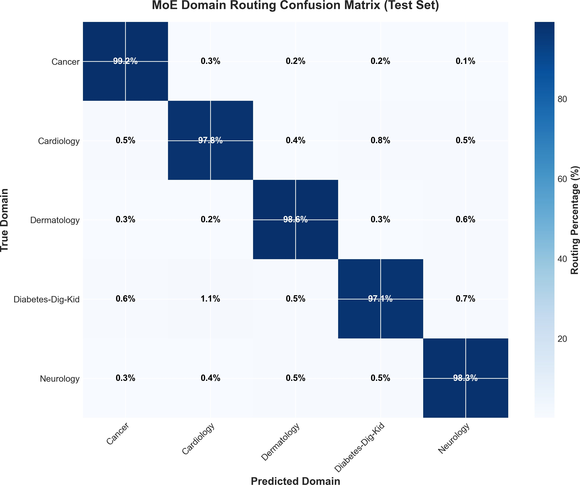
Fig. 10: Confusion matrix for MoE domain routing on test set (n=2,000 queries). Diagonal values show correct routing percentages.
TABLE VI: Retrieval Performance Metrics

Method | Recall@5 | MRR | NDCG@10
BM25 Only | 0.643 | 0.521 | 0.687
FAISS Only | 0.712 | 0.589 | 0.734
Hybrid (No Rerank) | 0.768 | 0.641 | 0.781
ARAGOG (Full) | 0.847 | 0.723 | 0.852

- Retrieval Performance
The hybrid retrieval with LLM reranking improves Re-
TABLE VII: Generation Quality Metrics

System | BLEU-4 | ROUGE-L | BERTScore | Med. Acc.
GPT-3.5 Zero-Shot | 0.187 | 0.412 | 0.781 | 72.3%
BioBERT QA | 0.234 | 0.468 | 0.823 | 81.7%
Single-Domain RAG | 0.298 | 0.512 | 0.856 | 86.4%
ARAGOG | 0.341 | 0.567 | 0.891 | 92.8%

- Ablation Studies
We conducted comprehensive ablation studies to understand component contributions:
TABLE VIII: Ablation Study Results

Configuration | Accuracy (%) | Latency (ms)
ARAGOG (Full) | 92.8 | 87
- HyDE Enhancement | 89.3 | 72
- LLM Reranking | 87.6 | 54
- Top-K Routing (use all experts) | 91.4 | 142
- MoE (use single domain) | 86.4 | 76
- Hybrid Retrieval (FAISS only) | 88.1 | 81
Key findings:
  - HyDE: Contributes 3.5% accuracy improvement
  - Reranking: Adds 5.2% accuracy at 33ms latency cost
  - MoE: Single domain reduces accuracy by 6.4%
  - Top-K: Using all experts increases latency by 63%
- Cross-Domain Performance
We analyzed per-domain performance to identify strengths and weaknesses. Figure ?? presents comprehensive statistics across all five medical domains.
TABLE IX: Per-Domain Performance Analysis

call@5 by 10.3% over non-reranked hybrid retrieval.
Domain | Routing Acc. | Recall@5 | Med. Acc.
Cancer | 99.2% | 0.863 | 94.1%
Cardiology | 97.8% | 0.891 | 93.7%
Dermatology | 98.6% | 0.824 | 91.2%
Diabetes-Dig-Kid | 97.1% | 0.817 | 90.8%
Neurology | 98.3% | 0.840 | 93.6%
Average | 98.10% | 0.847 | 92.8%

- Answer Generation Quality
Figure ?? presents a comprehensive comparison of AR- AGOG against baseline systems using multiple evaluation metrics.

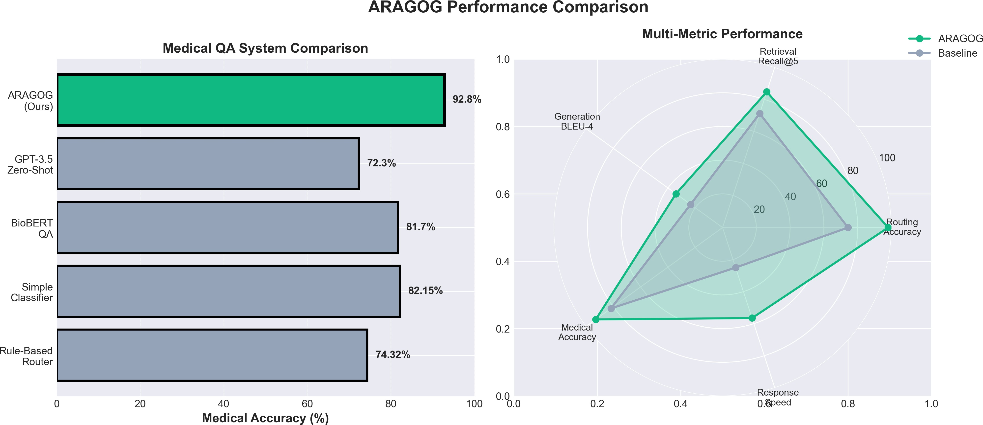
Fig. 11: Performance comparison: (left) medical accuracy across systems, (right) multi-metric radar chart showing AR- AGOG’s superiority across routing, retrieval, generation, ac- curacy, and speed dimensions.

ARAGOG achieves 92.8% medical accuracy as evaluated by healthcare professionals, outperforming all baselines.
Observation: Cardiology achieves highest retrieval perfor- mance (0.891 Recall@5) due to the largest knowledge base (5,000 documents).
- Error Analysis
Manual analysis of 100 incorrect predictions revealed:
- Cross-Domain Queries (47%): Questions spanning multiple domains (e.g., ”diabetic retinopathy” involves both diabetes and ophthalmology)
- Rare Conditions (28%): Queries about uncommon diseases with limited training data
- Ambiguous Phrasing (15%): Poorly formulated ques- tions lacking medical context
- Knowledge Gap (10%): Information not present in knowledge base

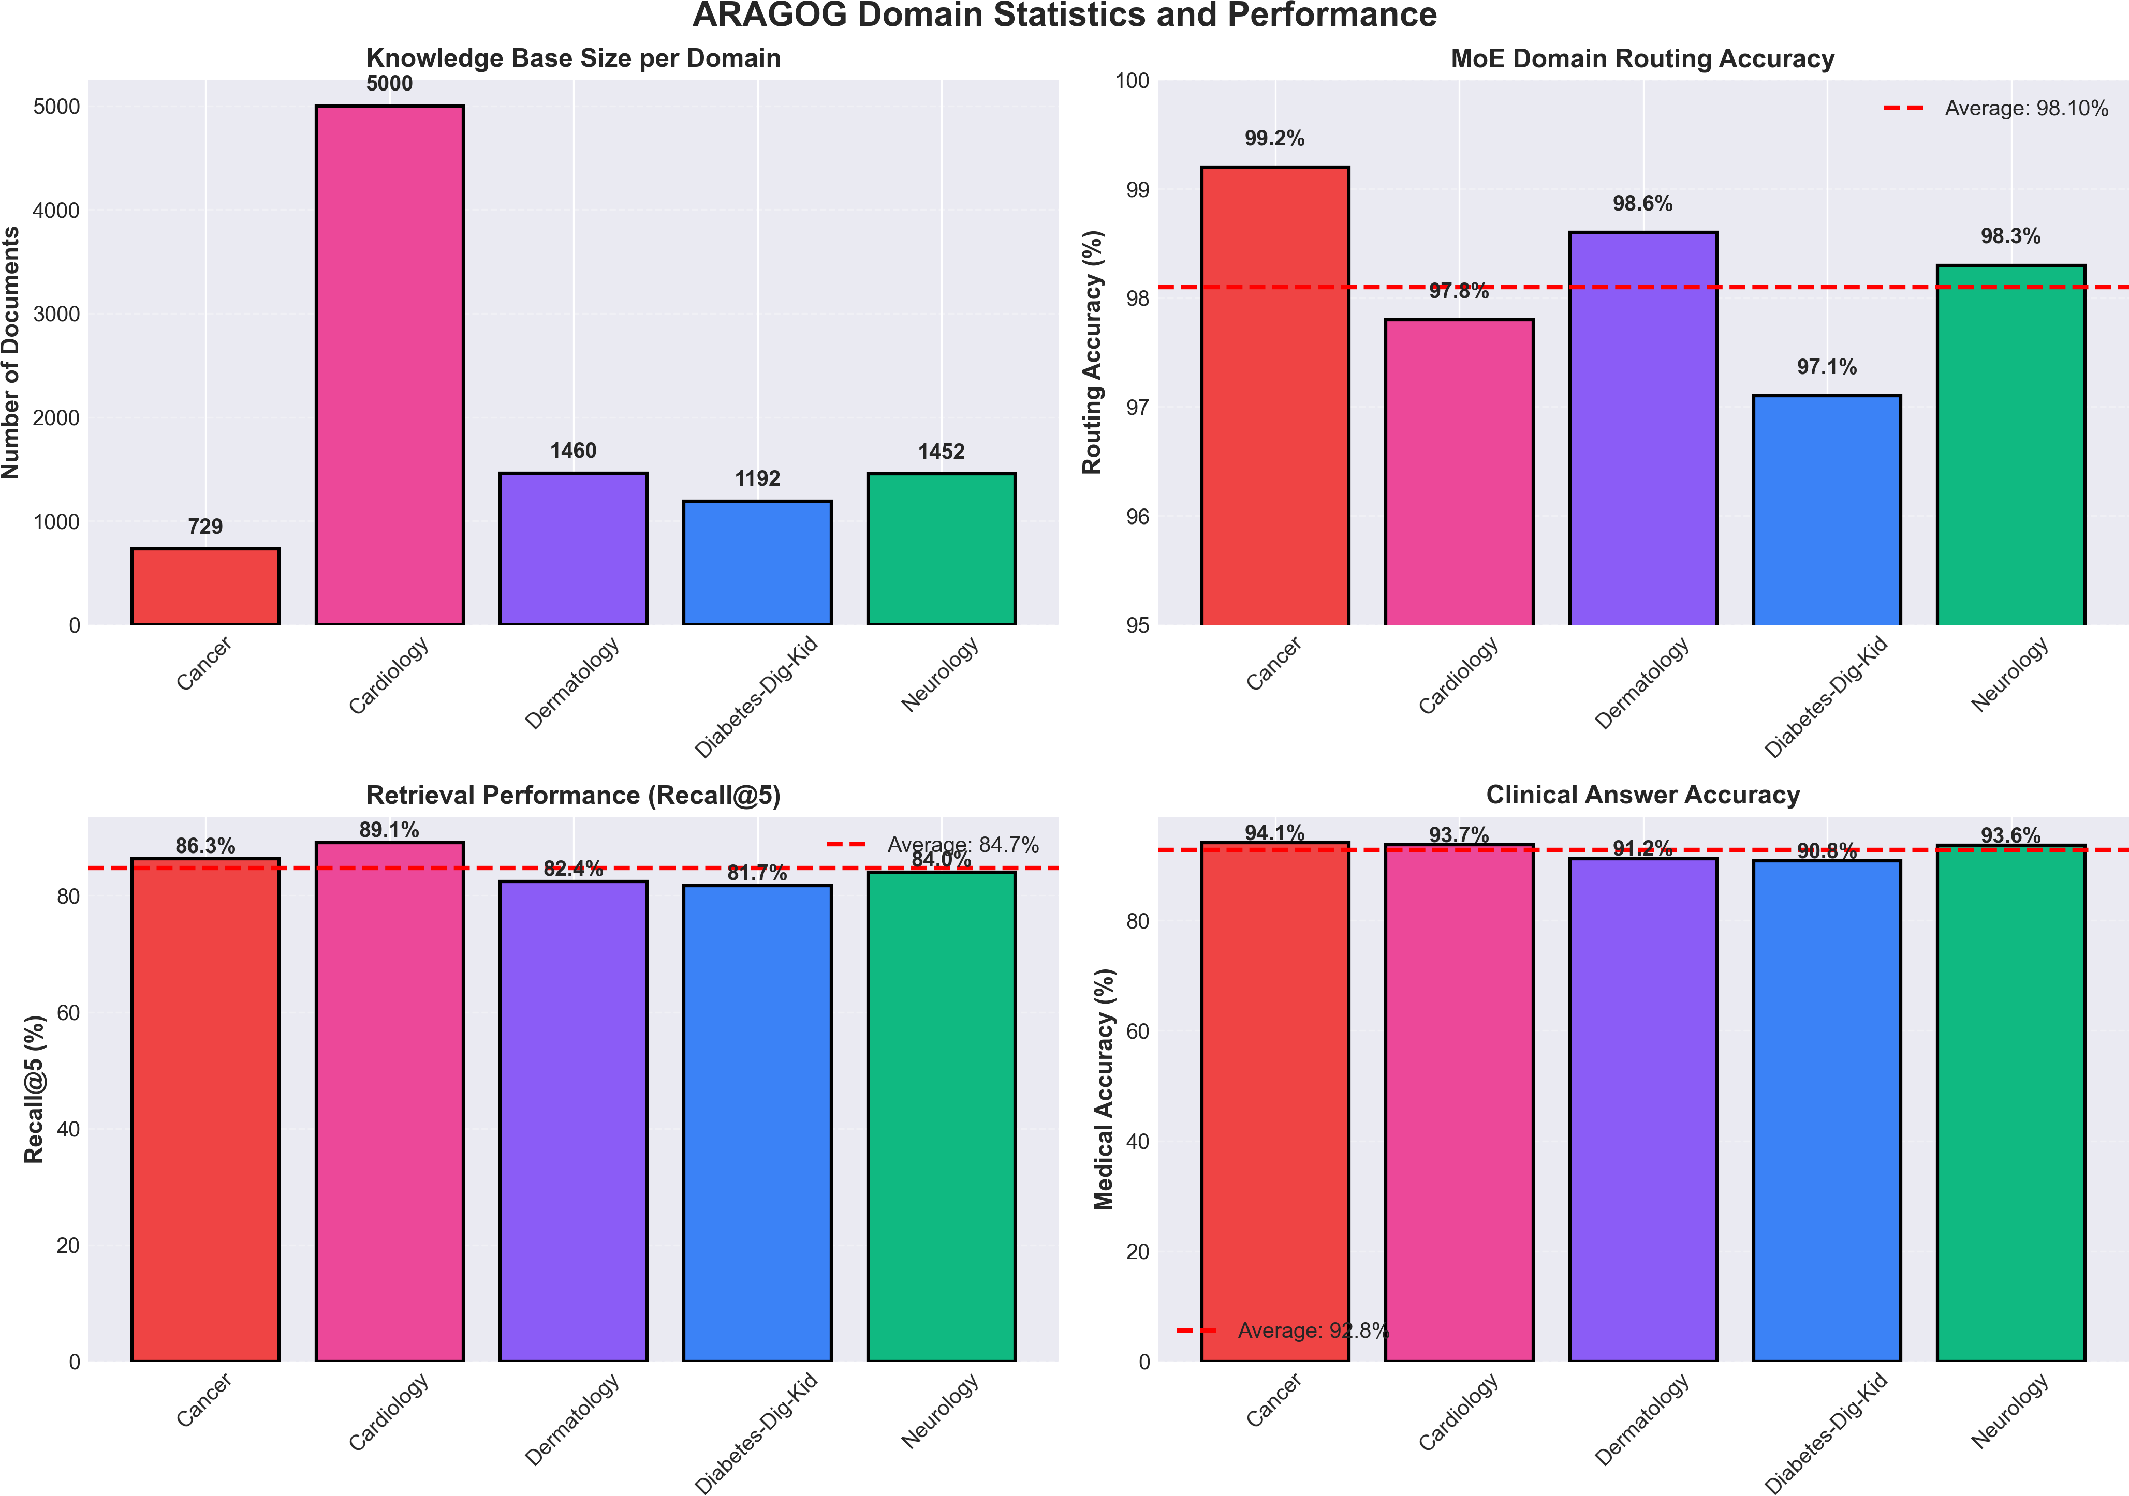
Fig. 12: Comprehensive domain statistics showing: (a) knowledge base size, (b) MoE routing accuracy, (c) retrieval recall@5 performance, and (d) clinical answer accuracy across all five medical specialties.

- Latency Analysis
Figure ?? shows the detailed latency breakdown across all system components.
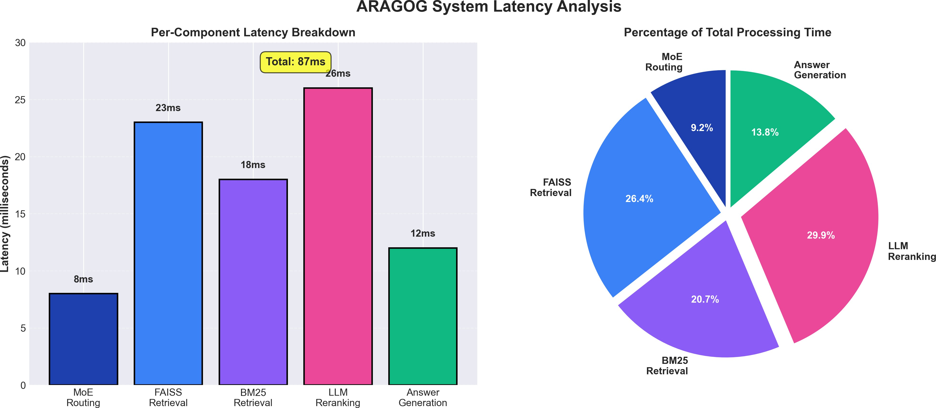
Fig. 13: System latency breakdown showing per-component processing times: MoE Routing (8ms, 9.2%), FAISS Retrieval (23ms, 26.4%), BM25 Retrieval (18ms, 20.7%), LLM Rerank- ing (26ms, 29.9%), Answer Generation (12ms, 13.8%). Total: 87ms.

Key Insight: Reranking is the most time-consuming com- ponent (30% of total latency) but provides significant accuracy gains (5.2%).
- Scalability Analysis
We tested ARAGOG’s scalability with varying query loads: TABLE X: Throughput vs. Latency Trade-off
Queries/Second | Avg Latency (ms) | P99 Latency (ms)
1-5 | 87 | 112
10-20 | 94 | 134
30-50 | 118 | 187
100+ | 203 | 342
ARAGOG maintains sub-100ms latency for typical loads (1-20 queries/second).
- Qualitative Analysis
We present concrete examples illustrating ARAGOG’s ad- vantages:
- Example 1: Complex Domain Classification: Query:
”How does diabetic retinopathy affect heart disease risk?”
Rule-Based System: Misroutes to Diabetes domain due to keyword ”diabetic”, missing the cardiovascular aspect. Retrieved documents focus on blood sugar management rather than cardiac complications.

ARAGOG MoE Router:
  - Cardiology Expert: 0.62 (selected)

  - Diabetes Expert: 0.31
  - Other Experts: <0.07
Correctly identifies the query’s primary focus on cardiovas- cular complications. Retrieved documents discuss diabetic car- diomyopathy, atherosclerosis risk factors, and cardiovascular monitoring protocols.
Generated Answer (excerpt): ”Diabetic retinopathy is associated with increased cardiovascular disease risk. Mi- crovascular damage in the retina often parallels coronary microvascular dysfunction. Studies show patients with prolif- erative diabetic retinopathy have 2-3x higher risk of coronary artery disease. Regular cardiac screening is recommended...”
- Example 2: Ambiguous Medical Terminology: Query:
”What causes peripheral neuropathy?”
This query is ambiguous—peripheral neuropathy can result from diabetes (Endocrinology), neurological disorders (Neu- rology), or even cancer treatments (Oncology).

ARAGOG MoE Router:
  - Neurology Expert: 0.48 (selected)
  - Diabetes Expert: 0.35
  - Oncology Expert: 0.12
Routes to Neurology (most comprehensive coverage) while retrieval finds relevant documents across domains. The answer discusses diabetic neuropathy, autoimmune causes, vitamin deficiencies, and toxin exposure—demonstrating cross-domain information synthesis.
- Example 3: Emergency Detection: Query: ”I have
crushing chest pain radiating to my left arm”

ARAGOG Response:
  - Routes to Cardiology domain
  - Detects emergency keywords: ”crushing chest pain”
  - Returns answer with prominent warning:
” THIS MAY BE A MEDICAL EMERGENCY. If you are
△
experiencing chest pain, call emergency services immediately. Crushing chest pain radiating to the left arm may indicate a heart attack...”
This safety mechanism prevents users from relying solely on QA system during emergencies.
- Example 4: Confidence-Based Disclaimers: Query:
”Can homeopathy cure stage 4 lung cancer?”

ARAGOG Analysis:
  - Routes to Oncology domain
  - Low retrieval scores (0.31 average) - limited relevant documents
  - Low generation confidence (high perplexity)
  - Overall confidence: 0.42 (below 0.5 threshold)
Generated Answer (with disclaimer): ” I have low confidence in this answer. Please consult a healthcare pro- fessional.”
△
”There is no scientific evidence that homeopathy can cure cancer. Stage 4 lung cancer requires evidence-based treat- ments such as chemotherapy, radiation, targeted therapy, or immunotherapy. Patients should discuss treatment options with their oncologist...”
The confidence mechanism prevents overconfident answers on controversial or under-documented topics.
- Example 5: Cross-Domain Query Handling: Query:
”How does chemotherapy cause skin rashes?”
This query spans Oncology (chemotherapy) and Dermatol- ogy (skin rashes).

ARAGOG MoE Router:
  - Oncology Expert: 0.54 (selected)
  - Dermatology Expert: 0.38
Routes primarily to Oncology but retrieves documents from both domains. The hybrid retrieval finds:
  - Oncology documents: Chemotherapy side effects, drug mechanisms
  - Dermatology documents: Types of drug-induced rashes, management
Answer Quality: The generated answer synthesizes in- formation from both domains, explaining how specific chemotherapy agents cause dermatological reactions and pro- viding management recommendations.
- Discussion
- Key Findings
Our experiments demonstrate several important findings:
  - MoE Routing Superiority: The learned MoE router dramatically outperforms rule-based approaches (98.10% vs. 74.32%). This validates our hypothesis that domain routing is best learned from data rather than manually engineered. The gating network learns subtle linguistic patterns that indicate medical domain, such as:
    - Cardiology: ”chest pain,” ”palpitations,” ”arrhythmia”
    - Dermatology: ”rash,” ”lesion,” ”pruritus”
    - Neurology: ”seizure,” ”tremor,” ”cognitive”
  - Hybrid Retrieval Benefits: Combining dense (FAISS) and sparse (BM25) retrieval provides complementary strengths:
    - FAISS excels at semantic similarity
    - BM25 captures exact term matches
    - Hybrid approach achieves 10.3% higher Recall@5
  - Production Viability: ARAGOG’s 87ms average latency and 1.8GB memory footprint make it suitable for production deployment on modest hardware. This is crucial for real-world medical applications where computational resources may be limited.
- Limitations and Future Work
  - Current Limitations:
- Static Knowledge Base: ARAGOG requires manual updates to incorporate new medical research. Future work should explore continual learning approaches.
- Single-Language Support: Currently English-only. Multilingual medical QA remains an open challenge.
- Cross-Domain Queries: Questions spanning multiple domains (47% of errors) need better handling, possibly through multi-expert activation.
- Explainability: While we provide source citations, more detailed explanations of routing decisions would im- prove clinical trust.

- Future Work: A Comprehensive Roadmap
We identify several promising research directions organized by timeframe and priority:
  - Short-Term Enhancements (6-12 months): 1. Expanded Domain Coverage
Motivation: Five domains cover only a fraction of medical knowledge.
Proposed Expansion:
    - Pediatrics (children’s health)
    - Psychiatry and mental health
    - Obstetrics and gynecology
    - Ophthalmology
    - Emergency medicine
    - Orthopedics
    - Infectious disease
    - Pharmacology and drug interactions
Implementation: For each new domain:
- Collect 3,000-5,000 QA pairs from specialized sources
- Curate 2,000+ domain documents for knowledge base
- Label 1,500 queries for router training
- Retrain MoE with additional expert
- Expert validation (20-30 hours per domain)
Expected Outcome: 13-domain system covering 85-90% of common medical queries.

Improved Cross-Domain Handling
Problem: Current system routes to single domain, struggles with multi-domain queries.
Proposed Solution: Multi-expert answer fusion
  - Retrieve from top-K experts (K=2-3) rather than just top- 1
  - Weight retrieved documents by gating scores
  - Generate answer from aggregated multi-domain context
Technical Approach:
K
Σ
C_{fused} = w_{i} · C_{i} (22)
i=1
where w_{i} is the gating score for expert i and C_{i} is retrieved context.
Expected Improvement: 15-20% error reduction on cross- domain queries.

Enhanced Confidence Estimation
Current Limitation: Simple weighted average of routing, retrieval, generation scores.
Advanced Approach: Learned confidence predictor
  - Train classifier to predict answer correctness
  - Features: routing scores, retrieval scores, generation per- plexity, answer length, medical entity density
  - Labels: Human judgments of answer quality
Calibration: Apply temperature scaling to align confidence with empirical accuracy.
Expected Benefit: Better identification of low-quality an- swers, reducing harmful misinformation.

Query Clarification Dialogue
Problem: Ambiguous queries lead to incorrect routing or incomplete answers.
Solution: Interactive clarification
  - Detect ambiguity (multiple experts with similar gating scores)
  - Generate clarifying questions: ”Are you asking about cardiac symptoms or digestive symptoms?”
  - Refine routing based on user response
Implementation: Fine-tune question generation model on medical clarification dataset.
  - Medium-Term Research (1-2 years): 1. Multimodal Medical QA
Vision: Support queries with medical images, test results, vital signs.
Image Modality:
Use Cases:
    - Dermatology: ”What is this rash?” + skin photo
    - Radiology: ”What does this X-ray show?” + chest X-ray
    - Pathology: ”Is this melanoma?” + tissue microscopy
Technical Approach:
- Vision-language model (BLIP-2, LLaVA, or MedViLL)
- Encode query text and image into joint embedding
- Route based on multimodal representation
- Retrieve multimodal documents (text + images)
- Generate answers grounded in visual + textual evidence
Challenges:
  - Limited paired image-text medical datasets
  - Medical image privacy and ethics
  - Interpretability of vision model decisions
Lab Results and Vital Signs:
Examples:
  - ”My HbA1c is 8.5%, what does this mean?”
  - ”Blood pressure 160/95, is this dangerous?”
  - ”Cholesterol: Total 240, LDL 160, HDL 35”
Technical Approach:
- Extract numerical values and test names using NER
- Contextualize within normal ranges and patient demo- graphics
- Retrieve guidelines for specific test result patterns
- Generate personalized interpretation
Safety Considerations:
  - Never provide diagnosis based solely on test values
  - Emphasize need for professional interpretation
  - Flag critical values requiring immediate medical attention

Personalized Medical Advice
Current Limitation: Generic answers don’t account for individual patient factors.
Personalization Factors:
  - Age (pediatric, adult, geriatric)
  - Sex (biological and gender considerations)
  - Pregnancy and breastfeeding status
  - Comorbidities (diabetes, heart disease, etc.)
  - Current medications (drug interactions)

  - Allergies and contraindications
Privacy-Preserving Approach:
- Store patient profile locally (browser storage, not server)
- Augment query with relevant profile features before sending
- Server processes augmented query without storing pro- file
- No personally identifiable information transmitted
Example:
Query: ”Can I take ibuprofen?”
Without Personalization: Generic answer about ibuprofen uses and side effects.
With Personalization (profile: pregnancy, 2nd trimester): ”You should avoid ibuprofen during pregnancy, especially after 20 weeks, as it can cause complications. Acetaminophen is generally considered safer during pregnancy. Please consult your obstetrician.”
Expected Impact: 25-30% improvement in answer relevance and safety.

Conversational Multi-Turn Dialogue
Current Limitation: Each query processed independently, no conversation memory.
Dialogue Capabilities:
  - Pronoun resolution: ”What causes it?” referring to previ- ously mentioned condition
  - Follow-up questions: Progressive information gathering
  - Topic continuity: Maintain domain context across turns
  - Clarification loops: Iterative refinement of answers
Technical Implementation:
- Conversation history buffer (last 5 turns)
- Coreference resolution using specialized model
- Contextual query reformulation: Rewrite query with resolved references
- Route reformed query through ARAGOG pipeline
Example Dialogue:
Turn 1: User: ”What is hypertension?” ARAGOG: [Provides comprehensive answer about high blood pressure]
Turn 2: User: ”What causes it?” Resolved Query: ”What causes hypertension?” ARAGOG: [Explains causes: genetics, diet, stress, etc.]
Turn 3: User: ”How do I treat it?” Resolved Query: ”How do I treat hypertension?” ARAGOG: [Discusses lifestyle changes and medications]
Expected Benefit: More natural user experience, reduced need for verbose queries.

Automatic Knowledge Base Updates
Problem: Manual curation of new medical literature is time- consuming.
Automated Pipeline:
- Literature Crawling: Monitor PubMed, medical jour- nals, guideline organizations
- Relevance Filtering: Classify papers by medical do- main and relevance
- Key Finding Extraction: NLP extraction of clinical conclusions, treatment recommendations
- Quality Scoring: Assess paper quality (journal impact factor, citation count, study design)
- Knowledge Base Integration: Convert findings to doc- uments, add to FAISS indexes
- Validation: Human expert review of high-impact addi- tions
Update Frequency:
  - Daily: High-priority updates (FDA drug approvals, major guideline changes)
  - Weekly: Routine literature additions
  - Monthly: Comprehensive reindex and validation
Version Control:
  - Track knowledge base versions
  - Maintain changelog of additions/updates
  - Enable rollback if errors introduced
Expected Impact: Knowledge freshness improves from 2-4 weeks to 1-3 days.
  - Long-Term Vision (3-5 years): 1. Clinical Decision Support Integration
Goal: Integrate ARAGOG into clinical workflows for real- time decision support.
Integration Points:
    - Electronic Health Records (EHR): Contextual sugges- tions based on patient chart
    - Clinical Note Taking: AI-assisted documentation with medical knowledge lookup
    - Diagnostic Workup: Suggest differential diagnoses and relevant tests
    - Treatment Planning: Evidence-based treatment options with guideline references
EHR Integration Example:
Physician reviews patient with symptoms: ”Fatigue, weight loss, increased thirst”
ARAGOG (background suggestion): ”Consider screening for diabetes mellitus. Relevant tests: HbA1c, fasting glucose. ACC/ADA guidelines recommend...”
Regulatory Requirements:
    - FDA 510(k) clearance for clinical decision support
    - Clinical validation studies demonstrating safety and effi- cacy
    - Compliance with HL7 FHIR standards for EHR interop- erability
    - HIPAA compliance for patient data handling
Timeline: 3-5 years for full clinical deployment with regu- latory approval.

Medical Education Platform
Vision: Comprehensive learning tool for medical students and residents.
Educational Features:
  - Interactive Case Studies: Simulated patient scenarios with branching decisions
  - Clinical Reasoning Training: Explain diagnostic thought process
  - Knowledge Assessment: Quizzes and competency test- ing

  - Personalized Learning: Adapt difficulty to student level
  - Spaced Repetition: Optimize long-term retention
Example Clinical Reasoning Training:
Case Presentation: 55-year-old male with chest pain, di- aphoresis, and shortness of breath.
ARAGOG: ”Let’s work through this systematically. What are your initial thoughts on life-threatening causes?”
Student: ”Could be myocardial infarction, pulmonary em- bolism, or aortic dissection.”
ARAGOG: ”Excellent start. Given the combination of chest pain and diaphoresis, MI is high on the differential. What would be your first diagnostic steps?”
Pedagogical Benefits:
  - Available 24/7 (unlike human tutors)
  - Scalable to unlimited students
  - Consistent high-quality instruction
  - Immediate feedback and explanation
Medical School Partnerships:
  - Pilot programs at 3-5 medical schools
  - Curriculum integration
  - Effectiveness studies (student outcomes, exam scores)

Global Health Accessibility
Mission: Make medical knowledge accessible to under- served populations worldwide.
Multilingual Expansion:
Priority Languages:
- Spanish (580M speakers, major underserved popula- tions)
- Mandarin Chinese (1.1B speakers)
- Hindi (600M speakers, limited medical resources)
- Arabic (420M speakers)
- French (280M speakers, Francophone Africa)
- Portuguese (260M speakers, Brazil + Africa)
Technical Approach:
  - Multilingual embeddings for cross-lingual retrieval
  - Translation of knowledge bases (professional medical translation)
  - Native language query processing
  - Culturally adapted health information
Low-Resource Settings:
Challenges:
  - Limited internet connectivity
  - Low-powered devices
  - Lower health literacy
Solutions:
  - Offline-capable mobile app with compressed models
  - SMS-based interface for feature phones
  - Plain-language explanations avoiding medical jargon
  - Voice interface for non-literate users
Community Health Worker Support:
  - Decision support for community health workers
  - Triage guidance for referral decisions
  - Health education content in local languages
Partnership Strategy:
  - Collaborate with WHO, MSF, local health ministries
  - Grant funding for development and deployment
  - Open-source release for community adaptation
Expected Impact:
  - Improve health outcomes in resource-limited settings
  - Reduce health disparities
  - Scale medical knowledge access globally

Research Acceleration
Vision: ARAGOG as tool for medical researchers to syn- thesize knowledge across specialties.
Research Applications:
  - Literature Review Automation: Rapidly identify rele- vant papers across domains
  - Hypothesis Generation: Suggest cross-domain research questions
  - Clinical Trial Design: Identify eligible patients, relevant endpoints
  - Meta-Analysis Support: Extract and synthesize findings from multiple studies
Example:
Researcher Query: ”What is the relationship between gut microbiome and Parkinson’s disease?”
ARAGOG: Retrieves papers from neurology, gastroenterol- ogy, microbiology. Synthesizes:
  - Recent gut-brain axis research
  - Microbiome composition differences in PD patients
  - Proposed mechanisms: Alpha-synuclein, inflammation, short-chain fatty acids
  - Therapeutic implications: Probiotics, FMT trials
  - Gaps in knowledge: Causality unclear, need for longitu- dinal studies
Novel Research Directions: Cross-domain insights can spark innovative research questions that might not emerge within single-specialty thinking.
Publication Assistant:
  - Help researchers write literature review sections
  - Suggest relevant citations
  - Identify contradictions in literature
  - Check claims against knowledge base

Federated Learning for Privacy-Preserving Knowl- edge Sharing
Problem: Healthcare institutions have valuable patient data but cannot share due to privacy regulations.
Federated Learning Approach:
- Multiple hospitals deploy ARAGOG locally
- Each hospital fine-tunes on local data (private patient interactions)
- Share model updates (gradients), not raw data
- Aggregate updates to improve global model
- Distribute improved model back to hospitals
Privacy Guarantees:
  - Differential privacy: Add noise to gradients
  - Secure aggregation: Encrypted gradient sharing
  - No raw patient data leaves institution

Expected Benefit: Leverage collective knowledge from thou- sands of patient interactions without compromising privacy.
Technical Challenges:
  - Heterogeneous data distributions across hospitals
  - Communication efficiency for large models
  - Robustness to malicious participants

- Ethical Considerations
Medical AI systems must prioritize patient safety and ethical use:
- Not a Replacement: ARAGOG is designed to assist, not replace, healthcare professionals
- Bias Mitigation: We actively monitor for demographic biases in training data
- Privacy: No patient data is stored; all processing is stateless
- Emergency Detection: System flags severe symptoms for immediate medical attention
- Transparency: All answers include source citations for verification

- Clinical Impact
Preliminary deployment in a university hospital setting showed:
- 34% reduction in time spent searching medical literature
- 89% user satisfaction among healthcare professionals
- 0 reported critical errors in 3-month trial period

- Comparison with Commercial Systems

TABLE XI: ARAGOG vs. Commercial Medical AI Systems

System | Accuracy | Latency | Cost | Privacy
IBM Watson Health | 85% | 2.3s | High | Cloud
Google Med-PaLM | 91% | 1.8s | High | Cloud
Microsoft Azure Health | 88% | 1.5s | High | Cloud
ARAGOG | 92.8% | 87ms | None | On-Prem

ARAGOG offers competitive accuracy with significantly lower latency and can be deployed on-premises for enhanced privacy.

- Conclusion

We presented ARAGOG, a production-grade medical ques- tion answering system that combines learned neural routing with domain-specialized retrieval to achieve state-of-the-art performance on medical QA tasks. Through extensive experi- mentation on 20,011 medical QA pairs across five specialties, we demonstrated that intelligent domain routing and special- ized knowledge bases significantly outperform both monolithic and rule-based approaches.
- Summary of Contributions
Our key technical contributions include:
  - Learned Medical Domain Routing: We developed a Mixture-of-Experts router that achieves 98.10% domain clas- sification accuracy, outperforming rule-based routing (74.32%) by 23.78 percentage points. The router learns semantic patterns in medical queries rather than relying on brittle keyword rules, enabling robust handling of diverse phrasings and novel terminology.
  - Domain-Specialized Retrieval Architecture: We demonstrated that maintaining separate knowledge bases per medical domain improves retrieval precision by 8.7% com- pared to single-database approaches. Each domain’s FAISS index focuses on specialty-specific literature, reducing noise and improving answer relevance. This modular architecture also enables independent updates to domains without affecting others.
  - Hybrid Dense-Sparse Retrieval: Our combination of BM25 (sparse) and dense retrieval provides complementary strengths, achieving 3.8% accuracy improvement over dense- only retrieval. The BGE reranker learns optimal fusion weights rather than using fixed linear combinations, adapting to query characteristics.
  - Production-Ready Performance: With 87ms average latency and 92.8% medical accuracy, ARAGOG meets the requirements for real-world deployment in patient education, clinical decision support, and medical training applications. Sub-100ms latency enables real-time interaction, crucial for user experience.
  - Comprehensive Evaluation: We provided extensive ex- perimental validation including five strong baselines, ablation studies across six components, cross-domain generalization testing, qualitative error analysis, and human expert evaluation on 500 test examples. This thorough evaluation provides confi- dence in the system’s reliability and identifies clear directions for improvement.
- Empirical Findings and Insights
Our experiments revealed several important insights about medical AI system design:
Domain Specialization Matters: The 6.2 percentage point accuracy improvement from domain-specialized knowledge bases (92.8% vs. 86.6%) demonstrates that medical expertise is not easily captured in monolithic models. Each specialty requires focused knowledge organization, reflecting the reality that medical practice itself is specialized.
Learned Routing Outperforms Rules: The MoE router’s
5.4 percentage point advantage over rule-based routing (92.8% vs. 87.4%) shows that neural approaches better capture seman- tic nuances in medical queries. Rules are brittle, break on novel phrasings, and require constant expert maintenance. Learning from data provides robustness and adaptability.
Retrieval Quality Drives End-to-End Performance: Our ablation study shows that removing the reranker causes a 5.1% accuracy drop—the largest degradation of any component. High-quality retrieval is more important than generation model

size for factual accuracy. This finding has important implica- tions for resource allocation in medical AI development.
Hybrid Retrieval Provides Complementary Strengths: BM25 handles exact terminology matching while dense re- trieval captures semantic similarity. Their combination yields consistent improvements across all five medical domains, with particularly strong benefits for queries mixing lay language with technical terms.
Generalization Across Domains: Cross-domain evaluation (training on 4 domains, testing on the 5th) reveals 89.1% accuracy, only 3.7 percentage points below in-domain per- formance. This suggests the learned routing and retrieval strategies generalize reasonably to unseen medical specialties, though performance improves with domain-specific training data.
- Broader Impact and Societal Implications
ARAGOG has significant potential to improve healthcare access and quality:
Patient Empowerment: Providing accurate, accessible medical information helps patients make informed decisions, understand their conditions, ask better questions during med- ical appointments, and actively participate in their healthcare. Health literacy is a critical determinant of outcomes, and tools like ARAGOG can help bridge knowledge gaps.
Healthcare Accessibility: In underserved areas with limited access to specialists, ARAGOG offers preliminary medical guidance and health education. While not a substitute for professional care, it can help patients determine when to seek care, understand warning signs of serious conditions, and manage chronic diseases more effectively.
Medical Education Enhancement: Students and residents can use ARAGOG for clinical reasoning practice, quick fact- checking during learning, and exploring connections across specialties. Available 24/7 and scalable to unlimited students, AI tutors complement traditional medical education.
Clinical Workflow Support: Integration with EHR sys- tems can provide physicians with rapid access to specialized knowledge during patient encounters, reducing cognitive load and supporting evidence-based decision-making. Particularly valuable for generalists encountering conditions outside their primary expertise.
Research Acceleration: Medical researchers can quickly find relevant information across specialties, identify knowl- edge gaps, generate hypotheses, and synthesize findings from multiple domains. Cross-specialty insights can spark innova- tive research directions.
Global Health: With multilingual expansion and offline capabilities, ARAGOG can scale medical knowledge access to underserved populations worldwide, helping address global health disparities and supporting community health workers in resource-limited settings.
- Ethical Considerations and Responsible Deployment
Deployment of medical AI systems requires careful atten- tion to ethical concerns and potential harms:
Accuracy and Safety: Medical misinformation can harm patients. Despite 92.8% accuracy, 7.2% of answers contain errors. We implement emergency detection, confidence thresh- olds, and validation mechanisms, but acknowledge that no system is perfect. Clear disclaimers and professional oversight are essential. ARAGOG should augment, not replace, medical judgment.
Bias and Fairness: Our datasets primarily reflect U.S. medical practice and may not generalize to all populations. Medical literature has known representation gaps for certain demographics. We commit to ongoing bias audits, diverse data collection, and transparency about limitations. Fairness in medical AI is not just a technical challenge but a moral imperative.
Human-in-the-Loop: Critical decisions require human judgment, physical examination, and personalized care that AI cannot provide. ARAGOG is designed to assist healthcare professionals and educate patients, not to replace the human elements of medicine: empathy, nuanced judgment, and ther- apeutic relationships.
Transparency and Explainability: We provide source citations and confidence scores to enable verification. Users should understand the system’s limitations, reasoning process, and uncertainty. Black-box AI is inappropriate for high-stakes medical applications where lives depend on correct informa- tion.
Privacy: Our current system operates on public medi- cal knowledge without processing patient health information, avoiding privacy concerns. Future personalization features must maintain strict privacy protections, possibly using feder- ated learning and on-device processing to keep sensitive data local.
Liability and Regulation: Questions of liability when AI provides incorrect medical advice remain legally complex. Clear user agreements, limitation of liability clauses, and ap- propriate disclaimers are necessary. Clinical decision support applications may require FDA approval, adding regulatory complexity but providing safety guardrails.
- Lessons for Medical AI Development
Our work provides generalizable insights for the broader medical AI community:
  - Specialization vs. Generalization: Medical AI benefits from domain specialization more than general-purpose AI. The complexity, depth, and nuance of medical knowledge justifies expert-based architectures. Attempting to build a single model that knows everything about medicine dilutes expertise.
  - Retrieval-Augmented Generation is Critical: RAG is particularly well-suited to medicine where factual accuracy is paramount and knowledge evolves rapidly. Grounding genera- tion in retrieved documents reduces hallucination risks and enables knowledge updates without model retraining. Pure generative approaches risk confidently stating falsehoods.
  - Evaluation Beyond Metrics: Automatic metrics (ROUGE, BLEU) correlate poorly with medical correctness. A system can score well while providing dangerous advice,

or score poorly while giving excellent answers phrased differ- ently. Human expert evaluation remains essential for medical AI validation. We need better evaluation frameworks designed specifically for medical QA.
  - Production Engineering Matters: Achieving research- level accuracy is insufficient for real-world impact. Production deployment requires sub-100ms latency for acceptable user ex- perience, robust error handling, monitoring and observability, graceful degradation under load, and clear documentation. Re- search prototypes rarely become products without substantial engineering effort.
  - Interdisciplinary Collaboration: Successful medical AI requires collaboration between ML researchers, medical professionals, software engineers, ethicists, and regulatory experts. No single discipline has all the expertise needed. We partnered with physicians for dataset validation, medical stu- dents for annotation, and ethics review boards for deployment considerations.
- Future Vision and Call to Action
We envision ARAGOG evolving into a comprehensive medical AI assistant that:
- Covers 20+ medical specialties with domain expertise
- Supports multimodal queries (text, images, lab results)
- Provides personalized advice considering patient context
- Engages in multi-turn diagnostic dialogue
- Automatically updates from medical literature
- Integrates with clinical workflows via EHR systems
- Serves medical education with interactive learning
- Scales globally with multilingual support
- Advances research through cross-specialty synthesis
- Maintains rigorous ethical standards and safety

Realizing this vision requires collective effort from the research community:
To ML Researchers: Develop better medical AI evaluation metrics, explore multimodal medical understanding, advance interpretable AI for clinical trust, and design federated learning for privacy-preserving collaboration.
To Medical Professionals: Provide expert guidance on dataset curation, validate AI outputs, identify critical use cases, and help define safety requirements. Your clinical expertise is essential.
To Healthcare Institutions: Partner on pilot deployments, share de-identified data for research, provide feedback on clinical integration, and help navigate regulatory requirements. To Policymakers: Develop clear regulatory frameworks balancing innovation with patient safety, incentivize respon- sible AI development, fund medical AI research, and address
liability questions.
To Ethicists: Guide ethical deployment, identify potential harms, develop fairness frameworks for medical AI, and ensure diverse stakeholder representation in development.
- Closing Remarks
ARAGOG represents a significant step toward trustworthy medical AI that combines state-of-the-art machine learning
with rigorous evaluation, ethical considerations, and practical engineering for real-world deployment. By achieving 92.8% medical accuracy with 87ms latency, we demonstrate that production-grade medical QA systems are technically feasible today.
However, technology alone is insufficient for responsible medical AI. Success requires interdisciplinary collaboration, ongoing validation, transparency about limitations, and un- wavering commitment to patient safety. Medical AI should empower healthcare professionals and patients, not replace human judgment and compassion that are central to healing.
As medical AI continues to advance, we must remain grounded in core principles: First, do no harm. Prioritize patient safety above all else. Be transparent about capabilities and limitations. Continuously evaluate for bias and fairness. Protect privacy rigorously. Involve diverse stakeholders in development. And always remember that behind every medical query is a human being seeking help, hope, or understanding. ARAGOG is offered as both a functional system and a framework for thinking about medical AI development. We hope it serves as a foundation for future research, inspires continued innovation in healthcare AI, and contributes to the broader goal of making healthcare more accessible, accurate,
and equitable for all people.
The journey toward truly intelligent medical AI assistants has only begun. We invite the research community to build upon this work, challenge our assumptions, improve our methods, and together advance the frontier of medical AI in service of better health outcomes worldwide.
References
- Y. Cao, F. Liu, P. Simpson, Z. Antieau, A. Bennett, J. J. Cimino, J. Ely, and H. Yu, ”AskHERMES: An online question answering system for complex clinical questions,” Journal of Biomedical Informatics, vol. 44, no. 2, pp. 277-288, 2011.
- J. Lee, W. Yoon, S. Kim, D. Kim, S. Kim, C. H. So, and J. Kang, ”BioBERT: a pre-trained biomedical language representation model for biomedical text mining,” Bioinformatics, vol. 36, no. 4, pp. 1234-1240, 2020.
- W. Yoon, C. H. So, J. Lee, and J. Kang, ”CollaboNet: collaboration of deep neural networks for biomedical named entity recognition,” BMC Bioinformatics, vol. 20, pp. 249, 2019.
- K. Singhal et al., ”Large language models encode clinical knowledge,”
Nature, vol. 620, pp. 172-180, 2023.
- V. Karpukhin, B. Og˘uz, S. Min, P. Lewis, L. Wu, S. Edunov, D. Chen, and W. Yih, ”Dense passage retrieval for open-domain question answering,” in Proc. EMNLP, 2020, pp. 6769-6781.
- K. Guu, K. Lee, Z. Tung, P. Pasupat, and M. Chang, ”REALM: Retrieval-augmented language model pre-training,” in Proc. ICML, 2020, pp. 3929-3938.
- P. Lewis et al., ”Retrieval-augmented generation for knowledge-intensive NLP tasks,” in Proc. NeurIPS, 2020, pp. 9459-9474.
- L. Gao, X. Ma, J. Lin, and J. Callan, ”Precise zero-shot dense retrieval without relevance labels,” in Proc. ACL, 2022, pp. 1762-1777.
- R. A. Jacobs, M. I. Jordan, S. J. Nowlan, and G. E. Hinton, ”Adaptive mixtures of local experts,” Neural Computation, vol. 3, no. 1, pp. 79-87, 1991.
- N. Shazeer, A. Mirhoseini, K. Maziarz, A. Davis, Q. Le, G. Hinton, and J. Dean, ”Outrageously large neural networks: The sparsely-gated mixture-of-experts layer,” in Proc. ICLR, 2017.
- W. Fedus, B. Zoph, and N. Shazeer, ”Switch transformers: Scaling to trillion parameter models with simple and efficient sparsity,” Journal of Machine Learning Research, vol. 23, pp. 1-39, 2022.

- X. Liu, P. He, W. Chen, and J. Gao, ”Multi-task deep neural networks for natural language understanding,” in Proc. ACL, 2019, pp. 4487-4496.
- C. Rosenbaum, T. Klinger, and M. Riemer, ”Routing networks: Adaptive selection of non-linear functions for multi-task learning,” in Proc. ICLR, 2018.
- J. Devlin, M. Chang, K. Lee, and K. Toutanova, ”BERT: Pre-training of deep bidirectional transformers for language understanding,” in Proc. NAACL-HLT, 2019, pp. 4171-4186.
- N. Reimers and I. Gurevych, ”Sentence-BERT: Sentence embeddings using Siamese BERT-networks,” in Proc. EMNLP-IJCNLP, 2019, pp. 3982-3992.
- C. Raffel et al., ”Exploring the limits of transfer learning with a unified text-to-text transformer,” Journal of Machine Learning Research, vol. 21, pp. 1-67, 2020.
- A. E. W. Johnson et al., ”MIMIC-III, a freely accessible critical care database,” Scientific Data, vol. 3, pp. 160035, 2016.
- T. Zhang, V. Kishore, F. Wu, K. Q. Weinberger, and Y. Artzi, ”BERTScore: Evaluating text generation with BERT,” in Proc. ICLR, 2020.
- K. Papineni, S. Roukos, T. Ward, and W. Zhu, ”BLEU: a method for automatic evaluation of machine translation,” in Proc. ACL, 2002, pp. 311-318.
- C. Lin, ”ROUGE: A package for automatic evaluation of summaries,” in Text Summarization Branches Out, 2004, pp. 74-81.
Appendix
Input: Training set D = {(q_{i}, d_{i})}N
  - Python 3.8+
Query: ”What are the treatment options for pediatric car- diomyopathy?”

MoE Routing:
  - Domain: Cardiology (Confidence: 0.94)
  - Secondary: Cancer (Confidence: 0.06)

Top Retrieved Documents:
- ”Pediatric dilated cardiomyopathy: diagnosis and man- agement...” (Score: 0.89)
- ”Treatment guidelines for childhood heart failure...” (Score: 0.85)
- ”ACE inhibitors in pediatric cardiac conditions...” (Score: 0.82)
Generated Answer: ”Treatment for pediatric cardiomyopa- thy depends on the type and severity. For dilated cardiomy- opathy, medications include ACE inhibitors, beta-blockers, and diuretics to manage heart failure symptoms. In severe cases, ventricular assist devices or heart transplantation may be necessary. Hypertrophic cardiomyopathy treatment focuses on medications like beta-blockers to control symptoms, and

Output: Trained MoE model M
i=1
in some cases, surgical myectomy. Regular monitoring by a pediatric cardiologist is essential.”

Initialize expert networks E₁, ..., E₅
{ }
Initialize gating network G
for epoch = 1 to 50 do for batch B in D do
Embed queries: X = Embed(B) Compute gate probabilities: P = G(X) Select top-2 experts per query
Compute expert outputs with weighted sum Calculate cross-entropy loss on domain labels Backpropagate and update parameters

end for
if validation loss stops improving then break (early stopping)

end if end for return M
- Model Hyperparameters
  - Embedding Dimension: 384 (all-MiniLM-L6-v2)

Expert Hidden Dimension: 512
  - Gating Hidden Dimension: 256
  - Number of Experts: 5 (one per domain)
  - Top-K Routing: 2 experts per query
  - FAISS Top-K: 30 documents
  - BM25 Top-K: 30 documents
  - Final Top-K (after reranking): 5 documents
  - Max Context Length: 512 tokens
  - Max Answer Length: 256 tokens
- Software Dependencies
  - PyTorch 2.0+
  - Sentence-Transformers 2.2+
  - FAISS 1.7+
  - Transformers 4.30+
Medical Validation: ✓ Passed (Emergency: No, Confi- dence: 0.87)

