Abstract
Configurable Real-Time Parking Management and Analytics Platform
This project proposes a configurable, real-time parking management platform designed to help organizations digitize and efficiently manage both structured and unstructured parking environments. Unlike conventional parking systems that rely on predefined parking slots, the proposed system can represent irregular or temporary parking areas through image-assisted mapping, where photographs of a designated area are analyzed to identify potential parking positions and subsequently verified by authorized personnel. For structured parking facilities, predefined slots can be configured directly within the platform. Once a parking environment is digitized, occupancy can be updated through multiple sources, including camera-based computer vision, compatible sensors, or authorized users and staff using photographs, QR-based actions, or manual updates when automated monitoring is unavailable. The backend is designed around a standardized occupancy-event interface so that different detection technologies can be integrated without changing the core parking-management system. Real-time communication is used to minimize latency between an occupancy event and its reflection across connected dashboards. The platform also manages organizations, parking zones, spaces, users, vehicles, reservations or assignments, and monitoring devices. Historical occupancy events are retained to provide utilization statistics, spatial and temporal heat maps, peak-occupancy analysis, and other operational insights. The proposed architecture therefore separates parking-space digitization, occupancy detection, management, and analytics, allowing the system to support different physical parking conditions and levels of automation. The project aims to provide a scalable software foundation that can be deployed in organizations with formal parking facilities as well as locations where parking is available only in semi-structured or irregular areas.

Keywords: Parking Management, Real-Time Occupancy, Computer Vision, Unstructured Parking, Image-Assisted Mapping, Smart Parking, Parking Analytics, Heat Maps, REST API

Key System Flowcharts
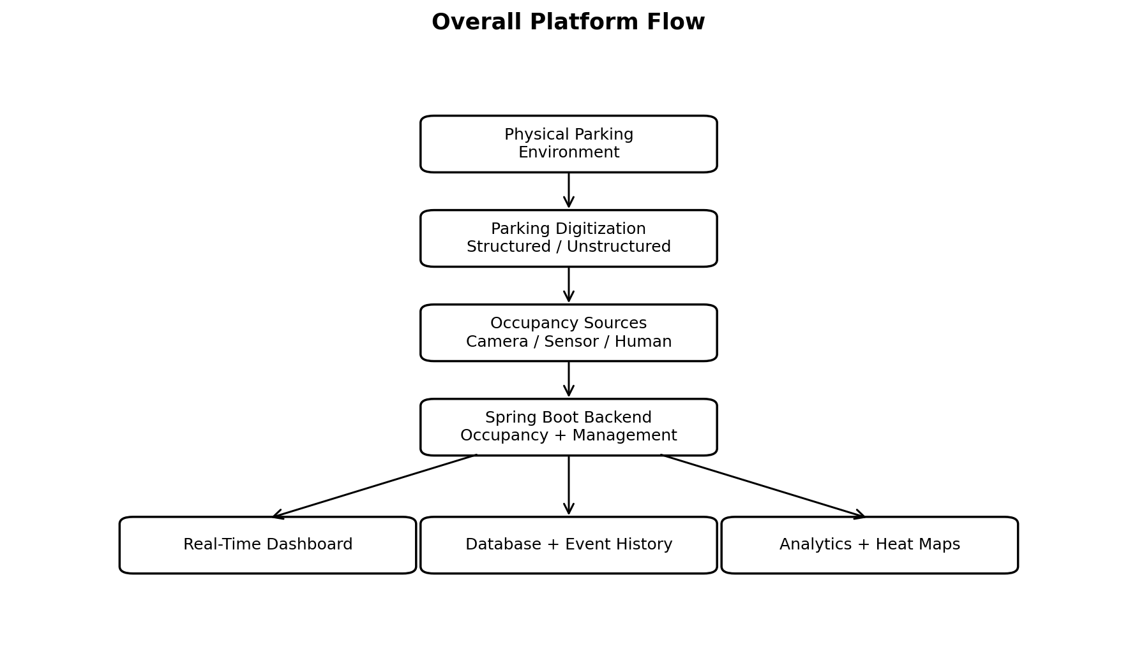
Figure 1. High-level architecture and information flow of the proposed parking platform.
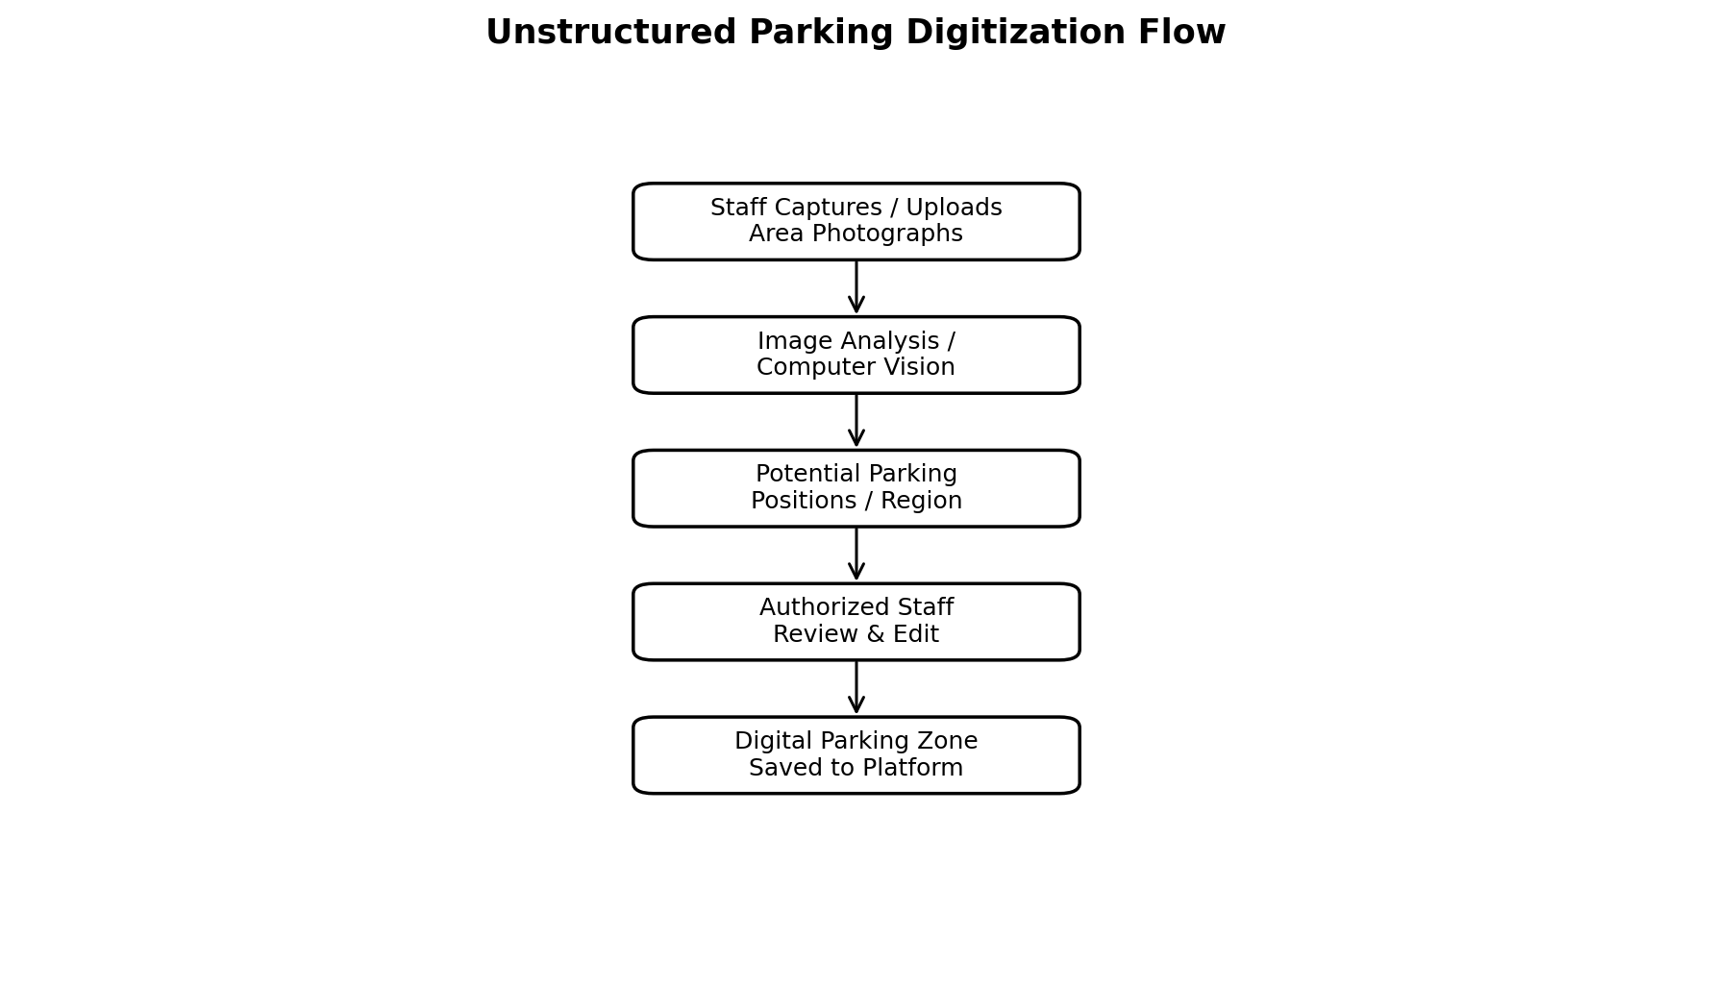
Figure 2. Image-assisted workflow for converting unstructured parking areas into digital parking zones.
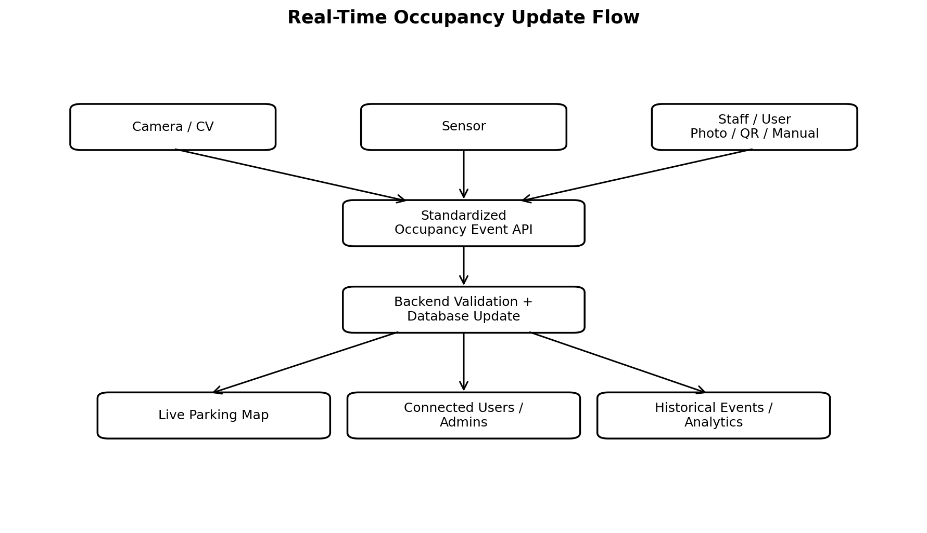
Figure 3. Multi-source occupancy flow enabling low-latency real-time updates.

