Criterion B: Design
UML diagram of the product:
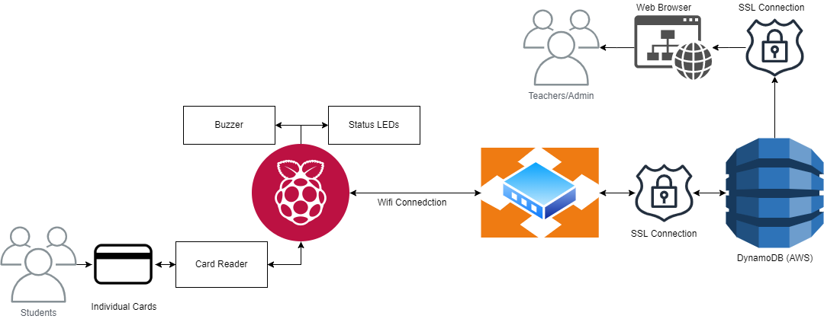

Testing:
Action | Expected result
Check if server is working by opening index page. | Page loads upon opening the product URL
Server is displaying data correctly | The same data exists in the database as is displayed on the website
Card reader is reading cards properly | After scanning the card and refreshing the page, the status of a student should change

