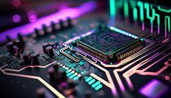**Problems and Challenges in Computer Hardware Technology**

Computer Design is the structure in which components relate to each other. The designer deals with a particular level of system at a time and there are different types of issues at different levels. At each level, the designer is concerned with the structure and function. The structure is the skeleton of the various components related to each other for communication. The function is the activities involved in the system *(geeksforgeeks.org, 2023).*

***ISSUES IN COMPUTER DESIGN:***

**Performance:** One of the biggest challenges in computer design is optimizing performance. Designers need to balance factors such as processing power, memory capacity, and input/output speed to create a system that is fast and efficient.

**Compatibility**: As computing devices become more diverse, ensuring compatibility across platforms and devices is a key challenge. Designers need to create systems that can run seamlessly on a variety of operating systems and hardware configurations.

**Speed mismatch between memory and processor:** Sometimes it is possible that the speed of memory and processor does not match. It may be memory speed is faster or processor speed is faster. A mismatch between memory and processor leads to create problems in designing.

**Handling of bugs and errors:** Handling bugs and errors are huge responsibility of any computer designer. Bugs and errors lead to the failure of the computer system. Sometimes these errors may be more dangerous.

**Multiple processors:** Designing a computer system with multiple processors leads to the huge task of management and programming. It is a big issue in computer design.

**TOP CPU BRANDS for Desktop Computers**

1. 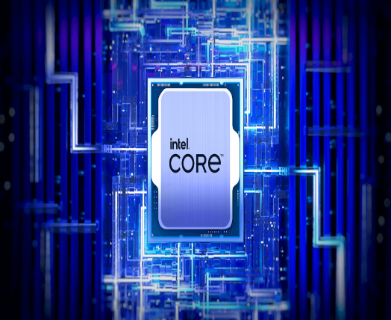**Intel** - The company's name comes from shortening the term integrated electronics. Although the company created its first CPU in 1971, Intel's primary business was static random-access memory (SRAM) and dynamic random-access memory (DRAM) chips.

1. 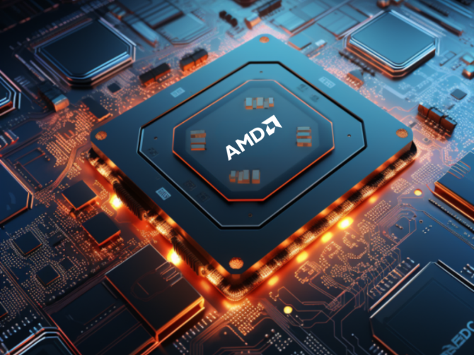**AMD -** AMD is the high performance and adaptive computing leader, powering the products and services that help solve the world’s most important challenges. Our technologies advance the future of the data center, embedded, gaming and PC markets. Founded in 1969 as a Silicon Valley start-up, the AMD journey began with dozens of employees who were passionate about creating leading-edge semiconductor products. AMD has grown into a global company setting the standard for modern computing, with many important industry firsts and major technological achievements along the way *(AMD, n.d.)*.

**LATEST INTEL CPUs**

1. **Intel - Core i5-14600K 14th**

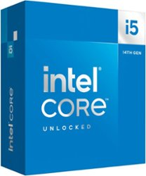Intel Core i5-14600K (14th gen) desktop processor. Featuring PCIe 5.0 & 4.0 support, DDR5 and DDR4 support, unlocked 14th Gen Intel Core i5 desktop processors are optimized for gamers and productivity and help deliver high performance. Compatible with Intel 700 Series and Intel 600 Series Chipset based motherboards. 125W Processor Base Power.

1. **Intel – Core i7-14700k**

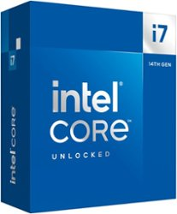Intel Core i7-14700K (14th gen) desktop processor. Featuring Intel Turbo Boost Max Technology 3.0, and PCIe 5.0 & 4.0 support, DDR5 and DDR4 support, unlocked 14th Gen Intel Core i7 desktop processors are optimized for gamers and productivity and help deliver high performance. Compatible with Intel 700 Series and Intel 600 Series Chipset based motherboards. 125W Processor Base Power.

1. **Intel – Core i9-14900k**

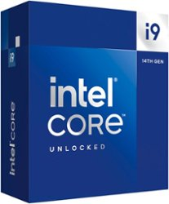Intel Core i9-14900K (14th gen) desktop processor. Featuring Intel Thermal Velocity Boost, Intel Turbo Boost Max Technology 3.0, and PCIe 5.0 & 4.0 support, DDR5 and DDR4 support, unlocked 14th Gen Intel Core i9 desktop processors are optimized for enthusiast gamers and serious creators and help deliver high performance. Compatible with Intel 700 Series and Intel 600 Series Chipset based motherboards. 125W Processor Base Power.

**LATEST AMD CPUs**

1. **AMD Ryzen 9 9950X**

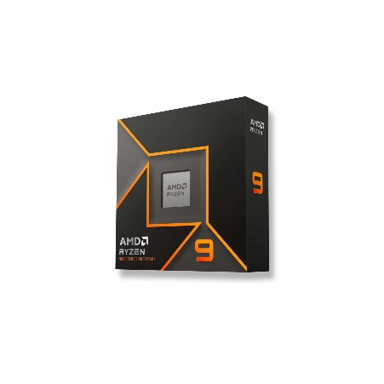

The AMD Ryzen 9 9950X is a desktop processor with 16 cores, launched in August 2024, at an MSRP of $649. It is part of the Ryzen 9 lineup, using the Zen 5 (Granite Ridge) architecture with Socket AM5. Thanks to AMD Simultaneous Multithreading (SMT) the core-count is effectively doubled, to 32 threads. Ryzen 9 9950X has 64 MB of L3 cache and operates at 4.3 GHz by default, but can boost up to 5.7 GHz, depending on the workload. AMD is building the Ryzen 9 9950X on a 4 nm production process using 16,630 million transistors. The silicon die of the chip is not fabricated at AMD, but at the foundry of TSMC. You may freely adjust the unlocked multiplier on Ryzen 9 9950X, which simplifies overclocking greatly, as you can easily dial in any overclocking frequency (techpowerup.com 2024).

1. 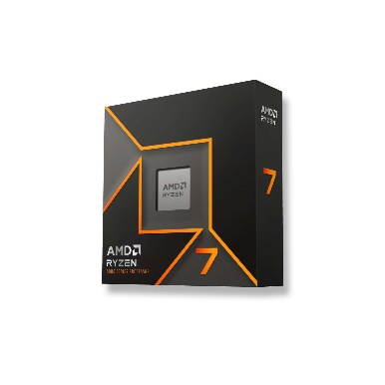**AMD Ryzen 7 9700x**

The AMD Ryzen 7 9700X is a desktop processor with 8 cores, launched in August 2024, at an MSRP of $359. It is part of the Ryzen 7 lineup, using the Zen 5 (Granite Ridge) architecture with Socket AM5. Thanks to AMD Simultaneous Multithreading (SMT) the core-count is effectively doubled, to 16 threads. Ryzen 7 9700X has 32 MB of L3 cache and operates at 3.8 GHz by default, but can boost up to 5.5 GHz, depending on the workload. AMD is building the Ryzen 7 9700X on a 4 nm production process using 8,315 million transistors. You may freely adjust the unlocked multiplier on Ryzen 7 9700X, which simplifies overclocking greatly, as you can easily dial in any overclocking frequency (techpowerup.com 2024).

1. **AMD Ryzen 5 9600X**

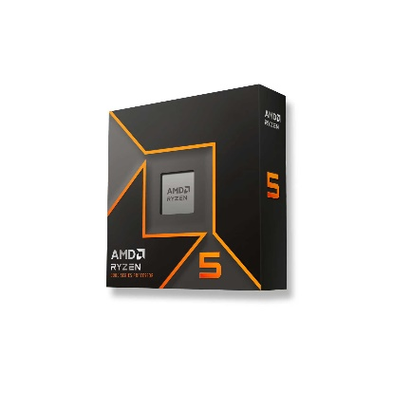The AMD Ryzen 5 9600X is a desktop processor with 6 cores, launched in August 2024, at an MSRP of $279. It is part of the Ryzen 5 lineup, using the Zen 5 (Granite Ridge) architecture with Socket AM5. Thanks to AMD Simultaneous Multithreading (SMT) the core-count is effectively doubled, to 12 threads. Ryzen 5 9600X has 32 MB of L3 cache and operates at 3.9 GHz by default, but can boost up to 5.4 GHz, depending on the workload. AMD is making the Ryzen 5 9600X on a 4 nm production node using 8,315 million transistors. The silicon die of the chip is not fabricated at AMD, but at the foundry of TSMC. You may freely adjust the unlocked multiplier on Ryzen 5 9600X, which simplifies overclocking greatly, as you can easily dial in any overclocking frequency (techpowerup.com 2024).

***LATEST TRENDS IN TECHONOLOGY***

**1. The Democratization of AI**

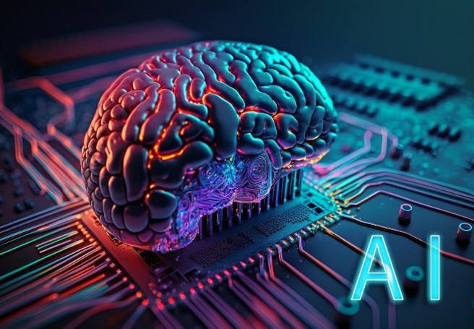AI is by far the biggest trend in the tech space right now. Adoption today is 2.5x higher than it was in 2017. **In fact, 50% of organizations have adopted AI for at least one business function.** Notably, AI is breaking into finance, healthcare, manufacturing, retail and dozens of other industries. And, it’s not a technology reserved for large enterprises anymore. With open-source AI solutions and lower cost and complexity of systems, the democratization of AI is in full swing. The prime example is OpenAI, the AI non-profit/company behind ChatGPT. It’s currently worth $80 billion. And, the company expects to hit $1 billion in revenue in 2024. OpenAI’s ChatGPT surprised the world when it was released in November 2022. The chatbot’s ability to take natural-language prompts and generate conversational text for a wide variety of outcomes made people rethink what was possible with AI *(Howart, 2024)*.

**2. Innovation and Investment in Cleantech Grows**

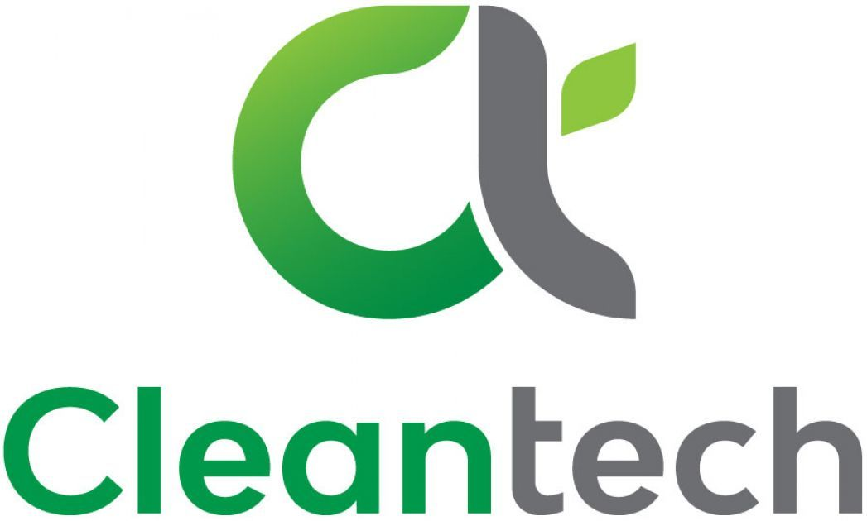$200 billion was invested in Cleantech companies last year alone (That's up 70% YoY). In fact, clean technology has gained so much momentum that more than 25% of all VC dollars now flow to cleantech companies. Industry experts suggest that more funding and interest is on the way due, in part, to the Inflation Reduction Act. The law includes loans, grants, and tax incentives aimed at encouraging the private sector to devote more dollars and time to cleantech. The leader of Breakthrough Energy Ventures estimates this act will lead to the creation of between 300 and 1,000 new companies. Many of these companies could be in the green hydrogen industry. Hydrogen is the most abundant element on Earth and burning it doesn’t release CO2, giving it great potential as a source of green energy *(Howart, 2024)*.

## **3. Digital Lives?**

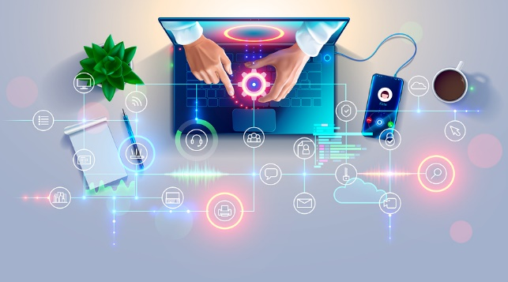More and more of our lives are spent online, using digital services and exploring virtual worlds. As technology becomes cheaper, more ubiquitous and more immersive over the next 10 years, there’s no reason to think this trend will change. In fact, particularly in the eyes of the younger generations, the differentiation between the online, digital world and the offline, physical world may start to fade. The concept of the “metaverse” may have fallen somewhat out of fashion in recent years thanks to the excitement over generative AI. But make no mistake, the concept that our digital experiences will be just as important and consequential as our offline lives is still just as true. Some predict that the coming years could see a revolt against this. They say that a future generation perhaps the upcoming “generation alpha” who are all children today – might reject this wholesale, valuing time away from technology and firmly anchored in physical reality.

But as virtual reality reaches the point (predicted to be in around 2040) that it can create experiences that are indistinguishable from actual reality, and augmented reality seamlessly blends the best of both worlds, the lure of putting on a headset or picking up a screen is still likely to be strong for people of all ages in 10 years’ time *(Marr, 2024).*

**4. Full Stack Development**

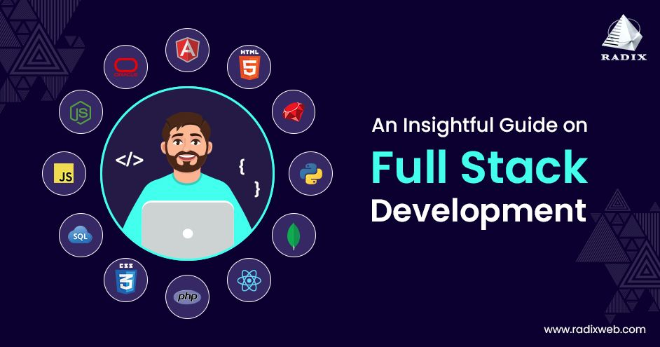Full-stack development is the latest technology trend in the software industry that is gaining momentum. It is becoming vital as the IoT gains momentum. A website or application's front end and back end comes under Full-stack Development. Companies aim to develop more comprehensive and user-friendly applications. This necessitates a solid understanding of both web development and server-side programming. If you have the skills to build websites, there will always be a market for your services. If you are interested in a career in web development, it is important to stay up to date on the latest web dev trends. There are a variety of Web Development courses available online to get started *(Ragala, 2024)*.

**5. Block Chain**

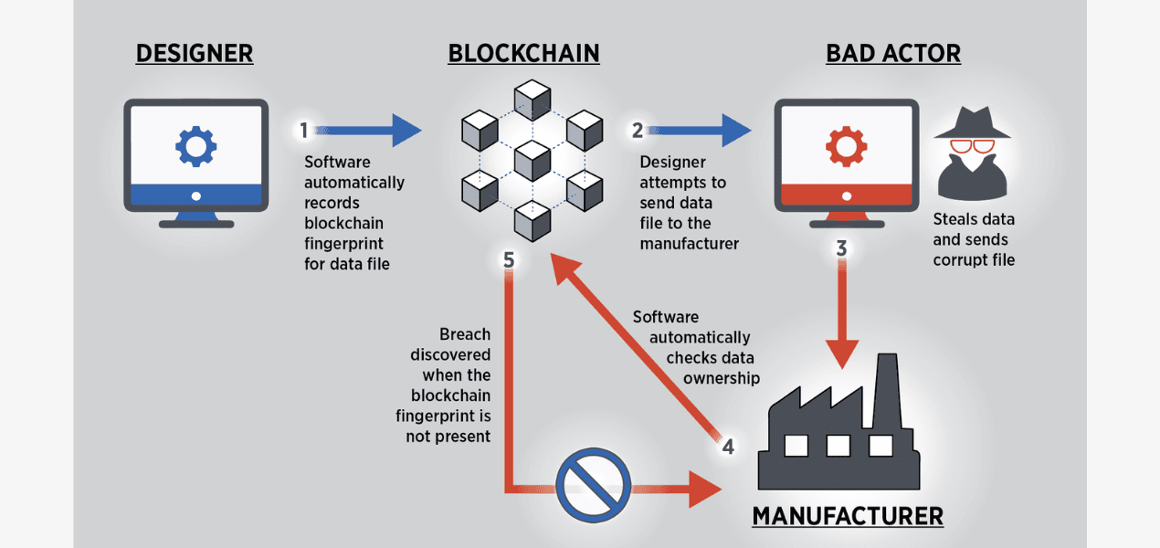Blockchain technology will have a significant impact across a wide range of industries. Blockchain is a distributed database that allows transactions to be safe and transparent without any central authority. Businesses are looking into how blockchain technology might help them streamline their procedures. There has been a lot of hype around this new technology in recent years. While it is still in its initial stages, there is a lot of potential for it to disrupt various industries. Blockchain technology is gaining traction in banking, finance, healthcare, supply chain management, etc. In the future, more businesses will incorporate Blockchain technology. It will soon become extensively used and accepted *(Ragala, 2024)*.

**6. Metaverse**

The metaverse is a virtual world where people can work, play, and socialize. It's still developing but could change how we interact with technology and each other. The metaverse is a loosely defined term referring to virtual worlds in which users represented by avatars interact, usually in 3D and focused on social and economic connection. Avatars socialising in the virtual world Second Life.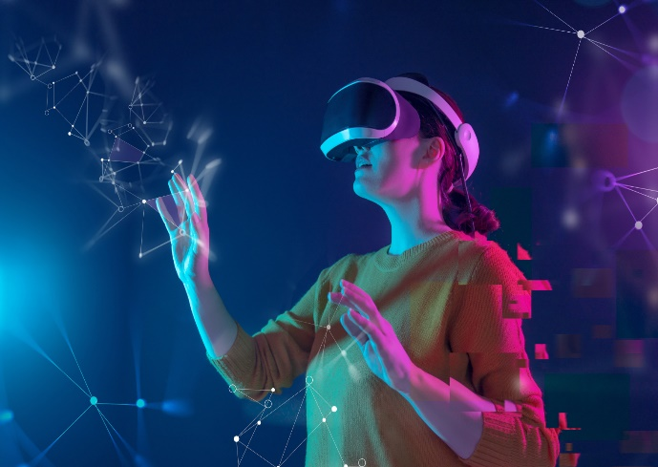 *(Ragala, 2024)*.

**REFERENCES:**

*AMD Ryzen 9 9950X Specs*. (n.d.). TechPowerUp. https://www.techpowerup.com/cpu-specs/ryzen-9-9950x.c3649

Howarth, J. (2024, May 24). 13 Top technology Trends (2024 & 2025). *Exploding Topics*. https://explodingtopics.com/blog/technology-trends

Marr, B. (2024a, February 12). *The biggest technology trends in the next 10 years*. Forbes. https://www.forbes.com/sites/bernardmarr/2024/02/12/the-biggest-technology-trends-in-the-next-10-years/

*Top 30 New technology Trends in 2024: Exploring the future*. (2024, June 27). https://www.knowledgehut.com/blog/web-development/latest-technology-trends