**UNIT - 1 (16 hours)**

**MOS transistors**: Structures, MOS system under external bias, operation of MOS transistor (MOSFET),

MOS transistors: Threshold voltage MOSFET current-voltage characteristics (GCA), channel length modulation, substrate bias effect.

**Measurements of parameters** – KN, VTP & γ. Short channel effects, Narrow channel effects. Latch up and its prevention. MOSFET capacitances.

**MOSFET Operation: A Qualitative View**

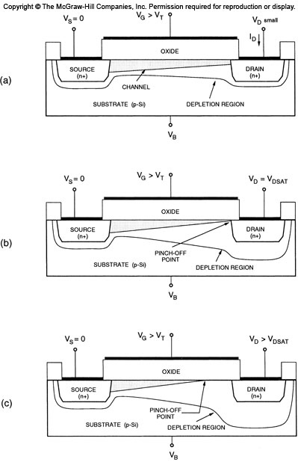

Cross-sectional view of an n-channel (nMOS) transistor, (a) operating in the linear region, (b) operating at the edge of saturation, and (c) operating beyond saturation

**Operating in the linear region**

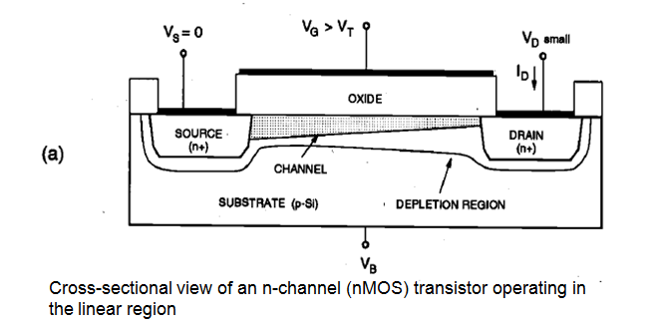

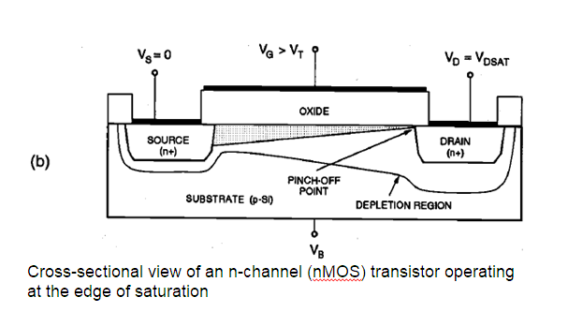

**N-channel (nMOS) transistor operating beyond saturation**

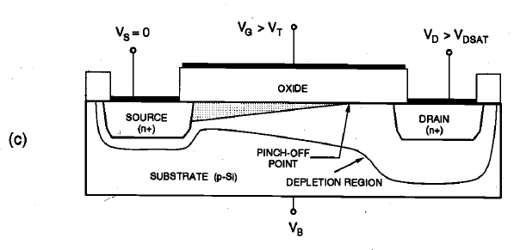

**MOSFET Current-Voltage Characteristics**

* The analytical derivation of the MOSFET current-voltage relationships for various bias conditions requires that several approximations be made to simplify the problem.
* Without these simplifying assumptions, analysis of the actual three-dimensional MOS system would become a very complex task and would prevent the derivation of closed form current-voltage equations.
* The analytical derivation of the MOSFET current-voltage relationships for various bias conditions requires that several approximations be made to simplify the problem.
* Without these simplifying assumptions, analysis of the actual three-dimensional MOS system would become a very complex task and would prevent the derivation of closed form current-voltage equations.

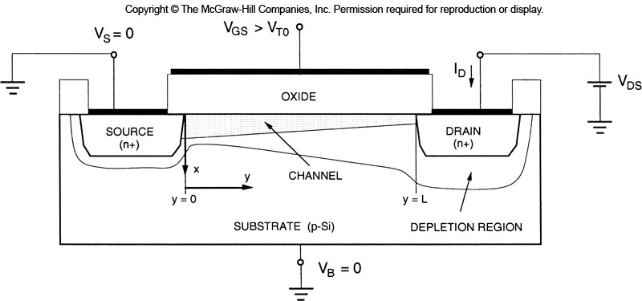

**Gradual Channel Approximation(GCA)**

* The *gradual channel approximation (GCA) for establishing the MOSFET current-voltage relationships,*effectively reduces the analysis to a one-dimensional current-flow problem.
* As in every approximate approach, however, the GCA also has its

limitations, especially for small-geometry MOSFETs.

1. Consider the cross-sectional view of the n-channel MOSFET operating in the linear mode, as shown in the figure. Here, the source and the substrate terminals are connected to ground, i.e., Vs = *VB = 0.*
2. *The gate-to-source* voltage *(VGS) and the drain-to-source voltage (VDS) are the external parameters controlling* the drain (channel) current *ID.*
3. *The gate-to-source voltage is set to be larger than the* threshold voltage VT0 to create a conducting inversion layer between the source and the drain.
4. The *channel voltage with respect to the source is denoted by Vc(y).*
5. *Assumption: T*he threshold voltage VT0 is constant along the entire channel region, between y = 0 and *y = L.*
6. *(In reality, the threshold voltage changes along the channel since the channel voltage* is not constant)
7. Assumption: The electric field component *Ey along the y-coordinate is dominant compared to the electric field component Ex along the x-coordinate.*
8. *(This* assumption will allow us to reduce the current-flow problem in the channel to the y dimension only)

**MOSFET Drain Current Equation (ID)(GCA)**

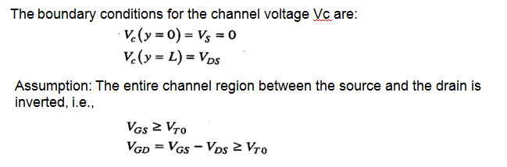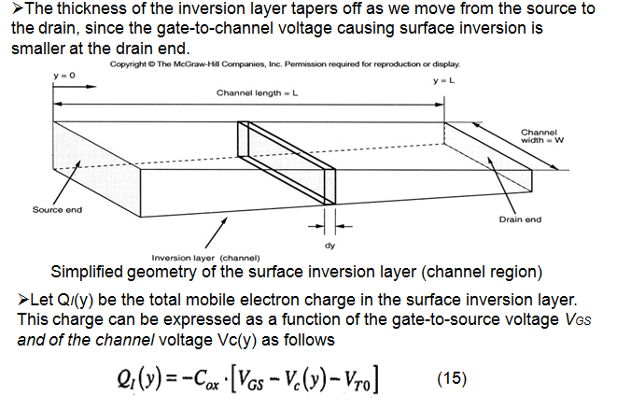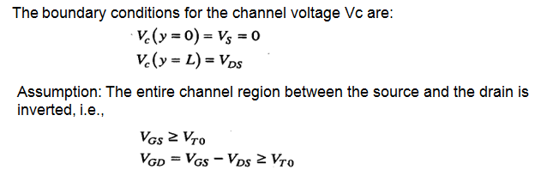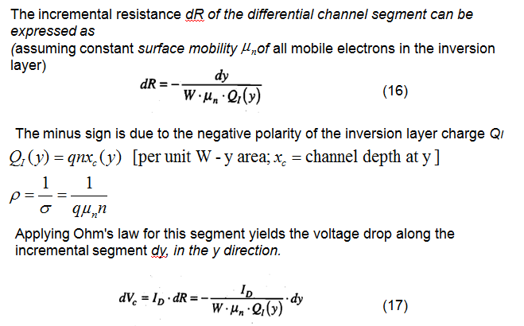

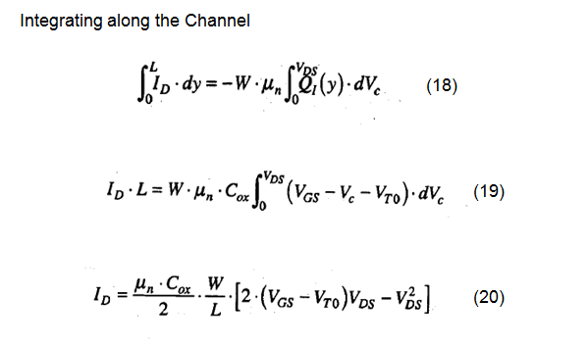

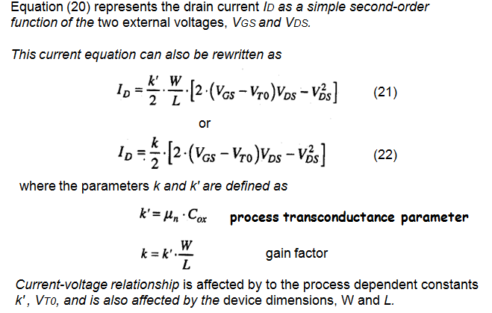

**Region of Validity of the Equation**

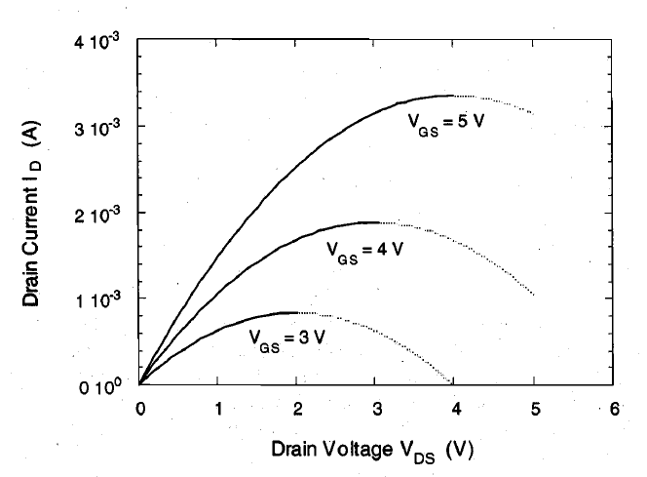

The second-order current-voltage equation given above produces a set of inverted parabolas for each constant *VGS value.*

The drain current-drain voltage curves shown above reach their peak value for *VDS = VGS – VT0*

*Beyond this maximum, each curve exhibits a negative differential* conductance, which is not observed in actual MOSFET current-voltage measurements (section shown by the dashed lines)

**Validity of the Equation (Linear Region)**

We must remember now that the drain current equation (20) has been derived under the following voltage assumptions,

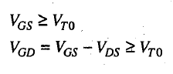

which guarantee that the entire channel region between the source and the drain is inverted.

This condition corresponds to the *linear operating mode for the MOSFET*

Hence, the current equation (20) is valid only for the linear mode operation.



**Current Equation for Saturation Region(ID)**

