2026.06

Improving Day-Ahead Electricity Price Forecasting in Hungary with High-Frequency Weather Features
A6LY4D
Polivka David

Declaration
This dissertation is a product of my own work and is not the result of anything done in collaboration. I consent to the University’s free use including online reproduction, including electronically, and including adaptation for teaching and education activities of any whole or part item of this dissertation.

Polivka Dávid

Word count: 10213

Acknowledgement
I would like to express my deepest gratitude to Zsófia Gyarmati, whose support and encouragement meant more to me than words can express. She was there for me when I needed it most, and her thoughtful feedback and advice helped guide me through this project from start to finish.

Executive Summary
“Improving Day-Ahead Electricity Price Forecasting in Hungary with High-Frequency Weather Features” -
The objective of this thesis is to examine the potential of using market information, cross-border energy flows and weather data to enhance the next day electricity price forecasts in Hungary. The prices of electricity are not easily predictable due to these factors and rapid changes in prices. Improved prediction facilitates energy companies to make better decisions regarding buying, selling, hedging and risk management. Hungary is a good country to study as it is heavily reliant on imported electricity, is highly integrated with the neighbouring markets, has fast growing solar power and was strongly impacted by the European energy crisis that started in 2021.
A forecasting system was developed to forecast electricity prices hourly 24 hours prior to the forecast, based only on information that would be available at the time of the forecast. Using ERA5 weather reanalysed data in conjunction with ENTSO-E market and system variables, a dataset was constructed for the time period 2015-2024 with a 15-minute time resolution. As prices have fluctuated since 2022 the main modelling period was limited to 2022-2024. We tested three different versions of input data: without weather data, with standard hourly weather data and with additional features that were extracted from the 15-minute data, including minimum, maximum and standard deviation values within the hour. This design tested the value of weather data, and the added value of weather detail at higher frequencies.
Modelling was done in stages starting simple and getting more complex. A very simple benchmark was set, where the price of 24 hours earlier is repeated (Naive_last_24h). Linear regression has also been tried but it proved to be unstable. XGBoost was used for the main comparisons, as well as classical statistical and neural network models which were tested over shorter windows. The same chronological splits and error measures: RMSE, MAE, and sMAPE were used to evaluate all models.
Best results in full year 2024 were seen with tuned XGBoost models. Both the 15-minute weather version (RMSE = 58.26 EUR/MWh) and the hourly weather version (RMSE = 58.37 EUR/MWh) were below the naive benchmark of 73.87 EUR/MWh. The naive model kept its competitiveness on MAE, however, indicating that the price persistence signal is still relevant on a day-to-day basis.
Findings indicate that detailed weather information helps but is not always determinate. It should be used as an additional input to the forecast, not the main forecasting factor. With regards to business use, it is recommended to deploy tuned XGBoost as the main running model, take Naive_last_24h as a monitoring model, and use NBEATSx for tasks with shorter horizons.
One restraint is that neural models were only run for short time periods, and not the full year. Future work would involve the incorporation of live weather data, rolling backtests and probabilistic forecasts. This project demonstrates that the quality of the forecast is as much about data quality and proper validation and understanding how to interpret the data to the business as it is about the complexity of the model.

Contents
Declaration 1
Acknowledgement 2
Executive Summary 3
List of Figures 5
1. Introduction 5
1.1. Background and Motivation 5
1.2. Business and technical significance 6
1.3. Problem statement and research questions 7
1.4. Scope, Boundaries, and Expected Contribution 7
2. Literature Review 8
2.1. Electricity Price Formation and Volatility 8
2.2. Classical time-series approaches 8
2.3. Machine learning and gradient boosting 9
2.4 Deep learning models for time-series forecasting 9
2.5 Weather conditions, renewable energy generation and electricity prices 10
2.6 Research gap and positioning of this study 10
3. Methodology 11
3.1 Overall research design 11
3.2. Data sources and raw inputs 11
3.3. Construction and validation of the 15-minute master dataset 12
3.4 Target definition and forecasting task 12
3.5 Feature Engineering and Ablation Design 13
3.6 Temporal Splits and Evaluation Metrics 13
3.7 Software environment and reproducibility 14
4. Exploratory Data Analysis 14
4.1 Purpose of the EDA 14
4.2 Price distribution and regime shift 15
4.3 Temporal seasonality and persistence 16
4.4 Market fundamentals and cross-border effects 18
4.5 Weather parameters and renewables sensitivity 19
4.6 EDA Implications for Modelling 20
5. Implementation of Algorithms and Models 20
5.1 Common Experimental Setup 20
5.2 Naive and linear baselines 21
5.3 XGBoost implementation 22
5.4 Classical models with StatsForecast 23
5.5 NeuralForecast models: NBEATSx and TiDE 23
5.6 Feature importance and diagnostics 24
6. Results and Analysis 25
6.1 Full-Year 2024 Performance 25
6.2 Value of Weather and High-Frequency Weather Features 25
6.3 Seven-Day Classical and Neural Comparison 26
6.4 Evaluation for 72-Hour Horizons 26
6.5 Overall Interpretation 27
7. Business Insights and Recommendations 27
7.1 Business Relevance of the Findings 27
7.2 Recommended Forecasting Architecture 27
7.3 Implication for High-Frequency Weather Investment 28
7.4 Risk Management and Decision Use 28
7.5 Recommendations 29
Conclusion 29
References 30
Appendices 31
AI and GitHub Usage Statement (per project handbook) 31
GitHub Repository URL and Folder Structure 31

List of Figures
Figure 1: Price Distribution – Pre vs Post 2022 15
Figure 2: Distribution of Hungarian Day-Ahead Prices Before and After 2022 16
Figure 3: Hourly Intraday Distribution of Hungarian Day-Ahead Prices After 2022 16
Figure 4: Average Hourly Price Pattern by Weekday, 2022–2023 17
Figure 5: Correlation Matrix of Day-Ahead Price, Load, Net Position, Solar and Wind Generation 18
Figure 6: Global Correlation Heatmap of Key Numeric Drivers and Day-Ahead Price 19
Figure 7: Correlation of Weather Variables with Hungarian Day-Ahead Price, 2022–2024 20

1. Introduction

1.1. Background and Motivation
Since the deregulation of the European power sector in the 1990s, electricity price forecasting has become a major topic (Bunn, 2000). This paradigm shift turned electricity into a traded commodity. The resulting market is where supply and demand interact, thus influencing the price. There are two other limiting factors in electricity markets, which are shaping the nature of the market. The balance between supply and demand needs to be maintained at all levels to maintain the grid stability at 50 Hz for safe and reliable residential use. On the other hand, electricity is a traded commodity, but it cannot be economically stored on a large scale as other conventional inventories. These attributes make for a more volatile market, with prices more sensitive to short-term factors (Weron, 2014). Hourly prices can be directly affected by weather-driven generation, scarcity shocks, and cross-border flows. Thus, the day-ahead market is used as a coordination mechanism for generators, large consumers and system participants and as a pricing mechanism as well.
Hungary serves as a prime example of the aforementioned characteristics. The Hungarian bidding zone is influenced by several factors, including domestic load, the generation mix, imports, exports, and regional market coupling. Furthermore, due to the proliferation of renewable generation, particularly solar photovoltaic generation, the generation mix has shifted towards higher RES penetration. Consequently, historical prices cannot be explained by historical prices alone. Instead, they are shaped by renewable output, short-term weather states, regional flows, and conventional generation.
The COVID-19 pandemic caused supply-side shortages, supply chain disruptions, and deferred investments, which collectively paved the way for the 2021 European energy crisis. The post-COVID-19 period further demonstrates the importance of precise forecasting. Geopolitical uncertainty, gas price shocks, and the increasing renewable energy source (RES) penetration ratio have shaped the market's core characteristics. Consequently, pre-crisis-related patterns may no longer be relevant, as their explanatory power has decreased significantly, a finding also confirmed by the project's exploratory analysis. The average Hungarian day-ahead price rose from 54.36 EUR/MWh before 2022 to 159.73 EUR/MWh after 2022, while the standard deviation increased from 42.70 to 126.27 EUR/MWh. This major change is an impetus for a regime-aware forecasting design, with a particular focus on the 2022-2024 horizon.
This dissertation is motivated by two reasons. The methodological motivation is to determine if there is any incremental predictive value of the additional high-frequency weather information over market fundamentals and standard hourly variables. The practical reason is to provide a working tool to help with day-to-day activities, which could help with bidding, optimizing hedging and operational planning. In short, the study is designed to investigate the interplay between the four key aspects of predictive modelling: data granularity, feature engineering, model complexity and temporal validation in a dynamic electricity market.

1.2. Business and technical significance
From a business perspective, the day-ahead electricity price forecast is not just a pricing mechanism, but also a coordination tool and a reference point. As all electricity market participants make decisions and optimise short-term strategies based on 24-hour predictions, forecast errors can lead to significant financial losses. For power generators, an accurate forecast informs bidding strategies and helps optimise revenue by determining whether production is profitable at the currently expected price. Conversely, a large industrial electricity consumer could lower electricity costs by scheduling energy-intensive processes during periods of lower prices. In these cases, forecasts play an essential role in decision-making.
The Hungarian case is also of strategic importance. Domestic prices are subject to regional system conditions due to import dependence and cross-border coupling. The increasing penetration of solar energy adds further sensitivity to weather, particularly to the levels of renewable output during the day, potentially leading to lower marginal prices but also to increased ramping and residual-load effects. A model based on calendar patterns and historical price lags might then be useful but incomplete. Conversely, it is possible that a model with a large number of weather variables merely increases the complexity of the system without providing significant benefits. This thesis directly addresses this trade-off.
The project is technically significant because it employs a controlled forecasting experiment. The same target definition, temporal split logic, and performance measure are used for all models. An ablation design separates the contribution of features other than weather, weather features, and 15-minute-derived intra-hour weather variability. This allows for the interpretation of results, as gains can be attributed to the additional information rather than to modelling conditions that vary from year to year. The project is also based on the idea that more complex models need to be justified against simpler models, particularly in time-series forecasting where persistence may be very high.

1.3. Problem statement and research questions
The business problem addressed by this dissertation is the demand for reliable 24-hour-ahead Hungarian day-ahead electricity price forecasts in a weather-sensitive, regionally coupled, and volatile market. The technical issue concerns the selection of an appropriate pair (feature granularity and model family) that yields the most informative out-of-sample performance through rigorous temporal validation.
The main research question is: To what extent do market fundamentals, cross-border flow variables, and higher-frequency weather-based features contribute to improving the 24-hour-ahead forecast of Hungarian day-ahead electricity prices during the 2022-2024 post-crisis regime? This question is further explored through four sub-questions:
- Is it possible to outperform simple persistence and classical time-series baselines using modern machine learning and deep learning models under a strict 2024 out-of-sample test design?
- Is the performance of the weather model better when it receives hourly weather data than when it does not?
- Does the inclusion of 15-minute-derived intra-hour weather variables enhance the performance beyond that achieved with standard hourly weather variables?
- What is the optimal modelling method for market participants that balances prediction, robustness, model interpretability, and operability?

1.4. Scope, Boundaries, and Expected Contribution
Empirical focus is limited. The target market is the Hungarian day-ahead electricity market, and the target variable is the day-ahead hourly electricity price (in EUR/MWh). The modelling task is to make 24-hour-ahead point forecasts. The main modelling period is 2022-2024 as exploratory analysis shows that this period is very distinct from the previous market regime. The last out-of-sample test period is the year 2024, that is, outside of the training period and outside of the model validation period.
No attempt is made to forecast intraday, balancing, forward or reserve prices or give probabilistic forecasts. Moreover, the bidding strategies, plant-level unit commitment, transmission constraints and regulatory actions are not explicitly modelled in this study. The exclusions are to make the project feasible, reproducible, and meet the Business Data Analytics guideline of solving a limited problem by using data science tools.
This dissertation makes three contributions. First, it provides the results of a post-crisis forecasting experiment using high-frequency market-weather data, Hungary specific. Second, it is a controlled comparison of feature sets, model families (such as persistence, XGBoost, StatsForecast baselines, NeuralForecast architectures, linear models, etc.). Third, it presents the technical findings in a way that is understandable to business users, providing practical recommendations on what forecasting stack to use, validation of the models, benchmark monitoring and when to use more complex models.

2. Literature Review

2.1. Electricity Price Formation and Volatility
The price of electricity is a result of the physical balance in the electricity system and the characteristics of the markets in which the electricity system operates. Day-ahead prices reflect the forecast of demand and supply offers. The price is then based on the marginal generating unit required to meet demand and the availability of cross-border supply. Electricity supply and demand are always in balance, so short-term shocks can cause large price swings. Electricity price series are challenging to model as they exhibit characteristics such as strong seasonality, mean reversion, spikes, heavy tails, and non-Gaussian distributions (Weron, 2014). The following features are also observed in the Hungarian data used in this thesis. As mentioned in the literature, the dynamics of electricity prices are also regime dependent. In relatively stable markets, a lot of the predictable pattern may be due to historical prices or to typical seasonal trends. During crisis periods, however, fuel prices, geopolitical events, system scarcity and renewable generation can influence price levels and volatility. This is consistent with the empirical motivation to restrict the modelling period to 2022-2024. Ignoring such structural breaks and combining pre-crisis and post-crisis observations could lead to models trained on patterns less relevant for current market decisions. The complexity is further increased by renewable energy penetration. Solar and wind are low marginal cost technologies, and high renewable output can result in lower wholesale prices through the merit order effect. Renewables can also make power grids more weather dependent and lead to more volatile residual-load profiles, however. Maciejowska (2020) shows the effect of renewable generation on price levels and distributional tails and Ketterer (2014) presents the price impact of wind generation in Germany. Solar energy is especially relevant for Hungary, since solar generation can help to reduce prices during the day. Conversely, during periods of high demand when renewable generation is low, scarcity can occur.

2.2. Classical time-series approaches
In the past, classical time-series models (AR, ARMA, ARIMA, SARIMA and ARIMAX) have been significant models in electricity price forecasting. They are helpful in that they offer a simple and clear modelling of serial dependence and seasonality. As demonstrated by Contreras et al. (2003) ARIMA-type models can work well in forecasting electricity prices for the next day provided that the autoregressive patterns and seasonality are correctly specified. Well-designed statistical benchmarks are also important, and are often difficult to beat, particularly in a strict evaluation setting, as pointed out by Nowotarski and Weron (2018).
In this thesis, classical models are employed primarily as reference models, not as the desired solution. This is important not only because of the comparison of machine learning models. They must also undergo validation of their simplicity and transparency. In particular, the Naive_last_24h model is important here, as day-ahead electricity prices exhibit a prominent day-of-the-week pattern. If a model is unable to make a better prediction than the previous day's same hour prediction, it will likely be of no benefit in practice.
But when relationships between variables are not linear or market conditions change rapidly, classical models can have difficulty. Renewables, weather, generation mix, load and cross border flows are the main drivers of price behaviour in the Hungarian post-crisis environment. These drivers are beyond the scope of conventional linear models and need machine learning models capable of processing higher dimensional feature space and non-linear patterns.

2.3. Machine learning and gradient boosting
Machine learning techniques have been gaining traction in the prediction of electricity prices, owing to their ability to include a large number of explanatory variables and detect non-linear relationships. According to Lago et al. (2021), strong benchmarks, careful validation, and systematic comparison among families of models should be an integral part of modern forecasting practice (Hong et al., 2020). This is consistent with the design of the current project, in which models are compared using the same temporal splits and metrics.
XGBoost is particularly well-suited for this project, as it excels with tabular feature sets characterized by non-linear interactions, varying scales, missing-value patterns, and a large number of engineered predictors. The method constructs sequential trees that mitigate errors from previous trees and regularize the complexity of the model using parameters such as learning rate, tree depth, and subsampling (Chen and Guestrin, 2016). This approach is appealing in electricity price forecasting, as the dependency of price on load, flows, calendar, and weather is not necessarily linear.
However, the literature also suggests that model complexity does not necessarily result in higher accuracy. Weak validation or data leakage from features not available at the time of prediction can lead to overfitting with a gradient-boosting model. For this reason, temporal splitting and leakage prevention are adopted as key design decisions for this thesis. XGBoost is not only powerful but also a model that can be tested against controlled ablation data to determine if increasing the weather detail is beneficial.

2.4 Deep learning models for time-series forecasting
Deep learning models have enhanced the forecasting toolbox through their ability to learn complex temporal patterns and interactions from the data. Oreshkin et al. (2019) presented a neural architecture for time-series forecasting, dubbed N-BEATS, which employs residual blocks. The NBEATSx model further enhances the approach by adding exogenous variables, making it applicable to energy problems where price is a function of external covariates. Das et al. (2023) proposed TiDE, a dense encoder-decoder architecture for multi-horizon forecasting that can efficiently handle a set of covariates. For example, PatchTST is a transformer-based model which, while also effective in forecasting, requires substantial computational resources for student-level projects or for conducting multiple experiments (Nie et al., 2023).
In this dissertation, the use of NeuralForecast models is evaluated as experimental challengers, not universal replacements for tabular models. This is methodologically justified as deep learning requires more computational resources, careful preparation of covariates, and sensitivity checks. The current analysis compares NBEATSx and TiDE on 7-day windows instead of the entire 2024 horizon. This results in a short-window evaluation rather than a demonstration of operational dominance for the year.

2.5 Weather conditions, renewable energy generation and electricity prices
Electricity prices are influenced by weather on both the demand and supply sides. There is a relationship between temperature and heating/cooling demand. Wind generation is dependent on wind speed. Solar production is affected by radiation and cloud cover. Precipitation, humidity, and other related meteorological variables can also serve as proxies for general weather patterns. High-dimensional structures are important in day-ahead electricity price forecasting, as pointed out by Ziel and Weron (2018), and weather forecasting errors may also impact day-ahead electricity price forecasts, as demonstrated by Sgarlato and Ziel (2022).
The question addressed in this thesis is not whether weather is important, but whether high-frequency weather variables provide additional information beyond hourly weather data. While weather covariates are included in many studies, fewer have investigated whether the incorporation of intra-hour variability (derived from 15-minute observations) delivers superior day-ahead price forecasts in a specific market (the European market) following the crisis. In this project, three feature sets are separated: no weather, hourly weather, and hourly weather plus 15-minute derived weather variability. This ablation design transforms a broad literature claim into a measurable empirical question.

2.6 Research gap and positioning of this study
This thesis fills three gaps in the literature, identified below. First, numerous studies have been performed comparing models without isolating the incremental value of weather granularity under consistent target variable and validation protocols. Second, many electricity forecasting experiments have been conducted during generally stable periods, whereas the European energy regime post-2021 necessitates a regime-aware evaluation. Third, complex models are sometimes offered as enhancements, but insufficient consideration is given to implementation cost, benchmark performance, and business usability.
This thesis stands at the intersection of these gaps. It applies a structured, leakage-aware forecasting experiment to Hungarian day-ahead prices for the period 2022–2024. It compares model families, ranging from naive persistence to XGBoost and NeuralForecast. The study directly tests data granularity through ablation. Lastly, it translates outcomes into statistics and provides evidence for practical forecasting architecture.

3. Methodology

3.1 Overall research design
A controlled empirical forecasting design is used. The central forecasting task remains unchanged throughout this project: forecasting the Hungarian day-ahead electricity price 24 hours in advance. The study consists of two varying key elements in relation to this fixed task: the feature set and the modelling family. With this design, it becomes feasible to dissect two questions that are often conflated in forecasting projects. The first is how much better more sophisticated algorithms perform compared to simple benchmarks in making forecasts. The second question is whether more detailed weather data provide any incremental predictive power in addition to hourly weather data and market fundamentals.
The workflow consists of five stages. First, a 15-minute master dataset is loaded and checked. Second, the high-frequency panel is aggregated
to hourly modelling tables, as the day-ahead price in Hungary is at an hourly level. Third, the 24-hour-ahead target is created by shifting the price series forward. Fourth, three ablation datasets are prepared: the no-weather dataset, the hourly-weather dataset, and the 15-minute-enhanced weather dataset. Fifth, chronological train-validation-test splits are employed to train and evaluate the baseline, machine learning, classical time-series, and neural forecasting models. This architecture facilitates the interpretation of the model performance both in terms of the granularity of the data and the complexity of the model.

3.2. Data sources and raw inputs
This project combines two main data families. The first family provides the fundamentals of the electricity market and system. These include the Hungarian day-ahead price, actual and forecast load, generation variables, cross-border flows, and cross-border net position indicators. These represent the physical and economic factors that influence the electricity system. Load refers to demand pressure, generation variables to the available supply mix, while cross-border variables refer to Hungary's exposure to neighbouring markets. This is particularly significant as Hungary is connected to an interdependent European electricity market, and imports, exports, and price coupling within the region can impact domestic day-ahead prices.
Weather variables from ERA5 reanalysis are included in the second data family (Hersbach et al., 2020). These include temperature, dew point, wind (10-meter and 100-meter), cloud-cover variables, radiation-related variables, precipitation, evaporation, runoff, and total column water vapor. Weather is included because it impacts electricity prices on both the demand and supply sides. Examples include the effect of temperature on heating and cooling needs, wind velocity on wind power generation, and radiation or cloud cover on solar PV generation. Accordingly, weather is not considered a generic exogenous input but rather a proxy for renewable generation, weather-dependent demand, and scarcity conditions more generally.
The analysis is based on a pre-built 15-minute master dataset spanning 2015-01-01 to 2025-01-01. The dataset comprises 350,689 rows and 131 numeric columns. The 15-minute source resolution is important as it enables the construction of intra-hour weather features prior to aggregation in the final hourly modelling task. This directly contributes to the research question of whether day-ahead electricity price forecasts benefit from higher frequency weather information.

3.3. Construction and validation of the 15-minute master dataset
The master dataset is structured at 15-minute intervals and is the primary source of data for the entire analysis. The timestamps must be chronologically ordered and aligned to a regular temporal grid to function properly with time-series data. The first step is thus to verify that all the timestamps are read correctly and that they are in a regular 15-minute sequence. If the same timestamp occurs multiple times, duplicate records are aggregated by taking the mean before the data is reindexed to a regular 15-minute grid. When there are no timestamps, the gaps are not hidden. This is critical as gaps can bias calculated statistics and impact model inputs.
The data set is then examined to ensure that it is of the proper size, contains a valid time range, is of the correct data types, has an acceptable missing value ratio, and contains sensible statistics for the target variable. Missing values are dealt with appropriately for each variable. Weather variables are filled using time-wise forward and backward filling. Where a cross-border flow value is not available, it is assumed to be zero, which indicates that no flow took place. In other numeric variables, missing values are also imputed with values from nearby times, and any remaining missing values are imputed as zero as a last resort. This way, the data is kept in time order, and the missing values are not replaced in a random manner, which would not be suitable for time-series data.
There are many missing values in the day-ahead electricity price at the 15-minute level. This is normal as the price is only published every hour and not every 15 minutes. This is not a data quality issue; it is just fixed when the data is subsequently aggregated into hourly records. The total number of valid price observations for the entire data set is 87,653. The average price is 85.98 EUR/MWh, the standard deviation is 91.61 EUR/MWh, the minimum price is -500 EUR/MWh, and the maximum price is 1,047.10 EUR/MWh. These figures illustrate that electricity prices are highly volatile and can be extreme positive and negative values. Therefore, it is important to select the appropriate performance measures and adopt a proper validation method.

3.4 Target definition and forecasting task
The master dataset covers 2015–2024, but the modelling window is limited to 2022–2024. This is because the Hungarian day-ahead market changed significantly after 2022. Average prices and volatility were much higher in this later period. Using the full 2015–2024 range would mix two very different market periods, which would reduce the relevance of the forecast. For this reason, regime consistency within the 2022–2024 window is more important than having a longer training period.
The forecasting target is the Hungarian day-ahead price 24 hours ahead of the feature timestamp. In practice, this is done by shifting the hourly price series 24 hours forward. This means that to predict the price at t+24h, the model only uses information available at time t. This reflects how real markets work, where participants must forecast the next day's price using only today's available information.
This design is important for preventing data leakage. Future realized prices must not be used to predict themselves. Therefore, lagged price features are only included if they were available before the forecasted time. Rolling statistics are calculated using past data only, never future data. The same logic applies to load, flow, and weather variables. This ensures that the evaluation framework is realistic and that results are not artificially optimistic.

3.5 Feature Engineering and Ablation Design
The raw market and weather data are turned into useful predictors through feature engineering. This is accomplished in two phases. Firstly, the 15-minute master data are aggregated into hourly data to correspond to the price target of day ahead. Then, several price features are formed, such as short-term price lags, 24-hour price lags, price differences, 24-hour rolling mean and 24-hour rolling standard deviation. These characteristics reflect the seasonality, persistence and recent volatility of the daily. Load features are actual load, forecasted load, load lags, and rolling load statistics. The calendar display shows "Hour of day", "Day of the week", "Month" and "Weekend" indications.
Features of the market are also added, like fundamental features. Generation variables are used to represent the generation mix. The effect of regional market coupling is captured by the cross-border flow variables and the net-position indicators. Net-flow values and flow values related to load are also calculated for all flow variables. These features are relevant as Hungarian prices are influenced by cross-border exchange direction and volume as well as by domestic demand and generation.
Weather features come in two stages. The hourly weather data consist of standard ERA5 variables including 10m wind speed, 100m wind speed, solar radiation, daylight indicator, temperature (Celsius), dew point temperature (Celsius) and temperature-dew point spread (Celsius). The 15 minute enhanced data set includes hourly minimum, maximum and standard deviation values derived from the 15 minute observations in each hour. These features are intended to capture the short time scale weather variations that may not be apparent in the hourly averages.
This results in three different datasets for modelling. The first, df_no_wx, is the set of market, calendar, lagged, rolling, generation and flow features and does not contain any weather features. The second df_1H includes hourly meteorological variables from ERA5. The third, df_15Tf, expands the weather minimum, maximum and standard deviation variables from 15-minute data. There are 135 common non-weather feature groups, 26 base hourly weather feature groups and 60 15-minute derived weather feature groups. The final data sets contain 26,251 rows and 136, 162 and 222 columns respectively.

3.6 Temporal Splits and Evaluation Metrics
The data is split in time order. The training set runs from 2022-01-01 to 2023-06-30 and has 13,078 observations. The validation set runs from 2023-06-30 01:00 to 2023-12-31 23:00 and has 4,438 observations. The test set runs from 2024-01-01 to 2024-12-29 23:00 and has 8,735 observations. This arrangement ensures that all the choices of models are taken care of prior to the final test year.
A random split is not used as it would combine older observations with newer observations (Hyndman and Athanasopoulos, 2021). This is not appropriate for time-series forecasts and may lead to misleading overestimation of forecast values (Hyndman and Athanasopoulos, 2021). The validation set is only used for hyperparameter tuning. A separate Test Set for 2024 is available and reserved for the final assessment. Two window sizes are used as well: a 7-day window for comparing the performance of the StatsForecast and NeuralForecast models; and a 72-hour window to test the model behaviour over a very short time horizon.
Three metrics are used to measure the models: RMSE, MAE and sMAPE. The dominant measure is RMSE as it is very expensive to have large errors in electricity markets. The average size of the errors is displayed by the MAE and it is less sensitive to extreme values. sMAPE is a measure of relative error, and care should be taken when prices are near 0 or negative.

3.7 Software environment and reproducibility
The project is coded in Python, leveraging libraries such as pandas, NumPy, matplotlib, seaborn, scikit-learn, XGBoost, StatsForecast, NeuralForecast, and TensorFlow. Random seeds, environment versions, exported modelling datasets, and exported model metrics are stored within the notebook. This facilitates reproducibility and provides the foundation for a GitHub repository, which includes the notebook, data instructions, dependency information, and documentation necessary to rerun the analysis.

4. Exploratory Data Analysis

4.1 Purpose of the EDA
The exploratory data analysis (EDA) is conducted to understand the empirical characteristics of the Hungarian day-ahead electricity price prior to formal modelling. It serves two primary functions. First, it identifies the primary statistical characteristics of the variable of interest, such as distribution, volatility, seasonality, persistence, and extreme values. Second, it assesses the validity of the chosen modelling approach with respect to the data structure. In the field of electricity price forecasting, EDA is of particular interest because prices are typically not normally distributed and are not constant over time. Their evolution is driven by demand cycles, renewable generation, fuel-market shocks, cross-border flows, and short-term scarcity. As such, the EDA is employed to justify the modelling window (2022–2024), the use of lagged and rolling features, the inclusion of market fundamentals, and the controlled testing of weather-related variables.

4.2 Price distribution and regime shift
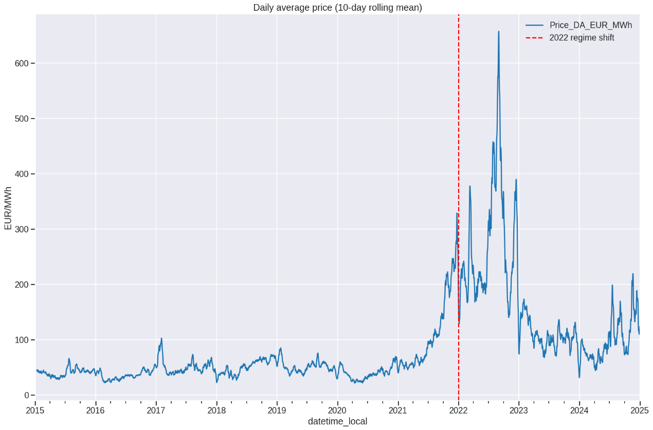
Figure 1: Price Distribution – Pre vs Post 2022
A primary finding is the discernible structural change observed post-2022. During the pre-2022 period, the mean Hungarian day-ahead price was 54.36 EUR/MWh, with a standard deviation of 42.70 EUR/MWh. From 2022 onwards, the mean value increased to 159.73 EUR/MWh, and the standard deviation rose to 126.27 EUR/MWh. This indicates not only a higher average price level but also a considerably more volatile market environment. Furthermore, the post-2022 period exhibits more extreme observations, with prices ranging from a low of -500 EUR/MWh to a high of 1,047.10 EUR/MWh.
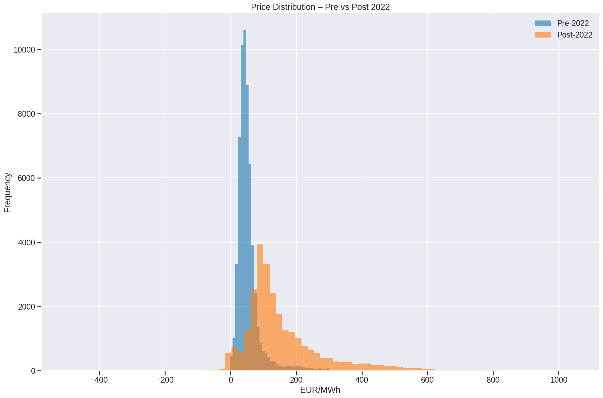
Figure 2: Distribution of Hungarian Day-Ahead Prices Before and After 2022
This regime change has methodological consequences. If the entire timeframe of 2015-2024 were used without distinguishing between regimes, the model would learn from both the relatively stable observations in the pre-crisis period and the volatile observations in the post-crisis period. Such a design might also diminish its relevance for current forecasting decisions, as older relationships could reflect a different market structure. The chosen modelling window (2022-2024) is thus data-driven. While it shortens the sample length, it yields greater regime consistency, which is crucial for a realistic post-crisis forecasting exercise.

4.3 Temporal seasonality and persistence
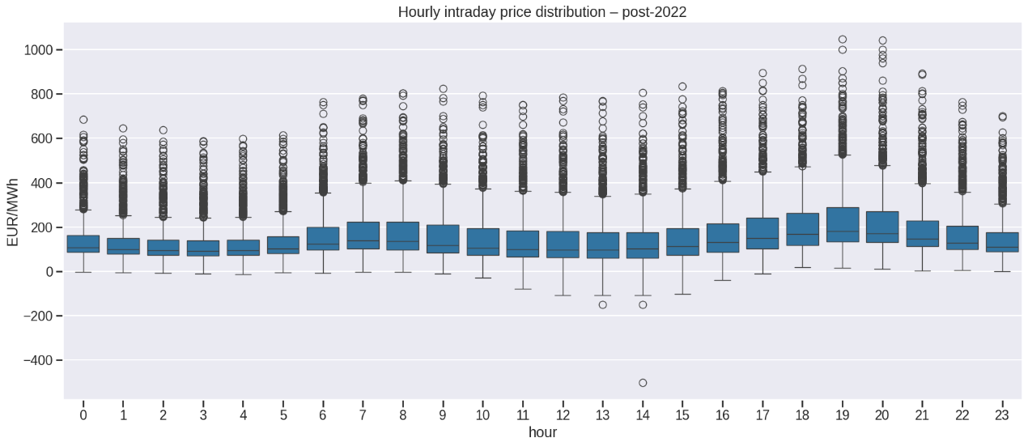
Figure 3: Hourly Intraday Distribution of Hungarian Day-Ahead Prices After 2022
The EDA also confirms a strong temporal structure. Hungarian day-ahead prices vary systematically by hour of day, reflecting daily demand, solar production, ramping needs, and changing system conditions. Apparent weekday/weekend variation also exists, and the demand pattern of the industrial/commercial sector varies by week. This enables the incorporation of calendar variables such as hour, day of week, month, and a weekend indicator. 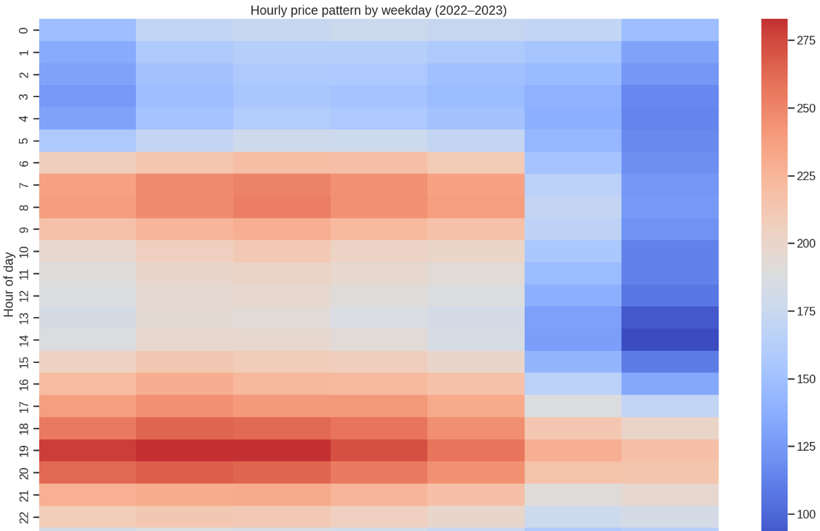
Figure 4: Average Hourly Price Pattern by Weekday, 2022–2023
Autocorrelation diagnostics also reveal significant price persistence. Short price lags and the 24-hour lag are particularly significant, as electricity prices tend to follow a similar daily pattern. This justifies the use of a benchmark called Naive_last_24h, which simply uses the price from the same hour of the previous day for prediction. It also facilitates the use of engineered lag and rolling variables later in the modelling pipeline, such as price_lag_1h, price_lag_2h, price_lag_24h, and price_rolling_mean_24h. This EDA finding is corroborated by later feature-importance results, which demonstrate that recent price data constitutes one of the strongest predictive signals in the XGBoost models.

4.4 Market fundamentals and cross-border effects
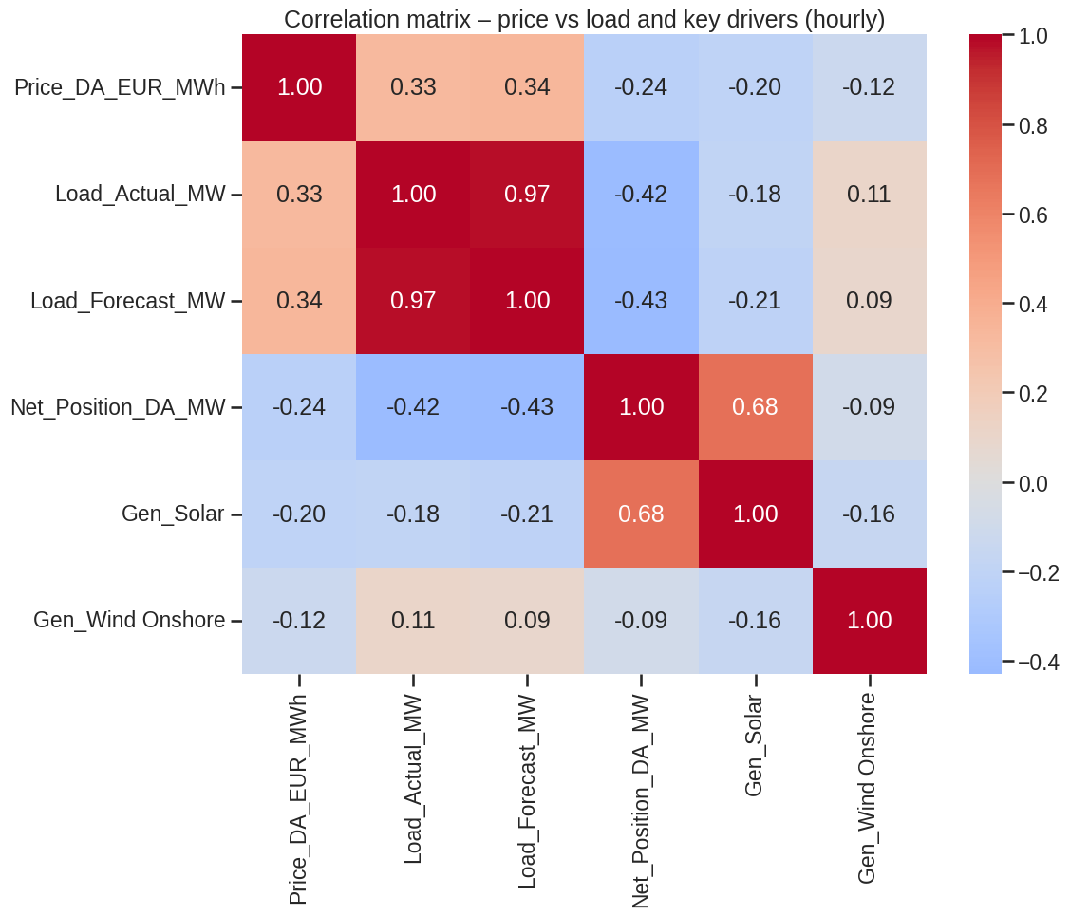
Figure 5: Correlation Matrix of Day-Ahead Price, Load, Net Position, Solar and Wind Generation
The relationship between electricity prices and fundamentals is evident. There is a positive relationship between load and prices. This is a normal phenomenon when demand increases, it puts pressure on the generation and imports. Cross-border variables and net position are also relevant, as Hungary is part of a regionally coupled electricity system. Conditions outside Hungary's bidding zone can have an impact on domestic prices if Hungary is more import dependent or in case of regional transmission limits. Generation variables are also important as the market clearing price will depend on the type of generation that is available.
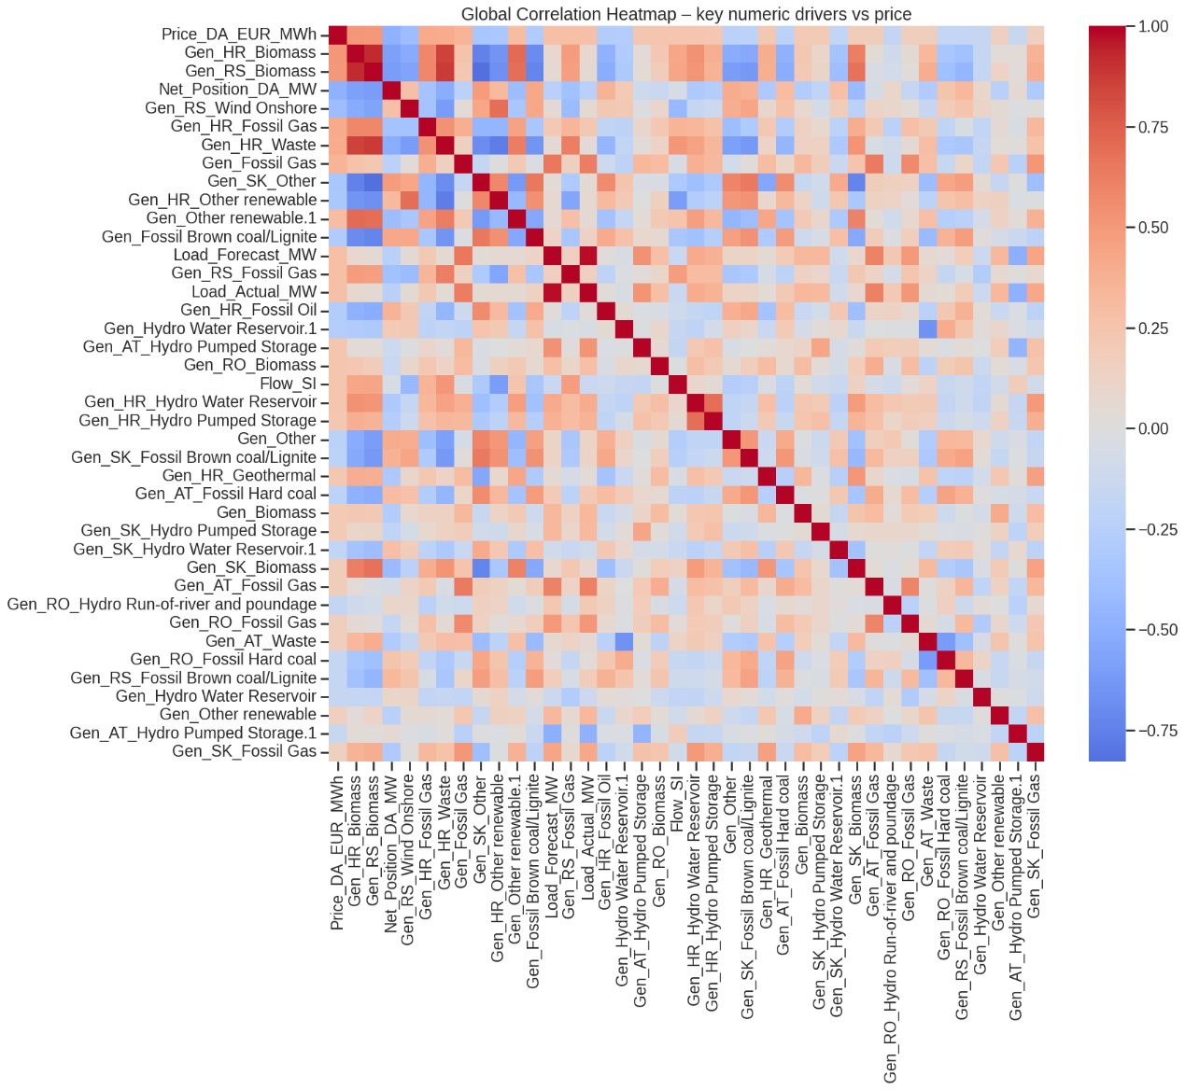
Figure 6: Global Correlation Heatmap of Key Numeric Drivers and Day-Ahead Price
This is verified by the high-price regime analysis. At the 90th percentile, the price is 380.09 EUR/MWh. The average price of the values above this threshold is 496.79 EUR/MWh while the average price of normal price periods is 155.07 EUR/MWh. Higher average load, a more negative net position, and lower solar and wind generation are observed during the periods of high prices. This is as would be expected when demand is high, renewable output is low and when additional supply sources are used, which tend to be more expensive. These results validate the use of load, generation, net position and cross border variables as primary predictors in the model.

4.5 Weather parameters and renewables sensitivity
There is a weaker direct correlation between weather and electricity prices compared with the correlation with market fundamentals. Evaporation, downward longwave radiation, total column water vapour and temperature are variables that show a weak positive correlation with price for the 2022-2024 modelling window. On the other hand, wind, solar radiation and runoff variables are negatively correlated. The results are directionally plausible, but should not be overinterpreted. The impact of weather on electricity prices is not direct, but rather through a number of channels, including renewable electricity production, heating and cooling demand, electricity supply shortages at certain times of day, or the residual load.
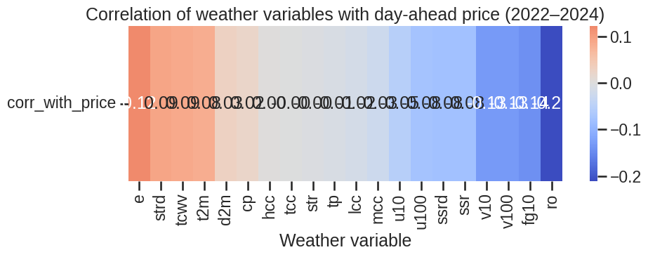
Figure 7: Correlation of Weather Variables with Hungarian Day-Ahead Price, 2022–2024
The weak direct relationships are not to be interpreted as a lack of importance of weather, but rather as conditional and interactional effects. For example, the effect of solar radiation is different during daylight and non-daylight hours, and the effect of wind speed is stronger at higher demand or lower supply. Pearson correlation can only detect linear relationships. This observation is used to justify the use of machine learning models and ablation datasets as well as correlation analysis to determine whether to use weather or not. Moreover, this gives a good reason to use 15-minute weather feature reports, because intra-hour variation can give information that is not available in the hourly averages.

4.6 EDA Implications for Modelling
The Exploratory Data Analysis (EDA) results yield five key modelling implications. First, the regime after 2022 should be modelled separately, given the significant differences in price levels and volatility. Second, to address the persistence of electricity prices, lagged prices and rolling statistics are required. Third, calendar variables are necessary due to clear intraday and weekly seasonality. Fourth, load, generation, and cross-border variables should be considered as key market fundamentals. Fifth, weather should be tested as an incremental feature family rather than automatically assumed to be decisive. The results of this study directly influence the modelling design applied in the subsequent chapter, which consists of a time-respecting forecasting pipeline utilizing no-weather, hourly-weather, and 15-minute-enhanced weather datasets.

5. Implementation of Algorithms and Models

5.1 Common Experimental Setup
The construction of the forecasting models and the comparison of the models is described in this chapter. The forecasting task to be fulfilled by all the models is the same: predicting the Hungarian day-ahead electricity price 24 hours ahead. This translates to making use of data from time t to make a prediction about the price at t+24h. It is important to keep the same target for all models as it would be unfair to compare models with different targets/evaluation rules.
The training period is from the start of the 2022-2024 modelling window. The validation period is used for selecting models and tuning the hyperparameters. The 2024 data is kept entirely separate and used only as the final test period. This is a realistic situation of forecasting in which one market participant is unable to make a day ahead forecast based on future information. A random train-test split is not used since it would combine earlier and later observations possibly leading to data leakage and prettied-up results.
The models are evaluated using the following measures: RMSE, MAE and sMAPE. The main measure is RMSE, which assigns a higher weight to the larger errors, which are more expensive in the electricity market. Forecasts errors are also reported in the form of MAE as an easily understandable measure of the average magnitude of the forecast error. Although sMAPE is a relative measure of error, it can be used with caution when the prices are very small or negative.
The models are presented from the simplest to the most complex. Step 1, is a simple benchmark: Can advanced models do better than simple daily persistence? The second steps is the linear regression which is a very transparent baseline for machine learning. The third step is the primary tabular machine learning model of this project, XGBoost. Step 4 is for classical time-series benchmarks with StatsForecast. In Step 5, you will use the NeuralForecast package to evaluate the ability of deep learning models to learn more patterns in a small evaluation window.
Three sets of features have been used to train each model. Market, calendar, lag, rolling, generation and cross-border features are included in the no-weather dataset. The hourly-weather dataset provides additional ERA5 standard hourly weather variables. A 15-minute enhanced data layer also provides intra-hour weather min, max and standard deviation data. This is an ablation configuration – to test effectiveness of the weather variables and to test if more frequent weather data is effective in addition to the standard hourly weather data.

5.2 Naive and linear baselines
The first benchmark is Naive_last_24h model. It predicts the prices of an hour based on the previous day's price of the same hour. For instance, the forecast at 10:00 tomorrow is just the price at 10:00 today. Though simple, this is a valid reference since the daily pattern of electricity prices is very strong.
The Naive_last_24h model is used for two purposes. Firstly, it serves as a realistic benchmark. If there is no way to outperform this model's RMSE with a more complicated model, there is little justification in making the model more complicated. Second, it illustrates the extent to which the price structure comes from very simple persistence on a day-to-day basis. There are days in which the electricity price from one day to the next is similar, particularly when the weather, system limitations and load are relatively constant.
In this project, the Naive_last_24h is not used as a feeble baseline, but as a serious reference. It could be used in practice as a short term forecast by a trader / generator / procurement manager. Therefore, it is necessary that an advanced model must demonstrate its superiority before it can be adopted in operations. However, the Naive_last_24h model has some practical merits: it is fully transparent, extremely inexpensive to compute and easily monitored. This can indicate model drift, data quality problems, or a shift in market behaviour, if a machine learning model no longer surpasses it.
Baseline models of simple linear regression are also compared. Their purpose is to ascertain if the engineered features can be utilized to generate a transparent linear forecast. A no-weather version, an hourly-weather version, and a 15-minute-enhanced version are trained. The same chronological split logic is applied prior to training. Numeric features are imputed using a domain-aware method, as explained in the Methodology chapter. Linear regression is also sensitive to feature scale; thus, standard scaling is applied. This is necessary because the feature set contains variables with widely differing units (e.g., prices, load, flows, generation, weather variables, calendar indicators, etc.).
However, the results from the final notebook indicate poor performance for the unregularized linear models when evaluated on the entire 2024 test set. Specifically, LinReg_1H achieved an RMSE of 519.04 EUR/MWh, LinReg_no_weather recorded 552.84 EUR/MWh, and LinReg_15T_feats registered 1,749.24 EUR/MWh. These results lack practical utility.
The underperformance of these models has an important interpretation. It does not imply that linear models are entirely inappropriate for electricity price forecasting. Instead, it demonstrates the instability of unregularized linear regression within this particular high-dimensional feature space. A significant number of variables in the modelling datasets are correlated, including price lags, rolling statistics, load variables, generation variables, weather variables, and high-frequency weather derivatives. This leads to multicollinearity and numerical instability. The target variable also exhibits extreme values, further complicating the problem.
Therefore, the unregularized linear models should be used for diagnostic purposes only, as they demonstrate that this setup requires a more complex linear approach. A more robust linear approach, potentially incorporating regularization techniques such as Ridge or Lasso regression, would necessitate feature selection. Consequently, the results of this linear regression are not utilized for drawing definitive business conclusions. The primary takeaway for the modeler is that model simplicity is only beneficial if the model also exhibits stability, accuracy, and robustness.

5.3 XGBoost implementation
XGBoost is the main machine learning model used in this project. It was selected because it has the ability to capture the complex and non-linear relationship between variables. This is particularly helpful when it comes to forecasting electricity prices as the link between price, load, generation, weather and cross border flows is not straightforward. Under high loads, prices can spike when renewable generation is low and imports are limited, for example. XGBoost is good for these kinds of complex interactions.
Three different ablation datasets were used to train three separate XGBoost models. The first one was a no-weather feature set, assessing the model performance without the weather. The second included an hourly-weather feature set to test if there is a benefit from using the standard weather variables. The third was based on a 15-minute enhanced feature set to determine if intra-hour weather variability contributes any additional predictive power.
In order to make a fair initial comparison, all three models were first trained with the same base settings. The hourly-weather and 15-minute-enhanced models were then hyperparameter optimised (Bergstra and Bengio, 2012). The test set was NOT used for tuning. This is an important point as the test set cannot be used to train the model and should only be used for final evaluation. If the test set was used in the tuning, the results obtained in the end would be better than actual results and this would give a false picture of actual performance.
The optimised hourly-weather and 15-minute-enhanced XGBoost models converged on the same primary hyperparameters: max_depth = 4, learning_rate = 0.03, n_estimators = 400, subsample = 0.8, and colsample_bytree = 0.8. These settings are characterized as moderate. A tree depth of 4 was selected to mitigate overfitting and maintain model simplicity. A learning rate of 0.03 indicates a gradual learning process for the model. The 400 estimators provide sufficient model capacity without introducing unnecessary complexity. The stochasticity introduced by the subsample and colsample values contributes to improved generalisation.
As observed from the validation results, the RMSE for the optimised hourly-weather model was 31.23, while for the optimised 15-minute-enhanced model, it was 32.59. The sole purpose of these values is for model selection. The final assessment is based on the unseen test period in 2024 and will be discussed in the Results chapter.
Another property of XGBoost that can be helpful is feature importance diagnostics. These diagnostics are useful in determining the most important model variables. The key variables in this project are predominantly recent price variables, rolling price structure, calendar variables, and selected market fundamental variables. The weather variables are also included as other contributors, particularly in the 15-minute-enhanced model, but they do not replace the dominant influence of price persistence and market structure.

5.4 Classical models with StatsForecast
The StatsForecast library includes classical time-series models. The models used are AutoARIMA and SeasonalNaive. They are evaluated on the same horizon (7 days) as the NeuralForecast models. This provides an equitable comparison of classical and neural time-series forecasting techniques over a short forecast window.
AutoARIMA is included because ARIMA-type models are common tools in time-series forecasting. The model automatically searches for an appropriate autoregressive and moving-average model. For this project, AutoARIMA is set with a seasonal length of 24 to capture the daily hourly seasonality. This is crucial, because there is a strong daily seasonality in the hourly electrical prices.
The simple classical benchmark, SeasonalNaive, is included. It is a method that forecasts future values based on the value observed at the corresponding season in the past. This employs a seasonal length of 24, corresponding to the same hour from the previous day. This is analogous to the Naive_last_24h benchmark but implemented within the StatsForecast system.
The StatsForecast models are not intended to take over the entire modelling process. They are intended to establish and provide open and accepted statistical standards. This is significant because machine learning and deep learning models should not only be compared with other complex models. They should also be contrasted with simpler techniques that can be readily explained and easily duplicated.

5.5 NeuralForecast models: NBEATSx and TiDE
NBEATSx and TiDE are components of NeuralForecast. These models are employed because they can generate time-series forecasts that incorporate exogenous variables. This is important for electricity price forecasting because the target is not only determined by its history, but also by load, generation, cross-border flows, calendar variables, and weather conditions.
The neural models are tested over a 7-day period rather than the entire 2024 testing period. This is primarily due to computational limitations and the impracticality of training neural models multiple times. Compared to XGBoost and simple baselines, deep learning models require more time, memory, and tuning. Thus, they are considered as short-window evidence rather than full-year proof of operation.
NBEATSx and TiDE are first trained on an hourly weather feature set. They are subsequently trained on a selected 15-minute feature set, which has been enhanced. The 15-minute-enhanced neural setup employs a reduced set of exogenous variables, as opposed to all possible predictors. This is necessary as an increased number of variables increases training cost and instability. The selected variables include price variables, load, net position, generation variables, weather variables, and calendar variables.
The 15-minute-enhanced neural models are tuned using a small tuning grid. The grid includes the arguments: input_size = 168 (representing one week of hourly history) and max_steps values of 100 and 200. TiDE performs well on the internal validation window, as demonstrated during the tuning stage. However, the final 7-day test comparison is won by NBEATSx using 15-minute-enhanced covariates. This is significant because it demonstrates that strong validation results do not necessarily equate to performance on the final test window.
Neural models are not considered the primary operational solution, as they are only assessed within a small window. Rather, they are considered specialist challenger models. They can be employed for stress windows, further research, or short-term experiments. They are, however, more difficult to train, monitor, and explain than XGBoost. As such, they are suggested as supplementary models instead of the main forecasting model.

5.6 Feature importance and diagnostics
To get a sense of the forecast, XGBoost feature importance is used. This is crucial, because business users are going to want to know which variables are most important to the model. Prices from the past and the rolling features of prices (price_lag_1h, price_lag_2h, price_lag_24h, price_rolling_mean_24h) are the variables that best predict in this project. day_of_week and hour are also among some of the most important calendar variables.
This fits well with the exploratory analysis. The Hungarian day-ahead prices exhibit well pronounced daily and weekly patterns, which is why recent prices and calendar variables are strong predictors. Generation variables are also relevant, thus affirming that renewable output and system conditions do have a role to play in price formation, particularly solar conditions.
Weather variables are not the main signal; they are obtained from 15-minute data. In the 15-minute-enhanced model, variables like e_1h_max, ro_1h_max, solar_irradiance, the selected wind extrema and the selected cloud-cover extrema gain in relevance and remain secondary. Recent prices, load, calendar structure, generation mix, and cross-border conditions remain the key forecasting signals. High frequency weather features complement at the edge and do not supplant the core drivers.
Model behaviour is also checked using diagnostic tools. The actual versus predicted price plots verify the model's performance in tracking the price path for 2024. Residual plots can be used to determine periods of over-prediction and under-prediction. Slice-wise measures for every hour of the day, month, and weekend day status indicates if the model is consistent across these time segments. These checks are helpful as the model may sound great on average, but not so great at certain hours or in certain markets.
Modelling setup is generally well written and well organized. Naive_last_24h is a good benchmark. The method of linear regression is simple, but is unstable in this context. The preferred model for operation is XGBoost as it can be effectively fine-tuned to learn complex, non-linear tabular data. Classical time-series benchmarks are included in StatsForecast, and the performance of NeuralForecast is evaluated to understand if deep learning is providing value. This model enables to compare fairly all the model families with the same set of rules and by explicitly designing ablation.

6. Results and Analysis

6.1 Full-Year 2024 Performance
The primary assessment is done on the 2024 test set which is not seen during training. This is the most important test period, because it reflects the models' performance on new, unseen test data that are not used in model training and validation. The findings show that during the test period, the tuned XGBoost models performed best. The top model, XGB_15T_tuned, achieved an RMSE of 58.26 EUR/MWh, an MAE of 39.17 EUR/MWh, and an sMAPE of 41.77. XGB_1H_tuned was the second lowest RMSE (58.37 EUR/MWh), MAE (40.24 EUR/MWh) and sMAPE (42.81). There is a very small magnitude of difference between these two tuned XGBoost models. This indicates that the improvement of the 15-minute enhanced weather features over the hourly-weather model is modest. From the above it is clear that the tuned models of XGBoost are clearly outperforming the Naive_last_24h model on the basis of RMSE. The naive benchmark RMSE is 73.87 EUR/MWh while the RMSE obtained with the best tuned XGBoost model is 58.26 EUR/MWh, which is about 15.6 EUR/MWh lower. This is a big step in a very volatile electricity market where large forecast errors can have monetary consequences. The results of the untuned XGBoost models are worse than the tuned models. The RMSE values are 61.04 for XGB_no_weather, 61.97 for XGB_15T_feats, and 66.10 for XGB_1H. This shows that hyperparameter tuning is not just a technicality, it can be seen to affect the performance. The validation process helps to reduce the possibility of overfitting and identify the best model structure for accurate tuning of the models. But it is not a one-sided affair. The naive benchmark is still very competitive with respect to MAE. It has an MAE of 39.56 EUR/MWh, similar to the best-tuned XGBoost model. This indicates that the daily price persistence is a very important factor in affecting the average errors. The difference is that XGBoost does a better job of reducing bigger errors, which are more important for RMSE. So the interpretation will be dependent on the specific business objective. RMSE improvement is significant for risk managers and traders, as substantial errors can be costly. The naive benchmark therefore serves as an important benchmark for analyses that are concerned only with average errors.

6.2 Value of Weather and High-Frequency Weather Features
The ablation results indicate that weather information can be of useful, but not universal. The tuned 15-minute-enhanced XGBoost model is the best-performing model on the 2024 test period. On the other hand, the difference with the tuned hourly-weather XGBoost model is very small (RMSE values of 58.26 EUR/MWh and 58.37 EUR/MWh). This means that high-frequency weather features offer only a small improvement in the best XGBoost configuration for the whole year.
The no-weather XGBoost model also performed well with an RMSE of 61.04 EUR/MWh. This is important as it indicates that a substantial portion of the prediction signal is non-weather-related. Much of the forecastable structure is already captured by lagged prices, rolling statistics, load, generation, calendar variables and cross-border features. Therefore, market fundamentals and price persistence continue to be the primary drivers of predictive power, with weather data offering helpful supplemental information.
The value of the 15-minute-derived weather features varies from one evaluation window to another. The tuned hourly-weather XGBoost model is slightly better than the tuned 15-minute-enhanced XGBoost model in the 72-hour diagnostic window. However, for the 7-day neural comparison, the best performance is achieved with the 15-minute-enhanced covariate set for NBEATSx. This indicates that the intra-hour weather variability can offer a conditional advantage, depending on the model family and evaluation window.
The overall results do not support the notion that the use of higher-frequency weather data results in a universal improvement. A better interpretation would be that in certain instances, high-frequency weather features can enhance performance, particularly when used with a suitable model and tuning approach. For practical forecasting, forecasters should use high-frequency weather data as an auxiliary input and not as the main driver of the forecast

6.3 Seven-Day Classical and Neural Comparison
The 7-day comparison is another method to evaluate the model performance. It enables comparison of classical StatsForecast models and NeuralForecast models in the same short time window. NF_NBEATSx_15T_7d produced the best result with an RMSE of 40.98 EUR/MWh and an MAE of 36.30 EUR/MWh. This is comparable with the performance of the tuned version of this model. The 7-day test also demonstrates that TiDE is less accurate than NBEATSx. NF_TiDE_1H_7d achieves an RMSE of 52.93, and NF_TiDE_15T_7d achieves an RMSE of 57.58. It is significant that this is found. In the internal tuning window, TiDE performed well but could not produce the same performance in the final test window. This demonstrates the importance of carefully distinguishing validation results from test results.
The classical models perform less effectively in this brief comparison. AutoARIMA yields an RMSE of 62.65, and SeasonalNaive an RMSE of 67.67. This suggests that, with well-prepared covariates, neural models may offer value in short, controlled windows. However, the neural models were not tested throughout the entire 2024 test year. Therefore, the results they produce must not be overstated. They should be understood as demonstrating that deep learning can be beneficial as a specialist challenger model, particularly for selected short-term windows.

6.4 Evaluation for 72-Hour Horizons
The 72-hour diagnostic window is the first three days of the 2024 test window. As before, the tuned XGBoost models showed to be the better ones in this assessment. XGB_1H_tuned had the lowest RMSE of 23.94 EUR/MWh. XGB_15T_feats_tuned came in second with an RMSE of 24.55 EUR/MWh. The third best model was NF_NBEATSx_15T_7d with RMSE of 28.98 EUR/MWh.
These results validate the good performance of tuned XGBoost models in short time window. They also demonstrate that the more frequent weather variables don't necessarily produce optimal results. The tuned hourly-weather XGBoost model was marginally better for this 72-hour case than the 15-minute-enhanced version. Though not the best model in this particular window, NBEATSx is a powerful neural challenger.

6.5 Overall Interpretation
Summarizing these results, a practical and balanced conclusion can be drawn. The most powerful full-year operational model family identified is tuned XGBoost. High-frequency weather features prove useful in certain instances, but not universally. In comparison to classical time-series models, NBEATSx with 15-minute-enhanced covariates demonstrates strong performance within the 7-day neural window. The naive benchmark is significant for its simplicity, transparency, and competitiveness regarding MAE.
The overarching message is that model complexity alone is insufficient to solve the problem. Instead, a combination of effective feature engineering, leakage-free validation, appropriate tuning, and careful comparison with other benchmarks yields the best performance. Hence, the most sensible forecasting configuration for the business involves a Naive model as a benchmark, tuned XGBoost as the main operational model, and neural models as challengers.

7. Business Insights and Recommendations

7.1 Business Relevance of the Findings
The results are applicable to market actors aiming to make day-ahead decisions in the presence of uncertainty. The reduction in RMSE from 73.87 to ~58.26 EUR/MWh is significant in a volatile market, as large forecast errors can profoundly impact bidding, procurement, hedging, and risk exposure. However, the results also caution against ignoring simple benchmarks. In terms of MAE, the Naive_last_24h model is competitive, demonstrating that the daily persistence model is operationally useful and should be routinely monitored.
The business insight derived is that forecasting should not rely on a single model. Therefore, a system should be designed without assuming a specific model. Instead, it should be conceived as a layered forecasting stack, comprising a simple benchmark, a robust operational model, and specialized challenger models. This architecture fosters performance, transparency, and good governance. Should the operational model underperform the benchmark, the system should trigger an investigation alert.

7.2 Recommended Forecasting Architecture
Based on the empirical results, a four-layered operational architecture is recommended:
- Benchmark Layer: Maintain the Naive_last_24h model as an always-available and low-cost benchmark, which is surprisingly competitive on MAE.

Primary Operational Model: Utilize the tuned XGBoost model for forecasting during operation. Both the tuned hourly-weather and tuned 15-minute-enhanced versions perform well. The simpler hourly version could serve as an effective default, while the 15-minute-enhanced version could be retained as a challenger, provided its data pipeline is verified.

- Challenger Model Layer: Keep a NeuralForecast challenger readily available for short-window analysis or stress use cases.
- Performance Monitoring Layer: Benchmark performance based on hour, month, weekend, status, and high-price regimes to identify areas where performance falls short.

Core Benchmark: Naive_last_24h – provides continuous sanity checking.

Operational Model: Tuned XGBoost using market fundamentals, lags, rolling features, calendar variables, and selected weather covariates.
With out-of-sample value as the objective, experiments should be considered independently for each tactical challenger, with NBEATSx as the first and TiDE as the second, if future rolling backtests reveal out-of-sample value.
- Governance Layer: Rolling performance monitoring, residual diagnostics, and retraining triggers.

7.3 Implication for High-Frequency Weather Investment
As a result of the evidence, high-frequency weather data should be used judiciously. The 15-minute-enhanced tuned XGBoost model achieves the best full-year
RMSE, albeit the margins in comparison to the other tuned model (hourly-weather) are very small. Furthermore, the RMSE corresponding to a diagnostic window of 72 hours is best for the hourly-weather model. If clean high-frequency weather data is already available to a company, the additional cost of features derived from 15-minute data may be worthwhile. For a company lacking such infrastructure, hourly weather data combined with strong market features might deliver most of the achievable value.
There are a number of operational costs associated with data granularity: storage, preprocessing, monitoring and data feature validation, and model maintenance. Consequently, there should be a tangible uplift for the business case for high-frequency weather data, rather than a mere belief that more granular data is inherently better. For this project, high-frequency weather is a useful parameter, but it is not a decisive factor. It should be applied as an enhancement and not as an absolute requirement, and its impact should be monitored.

7.4 Risk Management and Decision Use
Various users have different preferences regarding performance metrics. For traders and risk managers, RMSE might be preferred, as large errors can lead to significant financial losses. Since MAE represents the average expected deviation, it may be more attractive to operational planners. RMSE is essential for understanding tail risk, while MAE is crucial for understanding normal-day reliability—both could be needed by senior decision-makers. Hence, the somewhat underwhelming result, where XGBoost performs better on RMSE, while the naive benchmark remains competitive on MAE.
The forecast should also be applied as a decision support tool, and not as a "decision rule." Events such as outages, policy announcements, fuel shocks, and even extraordinary weather events that may not be well modelled in historical data can affect electricity markets. Human market knowledge remains necessary, particularly during unusual market periods. The model can initiate the decision-making process, but expert review and market intelligence should be used in conjunction with the model.

7.5 Recommendations
The first proposed solution is to use a tuned XGBoost as the primary model for forecasting day-ahead prices for Hungary (24 hours ahead). It offers the best full-year RMSE and a strong score in the 72-hour diagnostic window.
The second recommendation is to maintain Naive_last_24h as a live benchmark.
The third recommendation is to establish the hourly weather-tuned XGBoost model as a robust operational default and to have the hourly weather model, enhanced by 15-minute time series data, as a monitored challenger where high-frequency weather data are available.
The fourth recommendation is to retain NBEATSx as an expert neural challenger for a limited period, focusing on selected small time windows.
The fifth recommendation is to create a dashboard-style plot displaying residuals and error by hour/month, benchmark comparisons, model drift indicators, and actual-versus-predicted prices.
A further key recommendation is to revise the next version of the project, particularly by incorporating probabilistic forecasting. While point forecasts are provided, uncertainty ranges are also needed (Gneiting and Katzfuss, 2014). Prediction intervals or quantile forecasts would enable risk managers and traders to appreciate the range of confidence and potential upside and downside in the prediction. This would be particularly useful in a heavy-tailed, highly volatile random setting, especially given the assumption that the price has a limited upside and a long, narrow tail.

Conclusion
This dissertation aimed to determine whether Hungarian day-ahead electricity prices are more accurately predicted with a combination of market fundamentals, cross-border system variables, and higher-frequency weather-derived features during the 2022-2024 post-crisis period. The project developed a 15-minute master dataset, converted it into an hourly modelling dataset, designed a 24-hour-ahead target, and validated models under strict temporal validation.
The empirical results indicate that the tuned XGBoost models performed best for the year 2024. The tuned 15-minute-enhanced XGBoost model yields an RMSE of 58.26 EUR/MWh, and the tuned hourly-weather XGBoost model yields an RMSE of 58.37 EUR/MWh. Both models outperformed Naive_last_24h in terms of RMSE and were competitive in terms of MAE. This shows that machine learning can provide benefits, especially for larger errors, but also validates simple persistence as a strong benchmark in the electricity-market context.
The outcome of analysing the granularity of the weather is nuanced. The added value of high-frequency weather features is not overwhelming but modest over the entire year, and not consistent across model families and evaluation windows. They are best used as a complement, rather than a substitute, to lagged prices, market fundamentals, and calendar effects. NeuralForecast models, particularly models based on NBEATSx with enhanced covariates at 15-minute intervals, exhibit potential in shorter evaluation windows, but their evaluation period is still limited, and the models should be considered specialist challengers rather than primary operational solutions. Care should be taken in the use of TiDE, as there is some promising validation behaviour, but the final 7-day test comparison favours NBEATSx.
There are several limitations to this project. Only the point forecasts are used in the analysis, and uncertainty intervals were not estimated. It utilized historical and reanalysis data; live deployment would necessitate careful treatment of covariates available for forecasting. Due to computational limitations, some model families were assessed on shorter time periods. Linear baselines were not as successful as expected in the final notebook, and so other regularisation or feature selection methods could be investigated before drawing general conclusions about linear methods. Neural models were tested on shorter windows, and the results obtained should not be construed as evidence of full-year operational performance.
Future work will involve expanding the project in four dimensions: probabilistic forecasting, rolling-origin backtests, improved model governance, and integration with live-weather forecasts. Despite the limitations, the dissertation makes a contribution to business data analytics. Forecasting quality relies not solely on cutting-edge algorithms, but also on regime awareness, leakage-free validation, disciplined feature engineering, and interpretation connected to real-life decisions. A powerful XGBoost-based forecasting stack with simple benchmarks, selectively incorporated high-frequency weather features, and NBEATSx-based neural challengers is identified as the most practical solution for Hungarian day-ahead electricity forecasting.

References
Bergstra, J., & Bengio, Y. (2012). Random Search for Hyper-Parameter Optimization. Journal of Machine Learning Research, 13, 281–305. Retrieved from https://jmlr.org/papers/v13/bergstra12a.html
Bunn, D. W. (2000, February). Forecasting loads and prices in competitive power markets. Proceedings of the IEEE, 88, 163-169. doi:10.1109/5.823996
Chen, T. (2016). XGBoost: A Scalable Tree Boosting System. XGBoost: A Scalable Tree Boosting System, 785–794. doi:10.1145/2939672.2939785
Contreras, J. (2003). ARIMA models to predict next-day electricity prices. 18(3), 1014–1020. doi:10.1109/tpwrs.2002.804943
Das, A. (2023). Long-term Forecasting with TiDE: Time-series Dense Encoder. Retrieved from https://openreview.net/forum?id=pCbC3aQB5W
Gneiting, T., & Katzfuss, M. (2014). Probabilistic Forecasting. Annual Review of Statistics and Its Application, 1, 125–151. doi:10.1146/annurev-statistics-062713-085831
Hersbach, H., Bell, B., Berrisford, P., Hirahara, S., Horányi, A., Muñoz‐Sabater, J., . . . Thépaut, J.‐N. (2020, June). The ERA5 global reanalysis. Quarterly Journal of the Royal Meteorological Society, 146, 1999–2049. doi:10.1002/qj.3803
Hong, T., Pinson, P., Wang, Y., Weron, R., Yang, D., & Zareipour, H. (2020). Energy Forecasting: A Review and Outlook. IEEE Open Access Journal of Power and Energy, 7, 1-1. doi:10.1109/oajpe.2020.3029979
Ketterer, J. C. (2014). The impact of wind power generation on the electricity price in Germany. 44, 270–280. doi:10.1016/j.eneco.2014.04.003
Lago, J. (2021). Forecasting day-ahead electricity prices: A review of state-of-the-art algorithms, best practices and an open-access benchmark. 293, 116983. doi:10.1016/j.apenergy.2021.116983
Maciejowska, K. (2020). Assessing the impact of renewable energy sources on the electricity price level and variability – A quantile regression approach. 85, 104532. doi:10.1016/j.eneco.2019.104532
Nie, Y. (2023). A Time Series is Worth 64 Words: Long-term Forecasting with Transformers. doi:10.48550/arXiv.2211.14730
Nowotarski, J. (2018). Recent advances in electricity price forecasting: A review of probabilistic forecasting. 81, 1548–1568. doi:10.1016/j.rser.2017.05.234
Oreshkin, B. N. (2019). N-BEATS: Neural basis expansion analysis for interpretable time series forecasting. Retrieved from https://openreview.net/forum?id=r1ecqn4YwB
Sgarlato, R. (2022). The Role of Weather Predictions in Electricity Price Forecasting Beyond the Day-Ahead Horizon. 1–1. doi:10.1109/tpwrs.2022.3180119
Weron, R. (2014). Electricity price forecasting: A review of the state-of-the-art with a look into the future. 30(4), 1030–1081. doi:10.1016/j.ijforecast.2014.08.008
Ziel, F. (2018). Day-ahead electricity price forecasting with high-dimensional structures: Univariate vs. multivariate modeling frameworks. 70, 396–420. doi:10.1016/j.eneco.2017.12.016

Appendices

AI and GitHub Usage Statement (per project handbook)
ChatGPT (GPT-5.5) was utilised to brainstorm about the structure of the report and helped me think trough the logic of my work. Accessed: [06/12/2025].
Available at:https://chatgpt.com/share/6a06c225-17d0-8393-aa8a-a81a7e56c41

GitHub Repository URL and Folder Structure
The notebook is available at:
https://github.com/PolivkaD/BDA-Capstone-hu-electricity-price-forecast

